2022
Asha for Education, Delaware Chapter – Meeting with Swami Vivekanand Vidyalaya, Lodhar
August 29th, 2022 (10:00 PM EST)

Organization: Asha for Education, Delaware Chapter
Project: SVV Lodhar (https://svvlodhar.blogspot.com/p/about-us.html)
Type of Project: School for underprivileged children in Kanpur

Type of visit: Virtual via Zoom
Date: August 29, 2022 (EST)
Time: 10:00 PM EST, 7:30 AM IST, 1hr 15 min
Google drive link to recording: Restricted access please email chapter for permission to view.
https://drive.google.com/file/d/11gvQomNK23_4FSote0t1M8ftz9B7M0d1/view?usp=sharing

Meeting Agenda:
- Tour of the school
- Interact with staff and children
- Discuss issues in school that require funds (salaries, infrastructure, student projects, etc)
- Closing Q&A

Attendees:
- Sai Praneeth, Asha Delaware Treasurer
- Lavanya Jakka, Asha Delaware – Project Steward
- Aditya Medury, Jagrithi Organization
- Prabal Maiti, Jagrithi Organization
School staff:
- Ms. Annapurna Dikshit, School Principal
- Mr. Uday Pratap Singh
- Anuradha Mishram
- Deepthi Shukla
- Chandra Kumar
- Pradeep Kashyap
- Desh Kumar
- Ankur
- Manoj Kumar
Brief Introduction: SVV Lodhar school is completely run based on funds generated in and out of India. They teach 1 to 8 classes. Professors from IIT Kanpur belong to Jagrithi association raise funds for two schools out of which SVV Lodhar is one.
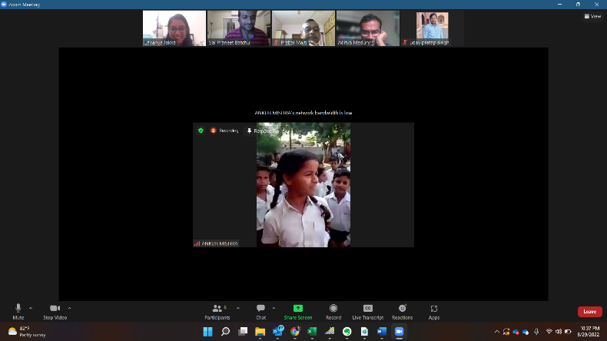
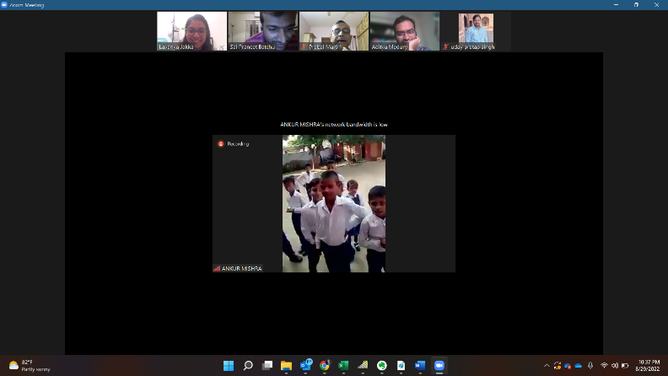
Interaction with kids who came early to the school.
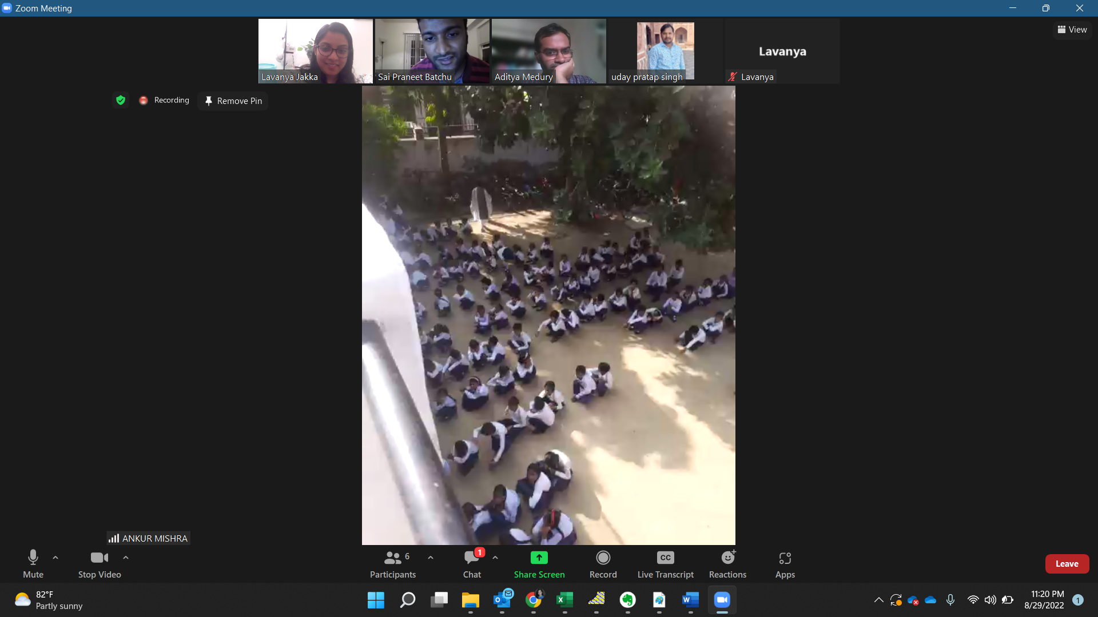
Children just finished prayer/ assembly and are waiting in line to go to their classrooms. 11:15 PM EST (8:45 AM IST)
Current situation at school: Conversation with Principal:
- No COVID situation, things are just getting back normal. Some children are sick with cough and fever due to rainy season. Children completed their 3rd monthly exam. There is an upcoming parents and teachers meeting next Saturday.
- Parents- Teachers meeting: It is flexible such that any parents who can not attend due to work usually catch up with teachers later.
- Nutrition Program: Currently due to lack of sufficient funds nutrition program is not running. The school prefers to provide supplemental nutrition rather than a complete lunch program if funds are sufficient. Lunch program requires further infrastructure such as kitchen that makes it difficult to support. However regular food such as rice and dal are eaten by children at home. Providing them with supplemental nutrition such as nuts, dry fruits and fruits like apple, banana, etc will add more nutrition to children’s diet which is preferable.
- Outing for students: Younger kids (below class 1 kids) are not taken on outing. 1 to 5 class children will be taken to outing in Kanpur area for example Zoo, which is nearby. 6 to 8 class children will be taken for outing to somewhat farther places.
- Playground: School has playground at the entrance. During the monsoon season, it is filled with water and Children can not play. Management tried to acquire nearby sites for playground or expanding school whenever the site becomes available. But it is more complicated process to have paperwork done and have funds available at the same time and the local ruling members support.
- Infrastructure: Partition (Plywood separator) between two classrooms.
Uneven cement floor, management would prefer to get it fixed before an event in November at school. The desk or benches not in best condition.
- Events:
- Science exhibition: In November there is science exhibition conducted in the school. 7000 to 8000 people attend each year. Each room is dedicated for a subject science, social, art (rangoli). Management would like to repair the floor ready for rangoli event if funds suffice.
- Annual function – January each year (sometimes in February as more students tend to get sick in January weather).
- GK competition – Multiple schools in the region participate.
- Picnic for school children.
- Games event in December – Organized in an area nearby where school staff will have to clean and organize as the school playground is small.
- School timings: 8:00 a.m. to 1:00 p.m. with lunch break. Saturdays are usually activity days where children in leadership position talk, art classes are conducted, etc. Every day last period is allocated for sports. Children like to play Kabadi, coco, bat and ball as outdoor sports. There are carroms, ludo, etc as indoor sports. Playground is too small for some sports such as cricket.
- Commute: Many children come in cycle, a few by walk and a few drops and pick up by parents.
- Recent grant: SVV school recently secured a grant that conducts classes for the girl children to learn self-defense, dance (Kathak), music (Tabala). A group of girl children performed a Taekwondo demo during the virtual site visit.
- School Curriculum: Over past two years, transitioning from open curriculum to UP government school curriculum.
- Moral values: School teachers and Principal do their best to let students understand moral values. Especially for 7th, 8th class children and try to keep in touch with most students until they study 11th and 12th to help them follow good conduct.
- FCRA status: The system has become more rigorous. There was a visit to Prabal ji’s place. Currently FCRA status is available till September 2022. They are renewing and also waiting for permanent FCRA status.
Main issues that require funding are the following in the order of priority:
- Teachers’ salaries
- Build a wall in place of partition to avoid disturbance between two classes.
- Repair floors in class and office
- Annual function/ Science exhibit
- Tour
- Benches
Based on the funding available apart from the teachers’ salaries, building a wall will be the priority item. Jagriti members plan to do target fund raising event for maintenance items that are not listed out in the annual budget such as benches, black boards, etc.
Multiple screenshots were taken during the virtual site visit. Below are the screenshots with description.
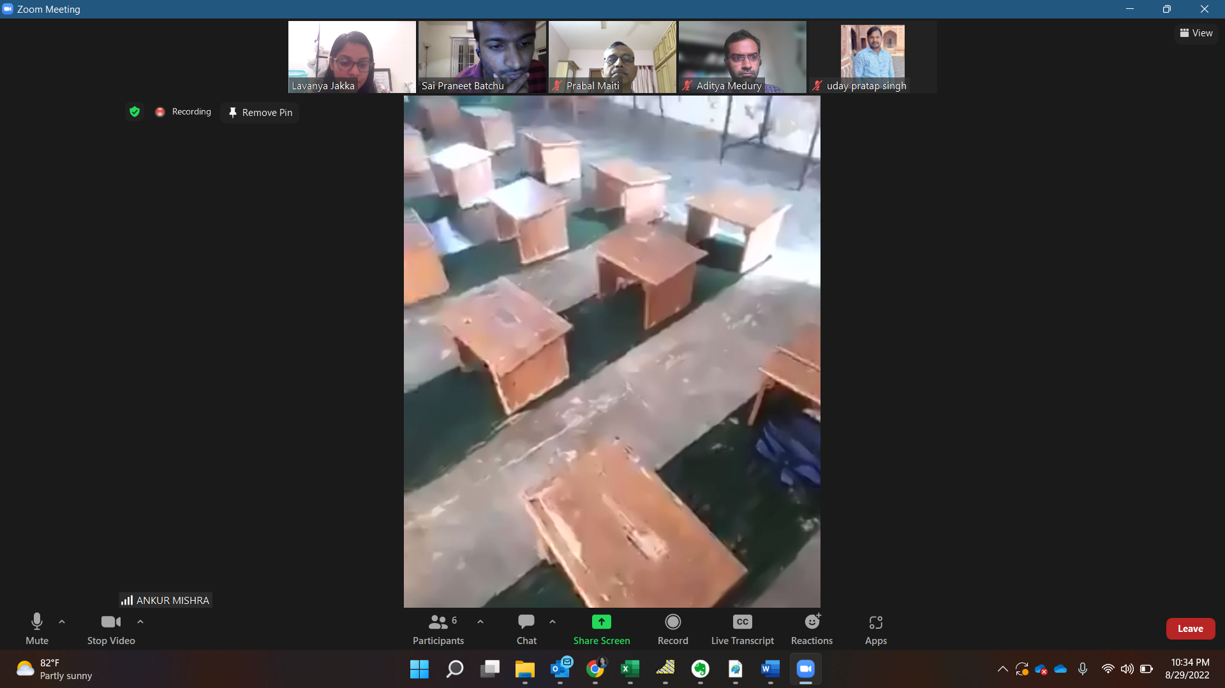
Benches in the KG section that are broken.
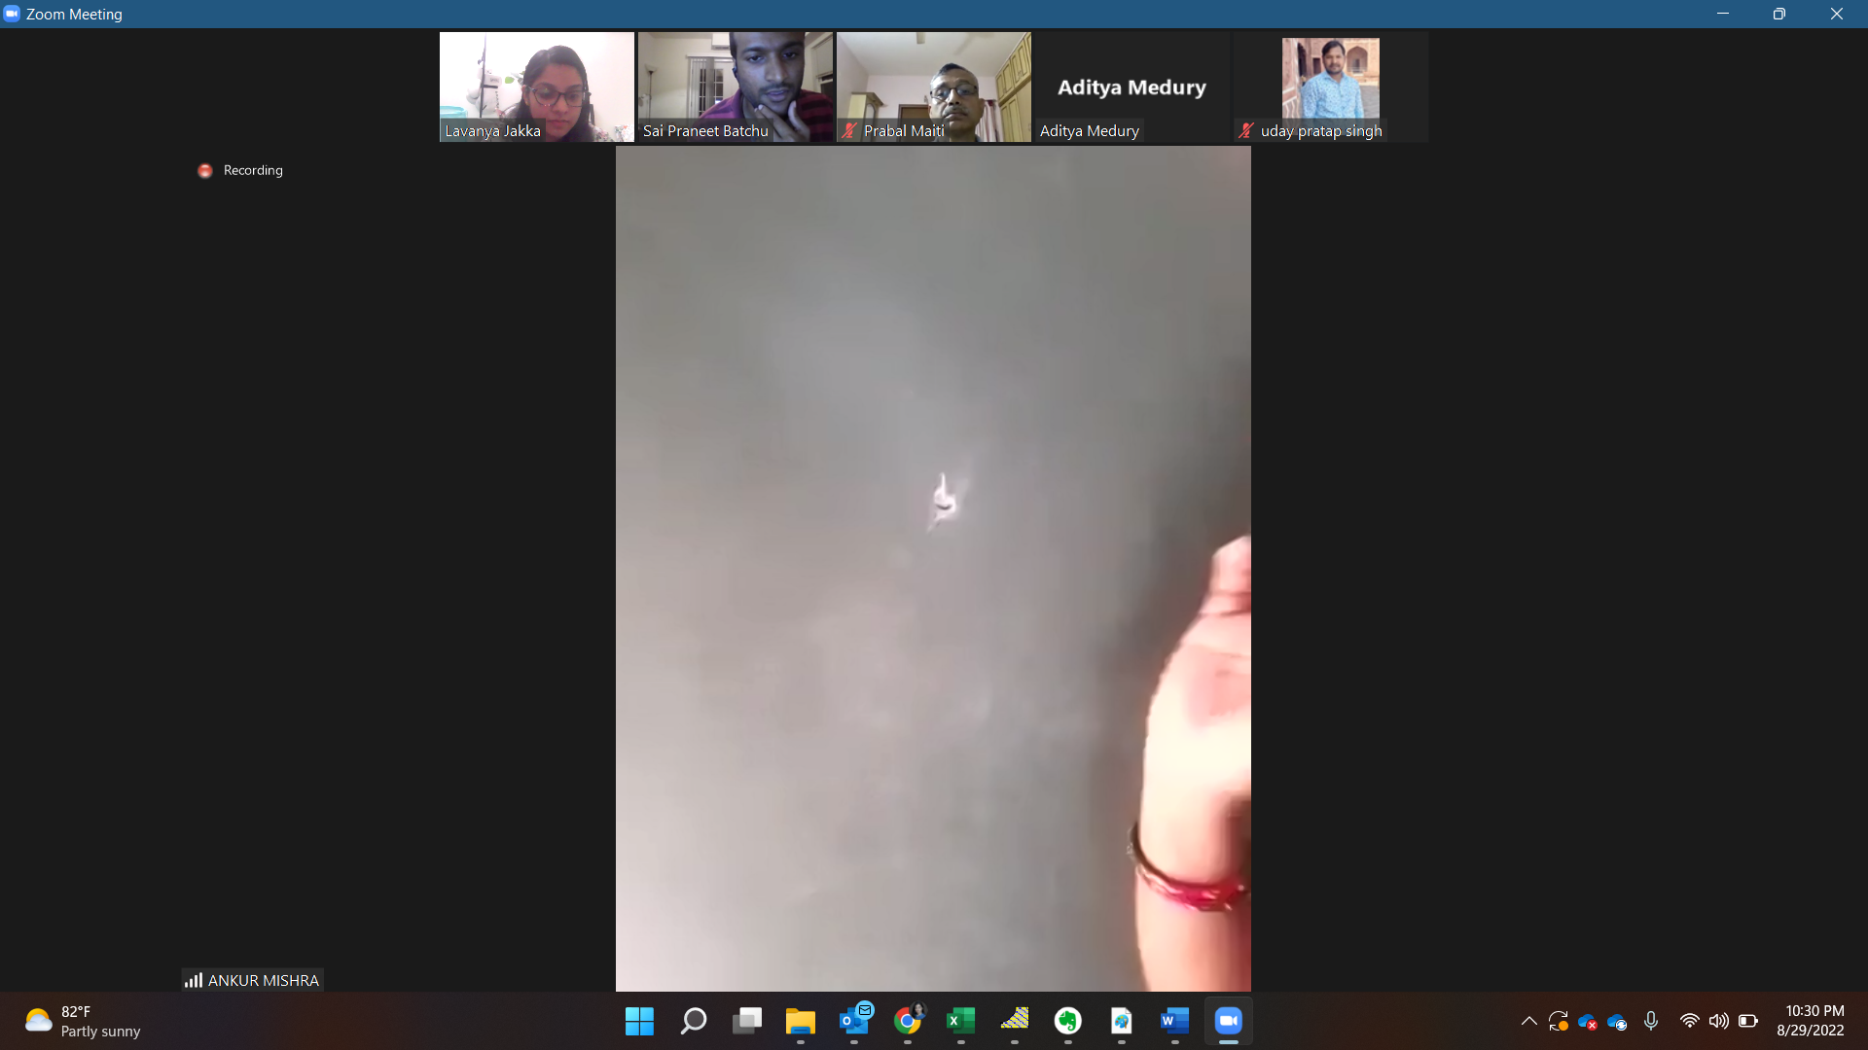
Damage on black board.
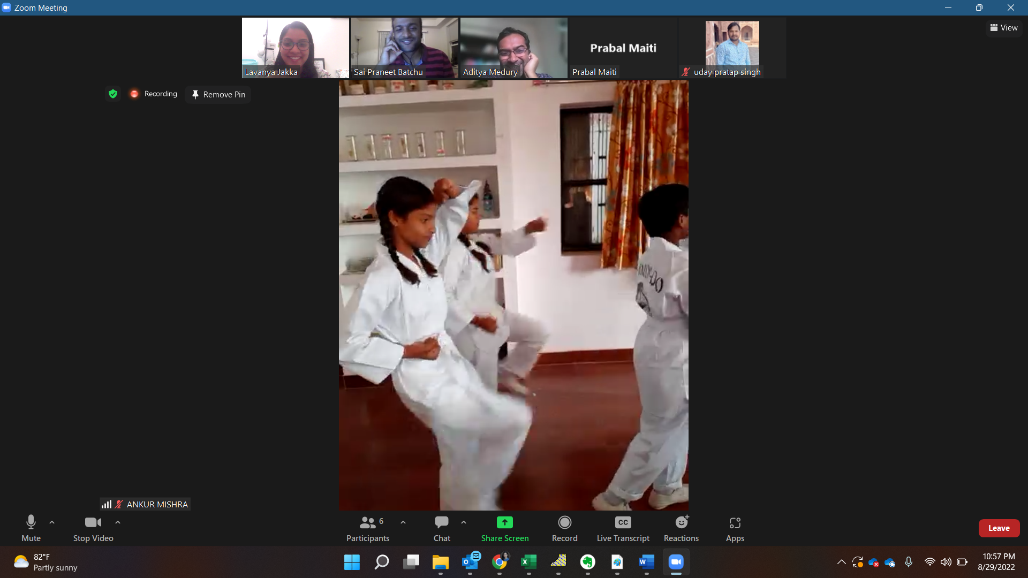
Taekwondo demo

Taekwondo demo
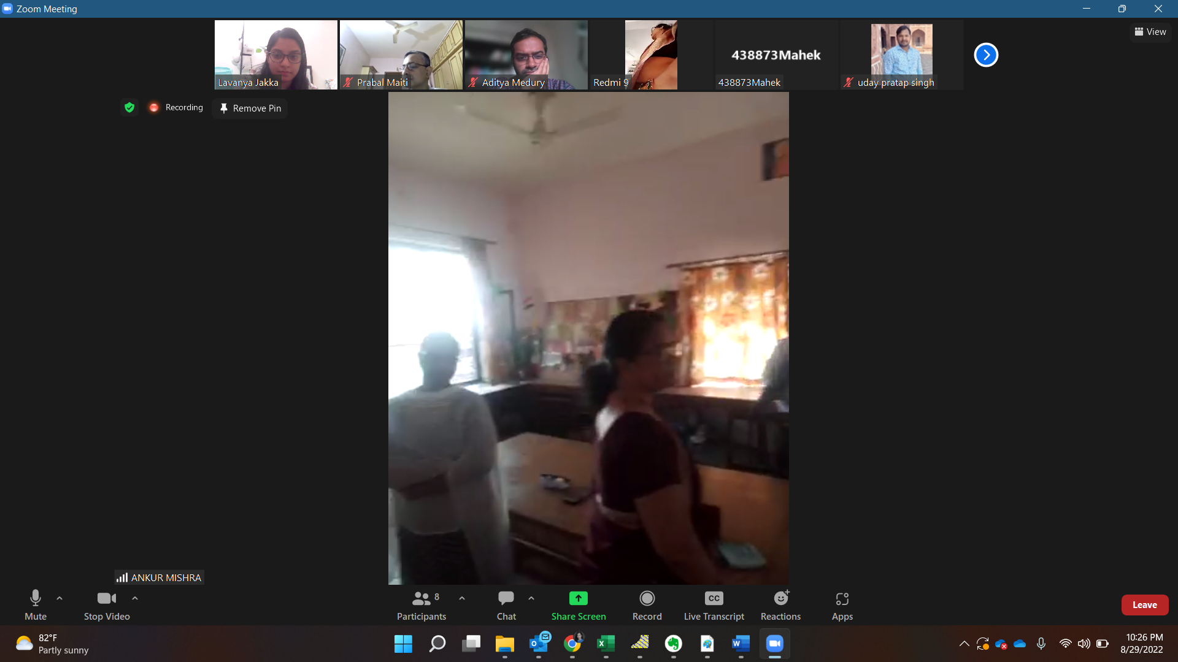Science lab

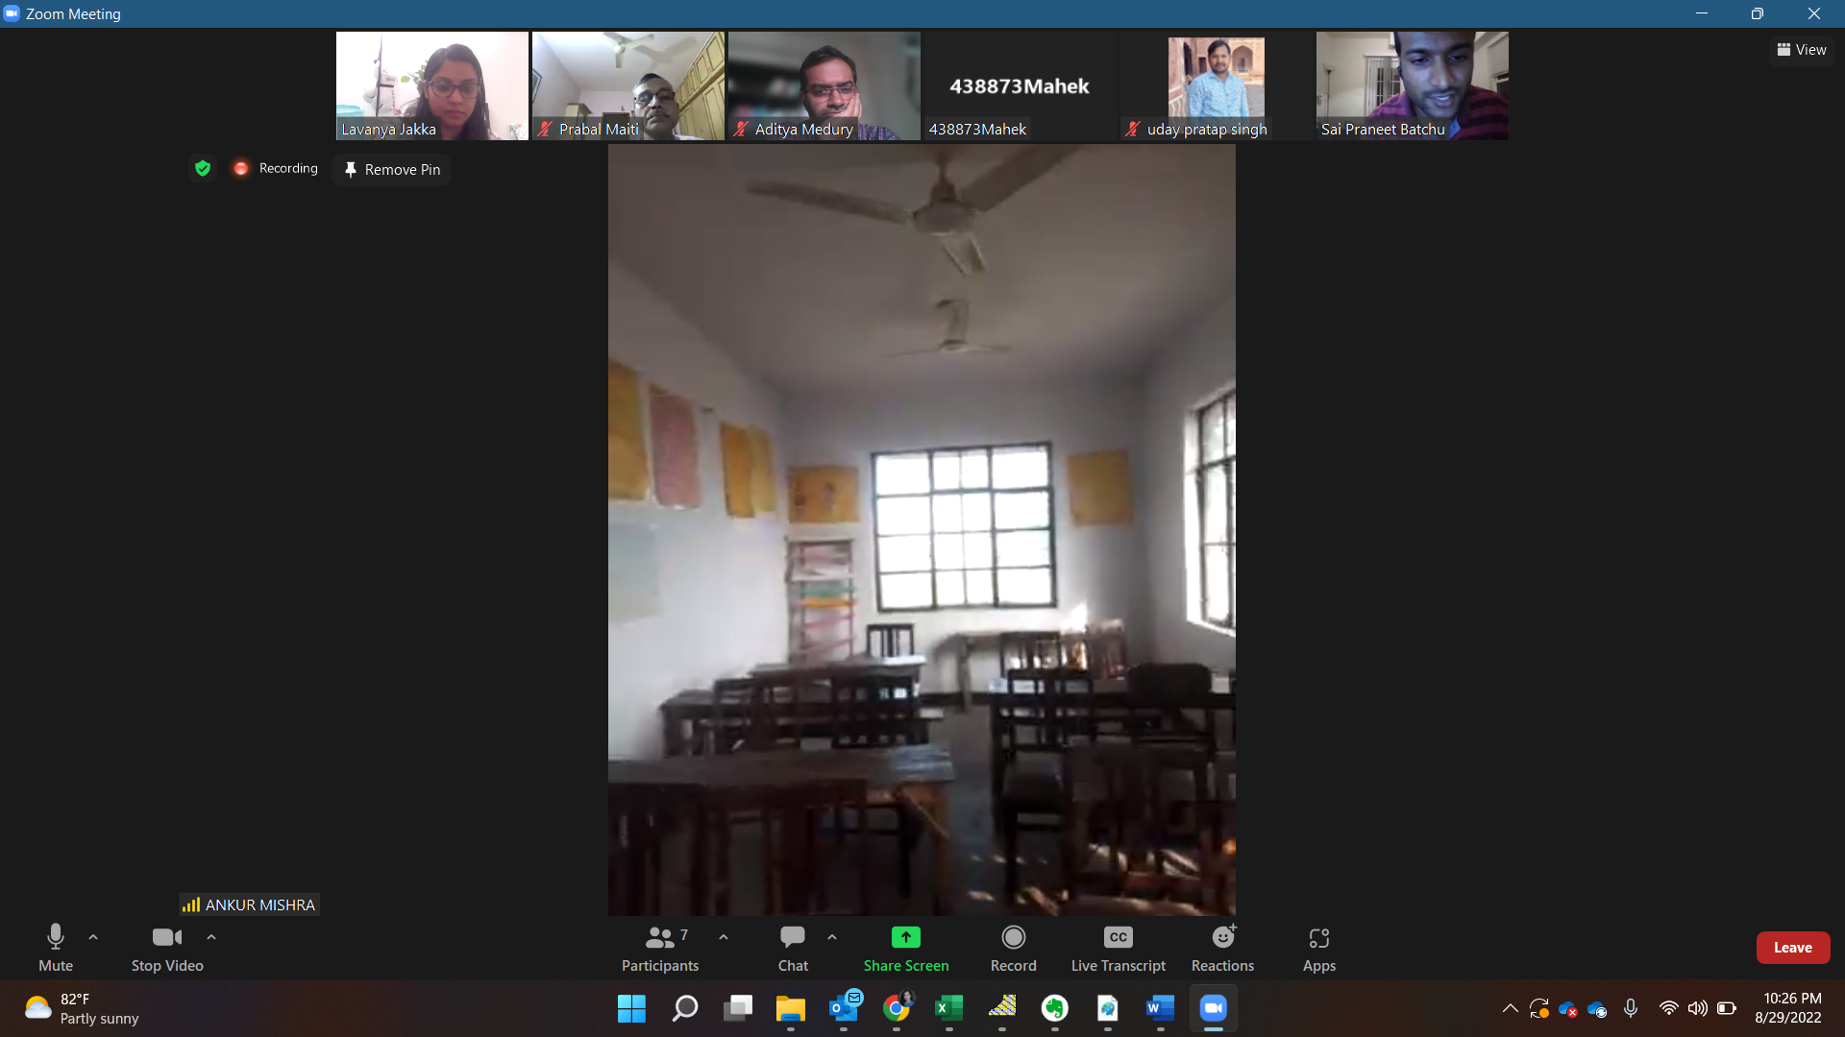
8th standard classroom

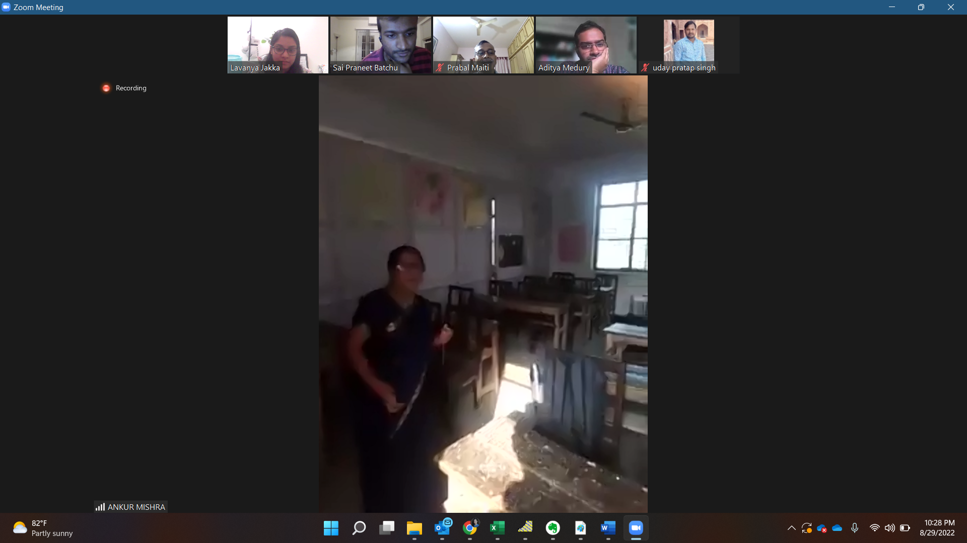6th standard, partition of plywood in two classrooms. Voice between the rooms is disturbing during classes.

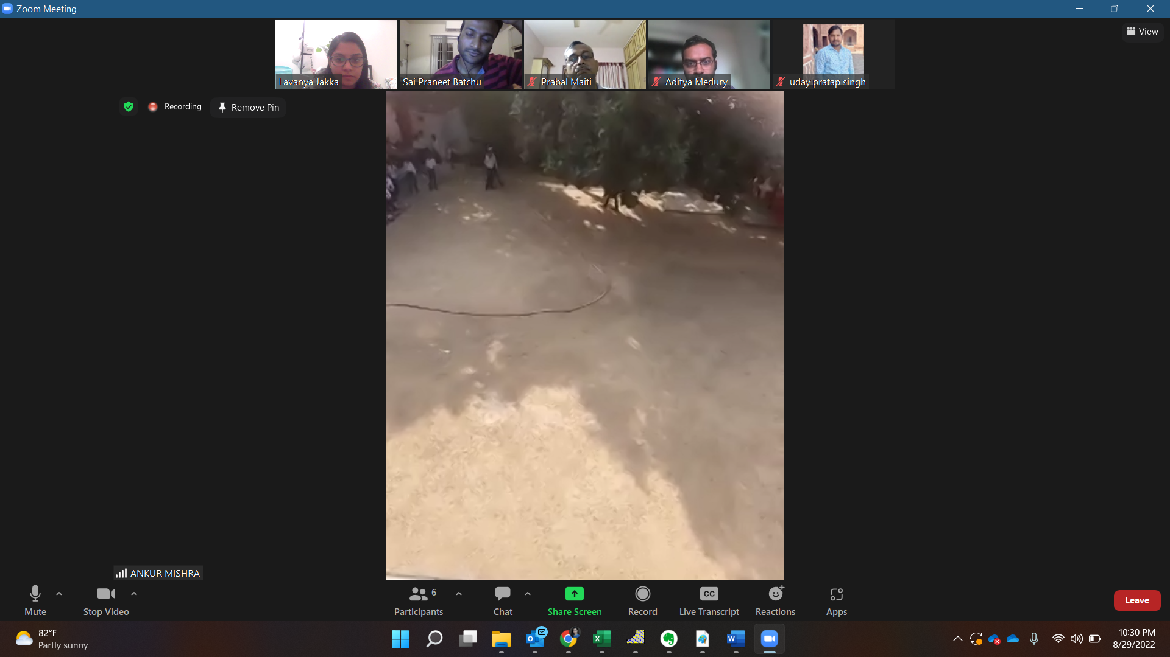
Playground in front of the school.
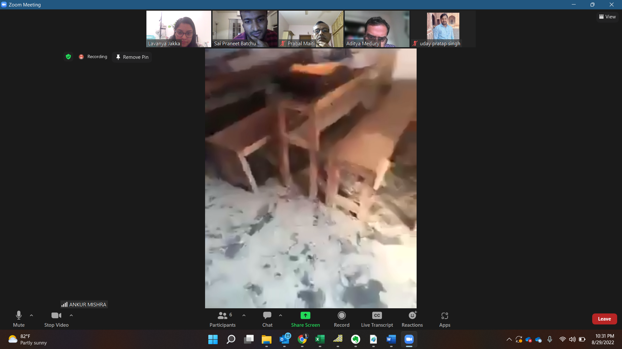
Cement floor damage in classroom that are damaged.
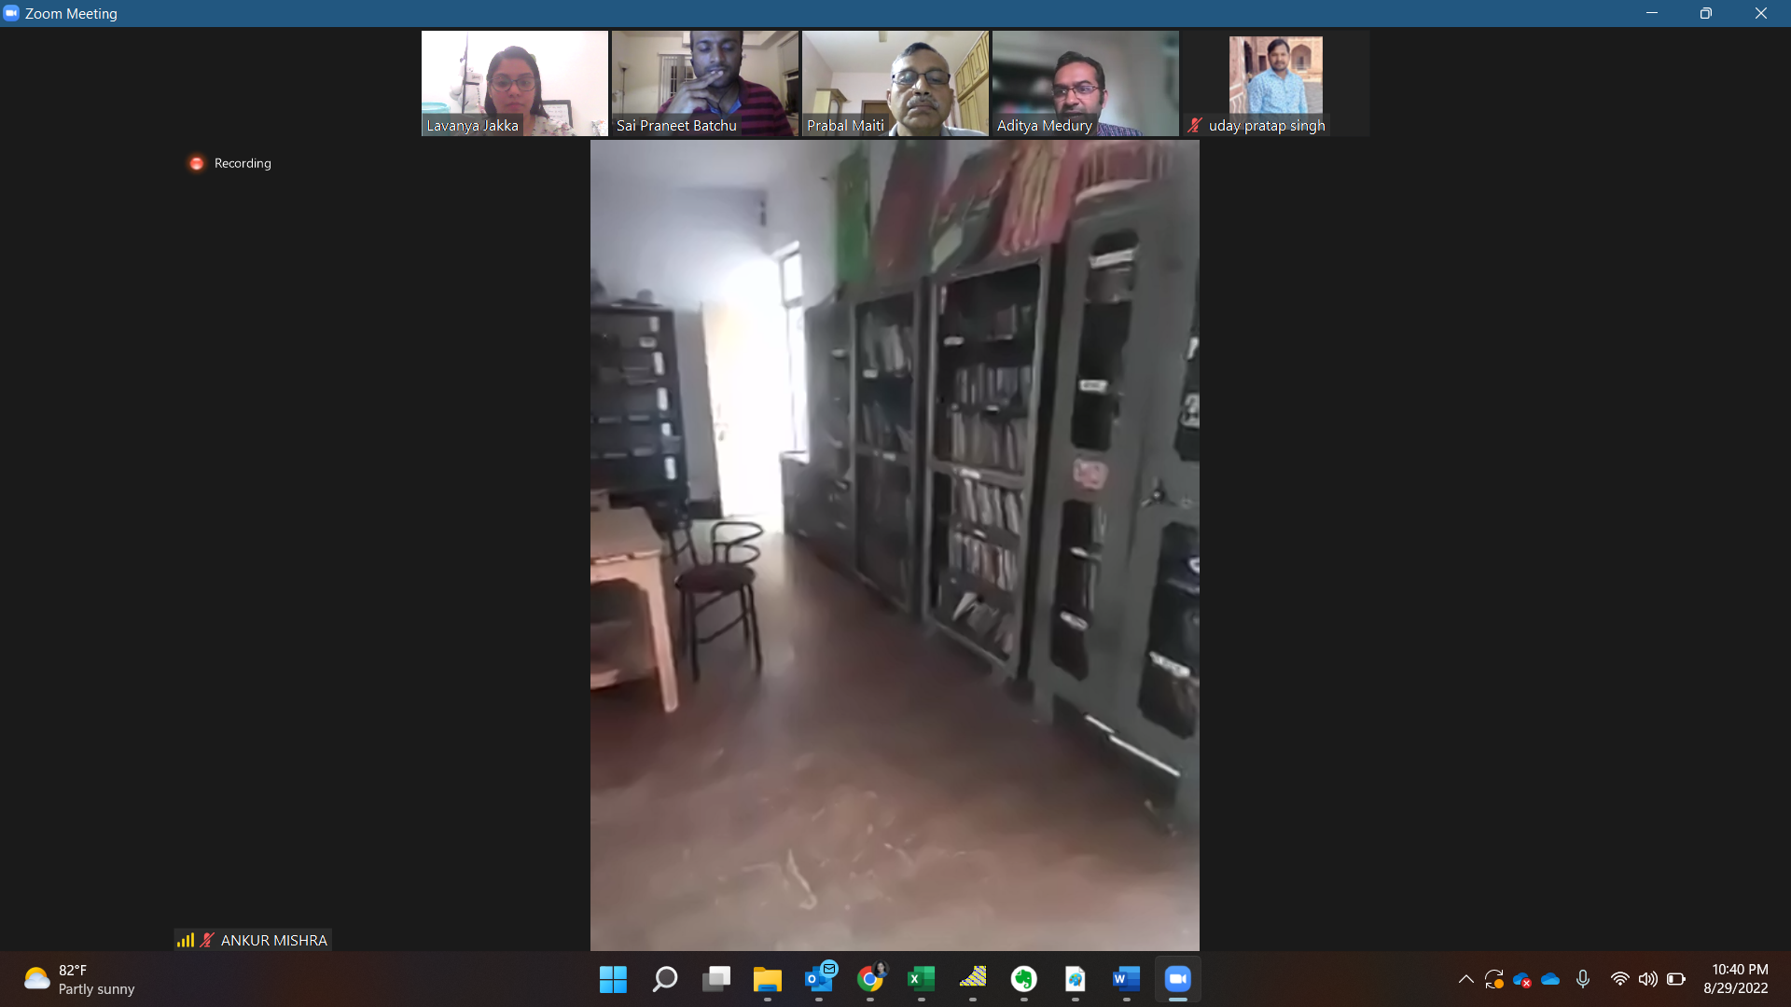
School library.

