Site visit done by: Jyoti Gawade
Date: 30th June 2018

Nandurbar is about 10-12 hours from Pune by bus. Since I have never been to the area and was not sure how remote it is, I was little hesitant to go there alone. So a after brief discussion with the Janseva and Jeevanvidya directors, we decided that Fr. Adolf who was coming to Mumbai for his work would come to Pune on his way back and I would travel with him.

We took a bus by Sharpline travels from Pune to Dhule at about 9 PM and Vineet travels from Dhule to Nandurbar. On the bus I had a long chat with Fr. Adolf. He has experience working at other boarding schools. He talked about himself, the organization, the kids coming to the hostel, their issues etc. He said he tries to employ new strategies to improve learning in kids e.g. asking them to summarize the school book chapter or a story book that they read which seemed to help.

When we reached Nandurbar, Fr. Vinay came in their jeep to pick us up from the bus station. The hostel is pretty close to the station but the last half a mile or so is not a paved road and was hard for the autorickshaws to drive on so the jeep was more convenient.

We went to Janseva first. On arriving, I met Fr. Florence who is the main coordinator there.
We had breakfast together. They served bread and omelette breakfast with some local mangoes. I took a tour of the hostel after finishing breakfast. I met with the accountant Dinesh but did not interact with him much. I met the boarding supervisor Nitesh. He is a past student of Janseva. According to the senior staff, he is sincere but needs directions.

They have good-sized plot of land around the hostel where they grow vegetables and other crops. Fr. Adolf said that they have a couple of people working in the farms and students contribute as well. I saw one of the workers there. Fr. Vinay is very much interested in experimenting with farming and involving children in working with him.

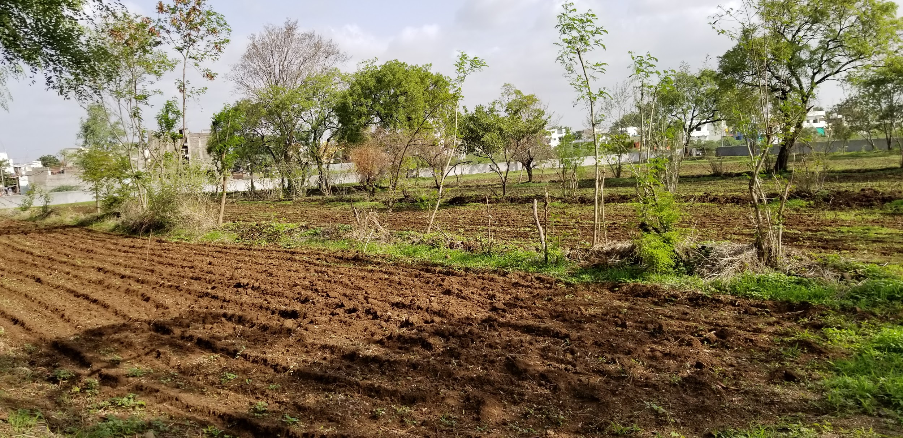

There are a couple of wells but the neighbors have borewells which pump water from surrounding and the wells are now mostly dry. I saw the tanker that supplies water. Kids use the open bathrooms where the wastewater goes to nearby plants.

Kids had one big and one small hall on the ground floor. The staff offices and staff kitchen are in the same building on the same floor so it is convenient to supervise the children. I could see that the hall flooring was replaced and new mattresses had been purchased from the one-time funding last year.

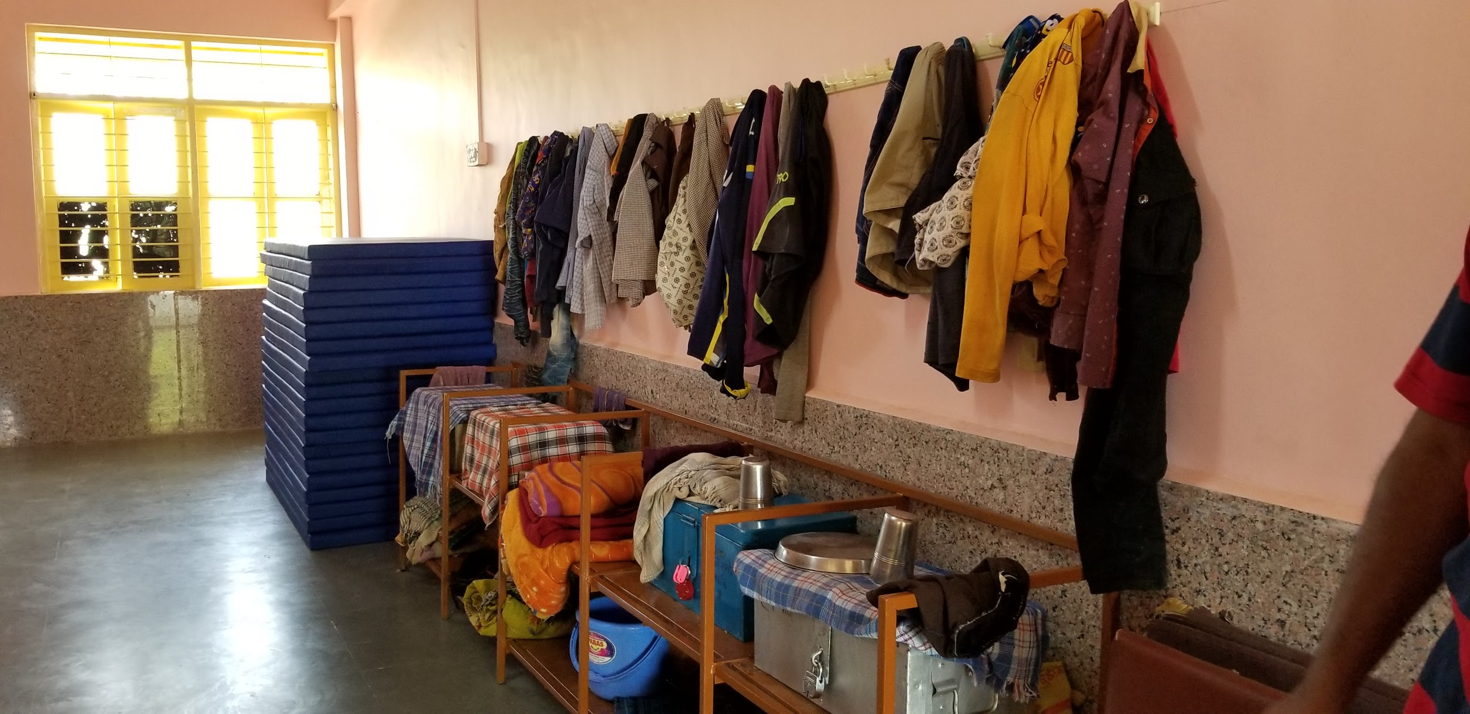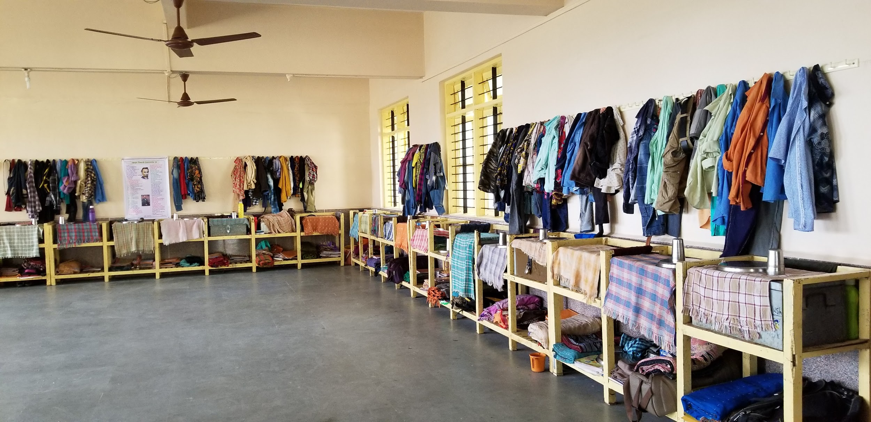

There is a computer room and a chapel also on the same floor. The computer room had about 15 desktops. We had given them one time funding for 5 laptops but they purchased desktops as they were more appropriate for their needs. The chapel is pretty small and is used by the staff though, as explained by Fr. Adolf the students are welcome to come there and join the staff but are never asked to attend any prayers. Kids have their own prayers which are a mix of different religions and philosophies. I heard the vipassana prayer at lunch time.
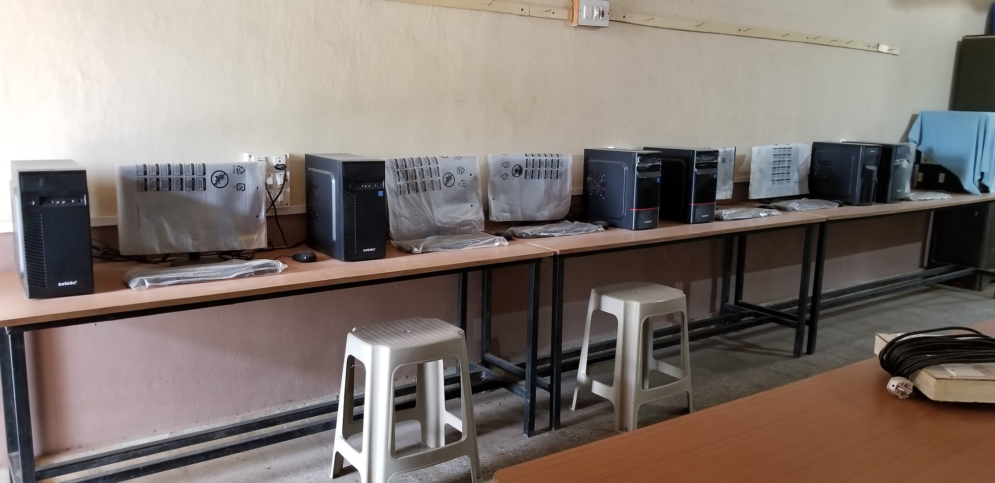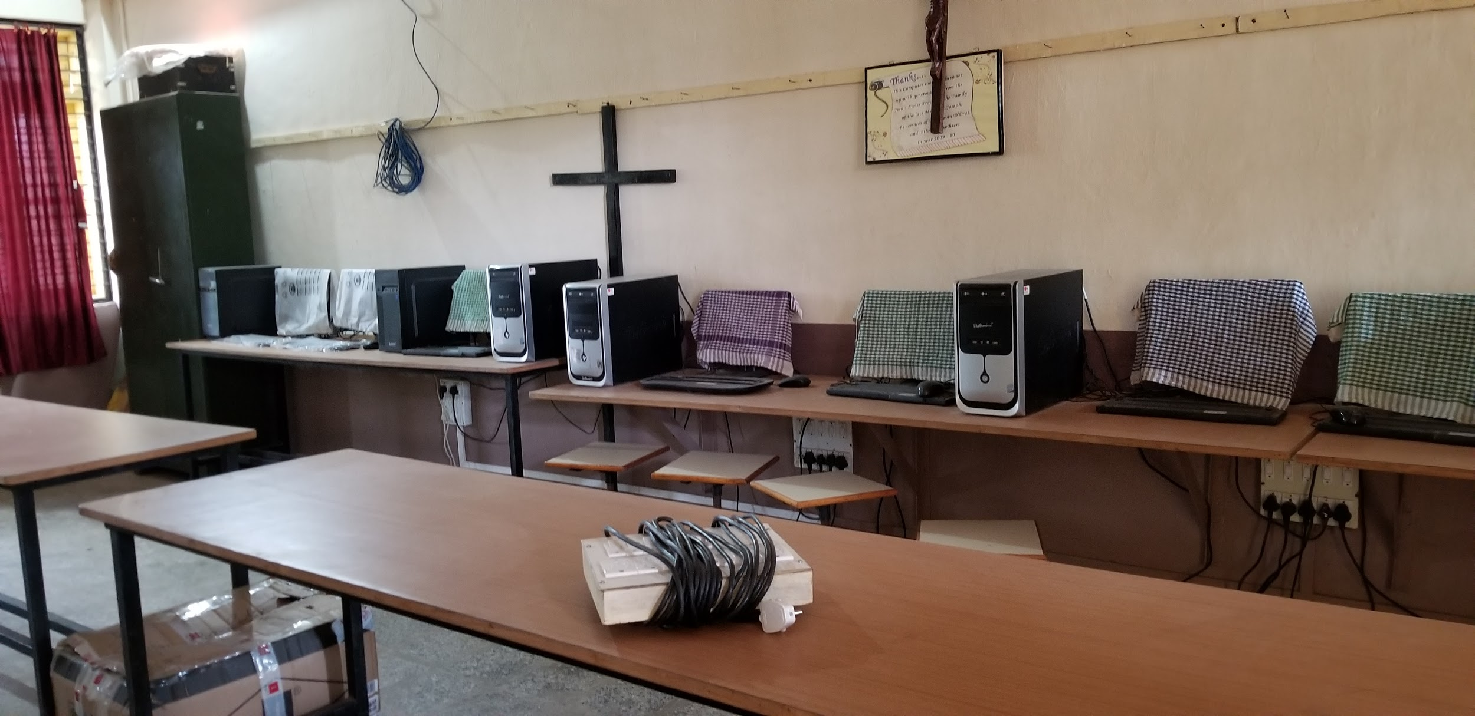

On the upper floor there are 2 big halls. One is mostly used for the other activities at Janaseva involving volunteers working in nearby villages. The TV is in this room. The TV was replaced recently from the one time funding. The room has too much stuff like older books, older registers, mattresses used by the volunteers etc and definitely can use some order and cleaning up though the kids use it only for watching TV.

The other one is study hall for the kids and has chairs and desks. Chairs were neatly upended onto the tables, There are couple of cupboards too with books. This year, from one time funding they added few smaller desks for younger kids. The hall is lighted and has enough number of fans.

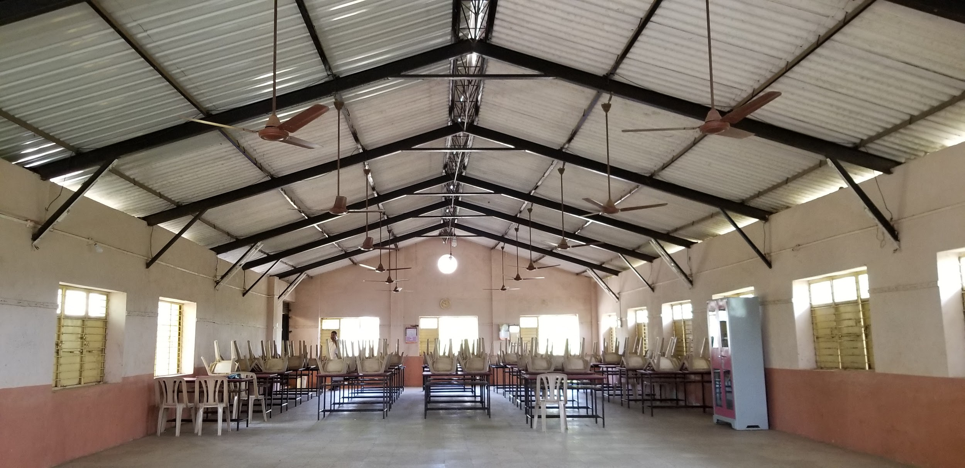

Behind the main building are the old and new toilets which were built from the one-time funding. In a separate building is the staff and guest accomodation.
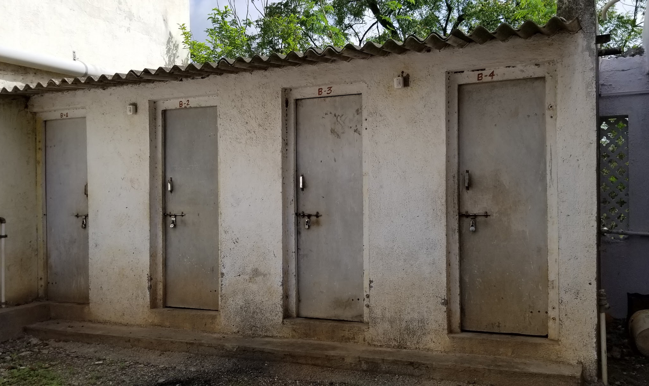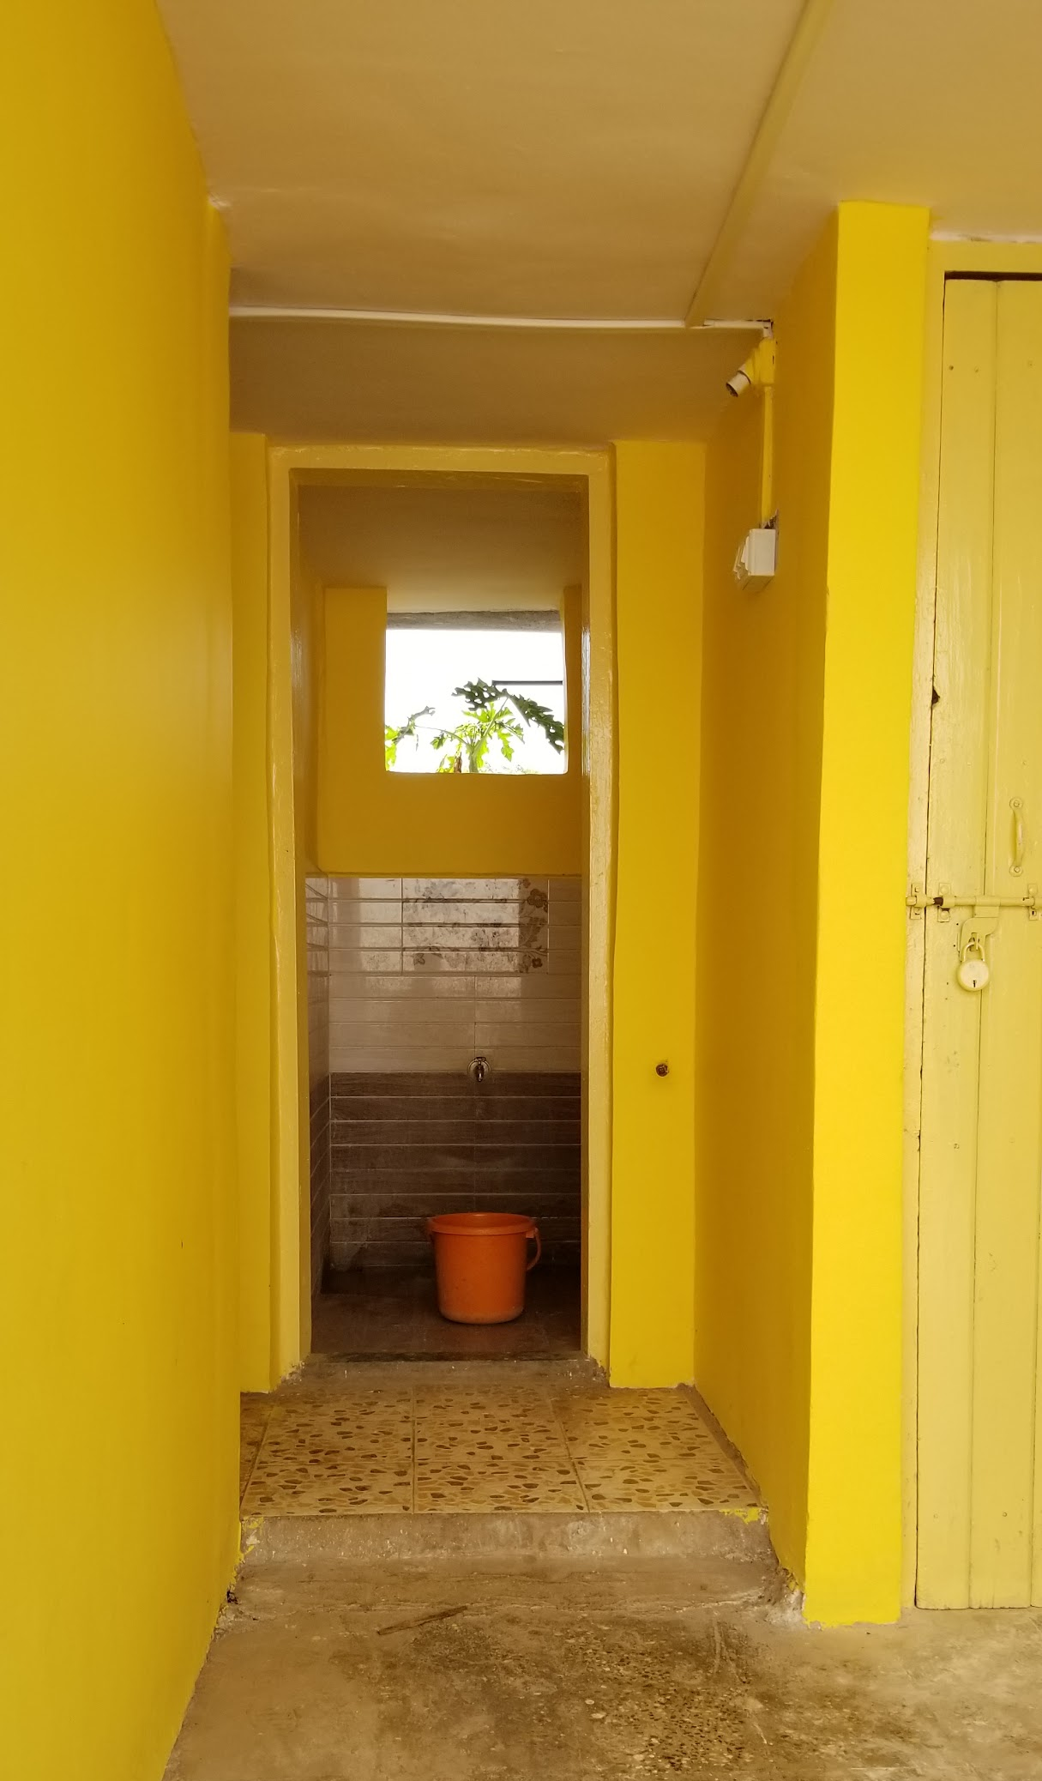

A few feet from is the kitchen and lunch shelter. The kitchen has good circulation, The flooring has been updated from the one time funding. Sajjabai, a local tribal women cooks the food. Another cook that works for the staff helps her in lengthy tasks such as making rotis.
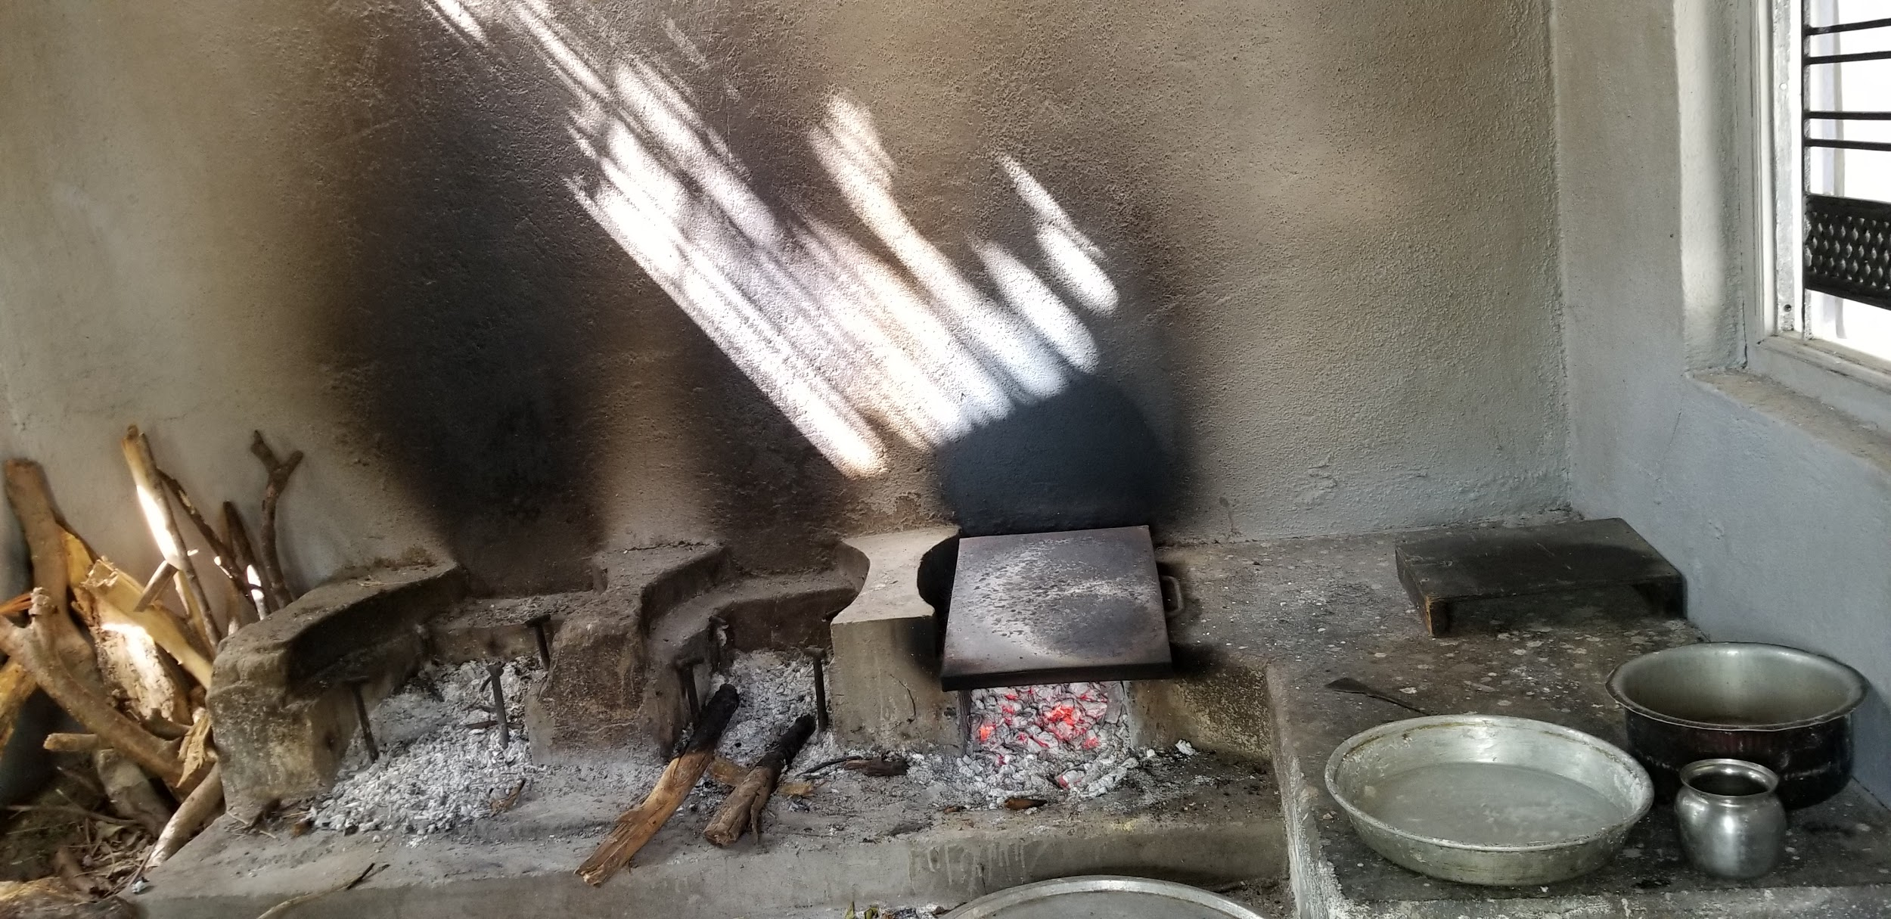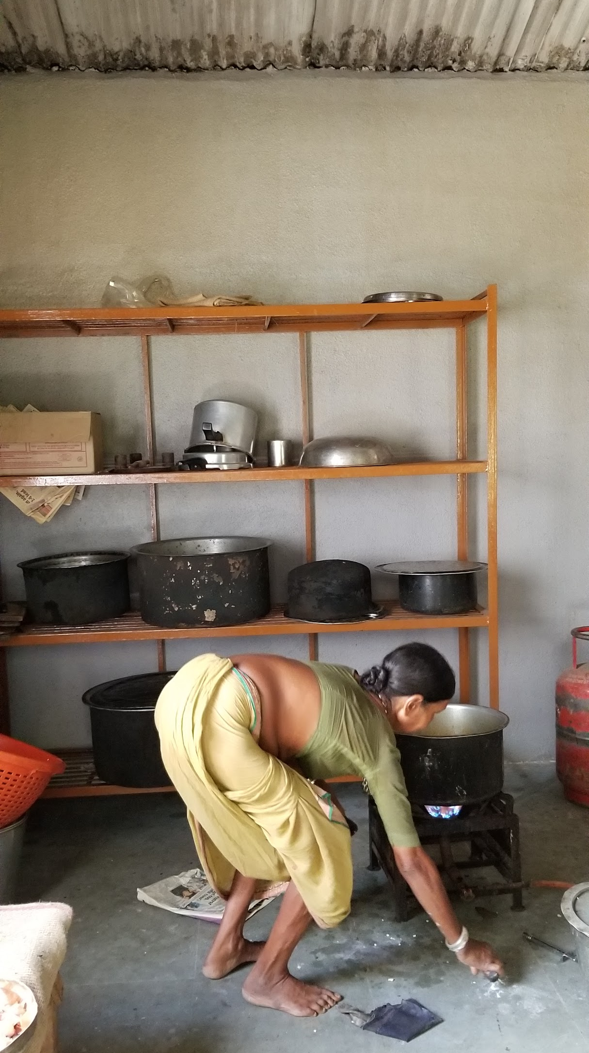

A little farther away from the main building, there is a big store room where they store the grains produced and also stock up the raw foods bought for the hostel.

When the kids came back to hostel they all walked in a line or 2-3 students in a row, they were happy to see us standing at the entrance, and greeted us with good morning. They call Fr Adolf and other fathers at the facility as Bhau or big brother.

The kids get their uniforms from the school. This year they got shoes also from the school. The kids change into their normal clothes and footwear after coming back. They neatly hang uniforms on the provided hooks in their rooms and put back the school shoes on the racks. Then were ready to interact with me. I asked one student how they recognize their shoes. He showed me the initials they put on the shoe for the identification.

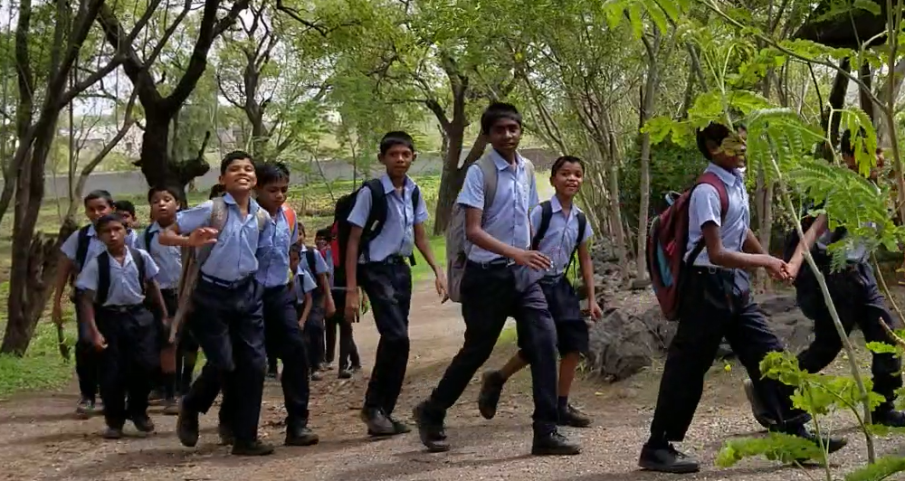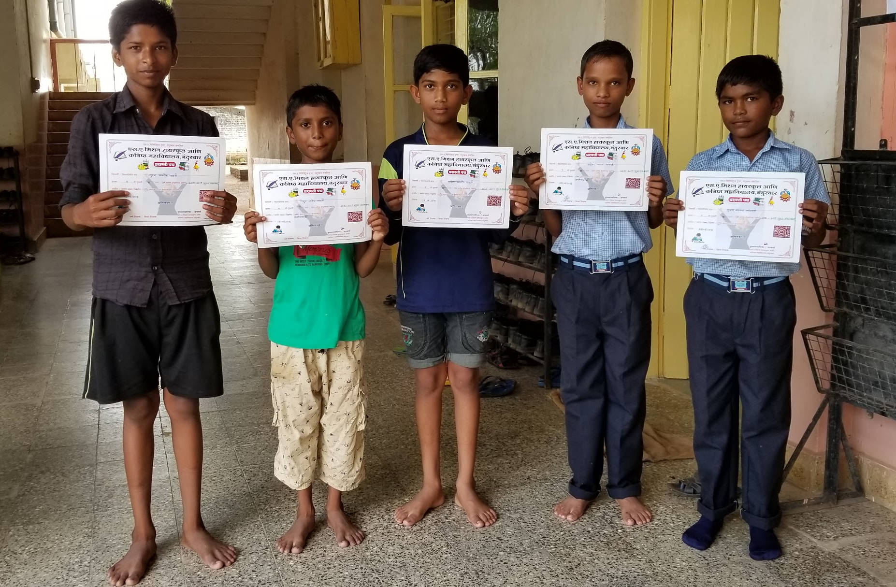

About 4-5 students had gotten a certificate that day from school for good handwriting. They showed me their certificates. When they gathered in the room to talk to me they were seated nicely in columns in the big hall. They presented me with a greeting card they made with mine and Deepali’s name. Fr. Florence later explained that the lamp in the picture stands for “Deep” and the flame stands for “Jyoti”. Some of them sang a song they had prepared to welcome guests. Fr. Adolf then left us so that I could interact with the kids without the staff being there.

Since Fr. Adolf mentioned that the kids are enjoying the world cup football matches, I started with the question about which countries are playing in world cup. They knew it in order and each group shouted the name of one of the countries. Then I asked which village are they from, how many are each standard from 5th to 10th, what are their favorite subjects, how do they like the school, do they like the hostel etc. Almost all the students were talkative and eager to answer. I asked them if they had any questions for me. Since they knew I am coming from the US and I am a computer engineer, they had questions about life in the US and computers.

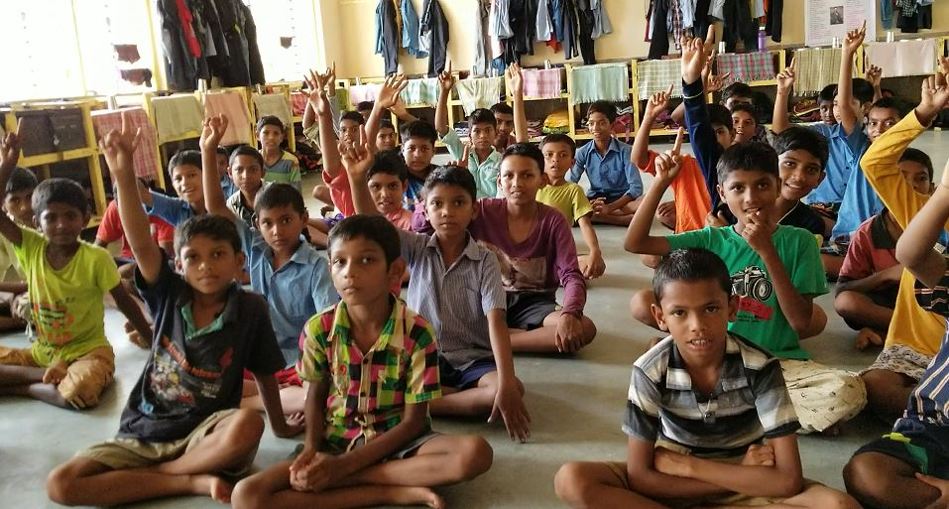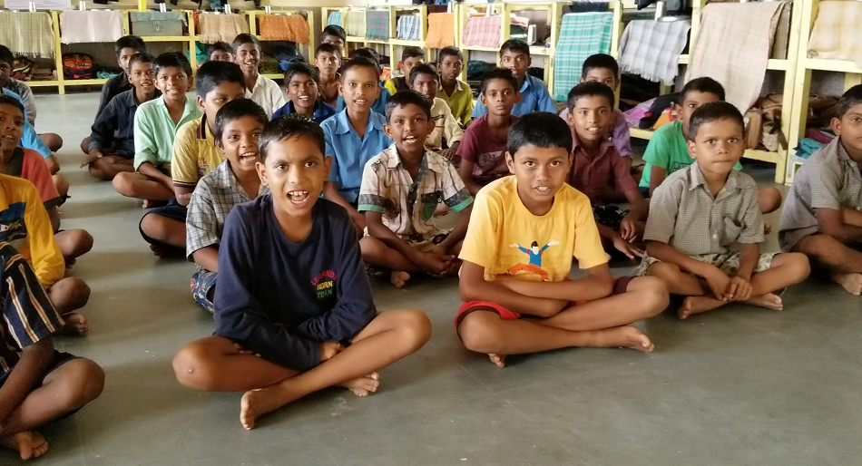

For the senior students I asked about their future plans. Most of them wanted to study further. Many were interested in vocational training and wanted to know what is needed to get that. I mentioned the DBRT course at Vigyan Ashram. They liked that concept but were asking about the fees and were probably put down since they may not be able to afford it. I mentioned the scholarships too. I later talked to Fr. Adolf as well about it and suggested him to visit VA if possible and if couple of students are ready then send them to VA for a year of training.

One of them wanted to be a bodybuilder and since he had heard I do lot of running and biking he wanted to know what he needs to do to be a bodybuilder. Fr. Adolf had told me that he tried to get the kids to exercise and play the outdoors games since they have ample space to play but they are more interested in sitting and chitchatting. I took this opportunity to tell them about the importance of exercise and told him he needs to exercise a lot and also showed him some exercises. Later when Fr. Adolf heard about it, he told the boy that why was he asking about exercise to a women when he could have asked about it to the men over there like himself. I mentioned that I have a personal trainer certificate so the boy asked the question to the right person :).

One of them does very nice paintings and he showed me his paintings. The greeting card also was done by the same kid.
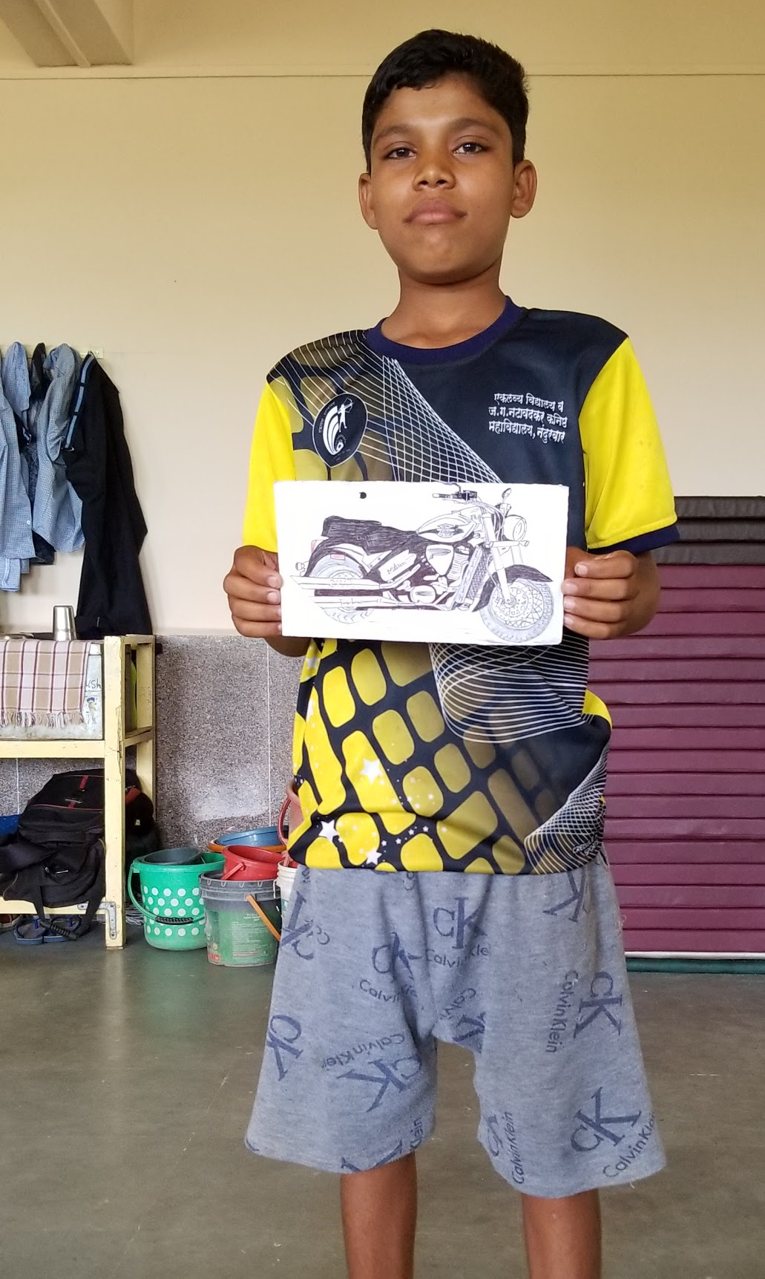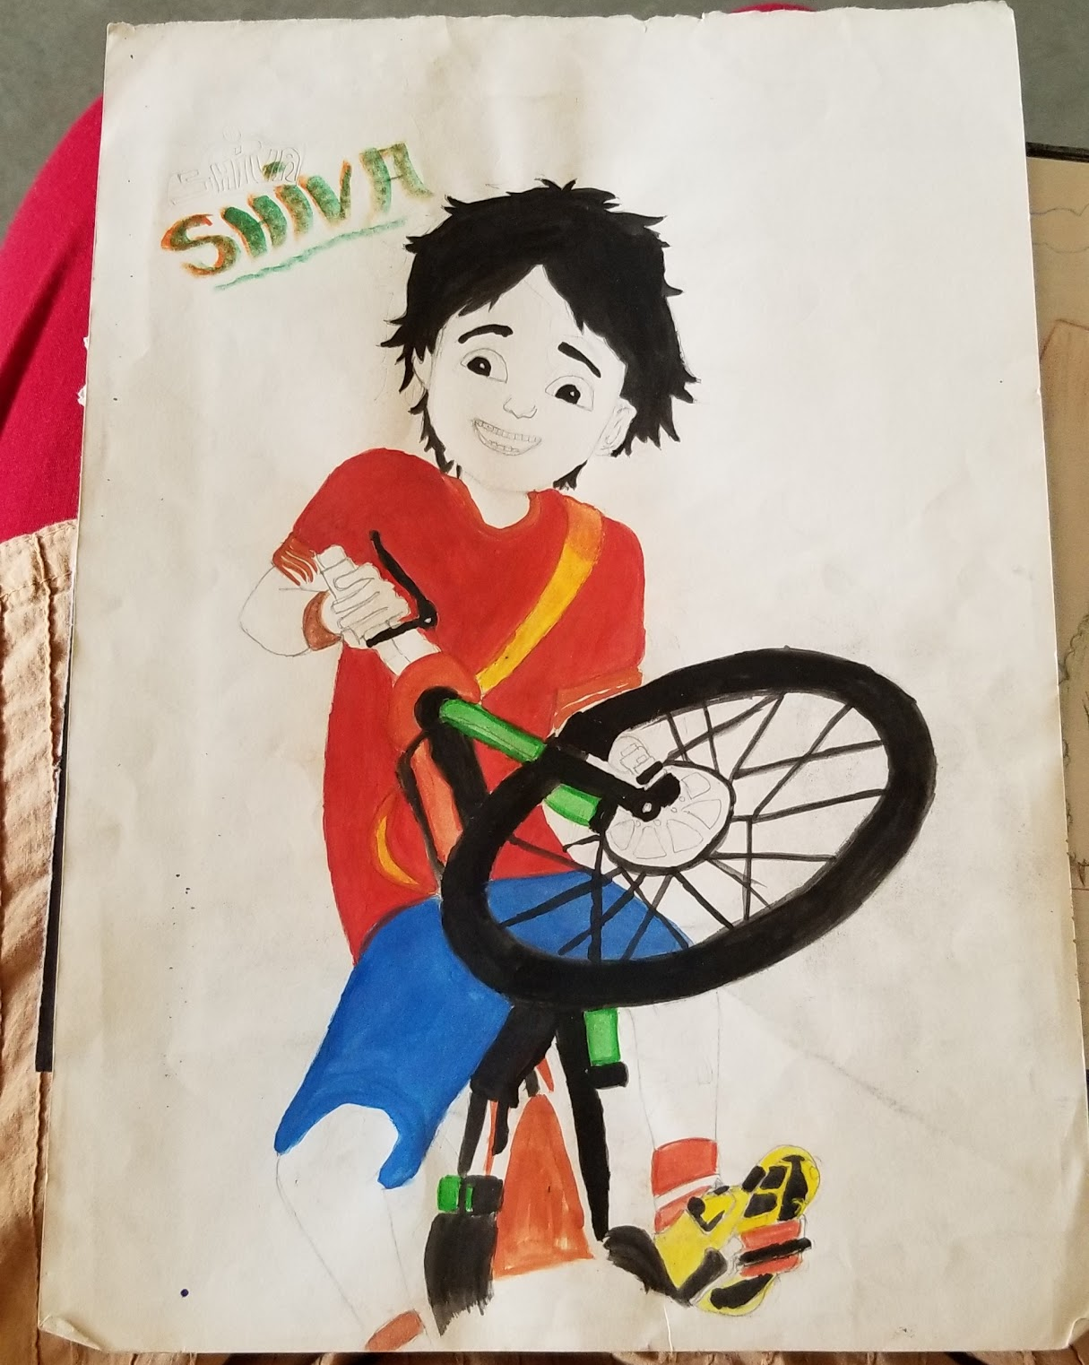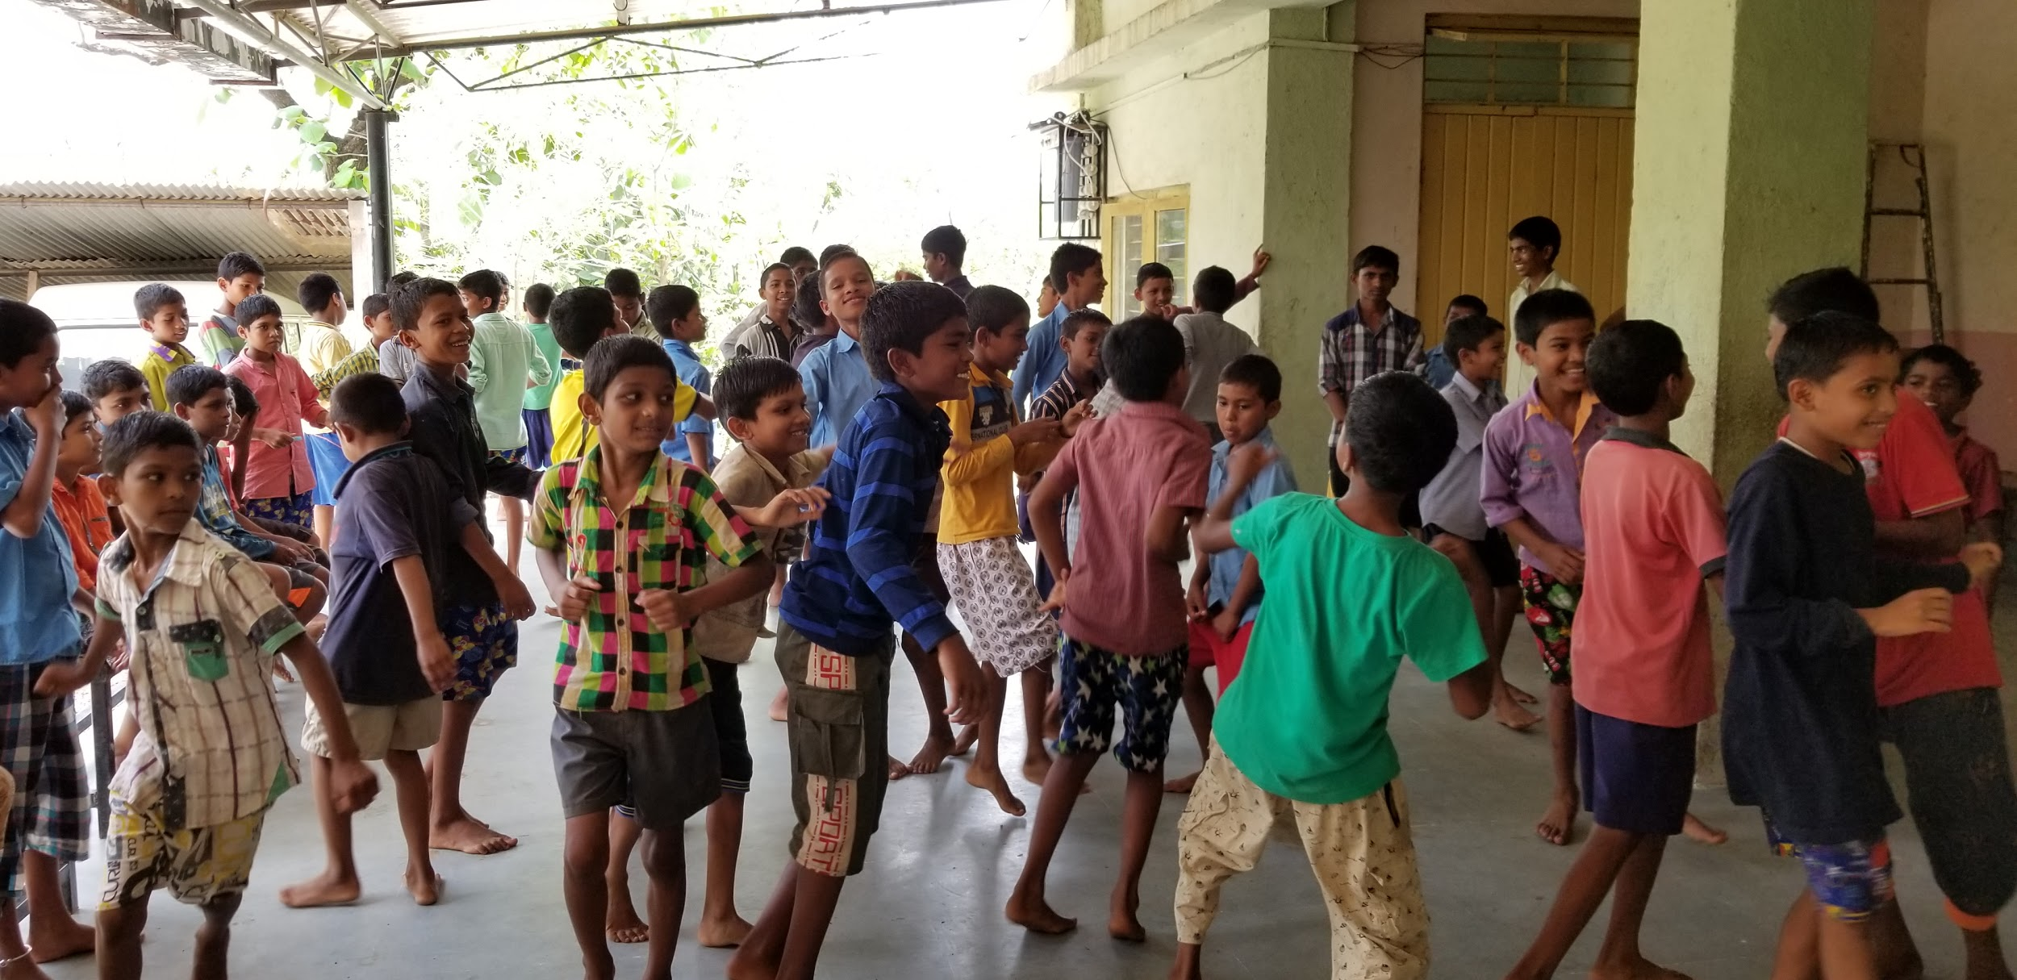

I asked them what do they like to do besides studying. Fr. Adolf had mentioned one of them is a very good dancer so I asked him if he would like to dance but he was shy. Then students suggested one of them to sing a song. He too was shy but he found someone to accompany him, so both of them sang a song in their language, Ahirani . Though the song was supposed to be making fun of a drunkard stupid father and kids were laughing when the punchlines came telling how he eats food saved for his kids, how he beats his wife, it was sad to see that the kids have accepted it as a norm to the extent of making jokes out of it.

Deepali had sent some chocolates for the kids. I asked kids whose birthday was in that week. There was just one of them and I asked him to distribute the chocolates to the rest.

I wanted to see their tribal dance but Fr. Adolf said they like to do their dance on modern songs. Since everyone was very enthusiastic about dancing, he played couple of songs. Students were very happy to dance and enjoyed dancing together. They tried to teach me the steps and I was able to follow a bit. We took a few group pictures after that.

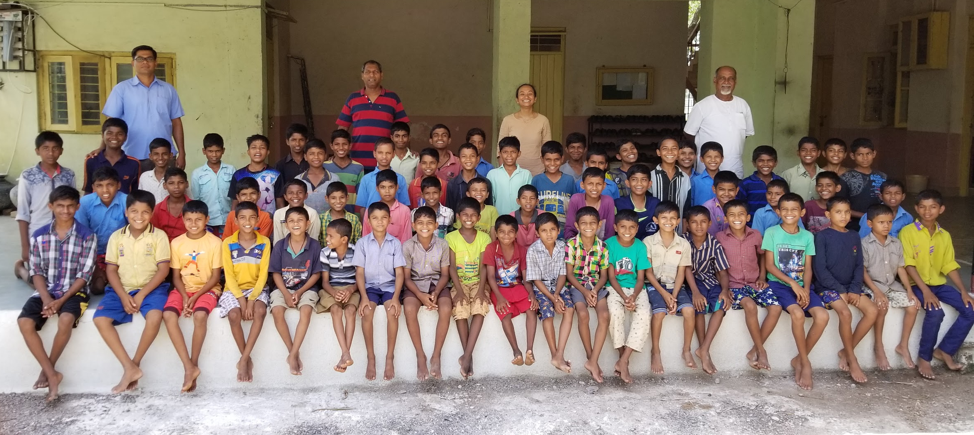

By that time it was lunch time. So we went to the kitchen shelter where kids have their lunch. The kids take turns to serve food. They first said their prayers then got in a line for food. Each one got vegetable curry with 2 rotis or fewer if they did not want that many. We came back to eat our lunch which was prepared separately. I wanted to taste their food and had asked for some. Their food too was cooked properly and was tasty. They get morning snacks, lunch, evening snacks and dinner. Fr. Adolf told me that they get a snack in the school too. Lunch and dinner consist of either Roti sabji or Rice and Curry/dal. They use vegetables, grains, pulses grown there. They get eggs and chicken once a week . The kids cook on Sundays. They do not make rotis. Given that it is a pretty laborious task to make rotis for a bigger groups, it makes sense to ask them to make other food items instead. When I asked if they know how to make rotis, a couple of kids said they did.

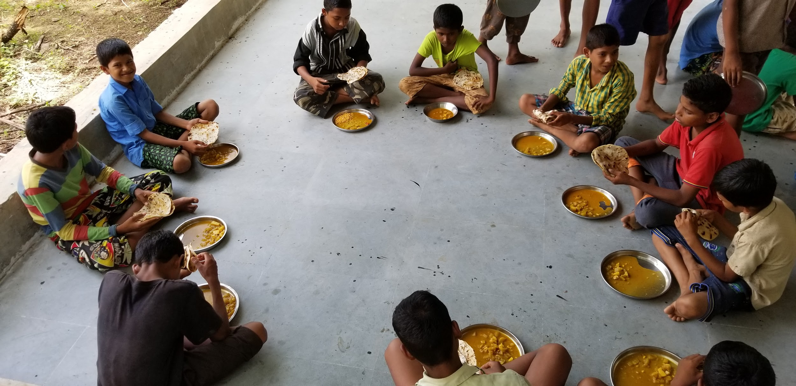

After lunch I rested a bit, freshened up and went to Jeevan Vidya with Fr. Adolf. Martina Tai and other staff members Savita, Ramila and Mary welcomed me with tea and snacks. I had a brief chat with the staff. Then they gave me tour of the facility. The staff quarters are in the same building as the girls accomodation. Compared to boys hostel, the girls hostel had smaller space inside and outside the building and the number of girls was significantly higher.

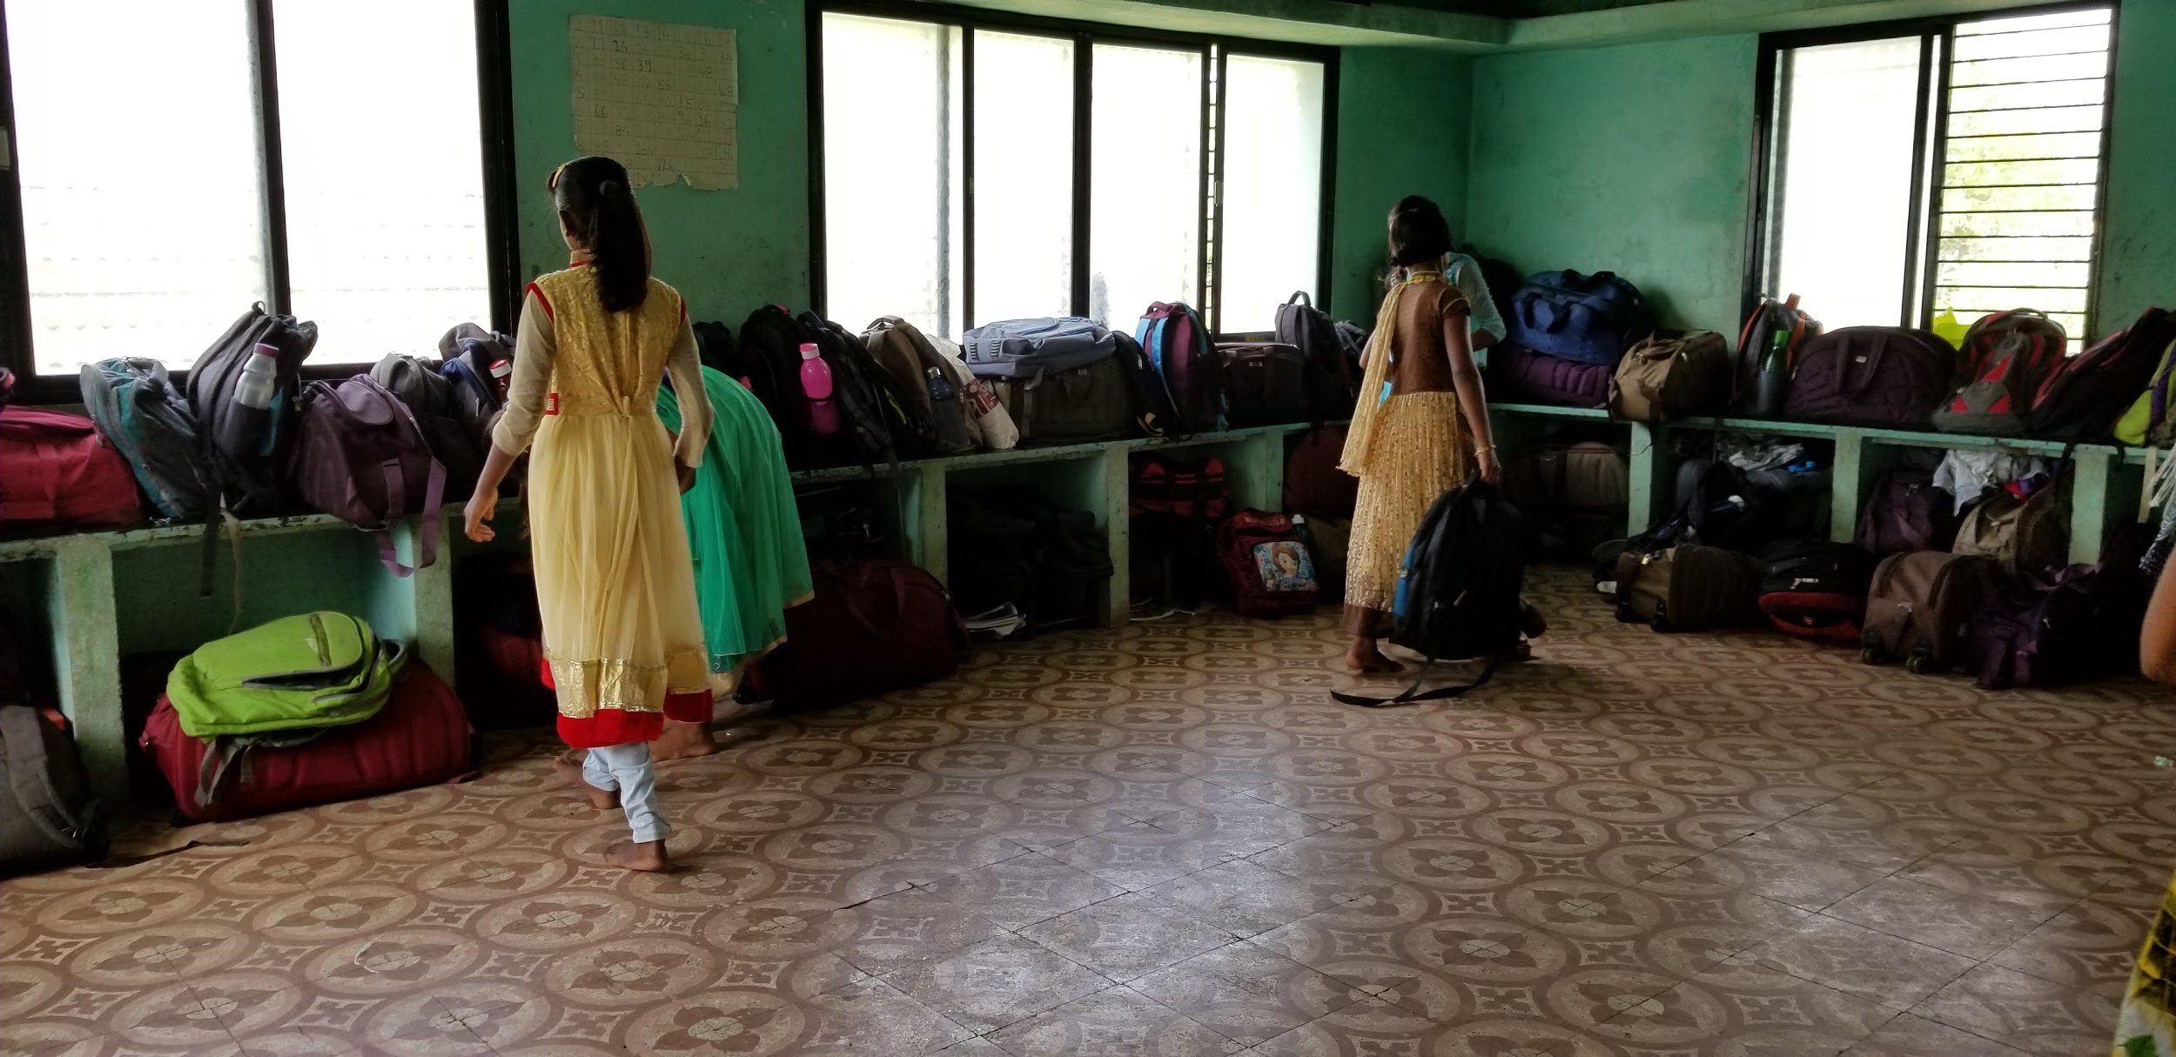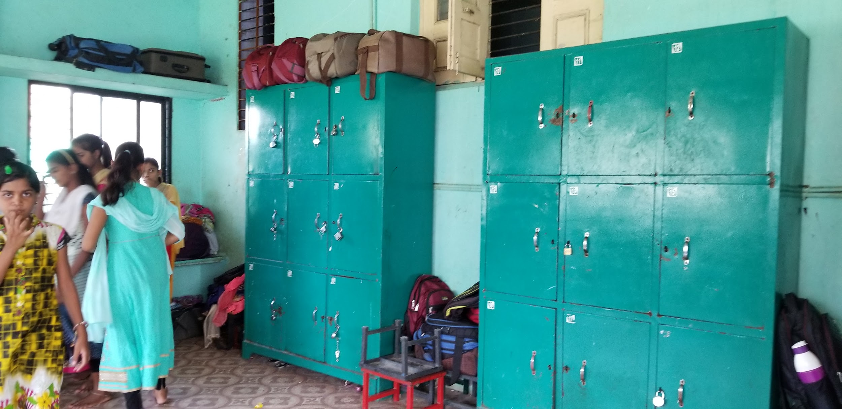

Their living halls were less lighted and updated while more crowded compared to the boys hostel. The older children are in a different room so that they can study in a quieter environment. The kitchen was better organized than the boys hostel. There was a computer room and a pharmacy too where they prepare and distribute herbal medicines with the help of local experts.
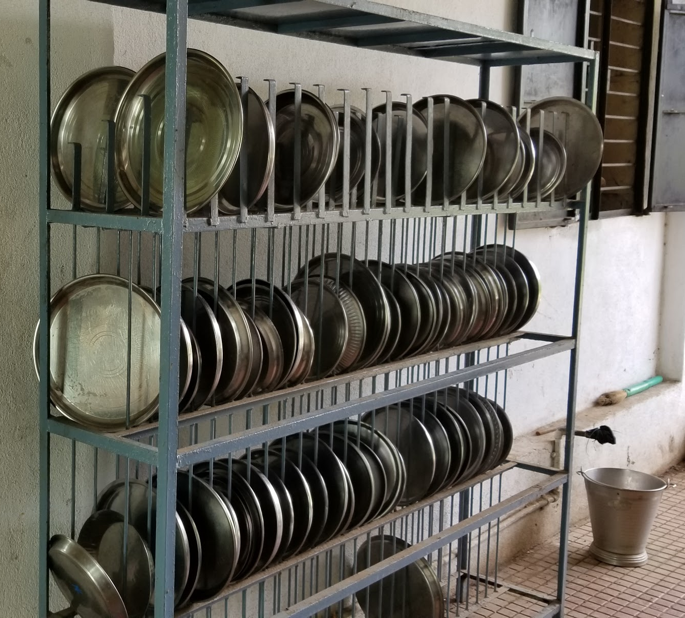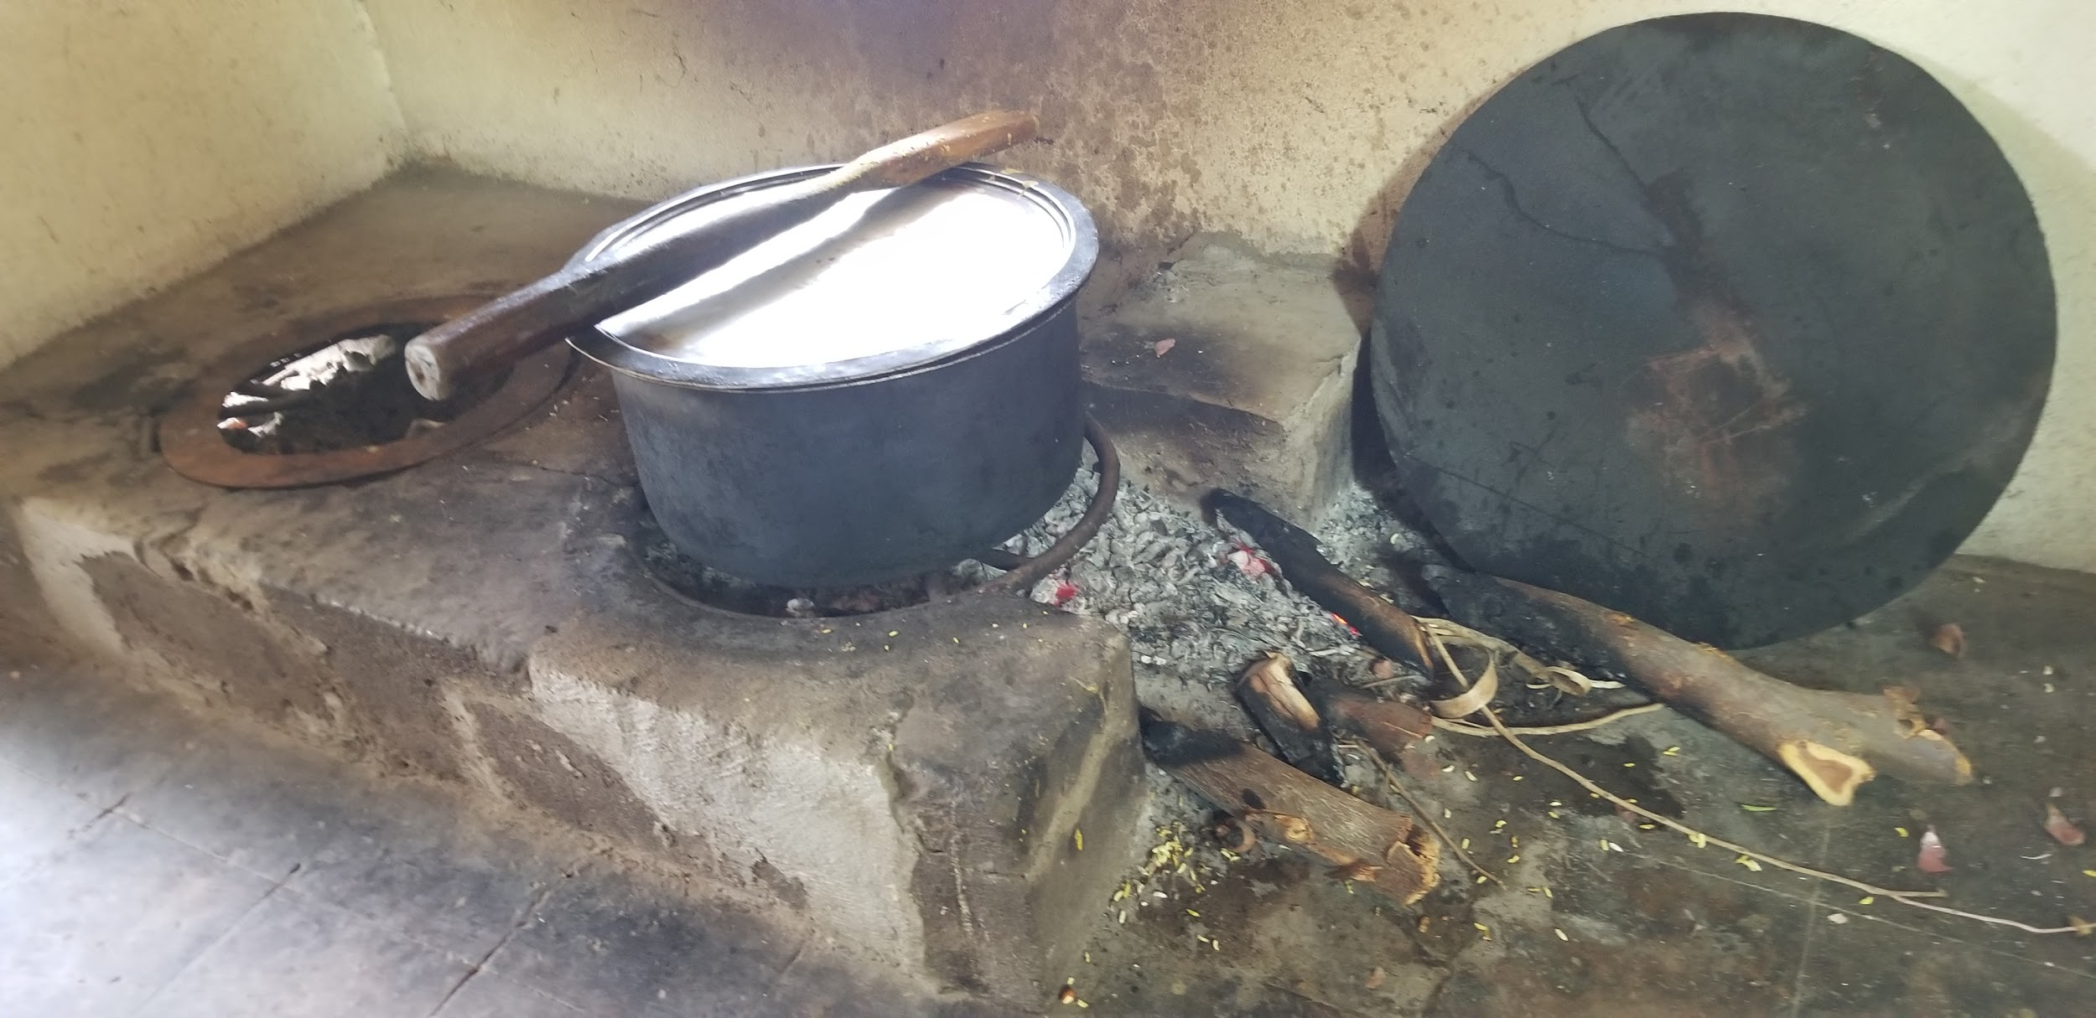

The girls had prepared some songs and dances to show me and they were enthusiastically getting ready for the performances. We got together in a big hall which was updated with the
one time funding. The hall was well-lit and well ventilated.

Martina Tai introduced me to the girls and asked me to give a short speech. I thanked them for their warm welcome. Since Martina Tai had told me that some of the girls miss their parents and homes, I tried to cheer them up by telling that how I liked being with friends and wished I would have got such opportunity as them when I was in school. The staff them left to give us a chance to interact in their absence. I asked the same questions as I did the boys group. The girls too were talkative and enthusiastic. They too asked me questions about what kind of food we get in the US and how I became computer engineer.

Then there was a group prayer song in the Ahirani language and it sang praises of Jesus. After that was almost an hour-long entertainment program. Kids had choreographed dances with the help of one of the girls who is a very good dancer. In the final traditional dance everybody participated and they pulled me in too. Since boys had taught me steps, it was easier for me to follow this time. They had a plate with a rotating decoration on it to keep on the head of the dancer so when the dancer rotates the decoration on the plate rotates in opposite direction. They were taking turns wearing it on their head. They gave it to me too try too. It was a lot of fun.

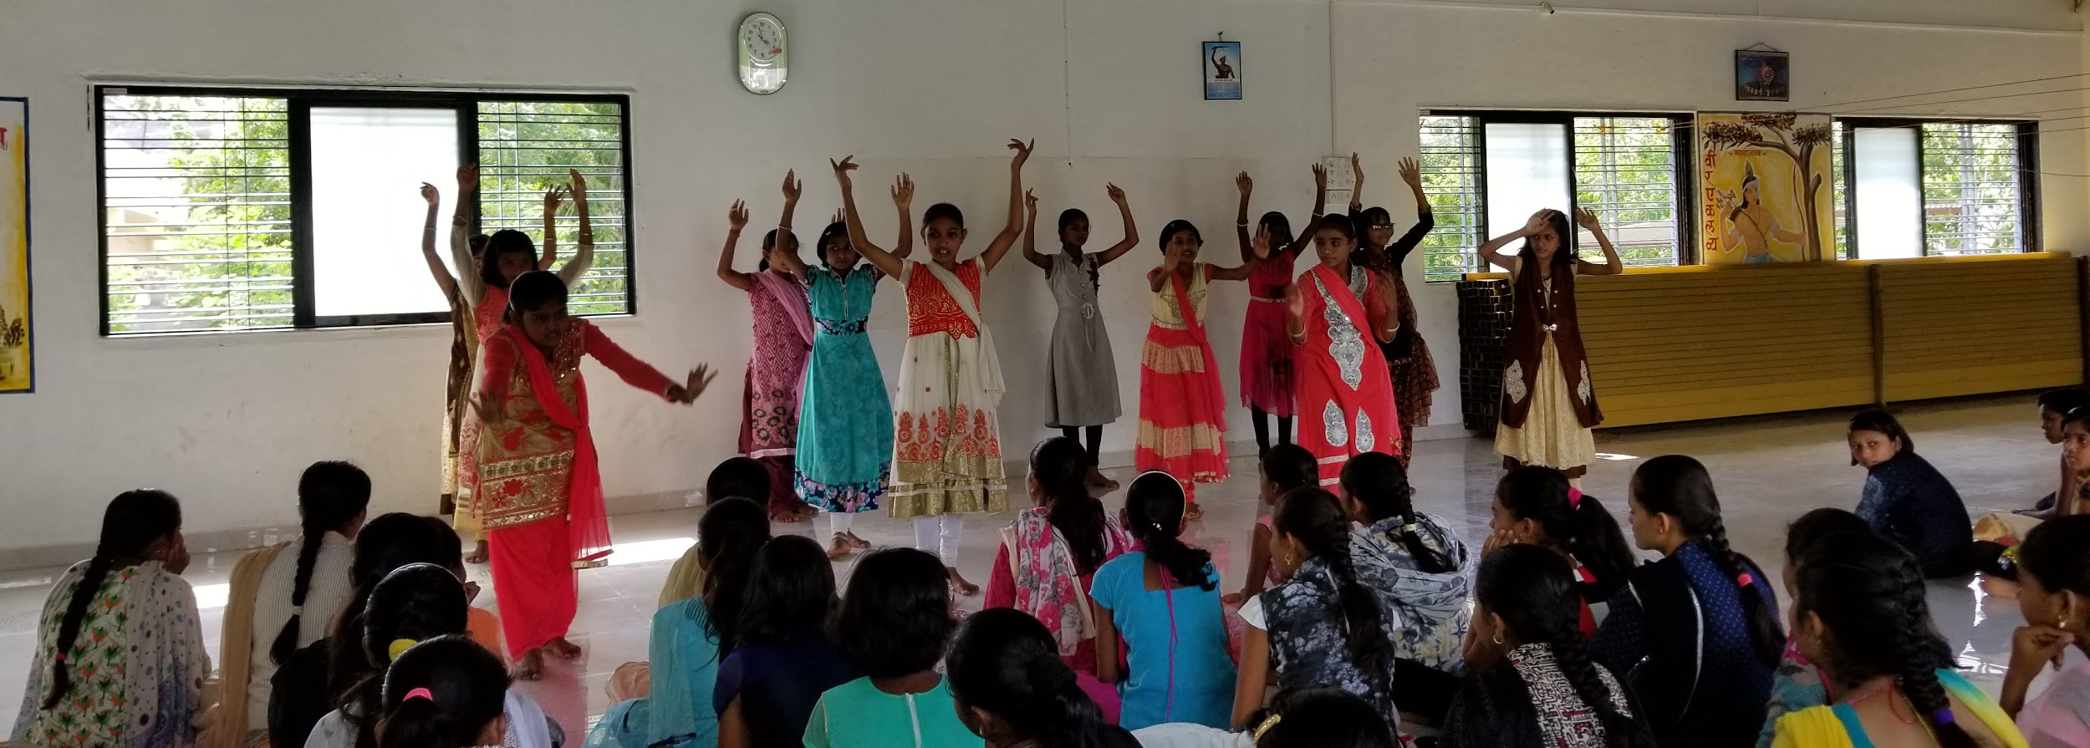
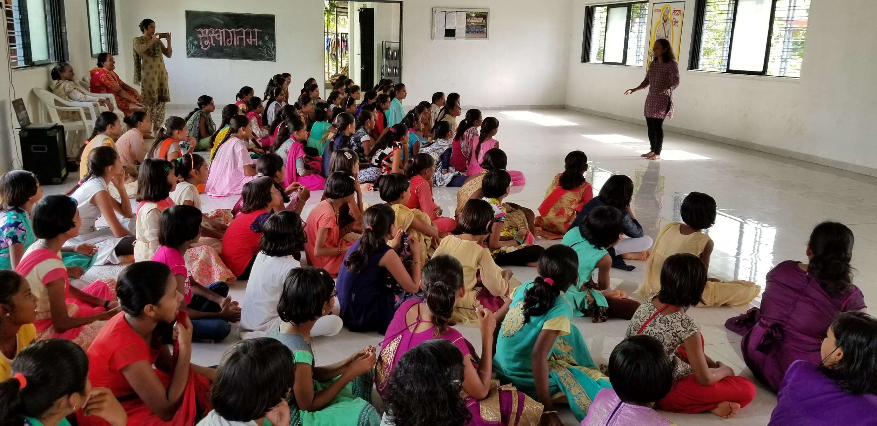

We then went out for a group picture. They showed me their bikes. I even rode one of the bikes. It was getting close to the bus departure time. In the end I visited their herbal garden and came back to get ready to leave.
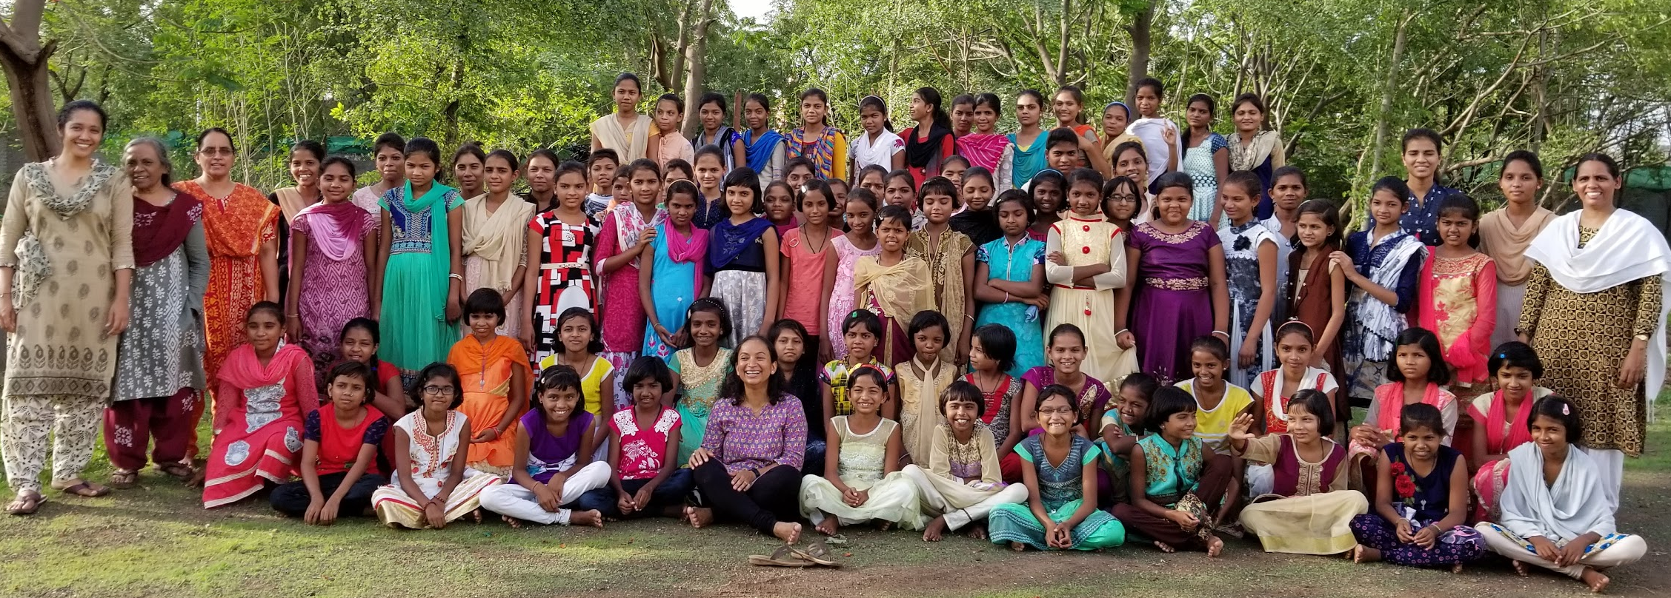

A couple of staff members had packed dinner for me. One of them dropped me on her bike to the bus station. Shortly after that Fr. Adolf and Fr. Florence came to see me off. I came back by a Sharpline Travels bus from Nandurbar (7:15 PM) to Dhule (9:15 PM) changing bus at Dhule to reach Pune (5:15 AM)

It was so nice of the staff at both the facilities to take care of my entire trip. Fr. Adolf invited me to come and stay there for a day or two and said he can take me to one of the tribal areas to meet the kids parent. I am looking forward to the next trip now.

