Visit to Jana Seva Mandal – Nandurbar

I arrived in Nandurbar by bus, and took an auto-rickshaw from the bus stand to the Jana Seva Mandal office as per Fr. Godfrey’s instructions. The first things I noticed were that the town was a typical Indian town, with enough shops and various establishments and did not look like a cut-off tribal area from the main land. The Jana Seva office is a few kilometers away from the center of the town. From the main road you need to take a dirt road which gets you to the Jana Seva gate. As you drive in, I could see fields being ploughed. After paying the rickshaw off, I was welcomed by William, a new staff of Jana Seva. I met Fr. Godfrey briefly since he was in a meeting with his local volunteers. After a shower, I took a stroll around and had some bread and eggs for breakfast.

Thereafter Fr. Godfrey introduced me to various members. I met the Campus Superintendent, Office Manager, Treasurer and a couple of volunteers. I also met the people who were there available for local help. Thereafter we took a walk around, and saw the various rooms. The Jana Seva Mandal main building has the following:
2 office rooms
1 room for stationary and other storage
1 room used by Fr. Godfrey as his office and sleeping room
1 room which has a couple of cots for volunteers who stay for the night, with a bath attached
1 large boarding room for the 60 boarders
1 kitchen with a dining space
In addition the adjacent structure has 4 rooms with bath-attached (one used by the Treasurer, John, and the other by William)
Outside there are 4 bath and toilet spaces for the boarders.
There is also a small room for the local helps and a house for the Campus Superintendent, Wazir.

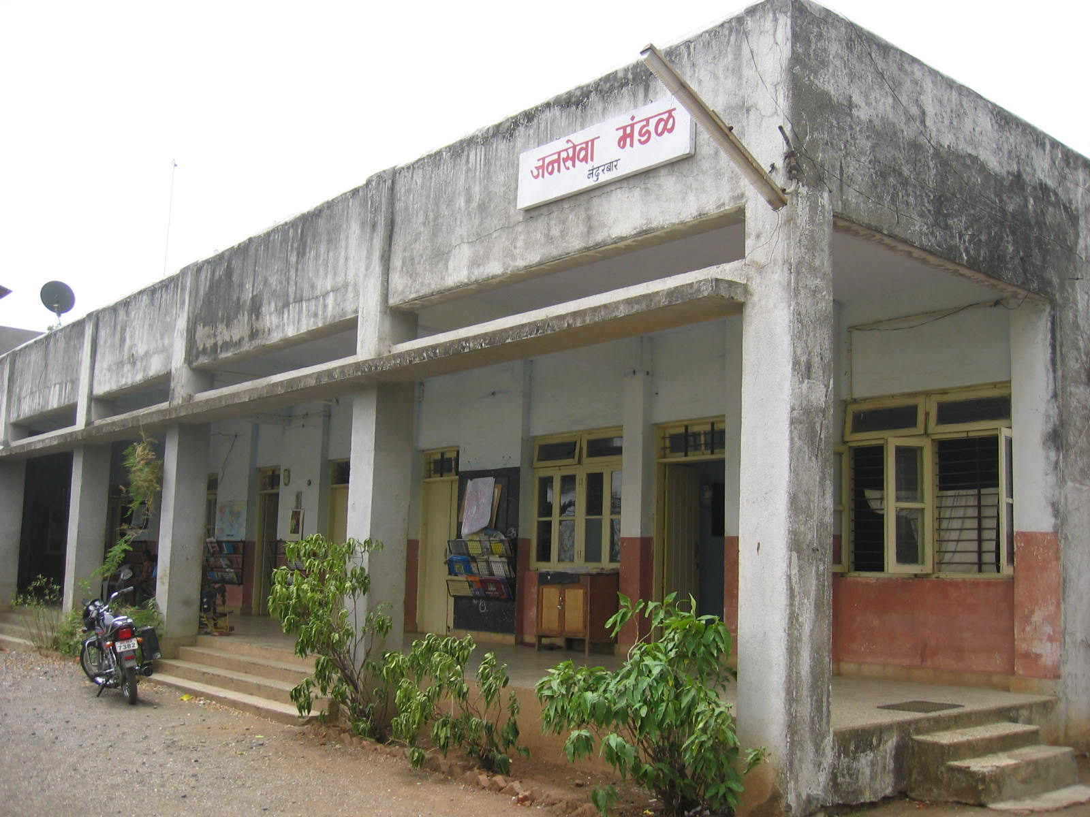

From there we moved on to the upper section which is being newly constructed. Since there were some leaks, they were planning some maintenance. With the help of the parent Jesuit organization, Bombay Xaviarant Corporation, they have started work on a large boarding room which could have upto 100 boarders. There is also work going on for additional baths and toilets here, and there is an open terrace next to it. Fr. Godfrey informed me that this was the only help that they had ever requested the parent organization for; since they preferred to do most of it by funds they raise themselves. I heard him discuss with the workers that they were short by 8 sacks of cement. In addition, I also got to see the solar lamps that they had recently been gifted by a corporate donor. They had received 25 solar lamps, of which they kept 7 for the boys boarding, passed 5 to the girls boarding and the remaining to the village units. After this, we walked on by the playground. It is a pretty big playground. I realized that the land that Jana Seva operates on belongs to the parent Jesuit organization. There is in total 13 acres of land. Adjacent to the playground is a nice structure. Fr. Godfrey informed me that this resembled a barn, and now had been transformed into this nice establishment due to the worksmanship of some locals. They plan to use this place for holding classes for their volunteers in future.

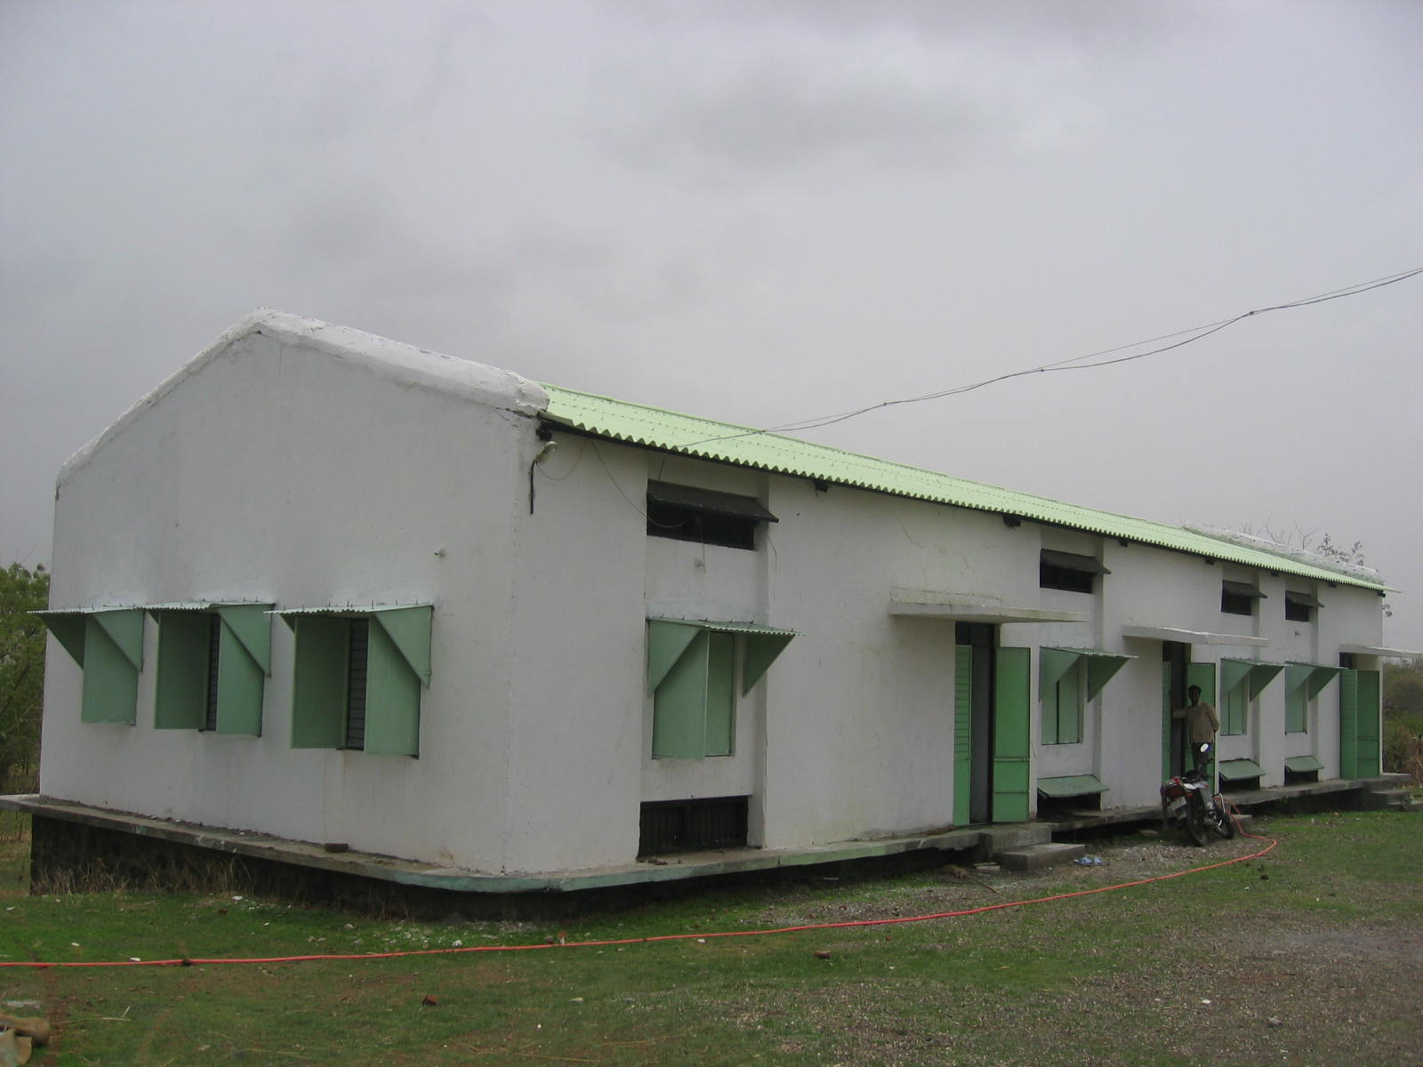

After this, we passed the dining area of the children. I could see the children themselves bringing out the food and distributing it. Fr. Godfrey told me that two children are given the job of deciding the menu for each day, and also distributing it. I saw the children having their food, and thereafter washing their own plates. This place seems to encourage the children to do their own job.

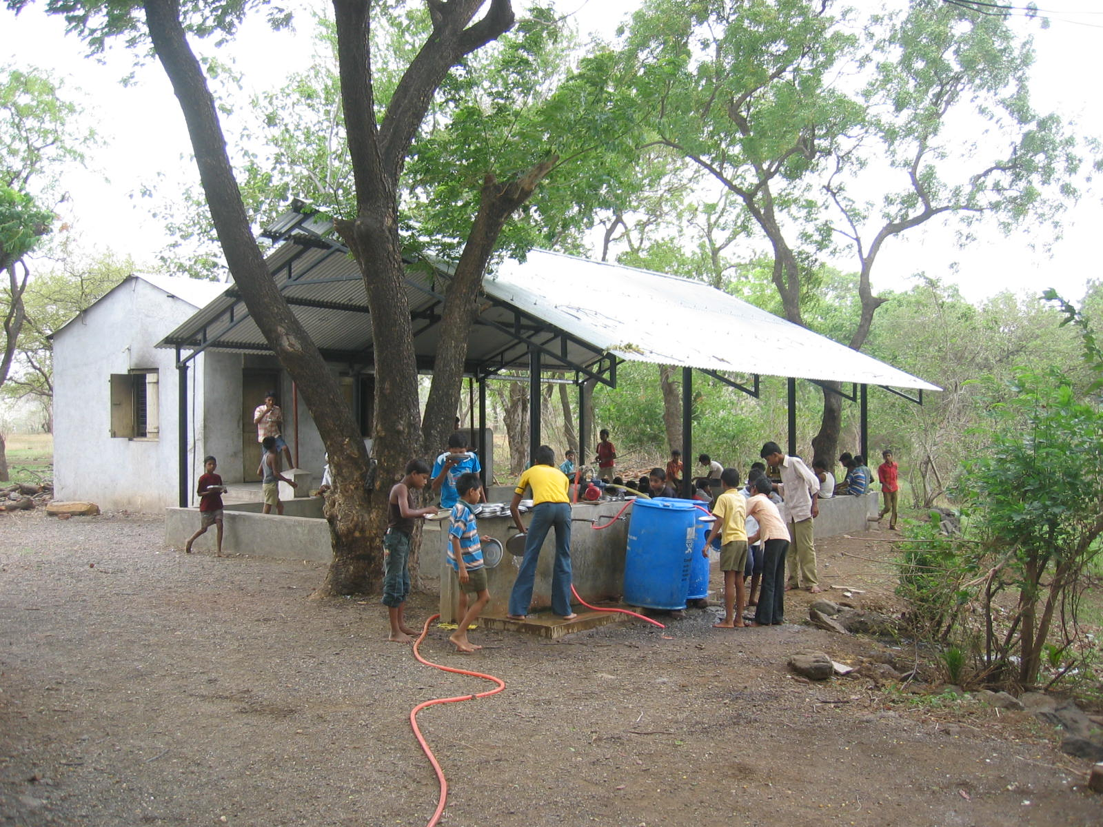

After this Fr. Godfrey had to attend to other matters, and so I walked around taking pictures and also chatting with some children. Most children belonged to the 6th or 7th standard. Their houses were around 40-60 km away, and they belonged to the Taloda or Shahada district. They mentioned that their parents were farmers, and there were not many schools near their houses. They were pretty talkative and did not seemed reserved at all, at least most of them. I asked them about studies, about cricket and the other activities they do. I then saw some children doing their own laundry and hanging out clothes to dry. They also mentioned that they do some farming in the morning. I could see a small section of the field dedicated for them to do their farming. Since they had their lunch, they were free to do whatever they wanted until 3PM. Some of them decided to go and play cricket, while others sat back and were reading some books. I questioned a few of them, and realized that they were pretty weak in Maths and in basic Geography. I also checked with them on the organization’s religious bias to check if they had to say some Christian prayers or anything. However they celebrated all festivals here, including some local tribal ones. I did not try to understand it further since this was only a boarding school. After that a few of them took me to the field to watch others playing cricket. Then I took a stroll with them around the property.

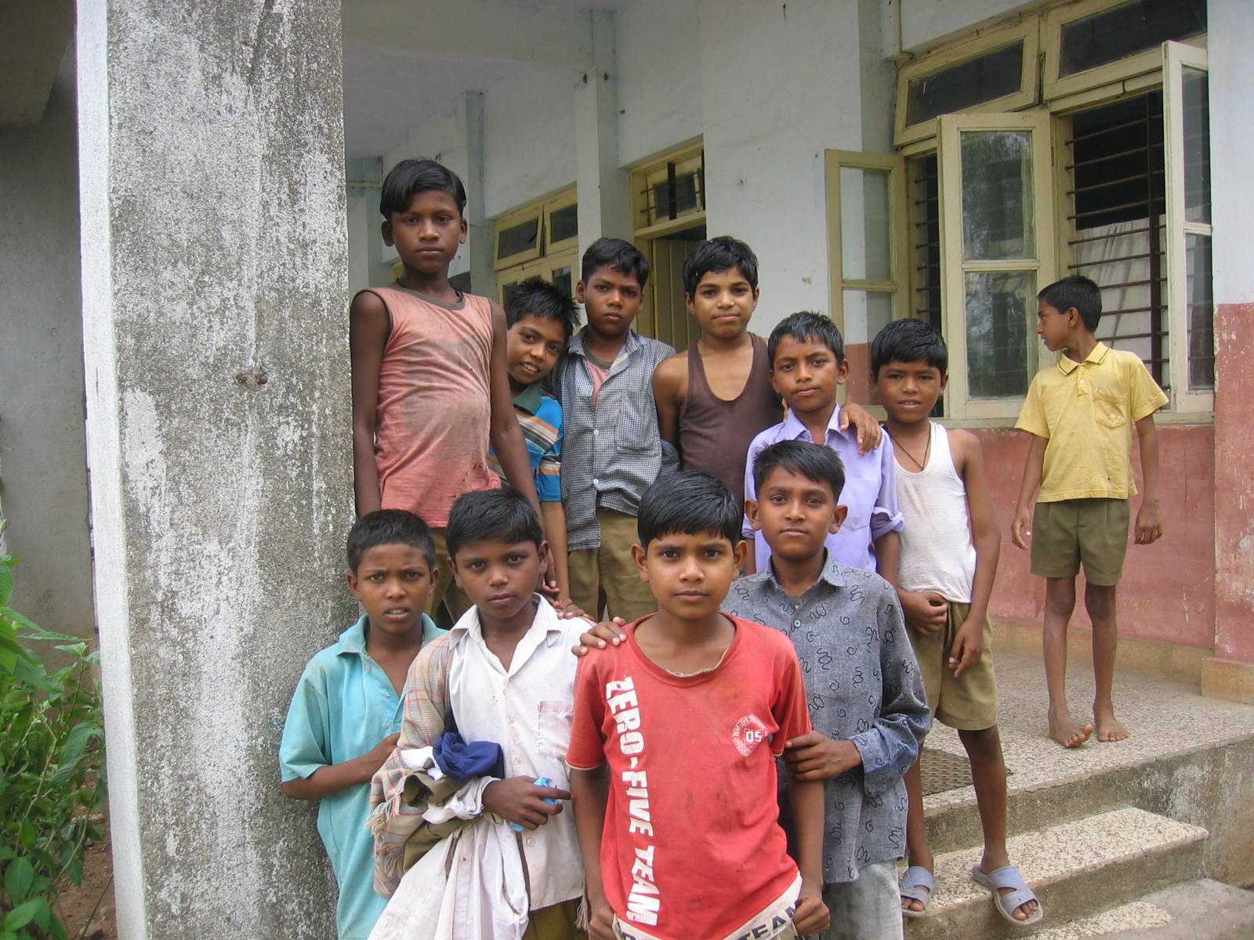

After this I moved on to have a talk with Fr. Godfrey on details regarding the establishment. The following were the details he gave me:
Jana Seva was started in 1969 by a Spanish person Bernard Massat for the upliftment of the tribal population. It was a part of the Jesuit organization, Bombay Xavierant Corp, who also had stake in Xaviers College, Mumbai. The trust had other boarding schools in Shirpur, Khandish, Manor and Thalassari. Most of them were on the payroll of the parent Jesuit organization. So the only people who were actually on the payroll of Jana Seva were the campus superintendent, office manager and the two people they have appointed as helps for cooking and cleaning. He explained that the volunteers were given some small stipend at times, Rs 500 or so. The school used to charge Rs 500 per year from each student, but has been lately increased to Rs 700 per year since Fr. Godfrey took charge a year back. It could probably be increased further since the migrant workers have started receiving higher wages, and hence it is possible to do so. They only provide boarding and food. There is a small library of books around which the students can use. They have notebook sold to the boarders at a discounted price. More than 50% of the students are from the remote areas in the hills. The students who come down here are generally poor, and have also been unable to get accommodation in the government boarding. The rich ones usually would have gone to the missionary boarding or the ashramalayas near by. The publicity is usually word of mouth and from the volunteer contacts. They have got some additional blankets and intend to sell them to the children for a nominal fee of Rs 30. The boarders are between the 5th and 10th standard. For the younger ones, there are village schools currently in place. The Jana Seva volunteers also go to these villages and conduct classes for the whole community at times. The boarding school has been in place for over 15 years, and it has mostly been run with funds generated by Jana Seva themselves. They get funds from various sources – a German friend, some corporates etc. But none of them is fixed, and hence they do not have a steady stream. Hence they have a limit on the number of boarders they can have too. The parent trust has verbally committed that if no funds are available, they would be able to accommodate the expenses for 50 boarders. Jana Seva does not want to take more boarders and thereafter turn them away next year due to lack of funds, and hence have restricted the count. They had to reject around 25 boarders this year. There were around 6 dropouts from last year. Most of the dropouts were due to personal reason. (For example the Dad of one the boarders became too religious and would not visit the child, which caused withdrawal syndromes in the kid and he decided to move out. This prompted his uncle to take the kid and also his cousins out from this boarding school). The boarding has been able to convince a nearby missionary school to admit the children free of charge. So all boarders go to the same school, which is around 15 minute walking distances from the boarding place. The children have a schedule they follow. They do some farming in the morning. They go to school together on their own. The children clean their own plates after food, and do their own laundry. They also have schedules to clean the boarding rooms during the weekend. There is no fixed way of finding poor children, except for the volunteers being able to know the details of the child’s background. Since the difference between poor and rich is a very thin line in this tribal community, they also do not emphasize this part too much except for trying to find the poorest of the lot. There are around 4-5 computers here, and the children are encouraged to use it, even though all that they do is play games. The treasurer, John, who is the computer instructor too believes this as a good way to attract them to computers.

After this, we decided to go and see the girls boarding section, Jeevan Vidhya. This is run women part of Nirmala Niketan.

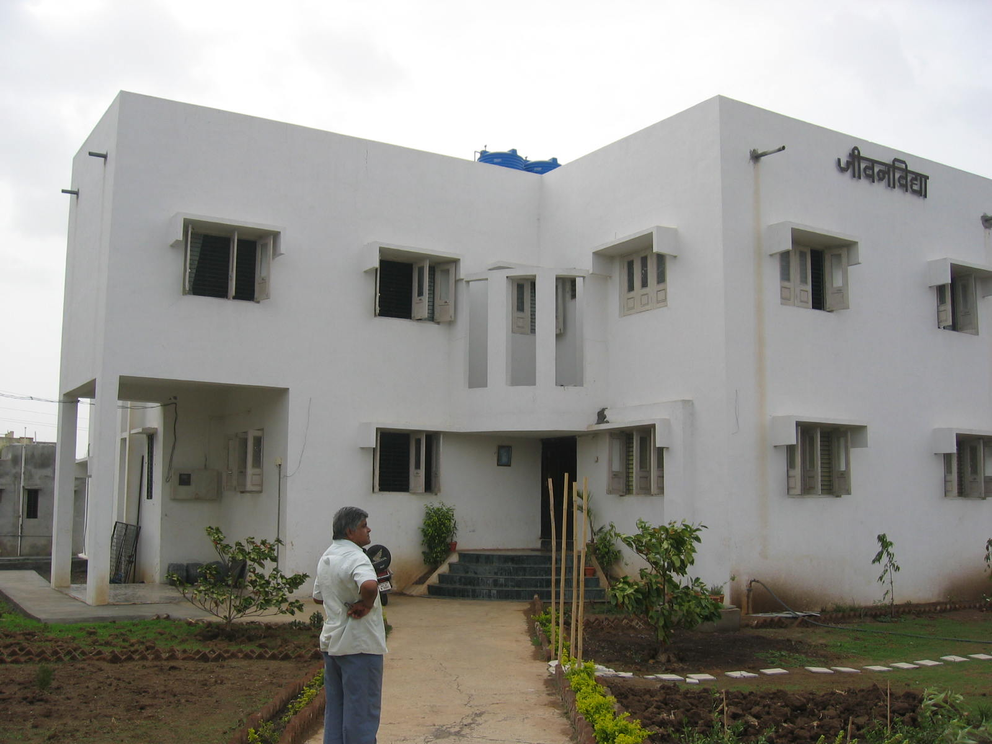

The land again belongs to the same parent organization. The building is a nice structure and is closer to the main road. Right besides the gate you can see the signs of some good farming. There are 4 staff members. The Director, Maya, has been involved in tribal upliftment for 12 years. They involve the local women in most activities and have around 50-60 such activists. The activists are not paid anything, except for food and at times some gifts. I did not explore in detail the activities they involve in, since it did not have any relation to the boarding place. This may be something which can be clarified by email, if needed. The boarding school started off only a year back, and has 60 students. She explained to me the working and took me around. Most of it is similar to Jana Seva boys section, and they follow a schedule too.

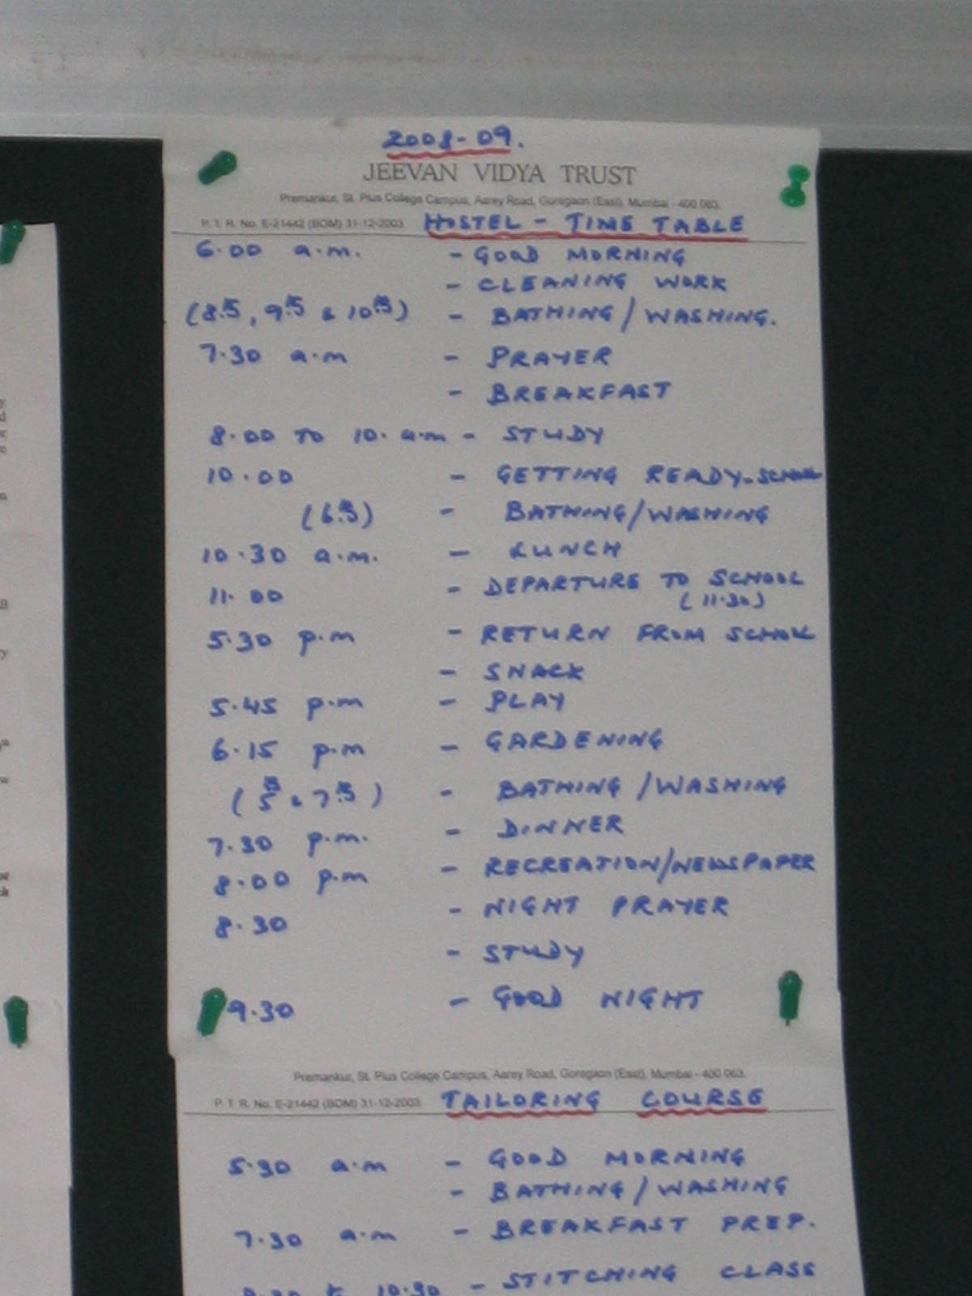

The girls are involved in herbal farming, and there is a staff that is well aware about this. There is another office superintendent and campus in-charge here too. However I believe in this organization, all of them are being paid by the parent organization since they were not locals. In addition to the boarding expenses, the only need they indicated was for a tutor. I could see a schedule on the wall which the students were expected to follow. I was shown that they have a vocational skill teaching place where there were around 15 sewing machines. So a local instructor would use this facility to offer some sewing classes to these local girls. We went out to the playground and Fr Godfrey chatted with some students. I did not chat much with the students, since they were in a playful mood and I did not want to ask any serious questions. After a few minutes we walked back to the boys boarding section. I noticed a school with boarding right besides the Jana Seva one. However as Fr. Godfrey pointed out, I could see it was not in a good condition. He mentioned that it was run by some person who was not a local and the staff also did not run it very well enough. If the school would have been working, the Jana Seva children would not have to walk far for their studies.

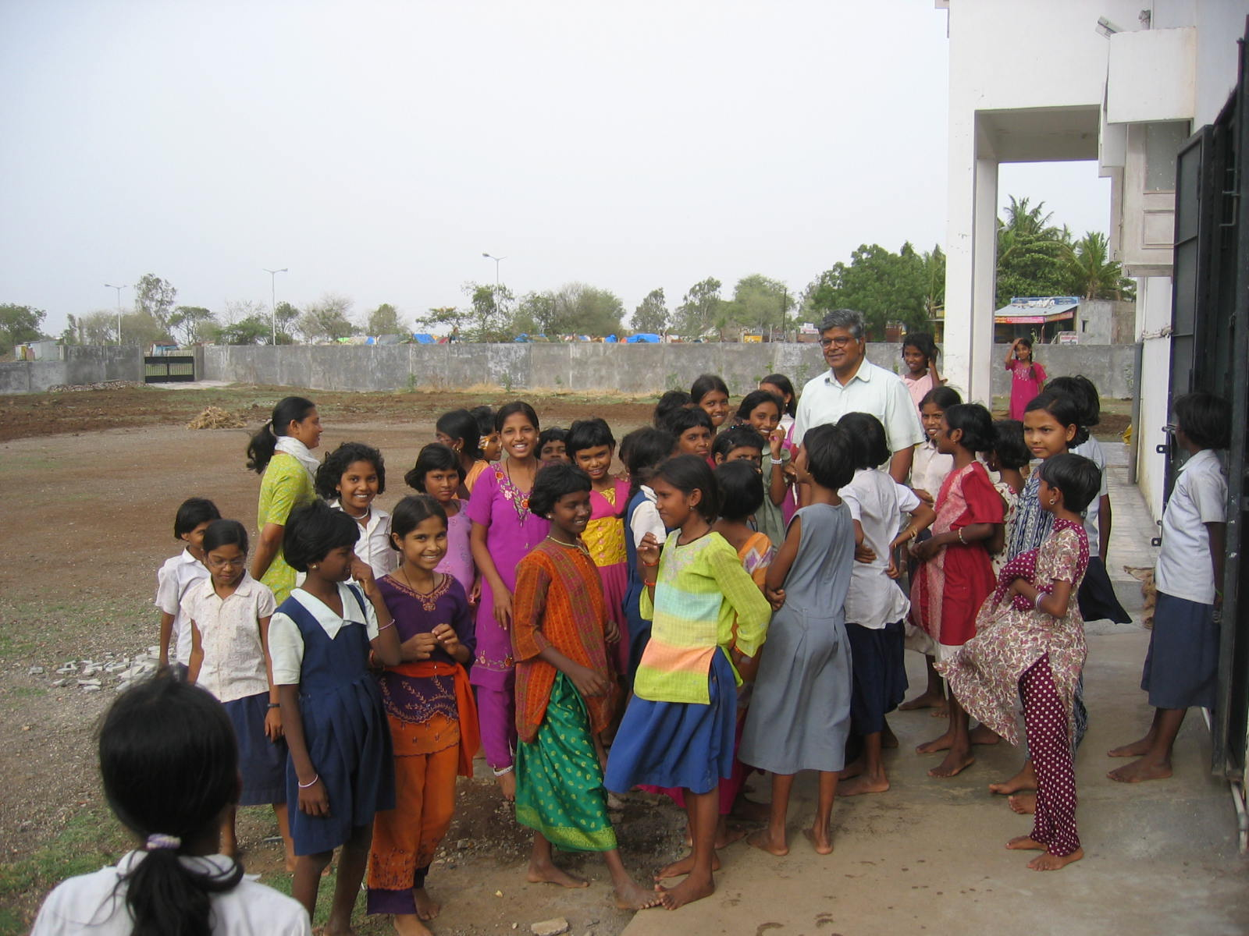

After this I just walked around taking some pictures. It was time for the students to study since it was evening. I could see all of them in the boarding room sitting and studying. Some of them would occasionally come over and buy a notebook from Fr. Godfrey. I took a few pictures more and was ready to head out of this place.

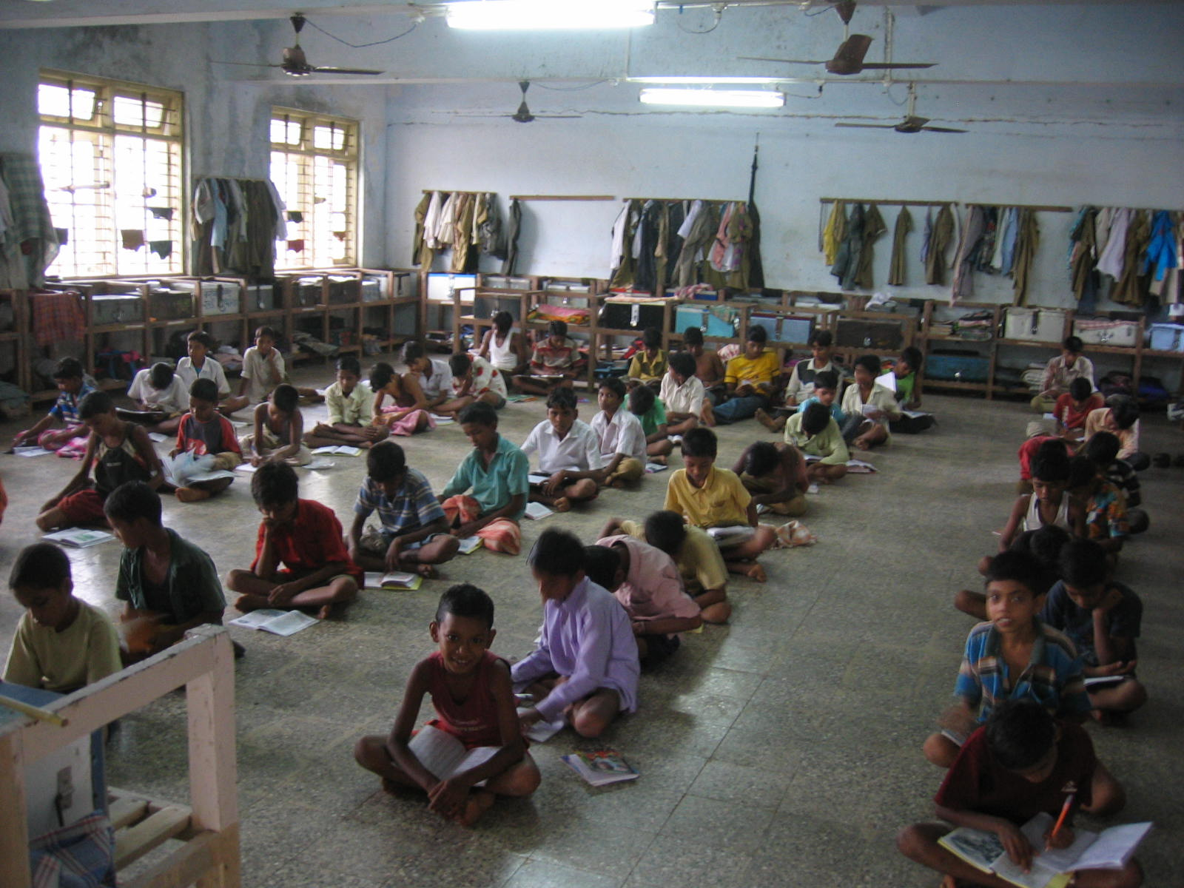

From what I summarized with Fr. Godfrey on funding options, There are various options:

- Recurring funding (with some commitment, since they do not want to enroll kids and then turn them away the next year)
- One-time funding

Recurring funding options:
- Sponsor 120 boarders. 450 Rs per month. Details of cost breakup are available. I did see them, so you can request for it.
- Alternatively sponsor 60 boy boarders or 60 girl boarders since both are run as individual outfits, and have separate locations/buildings and staff. For the girls section, the Director is Ms. Maya. You may want to get contact information, since I did not gather it when I met her and her staff.

One-time funding options:
- Provide solar heaters to the boarding schools (no estimate available)
- Provide bunker beds for the boarders to sleep on (no estimate available)

I also discussed with them the options of:
- Having a tutor who would take a single class for both the girls and boys boarding section
- Sharing the computers with the girls boarding section

I also mentioned that funding may be only partly available. They do have FCRA clearance for Jana Seva. However I am not sure whether the same can be used if only funding the girls section. This needs to be verified with them. Overall I believe that this is a good project. There are ways to improve things down here, and Asha can definitely offer some constructive suggestions to improve functioning. But for the tribals, boarding seems to be the only way for them to get into the mainstream. This seems to be the only option to get the basic education, even if they want to get back into farming after that.

