Site Visit Information

Project/Site Name | Sri Sai Seva Sadan, Hyderabad, India
Site URL | www.saisevasadan.com
Asha Site URL | http://www.ashanet.org/projects/project-view.php?p=993
Site purpose | Alternative education
Site Visit Date | 24th July 2012
Site Visit Report Date | 5^{h} Aug 2012
Site Visit Done by | Sridhar Dandapanthula( Asha Seattle volunteer), Sandeep Athreyas (Make A Difference in Hyderabad)
Site funded by | Asha Seattle Chapter
Project Steward | Vamshidhar Kommineni
Years of operation | 5 years

Snapshot:

People
Students | 19 in residential, 10 in day scholar
Teachers | 4 full time teachers, 1 speech therapy teacher (once in a week) and one Music teacher (twice in a week)

Teachers:

4 teachers for regular classes. One teacher is post graduate and other 2 teachers completed are diploma in special education. 1 teacher is for helping vocational training.

Before site visit
We (Sridhar and Sandeep) started from CFL and informed Mr. Bhaskar that we would arrive at the organization on December 11th, 2013 @ 12:30pm.

Site visit Summary
We reached Sai Seva Sadan at around 1:00 PM with some fruits and biscuits for children. Mr. Bhaskar introduced his staff. Mr Bhaskar has gone over the latest developments with the school and rooms in the building. He explained about challenges in retaining teachers for long term. He did walk through budget reports for the last year and proposed budget for this year. He is trying for lending land from government, so he showed the recent progress from local ministers and chief secretary’s proposals in the papers with their signatures with comments. If everything goes well and get land, we may need budget for building.

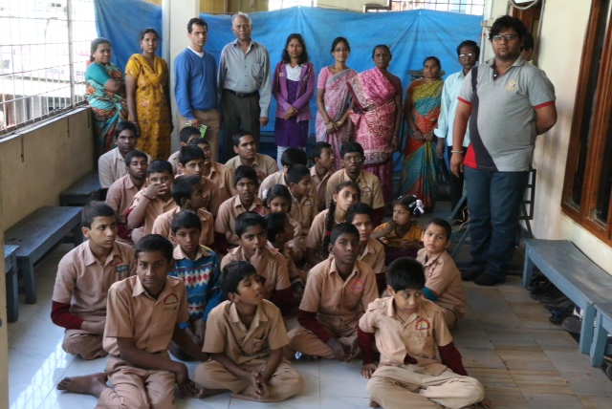

I went to each class and adults were able to show me their progress by giving their introduction and showing their class work books and daily practices. Mr Bhaskar showed their analytical reports and how they are progressing each year. He gave me annual expenses and budget documents.

Here are some of our impressions in different categories:

Location Details
The location is about 4,000 sqft in area. Residential facility at level 2 for 29 underprivileged kids is about 2000 sqft. Apart from a big hall, level 2 has 3 open bathrooms, 3 open toilets, 23 beds, and 1 warden/children playing room and 1 washing machine. A corner of the big hall has about 6-8 benches that are used for classes during day-time. Level 1 has administrative office, class room, TV room, dining hall, store room, kitchen, playing hall and a common bathroom/toilet. The facilities were adequate. This location is almost in the heart of the city and may not be available in the longer term.

As I mentioned above Mr. Bhaskar is trying for getting land from government for permanent place.

Teachers
Three special educators are presently working at the organization. One of them is post graduate and other 2 teachers are diploma in special education program. They seem to be decent, if not the best, teachers. But, we believe the quality of teachers could be further improved. A couple of kids existed at the organization since the inception and they have improved better, couple of them will be sending out as their training is complete, once teachers give confidence they can live themselves with vocational course they completed. Speech therapist was when I visited and showed us how they are going to start exercises on speech therapy. Physical therapist is not there. They are trying to recruit one very soon.

Kids
At the time of the visit, they are about 25 children. These students showed interest and some progress compared to last year. They were able to show all their abilities. Some of the students showed interest in dancing with music, some of them are trying to imitate. Some children showed their abilities on preparing meal plates too.

There were about 9 day scholars in the school. I talked with one of the parent, she expressed very much satisfaction with the progress her child made in the last 6 months.

Logistics
All the class rooms and kitchen were very neat. Toilets may need to cleaned 3 to 4 times a day instead of 2 times as they were challenged children, difficult to maintain the neat for another half of the day. Tabla teacher was there when I visited. Couof students seemed to be interesting in the music. Yoga teacher and Physio threpist were not there during our visit.

Based on discussions with Mr Bhaskar if Asha can provide 2 vehicles this location can provide training for another 20 students.

Quality of Personnel

The teachers are very much professional, but we may need to improve the confidence to them by providing support like supporting their higher certificate or graduation course fee and little more salary as they are taking very much basic salary currently according to the market. Organization has to be highly advised to improve the quality of services and try not making the organization a place for kids to stay longer periods of time. The faster the kids get discharged, the more useful the organization could be for more kids.

Food
Cooking facilities are available level 1. They all seem to be adequate for the current strength of school. I didn’t get a chance to taste the lunch or any other food items from kitchen.

Funding utilization
Funds are reasonably spent on various activities required for managing a challenged school. Expenses are quite reasonable for the kind of services the school offers. Asha funds approximately 90% of their total funds. 10% of the funds are obtained through fees collected from local charities.

Overall Impression
In general, I came away with a very positive impression of how the school is run.

Notes/Action Items for Asha:
Send the targeted budget as soon as possible.
Asha need to think successor of Mr. Bhaskar to take care the school.
How to handle retain teachers and place for the kids.

