SWIRD Visit – Asha for Education – May 25, 2017
By Padmanava Sen (Asha Bangalore volunteer, padmanava.sen@gmail.com)
Visit Snapshot:
- Boarded the 5-35 am Midnapore Local and got down at Bhogpur station around 7 am. I have met Mr Ajay Kumar Chakraborty, Pradip Kumar Jana (Accounting) and two animators (Bishnupriya Pramanik and Sushmita Nayak) in the station. They accompanied me for the complete visit.
- I have covered 8 pre-primary schools covering Bhogpur, Sagarbar and Kolaghat area in next 3 hours. The names are Kushar, Kishorechak, Kodalia, Nahala (2), Tahala, Saradabasan and Baradabar.
- In every center, the children have uniform in good condition, good shoes and same books. Some centers have better ventilation than others.
- Every center has two levels of kids. The lower level students are in the age group 2.5 to 3.5/4 yrs. The higher level students are 4+. I could mostly communicate with the higher level students. For lower level students, they mostly participate in reciting poems or dancing with the class.
- Academic checks
  - Language - The higher level students can write their names in Bengali, can read English and Bengali Alphabets. They can even pronunciate simple Bengali words. They have decent general knowledge about their village.
  - Math – The higher level students can do simple additions and subtractions (single digit). 20% students can tell tables till 5. 1-2 in each class knows tables beyond 5.
- I have discussed with the parents in two centers. They mentioned the lack of teachers in Government pre-primary centers. Also they believe the quality of education is better in SWIRD schools as well.
- I met the Doctor as well. Doctor stressed on the fact that some malnutrition exists due to the trust issue of locals for Government support in Anganwadi centers. He promotes awareness regarding local vegetables for better nutrition. There is 10-15 pct malnutrition from the checks done in the centers.
- After the school visits, I went to Mrs Krishna Roy’s house and we all had a discussion about the current plans of SWIRD and the way forward. She also mentioned the history of SWIRD. Currently Mr Ajay Chakrabarty is doing most of the coordination.
- I got the unaudited financials from Mr Jana. After that, I visited the eye care center run by NSN. Before leaving for Kolkata, I visited the land bought (next to a school) for SWIRD office.
Selected Pictures
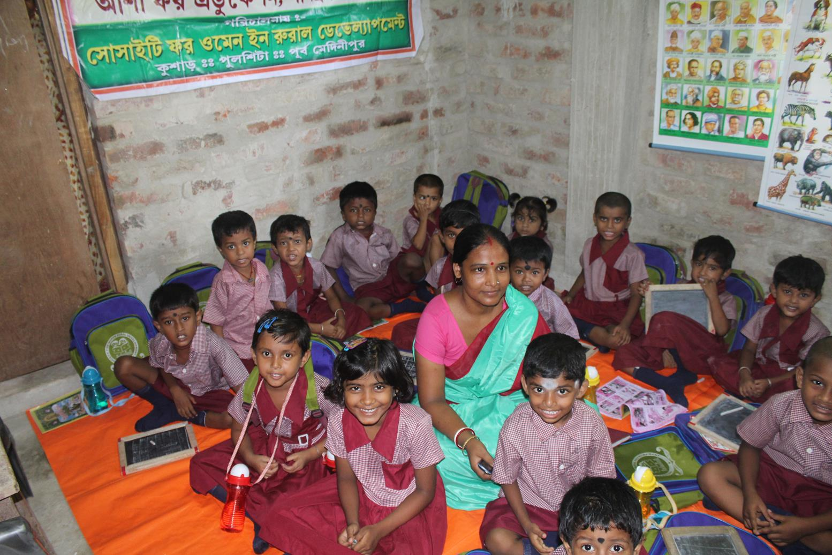
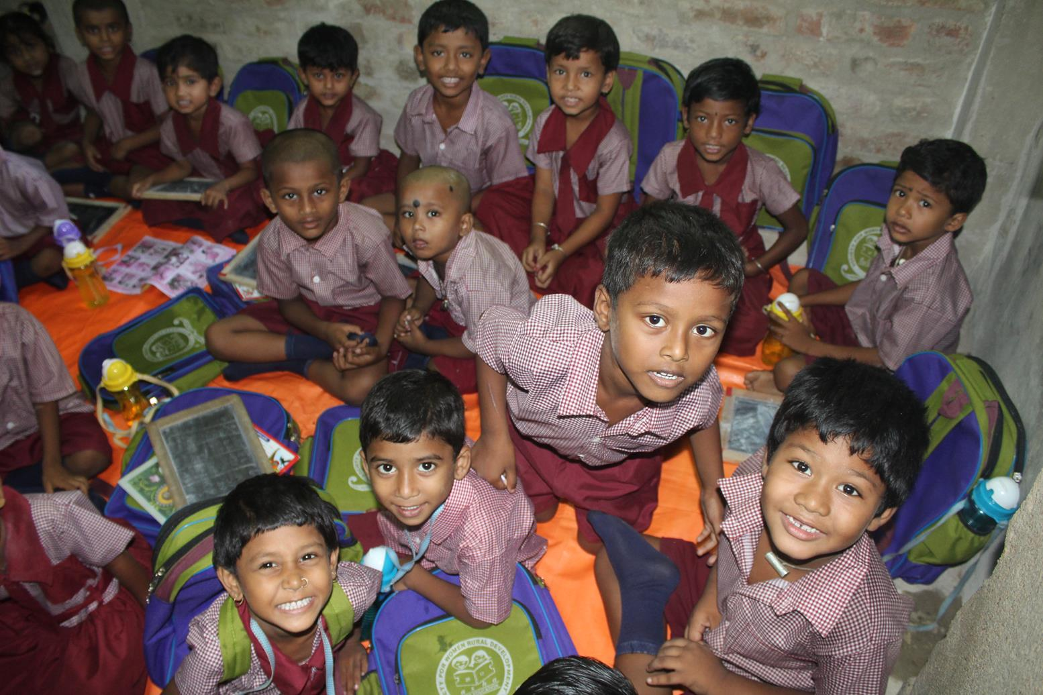
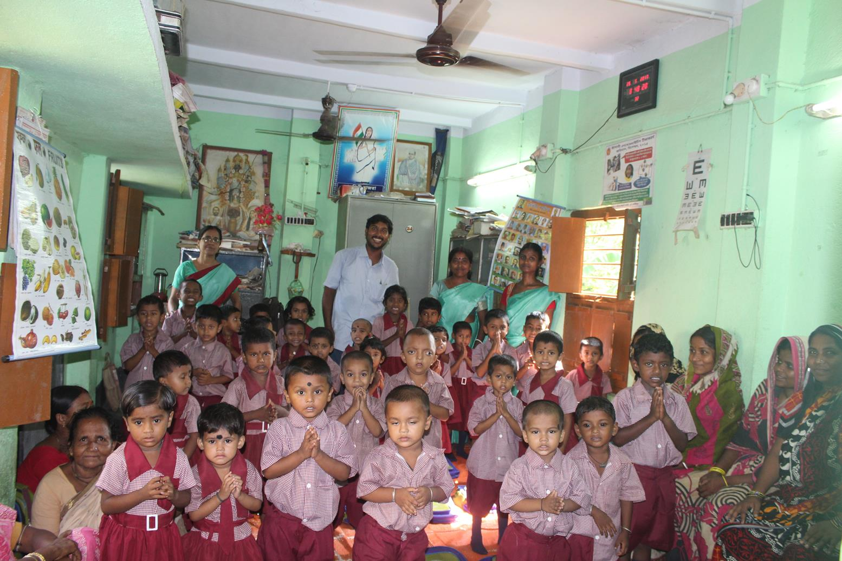
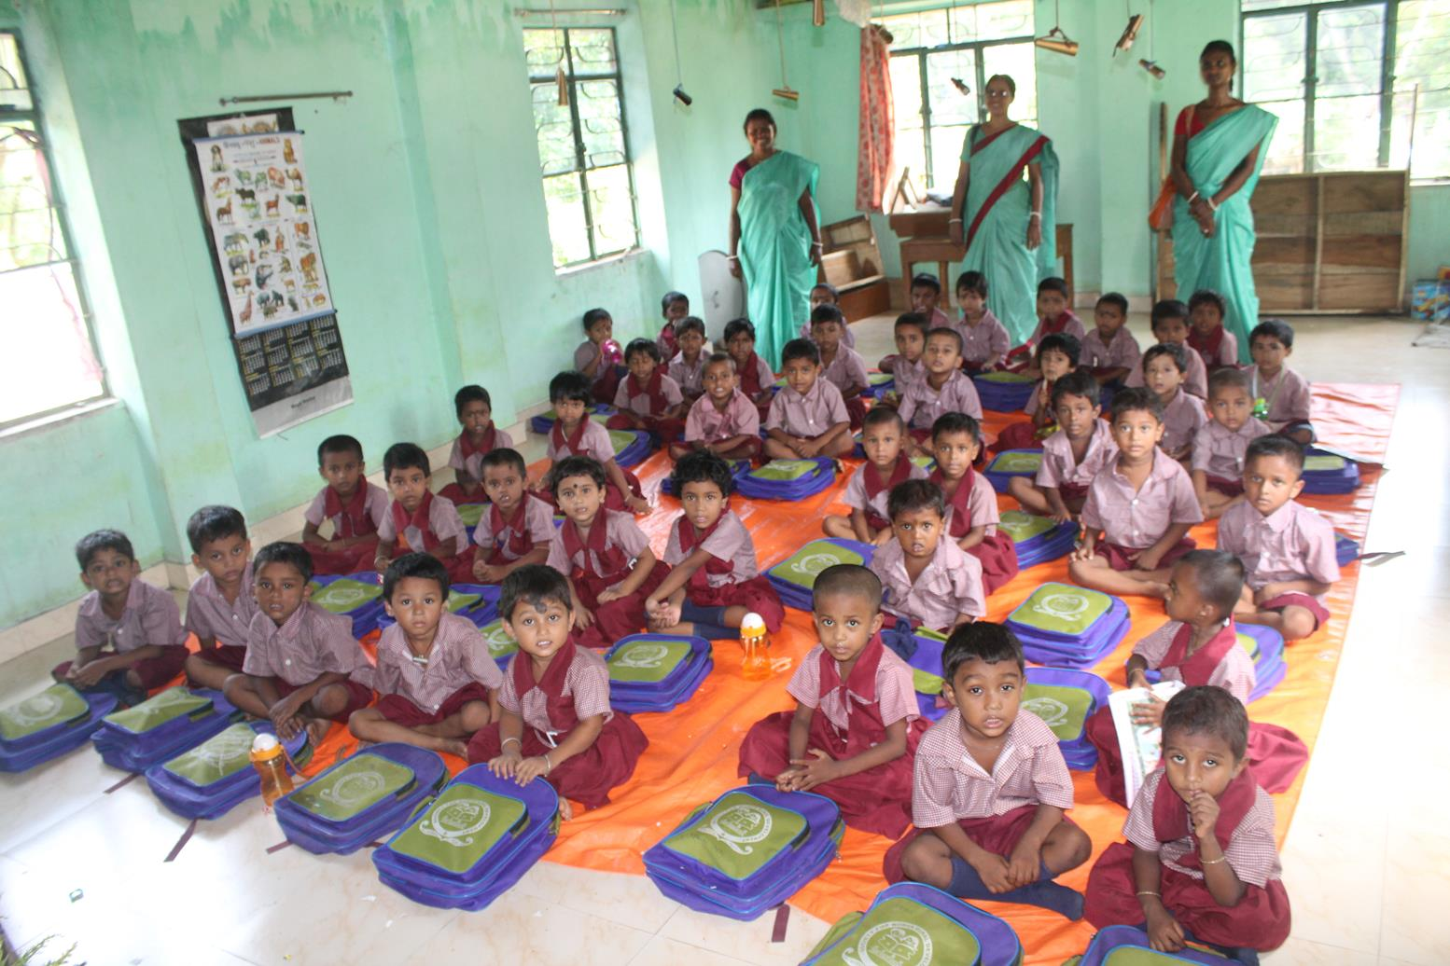
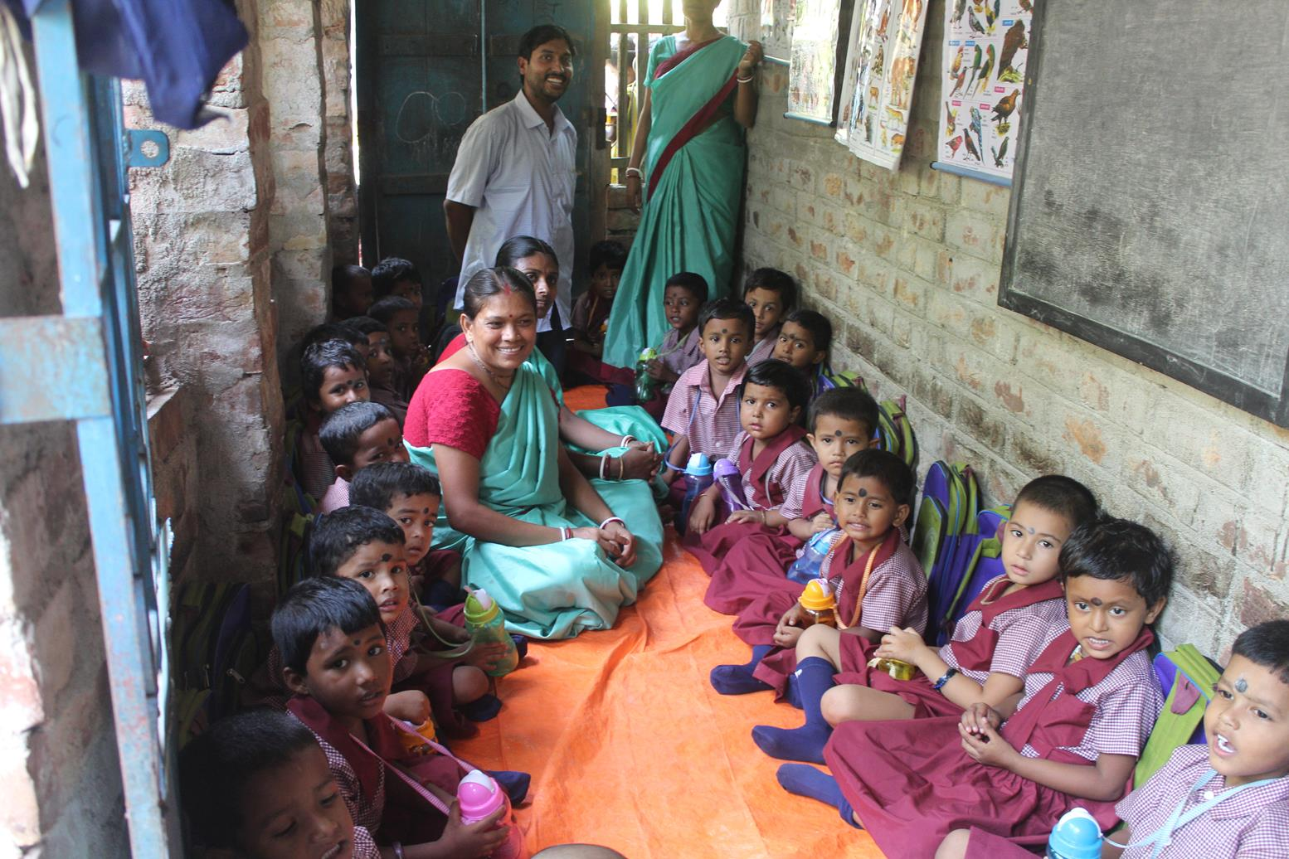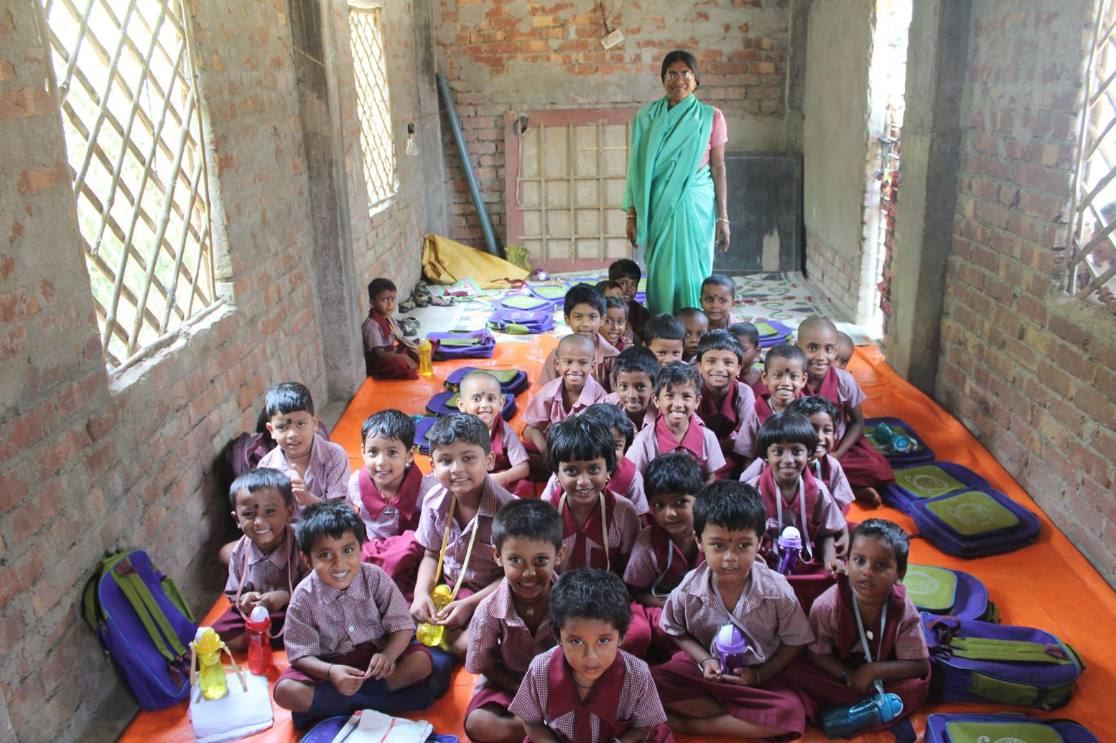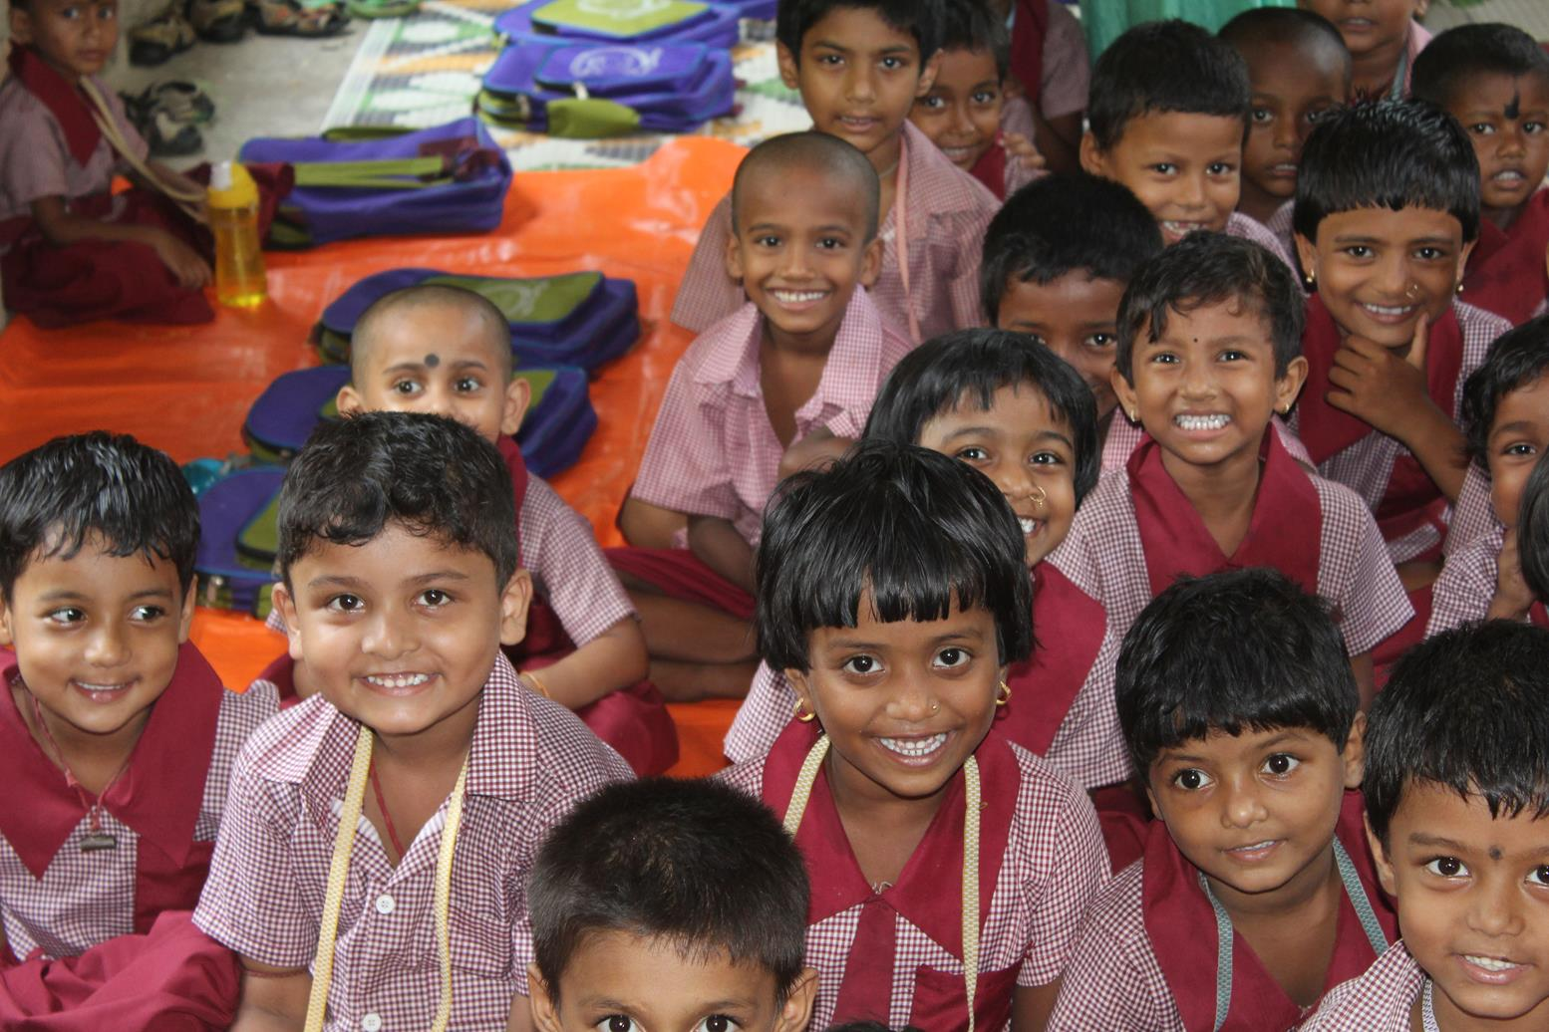
Current Students
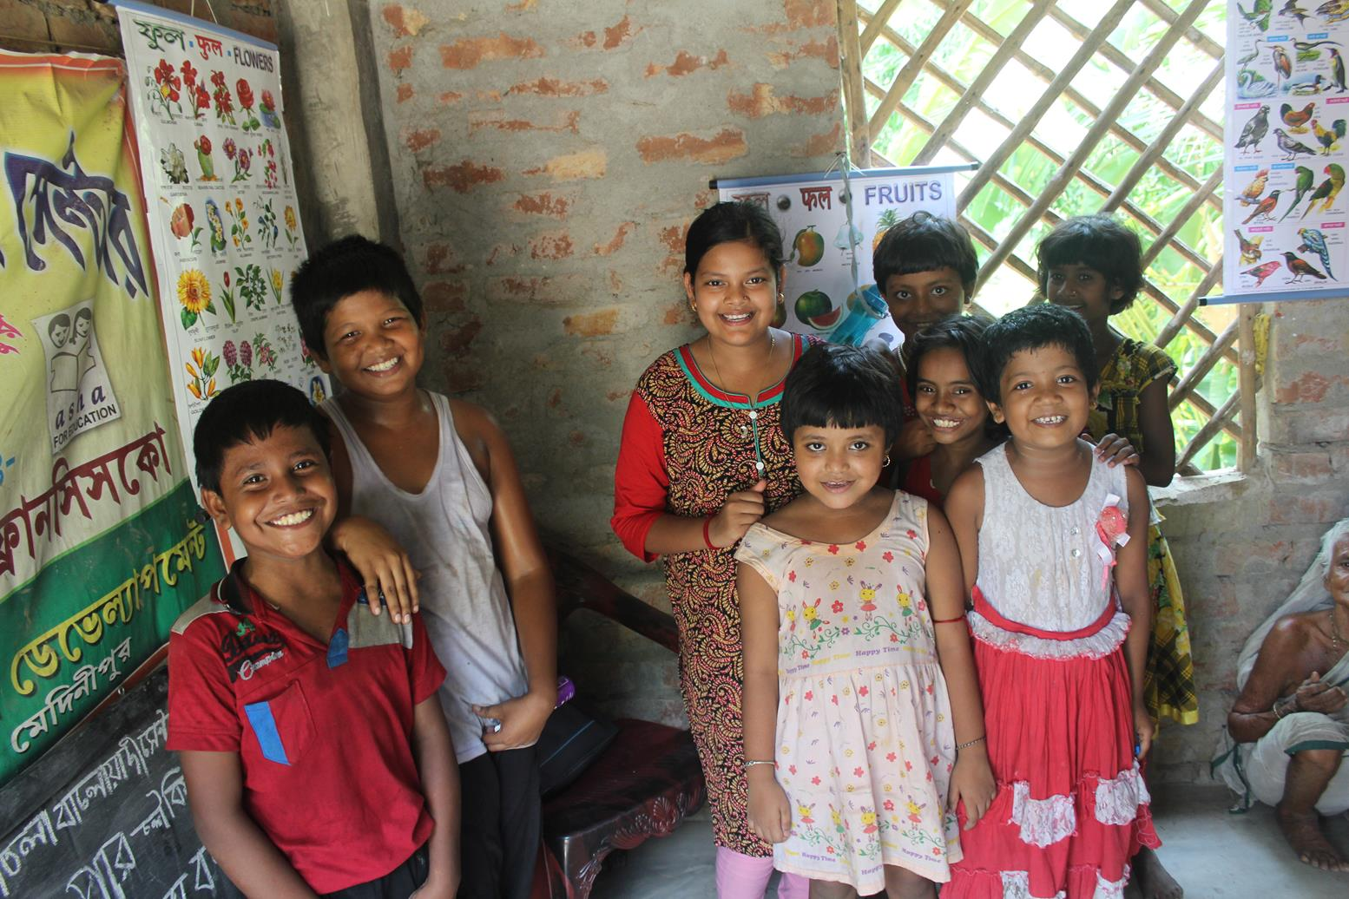
Previous students
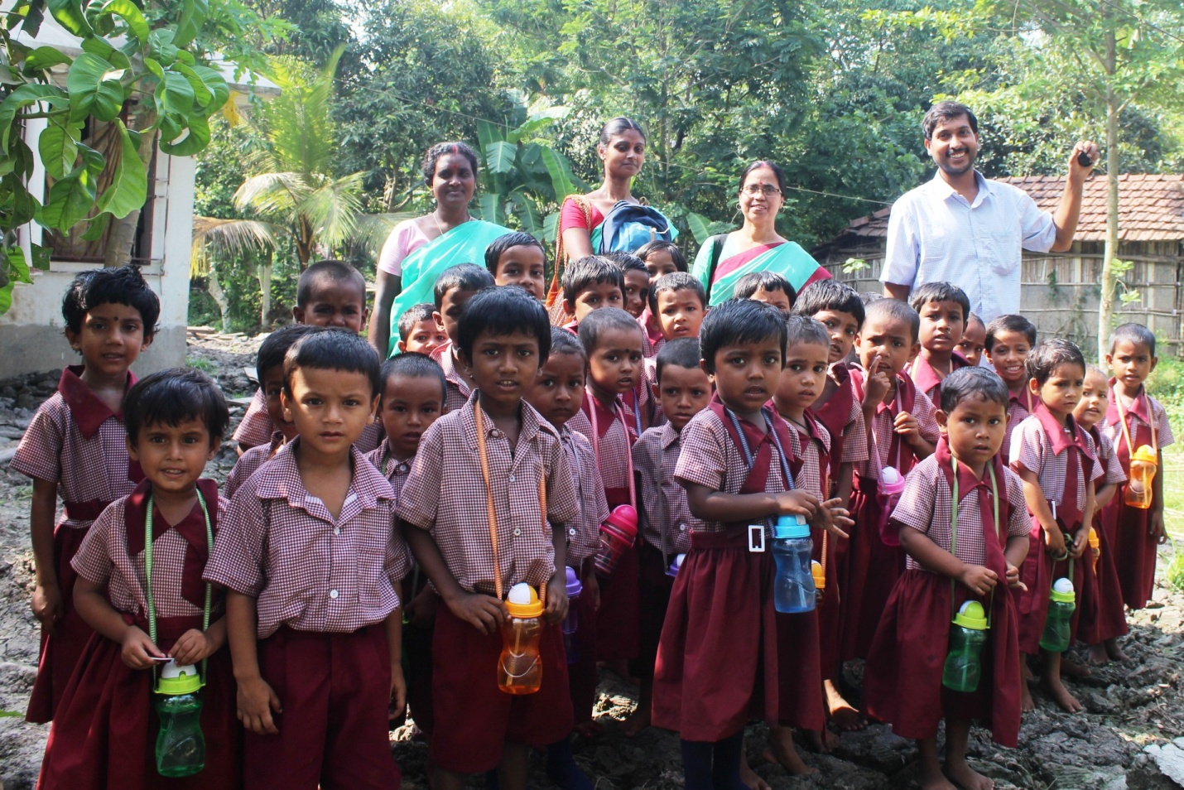
All in well, it was a good visit.

