Little Stars School

Application for Asha Education

Teacher Salary Funding

Total Number of Teachers: 16

Total Monthly Salaries: ₹ 59,500

Total Annual Salaries ₹ 654,500

Note: Teachers work 6 hours a day 6 days a week (Monday – Saturday)

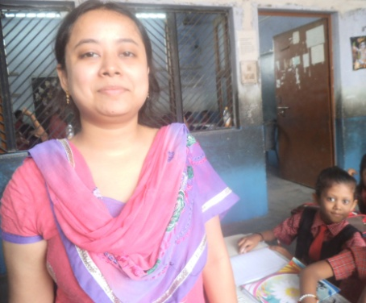
Anuradha Gupta - MA. Sociology
Anuradha teaches all subjects in Upper Kindergarten.

Salary:

Monthly | ₹ 3,000
Annual | ₹ 33,000

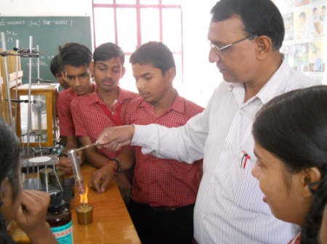
Ghanshyam is a science teacher for classes 9-11.

Salary:

Monthly | ₹ 4,000
Annual | ₹ 44,000

Ghanshyam Singh - MA. Science
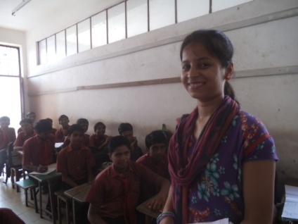
Neha teaches English from class 4 - 8

Salary:

Monthly | ₹ 4,000
Annual | ₹ 44,000

Neha Malwiya – Pursuing MA in English

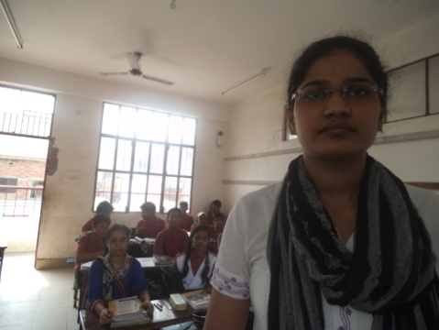
Bharti Singh teaches Biology for class 9th to 11th

Salary:

Monthly | ₹ 3,500
Annual | ₹ 38,500

Bharti Singh - MA in Biology
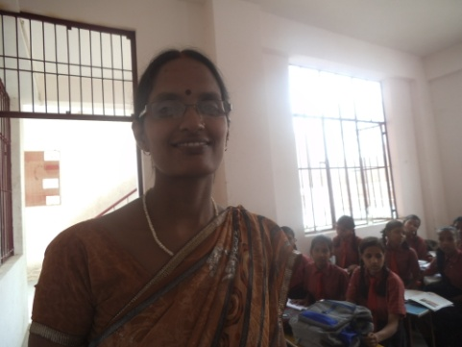
Mamta Pathak Social Studies Teacher for class 3 to 8th

Salary:

Monthly | ₹ 3,000
Annual | ₹ 33,000

Mamta Pathak – MA in Hindi & History

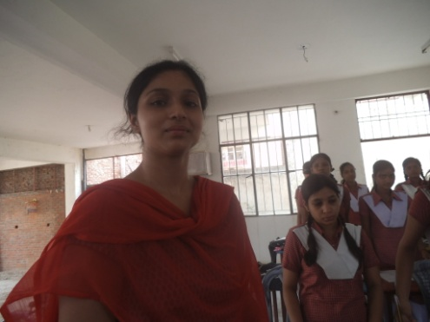
Rashami Rai teaches English from classes 9 – 11

Salary:

Monthly | ₹ 4,000
Annual | ₹ 44,000

Rashami Rai – Pursuing MA in Linguistics & English.

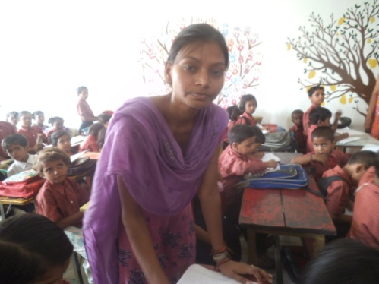
Anita Rao teaches Nursery, Hindi and Mathematics

Salary:

Monthly | ₹ 3,000
Annual | ₹ 33,000

Anita Rao – Pursuing MA in History

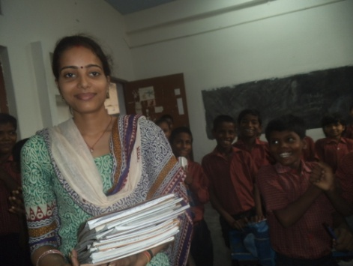
Sonam Tiwari teaches all subjects in 2nd class

Salary:

Monthly | ₹ 3,000
Annual | ₹ 33,000

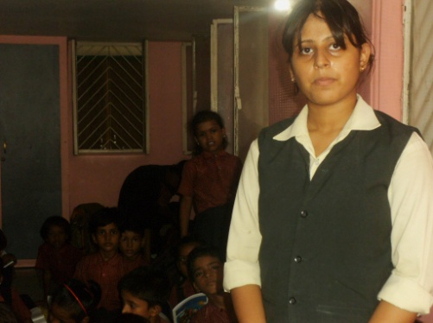
Sonam Tiwari – Pursuing MA in Sociology
Asha Pathak is the Art Teacher for class 2nd to 8th
Salary:

Monthly | ₹ 3,000
Annual | ₹ 33,000

Asha Pathak – MA in Fine Arts

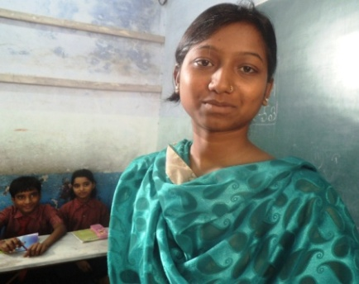
Puja Bhardwaj teaches all subjects in Class 1, Section B (Student of Little Stars School pursuing Bachelor)
Salary:

Monthly | ₹ 3,000
Annual | ₹ 33,000

Puja Bhardwaj – Pursuing Bachelor (2nd year), English, Sociology and Pol. Sci.
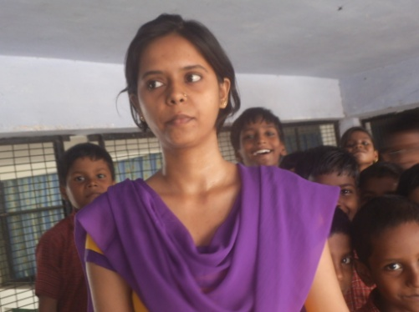
Jyoti Singh teaches all subjects in 2nd class, Section B

Salary:

Monthly | ₹ 3,000
Annual | ₹ 33,000

Jyoti Singh – Pursuing MA in Education

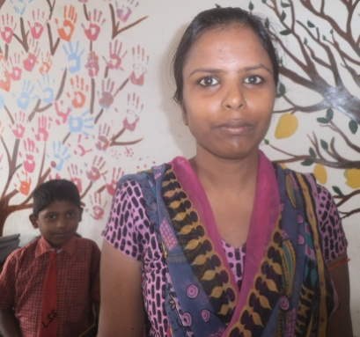
Sangita Kushwaha is a helper to all teachers from Pre-Nursery to class 2nd Substitute/Assistant Teacher.

Salary:

Monthly | ₹ 3,000
Annual | ₹ 33,000

Sangita Kushwaha – Teacher’s Training in Hindi & Philosophy

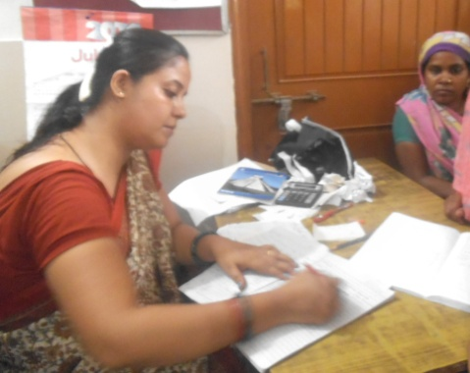
Gitika Bagga is the headmistress from Pre-nursery to Class 3

Salary:

Monthly | ₹ 6,000
Annual | ₹ 66,000

Gitika Bagga – Pursuing M. Com.
Jyotima Sinha is the Head Mistress for the senior wing, classes 4 – 11
Salary:

Monthly | ₹ 7,000
Annual | ₹ 77,000

Jyotima Sinha head mistress of senior class 4 to class 11

Salary:

Monthly | ₹7,000
Annual | ₹77,000

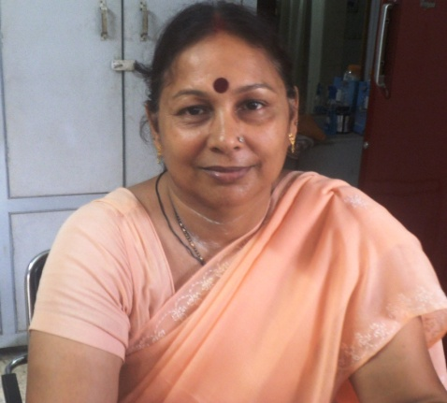
Jyotima sinha – MA in Hindi & Sociology

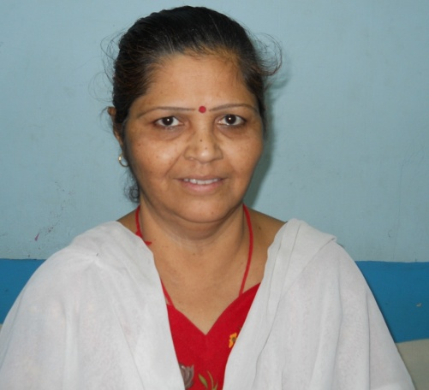
Sarika Saxena is the Art Teacher for class 9th and to 11th and teacher of class L.K.G.

Salary:

Monthly | ₹ 3,000
Annual | ₹ 33,000

Sarika Saxena – Bachelor of Arts

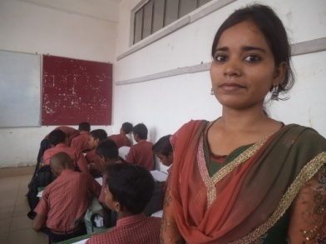
Sangita teaches Social Studies for class 6th to 11th

Salary:

Monthly | ₹ 4,000
Annual | ₹ 44,000

Sangita Kumari – Pursuing MA in Commerce

