Flood relief work for 2015
Supported by ASHA

Society for Education and Action (SEA)
(Social Audit certified)

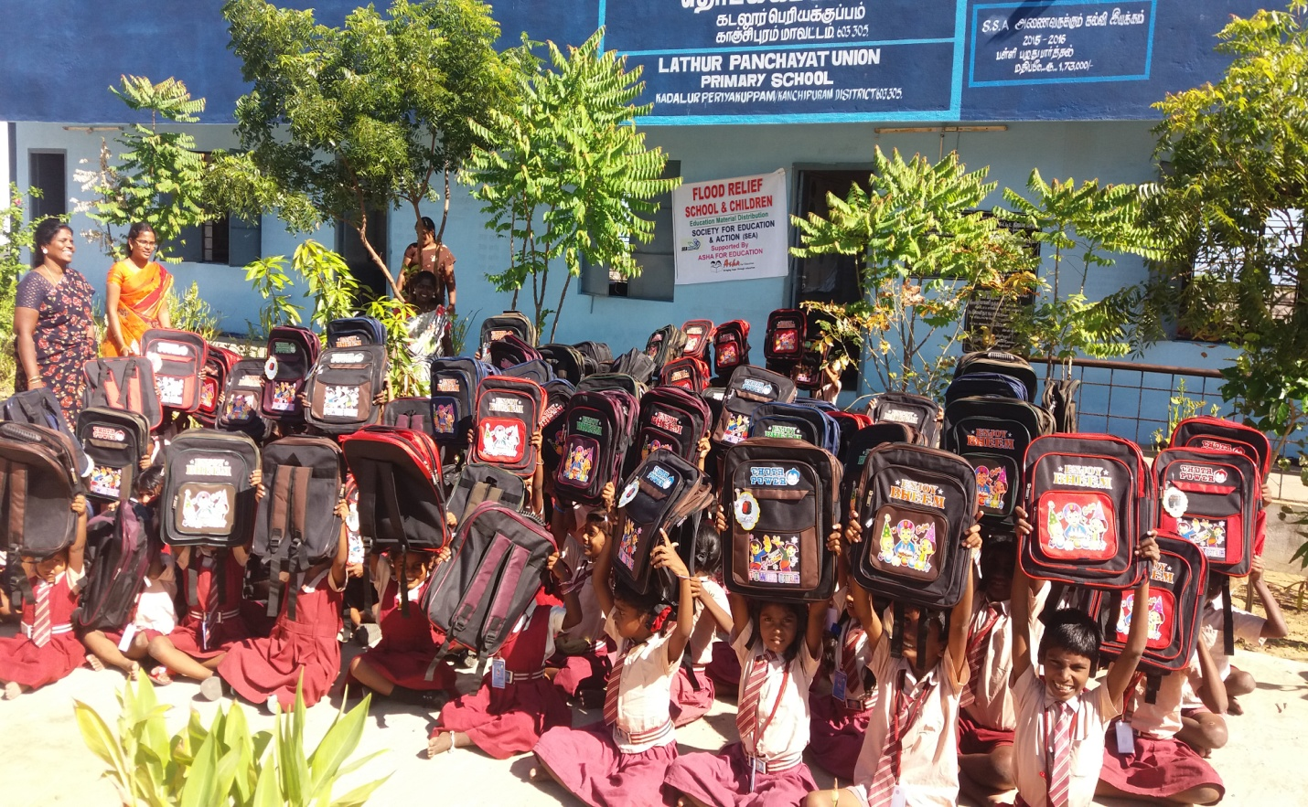

- Brief line of natural calamities:
The north east monsoon in India has brought heavy rainfall to Tamil Nadu in general and kancheepuram district in particularly. According to department kancheepuram district received 1007 mm methodological of rain fall during Oct – Nov 2015 , where as the normal rainfall for the district will be around 445 mm the recent torrential rain has flooded many part of the district . The excess rainfall could not be stored in water bodies like ponds, lakes, and rivers as they were enclosed with by un planned human habitation in the district. As well as rain water entered the villages and houses, the house thatched roof tops and muddy walls collapsed .All the material in the houses and completely damaged including the study materials of the children.
The same in the case of Govt School in which there was a heavy damage of infrastructure and education materials
The ponds and lakes in the district received water up to their full capacity and in some case breached and this floods entered the village.

- School relief requirement:

With their background we have requested ASHA to support for providing following relief materials

- Education material like school bags, books , notebooks, etc to be replaced to the affected children
- Mat, charts , drinking water drums, ABL material, water pump motor etc to be replaced to the affected schools

- Funds utilization by SEA
We have also given an undertaking that the Education material will be purchased and distributed to the floor affected children – schools under direct supervision of SEA team, inspect of the following ASHA funded schools and motivation centers.

- ASHA funded villages of school:

- Panchayet union primary school ( Kadalur peria kuppam)
- Govt primary middle school ( Alambarai kuppam)
- Panchayet union primary school ( Keezhar kollai)
- Panchayet union primary school( Kanathur )

- Beneficiaries of the children:

1. | - Panchayet union primary school ( Kadalur peria kuppam) | 157
2. | - Govt middle school (Alambarai kuppam ) | 195
3. | - Panchayet union primary school ( Keezhar kollai) | 38
4. | - Panchayet union primary school( Kanathur ) | 44
5. | Total beneficiaries of the children | 434

- Motivation centers of the beneficiaries:

- Kanathur { 35}
- Kadalur periyakuppam {30}
- Alikuppam {26}
- Alamparikuppam { 25}

Total number of the beneficiaries – 116

- Brief line about ASHA & SEA in flood relief work:
Our hearty and sincere thanks to the ASHA & beloved team volunteers, that who came forward and assisted presently the needy things to the flood offended school going children and motivation centers. The villages are totally affected by the rain water as they damaged the roads, houses and community infrastructure like schools, with the assistance provided by ASHA, we have provided relief materials to children and affected schools.
Some of schools have requested water pumps and school material, as they are damaged due to rains, so in the all sort of requirements have been accomplished and gifted by ASHA.
We hereby honor Asha which funded SEA to provide immediate needs for the school going children which who affected in flood and issued education materials, Sea had done the job what ASHA has assigned during flood , SEA has classified the flood relief work while distributing the education material for each school which is ASHA funding schools .
Once again we appreciate to ASHA & Team for assent the following school at the right time of need at our kancheepuram (Dist). Right now our present atmosphere is getting much better, and their needs have been fulfilled by fabulous support of ASHA.

- Special occasion of the visit to Anjalammal Special School during flood occur Mr. Gurumathur and his father has given their presence by distributing materials for the mentally challenged children.

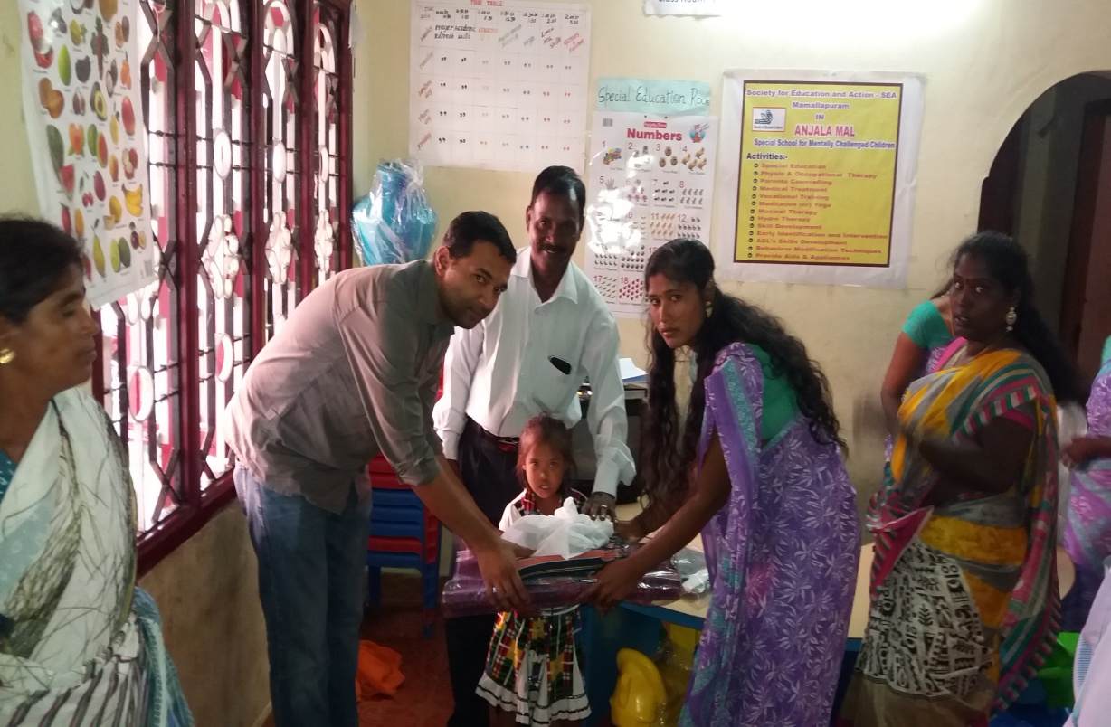

- Panchayet union primary school at Kizharkollai:

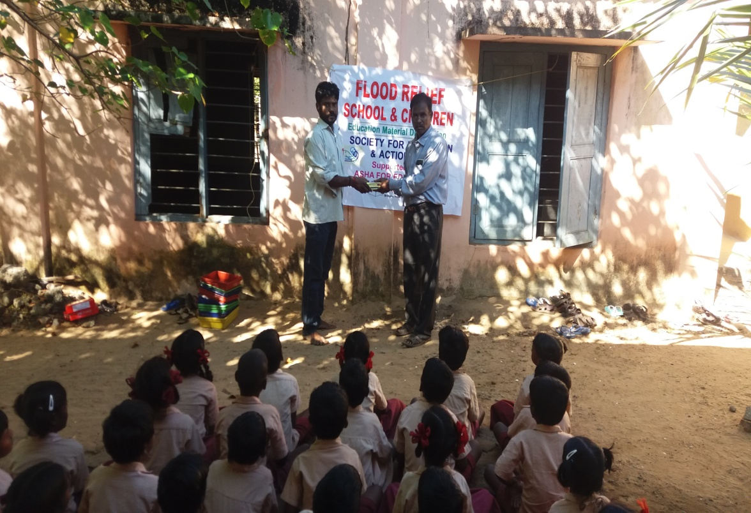

- Panchayet union primary school at Kadalur periyakuppam:
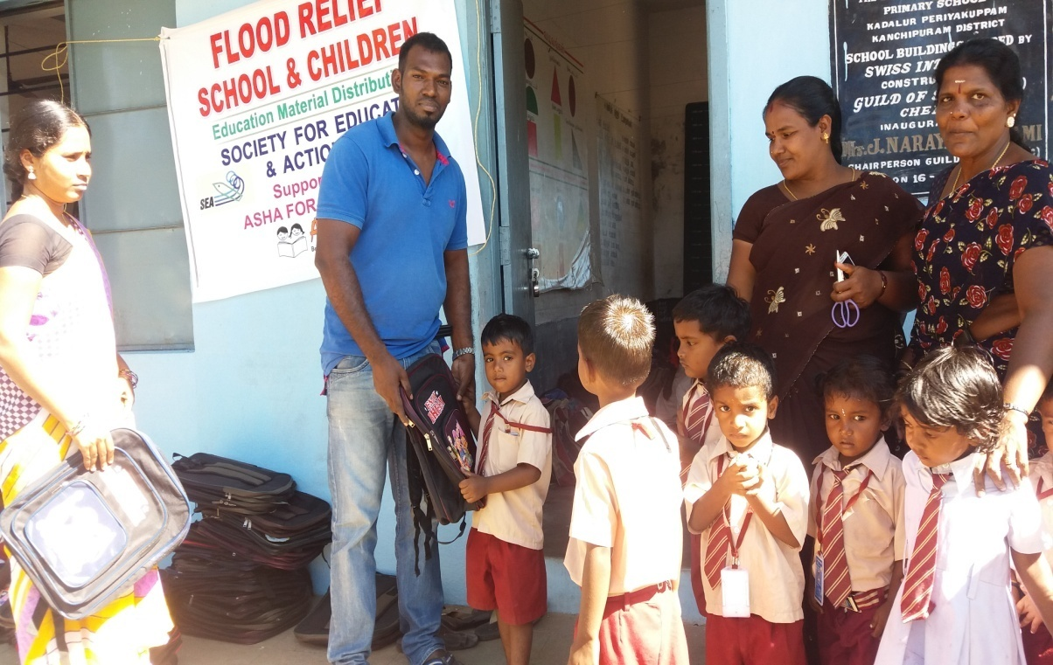
- Govt Middle school at Alambarai kuppam :
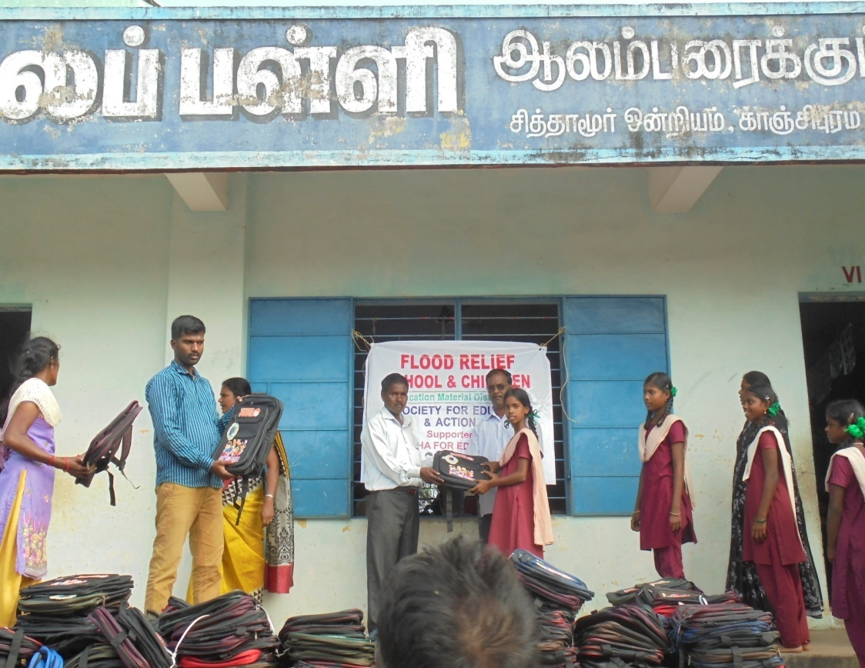
- Panchayet union primary school at Kanathur:

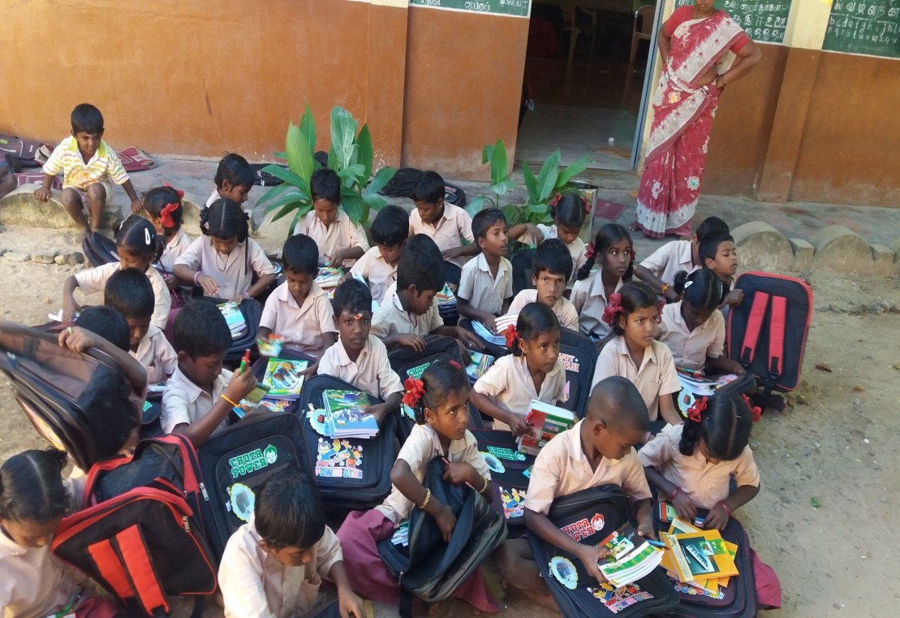

- Motivation of the beneficiaries:

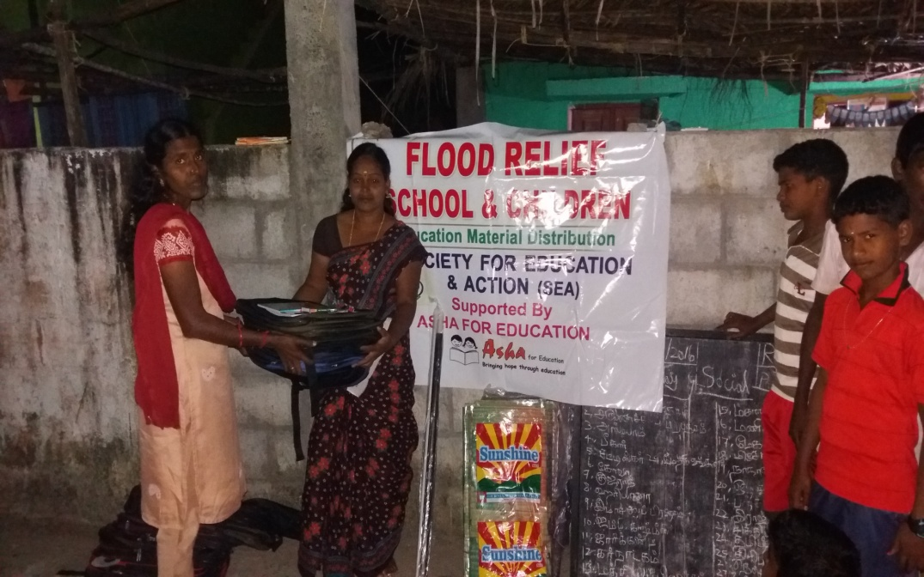
- Panchayet union primary school at Kanathur school, Specially Mr. Kurumathur has directly distributed the education materials to the school children:

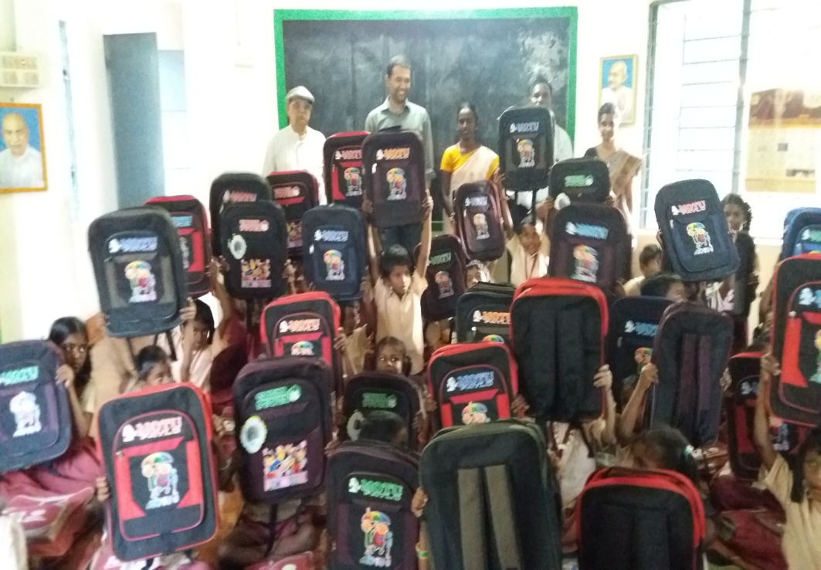

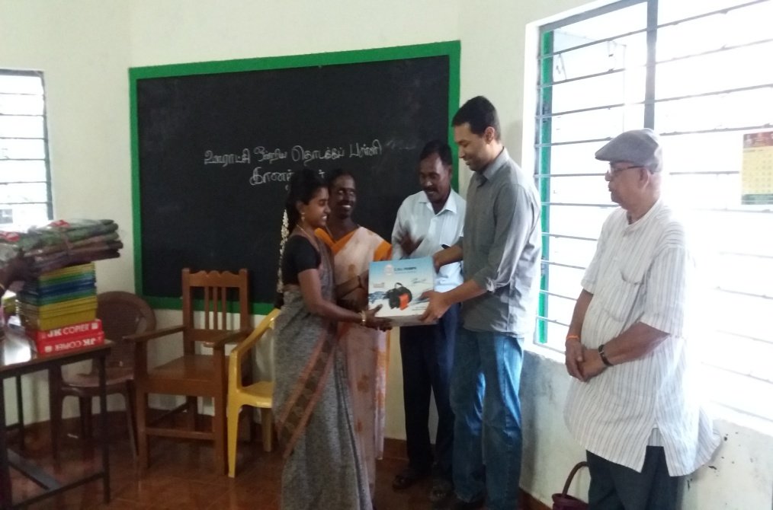
- Our sincere Thanks to Asha & Team members…….

