Pictures from KNUC Site Visit – January 2007

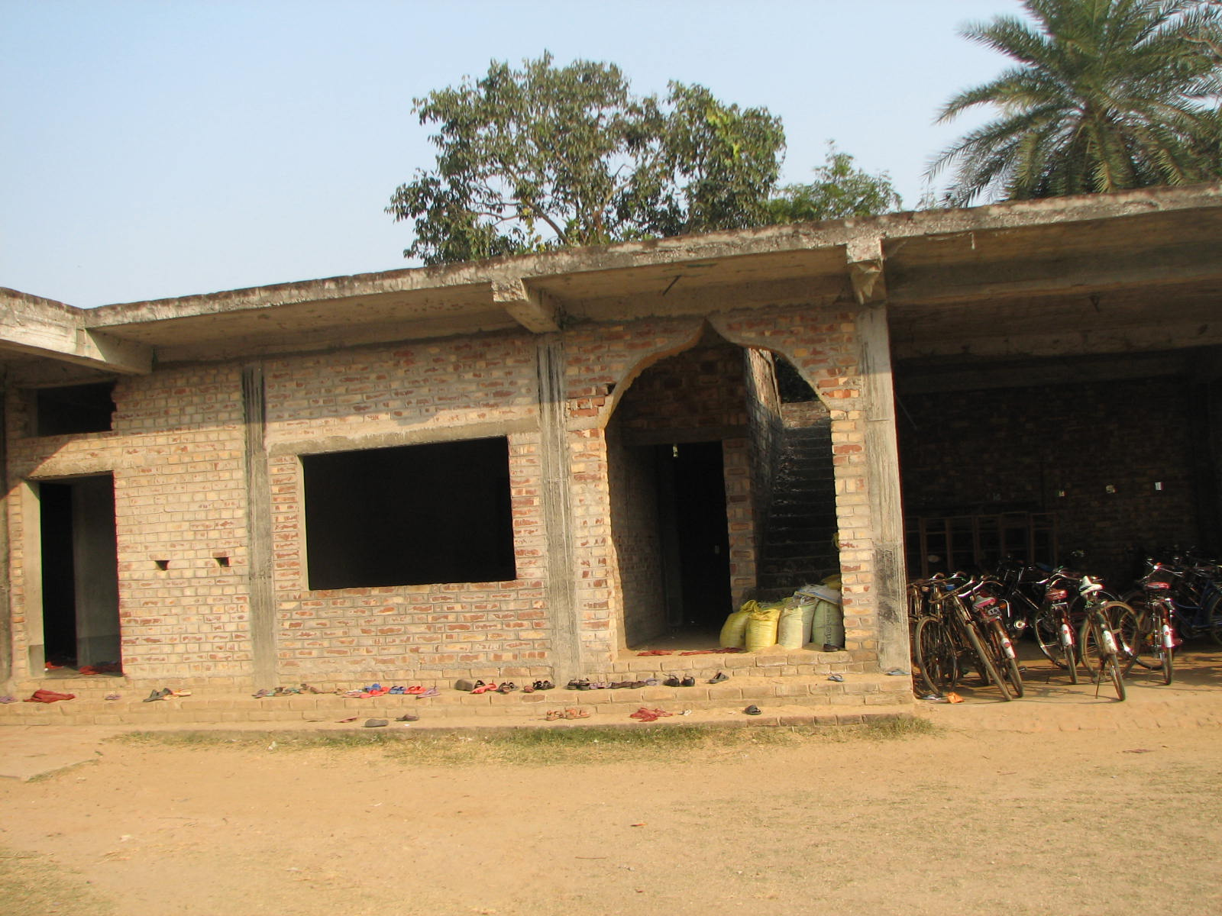
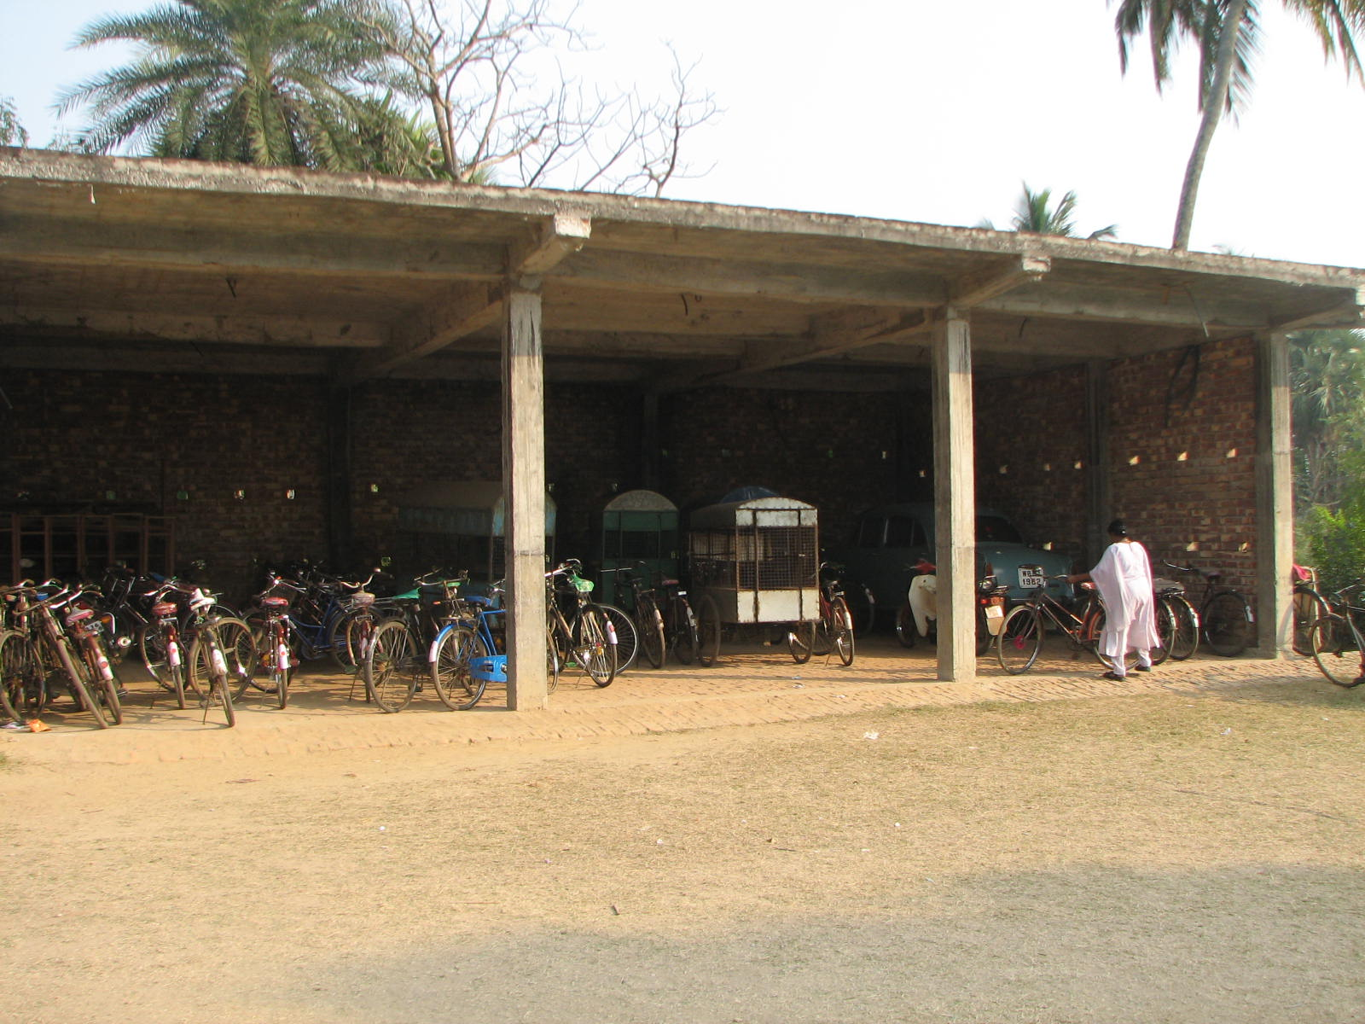

New Construction – Primary School Building Supported by Asha Princeton
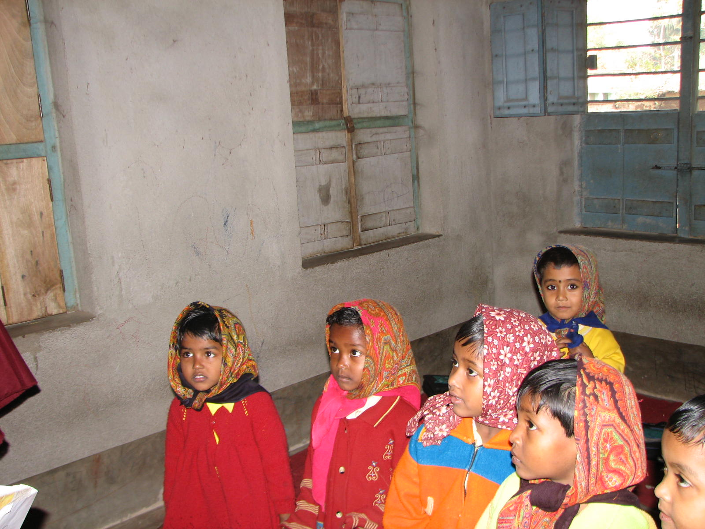
Pre-Primary Children

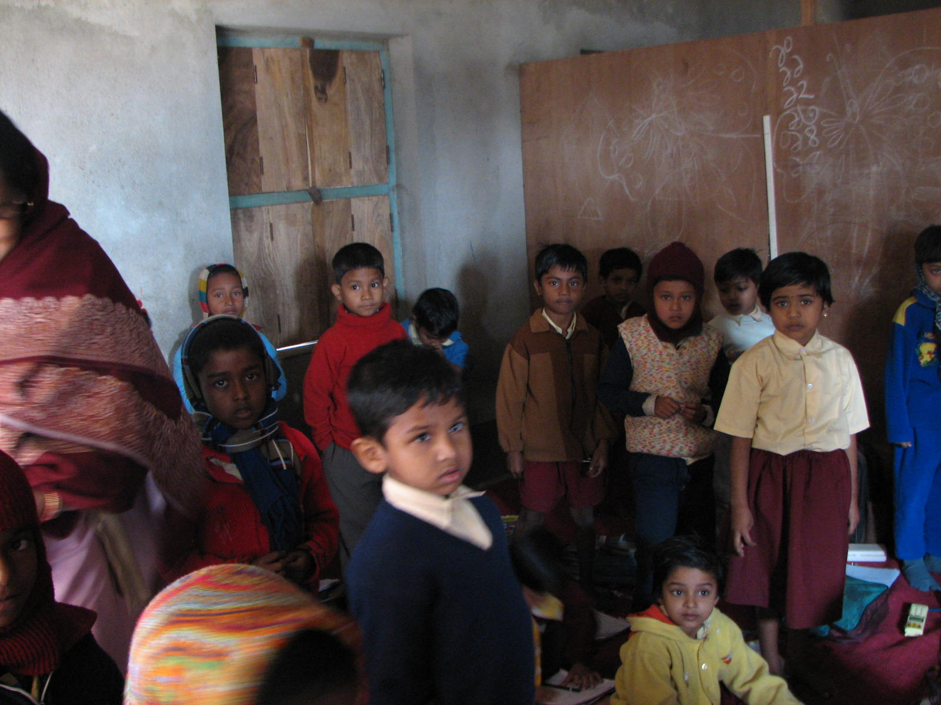
Upper Primary Children
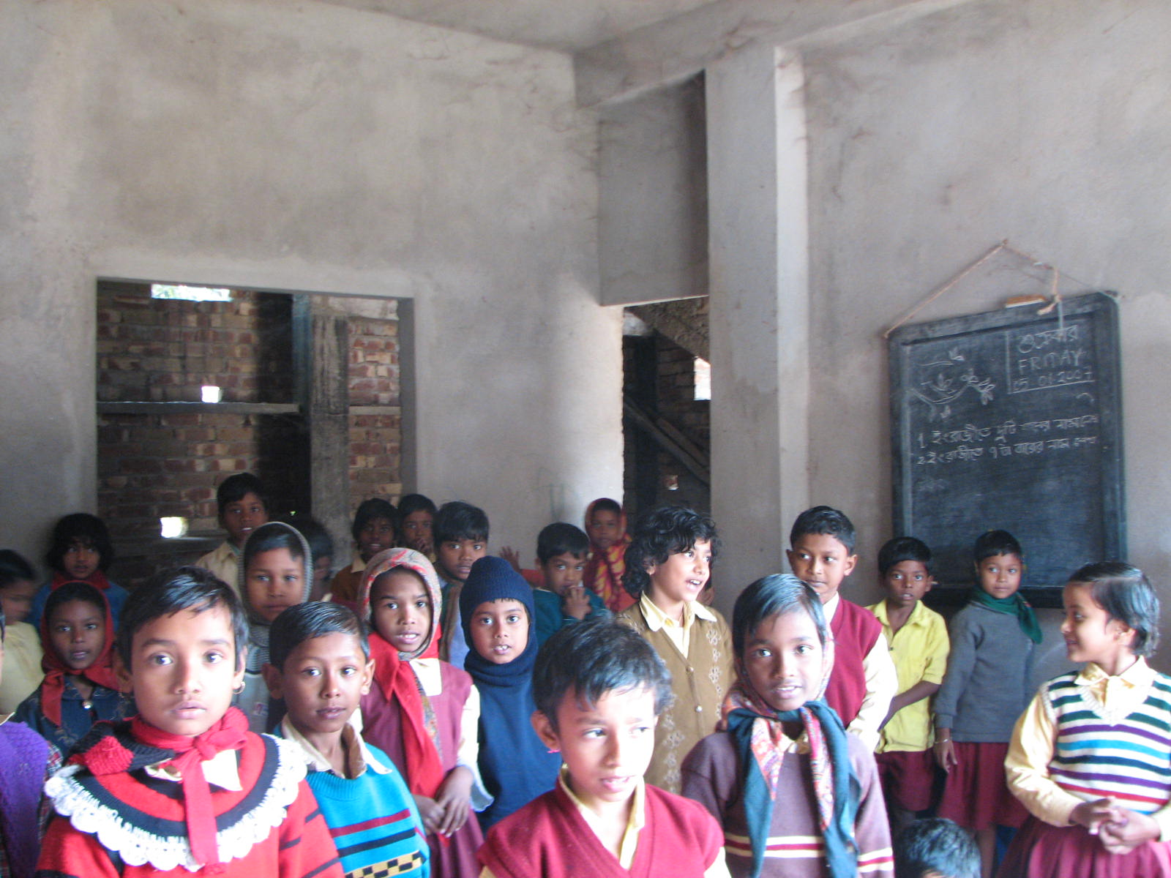

First Grade
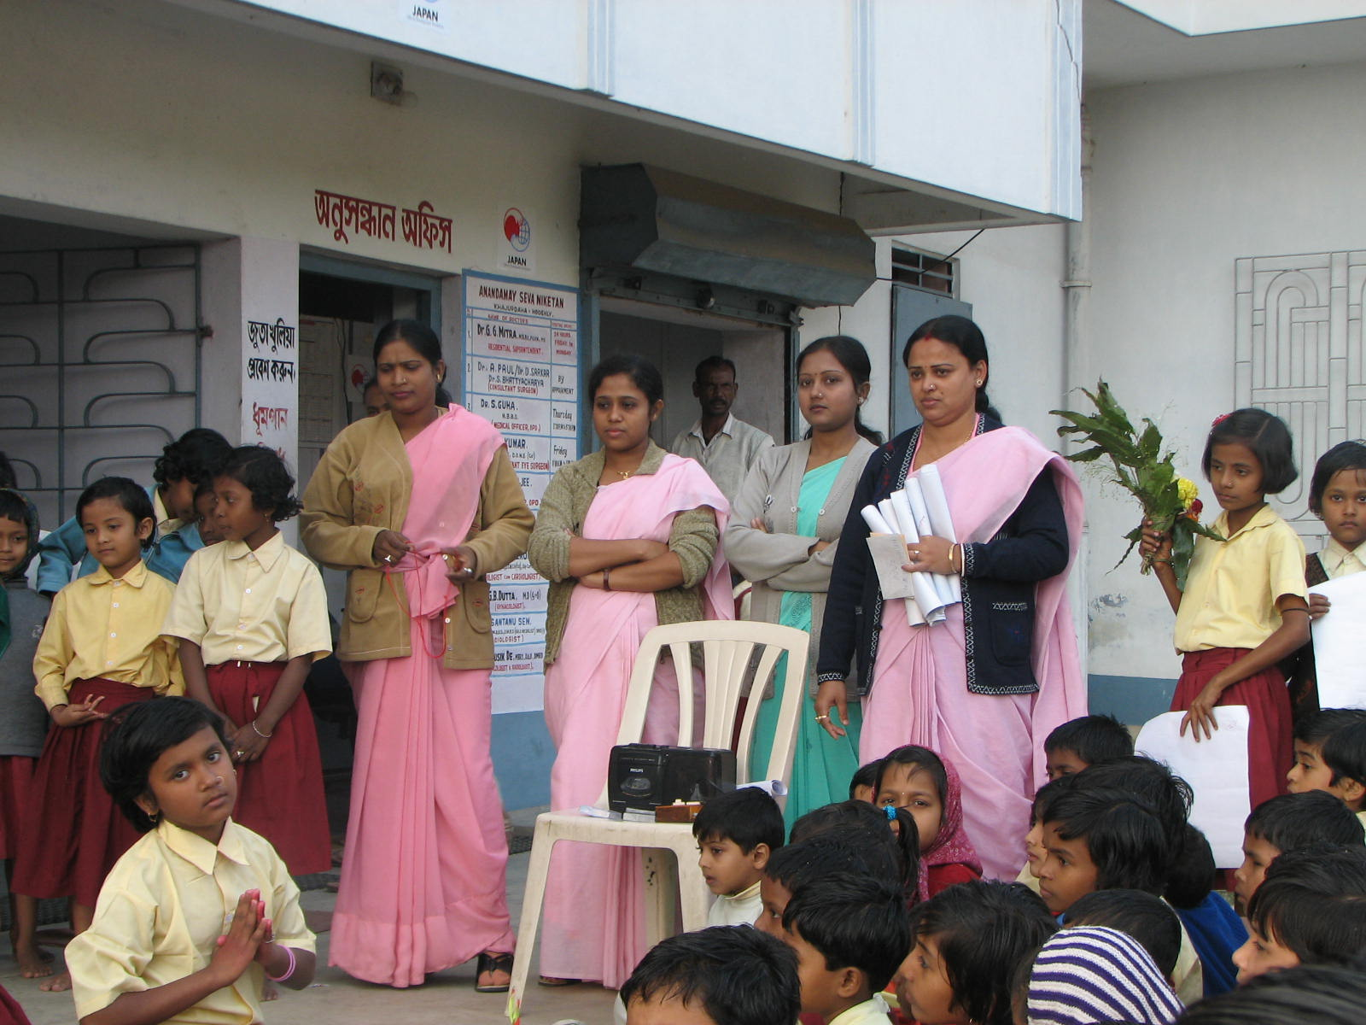
LTTO – Primary School Teachers
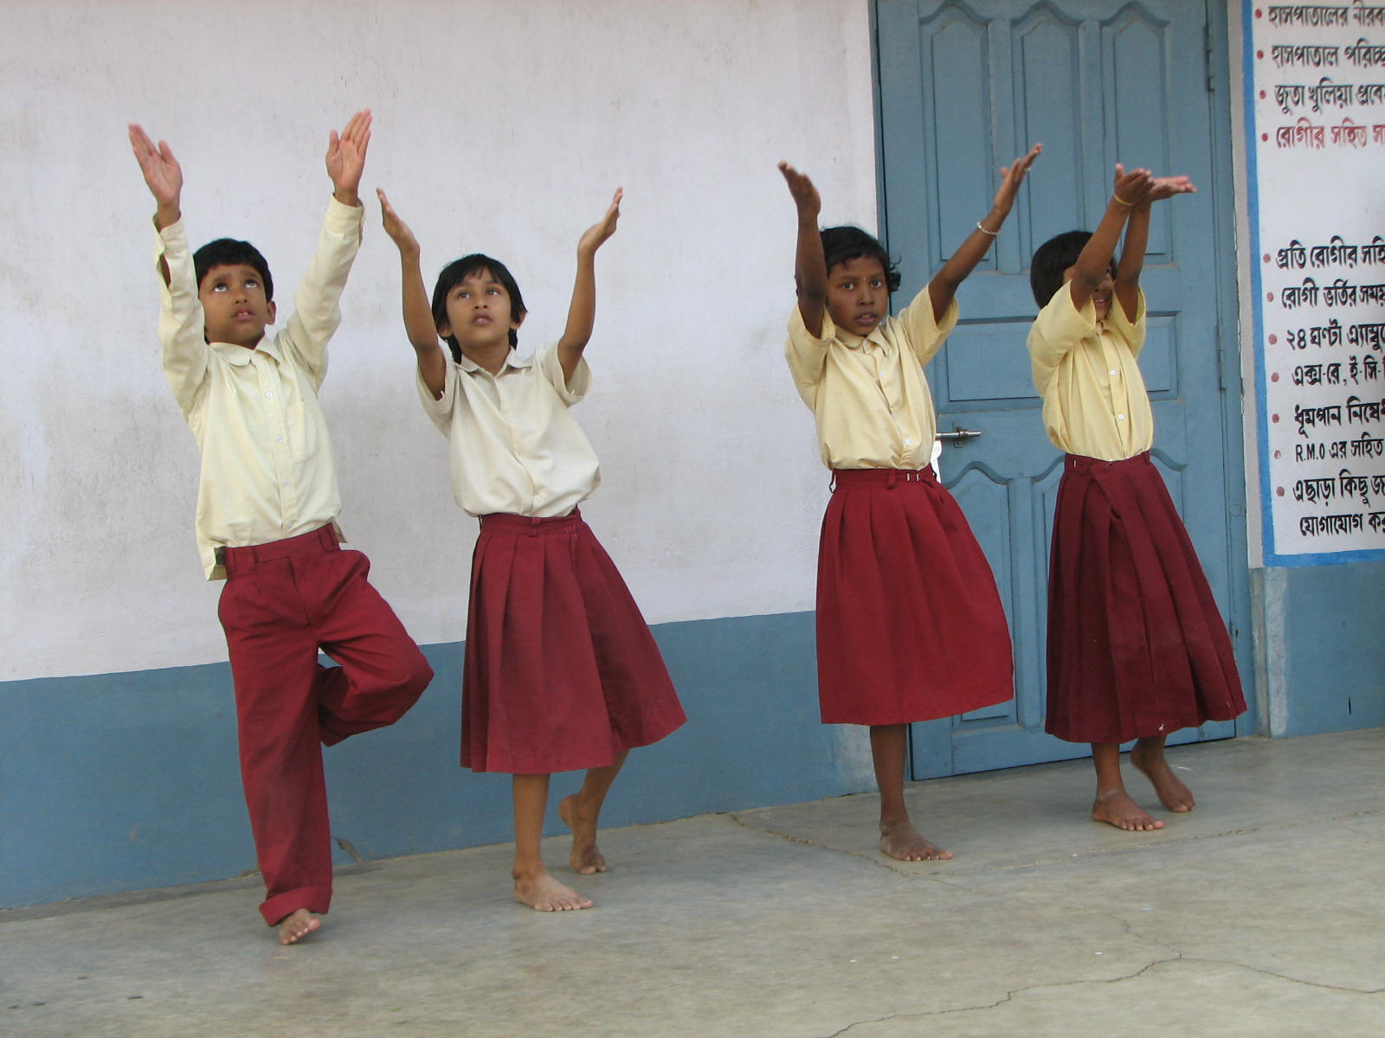
Dance Performance by LTTO Children
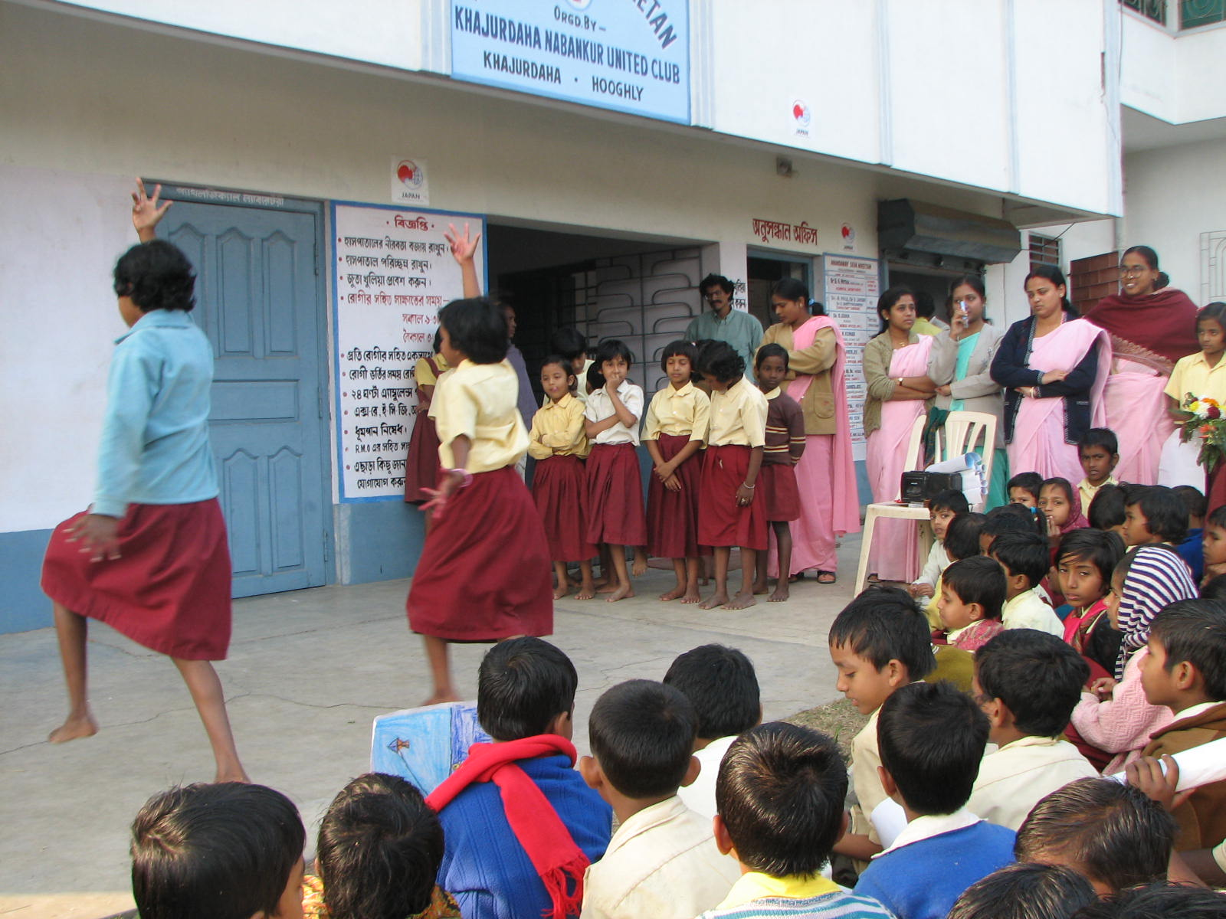
Dance Performance by LTTO Children
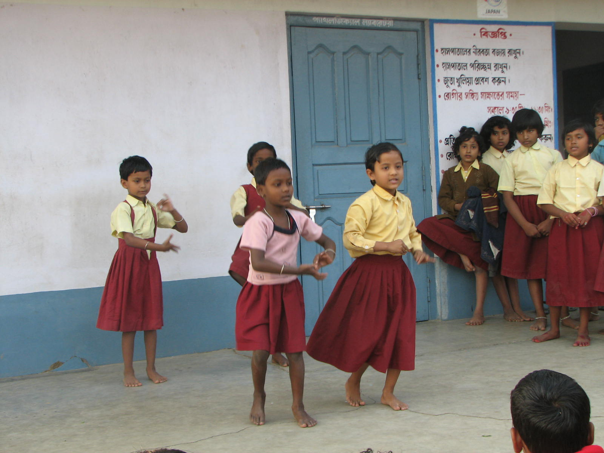
Performance by LTTO Children
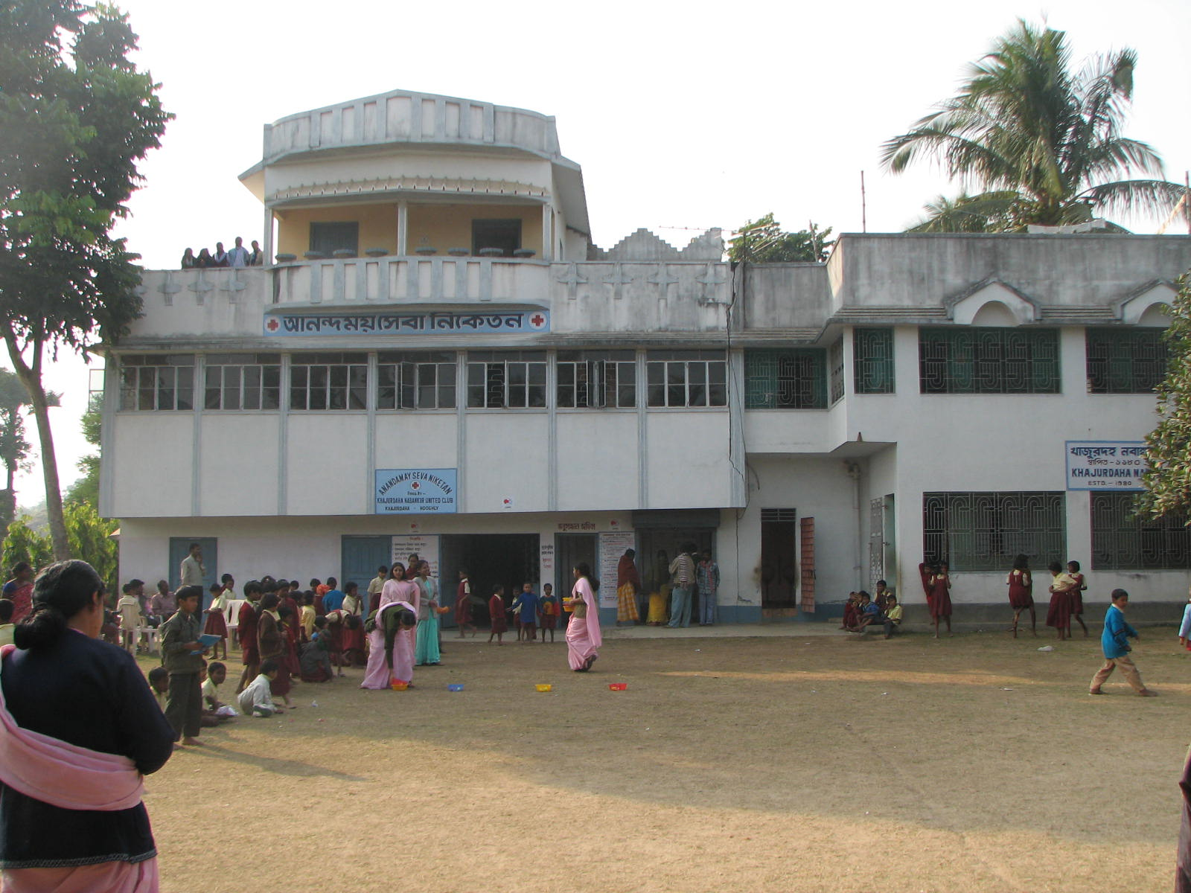
KNUC Hospital (Supported by Japanese Embassy) and Secondary School (Supported by Asha Princeton)
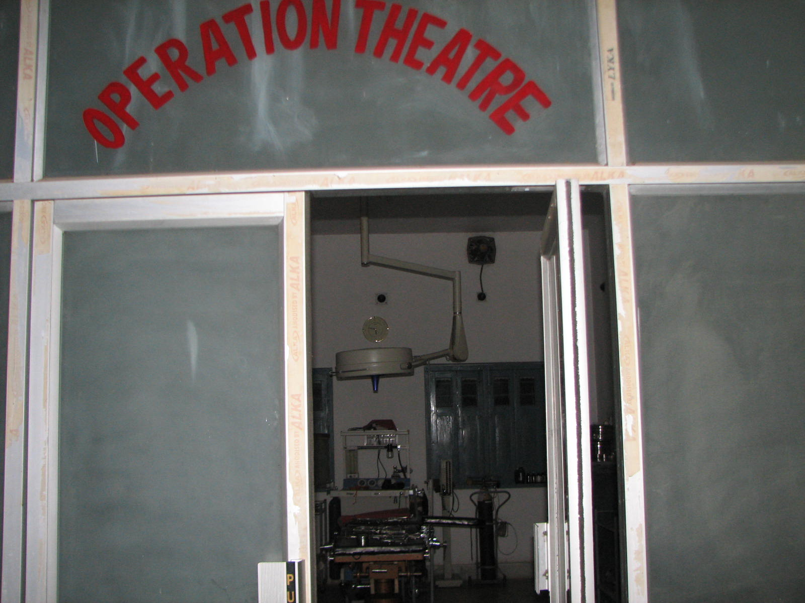
KNUC Hospital (Supported by Japanese Embassy and other sources)

