Khajurdaha Nabankur United Club
(Organization for Rural and Urban Development) Regd. Under Act XXVI of 1961
Regd. Office.
P.O. & Vill. – Khajurdaha, Dist.- Hooghly, West Bengal, Pin.—712 149,India,
Phone – 09434125297, E- mail – knuc80@gmail.com ; Website- http://www.knucindia.org

TO,
Mr. Amrish Garg,
ASHA FOR EDUCATION,
P.O. Box-340, S Lemon Ave., Ste 2742, Walnut, CA 91789

Subject: LTTO Programme
Dear Amrish Babu,
At the outset, we convey our heartiest thanks and gratitude to you & other volunteers at Asha For Education, U.S.A. for spontaneous financial support to our LTTO programme.

The LTTO program has been running with the active support of Asha For Education since 1998. Since inception the programme has got stewardship of Mr. Sridhar Desikan and from 2008 onwards the programme has got stewardship of Mr. Sohil Tiwari and from 2013 onwards the programme has got stewardship Mr. Ravi Gangavarapu and presently the programme is running under the stewardship of you.

We also submit herewith the Future Plan for the period from April ’20 to March 2021 for your kind perusal and necessary action. Hope, you would be kind enough to approve it and disburse the fund at the earliest for smooth running of the programme.

Conveying thanks and gratitude once again to all of you we look forward to hearing from you. With the best regards.
Yours Sincerely,
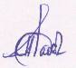
Satyajit Mondal.
Hony. General Secretary, Khajurdaha Nabankur United Club.

N.B: We shall be much obliged if you kindly acknowledge receipt of the report.

BUDGET FOR THE LTTO PROGRAMME FOR THE PERIOD APRIL 2020 to MARCH 2021

Sl  No | Item of Expenditure | Amount  (Rs.) | Amount  (Rs.)
 | RECURRING COST: | 60000.00  36000.00  36000.00  56000.00  103050.00  540000.00  48000.00  34350.00  34350.00  34350.00  114500.00  36000.00
1. | Administrative :  = Honorarium to Coordinator @ Rs.5000/-per monthx12 months.
 | = Honorarium to Sweeper @ Rs.3000/- per month x 12 months.
 | = Stationary, Audit Fees, Electric, Phone, Conveyance etc.
 | @ Rs. 3000/- x 12 months
 | =Bonus to all staff (16Nos.) @ Rs. 3500/- per year x 16 Nos. (including Teacher of Arts, Bratachari & Computer) |  | 188000.00
2. | Education :
 | = Books, Exercise books, pen, pencils etc @ Rs. 450/-(average)
 | per child per year x 229 children.
 | = Honorarium to teacher @ Rs. 4500/- per month x 12 months
 | x 10 teachers.(for Basic & Primary standard)
 | = Honorarium to Clark @ Rs.4000/- per month x 12 months
 | = Provision for Recreation @ Rs. 150/- per child per year x 229
 | children.
 | = Provision for Exposure Visit @ Rs.150/- per child per year x
 | 229children.
 | = Provision for Arts, Crafts etc @ Rs. 100/- per child per year x 229 children. |  | 794100.00
3. | Health Care:
 | = Nutrition @ Rs. 500/- per child per year x 229children.  = Wages to Cook @ Rs. 3000/- per month x 12 months |  | 150500.00
 | Grand Total : |  | 11,32,600.00

  - :
    - Total number of Teachers have been 10 (ten) as Basic I & II and Class-I & Class-III are divided into two section.
    - Proposed Expenditure as mentioned in the suggestion (Point-10) has not been incorporated in the Budget. If you ask for the same we shall provide you the budget immediately.
S. Mondal.
Hony. General Secretary. Khajurdaha Nabankur United Club.

PHOTOGRAPHS OF SOME EVENTS
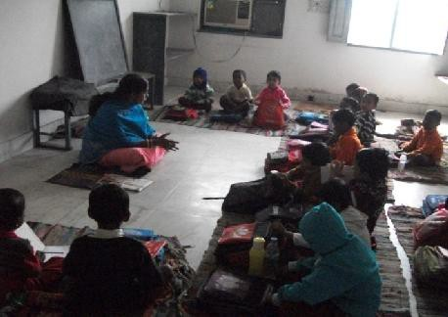
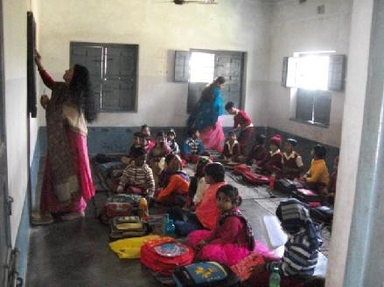
Picture of Class room education

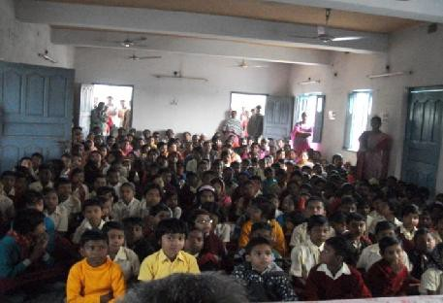
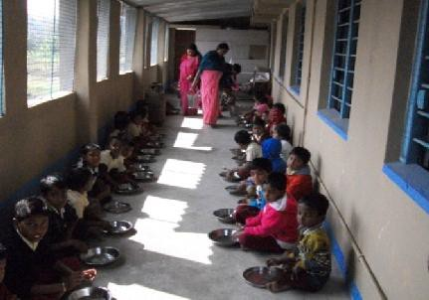
Annual Result Distribution Ceremony Event of daily Midday meal
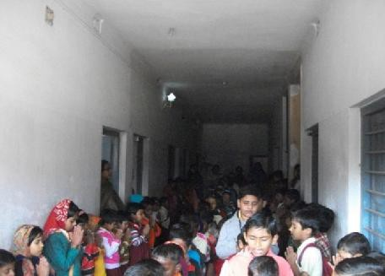
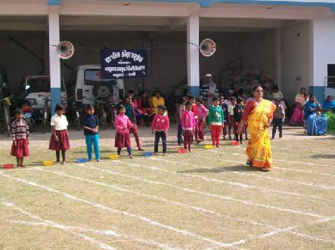
Event of Daily Prayer Event of Annual Sports
(S. Mondal)
Hony. General Secretary Khajurdaha Nabankur United Club

