**ISHA VIDHYA – EDUCATING RURAL INDIA**



Though India is experiencing an economic boom, poverty continues to pervade rural life. Lack of education is the greatest obstacle preventing India’s rural populations from escaping poverty and joining in the country’s economic growth. For most rural children, education means run-down facilities and teacher absenteeism.[1] While local language learning is of fundamental importance, education without English proficiency limits graduates’ career opportunities to the narrow boundaries of their native locality. After completing 12 years of schooling, the majority of rural youth lack basic skills and are unable to find suitable employment or pursue higher education.

Less than 50% of Tamil Nadu students from the 3rd through 5th grades of primary school can read simple sentences in Tamil, and only 10% can read simple sentences in English.

-Annual Status of Education Report, India 2007

**Isha Vidhya, an Isha Education initiative, aims to transform the lives of rural children by providing affordable, high-quality education where it is otherwise unavailable.**

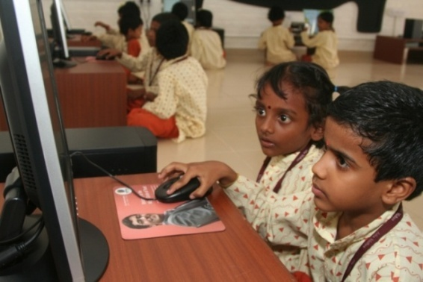With its scalable and easily replicable model, Isha Vidhya plans to establish schools in villages across Tamil Nadu: one school for each of Tamil Nadu’s 206 districts. After completing this phase of the project, Isha Vidhya schools will be opened in other regions of India.

The first Isha Vidhya School opened in 2006 in Sandegoundenpalayam, 25 km from of Coimbatore. Three additional schools were opened in 2007 in villages near Erode, Nagercoil and Tuticorin. 1,100 students are currently enrolled between the four schools, and 60% of these students are covered with full tuition scholarships. Gender equality is paramount; currently 45% of students are girls. Two new schools will be opened in 2009 near Cuddalore and Villupuram.

***You give them food, you give them money: Today they’ll eat, tomorrow they’ll forget. If you empower them to make their lives, this is the best think we can do for another human being.***

* *SADHGURU*

**Where It Began…**

Next to the Isha Yoga Center at the base of the Velliangiri foothills, lies the tribal village of Thanikandi. The barest of amenities is a luxury, with a tamarind tree standing as social center, central court and post office. All community activities happen around the tree; the activity glaringly absent was education. The only school in the near vicinity was located in a rudimentary shed moretypically used as a shelter from the elements than a classroom. To reach the school, the teacher had to trek 3km over rugged terrain frequented by elephants and other wild animals. As a result, she rarely made it, and the prospect of school faded into the backdrop. The children spent their time in the playing in the forests and engaged in income-generating activities to supplement their families’ meager earnings.

When Isha Foundation adopted the village, its top priority was establishing a school for basic learning. Creating employment opportunities for the adults ensured essential needs were met, freeing the children from the necessity of working. Providing the children with proper clothing, footwear and food further earned the confidence of the parents. With these basics in place, Isha Foundation recruited a passionate teacher and set up simple classrooms. The same process was carried forth in other nearby tribal villages, and today these children are preparing for their board exams. Thus, informally, Isha Vidhya was born, with the broad objective of bringing quality education to the often neglected rural areas.

**Isha Vidhya schools:**

* **Provide affordable, high-quality education in rural areas**
* **Take education beyond literacy and rudimentary skills**
* **Create confident, English-speaking, computer-skilled youth**
* **Focus on education of girls, lower caste children and other marginalized groups**
* **Recognize and celebrate the identity, culture and tradition of rural communties**
* **Will empower rural children to participate in national and global affairs**

**The Isha**

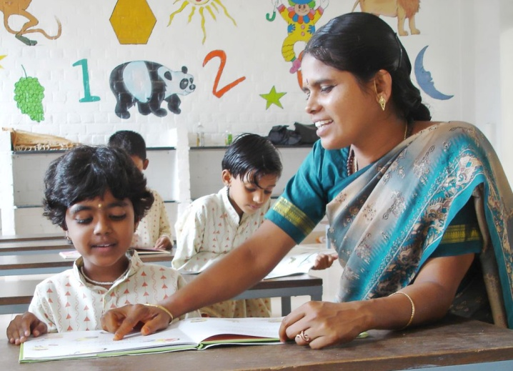

***This effort will be a vital contribution to India’s growth by providing a continuous stream of qualified personnel to take India to a level of self-sustenance while at the same time empowering the rural masses.***

**Scholarship Program**

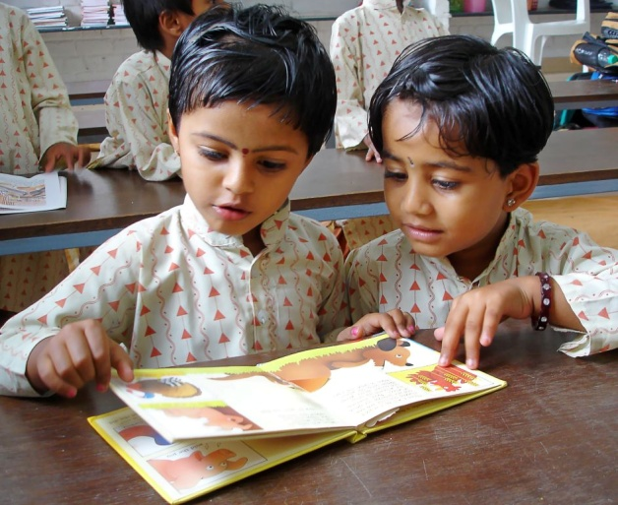Isha Vidhya provides high quality education at very low costs. However, even minimal fees are unaffordable for many rural families. Most students’ parents work in temporary jobs as laborers, dhobis, barbers, carpenters, field workers, construction workers, tea shop owners, and street vendors. Income from these jobs is inconsistent, varying based on the season and demand for employment, and often insufficient for meeting basic household and dietary requirements. With most families being large in size, even minimal school fees strain limited budgets, forcing families to cut expenditures in other areas such as food, medicine and clothing.

The reality of this situation necessitated the development of a scholarship program. Isha Vidhya’s scholarships are entirely need-based and cover tuition, teaching aids, books, notebooks, nutritional health supplements and transport subsidy. The scholarships create a truly life-changing opportunity for rural children. Many Isha Vidhya students are the first in their family to attend a matriculation school, learn English, and see hope for a future beyond poverty.

Parents have expressed their gratitude with tears in their eyes as they see something they never thought possible becoming a reality for their children- quality education.

*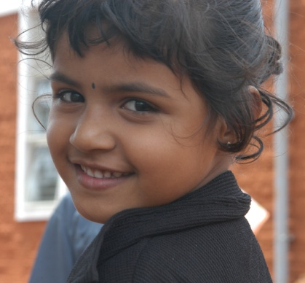“I’m a barber by profession. Only because of this scholarship program is my daughter Sunmathi able to study in this type of English-medium school with computer facilities. She is the first one in my family to study in a matriculation school."*

*Mr.Rangasami, parent of Sunmathi  
Isha Vidhya School, Perumapalayam*

*We are very poor. To educate my two daughters in a matriculation school is my lifelong dream. You have given the scholarship amount to my child. My family members and I will be grateful to you throughout our life.*

*Mr. C. Thangavelu, parent of T.Harishka   
Isha Vidhya School, Perumapalayam*

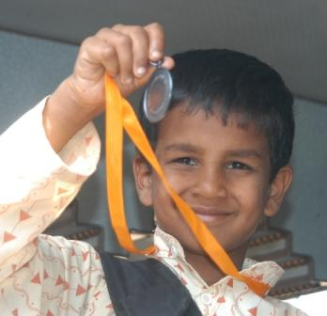The Scholarship Program began in the 2007-08 academic year, with 238 students covered between the four Isha Vidhya schools. The number of scholarships more than doubled the following academic year (2008-09) to include 663 students. Two new schools will be opened for the 2009-10 academic year in very economically weak areas. Between these two schools, plus new admissions for Lower Kindergarten in the existing schools, an estimated 1000 new students will need scholarships for the 2009-10 academic year.

Sponsoring a student represents a unique way to dramatically touch the life of a child. Each sponsor is matched with a student(s) and encouraged to donate yearly for the child’s full education at Isha Vidhya. Sponsors receive regular updates on the student’s progress, including letters from the student, photos, and academic progress reports. The school facilitates correspondences between the sponsors and students, and sponsors are welcome to visit their student at school. Over the years, sponsors can become involved in the life of their scholarship student, acting as a mentor, and watching as the child grows and blossoms.

The scholarship donation amount of Rs. 7000 / USD 180 provides tuition, books, notebooks and nutritional health supplements for the scholarship student; in addition, the donation helps cover expenses for teacher training, classroom learning materials, computer facilities and school administrative costs.

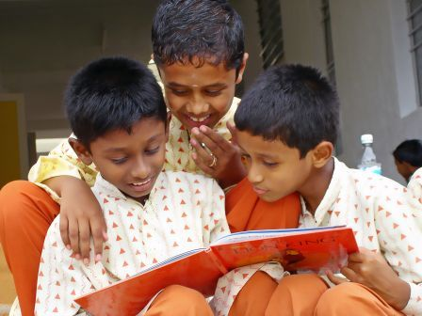

*Sponsoring a student was so clear a choice. It was so obvious. What it costs to support a child for a year is very little by American standards. But how it’s put to use here… it means everything for someone else.*

*Deanie French, sponsor of M. Vinoth, class I student, Isha Vidhya Perumapalayam*

*Massachusetts, USA*

**Health Body, Healthy Mind…**

Today, if you walk into any village, you will see that almost 60% of the men have underdeveloped skeletal systems.  This is a quiet, but very huge disaster. It does not make a big noise like a tsunami or an earthquake, but the scale of disaster is much bigger.  If one's body does not develop, his mind will also not develop fully.  If these people have an opportunity to be healthy in mind and body, it will be a huge asset for this nation and the world.

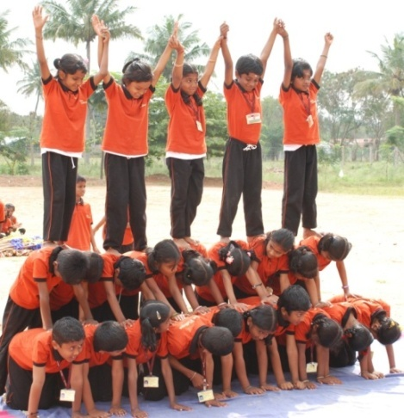 -Sadhguru

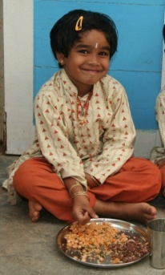Educating the mind is possible only when the basic needs of the body are met. Isha Vidhya takes on the responsibility of ensuring its students receive proper physical care. The schools hold annual medical camps to check vision, hearing, nutrition and other health levels of the students. Follow-up care is provided where necessary. Ongoing guidance and education is given to the parents regarding nutritional needs, proper hygiene and health requirements of their children.

If asked what they eat at home, many rural children answer: rice. What else do they eat? Idli, dosa (products made from rice)… but no protein, no vegetables, no fruit. Isha Vidhya students receive protein-rich snacks composed of peanuts, lentils or sesame on a regular basis. The protein in these nutritional snacks is critical for ensuring the children’s proper physical and mental development. After just a year of attending school, students’ physical and mental development levels, which had been below standard, were visibly improved.

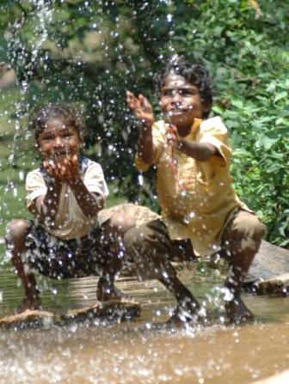**Impacting Tribal communities…**

Beyond broadly addressing the educational needs of rural children, Isha Vidhya schools make special efforts to include the most economically and socially disadvantaged and excluded children. In addition to promoting education of girls and children from all castes, Isha Vidhya schools have reached out to include tribal village children.

Compared with other rural Indians, tribal villagers have a distinct culture, including dialect, social habits, and hygiene, which can act as obstacles to their inclusion in formal education. Families rarely keep birth certificates and other official documents and records. Children receive inadequate food and clothing, with high rates of malnutrition and other health and development problems a commonality. Minimal attention is given to bathing and grooming. The majority of tribal children lack even basic education. Those who do attend school, go to the local government schools often with the intent of receiving a free lunch rather than an education.

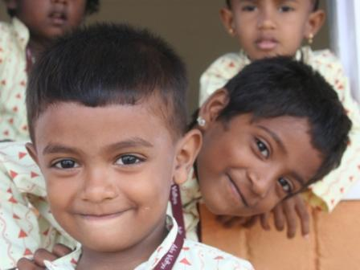Twenty-three tribal children coming from three villages began attending the Sandegoundenpalayam Isha Vidhya school in June 2008. Isha Foundation is fully sponsoring their education, including transportation, tuition, notebooks, books, uniform, midday meal and nutritional health supplements. The school principal and teachers have taken on the role of helping the students adjust- from encouraging the parents to bathe and groom the children before sending them to school, to providing extra tutoring classes after school.

Born and raised in the hills and forests, the tribal children are in many ways more comfortable with nature than people. Compared with the other students, they tend to avoid eye contact, are very shy, and hesitate to interact with other children. Initially, some were reluctant to attend school. However, things have changed over the course of the year. Enjoying the many activities, games and learning, the tribal children are eager to come to school. Their attendance has improved, and they have started to take more care in their personal bathing and grooming. Their health and nutrition levels have also visibly improved. While their academic progress has been slower than many of the other students, marked advancements have occurred in their motor skills, listening skills, attention level, and oral communication skills. None of the tribal children knew as much as the alphabet or numbers when they first enrolled; now they are on their way to reading, writing and doing simple math problems. Truly, their education at Isha Vidhya is opening a whole new world of possibilities to them.

*In my other school, there was no water and the food was bad. Here, I like the clean place, food and water.  I play a lot, learn English and Tamil, play on the computers and watch DVDs. I like games and the cartoon drawings on the classroom walls.*

*I have learnt Tamil, English rhymes, drawing and letter sounds.*

*Ayyasamy, Upper Kindergarten, (quote translated from Tamil)*

*Isha Vidhya School, Sandegoundenpalayam*

*Here, we study, write, read, play, draw, watch DVDs and learn to use the computers.  I like the uniform, my friends and the PT class (physical training).  I have learnt new games, gymnastics, writing, prayers, and rhymes.  I now take baths everyday and I like it.*

*-  Madhavan, I-A, 1st Standard (quote translated from Tamil)*

*Isha Vidhya School, Sandegoundenpalayam*

**ACADEMICS…**

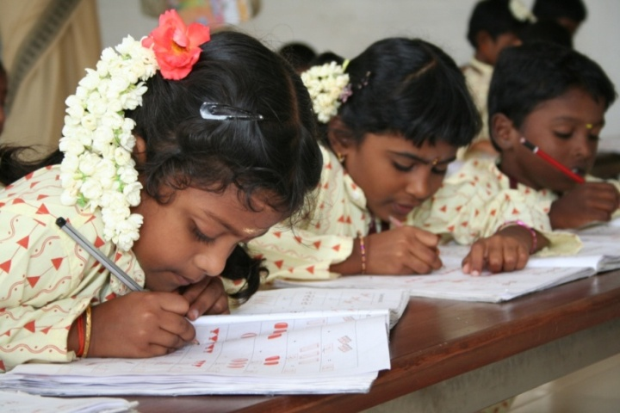Isha Vidhya’s uniqueness lies in its high potential for scalability and replication. The methodology focuses on guarantying the delivery of high-quality, English-based education, while recognizing and accommodating for the limited resources, finances, teacher experience, and parental support available in rural schools. Technology-based classes are woven into the curriculum to support the capacities of the rural teachers. Teachers also receive ongoing training and guidance in the Isha Vidhya methodology.

The majority of students lack exposure to spoken or written English outside of school; therefore, extra focus is given in the lower classes to establishing a strong foundation in English. Departing from the traditional approach of memorization and recitation, English classes include song, dance, movement, computer games, and hands on materials. Students gain confidence and understanding in English at a young age, and by class 2, the curriculum is expanded to include social studies, science and nature period. Starting with the standard matriculation books as a base, the curriculum is enhanced with multiple-sensory learning methods, computer-assisted classes, math & science laboratories, & library period. Students engage their whole minds and bodies in the learning process, immensely enjoying themselves all the while. As a result, they look forward to coming to school each day. When they graduate from Isha Vidhya, they will be prepared with a strong education to pursue higher education or find suitable employment to support their families.

*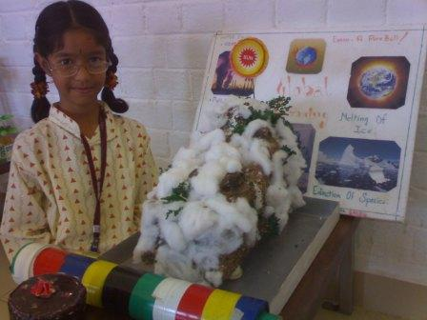This school is very, very good. It is different from other schools. In other schools, if you tell one thing wrong, they will beat you. Here it is not like that. I like school because the teachers are not beating or scolding us. They are teaching nicely.*

*S. Sachin and M.P. Amritha Devi  
Class II students, Isha Vidhya School, Kurandi*

*My experience at Isha Vidhya is my greatest pleasure. Here in Upper Kindergarten, teaching and playing with the alphabet in a fun way keeps the children interested. Also, using different methods of teaching, such as Total Physical Response, helps the children learn, whatever their natural ability. Using the Karadi Path method, I find that we can teach music, songs and dance easily.*

*P.S. Girija Kumari   
Teacher at Isha Vidhya School, Kurandi*

**Education and Beyond - Extra-curricular Activities…**

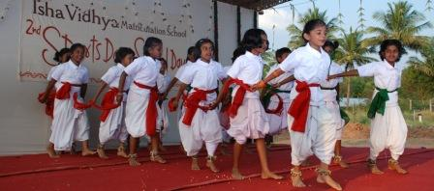School is not just about learning the basics- reading, writing and arithmetic – or even about passing an examination; but rather, education means nurturing the wellbeing of children on all levels – academically, physically and mentally. Isha Vidhya schools enhance the academic curriculum with a wide range of extra-curricular activities, events and competitions.

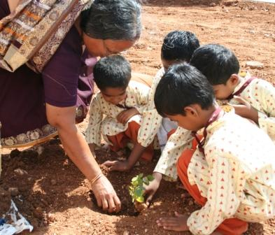Students explore their talents and interests in classes such as art and craft, physical education, nature class and library period. Students push their limits and display their prowess in writing, elocution, running, and sports competitions. They have an opportunity to display their work and appreciate the work of others during the yearly exhibitions for science and art. Parents and Isha volunteers from the community are regularly invited to attend the competitions, sharing in the joy of the day and in acknowledging students’ achievements.

*I enjoy very much to come to school.  I like our school playground.  I like doing projects.  I like the arts period.*

*S. Mehala,*

*Class 3 student, Isha Vidhya School, Perumapalayam*

*Students plant and care for their own gardens during nature period. Over the years, they’ll watch as their plants flourish and grow, providing them and future generous with shade, fruits, vegetables and flowers.*

With its diverse cultural and religious background, the key to communal harmony in rural India is respect and appreciation for others. To preserve cultural traditions and values, students celebrate key religious and cultural festivals from a variety of regions and religions. While teachers are a guiding force, students take the lead in preparing, exhibiting and participating in the festivities. Celebrations take unique forms within each school, often incorporating dance, drama and an educational discussion or explanation tied to the significance of the day. *Independence Day, Teacher’s Day, Sports Day, Adi Perukku, Navaratri Kolu, Diwali, Pongal, Ramzan Id* and *Christmas* are just a few of the special days recognized at the schools. **Community Interactions…**

Beyond the scope of education, the presence of the Isha Vidhya schools positively impact the local communities in a multitude of ways. Often the schools act as catalysts to mobilize future community efforts, resulting in improved infrastructure and development in the villages. Village leaders have taken the support of Isha Vidhya to successfully lobby local authorities to obtain improved roads (from dirt tracks to paved), 24 hour electricity links to homes in the surrounding villages, and the laying of telephone cables and pipes for drinking water. The Isha Vidhya schools provide an increasing number of employment opportunities to the local communities for construction work, teachers, administrators, and other school staff.

Involvement of the local community plays an integral role in the success of the schools. Before the school is even built, local volunteers help in identifying a suitable location, securing land donations, acquiring grant money for construction, and mobilizing community support for the project. As the school comes together, volunteers and community members continue to lend their hand to solve problems and make things happen, be it taking photos during an event, painting decorations on the classroom walls, or donating a computer.

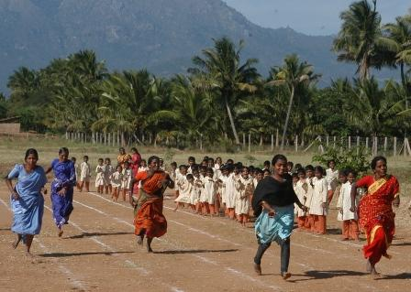Parents take part in school functions and celebrations throughout the year - from running races on sports day to helping prepare the pongal (sweet rice) for the Pongal celebration. As the majority of parents are illiterate, a regular schedule exists throughout the year for parents to come and speak to teachers, thus minimizing the need for written communication. Parent-Teacher Meetings are held at the end of each term to share ideas, discuss new plans, and address any issues that arise during the year.

*Isha Vidhya is truly a boon to our village. I am grateful for being able to contribute my small part to this effort. It’s simply beautiful to see this opportunity of education given to so many hopeful, eager children. They would otherwise never have such a chance.*

*-V. Kumar*

*Volunteer at Isha Vidhya school in Perumapalayam*

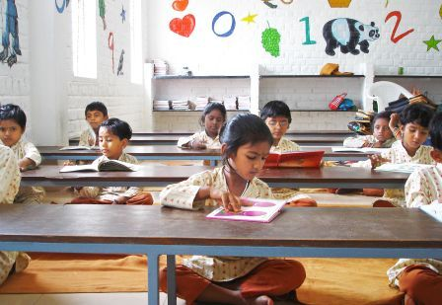**WHERE WE ARE…**

**Isha Vidhya schools are non-religious and do not discriminate based on religion, caste or gender.**

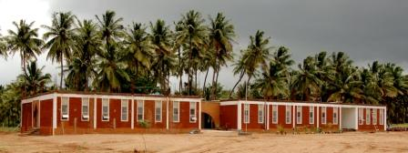The first official Isha Vidhya school opened June 2006 in Sandegoundenpalayam (SGP), Coimbatore. In its first year, the school enrolled 263 students from 26 nearby villages in lower kindergarten through class II. The following academic year saw the opening of three additional schools in villages near Erode, Nagercoil and Tuticorin. 1102 students are currently enrolled between the four Isha Vidhya schools, with 60% covered by full tuition scholarships. The schools strive to maintain an gender equality; currently, 55% of students are boys and 45% are girls.

Over the next 5-7 years, one Isha Vidhya school will be opened in each of Tamil Nadu’s 206 taluks. From there, the model can easily be replicated and transplanted throughout the country.

**WHERE WE’RE GOING…**

Two new schools will be opened for the 2009-10 academic year, one near Villupuram and one near Cuddalore. Cuddalore was devastated by the 2004 Tsunami and Isha Foundation performed substantial rehabilitation work in the area. Isha Foundation’s *Tsunami Rehabilitation Fund* is dedicating the Cuddalore school to the local community as a means to empower the future generations. Villupuram is an economically weak, agriculture dependant area with the majority of the population comprised of Dalits (lowest Hindu caste). A group of volunteers donated land for the Villupuram school and Agility Logistics Pvt Ltd. sponsored the school construction.

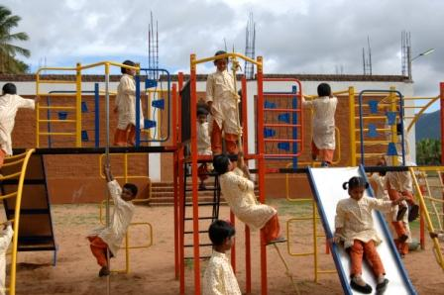As the project scales up, funding presents the greatest obstacle restricting growth. Dedicated volunteers are there, the model is in place, but only with generous donations from individuals and corporations can the dream of providing quality education throughout rural India become a reality.

**ACKNOWLEDGEMENTS**

Isha Vidhya acknowledges the support of the numerous, donors, volunteers and corporate sponsors without which the project would not be possible. Special recognition is given to the following:

The **London Walk-a-Thon for Isha Vidhya**, held 22nd June, 2008 in Richmond Park, gathered a crowd of more than 120 supporters and raised over £15,000.

The annual **Mumbai Marathon**, to be held January 18th, 2009, includes 125 runners and walkers in support of Isha Vidhya. Fundraising for this event is ongoing at this time.

**Agility Logistics Pvt Ltd.** sponsored the construction of the school for Villupuram.

The **Royal Bank of Scotland** sponsored the construction of the outdoor play ground at the Kurandi school near Nagercoil.

**ASHA for Education** funded 80 student scholarships.

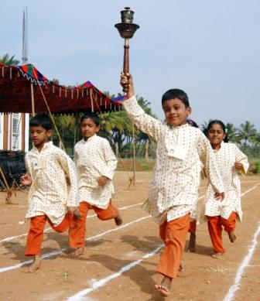**Isha Foundation** has lended its support in innumerable ways to make the Isha Vidhya project possible.

*It’s so exciting to have the opportunity to help transform these young lives from the grim alternative of government schools, with corporal punishment and poor teaching. It was a profoundly moving experience to visit the Isha Vidhya school and see so many bright-eyed little ones completely engaged in their experience of learning and interacting with each other.*

*-Pippa Vine,*

*Fundraising volunteer, UK*

1. Primary school teachers in rural India have a 25% absenteeism rate. Study by Chaudhury N., J. Hammer, M. Knemer, K. Muralidharan, and F.H. Rogers (2006). ‘Missing in Action: Teacher and Health Worker; Absence in Developing Countries’, Volume 20, November 1, *Journal of Economic Perspectives*, Pittsburg.