PNEUMA
Annaul Report 2018-2019

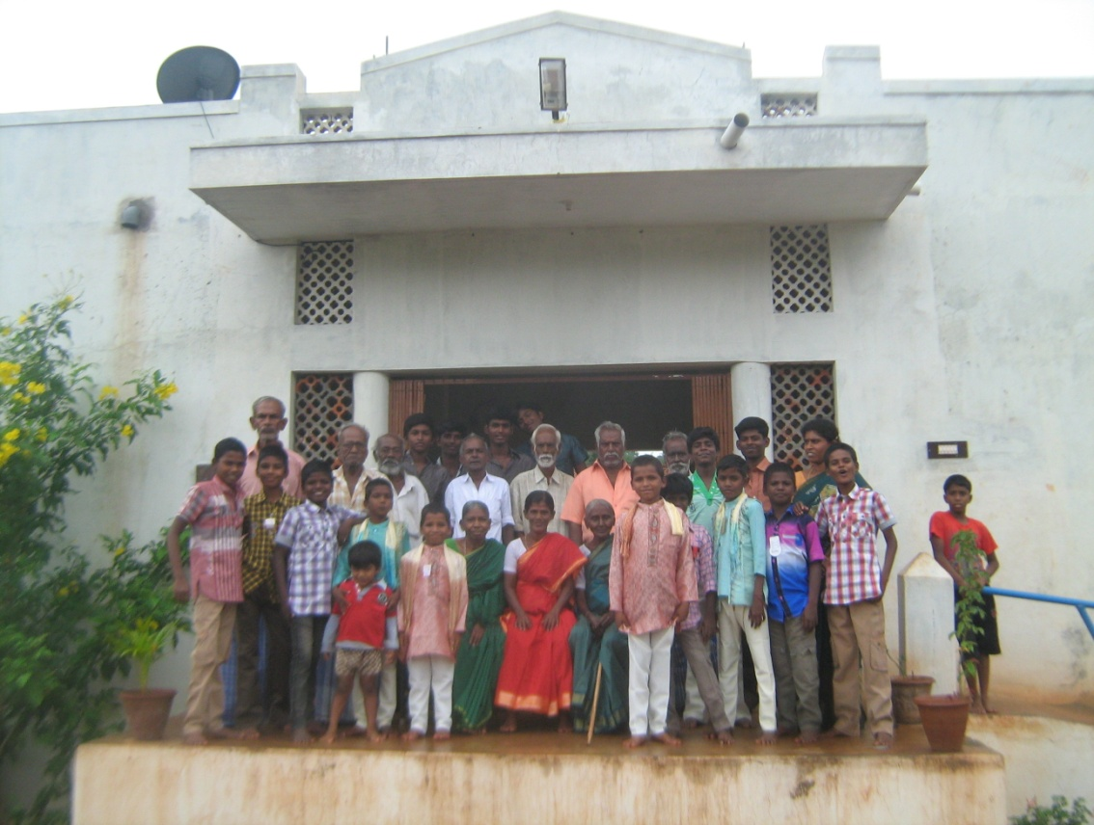

About US
Pneuma is working in Madurai district since its founding from 2003. The Primary focus is for the sustainable development and holistic development of the community by promoting their status in Health (Physical and Mental), Education (especially children), Community Development and Economic development.
Pneuma was formed by the professional Social Workers with the primary goal of providing quality, food, education and shelter to the under privileged children, destitute women and the aged.
Pneuma believes that “education will bring the positive physical, mental and social outcome in an individual which in term brings the change in community at large.”

The Vision
The PNEUMA envisions

“To Enlighten, Emancipate and Empower
the community”
The Mission

To improve the quality of life of the community
and to make them self reliant and self sufficient with
the cooperation and participation of the community.

Projects and Activities

Home for Aged

The Special homes for Destitute Children and Senior Citizens as the integrated complex. This programme constitutes of 25 Old aged people and 25 children. These inmates are housed in a spacious place. The children are sent to regular schools. They are given food, clothing and shelter. This programme helps the children and the old aged persons to share their love, care and affection between themselves and complement each other.
Pneuma, home for the aged constitutes of 25 aged persons from the age group of 60 years to 79 years. They are from the poor socio economic background; orphan and destitute .They are in provided with of care, shelter and nutritional support.
Pneuma organized old age day celebration along with the District Social welfare Office, Madurai. The programme aims to inculcate the habit of respect and care for the aged. Chief Guest of the programme was Mrs. Shanthi, District social welfare officer. Celebrated the day by honouring they by put towel, sweets a savouries to the residents and cultural programme by them.

Home for the children

This is the home for children in under privileged circumstances.

The children are from the background of,
- The children born for the people living with HIV/AIDS
- Children of Female sex workers
- Children from broken family
- Children of Prisoners
- Children whose parents are Mentally Ill

The children are given care and protection in a clean, protective environment; the children are given food, clothing, shelter, discipline and education.

The children are sent to the regular educational institutions for education. They are trained Yoga, Meditation, Folk arts, Street theatre, computer education, Karate, Arts and crafts, which makes them to improve their physical and Mental Health for the all round development. The children will be supported by Pneuma until they become self - reliant.
Community based care and support for the children.
Pneuma also extends its programme Home for children as the community based approach, 25 children are given community based support. They are provided with material and educational support to continue their education without any obstruction or drop out.
Afterschool supportive centers
There will be 10 supportive centers around (Belt of Sirumalai hills) Palamedu, Allanganallur block, Madurai District. There are many villages nearby to be covered and to start after school supportive centers. There are about 241 children benefited through this programme.
- These villages have poor basic facilities like transportation,electricity.We plan to start centers in these remote villages.
- To serve more number of Socio economically poor (OBC/SC/ST) children .Because the nascent children need a conducive environment. The caste system is dilapidated and children born in the particular caste are treated with the prejudice.
Activities and approaches :
- There will a mentor each center,they will guide and supervise the children in scholastic education.
- Each center will have 20-25 children from the age groupof 05-13 years.
- The center timing at 5.30 pm-7.30pm.
- The children will be given evening snack.
- The children participate interact and discuss about the subject matter each child has the chance to express his/her feelings.
- To create a conducive path for learning and understanding their subject and related matters. The child understad and study.
- Experts and resource persons are invited to train and motivate the children in
• Writing essays in Tamil(1st language)and English(2nd language)
• Oratorical
• Scientific sessions,Arts and crafts.
• Cultural activities ,health and Hygein
- Competitions among the other centers are conducted, makes the child productive and enjoy learning.

Health Education programme for the Rural school children

Pneuma worked in Allanganallur Block on Sexual and Reproductive Health. The School in the Block were selected. The children from the age group of 12 -16 years from 6th std-10th std were given training on health Education programme. A team consists of a Social Worker, Counsellor and a field worker conducted programme for 3 schools were covered 185 adolescent children participated in the programme.
Community based programme
Community participation for the environment cleanliness, not to use open defecation and insist to use on toilets, avoid plastics keep the environment clean and to prevent themselves from diseases like dengue and malaria.

Health Camp
Pneuma organised General Health Camp for the Villages in Valayapatti Panchayat. 210 participated in the camp and benefited through the camp. Dr Gowri ,MBBS, DGO and Dr Saravan MBBS, DLO along with the other paramedical team were the medical team conducted the camp and issued medicines and conselling for the participants.

Arts and Crafts Programme
The children in the center had training by Miss. Selvi on Nib painting. Compititions on drawing and painting were conducted on the topic Rain water harvesting and pollution. The children participated in the programme and won prizes in the compitituons.

Environmental programme
The programme on preserving our nature an environmental awareness camp was organized by PNEUMA in collaboration with Muhil gardens, Thirumangalam, Madurai District .The programme was inaugurated by Ms. Fatima Rani. BNYS the director of Muhil Gardens. The programme focused on,
- Bio Diversity,
- Rain water Harvesting
- Organic Farming
- Plantation-100 Sapling was planted to envisage the importance of Plants and Trees.
Pneuma organised programme with Lions Club of Allanganallur, Plannted sapling in the Etchikulam Village. Community participation was envisaged by taking due care for the planted saplings.

Counselling and Guidance centre
The center provides counseling and guidance services to the people in need, They includes general public, geriatric, adolescent children and their parents. Professional social workers, counselors are the resource persons who render counseling service the needy. There are 68 clients have given guidance and counseling in the center

Yoga and naturopathy programme
Yoga, Meditation and Naturopathy programme for the general public was conducted along with the Ganodhayam and Muhil naturopathy center.137 Participants participated in the Programme. The Participants were given natural and fresh fruits and vegetables. Lecture on how important to eat healthy and natural food session were conducted and demonstrated.

Conclusion
Pneuma is working for the past 16 years with children and women in close relation. Pneuma wants to start a home exclusively for the girl children like Home for children boys.There is lots of potential to work on the development and vocational training for the rural and semi urban youth.We are also planning to start a center for the children with special needs. Special training and educational programme for the children with special needs and their parents will be provided.
Pneuma is also interested to do work on environment related projects. In the forth coming years it will expand its sustainable framework to balance the needs of the people. Measures will be taken to receive funds from Donors other than the local contribution for Pneuma Home for Children, Children clubs and other projects.
At this juncture Pneuma Trust looks back at the year that was, with a sense of gratitude to all those who have been with us in making us realize the king of success that we are able to experience today. The government officials were very helpful whenever we approached them. The Friends from or non-government sector were always with us in all our efforts as resource persons and collaborators. The service providers were very obliging to our demands and the primary stake holders were always with us guiding and motivating us to do our best even in very trying and critical situations

Funds Utilization Report for 1 year from receipt of Asha funds
Amount of grant received from ASHA FOR EDUCATION during the period:- 2018-19 Rs.4,50,000.00
Amount of expenditure incurred during the period : Rs.4,50,000.00

Receipts and Payment Account for the period relating to project funded by Asha

 | Receipts | Amount |  | Payment | Amount
To, | Opening Balance  Cash in Hand  Cash at Bank  Grant Received from Asha  TOTAL | 7,970.46  11,602.29  4,50,000.00  4,50,000.00 | By, | Costs (list all items in detail, specially uses of Asha funds)  After school Supportive Centers  Teacher Salary  Education Materials  Nutrition support  Tours/Picnics  Community events  TOTAL | 1,80.000.00  50,000.00  1,50,000.00  30,000.00  40,000.00  4,50,000.00

