PNEUMA TRUST

Professional Network for the emancipation of the under privileged masses.

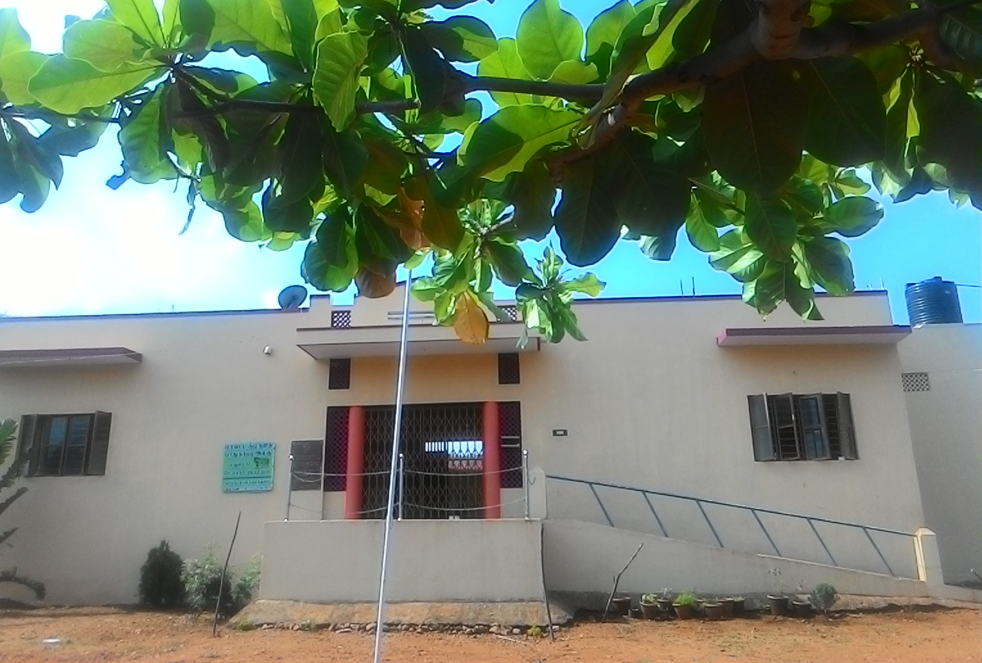

Annual and Activity report

2016-2017

Introduction
Pneuma is working in Madurai and surrounded districts since its founding in 2003. The Primary focus is for the sustainable development of the community by promoting their status in Health (Physical and Mental), Education (especially children), Community Development and economic development. Pneuma was formed by the professional Social Workers with the primary goal of providing quality, food, education and shelter to the under privileged children. The children focused were the children affected by HIV/AIDS, street children, children of Female sex workers, Total orphans, and children from broken families were housed in a spacious clean environment with the essential facilities food clothing and shelter. The children were sent to regular schools for education. Pneuma believes that “education will bring the positive mental and physical outcome in an individual”.
The Vision The PNEUMA envisions

“To Enlighten, Emancipate and Empower
the community”
The Mission

To improve the quality of life of the community
and to make them self reliant and self sufficient with
the cooperation and participation of the community.

Projects and Activities

Home for Destitute Aged
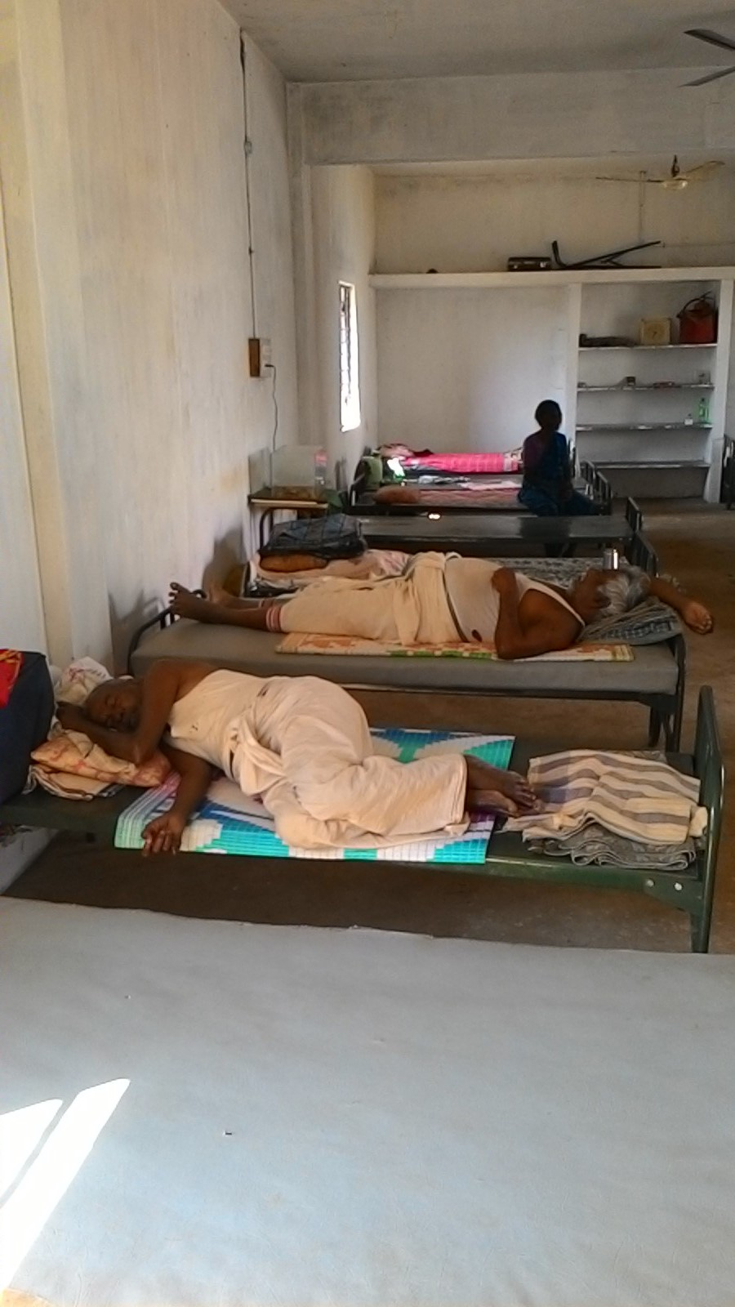

The Special homes for Destitute Children and Senior Citizens was started in the integrated complex from this financial year. This programme constitutes of 25 Old aged people and 25 children. These inmates are housed in a spacious place. The children are sent to regular schools. They are given food, clothing and shelter. This programme helps the children and the old aged persons to share their love,care and affection between themselves and complement each other.
Old age Day Programme

The older people are facing various Physical and Psychological issues and problems.

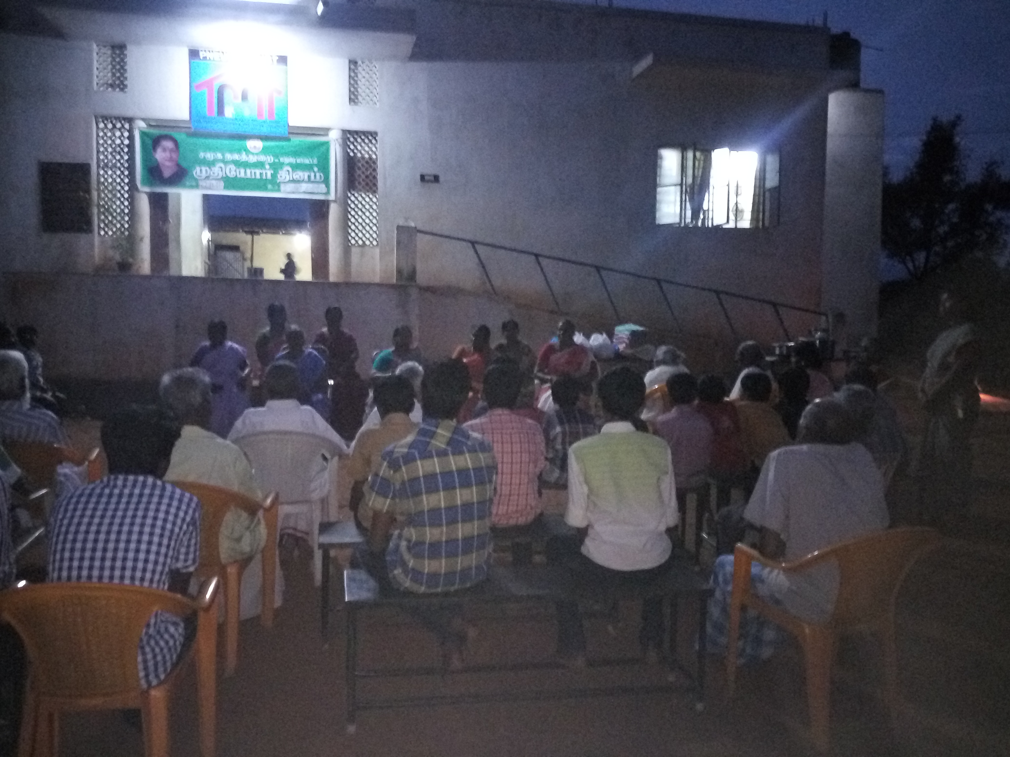

Pneuma home for the aged constitutes of 25 aged persons’ minimum of 68 years and the maximum of 79 years. They are from poor socio economic background, orphaned. destitute and abended. Pneuma organized old age day celebration along with the District Social welfare Office, Madurai. The chief guest was Mrs. R. Ananda Valli District social welfare officer. Celebrated the day by giving towel, sweets savories to the residens and cultural programme by them.

Home for the children

This is the home for children in under privileged situations. .
- The children born for the people living with HIV/AIDS
- Children of Female sex workers
- Children from broken family
- Children of Prisoners
- Children whose parents are Mentally Ill

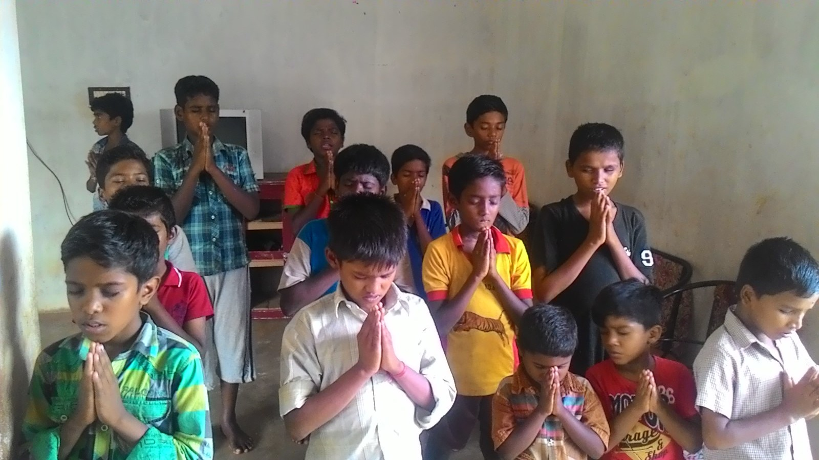

The children are housed in the clean, protective environment; the children are given food, clothing, shelter, discipline and education. The children are sent to the regular educational institutions for education. They are trained Yoga, Meditation, Folk arts, Street theater, computer education, Karate, Arts and crafts, which makes them to improve their physical and Mental Health.

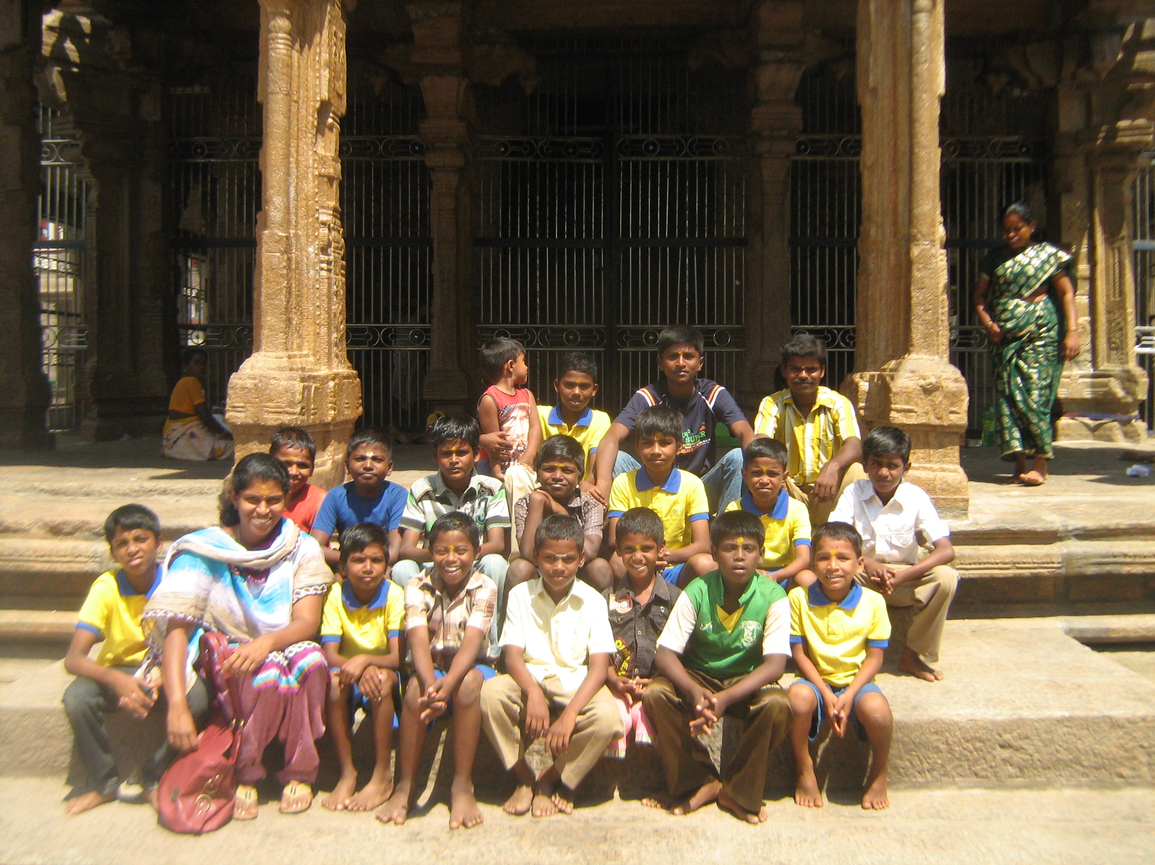

The children will be supported by Pneuma until they become self - reliant. Pneuma also extends its programme Home for children as the community based approach,
Programme by Voluntaries
the 25 children other than housed in home for children are given community based support. The children are trained by Nihal Nataka MAyam By Mr.Shanmugarajan, Fine art training by Mrs.Viji, Computer training by Mr.Sabari Ganesh.
Motivation Programme
The Manager of Lakshmi Vilas Bank, Mr. Gupta, Madurai, interacted with the Children in Pneuma Home on Goal setting and achieving it. The session was very informative and useful for the children.
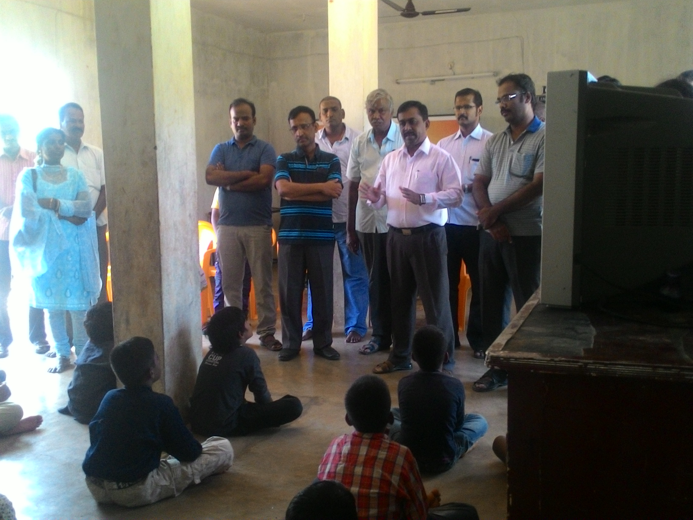
Motivation program for the children
Talent and Cultural programme
The children participated in various talents shows conducted and won prices in competition. The children were trained by experts in dance and drama. This make the children creative. Improves their self- confidence and self-esteem.
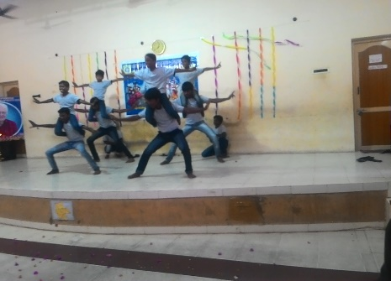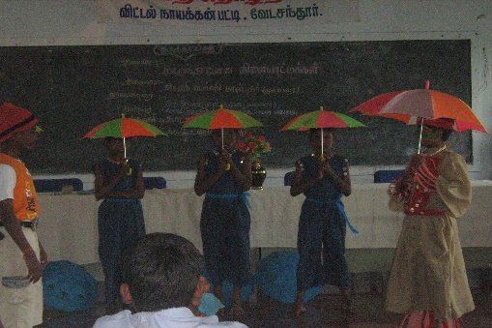
Competition, talents show and drama enacted by the children

Picnic and Tours
The children were taken to trekking and some of the monumental places. The palces are The Jain temple in Kela Kuilkudi, Alagar Kovil, Malaiyur and Siru malai.. This gave the children an hands on experience and which made them an enjoyable day.
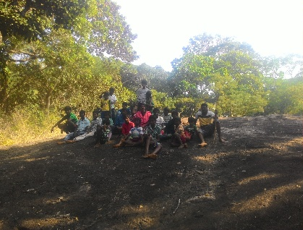

Celebrations at Pneuma
Here are the celebrations at Pneuma. As Pneuma is a secular organization all the festivals and celebrations by all the religious are celebrated. They are as follows.
Republic day Celebration
Pneuma celebrated 68th republic celebration the residents and the village people participated in the programme. The director Mrs. P.Paulin flag hoisted and distributed sweets to the participants.
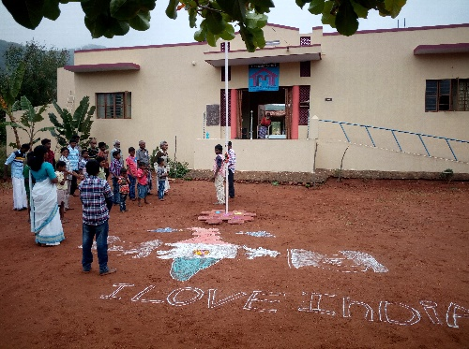
Dewali Celebration
This year’s Dewali was celebrated with the sponsor’s from Lakshimi Vilas Bank, Barathi Ula Street, Madurai. The residents were distributed with new cloths and crackers. In the evening, delightful dinner was given by Aravindham group, Chinna Chokikulam Madurai.
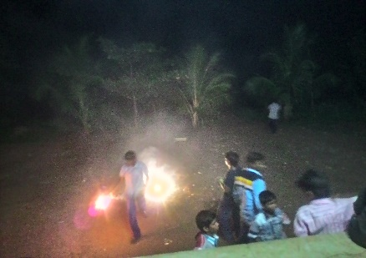

Pongal Day Celebration
Pneuma celebrated the Pongal day celebration with the residents of Pneuma home. Made delicious sweet Pongal and Ven Pongal and distributed to all by offering prayer to the God.
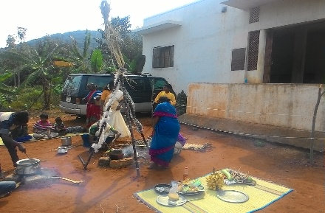

Health and Hygiene Programme
Health and hygiene programme organized along with the Palmedu Primary health Center. General Health check-up and supplementary nutrition given to The Residents and Pneuma. Apollo CSR project issues medicine and supplementary medicines. Along with residents of Pneuma the general public also participated in the programme.
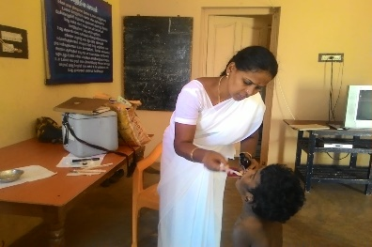
Awareness health camp for the General Public
General Health amp for the public in the the nearby villages of Plamedu the were given talk on protection from Malaria, Dengue and Chikukunia. The ways of prevention and early detection and treatment of these diseases were made aware to the people who participated in the programme about 117 people benefited through this programme.

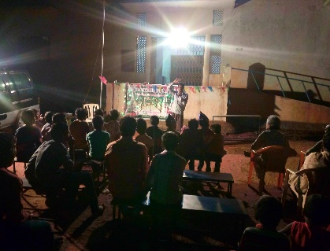
After School, Supportive centers for the Rural Children
After school, supportive center functions in 10 villages of Plamedu Villages. There are about 250 children of both the sexes benefit out the programme. The children are from the backward socio- economic back ground. The centers provide supervised supportive education in the evenings along with that the children are given co-curricular activities. Which brings a holistic development of the children.
Motivational Programme
The children in the after school supportive center underwent Motivational programme. Mr.P. Rajan talked on Goal setting and ways of achieving the goals. It was really informative and life oriented. About 250 children participated in the programme at the different centers.
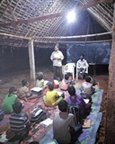
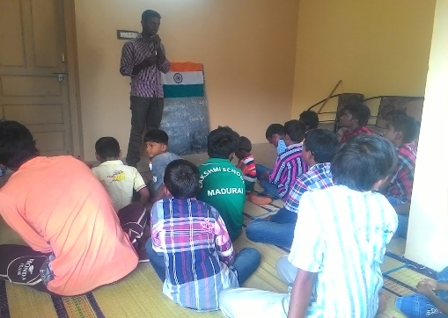
Motivational talks by resource person’s
Arts and Crafts Programme
The children in the center had training by Miss. Selvi on Nib painting. Competitions on drawing and painting were conducted on the topic Rain water harvesting and pollution. The children participated in the programme and won prizes in the competitions.
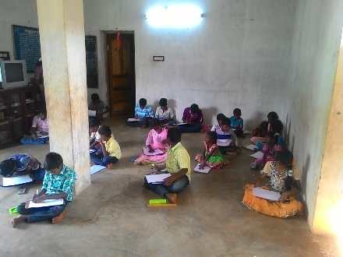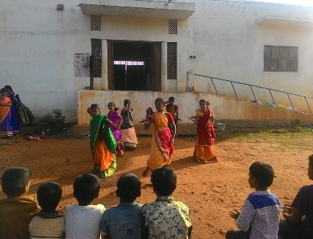
Drawing and dance programme by children

PLHA Programme
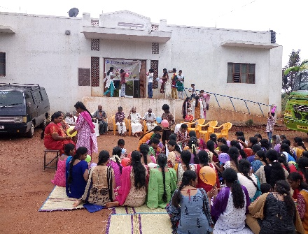
The programme for the people living with HIV/AIDS. Mr.Karuna Social worker/ Counsellor lectured on the healthy practices both Physical and Mental heath of the PLHA.

Mr.Issac gave an awareness about the government programme for the PLHA. Trans gender Ms.Bharathy talked to the gathering on HIV and the transgender. There were 140 general public, transgender and the PLHA.

HIV/AIDS Awareness programme for the Women groups
HIV/AIDS is prevalence in women. The women are ignorant about its spread and the diagnosis, treatment and healthy living. A street play for them was organized by PNEUMA along with Image Ladies Club,Madurai-02.The Street play was enacted to them on The HIV/AIDS day December 1st .The programme was conducted exclusively for women. The female of age groups participated in the programme.

Counselling and Guidance Center
Th center provides counselling to the general public and others who are in need and approach. Counselling given to the children with deviant behavior, special children, women and adolescent children and guidance for the children to take up carrier. Experts with masters in social work and psychologists are in the team to provide counselling and guidance.
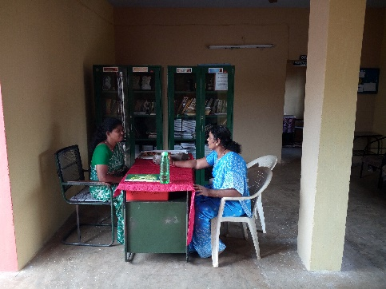
Conclusion
Pneuma is working for the past 14 years with general public, children, aged and women in close relation. There is lots of potential to work on the development and vocational training for the rural and semi urban youth. We are also planning to start a center for the children with special talents. Special training and educational programme for the children with special needs and their parents will be provided.
Pneuma is also interested to do work on environment related projects for that Pneuma had purchased land and will start in the near future. In the upcoming years it will expand its sustainable framework to balance the needs of the people. Measures will be taken to receive funds from Donors other than the local contribution for Pneuma Home for Children and aged, Children clubs and other projects.
At this juncture Pneuma Trust looks back at the year that was, with a sense of gratitude to all those who have been with us in making us realize the king of success that we are able to experience today. The government officials were very helpful whenever we approached them. The Friends from or non-government sector were always with us in all our efforts as resource persons and collaborators.

