ADDITIONAL CLARIFICATIONS ON THE PNEUMA PROPOSALS
AFTER-SCHOOL EDUCATION CENTERS
- In the proposal, it is mentioned that volunteers are paid 6000 INR.
Why are the volunteers paid more than the staff/teachers?

Rs. 6000 is not for each volunteer, the amount is for all the volunteers who participate in the programme. A volunteer is paid Rs.500-600(approximately) as Travel and Dearness allowance.

2. Could you list the educational/exposure visits that you have taken
the children to in the previous year?
The children are taken to Palani, Alagarkovil, Malaiyur(natural farming), Manjamalai( study on Butterfly) Sathiyardam,Vagai Dam,Sothuparrai and Keelakoilkudi(Samanar Statue)

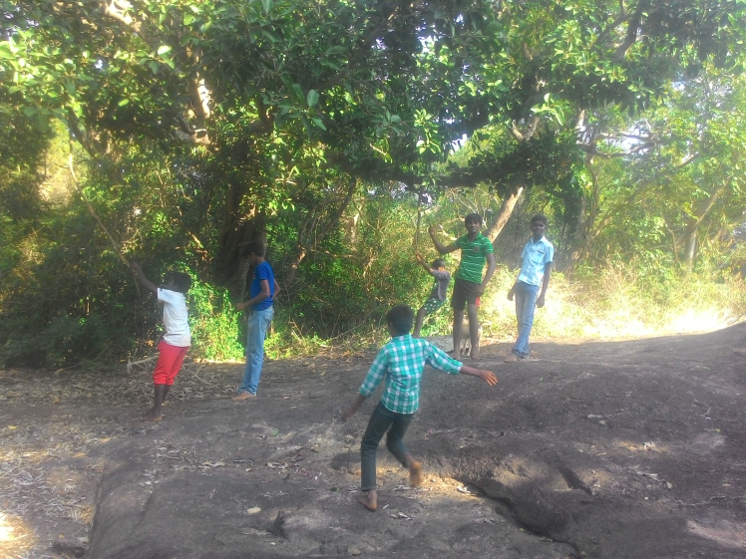

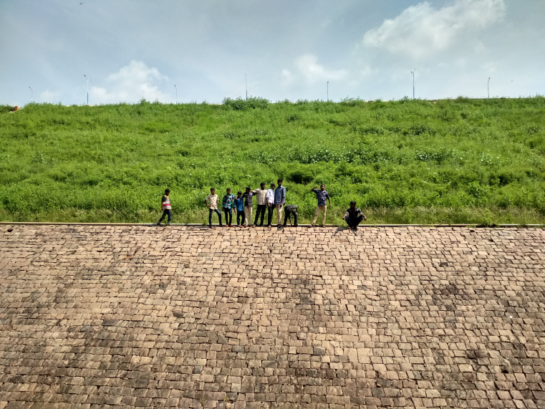
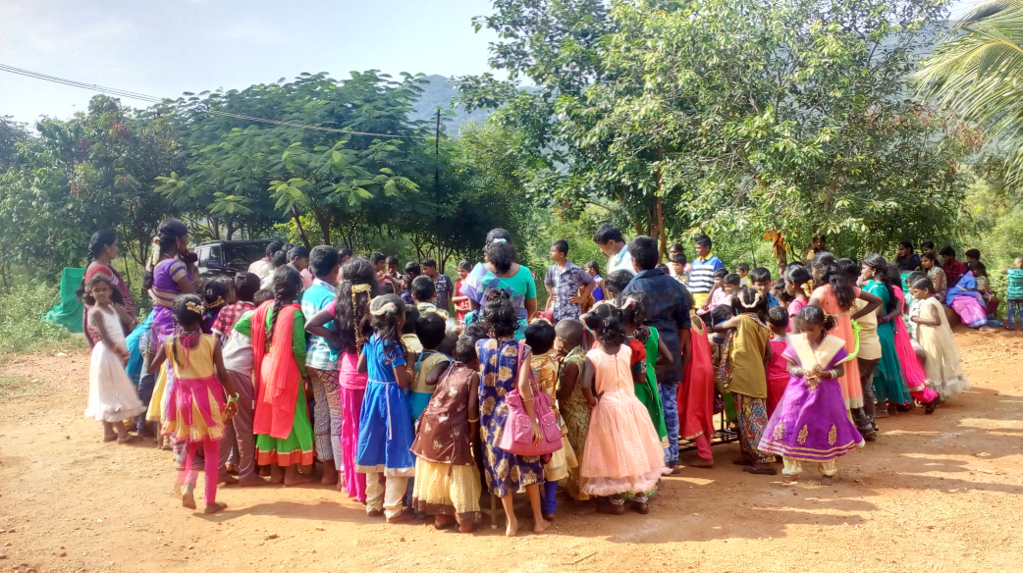
3. Are there any other NGOs that operate in the same villages that you
are operating in and aimed at education of children in those villages?
If yes, please list how many of the villages are supported by other
NGOs.
No. There is no other NGO working in the area.
4. An after-school center was run in Arasampatti last year. Why has it
been closed down for this year? What happened to those children?
Pneuma had a centre in Arasampatti Village. The Presidents and the other local leaders were less cooperative. They insisted us to join along with the other new tuition centre who were the Christian missionaries, their motto is to spread Christianity and its spirituality through the tuition centres to the children and people also supported them. As Pneuma is a secular organisation and we do not support these kind of activities we do not want to join with them and work, so we were in a position to close down the centre.

5. Could you give a breakdown of the budget for educational
materials/picnic/cultural acitivities? What do they involve?
Items | Budget | Involved
Educational | Rs.96,000.00 | Stationary, Notes, Books, Sitting Mates, Black Board.
Picnics | RS.40,000.00 | Educational and exposure visits.
Cultural activities | RS.50,000.00 | Life skill education.  Train them in street theater, dance and drama.  Games,drawing, painting, arts and crafts.  Exhibition their talents.

HEALTH AWARENESS PROGRAM
Health education
1.Who exactly are the "field worker" and "psychologist/counselor"?
What is their role? What are their qualifications?
Team members | Their qualification | Role
Psychologist/Counsellor | - Masters in Social work Specialised in Medical and Psychiatry,  - Masters in Psychology,  - Post graduation in Guidance and Counselling,  - Doctorate in the field of social work. | Individual counselling for the children who seek for counselling  If found any peculiar issues given counselling to the child if needed the family and the school are also provided.
Field worker | - Bachelor degree in Sociology | Helps in the organisation of the programme.  Arrange the programme  Technical help like audio visual setting up.

2. Has anyone in this field reviewed the materials that you use?
The materials are being reviewed by the expertise.
- The Cheif education officer , Madurai
- Dr. R. Kumaran,Ph.D, Associate professor, Department of Sociology, Gandhi gram University, Dindigul.
- Dr. Fathima Rani.B.S.M.S, Mughil Gardens, Madurai
- Mrs.B. Nalinadevi M.S.W. ICTC Counsellor.
- Mrs.A. Elamathy M.S.W Livelihood expert.
Few specific case studies:
Case study: 01
A girl aged 13 years studying 8 class in a rural government school . After the completion of the session approached the counsellor and said that she wants to talk in person.
So the counsellor and the child where given a separate place. The child told that she is being sexually abused by her father. She also added that is being also known to the mother and the mother asks the child not to say to anyone. She said she wants a protective place.
The child was referred to the child welfare committee and she was given shelter in a child care institution.
Now she is continuing her education in the shelter home with her mother’s consent.
Case study : 02
It was found during the session that the girl children had poor menstrual hygiene.
The girl children are in poor awareness on the usage of napkin. They use old unhygienic cloths during menstruation. There were given awareness on using napkins and to change them at least thrice a day. Even if they are using cloths, taught them to wash, clean and dry properly in sunlight to prevent infection.
Case Study : 03
The children educated on importance of rain, avoidance of plastics, climate change and environmental cleanliness. The children participated in the programme took an initiative and created a small garden in their school campus.
- Are you repeating the program in the same schools you had conducted
last year? Or are you planning to do it new schools? How many schools
are you planning to cover?

We were not funded for this programme last year so we had reduced the number of schools and we had follow up programme.
We plan as, per day one school one session
In one session the children ranges from 50-100.
The session is for 2 hour-2.30 hour
It may cover two or three classes, example 6std, 7std, 8std or 8std and 9std.
Sometime we go to the same school for another session for new set of children (other classes)
Health Education Programme For the Rural Children
Training Content
Session | Topics for Discussion | Methods and tools | Out comes | Time
01 | Introduction about the programme | Ice breaking group game | Focus towards the program  Involvement of every participant | 15 minutes
02 | Physiological and Psychological transitionof the body in adolescence-A glance | Information Education Materials, Charts,  group work,  One to group Lecture method | Insight over the bodily and Psychological changes.  Awareness on Sexual and Reproductive Health. | 45 min
03 | Child Marriage  Why No to Child Marriage  Legal Aspects | Role Play by the Participants  Lecture  Documentary film | Knowledge about ill effects of early Marriage | 15 Min
04 | Importance of Women Education | One to Group Lecture  Real model to represent their Life history- Education changed their life. | Awareness about the importance of Women health and education | 15 min
05 | Say No to Open Defecation  Personal health and Hygiene | Information Education Materials, Charts,Picturs,Lecture and Group work – Chart work list it out the problems of open defecation  Slide show | Educated to use Toilets | 25 min
06 | Conclusion  And  Question session |  |  | 10 min

