Reports of Sita Vanam Learning Centre
June – October 2017

From June Sarojini Bhat, Rebecca John and Jane have been working each day sorting and preparing materials to be able to share these effectively. Work on the library continues and the cataloguing is now almost complete. Next month we plan to work with some volunteers to cover the books. Sarojini has now completed the Kannada translation of “In Our Own Words” a resource book for teachers about independent writing and it is being reviewed with the hope of getting it published in the near future.
From July weekly visits have been made to an anganawadi and a Kannada medium primary school in the locality. Sarojini and Rebecca spend one morning a week in the nearby anganwadi. When they began to visit, apart from giving lunch, the nursery school was almost dysfunctional and the carers provided few activities for children. The teacher was very often absent and very few children came. Gradually over four months we are beginning to see some changes and the teacher has been ready to respond to some new ideas. Some materials have been given such as scrapbooks of pictures have been made and given to the school. Each week a new activity is introduced such as drawing with chalk, threading beads, building with construction kits and sorting activities. In addition Sarojini and Rebecca have told stories, sang songs and played some games with the children and have demonstrated how with minimal resources much can be done. It has been important to do this on a regular basis if there is to be any lasting change and also to involve the teacher. We plan to extend this work and spend time in other anganwadis in the neighbourhood.
From July we have also been going on a weekly basis to the local Government aided Kannada medium school to do spoken English with 4th standard children. This is something we plan to continue and expand as children need additional support to be able to understand and negotiate the difficult text book that they are expected to work with. We have concentrated on stories, songs, language games to support them to learn some basic vocabulary.
We hope in the coming months to work in the High School in the library session to help children to respond more meaningfully and enjoyably with books.
In July we had a workshop with 15 teachers working as parallel teachers in a Kannada medium Corporation School. The morning was spent discussing different forms of assessment and one activity was to extend, change or re-tell a story as a way of judging levels of comprehension and a creative response to the story.
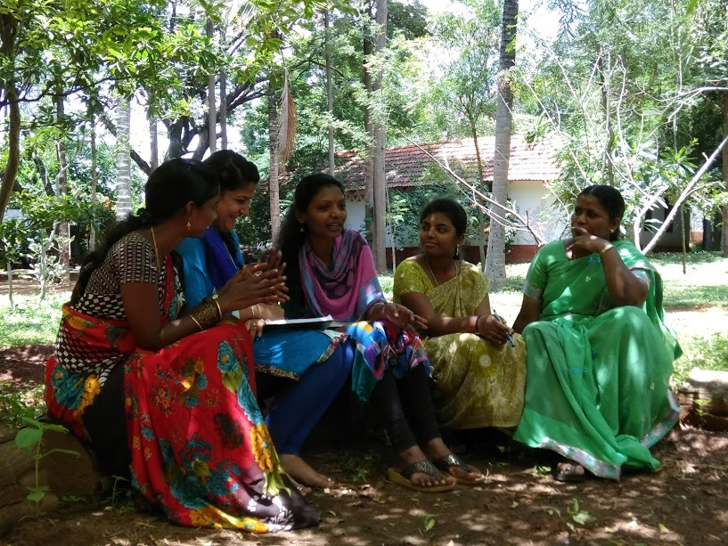
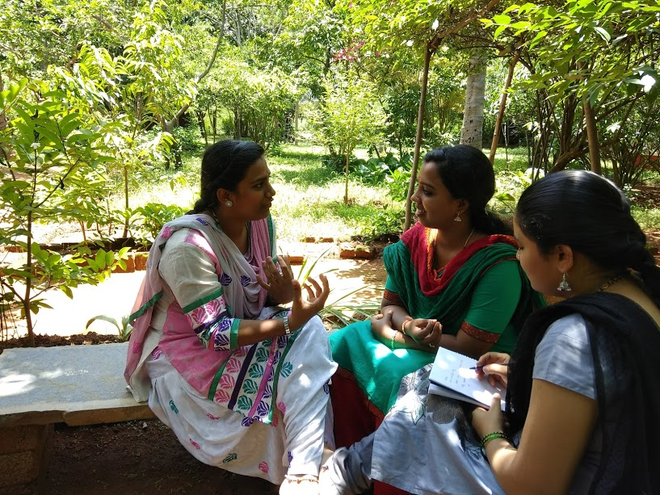
Participants worked in small groups and then presented their ideas as dialogues, poems, role plays and re-telling the story from a different perspective.
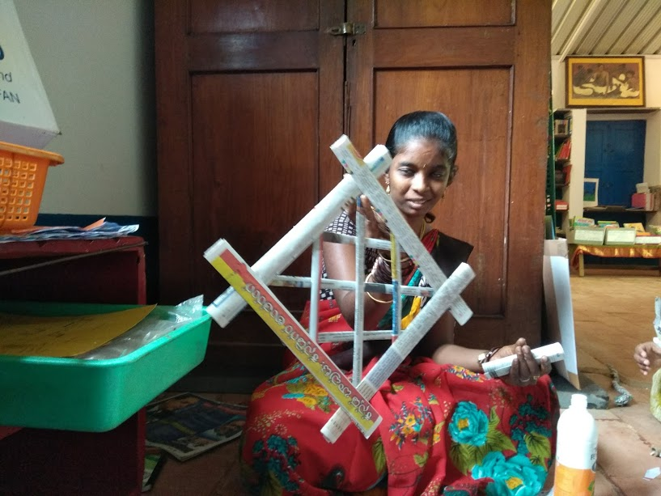
Participants making a wide range of things from waste newspaper. Baskets, puppets ,has, symmetrical patterns and picture frames were some of the things made.
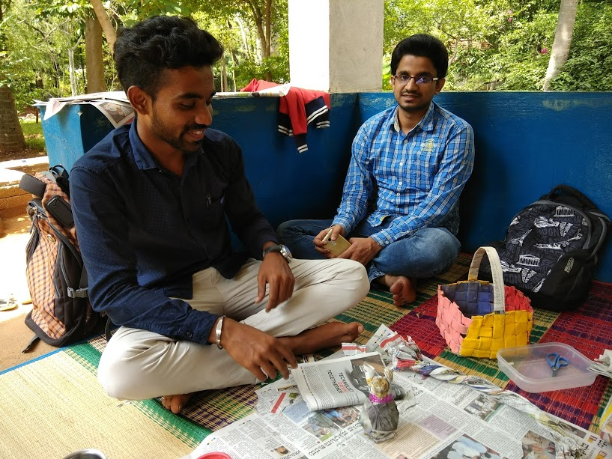

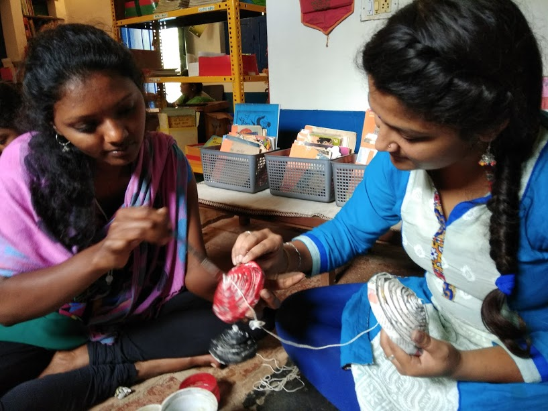

In September we had a group of 20 Government School language teachers who are part of an ongoing training programme
Various activities were introduced including a nature treasure hunt. The participants made a design with the leaves and flowers that they had identified.

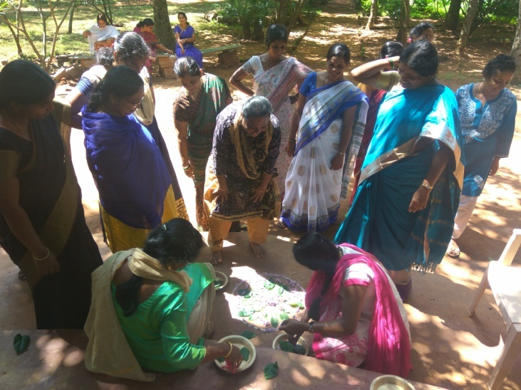
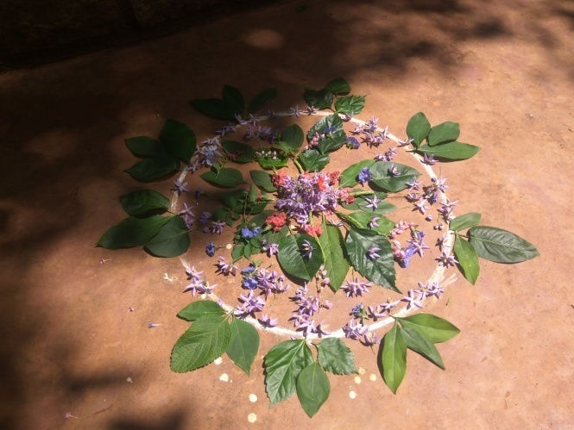
Book Talks were modeled and the teachers were invited to borrow a book from the library and to prepare to present their own book talks for the next session in November.
Rebecca and Sarojini shared children’s work and demonstrated how children can generate their own reading materials to be used with peers and younger children. Diaries, reading cards, wall newspapers and books about the history and geography of the village were shown.
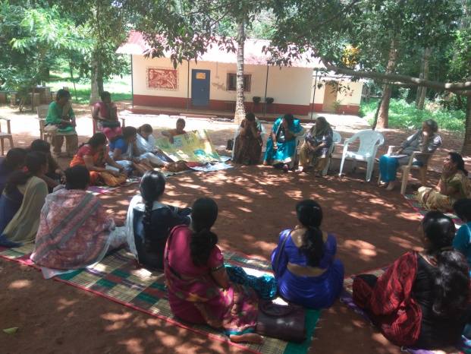
Rebecca displaying a wall newspaper made by the children of the school
Interactive displays were organized and teachers were invited to think how they could introduce such ideas in their own schools.
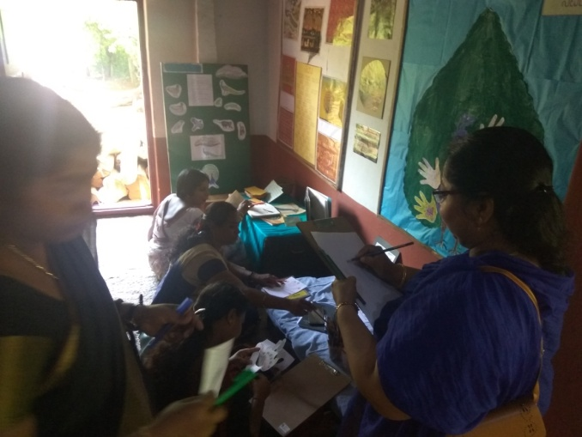
Adding to a peacock image with hand-cut out designs

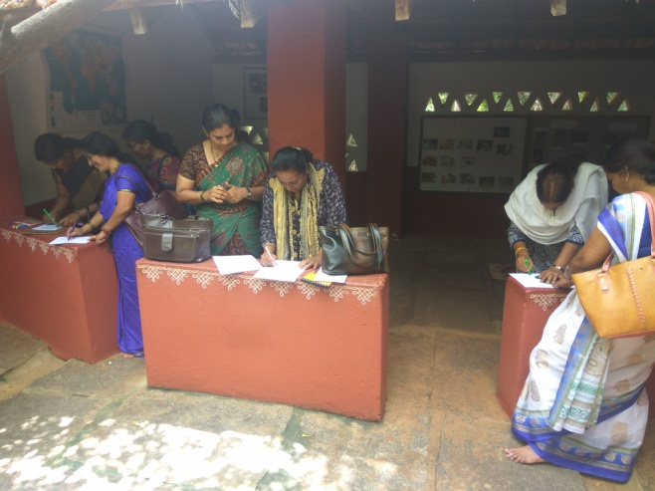
Teachers adding to the collection of Kannada proverbs about friendship.

We have had two workshops for children one working on a text with images taken with an i-pad in August and in October 32 children came for a day’s workshop with a choice of activities including origami work, paper weaving, puppet making and glass painting. Some of our old students were invited and each brought a friend so there was a good mixture of children who were used to such activities and those who had little experience of this kind of craft work. Bringing children in to give them a different kind of space from school to explore materials is something we would like to continue. In the coming months we plan to have the 4th standard children from the local school and to invite some children from the city. In April we hope to have a weeklong workshop on doll making and stitching.
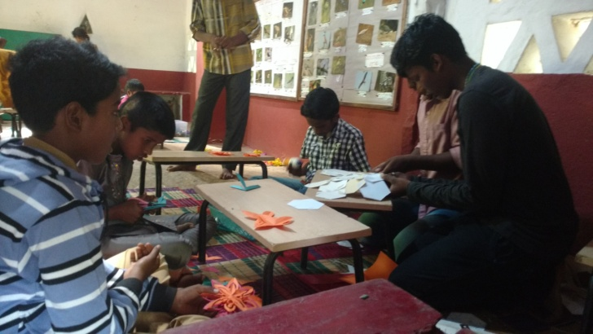

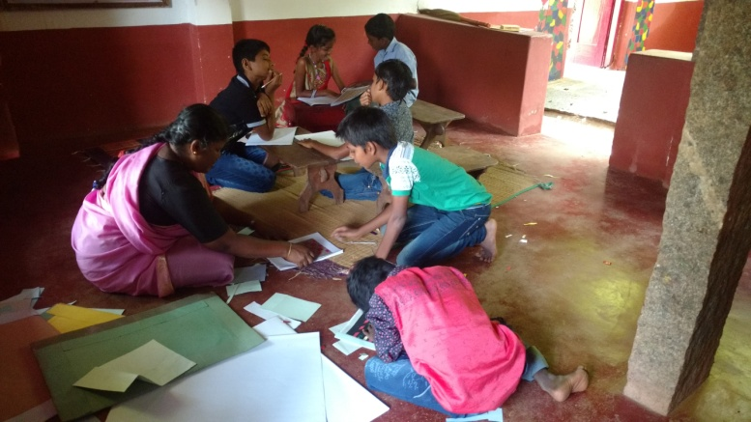
Children making cut-out star decorations and books with covers from their paper weaving designs.

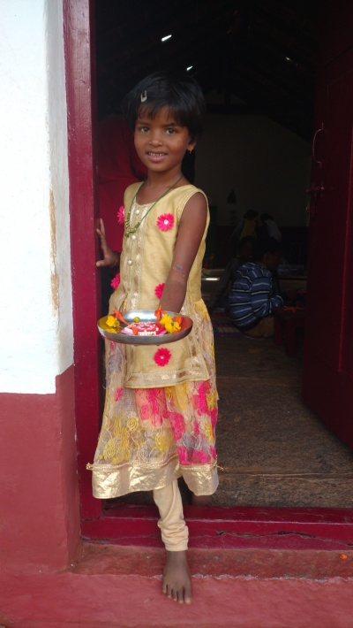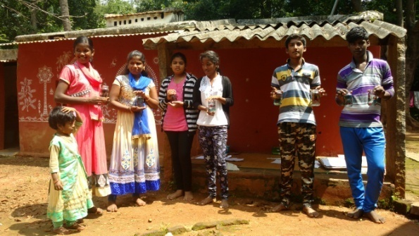
Children showing things that they have made during the morning’s activities. Below are bottles decorated with glass paint that will be used for holding candles.

We recently purchased a projector and have so far had one screen showing for local children and hope this is something that will engage the children. We plan to show Kannada, Hindi and English children’s films.
We are beginning to find ways to share the books of the library with other organizations. A selection of Kannada books will be used for a workshop with Government School teachers organized by APU in the month of November.
There are a number of plans for the future both in terms of outreach in the immediate locality to continue and extend what has been started and also inviting groups for workshops and activities. A number of workshops will be conducted in the next five months and we also plan to start a lending library with the 4th standard children as an experiment to work through the school.

Jane Sahi
October 2017

Report of Sita Vanam Learning Centre
November – mid-April 2018
In the last five months we have tried to consolidate the work that began in June of last year.
We have been going once a week to both the Kannada medium Government aided school and the nearby ‘anganwadi’. We had begun by teaching conversational English but as it became apparent that many of the children in the 4th standard could not read Kannada - about half the children had problems in basic de-coding skills - we decided to increase the time we spent at the school and try to address this problem. We spent part of the time doing oral work with the children and had activities like ‘read-alouds’, riddle making, reciting tongue twisters and poems. The group was then divided into two and one group focused on activities related to letter and word recognition. The other group was given a choice of books and did paired reading. We also continued the English conversation classes. This continued until the week before the exams in the first week of April.
In the coming year we plan to continue with the class as they move into the 5^{th s} standard and also begin working once a week with the 2nd standard so that we can support children at an earlier stage to become proficient in reading. Sarojini has also made contact with the nearby Government Primary School in Tarabanahalli and we plan to begin work there from June.
In the ‘anganwadi’ a number of activities have been introduced including singing, matching games, number games, storytelling, drawing and colouring. In December the children enacted a small drama and the parents were invited for the occasion. It has been rewarding to see the children more actively engaged and not just there for the lunch!
In the holidays more children will be available for activities at the ‘anganwadi’ in Kasaghattapura and we will be doing activities three times a week as children have more time. This work has just begun.
On two occasions In November and January we were fortunate to have a group of volunteers who have helped us cover most of the library’s story books with plastic. This will make the books more durable.
In November we had a second workshop with the Government primary school teachers. Using the books from the library they each gave book talks. We also discussed how displays could be made in a library to encourage children to engage with the books and look at a subject through multiple lenses. One of the areas we opened up was inclusion and we looked at books about children who are differently abled. In addition we had activity about using pictures as a prompt for creative writing.
Also in February we had a half day workshop with the 4th standard children from the local school. The children enjoyed a number of activities such as origami, colouring and collage with leaf rubbings.
In February for the first time we hosted a drama workshop for children from Aditi School in Yelahanka. The fifth standard class of 35 children came for five continuous days. A professional, facilitated the workshop and Aditi School paid for the use of the place and facilities. We are hoping that this may be a way forward to cover some of our expenses and to enable us to work with local children.
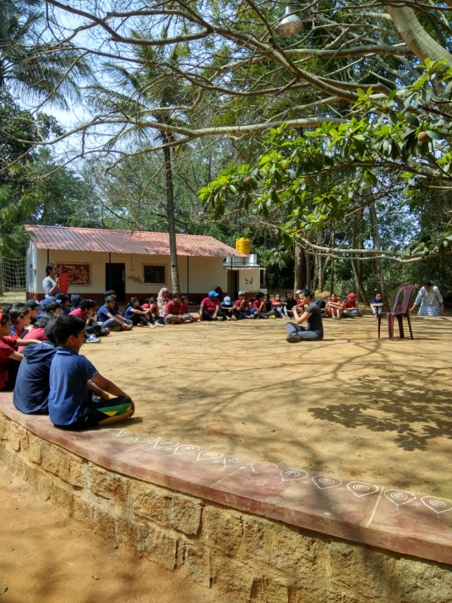
A scene from the drama workshop conducted
on the open stage with 5th standard children
from Aditi School, February 2018.

In March there was a two day dance workshop with a group of students from Baale Mane, a home for disadvantaged girls and a group of American High School students. The workshop was conducted by Anjali Sahi.
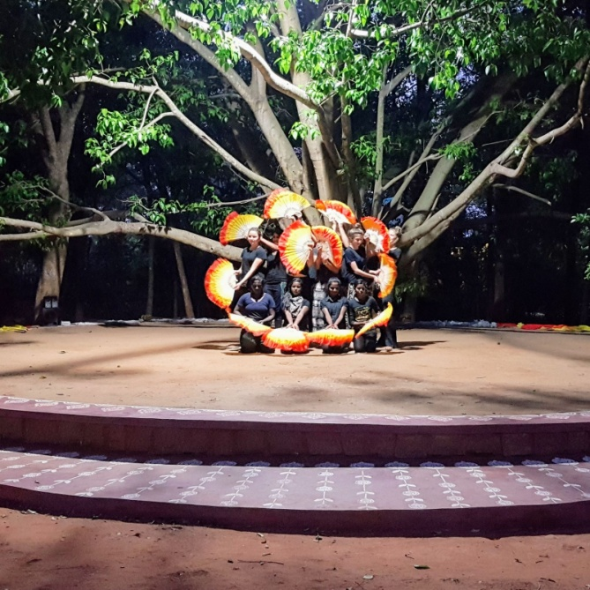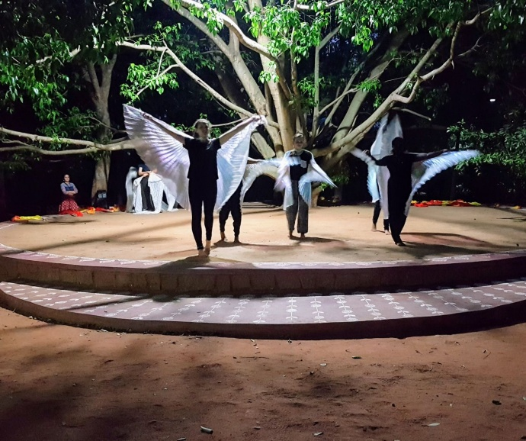
A dance workshop on The Elements : Fire and Air
In March we also had a two day meeting for the faculty of Library Educator’s Certificate Course. This Course is a 7 month blended Course and is organized by Bookworm trust in Goa. Jane is one of the faculty.
Also in March Sarojini and Jane had the opportunity of visiting the Shivanahalli School , Vidya Kendra, near Banneraghatta. The school is run by the Ramakrishna Mission and serves the village community where there is no government school. The work done by the school was very inspiring especially the environmental programme and an extensive area has been afforested over a number of years.
In the course of the year a lot of sorting and cataloguing of children’s work has been done particularly samples of creative writing and art work. It is hoped that this will be a useful resource to share with visiting teachers. In addition Sarojini has now completed a Kannada translation of the book, “In Our Own Words” resource book for teachers working with children to support their independent writing skills.
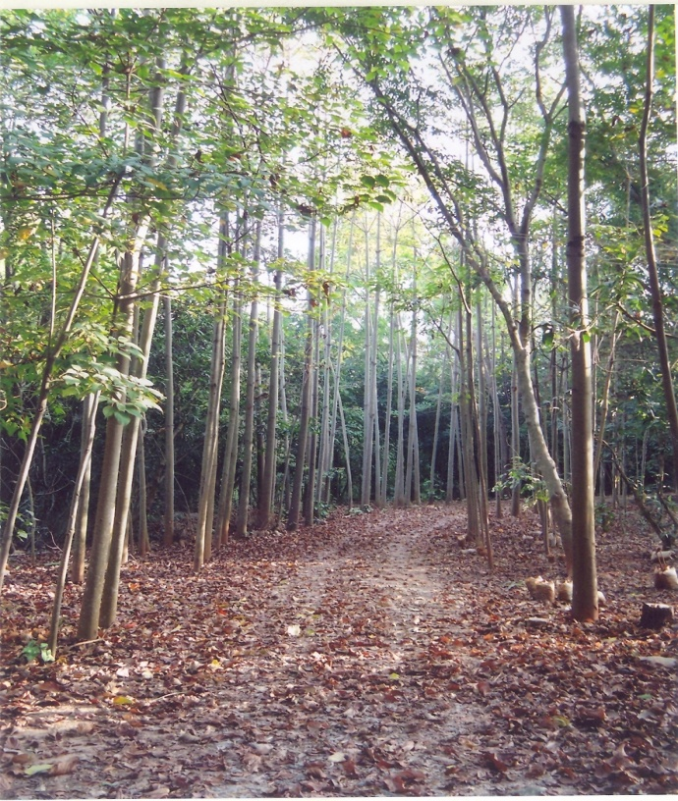
A forested area adjacent to the Vidya Kendra School in Shivanahalli
.
The school has a strong conservation component and the surrounding eco-park is used for encouraging awareness about the environment. The school follows a distinctive curriculum designed to integrate children’s learning through the surroundings.
In January we completed some further repairs on the school building. Last year a tree had fallen on the roof and veranda of the school kitchen and during the rainy season there were problems with mould and leaking. The broken asbestos roof has now been replaced by an aluminum roof. An old woodshed was dismantled as the walls were in danger of crumbling and a covered open space has been constructed. The cost of this was covered by a fixed deposit that was in the school’s account.

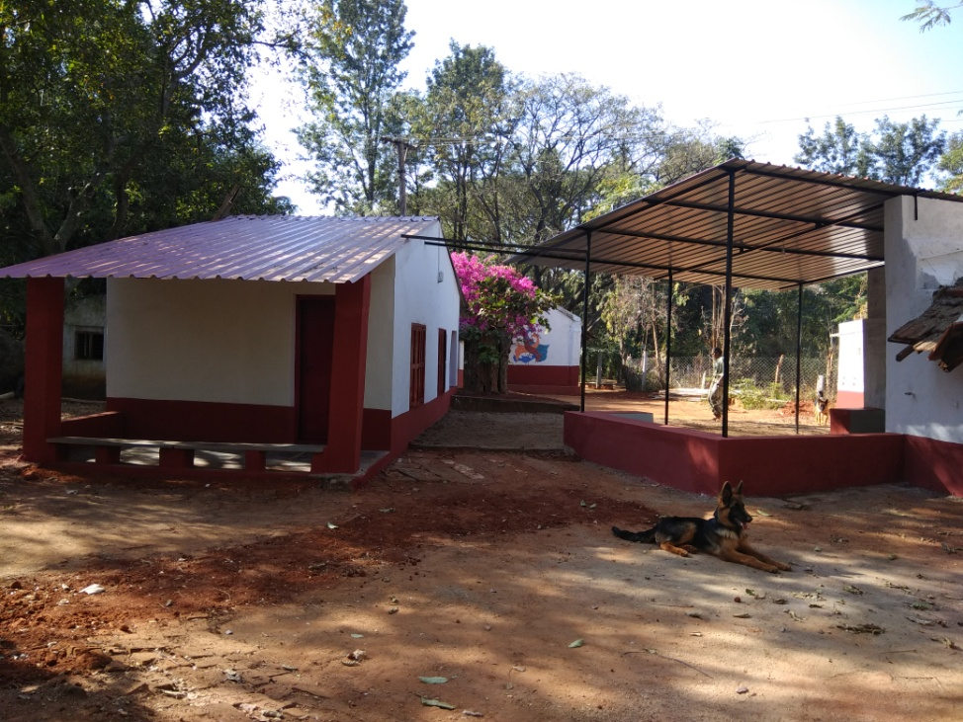
The new roof and the covered area
for craft activities.

The children who left Sita School last year have all been placed in nearby schools. The workshop account which was built up through the sales of screen printed calendars made by the children up until the year 2009 have provided the funds for children’s school fees and uniform. There is a commitment to support the children for two more years. Last academic year we supported a total number of 21 children from 1st to 10th standards. This year three children have appeared for the SSLC exam.

The children have all attended regularly and completed the year. However there are concerns that even though the children have all passed the necessary exams to be promoted to the next class their actual levels of learning have not been closely monitored. For example, one child, Manoj Kumar who has severe learning difficulties was placed in an age appropriate class. He was therefore put in the 8th standard despite the fact that he is unable to write his name or count beyond three. It is worrying that children’s special needs cannot be addressed because of a uniform syllabus and a single assessment tool.
In the coming month over the holiday period we are planning to open a small library and learning centre where children can come three afternoons a week. We will be using the books from the old school library and Rebecca will be present to facilitate the activities. A room in the village of Kasaghattapura will be used for this purpose.
In December of last year old students organized a function to celebrate the school’s history over 45 years.. Many old teachers, former students and their families came. It was a very memorable occasion and a number of students spoke with appreciation and warmth of their time in the school and what it has meant to them.

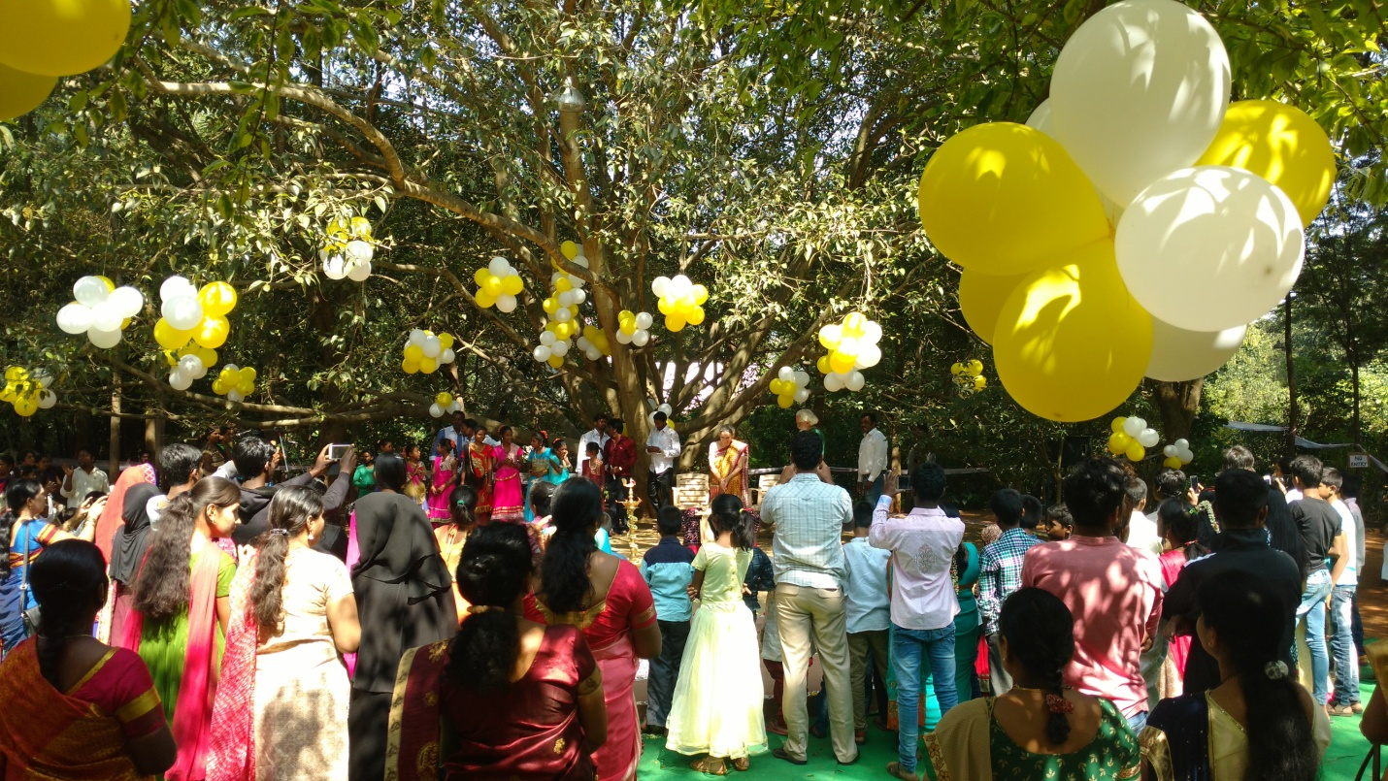
December 11th 2017 – function organized by old students of Sita School
Plans for the coming year
We plan to continue and expand the work in local schools and have found this to be a very valuable use of our resources in terms of personnel, books and activities. We will also be continuing the work in the anganwadi.
In this month we are learning to use a room in the village of Kasaghattapura as a library and activity center. We think that this will be most used in the holiday period.
We also plan to continue the work doing workshops and acting as a resource centre for teachers and educators.

Note on finances.
We are in the process of opening a Trust for the Sita Vanam Learning Centre.
We would hope then to receive only funds generated within the country and hopefully this would come within the scope of Asha’s concerns. Once the Trust is started we would like to request Asha to cover the salaries of two people and the materials needed to continue the work in the schools and in the community.
This year we received from Asha Rs. 3,35,000. This was spent on salaries as mentioned in the budget and stationery and craft materials etc. A utilization certificate from the auditor will be sent by next month explaining the detailed use of the funds.
We had sent a budget for Rs.6,78,000 for the whole year. However we did not utilize money for rent and food as requested and so did not ask for a further amount. The other expenses were met though two fixed deposits from the school’s funds and some amount that was given for the use of the space for a workshop by Aditi School.
Jane Sahi
April 18th 2018.

Questions:
- The training was initiated by whom for the certification?
- Utilization certificate is needed to understand
- May be we should visit Sita school and have a meeting there? Can we come in June there
- Long term plan is not clear nor the goals are clear
- Jane would be coming to Rajeev’s organization and may then he would discuss the AIs next month and share the plan of action
- Going forward Asha Bangalore may not be able to support SitaVanam so what is the next plan?
- Apart from Teacher’s salary what is the other expense they are looking at?

Timbaktu & PBs
- Can they send the proposal for CYRC?
- Network Learning Conference - 8K per person are they interested?
- Rajeev is sending the details to MadhuSudan on this
- Mani and MadhuSudan who is the PoC
- Pictures of the new buildings can you send?
- Videos of the experiments can we get?
- Utilisation certificate

Action Item :
MoM for today’s meetings
Padmanava will upload the pages

