Project Work plan
1. The title
Water, health and education for women and children of Thar
2. Location
6 villages of Jodhpur district in Rajasthan, Thar Desert
3. Duration
One year (April 2018 to March 2019)
4. Target population
Women and children living in the project villages
5. Project Plan
GRAVIS and Asha for Education effort focusing on water security, healthcare and education have benefited the rural communities to a very good extent over the last 9 years. GRAVIS always learns from community and develops project for them and replicate best practices in area for sustainability. In coming year also GRAVIS would like to replicate outcomes of project intervention in 6 new set of villages in Jodhpur district. Two schools supported by Asha for Education will be continued with more effort to cover girl children. Preventive healthcare will be part of project with special attention to community based cadre development. Rainwater harvesting work will be done to reduce the drudgery of women and to promote the girl child education who are left out because of their involvement in procuring water for house.
6. Activities
Water security:
45 Rainwater harvesting Taanka will be constructed and 2 taanka management training will be given to beneficiaries. The beneficiary selection will be done with the support of VDCs formed in project villages.
Preventive healthcare:
12 Medical camps will be organized to cater health needs of villagers specially women and children. A cadre of Peer health educators will be strengthened through refresher training on maternal and child health, seasonal diseases and preventive healthcare. This will help rural women to become healthier and responsive in seeking their healthcare needs.
Primary Education:
Asha for Education supported schools will be continued in Minno ki Dhnai and Gajanbas villages. Children of these schools will receive information on Nutrition and Hygiene through 4 sessions planned in project. These children will also participate in educational tour and get exposure on historical, geographical and educational knowledge. Along with material supports to schools, teachers will be trained in teacher training; GRAVIS would like to propose a comprehensive training including teachers of 7-8 schools running in near about vicinity with the support of GRAVIS. To give children a healthier competitive environment Children Day will be celebrated on 14th November. Cultural event, singing and sports will be part of celebration. This will be organized in Gagadi and children of Minno ki Dhnai and Gajanbas schools will participate in it.

7. Proposed Budget
USD 35,000
Details of budget and work plan are attached.
Budget:
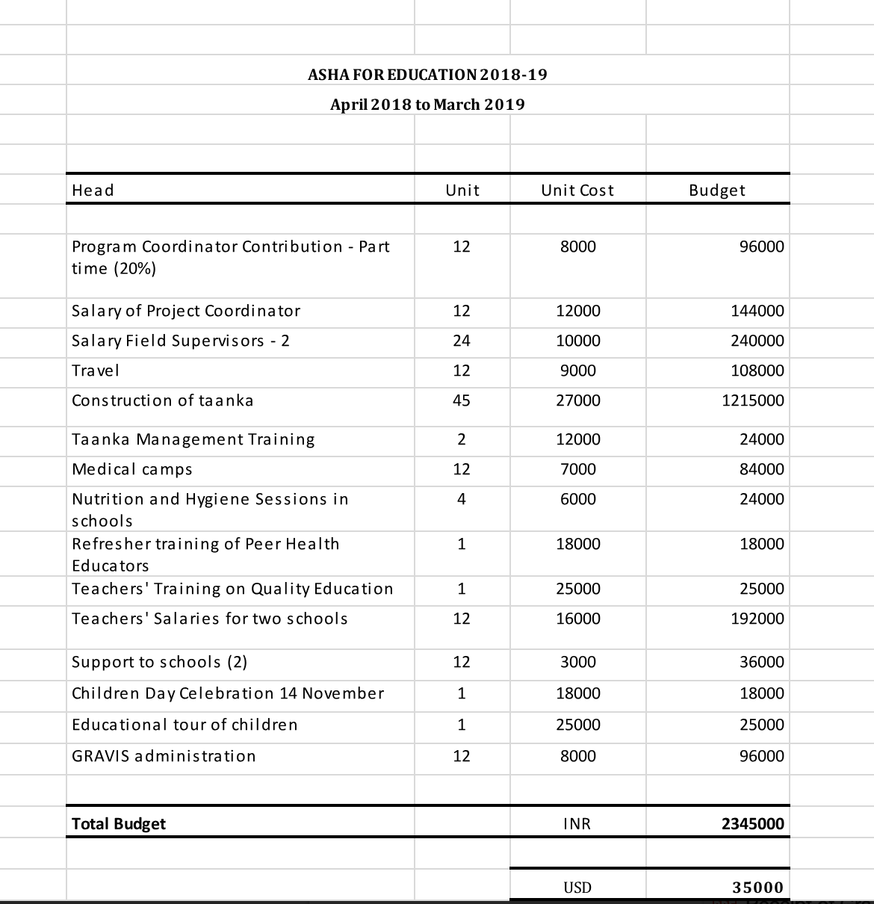

Work Plan:
