Purchase of X – Ray machine for GRAVIS hospital
There was no X –ray machine in GRAVIS hospital and also in lack of facility in nearby PHCs, the communities were forced to go to Jodhpur for checkup. This creates cost for poor families. GRAVIS purchased a digital X – ray machine for hospital to benefit rural communities and children. Advantages of digital X-ray include time efficiency through bypassing chemical processing and the ability to digitally transfer and enhance images. Also, less radiation can be used to produce an image of similar contrast to conventional radiography.
Instead of X-ray film, digital radiography uses a digital image capture device. This gives advantages of immediate image preview and availability; elimination of costly film processing steps; and most important display of quality of the image. A radiologist is appointed to operate the machine.
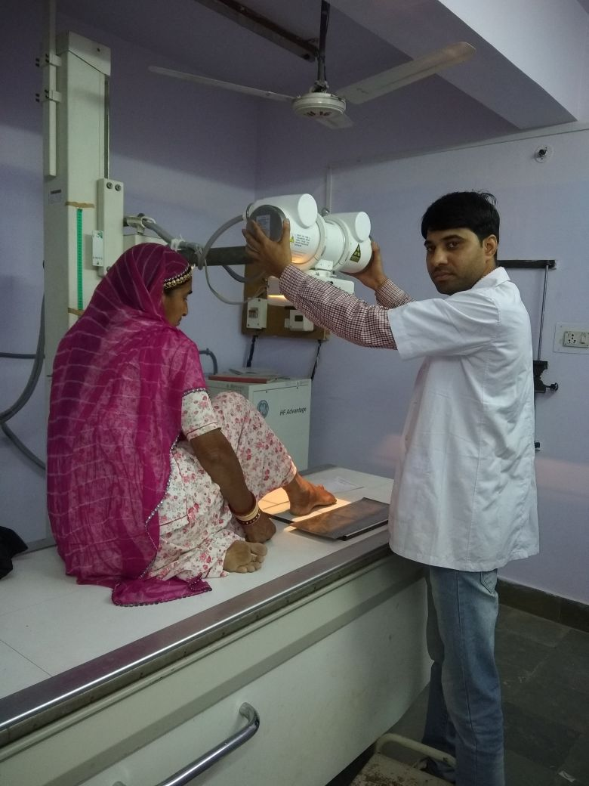
Pic 1: Digital X-ray Machine
Because of mining community the prevalence of Tuberculosis and other occupational hazard is high in region and because of low income group and in lack of hygiene chance of pneumonia among children is also high. Through X –ray machine children and community are availing benefits and treatment to diagnosis is started on time. It has saved the time and cost of people with quality service.

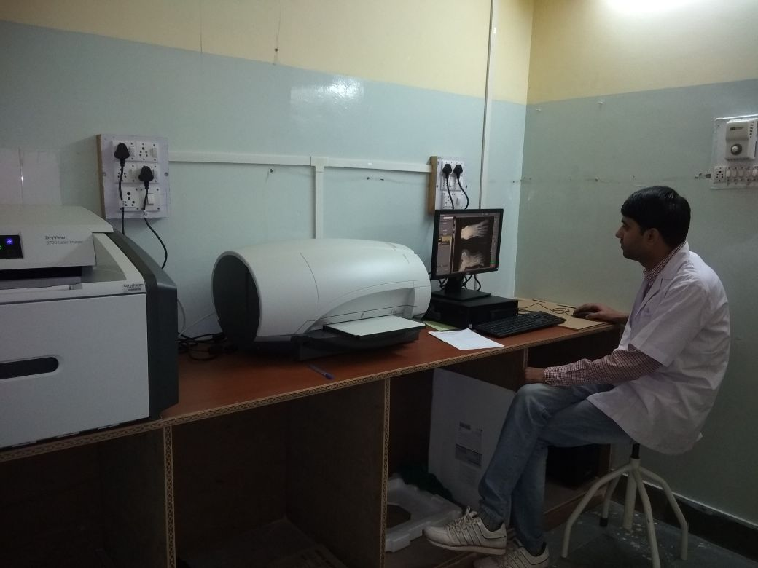
Pic 2: Digital image and printing
Complete Blood Count Machine
A complete blood count, or CBC, is an easy and very common test that screens for certain disorders that can affect your health. A CBC determines if there are any increases or decreases in your blood cell counts. Normal values vary depending on your age and your gender. As GRAVIS closely works for reducing maternal and infant mortality, CBC machine is very useful to examine expecting mothers in their health needs. GRAVIS purchased CBC machine and it is operated by a technician. This machine is giving services to community especially women and children. A complete blood count machine measures several components and features of blood, including:
- Red blood cells, which carry oxygen
- White blood cells, which fight infection
- Hemoglobin, the oxygen-carrying protein in red blood cells
- Hematocrit, the proportion of red blood cells to the fluid component, or plasma, in your blood
- Platelets, which help with blood clotting
- Abnormal increases or decreases in cell counts as revealed in a complete blood count may indicate that you have an underlying medical condition that calls for further evaluation.
Pregnant women, patients of Malaria, Dengue, and other vector borne diseases are getting early and accurate diagnosis of various infectious diseases. People are getting benefits from this machine and availing timely medication.

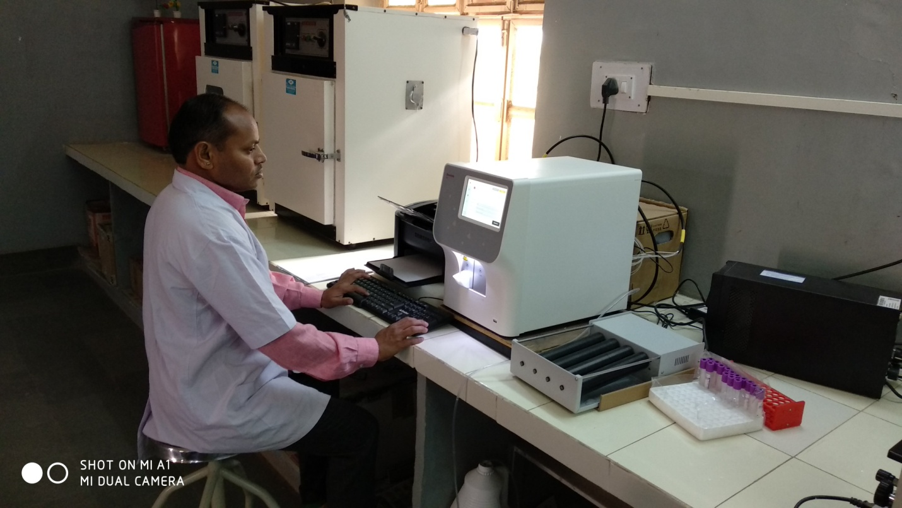
Pic 3: Complete Blood Count
Repairing of primary school and construction of toilet at Bheel Basti school
The primary school for mineworker children was constructed in outskirt of Jodhpur at Soorsagar. The school was constructed in 2006-07 at placed largely habited by mine workers called as Bheel Basti. Bheel are poor unprivileged community in Rajasthan largely engaged in mining and other wage activities. During the time of construction of school the land was donated by community. After some years minor repairing is always required to maintain any structure. The school is giving primary education to 62 kids of mineworker families. With the support of Asha for Education school is repaired. The repairing work includes plaster of rooms, making of floor, repairing of roof, sanitation facility at school, boundary wall, gate installation and overall painting of school. Now the atmosphere of school is more attractive and attendance is improving. Many children those who are still not registered are also willing to come to school. Before repairing only 50 kids were registered in schools. But after this renovation, the registration of children is also improved by almost 20 %. Health and hygiene practice among children is improved and this is creating change in their behaviors.

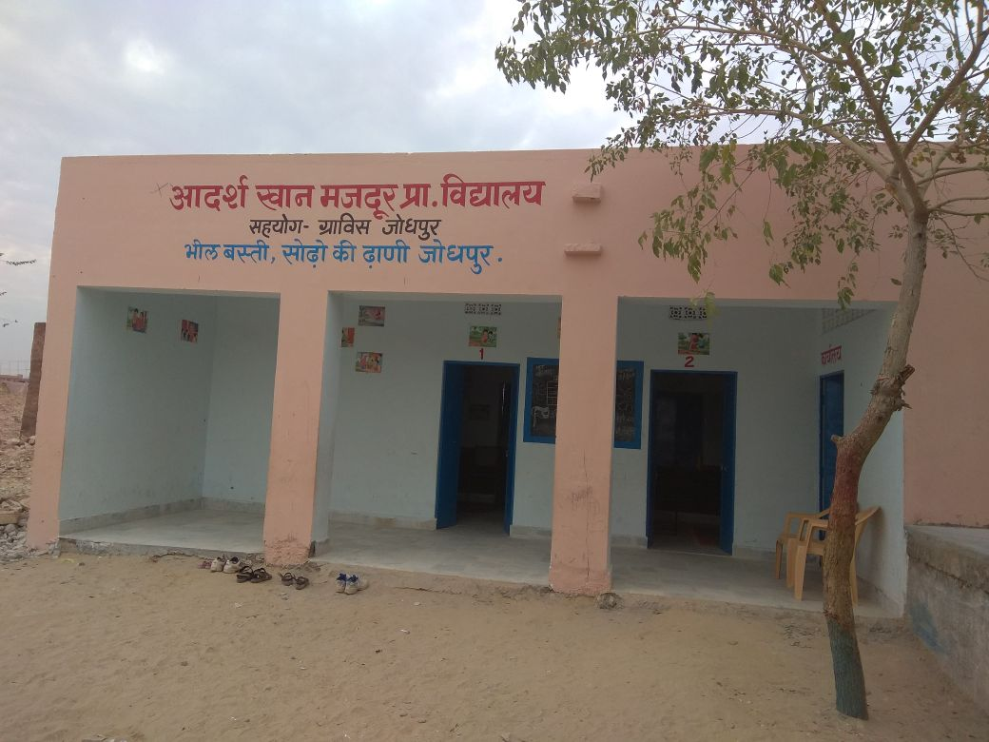
Pic 4: Repaired Primary school at Bheel Basti , Soorsagar (Jodhpur)
Construction of toilet for Primary school in Utamber
GRAVIS with the support of Asha for Education is running Primary School in Utamber. This school has a capacity of 40 students and potential to increase number but in lack of toilet many children stay at home. The toilet is required for kids to develop hygiene and sanitation practice and to improve their quality of life and study. Two gender segregated toilets are under construction with cost of Rs 70,000. After construction children will be free from water borne diseases and will adopt hygiene practice and finally behavior change will be observed among children and their families.
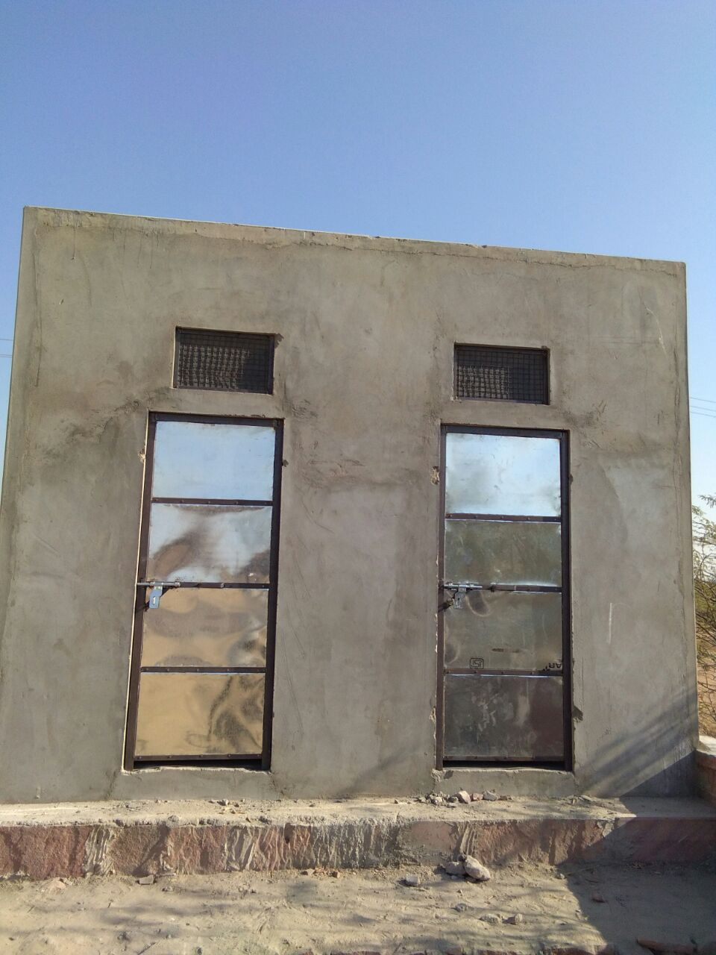
Pic 5: Construction of gender segregated toilet for school kids

