GRAVIS SiteVisit Report by Sandeep Nain (Jan 2013)

I visited GRAVIS, Jodhpur, Rajasthan on behalf of Asha for Education in January 2013.
I visited the following GRAVIS Sites:
- Rain Water Harvesting Structures (Taankas). Visited around 8 Tanka beneficiary families. Taanaks seemed to have a big impact on all the families I visited. Few of the have started a small garden. One old woman now living by herself was very happy about the Taanks as now she was not dependent on others to help her out.
- Two schools started by Asha-GRAVIS project. Both seem to be running fine. The one in Dabri is in a need to move to a better site asiit’s currently being run in huts. Both schools need toilets
- Self Help Groups (SHG)n – I met multiple SHGs, few of them newly started. I also met one SJHG that has been running for 5 years now when Asha-GRAVIS project was started. Every woman I talked to had good things to say about SHG. They seemed very confident.
- Community Hospital & Health –I visited the GRAVIS Hospital. They had a Cataract surgery day going on when I visited. I met few patients who had cataract surgery performed on them. Cataract seems to be prevalent in the area. Cataract surgery is minor surgery and brings back the eye sight for people affected by it.
- I also visted few GRAVIS sites not supported by Asha project:
  - Nadi
  - Khadeen
  - Pastures
  - Family Vegetable Gardens in desert land
  - Village Information Centre

Attached are few pictures from my site visit:

- TAANKA
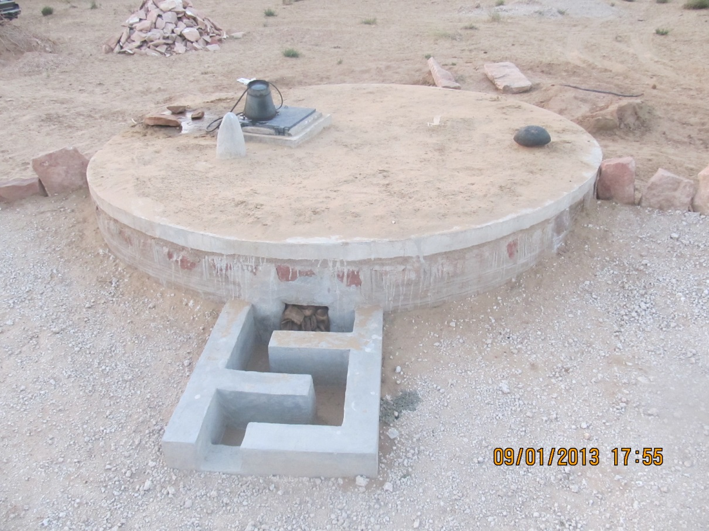

- 84 year old Taanka Beneficiary
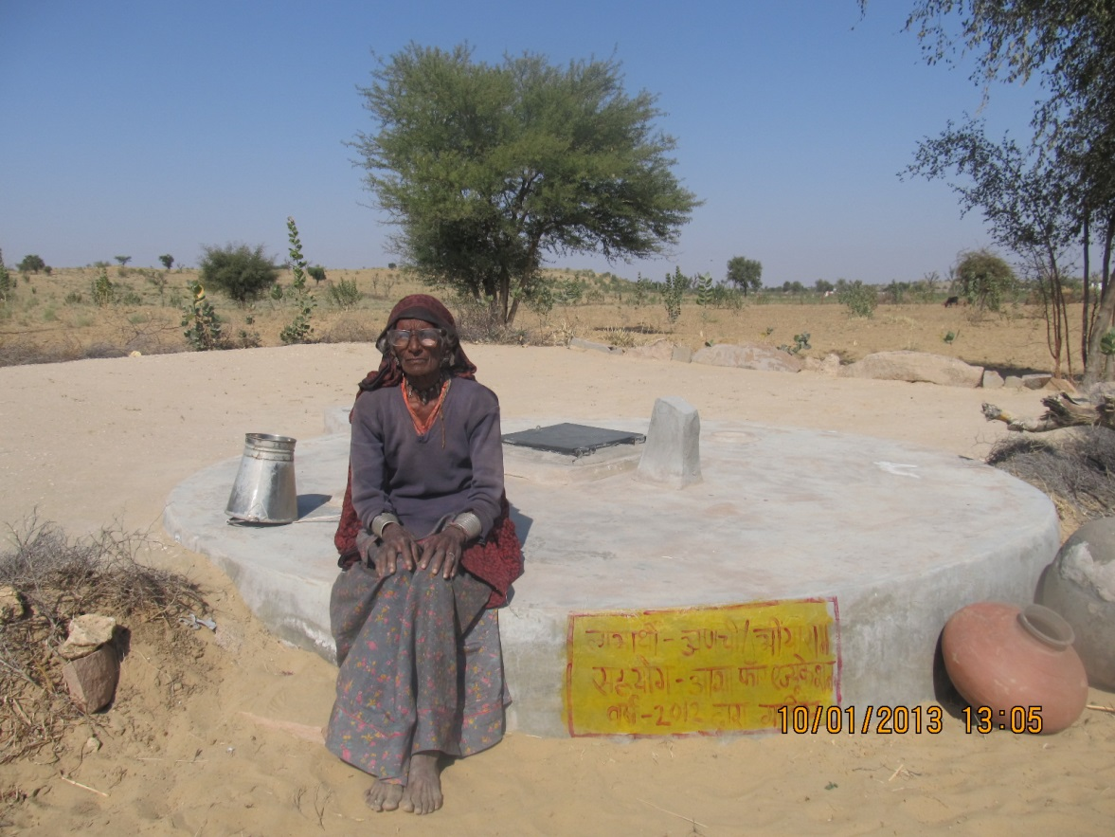
\
- Minno Ki Dhaani School
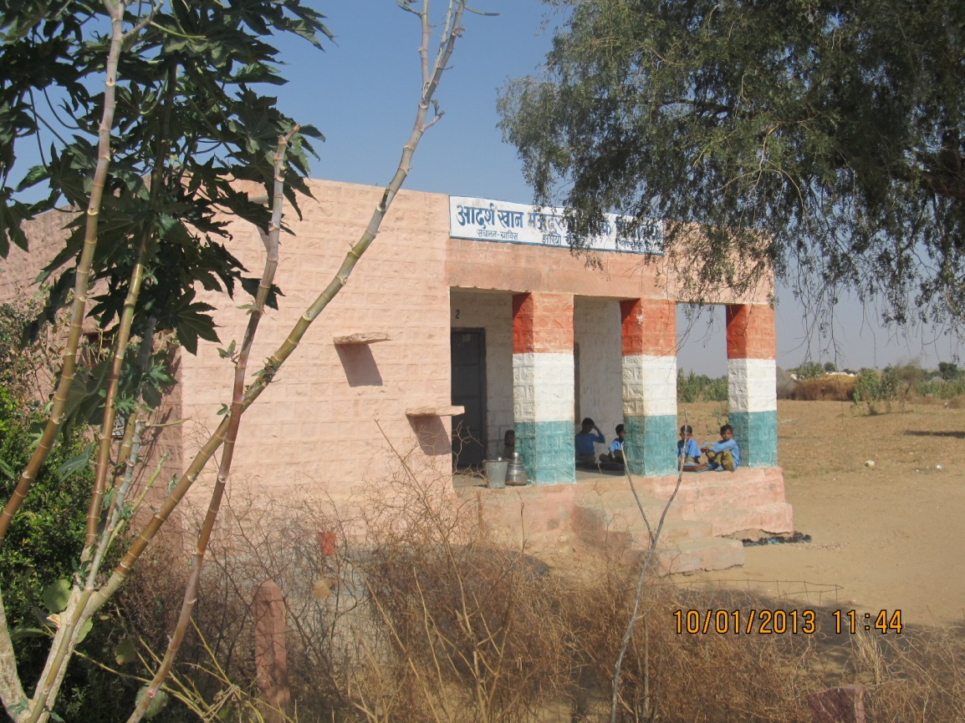

- Minno Ki Dhaani School Classroom
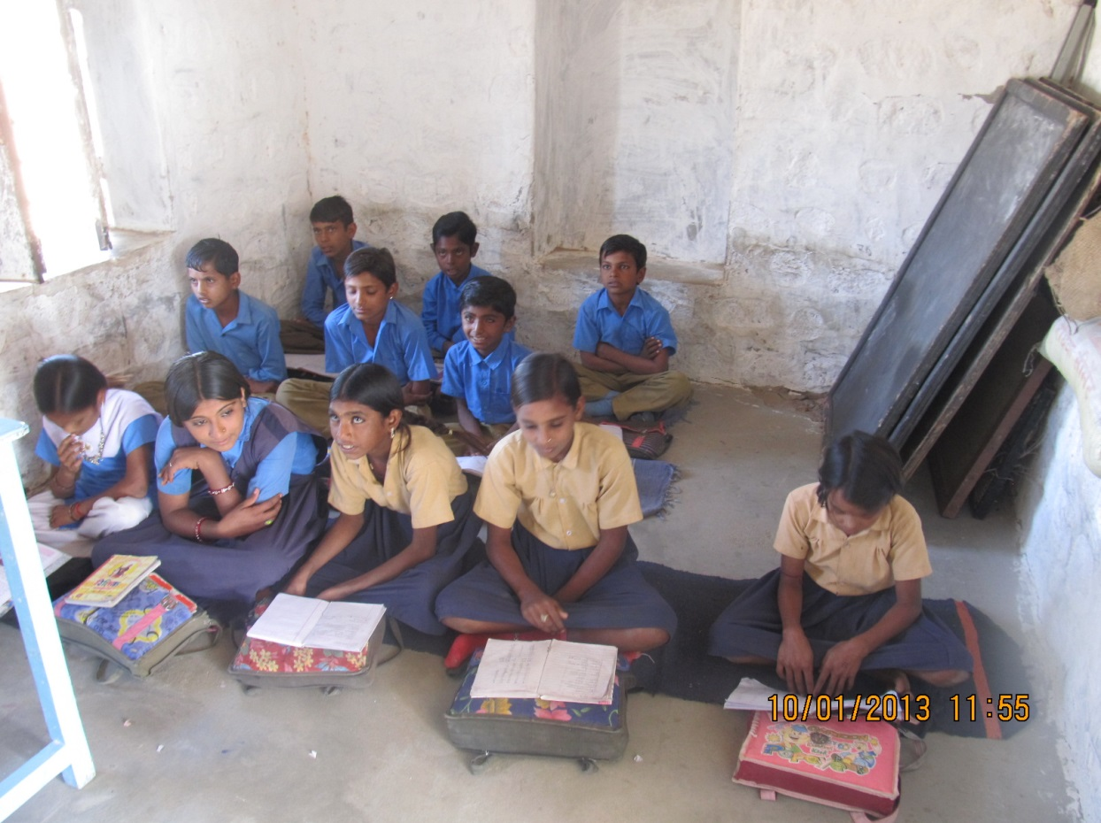

- Dabri School Class running in the hut structure
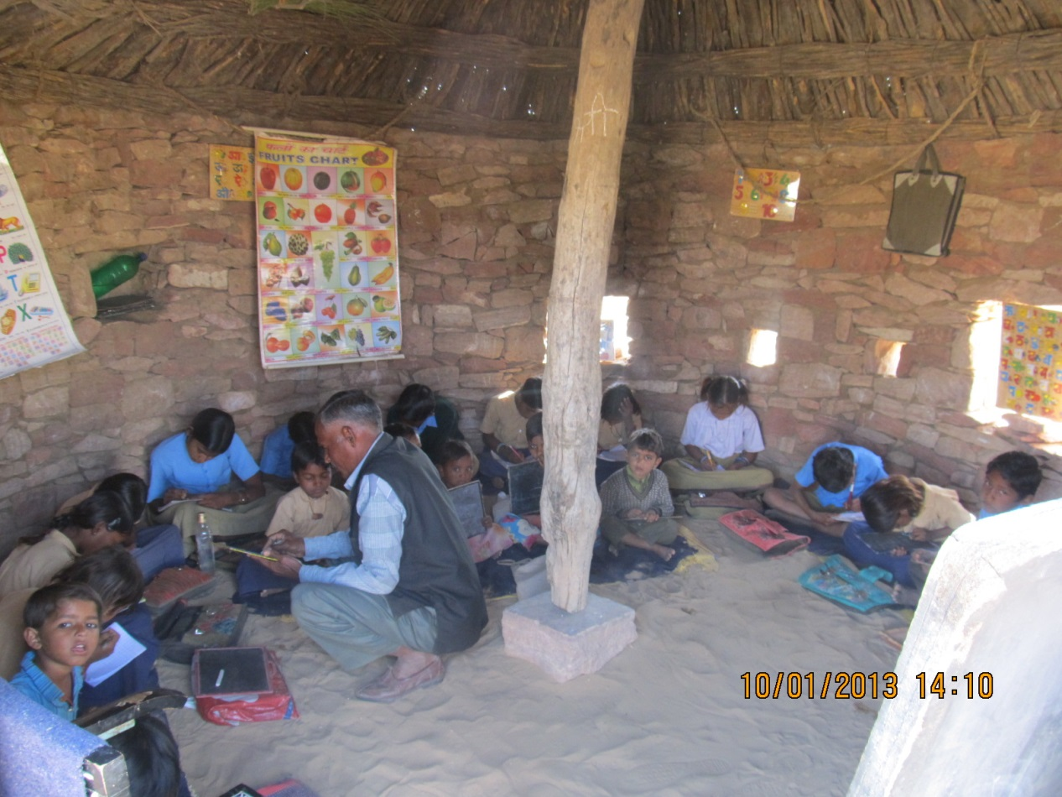

- Dabri School Kids Sandals
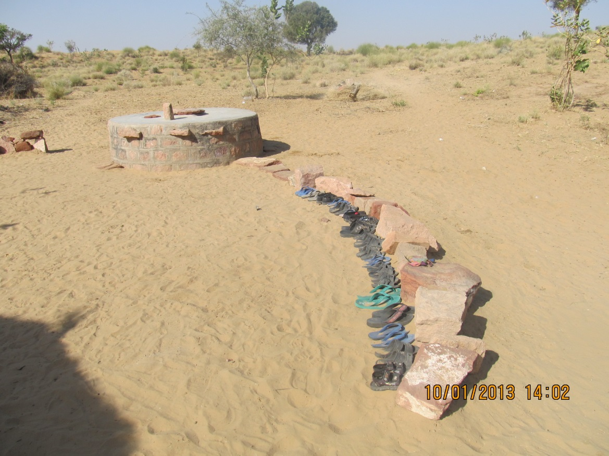
- Women Self Help Group
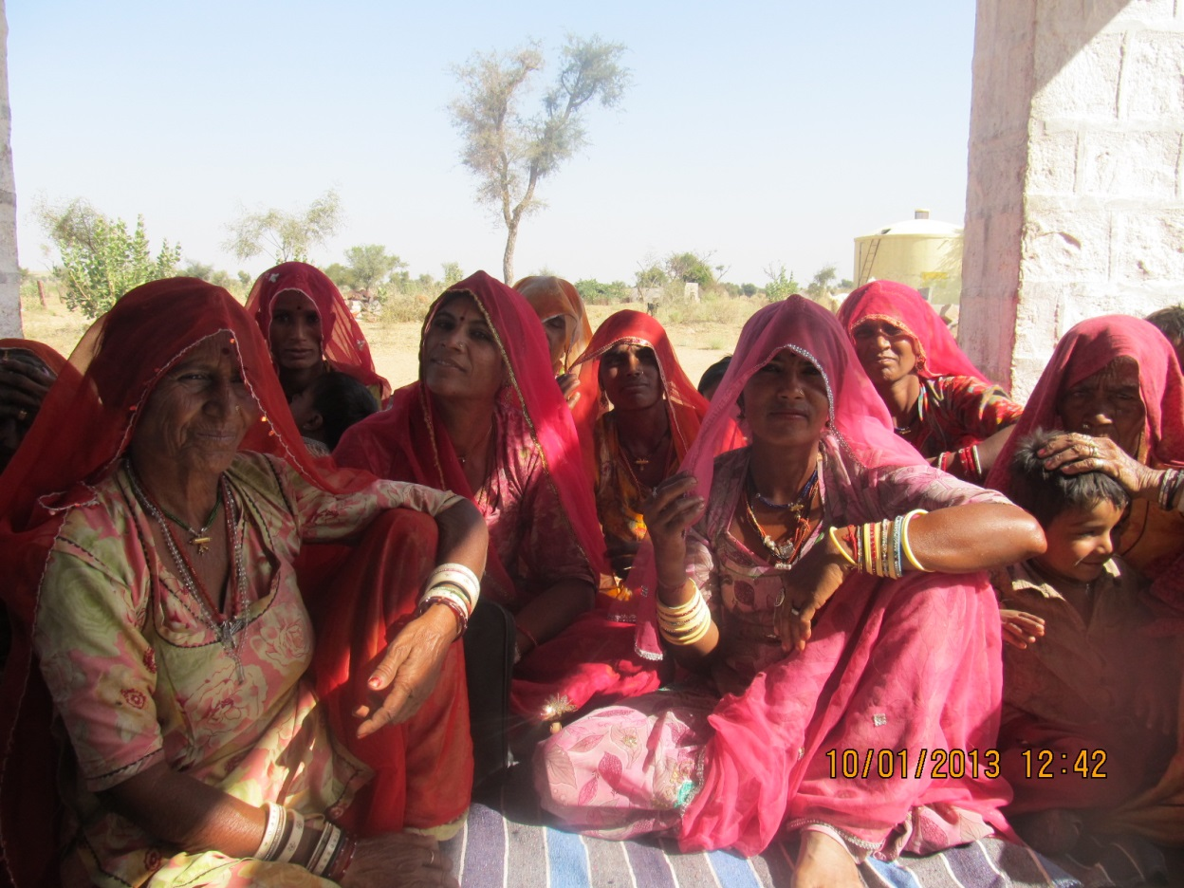

- Women Self Help Group with Shashi Ji
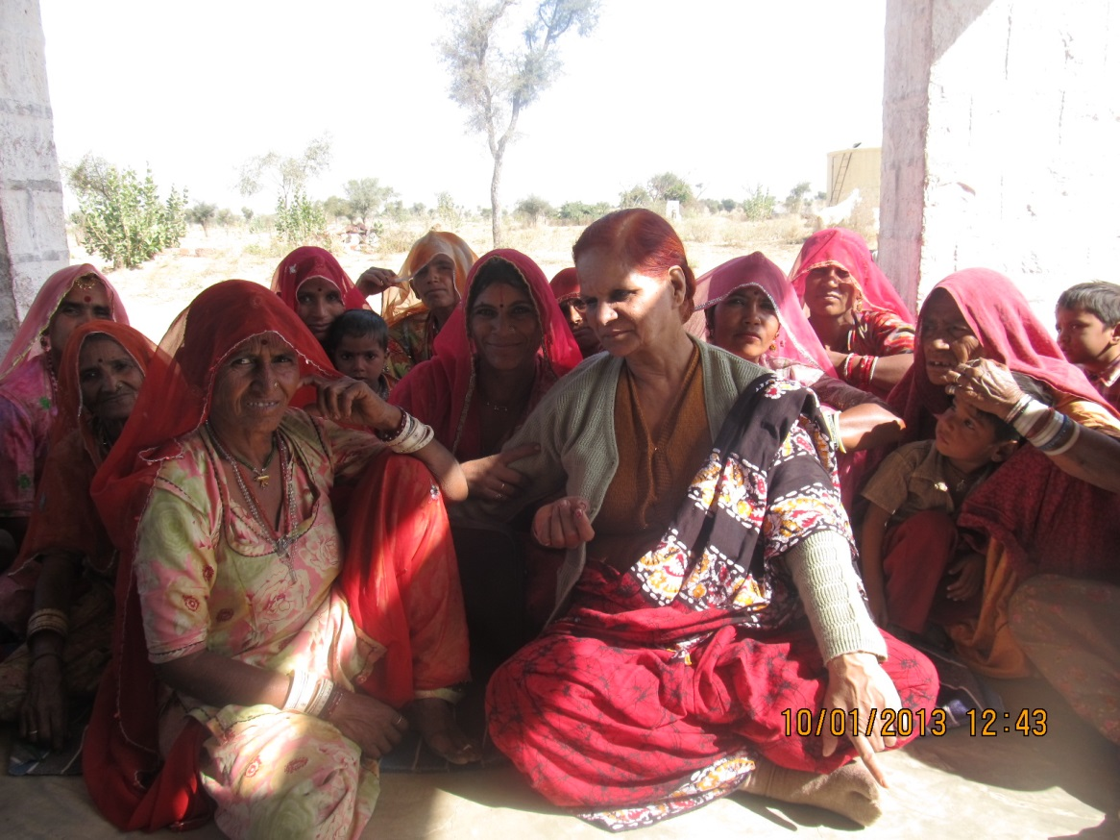
- Pasture built with GRAVIS Support.
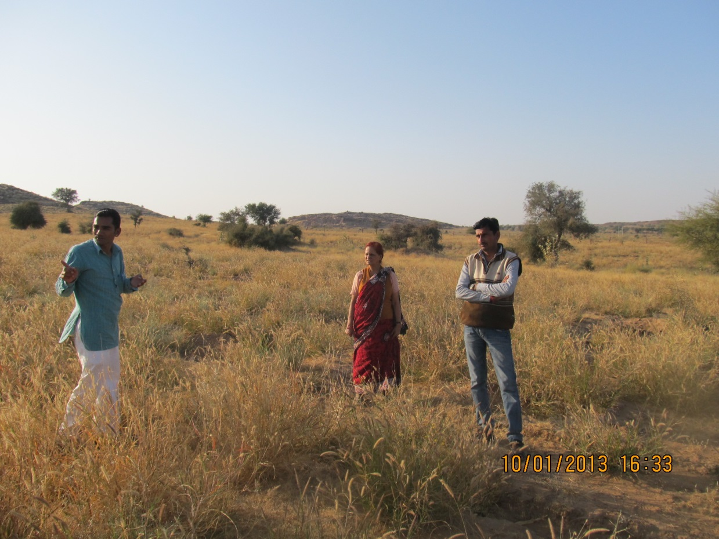

- Gram Vikas Samiti
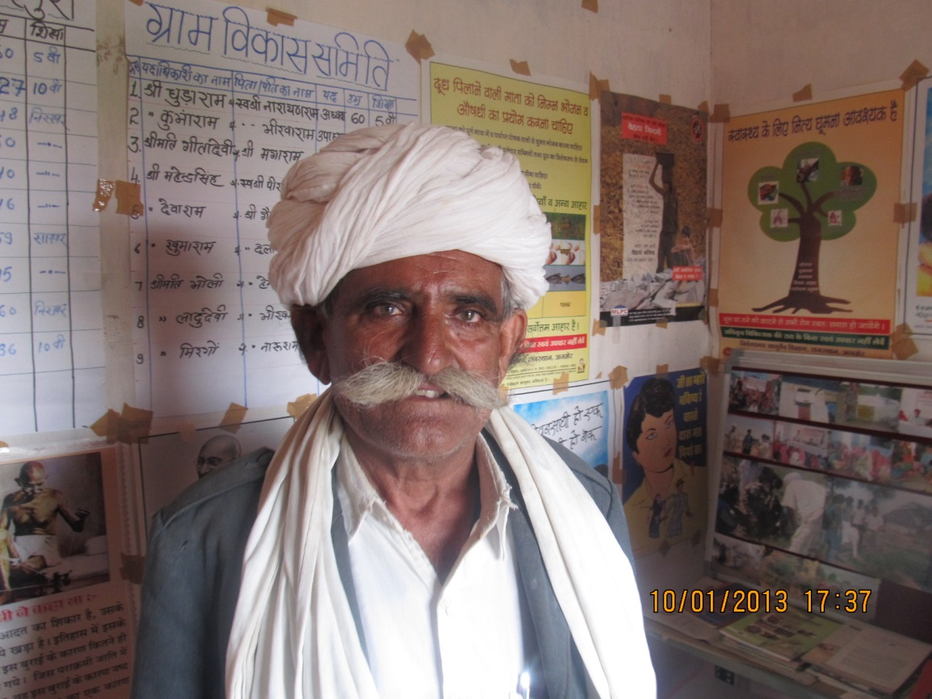

- GRAVIS Hospital Operating room with doctor
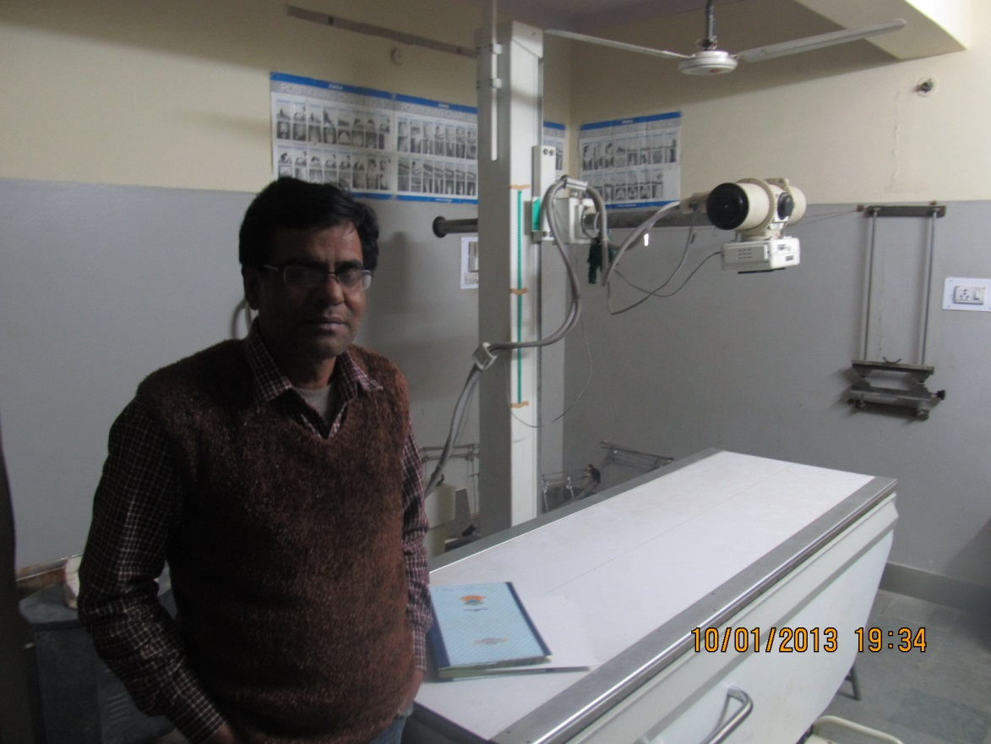

- Cataract Surgery
