Water, Health & Education for
Women and Children in Thar

Annual report for the year 2015-2016

Submitted to:-  ASHA for Education | Submitted by:-  Gramin Vikas Vigyan Samiti  (GRAVIS)

Preface

Rajasthan is known for its arid climatic zone, high wind velocity, soil erosion, lack of drinking water and sandy loams. The state is the largest in area comprising of very sparse and scanty vegetation, having low ground water, less rainfall, and rainfed agriculture and livestock rearing is the main occupation of its inhabitants. People have adapted to various strategies for their living in the harsh climate like capturing rain in underground water tank, storage of seeds for years, practicing mixed farming, rearing of livestock like goats, and eating of weeds and herbs in vegetable form, which goes from 48⁰ to 50⁰ in summers and 22⁰ to 10⁰ in winters. The state is also known for its minerals and stone production. People are working in these salt & stone quarries, mines, and working under the high ultra violet rays for the whole day to earn the livelihood for their families. These families sometimes live in hamlets in Rajasthan, which are beyond the basic facility of lifestyle, like drinking water, electricity, pucca roads, education, hospitals, pucca roads, etc. Sometimes, these persons have to cover about more than two kilometres of distance to fetch drinking water for their Household (HH). Food issues have been resolved somewhat by rain-fed agriculture but seeking education for the kids is altogether cumbersome. Therefore, families who face similar situations do not tend to send their children to schools, and boys of the families, join their parents, as extra earning hands to the household income, whereas, girls of the families, help their mothers, in doing the household chores and fetching water, from the long distances. The scenario is common in Rajasthan, because most of the population falls under Below Poverty Line (BPL), and lacks basic facilities. Water, education, and health have become the major issues in the state to deal with, as some of the social practices of importance of gender education are still prevalent. Accessing, to these basic amenities of self sustenance of the life are attached with feasibility and accessibility. Therefore, GRAVIS has come up with and integrated kind of projects in these areas which revolves around water security, food security and education and health. GRAVIS with the support of Asha for Education works on integrated development project dealing with these issues and benefitting the community in estranged conditions. The project named ‘Water, Health & Education for Women and Children’ has been implemented in Osian block of Jodhpur district with new set of villages. The project is focussed on development of women and girls through improved health and education status respectively and simultaneously, increasing the water and food security prospects in the concerned region.
- Grant Details

Grant Period | October 2015 – September 2016
Name of Project | Water, health & education of women & children in Thar
List of communities where  project is being carried out | Six villages of Jodhpur district. The list of villages is being attached as annexure in Table 1.
Target Group | Women, children & village community.

- Project area: The project area was selected on the basis of community working in mines, quarries, and unorganised sector and living in Dhanis, which were difficult to access of drinking water and basic amenities like food and education. The project has been located in Osian block in six villages. GRAVIS has started in new set of villages through this project for last two years. The socio- cultural mix of population is inhabited in the block, comprising of many socially and economically deprived castes and communities. Irrigation in the block mainly relies of rainwater but some elite groups have tube wells, and drinking water is fetched through tanks and Naadis in the villages.

- Project objective: The project has been implemented with a hope to secure water and food and integrate it with the health and education of women and girls. Therefore, an objective has been drawn to adhere to the project implementation.

- Construction of taankas and khadins for securing drinking water at home and food for the household.
- Holding up of health camps in the community for adhering to the health issues and referral to our organization’s hospital.
- Felicitating girl child education through supporting primary schools, tracking their attendance rate and conducting exposure visits.
- Lastly, capacity building trainings for the villagers for the maintenance of taanka and khadin.

- Method of selection of beneficiaries: Selection of villages was done by obtaining the number of health, education and ground water facilities and access to them by the villagers from Block Development Office of Osian. And beneficiary selection was done by the Village Development Committee (VDC) of the concerned villages. They holded up a meeting into the community of the target villages and informed about the project and its activities to the villagers. And then after some time, the registration of beneficiaries was done for the construction of taanka and khadin in the villages.

- Description of activities in the project:
- Construction and Maintenance of Taanka: Taanka is a drinking water storage tank primarily to capture rainwater through elevated catchment, constructed either in the community or in the household. In our project, the emphasis was on construction of Household (HH) taanka, as it will adhere to the particular family in question and will be in the reach of those families who were not financially sound and have to fetch water from the long distances. Taanka is the traditional rainwater harvesting technique being practiced in Rajasthan to conserve water. The proposal to construct taanka in the HH of the beneficiary was with the motive to ensure the better health of the beneficiary and the family members. The taanka beneficiaries were primarily women so as to promote women empowerment in the community. The construction of taanka in the HH saves money which is being saved approximately Rs. 1000- Rs. 2000 on monthly basis, which are being used in other HH activities like buying agriculture products, education of the children, saving for medical purposes of the family. This year in 2016, 50 rainwater harvesting tanks have been constructed in project. For maintenance of tanks, two trainings have organized for beneficiary families. In training, community learnt about designing of tanks, importance of catchment, cleaning of tank and protection of catchment and tank from any damage. A session of safe drinking water was also taken by Master trainer and he suggested proper use of alum and potassium permanganate to purify water.

- Construction and Maintenance of Khadin: This is traditional rainwater harvesting system in farmlands, by constructing the earthen embankments built across the lower hill slopes lying below gravely uplands. Khadins are also called as dykes to hold and store water in form of Dam but significantly for few months and subsequent use of generated moisture for the production of crops to ensure food security into the community. Similar process of selection of beneficiaries was done to construct khadins in community. The construction in more preferred in gentle slope and usually in water runoff land due to undulating topography. This year in 2016, 10 khadins have been constructed in project. For maintenance of khadins, one training was organized for beneficiary families. In training, community learnt about designing of khadin, importance of rain-fed agriculture, mix cropping in khadin according to moisture and protection of bunds and spillway from any damage. A session on taking measurement was taken by Master trainer to maintain the height of khadin.
- Medical Camps: These camps were holded into the community to ensure better medical attention at the doorstep of those families which resides in dhanis and have less access to medical facilities, due to lack of transport and low financial structures of the HH. In these camps, our organization adheres to all kind of medical problems into the community and those cases which needs more care were referred to our organization’s hospital in Tinwari. In general term, these medical camps can be called as open OPD camps, which adhere to several issues of seasonal diseases, eye related problems like cataract and vitamin A deficiency, women and child problems, etc, several other cases of silicosis and TB also adhered to on the occasion and referred to our hospital if required. These camps also hold one to two hour advocacy sessions into the community to create awareness about being healthy and practice of healthy and nutritive lifestyle for better and safe living. GRAVIS has organized 12 medical camps in this year to make outreach in remote hamlets of villages.

- Girl child education: Importance of girl child is the main issue of this project, which is being looked after by holding up of advocacy and focussed group discussion forums into the community. Girl child is mostly being debarred from getting educated due to social ill practices and using her as a helping hand to do HH chores. If she is going to the school then she can take care of one HH completely in future and can be later on ad to an additional income to the family. In this project, we have advocated the community and simultaneously, kept a track of her retention of her in the schools till the completion of her education. Project facilitated the target girl children of the community with girl child exposure visit which ensured her thought provoking nature to attain education, broadened her perspective of life and increased her learning capacity. Two primary schools in Minno Ki Dhani and Gajnabas is being supported by Asha for Education. The teachers of school received periodic training through GRAVIS comprehensive educational programme.

- Exposure Visit of Children: Exposure visit is considered to be an easy learning tool for capacity building, especially for children as it helps in understanding things in a practical way. An Exposure Visit was organized for the students of two schools in July. 25 students and 2 teachers involved themselves in the visit. Children were taken to a place called Osian. They visited administrative offices of block development. On the way they visited GRAVIS hospital and gained information about personal health and hygiene. Doctor took health check-up of kids and suggested them the importance of nutritive diet. Children also enjoyed cultural program played many games. The students were taken to ITI where they gained knowledge about various vocational courses. They also visited gardens, temples and other monuments and gained knowledge on historical, cultural, social, and religious contexts so that a holistic approach of development can be done. They received breakfast and lunch and return back with lots of happy memories of visit. Such kind of exposures not only helps the children to understand things going on outside their village but also subjects related to their daily life and upbringing to bear hardship, and this is a good training for success in the struggle of life.

- The Impact:

Following has been the main impact of the project during the year:
- Enrolment in schools is increasing. The ratio of boys and girls in students is close to 60:40. Students are getting exposure to various external facilities
- Teachers received trainings and their skills and knowledge are improving. This is increasing the quality of education.
- Community members are coming forward and taking ownership of the programme through various capacity building sessions.
- Medical team and health workers provided support to patients through outreach medical camps. During the year, as a result, over 700 patients benefitted with immediate relief. Many of them understand the importance of medical treatment.

Annexure

List of project villages

S. N. | Village | Implemented from
1 | Basni Manra | GRAVIS sub-center Gagadi
2 | Vijay nagar | "
3 | Chanchlwa | "
4 | Bawalri | "
5 | Gajanawas | "
6 | Ramnagar | "

Pictures of project

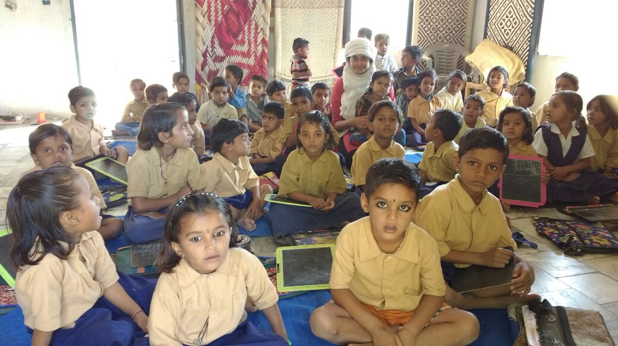
Pic 1: Kids in Gajnabas schools

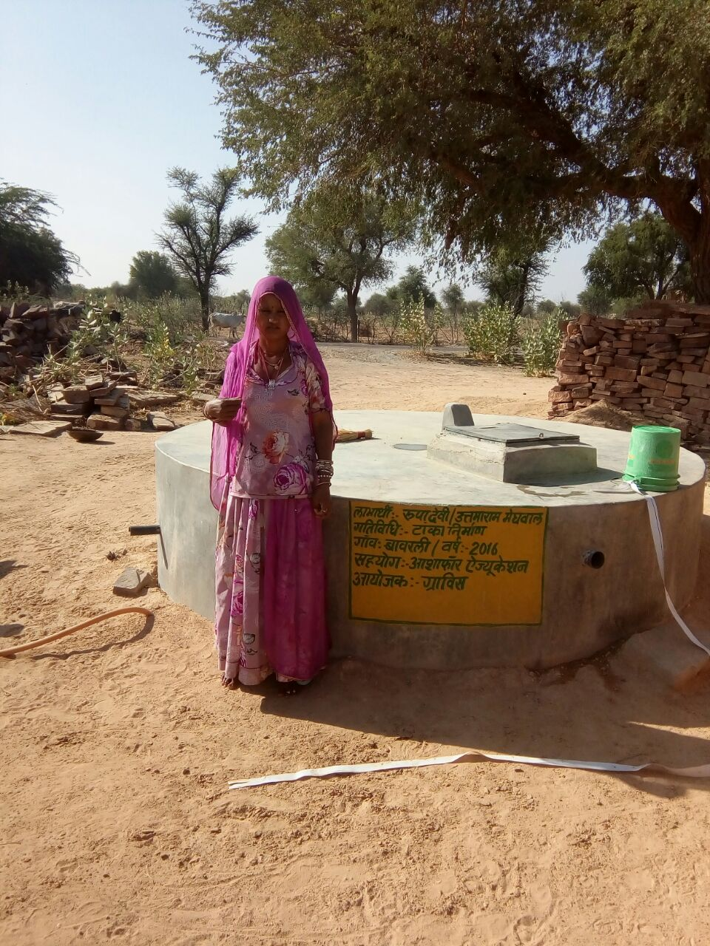
Pic 2: Taanka Beneficiary

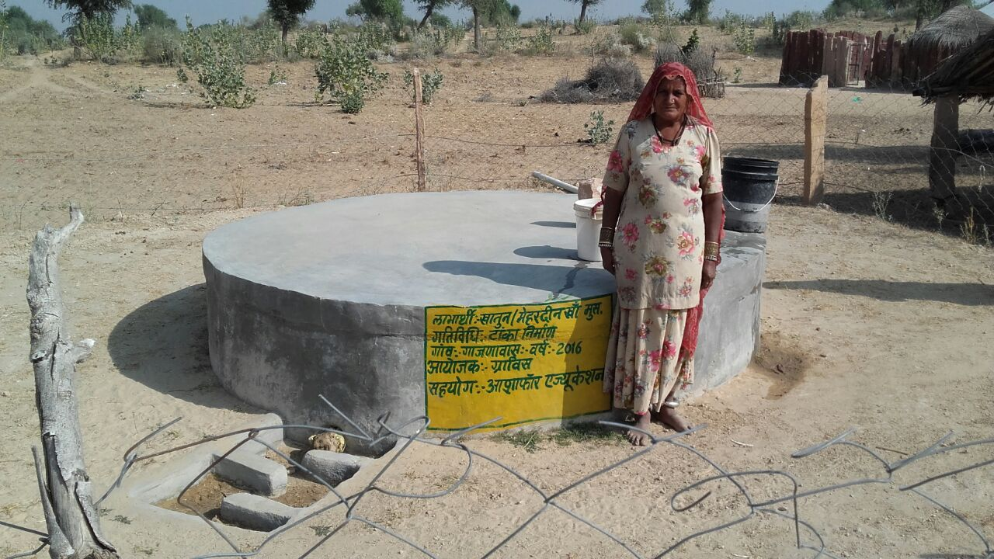
Pic 3: Taanka Beneficiary

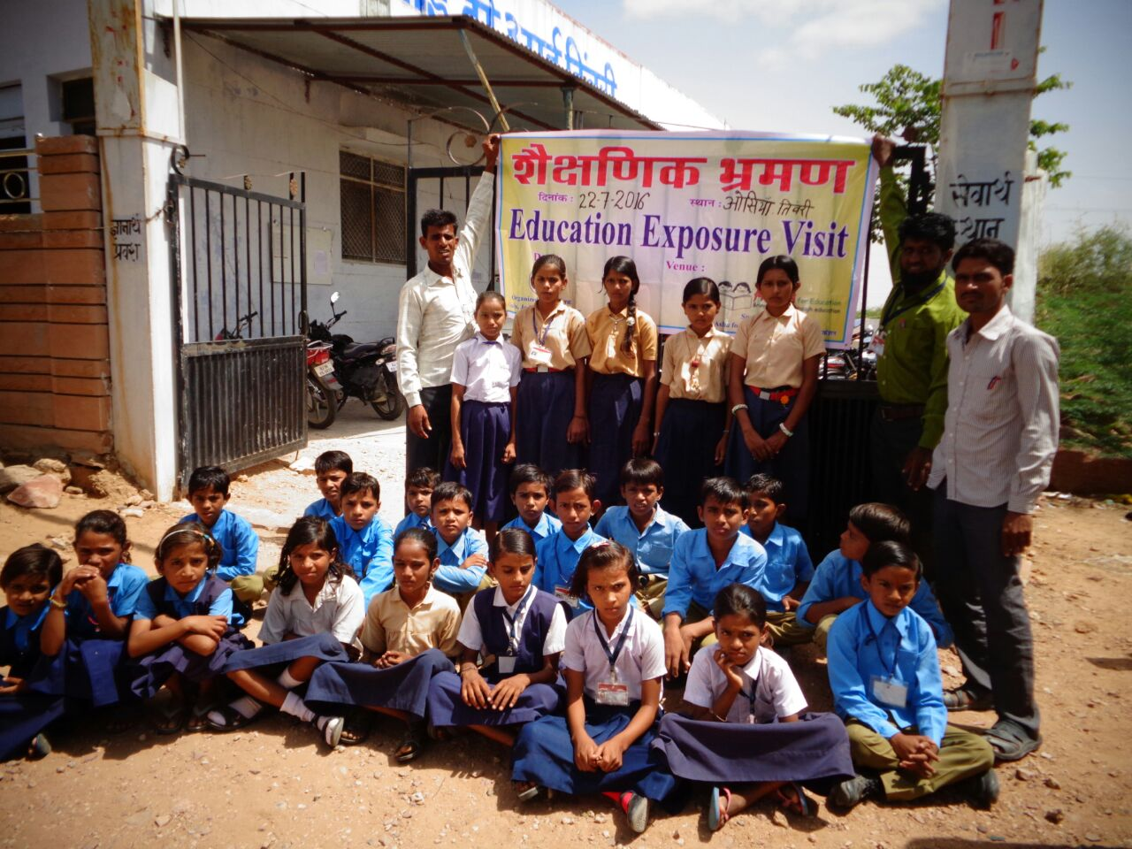
Pic 4: Exposure Visit
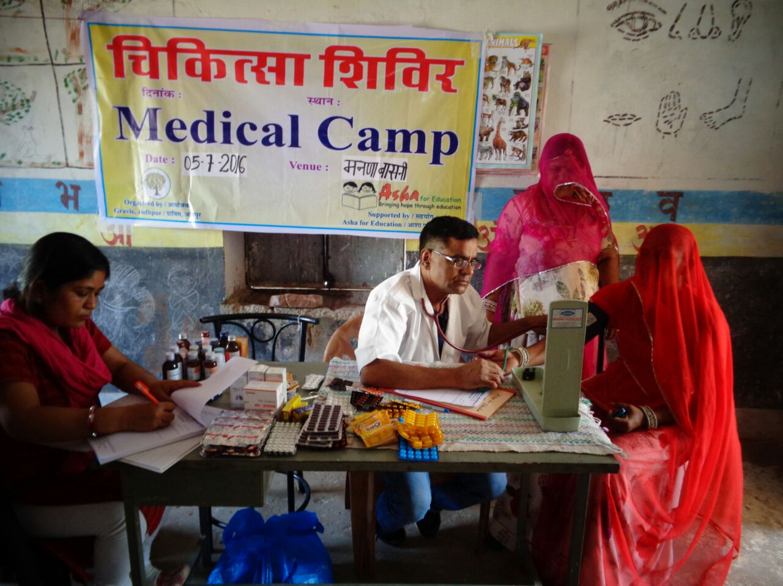
Pic 5: Medical Camp

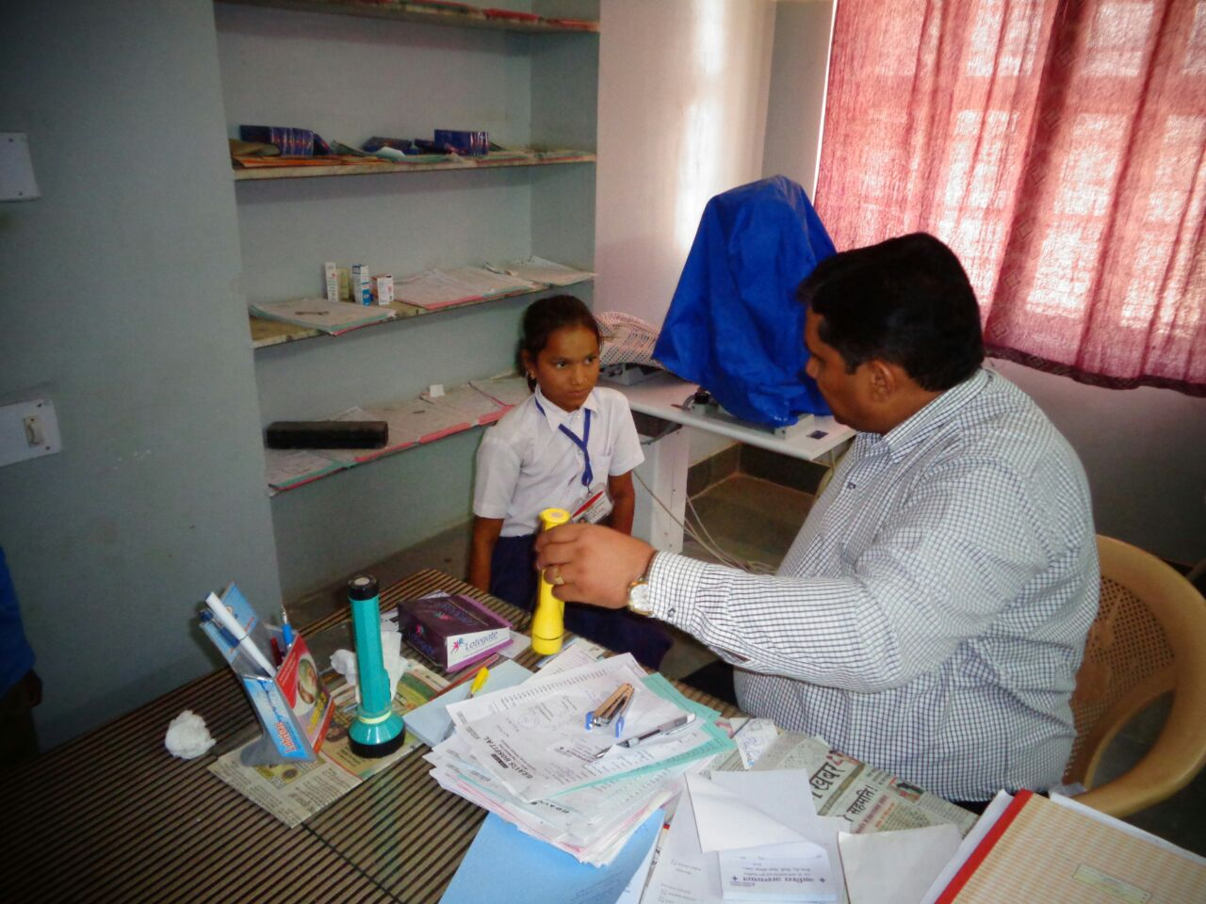
Pic 6: Health check-up of children
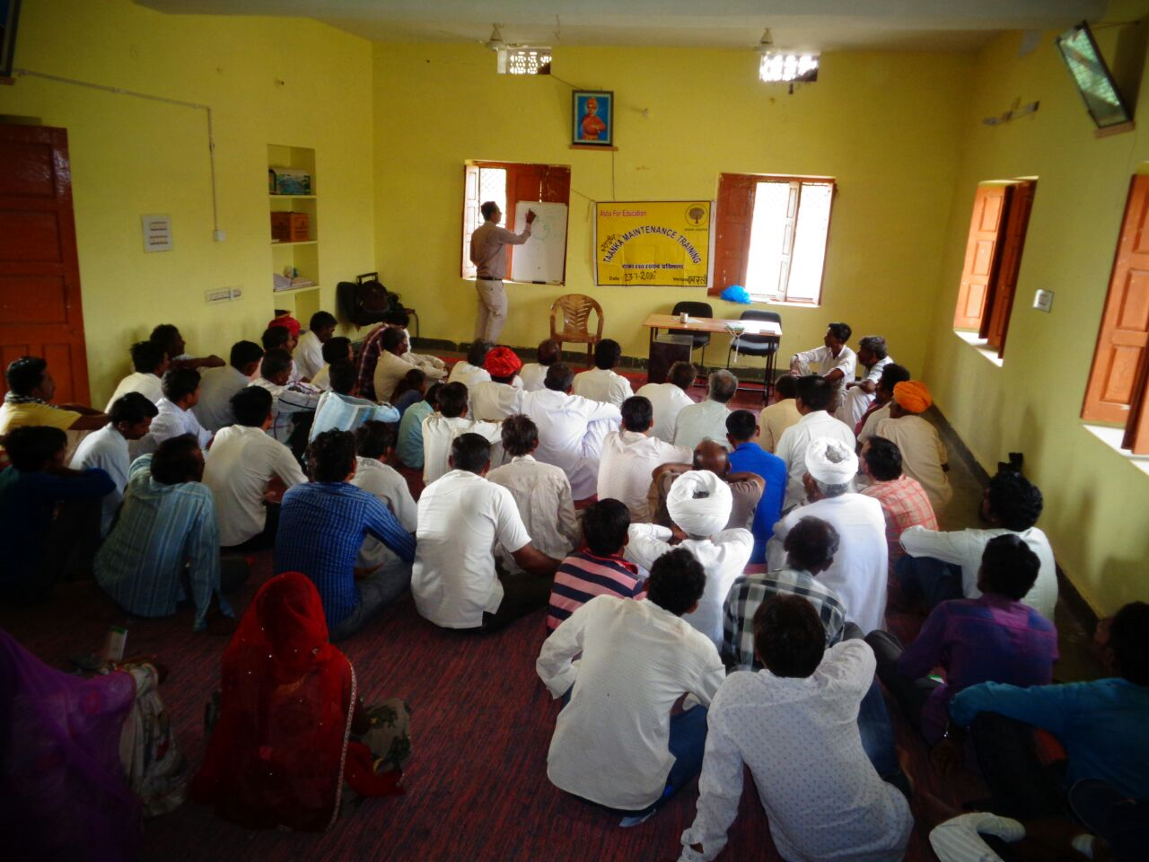
Pic 7: Taanka Maintenance Training

