Navjagriti Collective
37,Sarai kale khan,1st floor
Nizamuddin,New Delhi-110014
India
09810997490 / 09717655371
Annual Activity Report
Project Period: April 2016 to February 2017
Activities
The activities carries out with the children during the period are as follows:
We celebrate all the Indian festival with great joy and happiness. Children are taught to celebrate all Indian festival and not to fall under the game of caste barrier. Festival celebrated each year includes Diwali, Eid, New Year, Christmas, Raksha bandhan, Holi, vasant panchami etc. Festival are always fun and are denoted by delicious food, party, dance etc. All the children and the staff are family and thus celebrate these festivals all together. Festivals give a new meaning to life. Each festival has some significance and importance. Navjagriti believes that Indian festival and cultures are our heritage and also we celebrate a birthday each month.
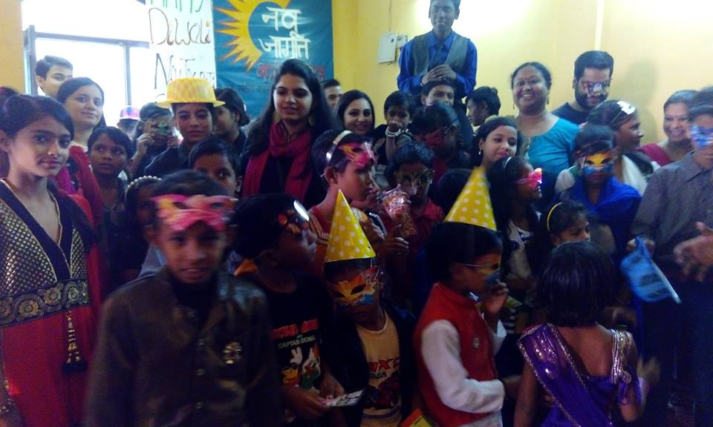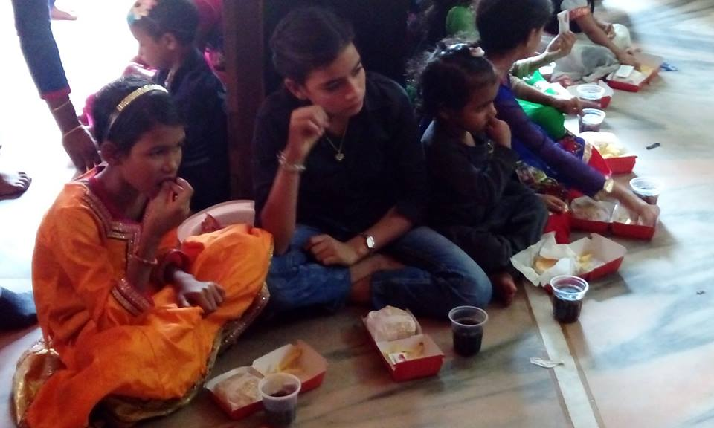
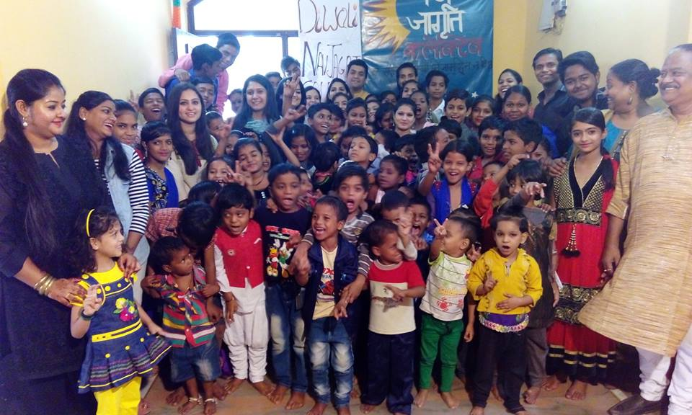
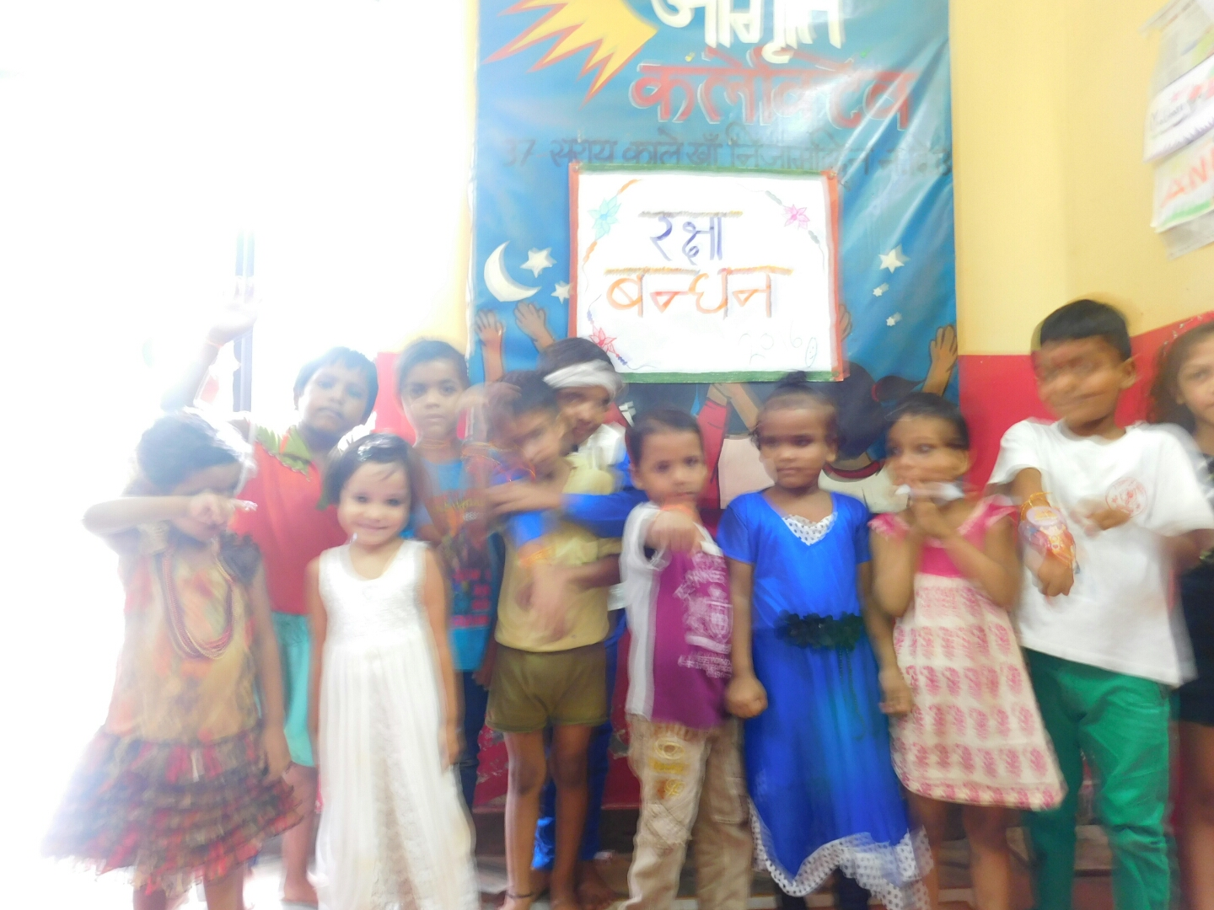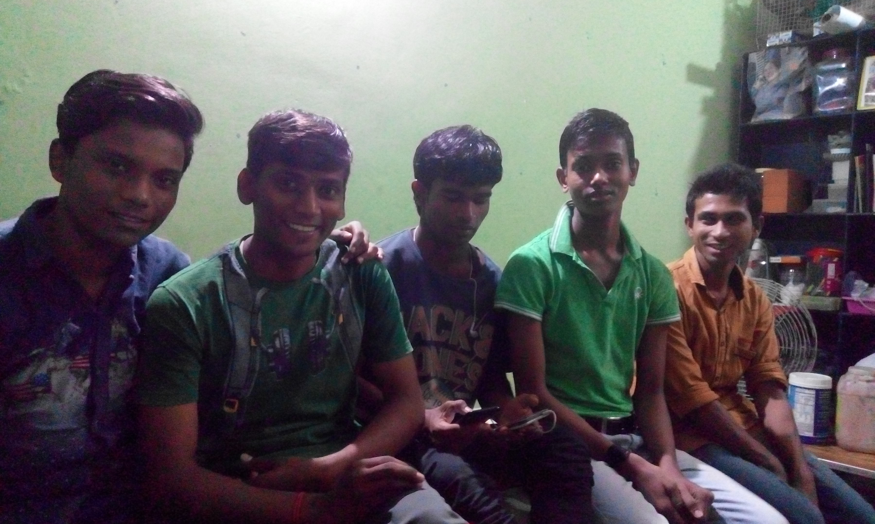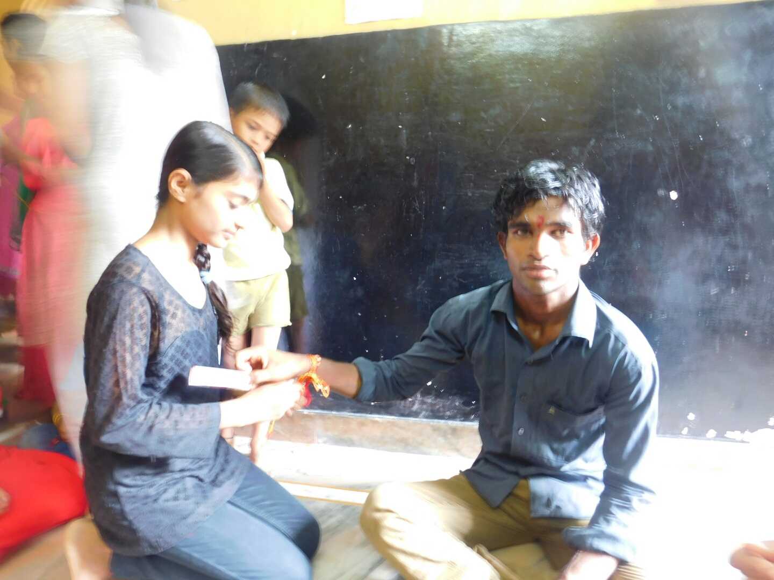
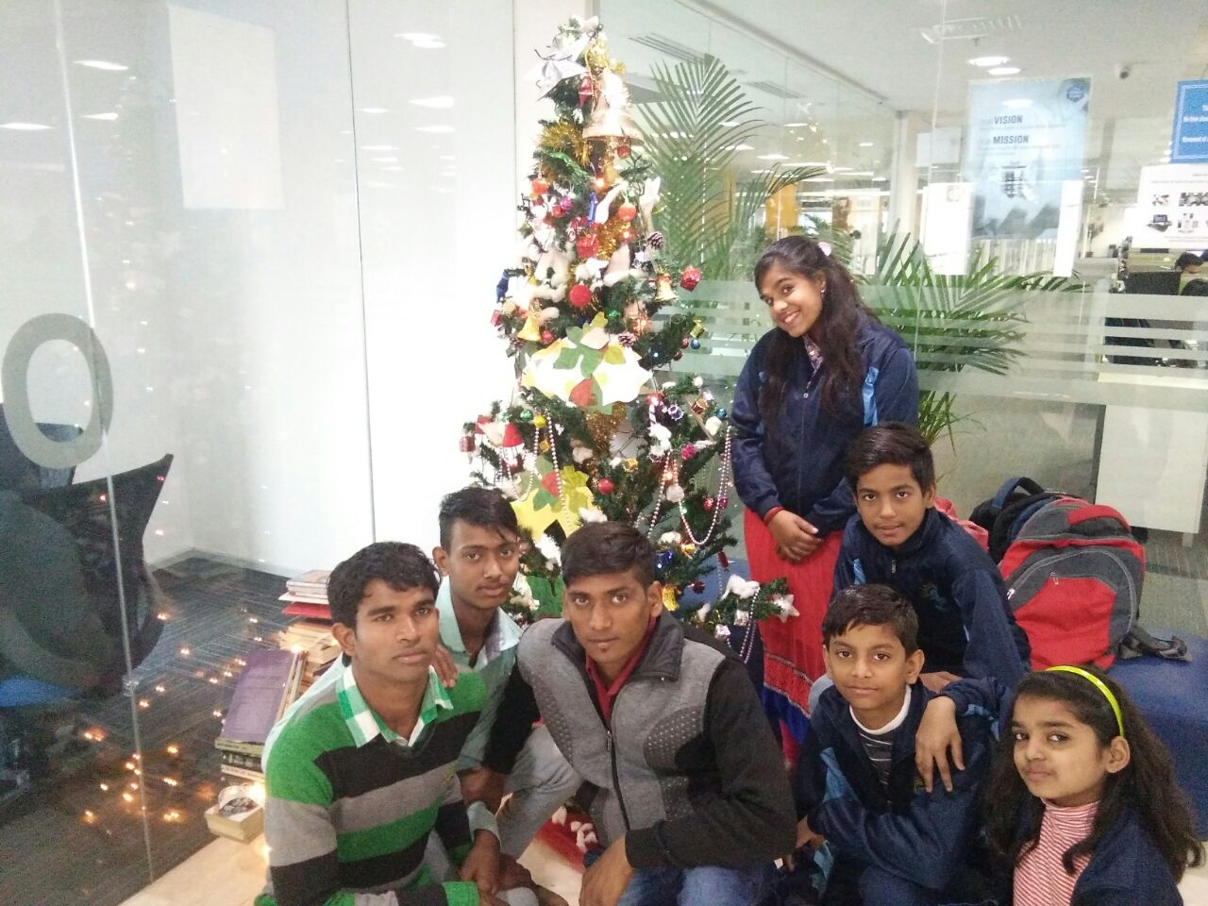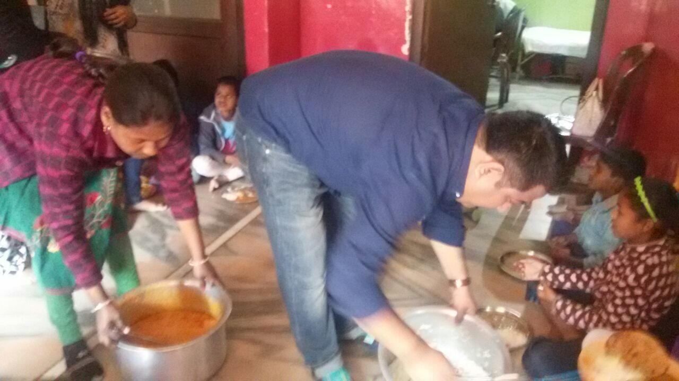
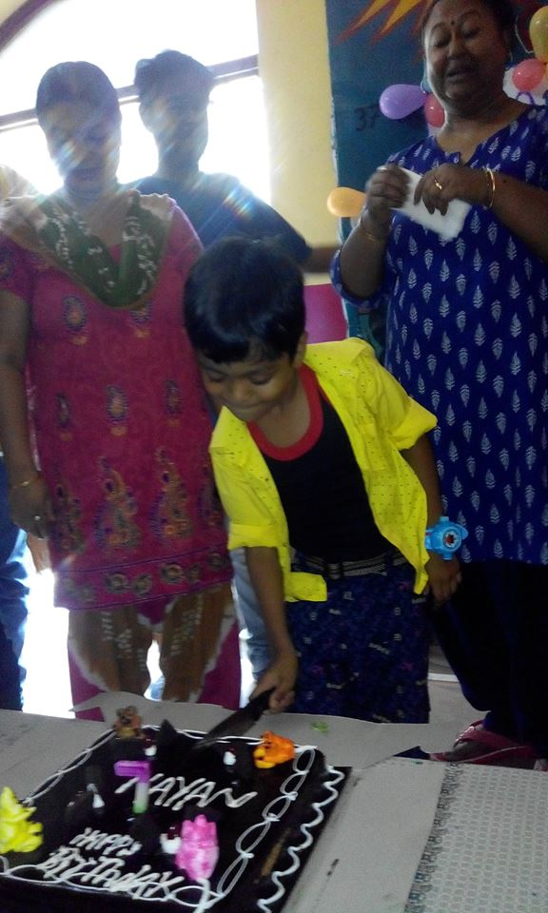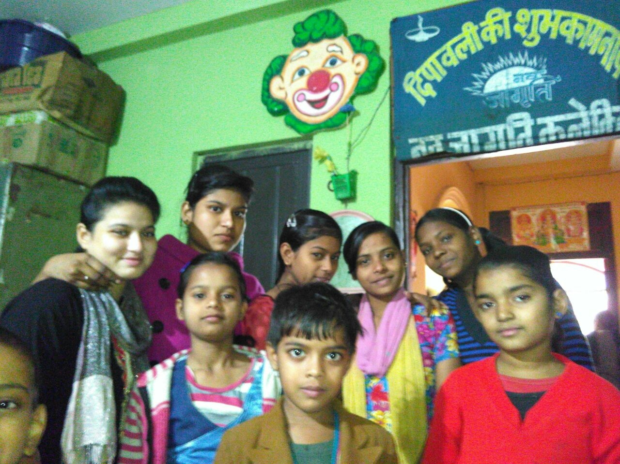
Workshop at National Bal Bhawan(May): The workshop organized by the National Bal Bhawan, focused on various activities like cricket, football, karate, badminton, kabaddi, chess, science activities, clay art, painting, photography, dance, singing, drama, skating, etc. Each children participated in two games. Last day, they performed in front of huge audience. So it was our first time that we took participated in such a big program which was organized by the central government. Around 2000 children came from different parts of Delhi. The workshop lasts for about twenty days. Children learned a lot of things.
Workshop at Smart cube(December): A group of professionals called Smart cube who has been active in taking up the financial responsibility of NavJagriti. They were really supportive; they organized a workshop with the kids. Our kids got nice appreciation from the audience. Our kids tried to enact in order to imbue everyone with the color of motivational and inspiring force. We also performed nine pay which reflected the non violence and more the environment free of threats and attacks. Self composed songs were much appreciated by all. Smart Group provided an excellent and interesting platform for our kids to open up. The event was so memorable and nice. We all had a very good time there.
Workshop at ISKCON(January): Our kids went to ISKCON temple to attend a meditation workshop and it was very helpful because we got to know about various meditation and yoga techniques which can help us to bring a positiveness and calmness in today’s world.
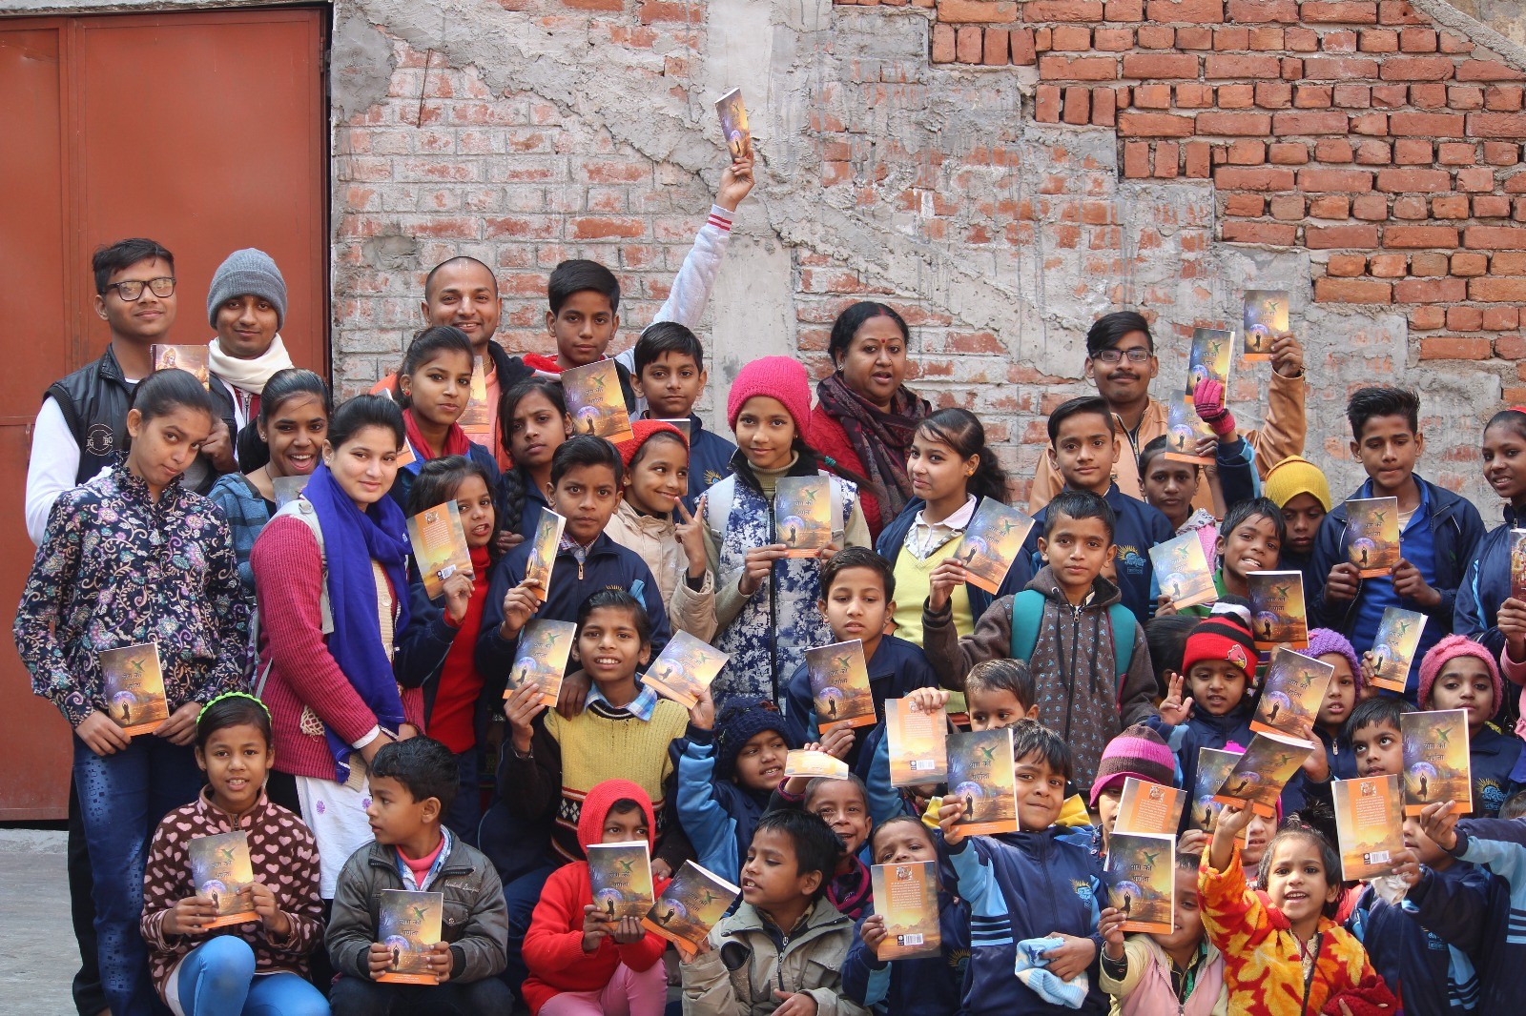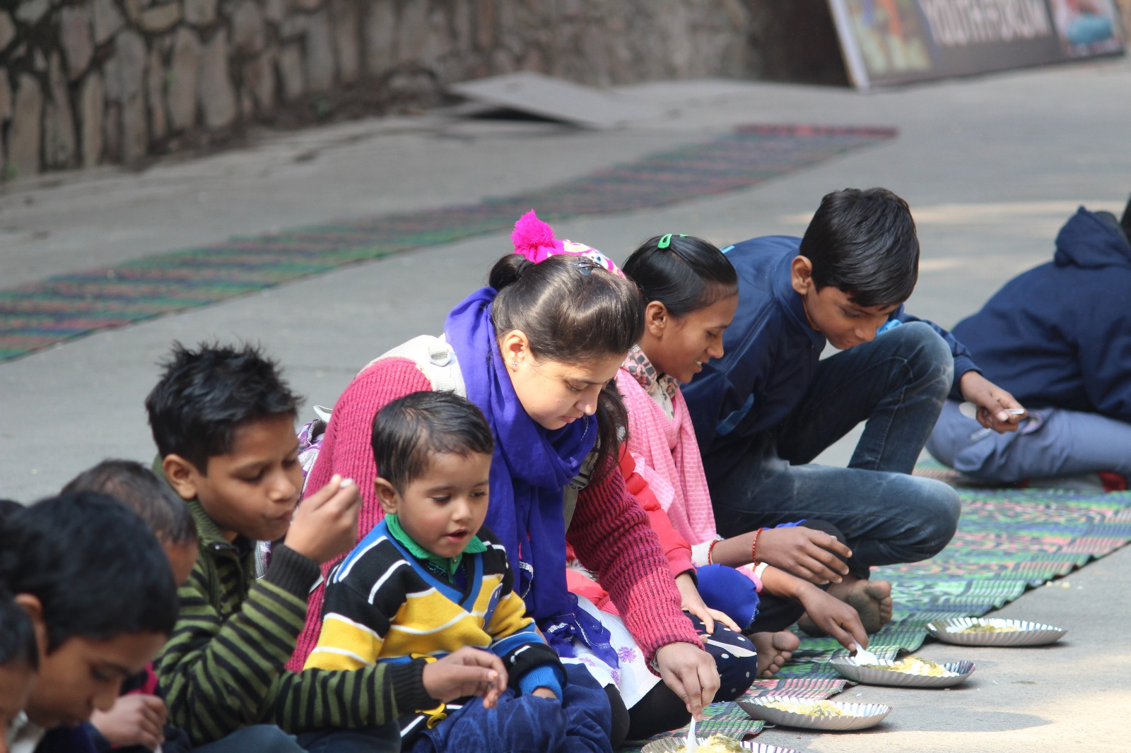
26 January Republic day celebrations
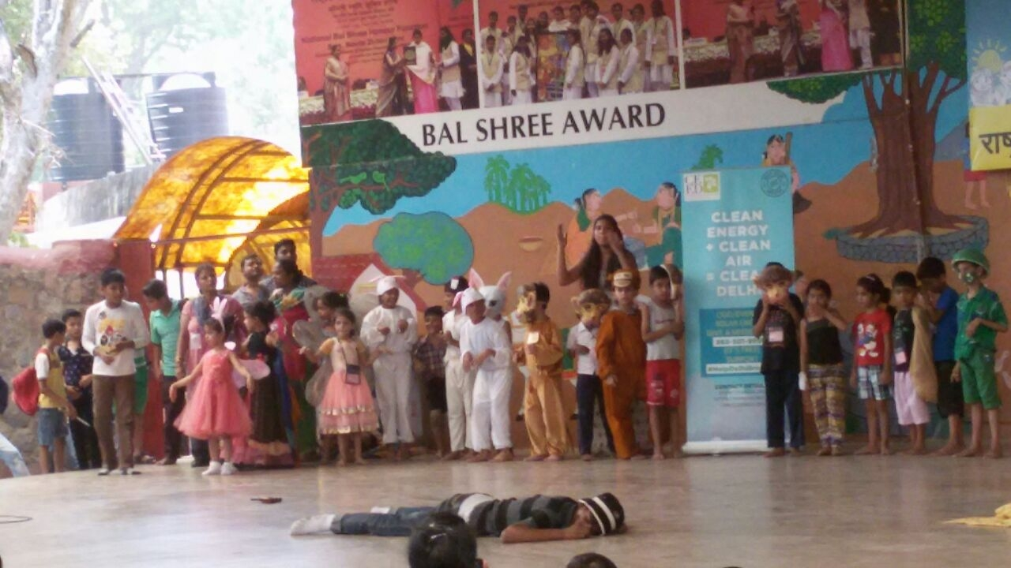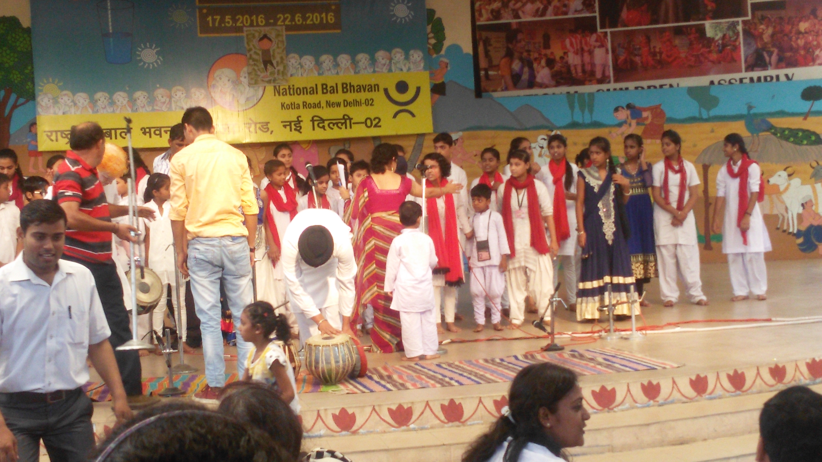

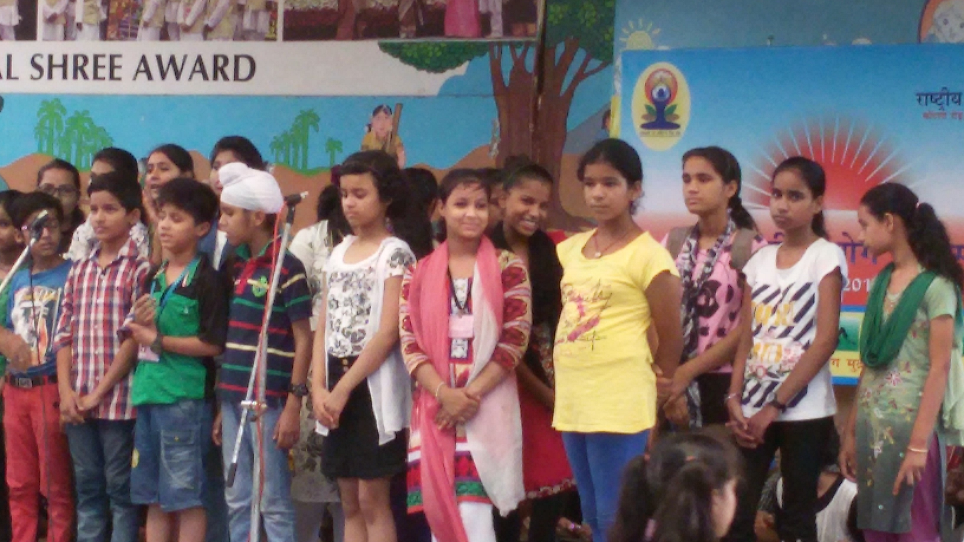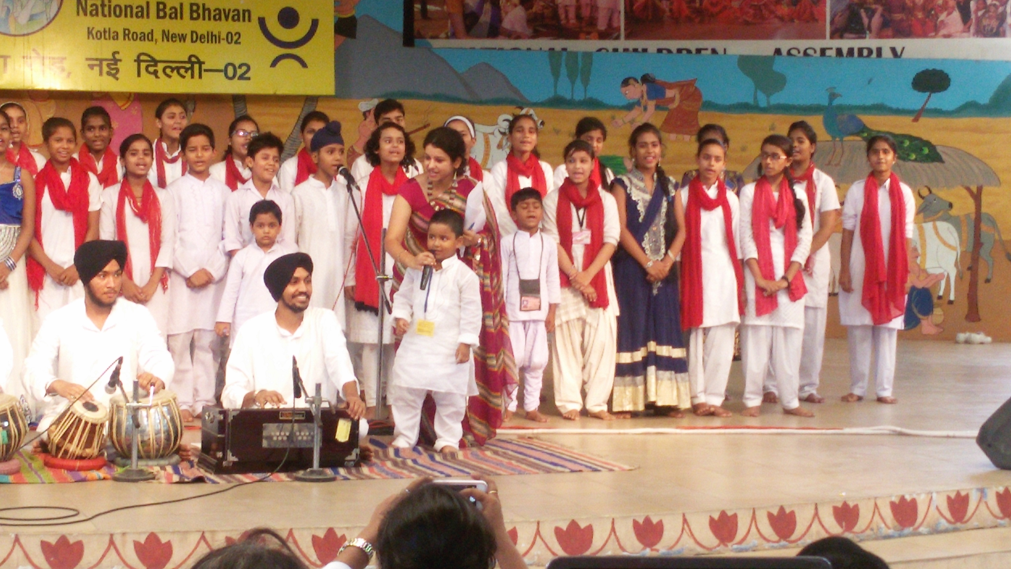
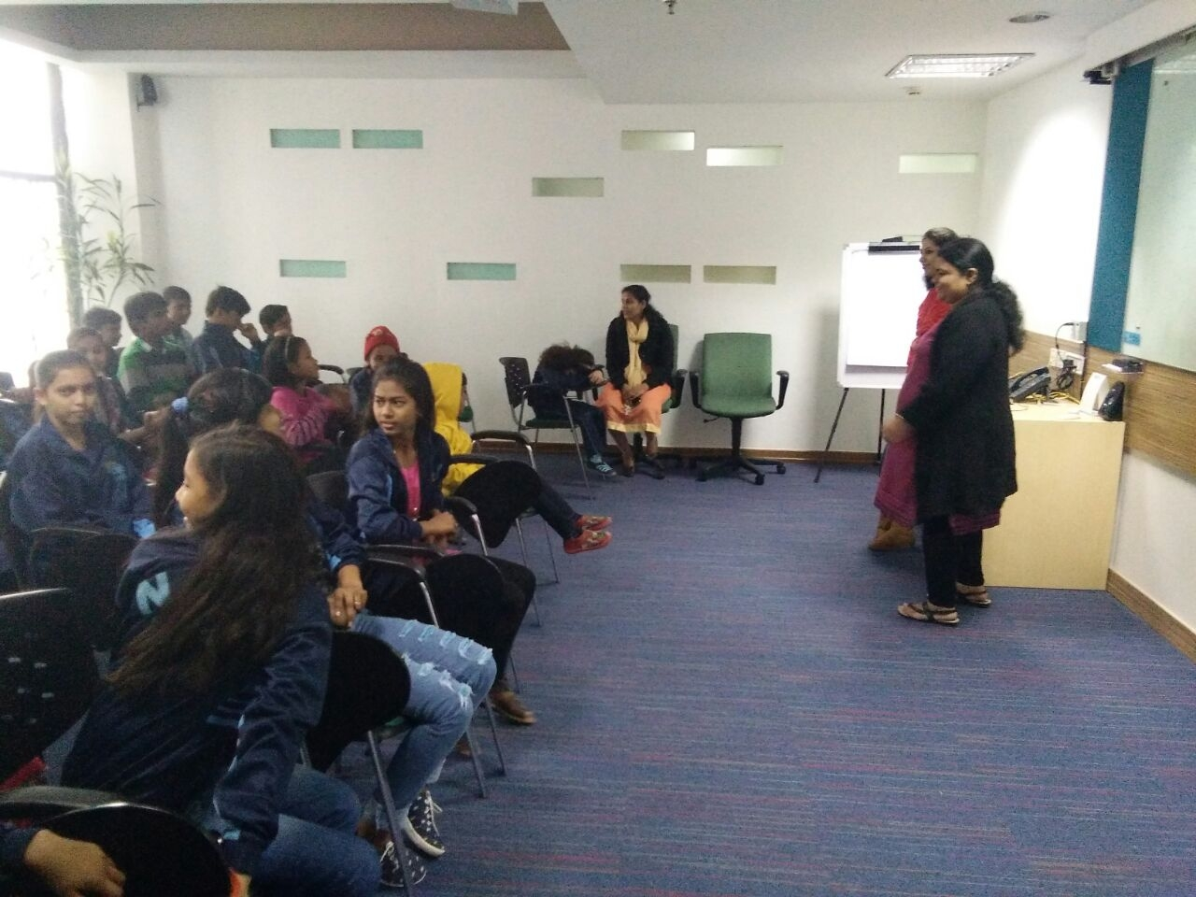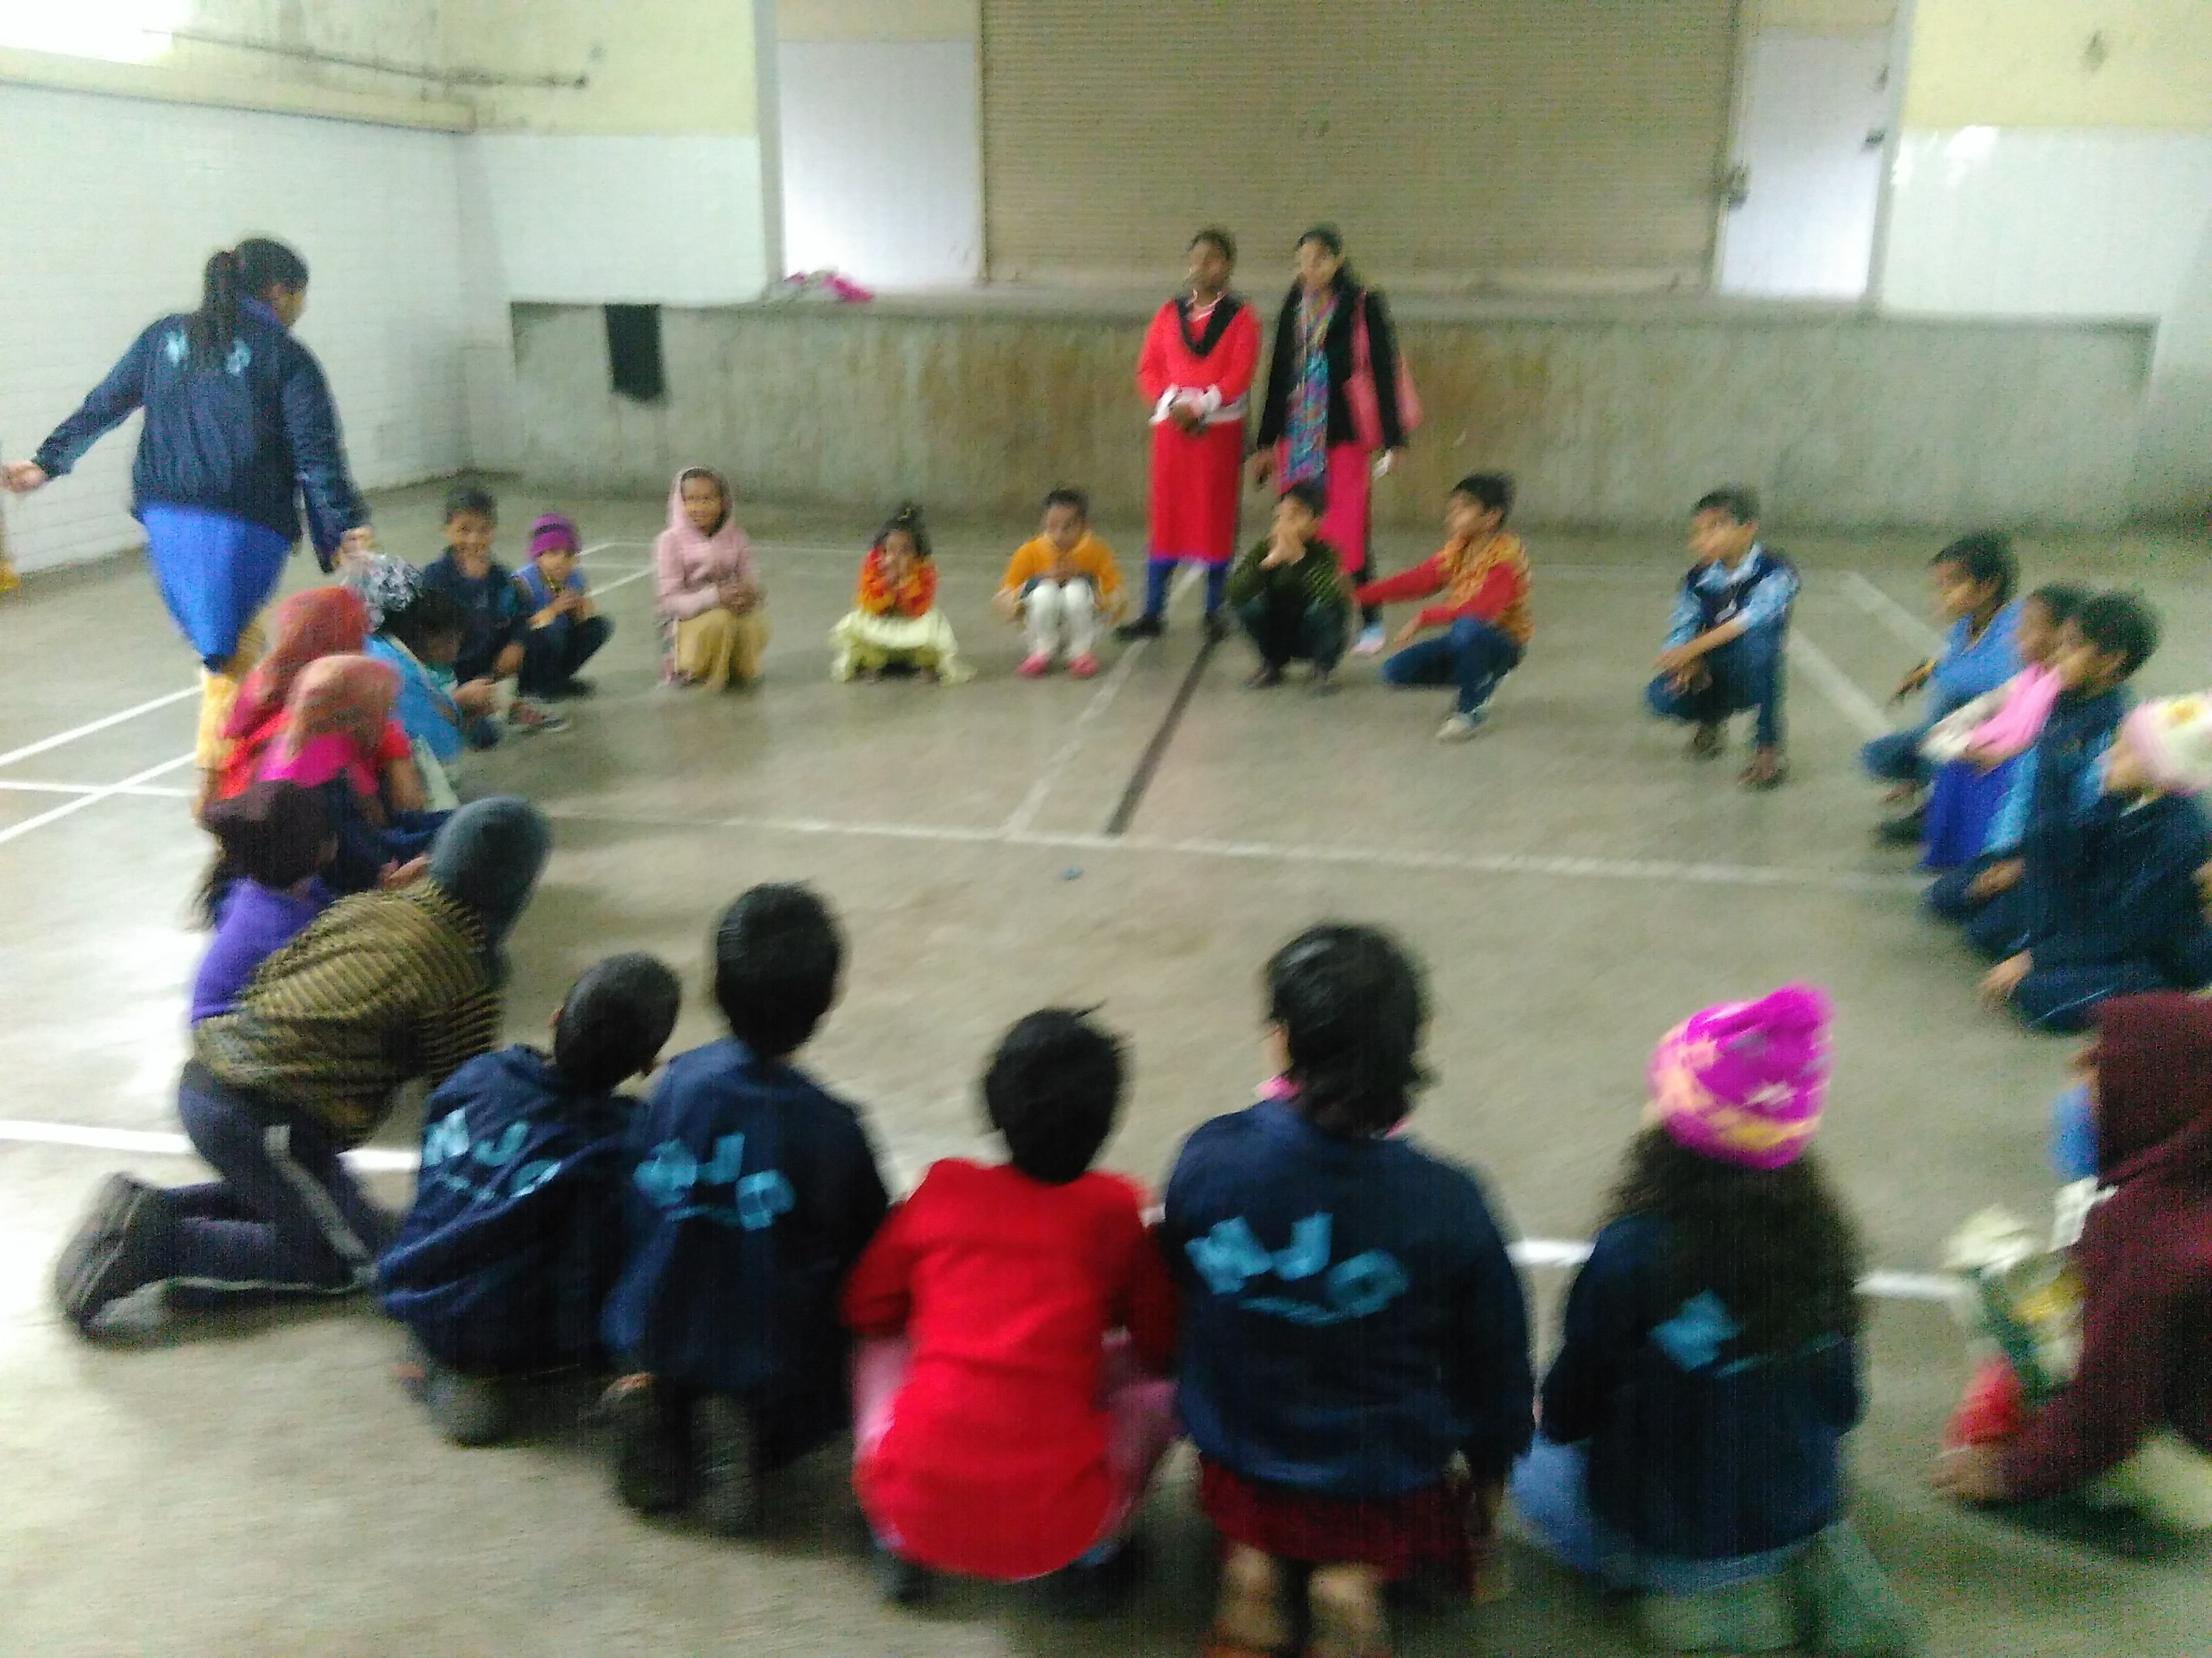

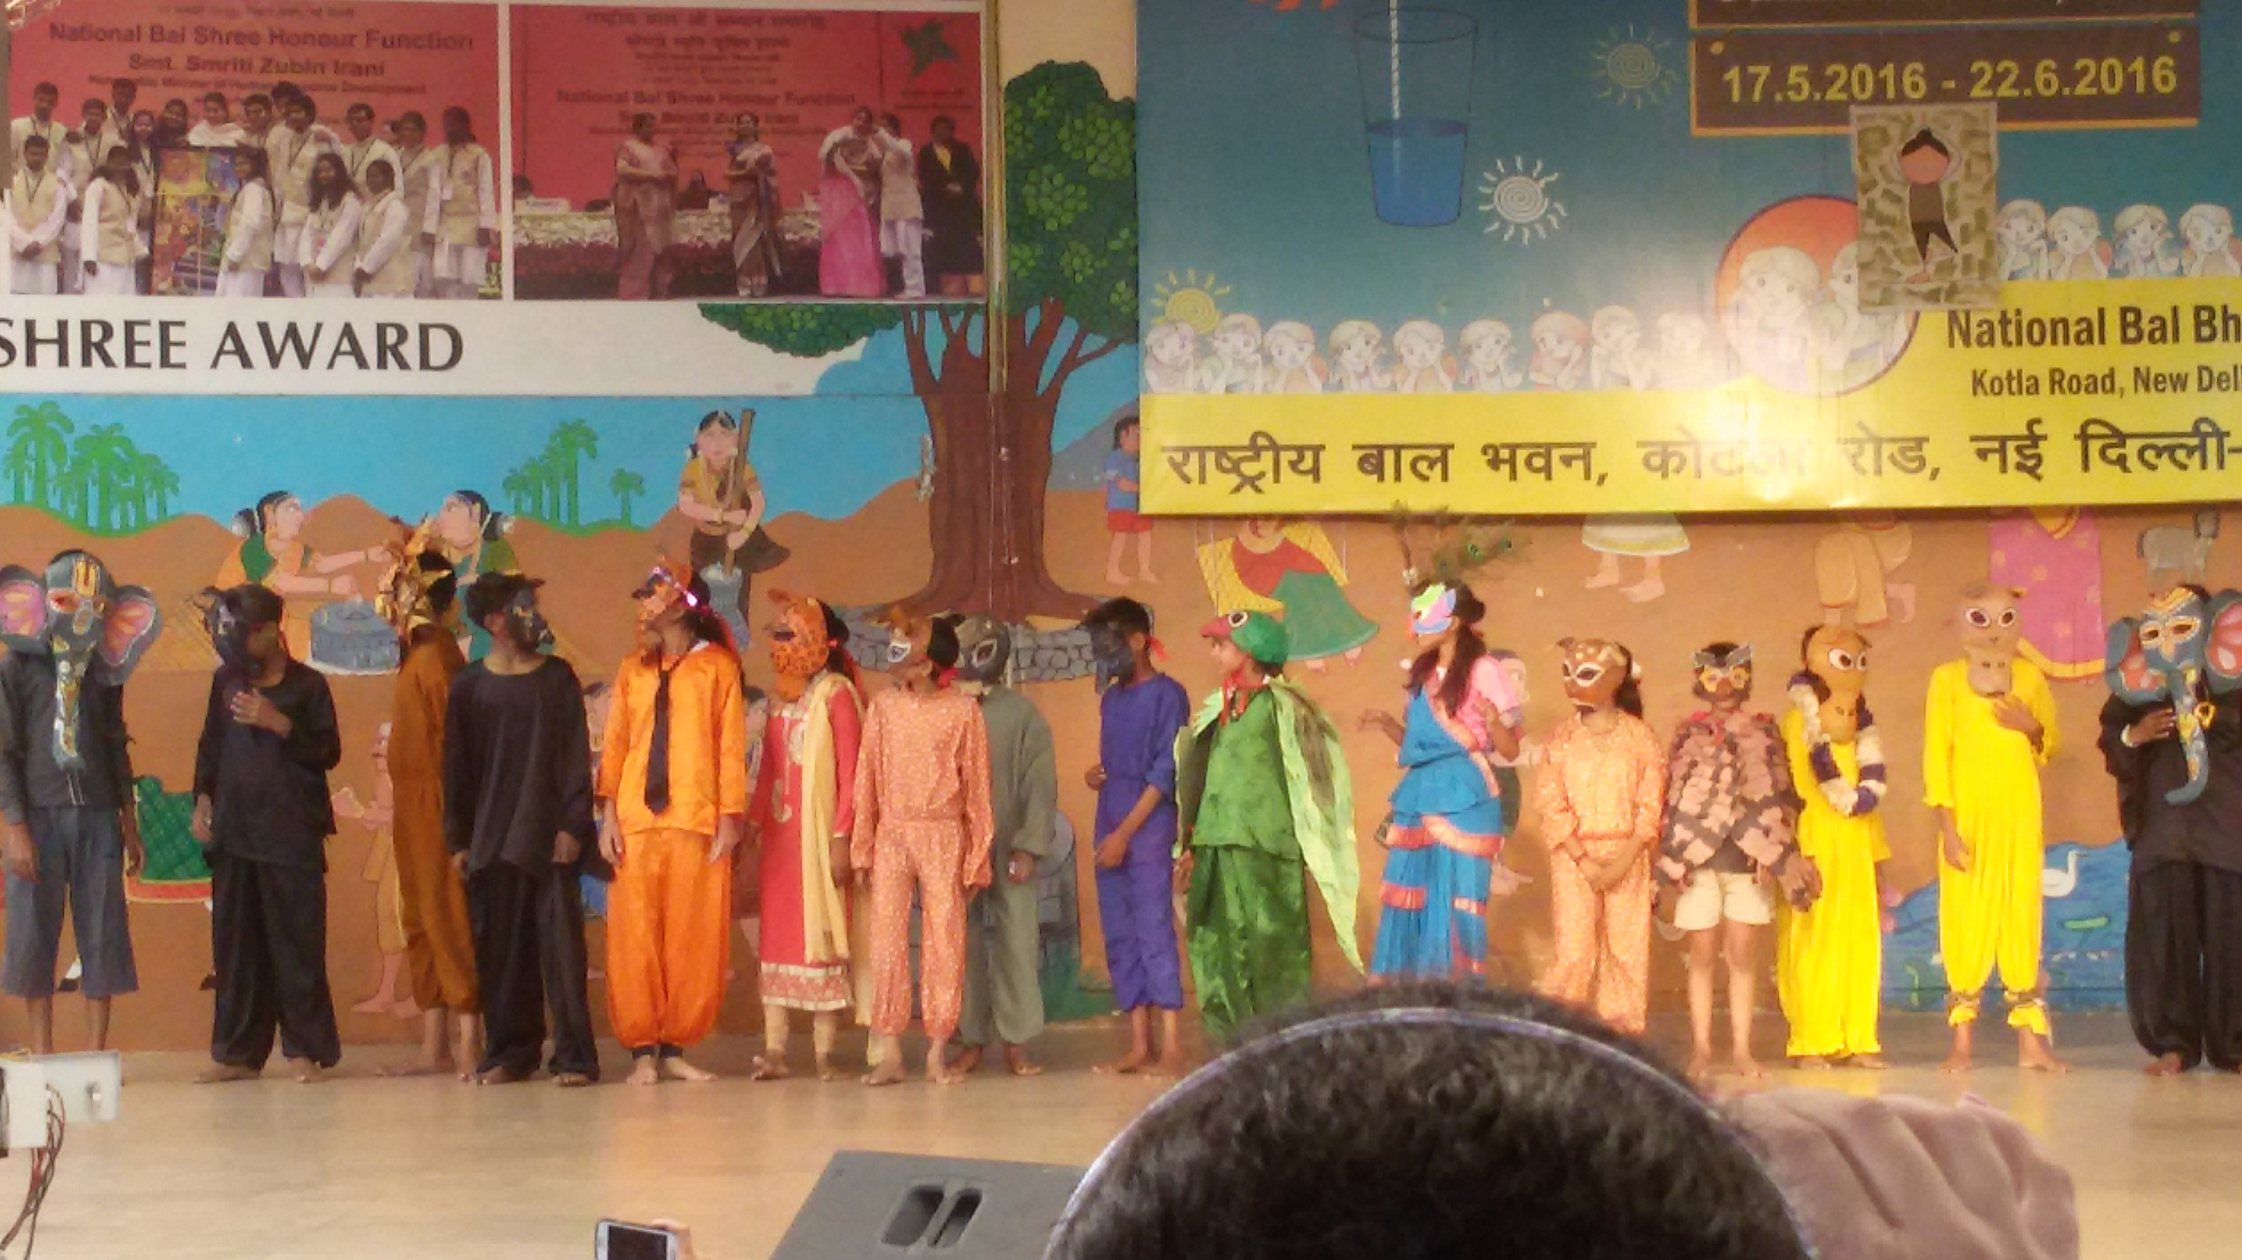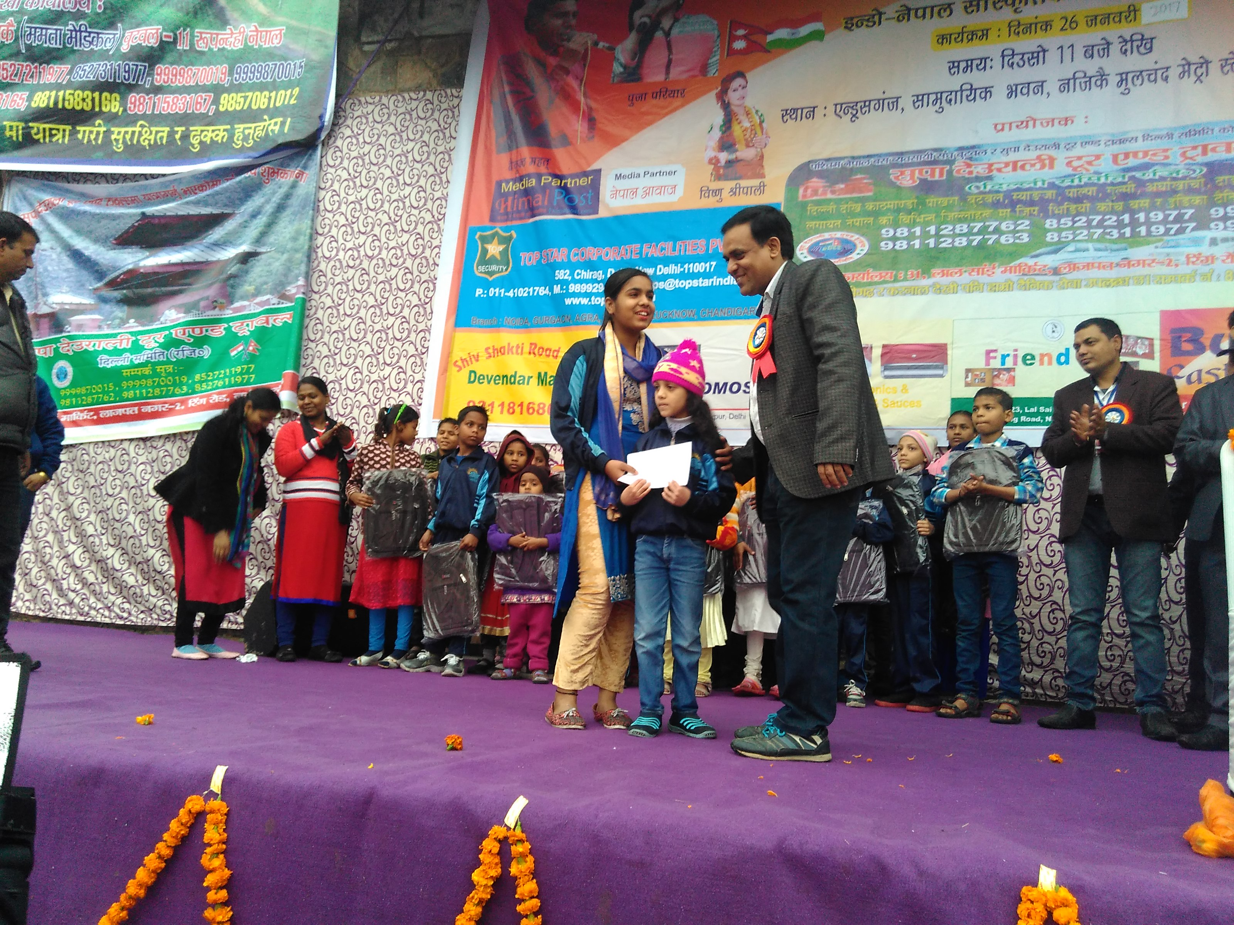

Extra curricular activities:
Navjagriti is providing computer classes to all the children above eighth class. Children are getting interested to the computers since there are getting computer classes from June 2016. Now they know to operate MS word, MS excel, MS power point and tally. They are very much enjoying the classes because now they are supported with the internet facility. They are getting the habit of reading blogs and do various things over internet.
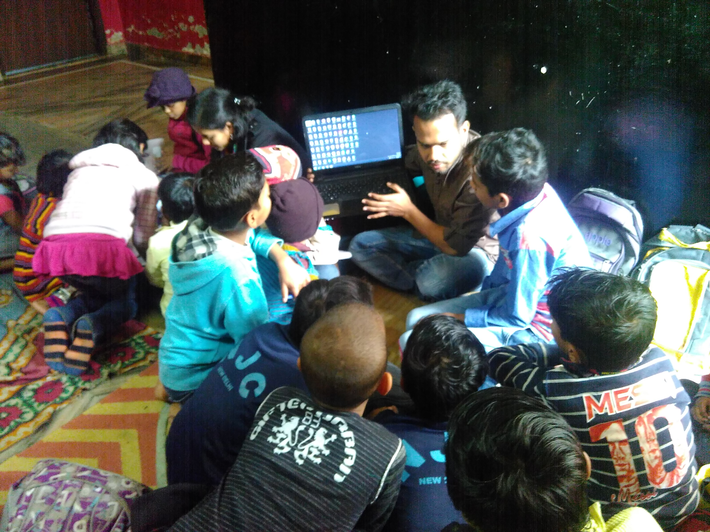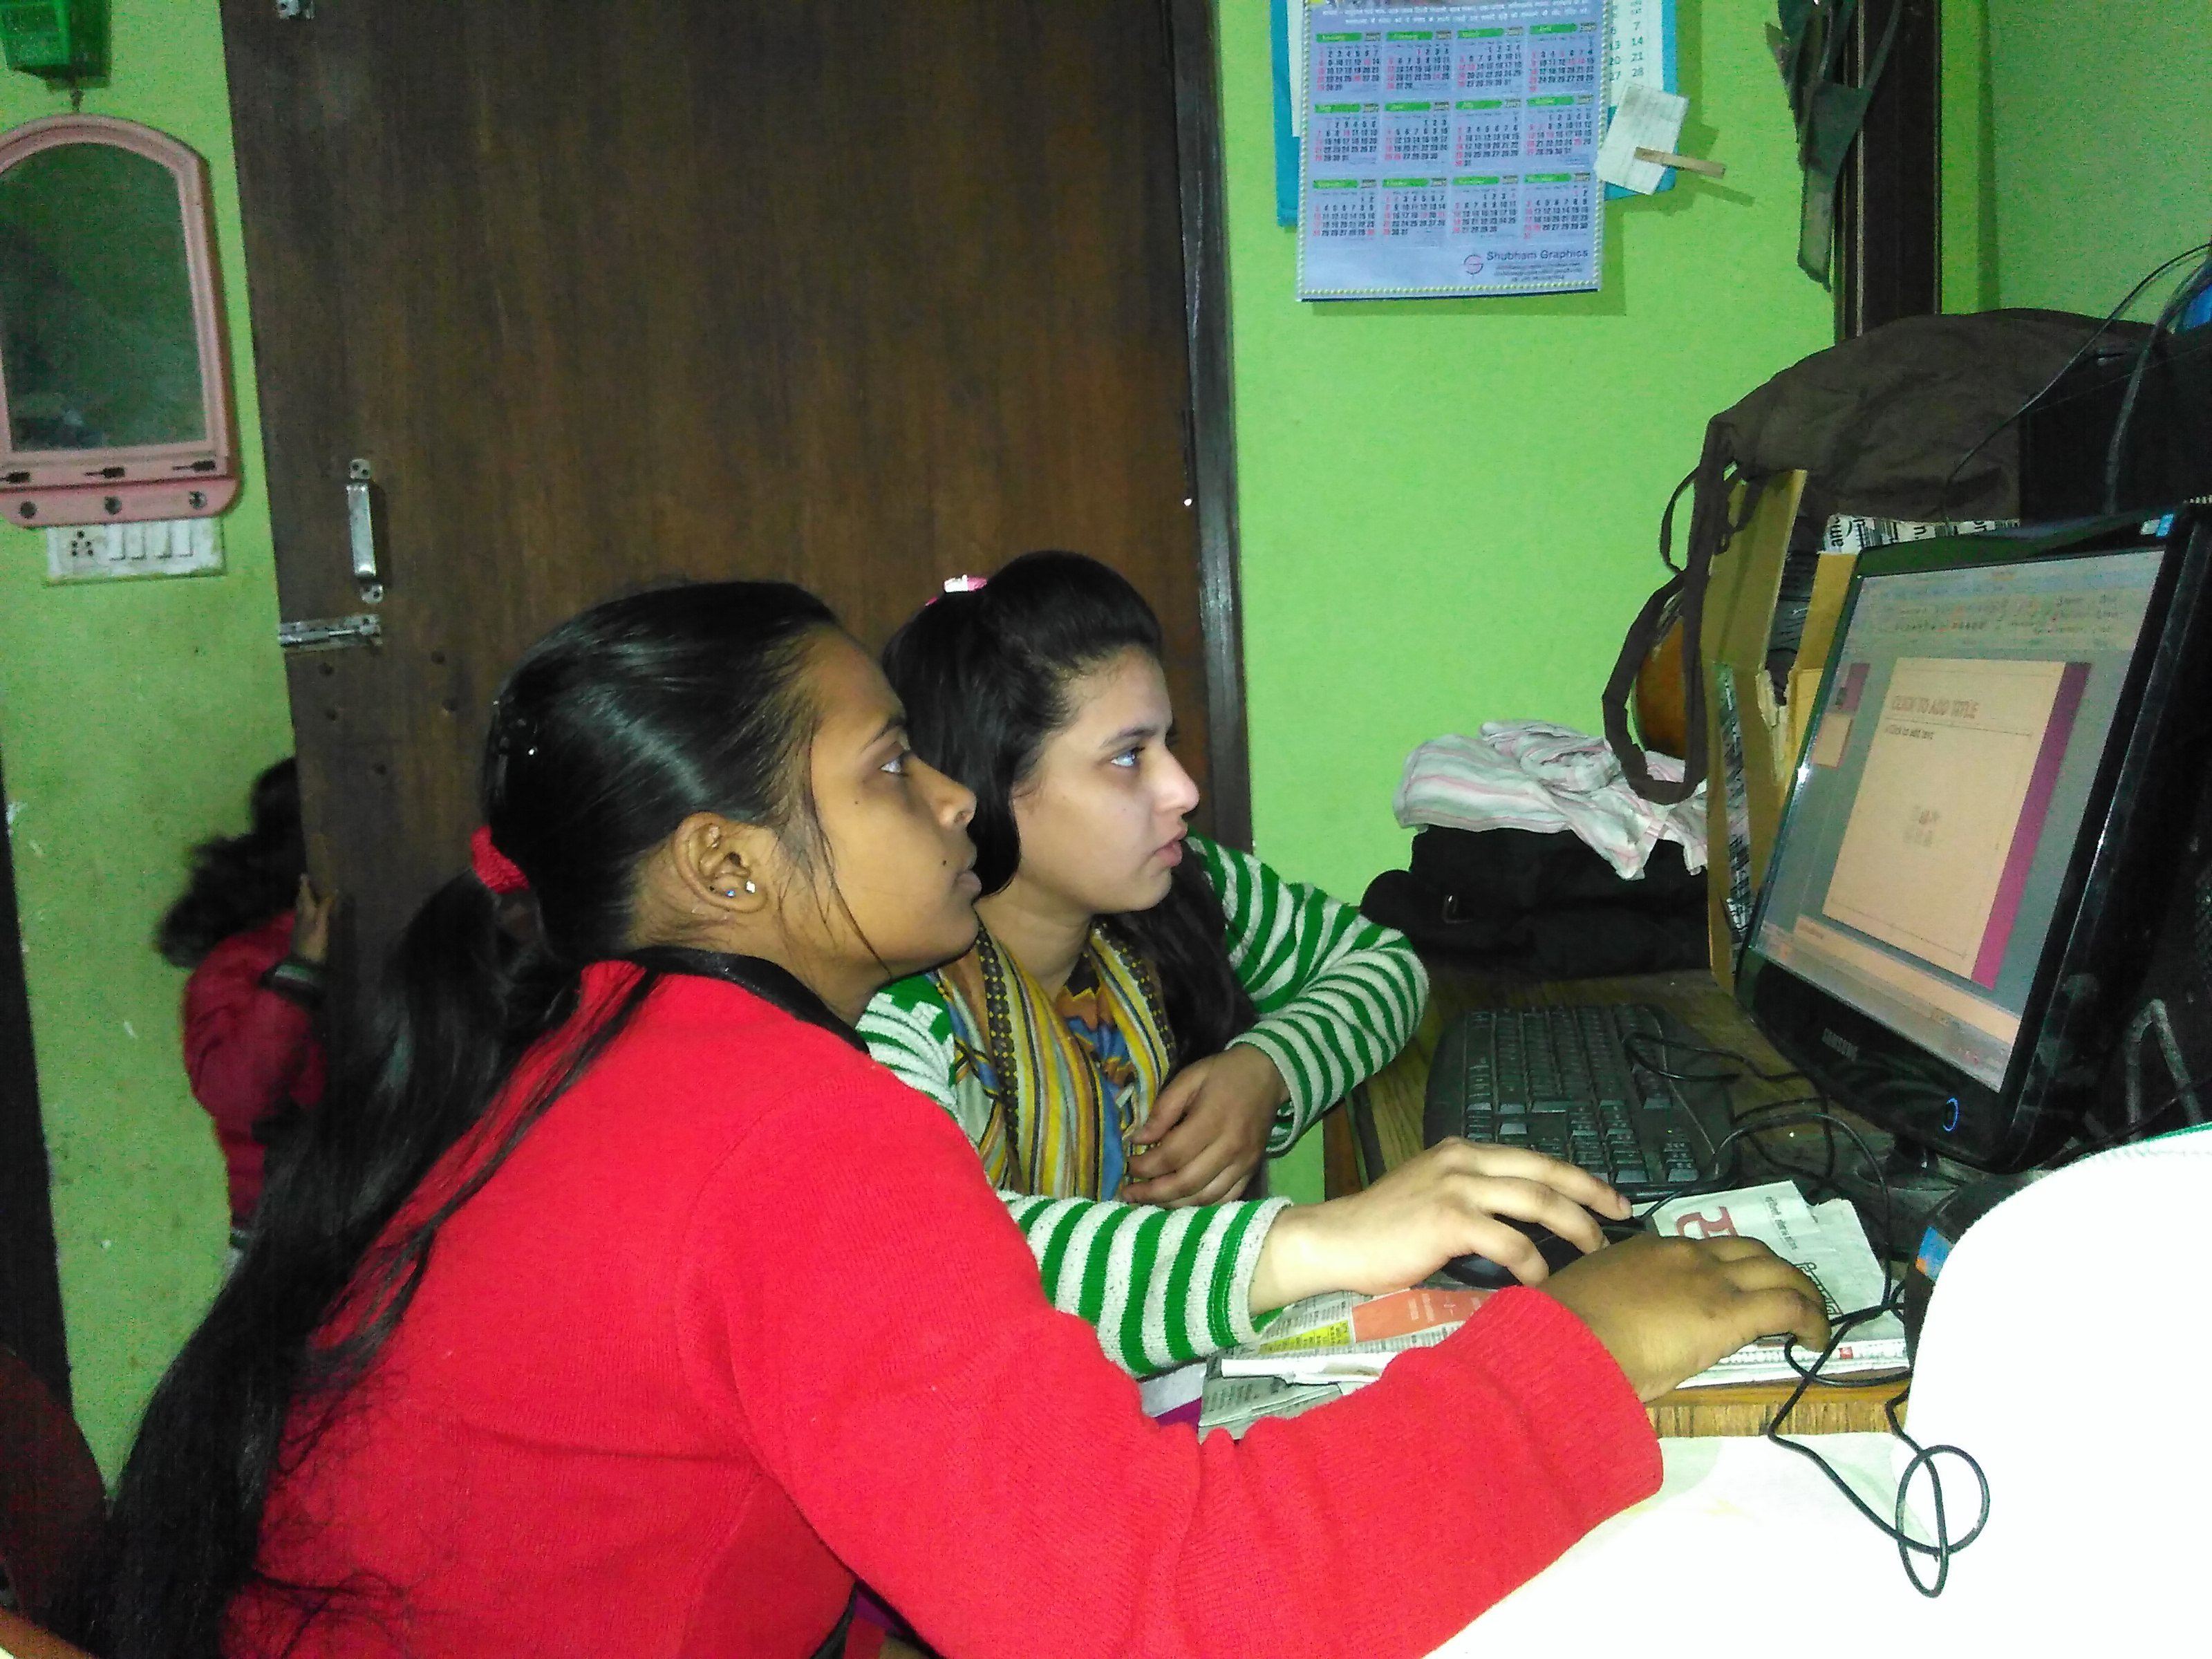
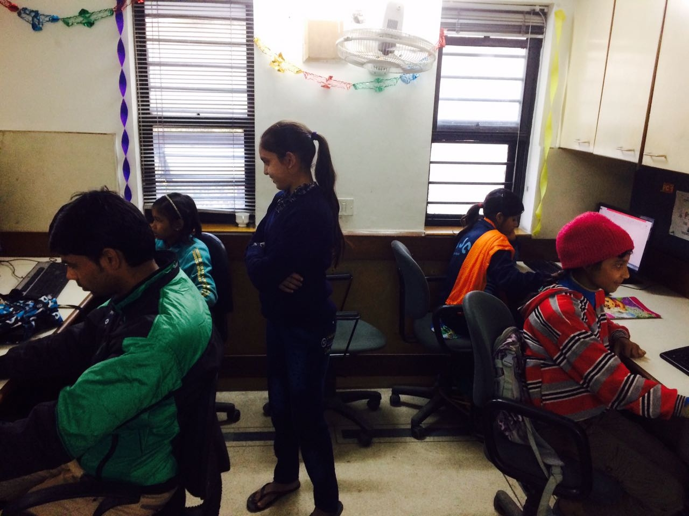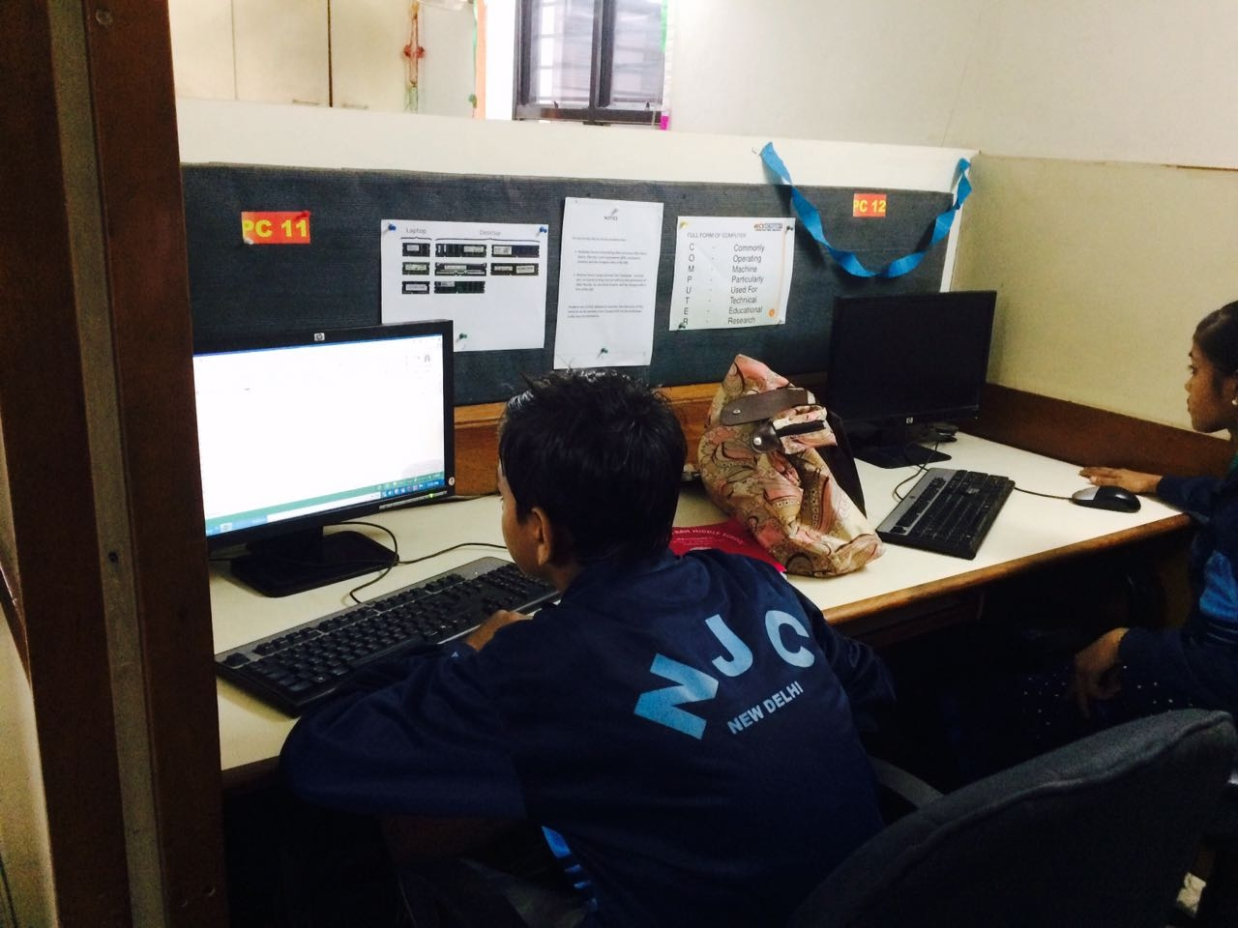

* Vishal Bhawsar , one of the student of Navjagriti got a job in subway after completing his tally course. So now he is doing his 12th studies from open school as well as working with subway as a part timer.

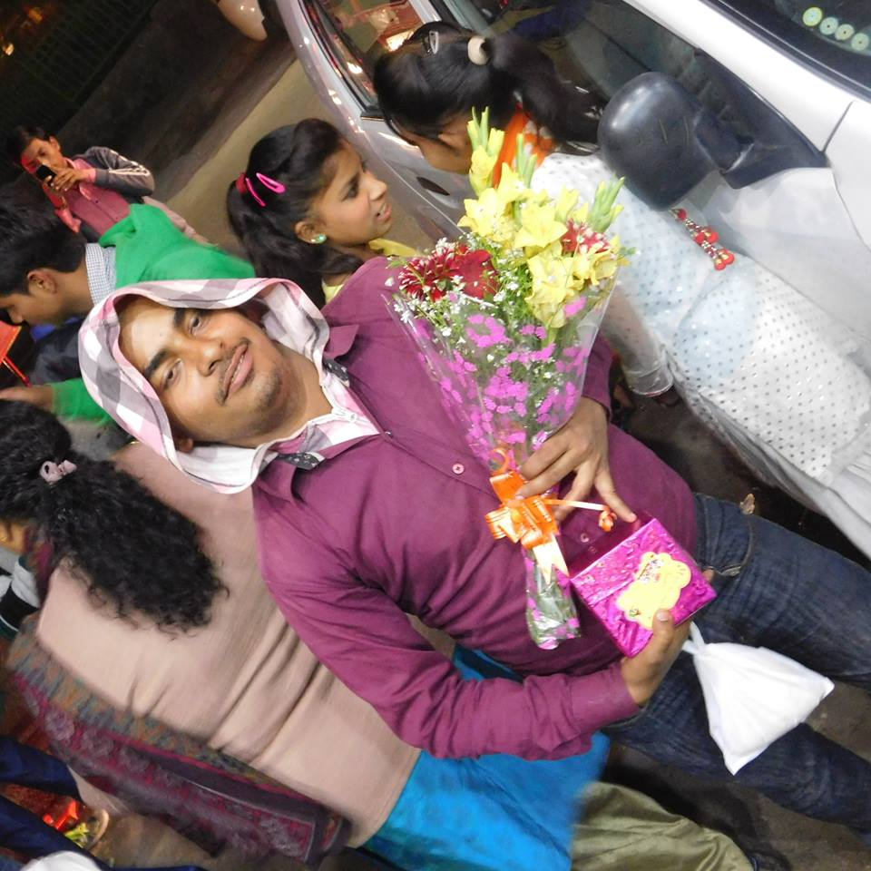

Educational trips are important in many ways.
Educational trips should always have a major educational element, but the impact of Educational trips can extend much further. The importance of Educational trips includes giving children the chance to build closer bonds with their friends, experience new environments and enjoy a day away from the center.Educational trips provide valuable educational opportunities away from the center, without using textbooks and other tools used in a normal school setting.children on Educational trips can often learn while having fun in a more informal environment. If the Educational trip destination has staff members who do hands-on teaching with visiting students -- such as at a science center or historical museum -- the children will be excited to learn from someone new
Navjagriti is organizing two trips annually. This time we went to WOW (worlds of wonder-August) and mussoorie(January-Maria). Both the trips were good and we enjoyed a lot. These trips are not meant for fun only, it helps to bring a positive change to the children since they learn discipline, travel, and learn to coordinate with each other. It is the only time in the year when we gets a chance to be together and learn good habits from each other.
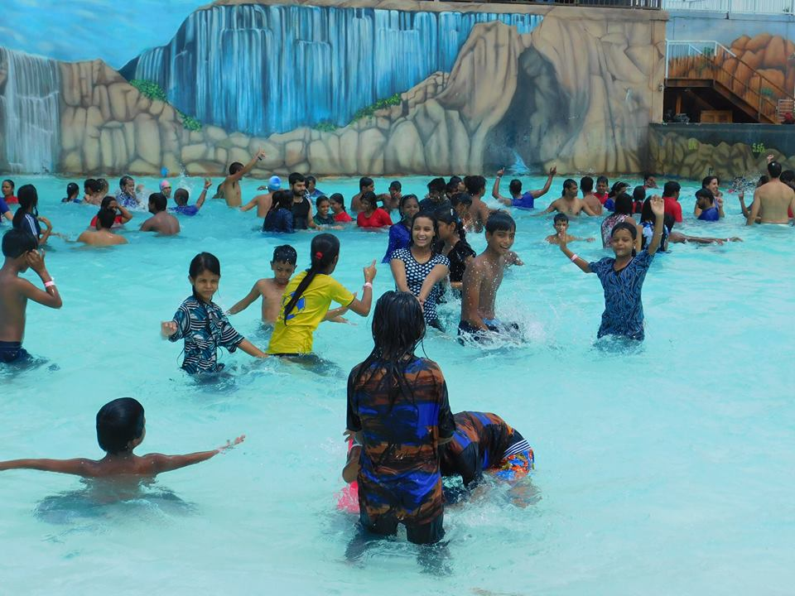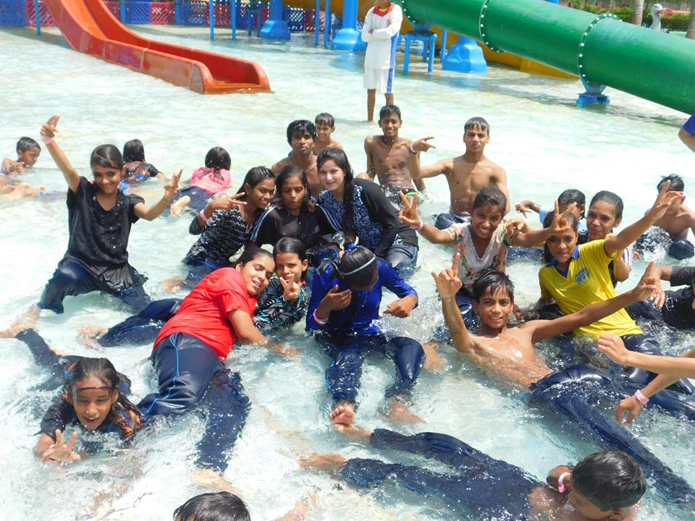
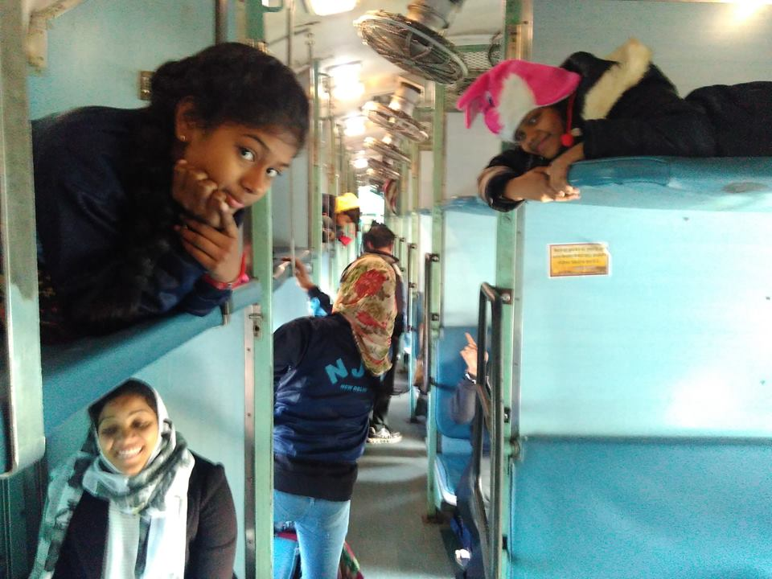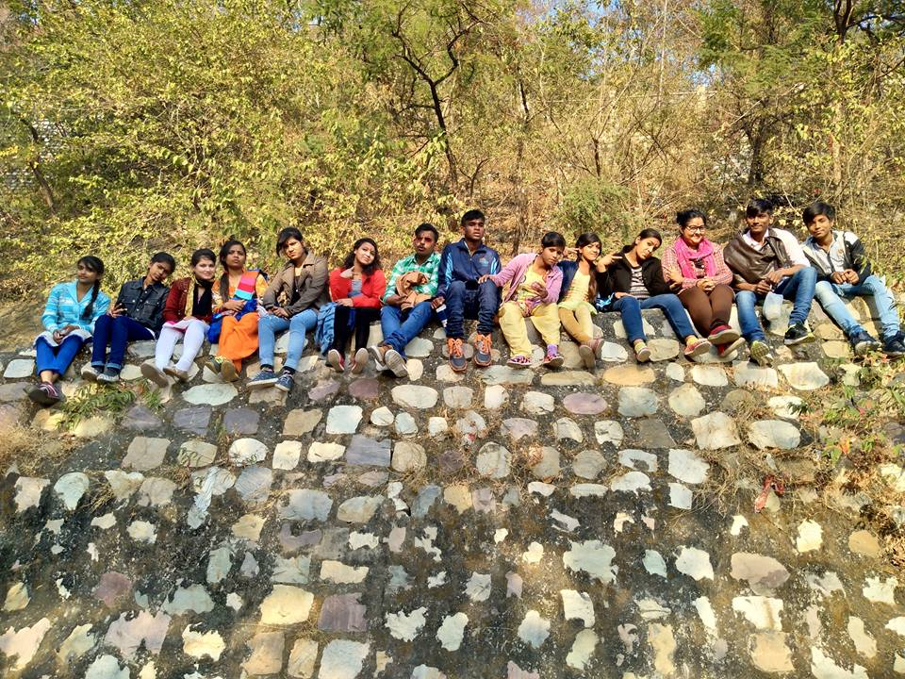
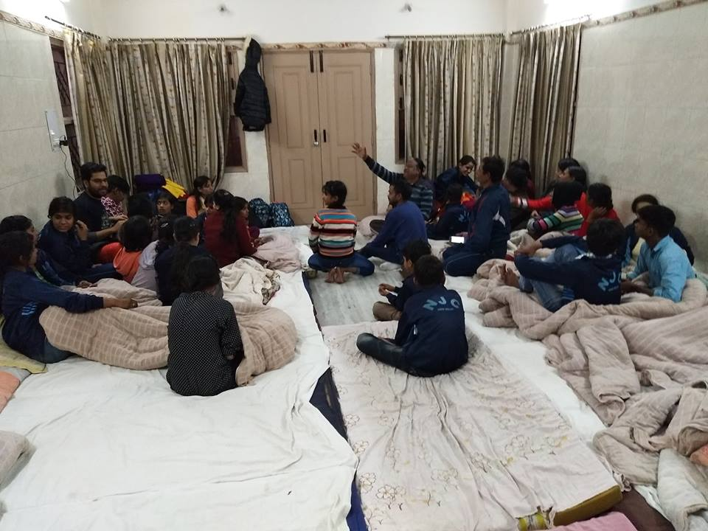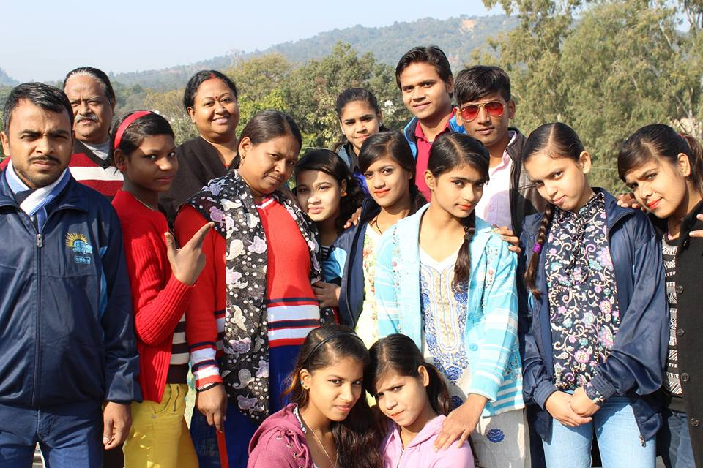

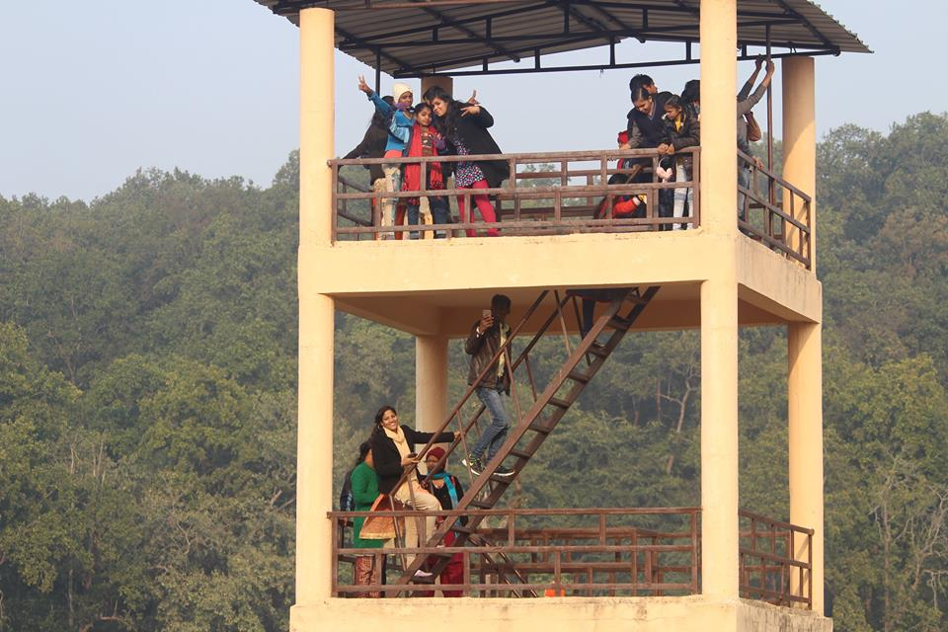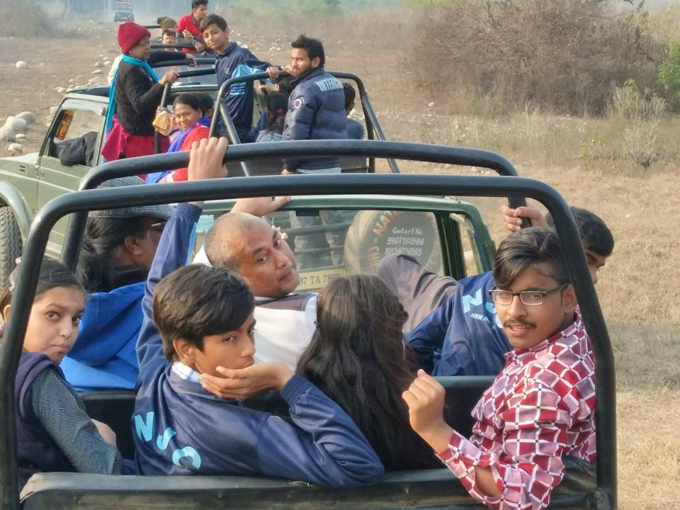
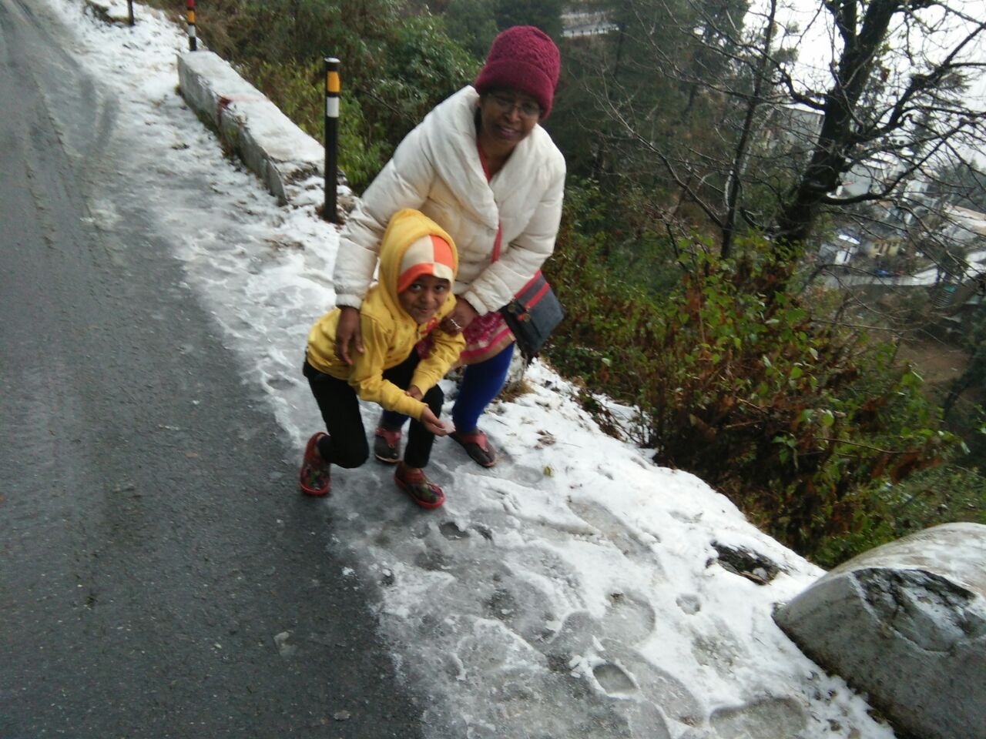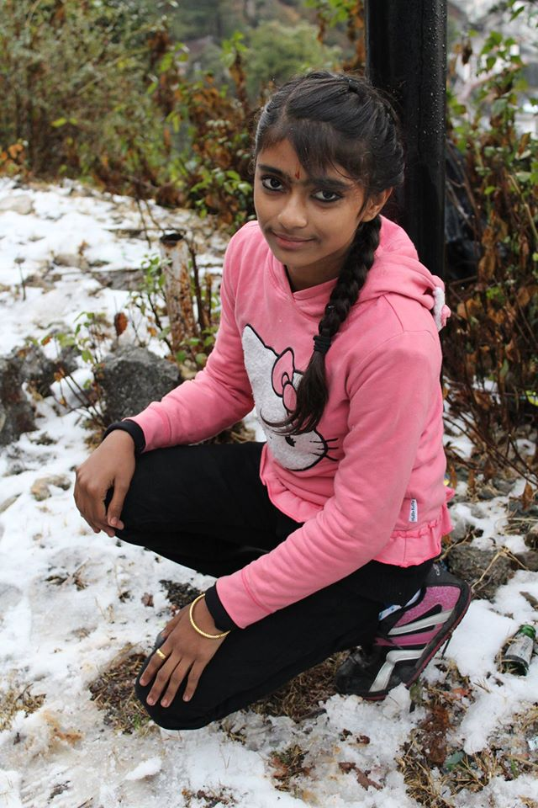
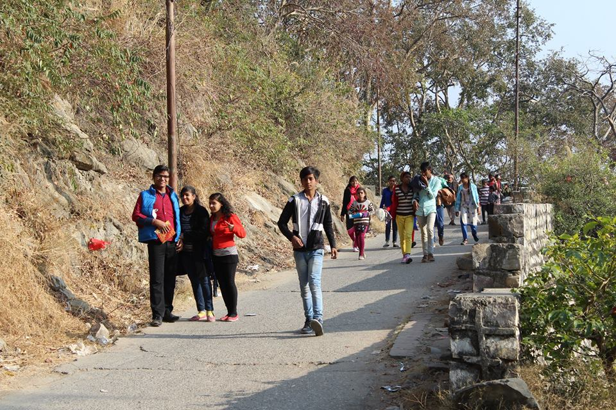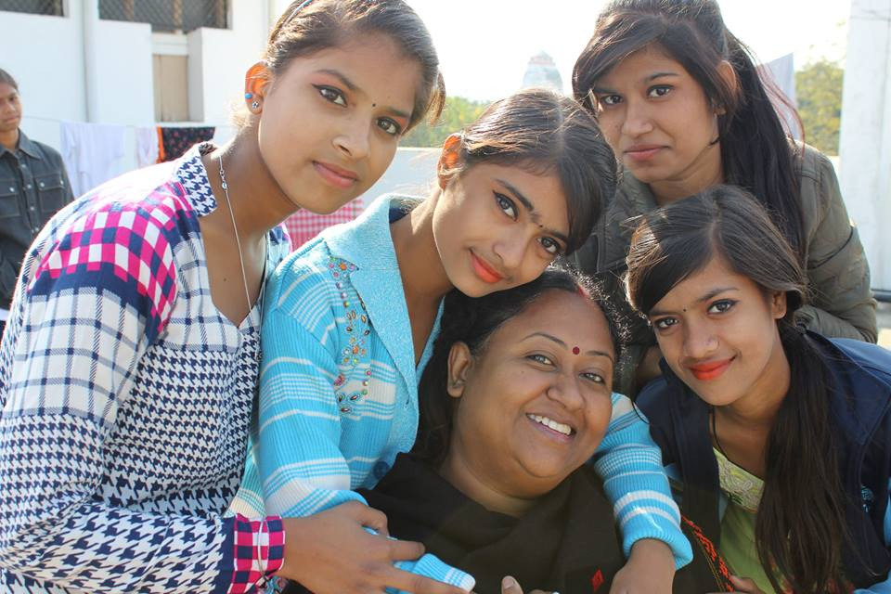

Volunteer’s Visit from Asha- Mariko and Aditya (December)
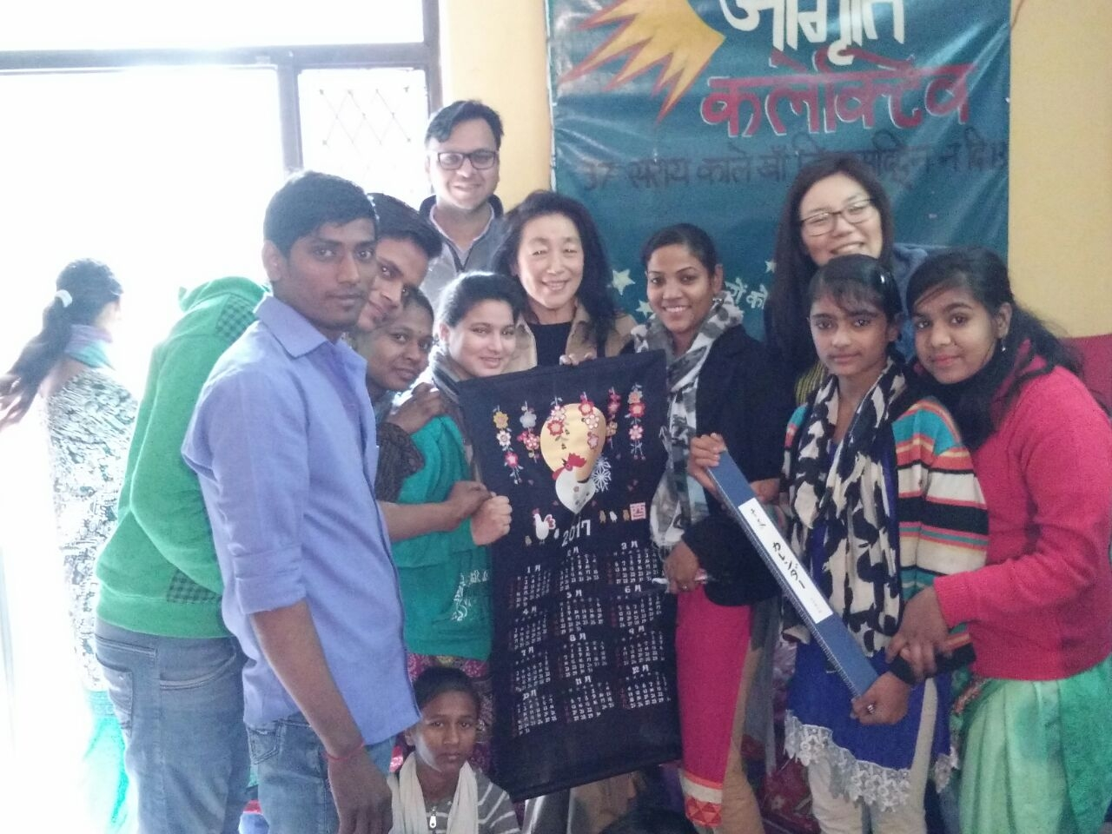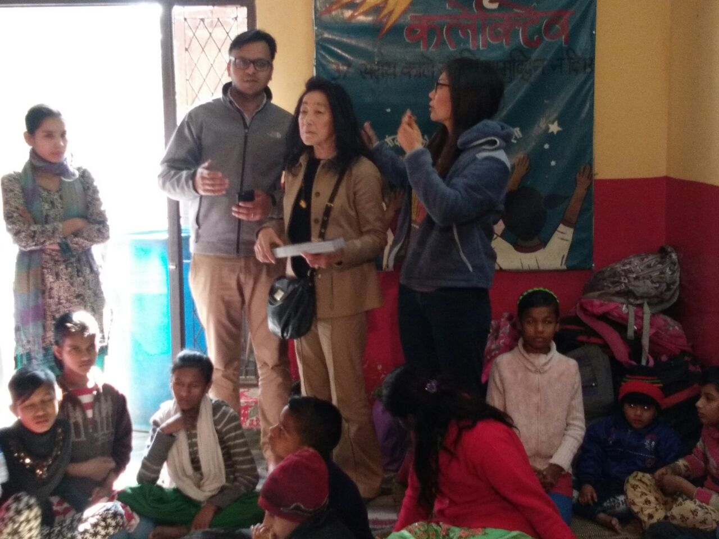
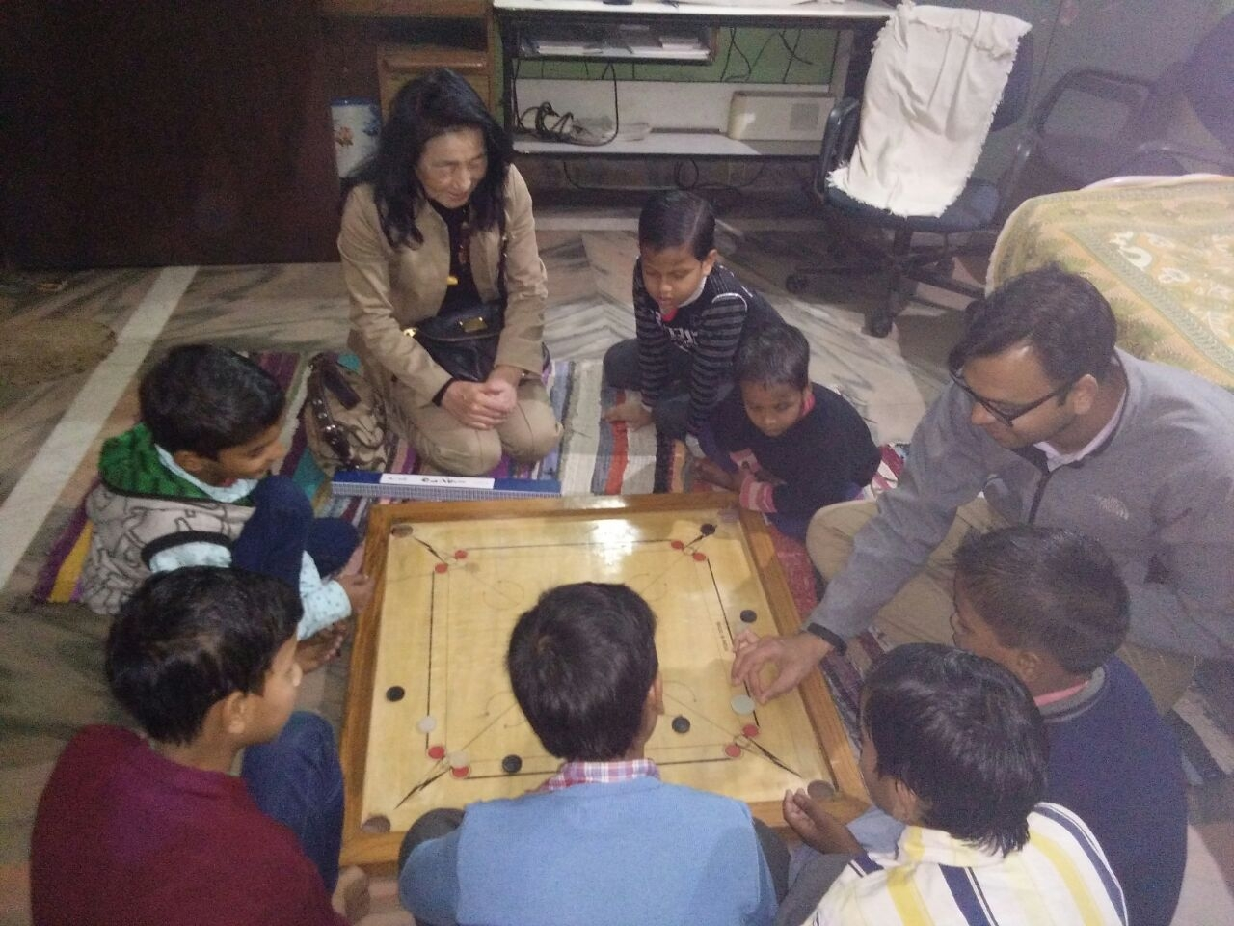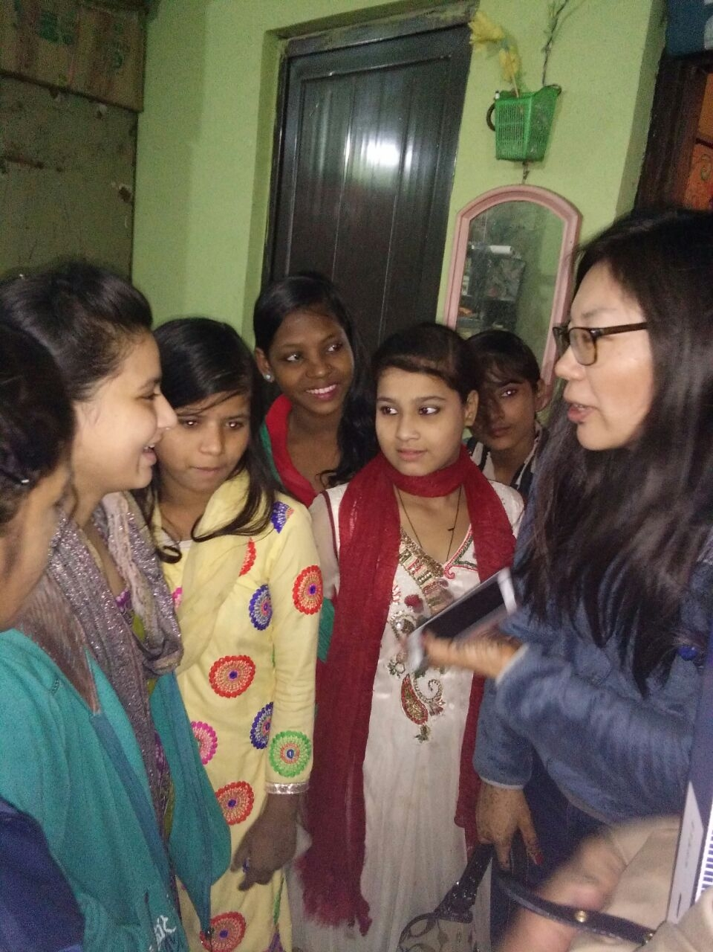
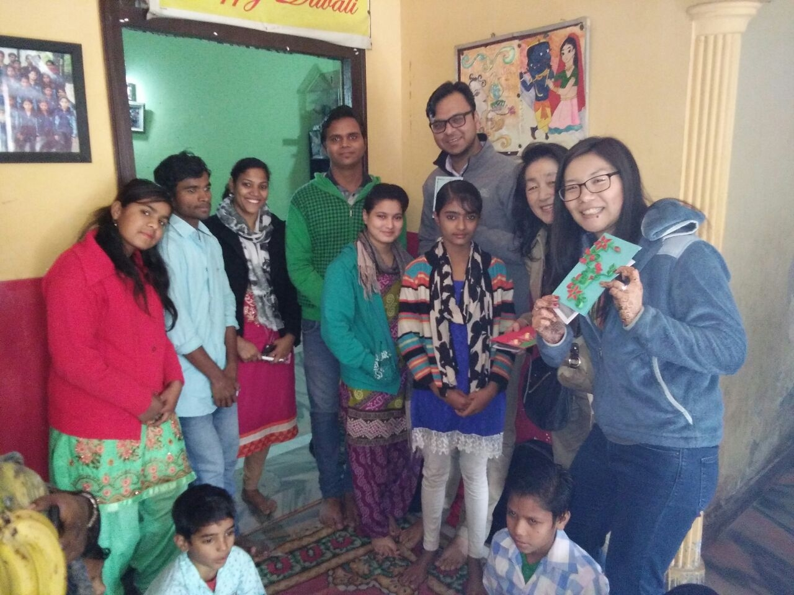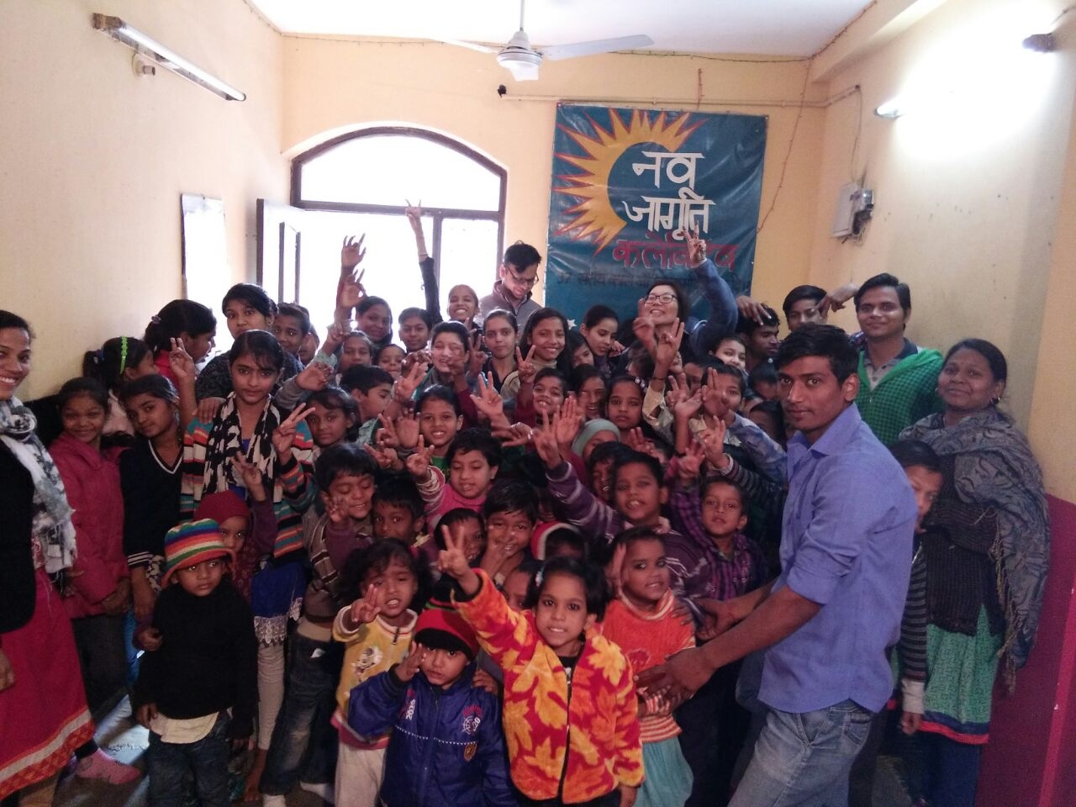

In the year 2016 NJC took part in several events such as:
Sports day-Children’s day-November 2016
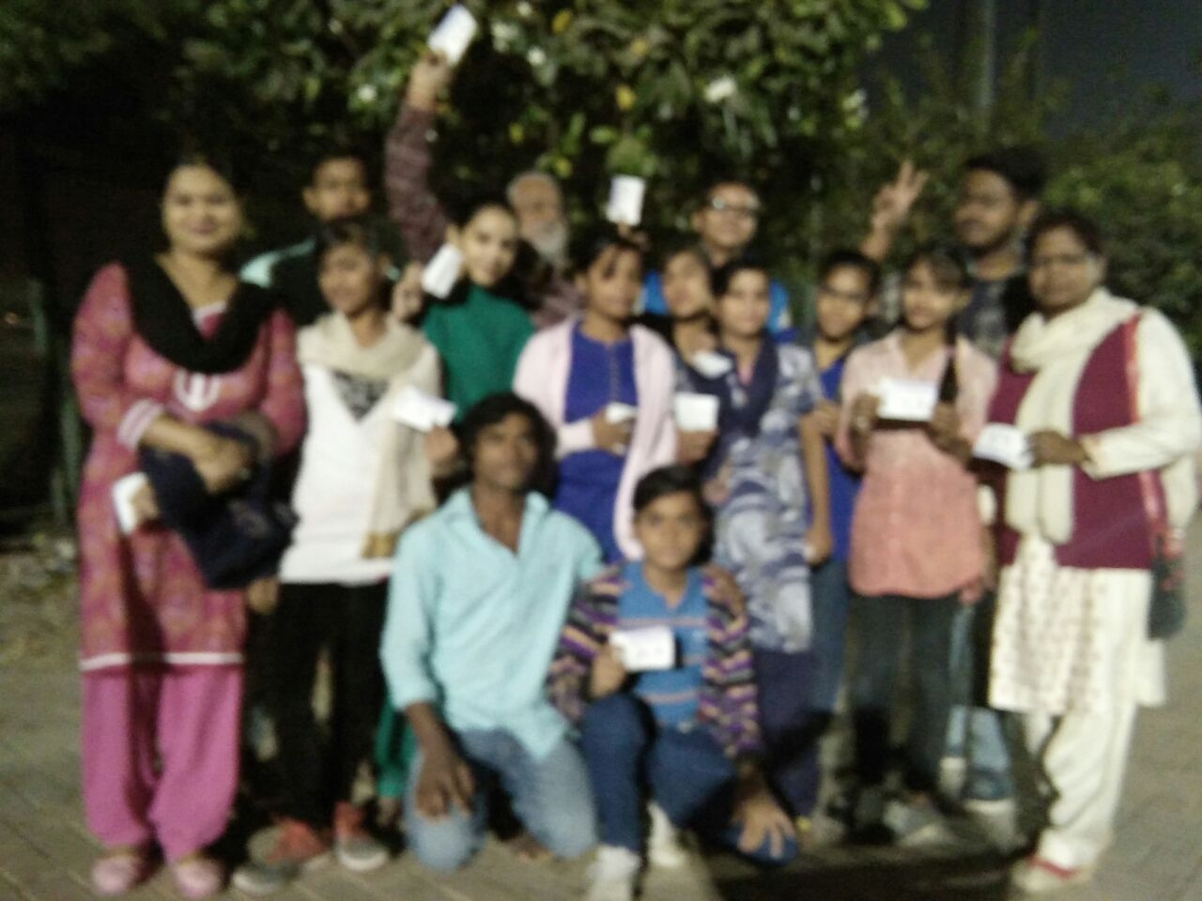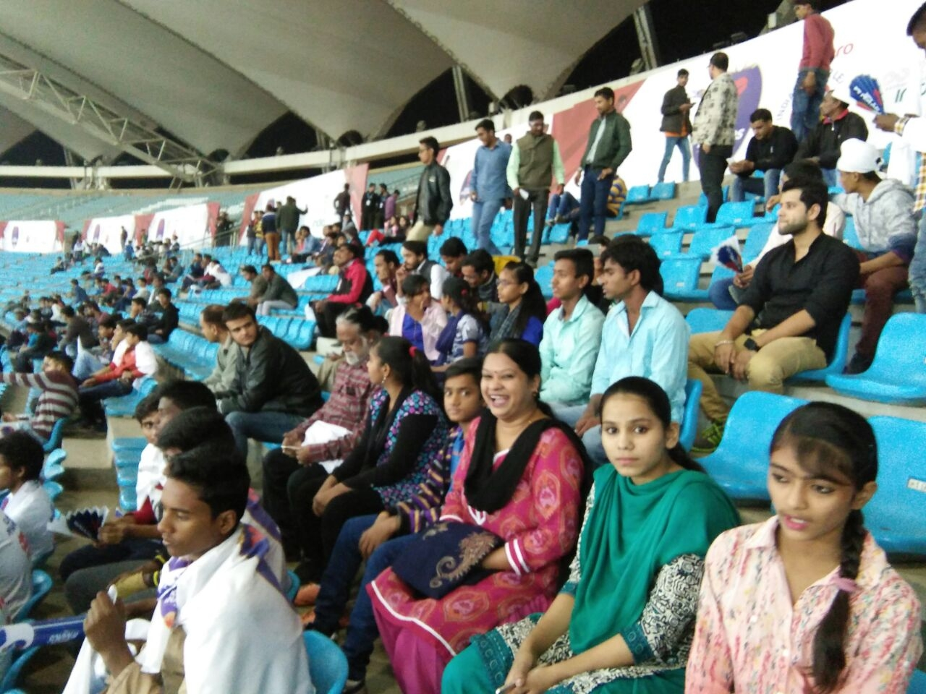
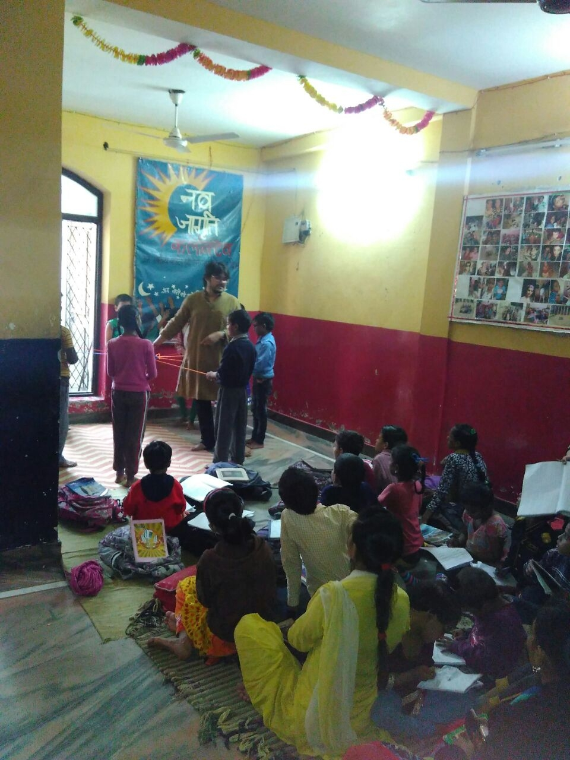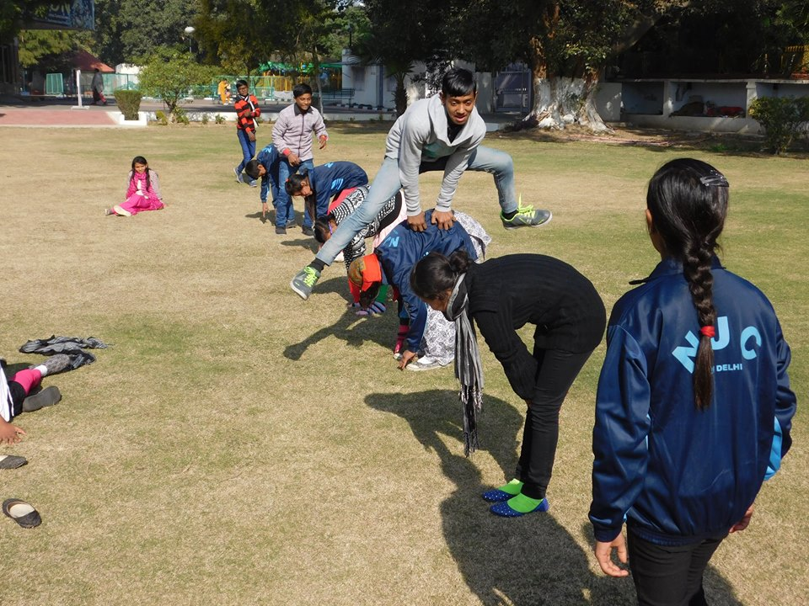
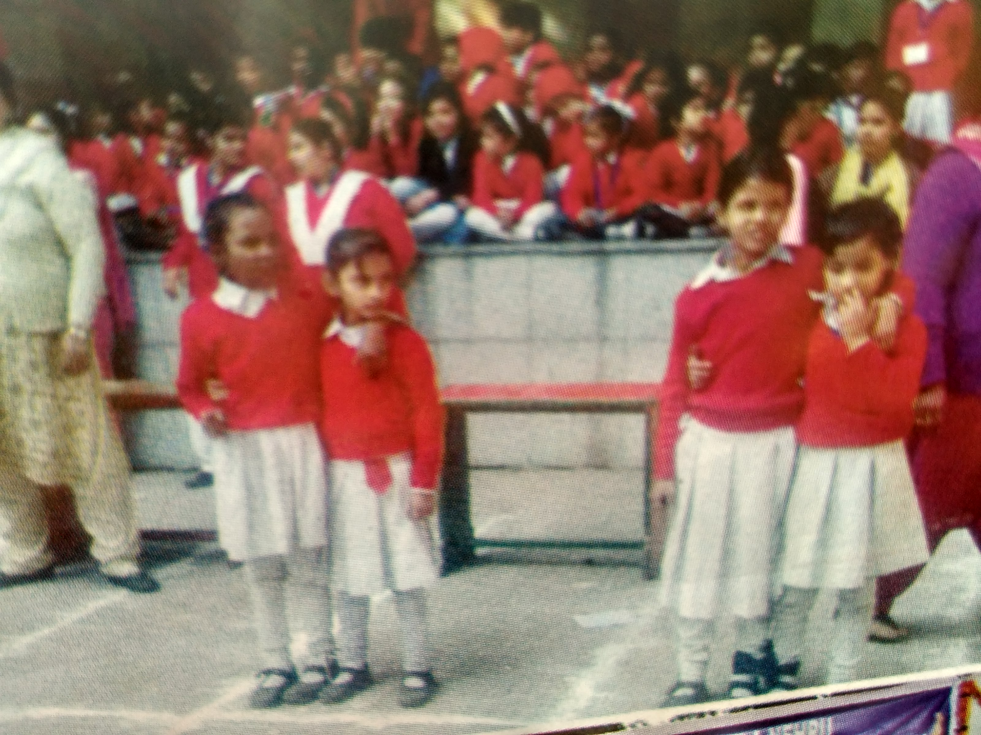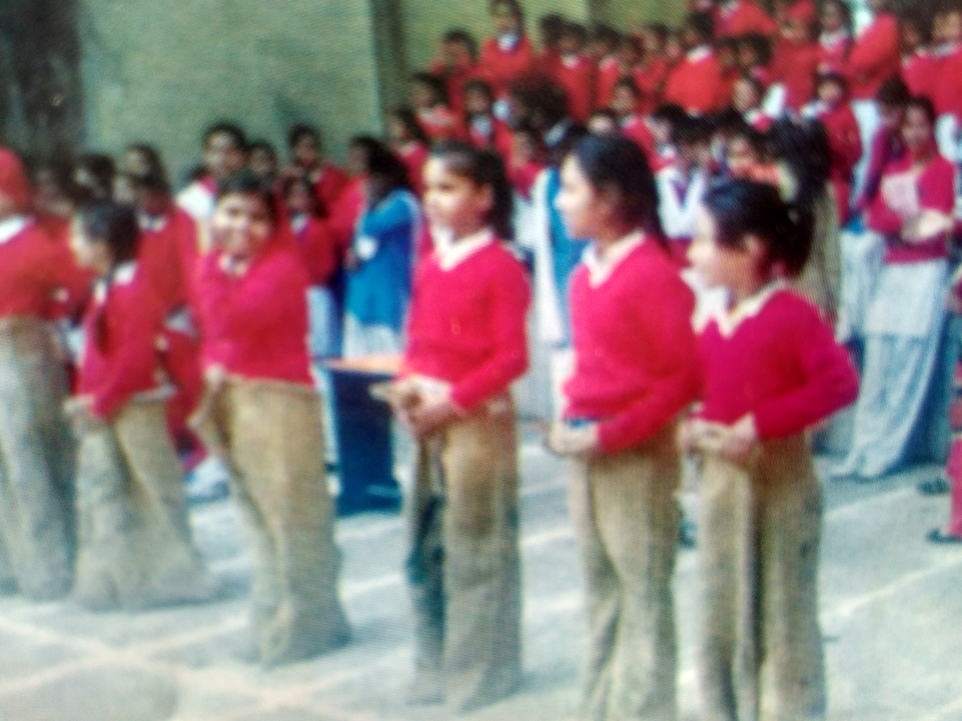

Now , all the students are preparing for the final exams which will take place on march 2017. We are looking forward to Sarmeen’s result because she would be the first girls to give 10th board exams from NJC
.

