PROJECT REPORT - 2017

WALKING THROUGH THE LANES OF THE PAST TO A MUCH BRIGHTER FUTURE…

A GLIMPLSE OF THE YEAR TILL OCTOBER 2017

For
Asha for Education (The Funding Partner)

Initiative by Nav Jagriti Collective with Collaboration of PEACE

ACKNOWLEDGEMENT
This project consumed huge amount of work, research and dedication. Still, implementation would not have been possible if we did not have a support of many individuals and organizations. Therefore, we would like to extend our sincere gratitude to all of them.
First of all we are thankful to ASHA- For Education for their financial and logistical support and for providing necessary guidance concerning projects implementation.
We are also grateful to PEACE, New Delhi for provision of expertise, and technical support in the implementation. Without their superior knowledge and experience, the Project would like in quality of outcomes, and thus their support has been essential.
We would like to express our sincere thanks towards volunteer researchers who devoted their time and knowledge in the implementation of this project.
Nevertheless, we express our gratitude toward our families and colleagues for their kind co-operation and encouragement which help us in completion of this project.

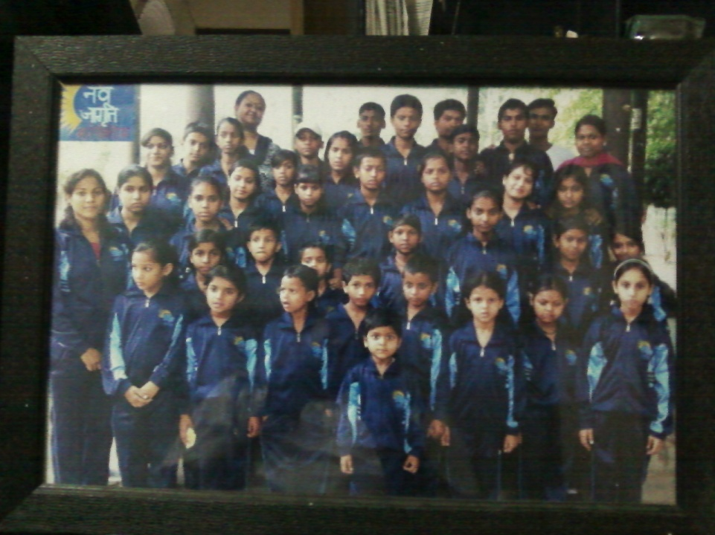

NAV JAGRITI COLLECTIVE

MARCH-2017

Learning to set goals is an important skill for children to develop. As children progress through school they will be expected to set both short and long-term targets for their educational development.
Our teaching staff helps with this process; children may need to become more proactive in order to support their learning.
Encouraging children to take on positions of responsibility at school and it also expose them to more opportunities.
We help them focus more on their studies and help them to get away from the other possible distractions.
Most parents in our country are suffering from fear psychosis which is driving them to wrong ways of parenting. "Parents are role models for children. But they are themselves suffering from fear psychosis. "In fact, in majority of cases, it is the parents who are at fault and not the children. Parents are role models for any child. If parents themselves drive on the wrong side, kids will learn that. If parents fail to control their anger, kids too will learn that,"
So, we took up the initiative to counsel the parents and teach them the correct measures of parenting and made them realize the importance of education with some real life story sessions.
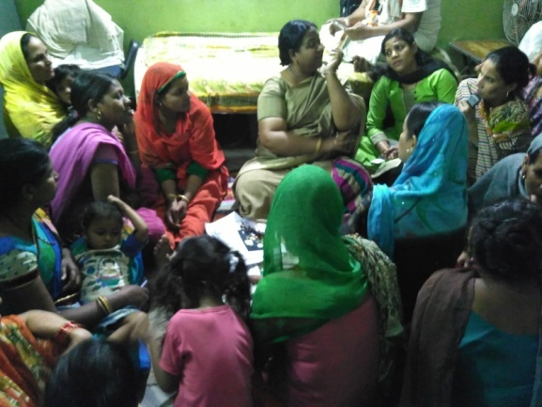 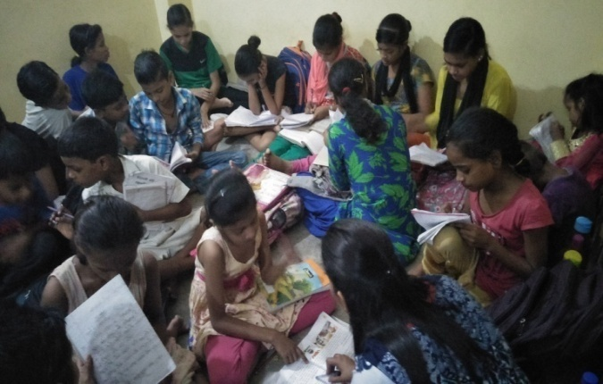Meeting parents
APRIL-2017

Relaxation isn't only about peace of mind or enjoying a hobby. Relaxation is a process that decreases the effects of stress on our mind and body. For many of us, relaxation means zoning out in front of the TV at the end of a stressful day.
This simple act of relaxation seems to be inopportunity for some people. We try to give the kids and their mothers one special day to enjoy, so we took them out to watch a movie in a theatre. We were surprised and equally happy to know that it their first visit to the cinema theatre. After the movie, small refreshment from Mc Donald proved to be the icing on the cake.
Again from 5th of April 2017, the new academic session started with great motivation.
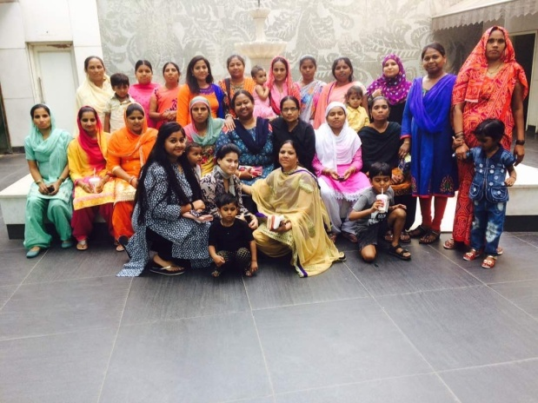 | 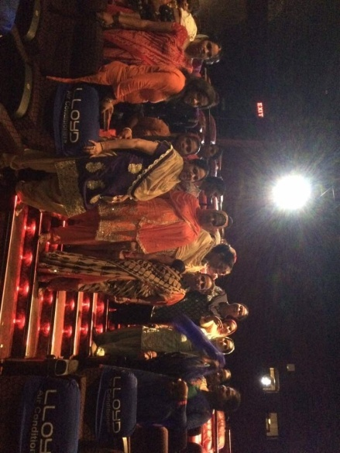 | 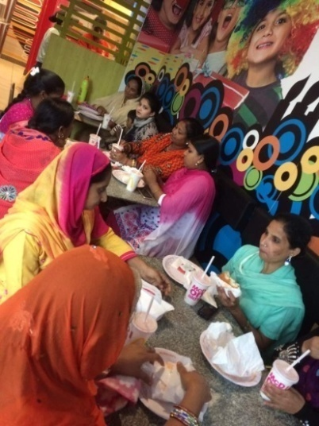

MAY-2017

“Whereas schools applaud good marks, summer camp acknowledges and rewards a broader range of accomplishments; it creates an environment where every child can feel valued for their contribution."
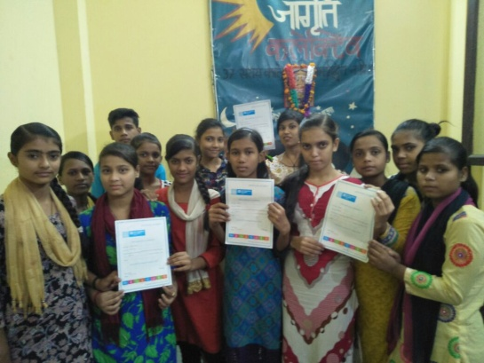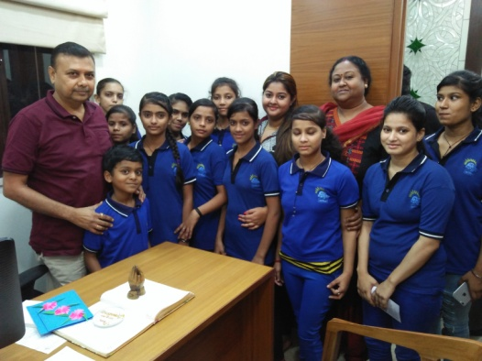
This year kids attended the summer workshop organized by “MAHIMA SOCIAL ACTION”. The new thing that they learned this year apart from Music, theatre, sports, dance and drawing is Mono- Acting, which is really a fun filled activity to learn.
During the middle of the may, CBSE announces the academic results of secondary and senior secondary level. We are proud to announce that Pradeep and Ashish get through with their higher secondary examination with 5.8 and 6.4 CGPA respectively. On the other, Sarmeen who is our only girl who cleared secondary level of education has got 6.5 CGPA. We are proud of these kids and hope that they may do well ahead also.
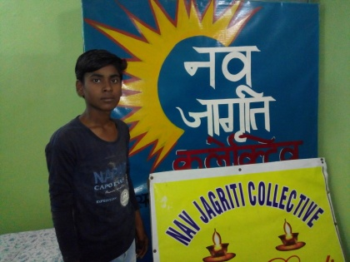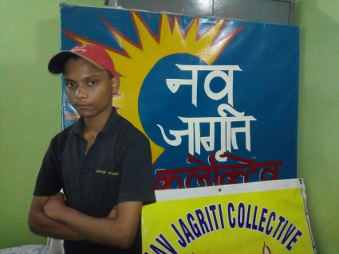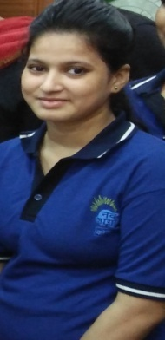
Pradeep Aasish Sarmeen
In the month of May Our very good friends and our full time supporters Peter and Camber visited us by the end of the month and the time calls for the celebration as they got engaged and all the other kids have performed quite well in their academic annual examinations.
Peter and Camber took the kids and even their mothers for a day out at a water park, it was a great experience indeed. They even sponsored the day’s meals and the other miscellaneous expenses as well for that day.
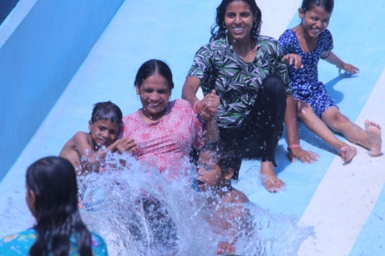 | 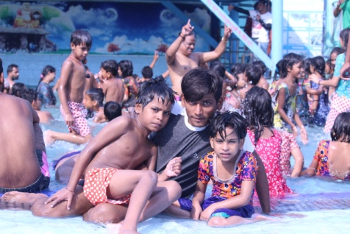 | 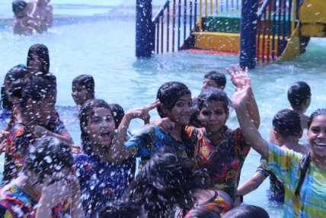
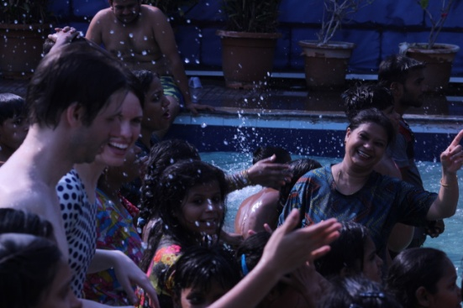 | 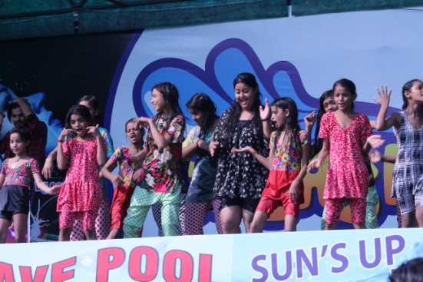 | 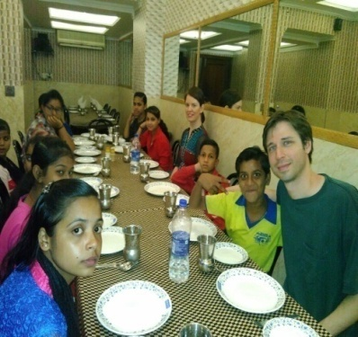
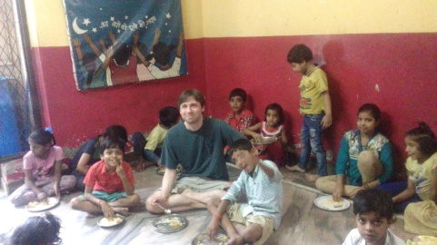 | 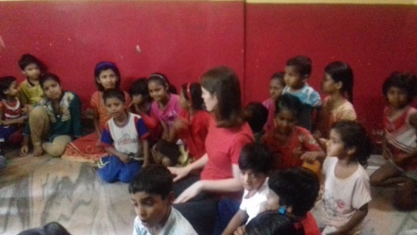

JUNE-2017
The entire month of June is involved in beating the heat and compiling all the holiday’s home work which is assigned by the schools.
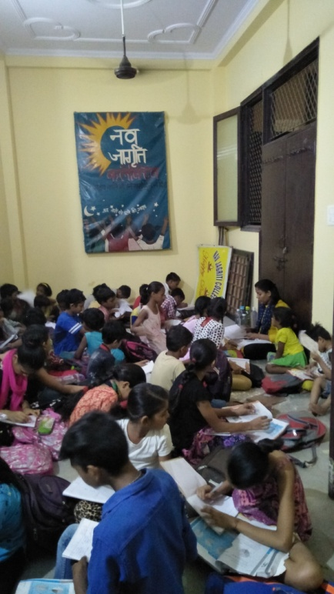 | 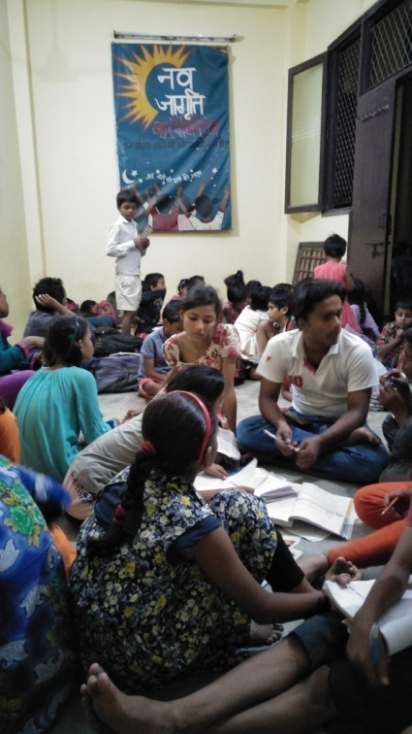
August-2017

“My idea of Education is based on Empowerment”- great words by Dr. Sandeep Pandey, who is a co-founder of Asha for Education.
Dr. Sandeep Pandey visited Nav Jagriti on 9th of August’17
It was our fortune to meet Dr. Sandeep Pandey, his great thoughts and his vision has motivated the kids to live a respectful life. His words had a great impact on the mindset of the children. It was our immense pleasure to have got his blessings with us.
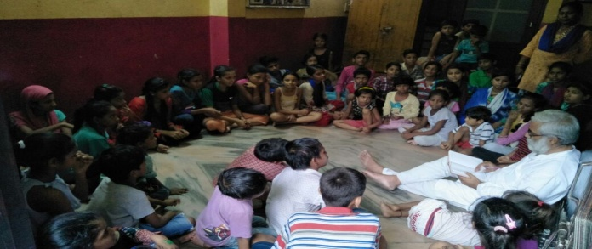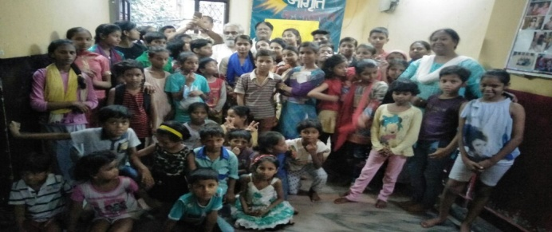
While his stay in New Delhi, we had become the part of a programme which is named as ‘Narmada Bachao Andolan’and it took place at Jantar Mantar. The active participation of the children not just impressed Dr. Sandeep Pandey but also impressed many other activists including; Dr. Sunilam, FaizaL, Ravinder Ravi and many more.
The kids also become the part of a rally-named as “anti constitutional elements quit power” which began from Mandi House and extended till Jantar Mantar, which is a continuous walk for about 4.4 kms via Deen Dayal Upadhaya Marg. The event took place to mark the 75th anniversary of Quit India Movement which is also known as August Revolution. The kids showed great enthusiasm in the rally. 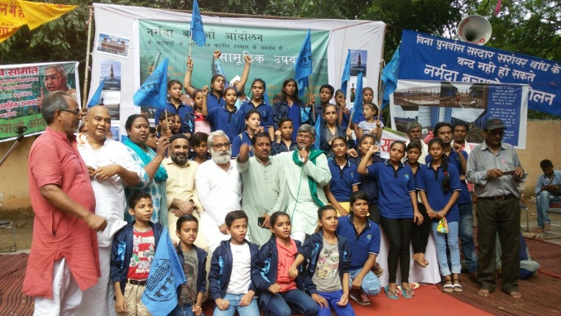nmn n 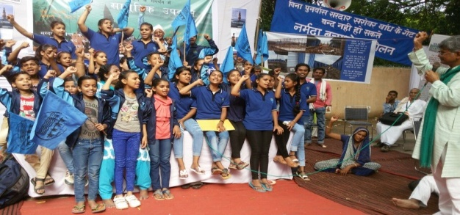
Ushering in the festival season is the Raksha Bandhan or Rakhi as it is popularly known. A festival that celebrates the bond between brothers and sisters, it has the sisters tying a thread around their brother's wrist as a symbol of their love and in turn the brother pledges to protect his sister.
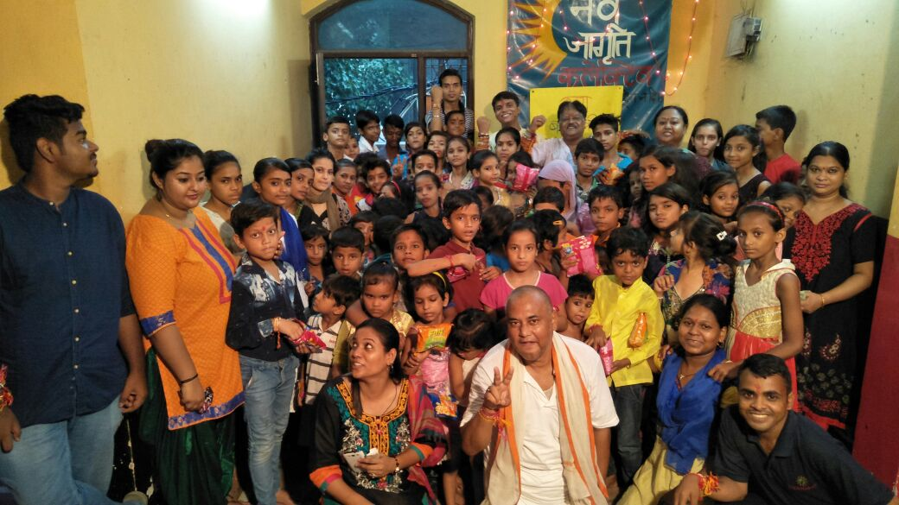
SEPTEMBER – 2017

Teachers are the important members of the society who play an important role in shaping one’s life. They are the inspiration, the mentor, the guide, the spark and the candle to the life. Teachers Day is a day meant to appreciate, honor and acknowledge the amazing contribution of teachers. India marks Teachers Day on the 5th of September every year. The day is celebrated in honour of Dr Sarvapalli Radhakrishnan, known for his contribution to the Indian education system.
It was our great fortune that we are involved with these kids. They made us feel special by performing dance and drama shows. We were even greeted with handmade cards and sweets.
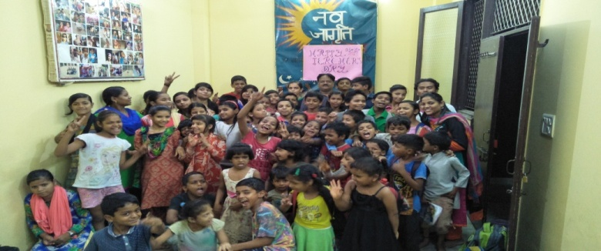 | 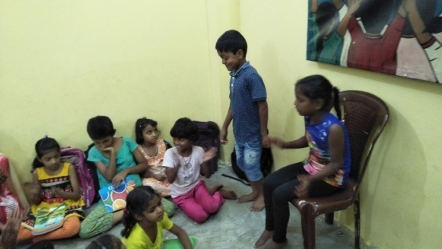
Traditions and celebrations surrounding birthdays are important for every children as it is one of the memorable part of their childhood.
The team of Nav Jagriti Collective organizes a birthday party each month, and all those whose birthday falls on the same month are under the light of celebrations.
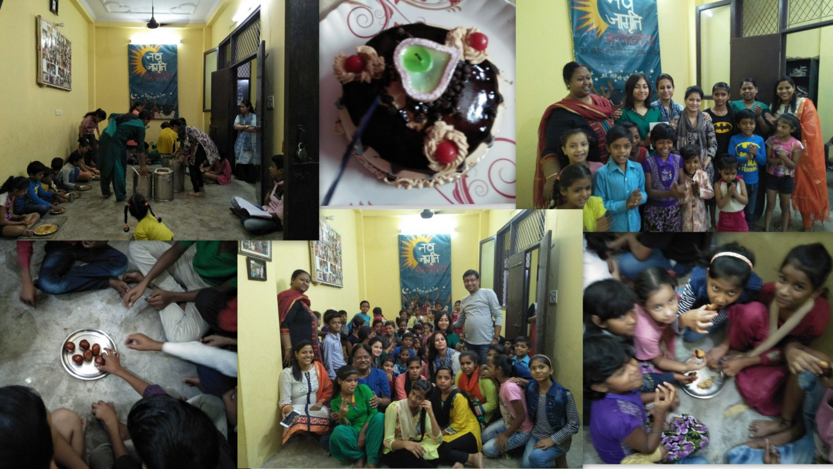

The festival of Dussehra is unique in its perception and significance. According to the great Hindu epic Ramayana, Lord Ram killed Ravana on the tenth day that is Dussehra. It is called as triumph of virtue over sin or immorality. Ravana is said to have abducted Ram’s wife, Sita and was also known as a dictating ruler. The end of Ravana meant end of bad and evil spirit as he was a demon by birth too. Our kids prepared and performed a skit on the same and it was amazing to watch the little artists performing the same.
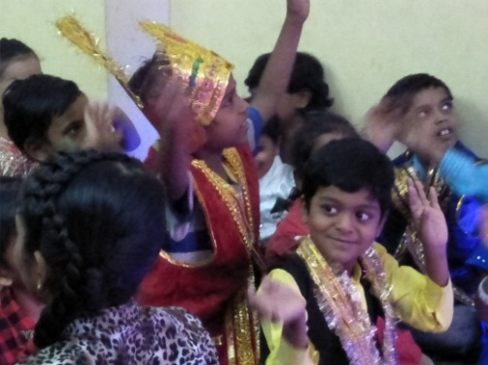 | 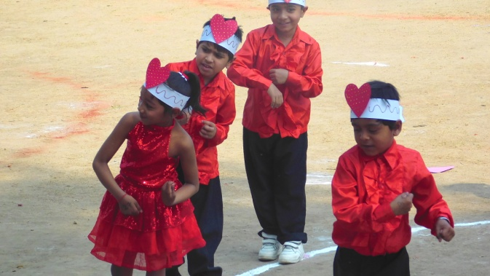

OCTOBER - 2017
Diwali is touted as a festival of lights. However, colours also play a big role in this festival. Houses are freshly painted and adorned with a multitude of decorations. People buy new clothes and gifts for their family and friends. Colours are most noticeable though in the traditional rangoli patterns that grace the entrance of every home. We also celebrate the festival of lights by lighting Diyas and making Rangoli. Sweets were distributed among the kids and we have arranged delicious lunch on the special day.
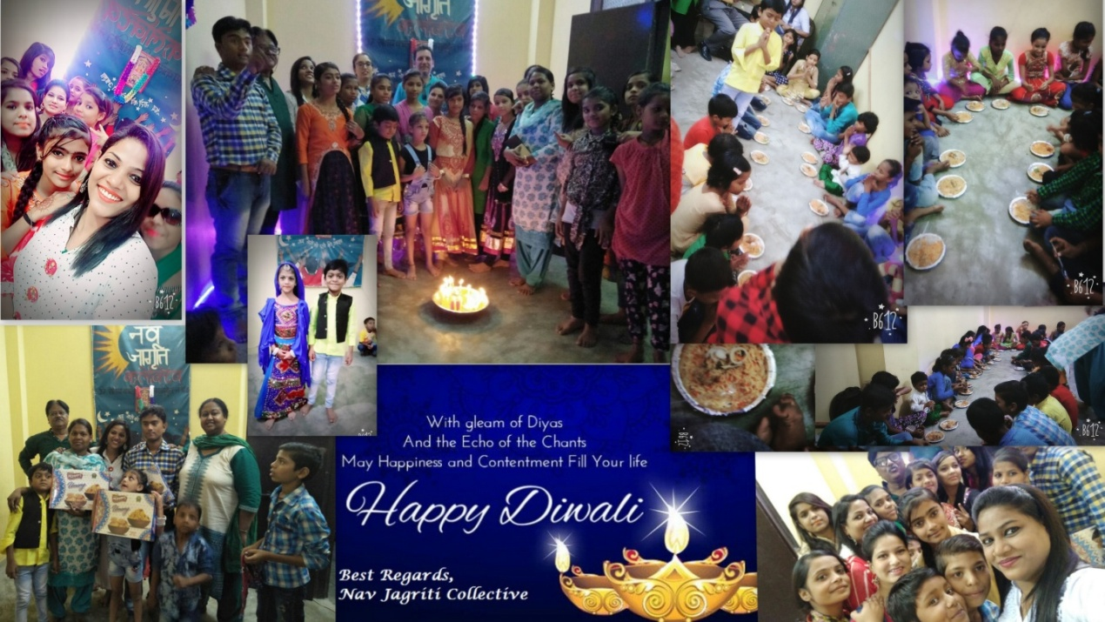

In October’17, Mrs. Shalini Dawar, volunteer of Asha for Education visited us. She spent time with children and share her views and experiences about why education is important in our life and also that education can leads to a great life. Her words had a great impact on the children.
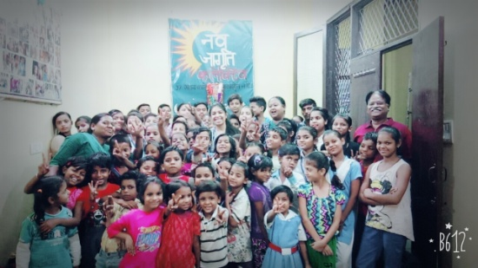 | 