Dear Ms. Shivani/ Sneha,

Further to your earlier email, we wish to inform you that 50% of the sanctioned amount against salary of 8 teachers for the Home-Based Programme was received in August 2009. The sanctioned amount is only for special teachers; physiotherapist is not included in this.

HOME-BASE REPORT [2009-10]
Home-Base services are being provided to 54 children in different slums of Jaipur. Regular exercises to the children and training to the parents are in operation by our 6 regular trained special educators. Additional trained special educators are not available and untrained special educators are not preferred. We have selected 4 educators who have been under training for the last 3 months by our clinical physiotherapist. They will join us from May 2010 in the Home-Based Programme. The next batch of special educators to be trained will be from June.

Below are a few short profiles of success achieved with our home-based cases to give an idea of the work being done in the Home-Based Programme.

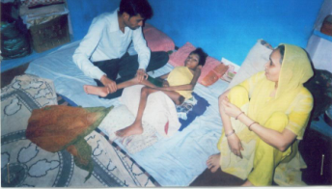
- NADEEM (Steady Progress)
Age: 7 Years
Admission Date: 04 January 2010
Father’s Name: Hakim Bhai

HISTORY
Nadeem lacked independence in his Activities of Daily Living (ADL) such as using the facilities, eating, drinking, grooming, dressing, etc. and was thus completely dependent on others. He was incapable of sitting even with a backrest/help. His family required awareness of the disability and did not have any information related to it.

PRESENT CONDITION
Today he manages to independently do a few tasks such as eating, indicating the need to use the restroom, etc. He is also able to sit without any help. Nadeem can stand and walk with some help. He is also capable of talking. His family is now aware of the disability in terms of its causes, effects and treatment required.

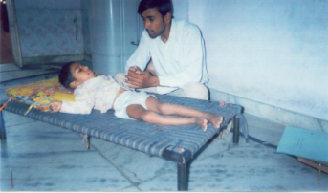
- ALFAIZ (Steady Progress)
Age: 6 Years
Admission Date: 19 November 2009
Father’s Name: Mohd. Nizam

HISTORY
Alfaiz was unable to control and lift his neck. He could not talk either. His muscles in the arms and legs were tight, lacking flexibility. He was incapable of sitting. He could neither hold nor grip anything with his hands. He was also completely ADL dependent. His family had little awareness of the disability.

PRESENT CONDITION
He has stated to control his neck. Today, he is able to speak a few words. The tightness in the muscles of the legs and arms has comparatively reduced. He is able to sit with some help. With some help, he can manage to hold objects. He indicates things related to the restroom s with signs. The family is now more aware of the disability

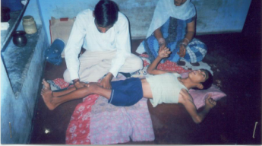
- IQBAL (A Lot of Progress)
Age: 14 Years
Admission Date: 10 November 2009
Father’s Name: Late Mohd. Taj

HISTORY
Iqbal used to be completely bed-ridden and was completely ADL dependent. He was incapable of lifting his arms and legs. There was a lot of tightness in the muscles of his arms and legs and so both legs were in a crossed position, like the blades of a pair of scissors. Iqbal’s family largely lacked information regarding the disability.

PRESENT CONDITION
Now, Iqbal has started to lift his hands straight upwards. Owing to the exercises, the rigidity has reduced. He is even able to keep his legs almost straight. He is capable of holding thick objects with help. At times, he indicates his need for using the toilet using signs. The family is now very much aware of the disability.

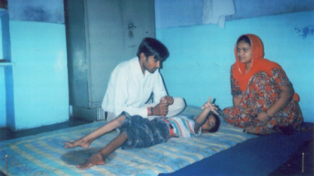
- Farhan (A Lot of Progress)
Age: 9 Years
Admission Date: 27 January 2009
Father’s Name: Wahid Baksh

HISTORY
Farhan was incapable of speech. His legs were bent and in a crossed position, like the blades of a pair of scissors. He was not able to hold objects. Also, he was completely ADL dependent. The family had no information whatsoever on the disability.

PRESENT CONDITION
Farhan is able to sit with support. The tightness of muscles in his legs has reduced and is thus able to straighten his legs to an extent. He can speak a few words and communicates his restroom related needs by indication or speech (at times). His family has awareness of the disability.

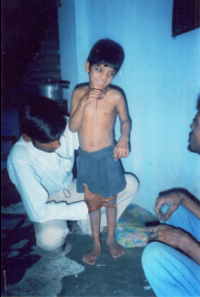
- AHMED ALI (A Lot of Progress)
Age: 9 Years
Admission Date: 19 November 2009
Father’s Name: Ahmed Salim

HISTORY
Ahmed could not stand and was also completely ADL dependent. He had a lot of behaviourial problems. He was unable to identify daily household objects. The family lacked awareness related to the disability.

PRESENT CONDITION
Ate present, he can stand with support. His behaviourial problems have reduced and he uses signs to indicate needs relating to the restroom. He is able to identify daily household things. Ahmed’s family has knowledge of things relating to the disability.

The delay in expanding and implementing the proposed plan was due to political disruptions and non-availability of special educators.

Under the circumstances, we have not spent the sanctioned amount for the programme. A very meager amount has been spent since February 2010. The unspent amount is in the bank and will be utilized for the coming months. The constraints are beyond our control despite our good intentions.

OUT-PATIENT DEPARTMENT
We may also mention here that at Jhalana Out-Patient Department (OPD), we are serving 65 children (51 males and 14 females) and giving them physiotherapy and training to their parents. All these children are coming with their parents to our OPD from different slums of Jaipur and villages adjoining the Jaipur district. The expertise of our clinical psychologist is so popular that a few children also come to our OPD from other states.
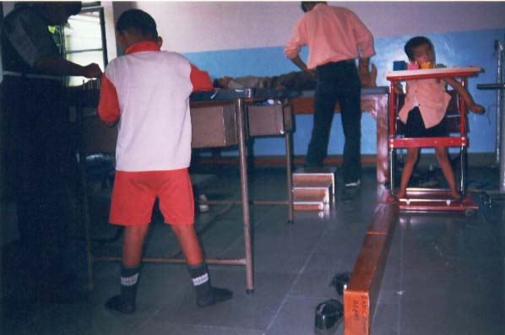
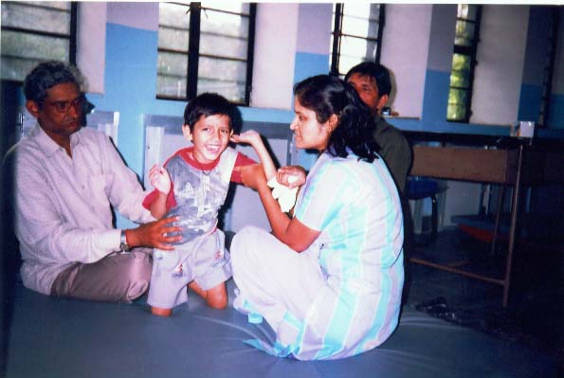

Encouraging Kneeling
Gait-Training with Invalid Walker (Left) and Maintenance of Sitting Posture (Right)

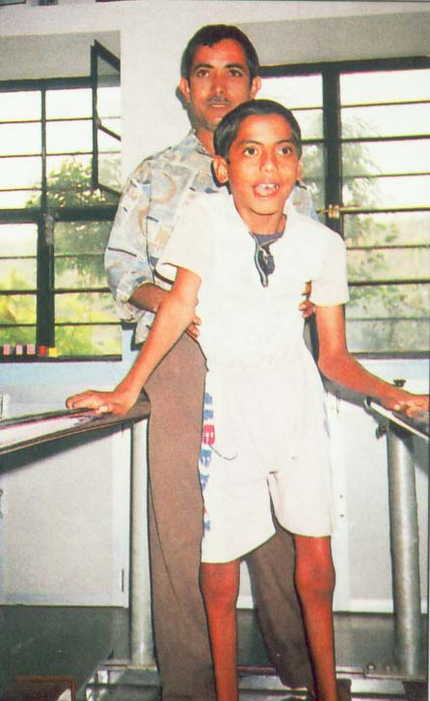
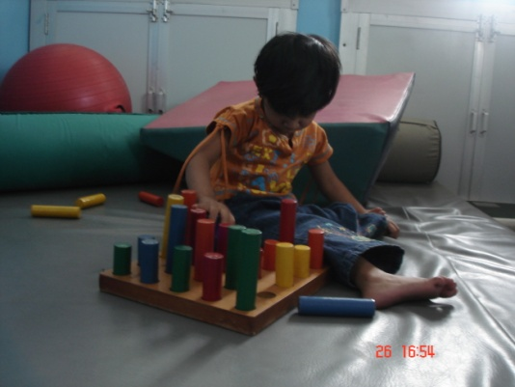

Fine Motor Coordination
Gait-Training In Parallel Bar

We hope that you will find the report to be in order. In case you’d like to know something more, we will be glad to reply to your queries.

With Regards,
For Prayas,
R.K. Mohla
Gait-Training in Parallel Bar
Fine Motor Coordination
Encouraging Kneeling

