Prayas
Sanganer Inclusive School
November 2015 to December 2016

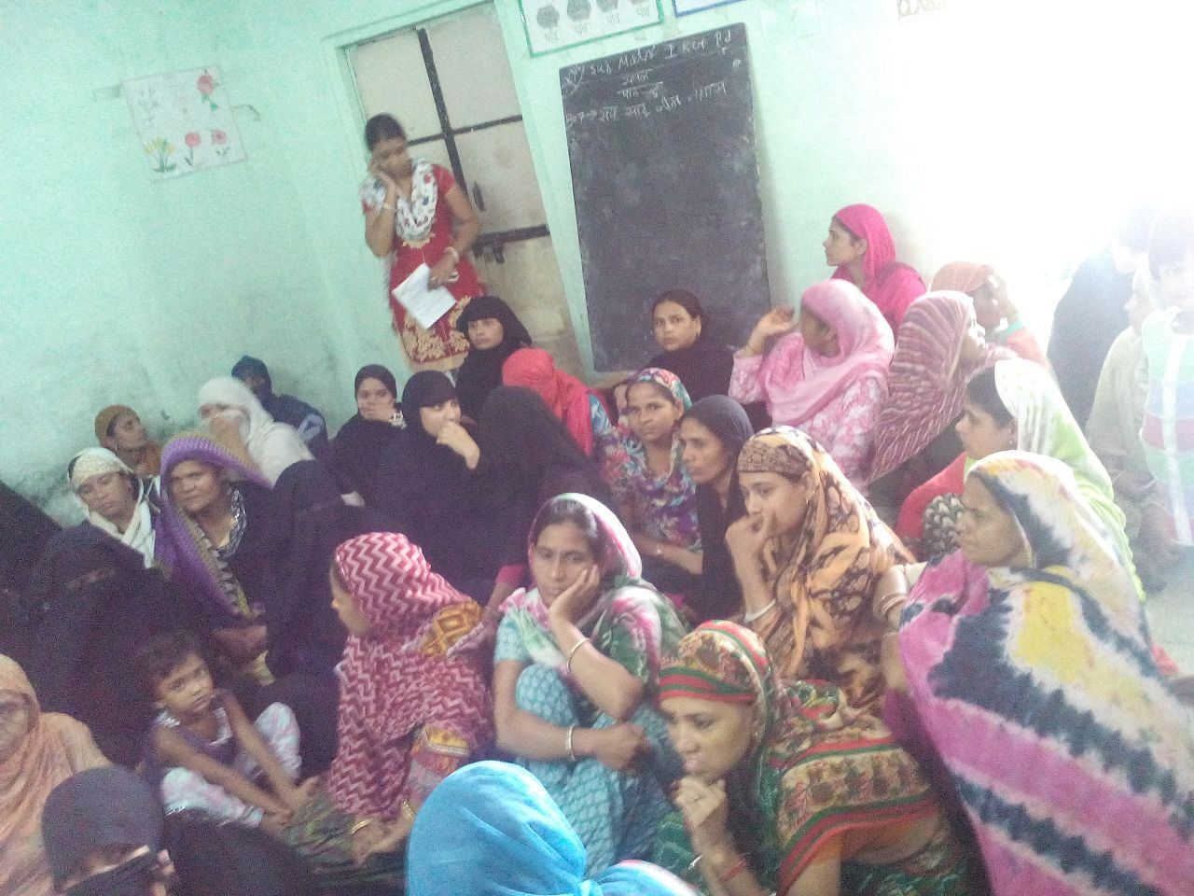
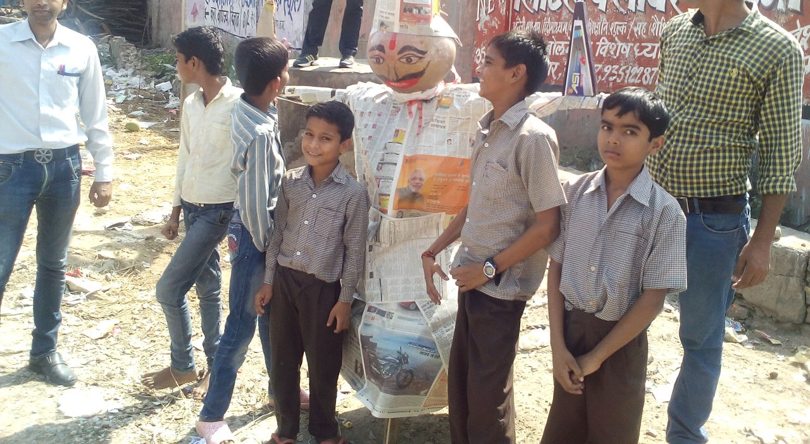

TABLE OF CONTENTS

- About Prayas.__________________________________________Page 3
- Academic and school activities_____________________________Page 5
- Excursion & Visits_______________________________________Page7
- Stories of change _______________________________________Page 7
- Teachers training_______________________________________Page 8
- Community outreach program_____________________________Page 15
- Bal Club Activities______________________________________Page 16
- Constraints____________________________________________Page 17

PRAYAS
SANGANER INCLUSIVE SCHOOL
REPORT: November 2015 to December 2016
ABOUT PRAYAS –
PRAYAS is an organization working for children with special needs and underprivileged children living in the kachhi bastis (slums) of Jaipur and the surrounding areas. Since the last two decades, we have been striving to bring about a positive change in the lives of these children, their families and community. Prayas was the first vocational school started for children with special needs. It has gained recognition as a model institute in Rajasthan. It currently has one centre exclusively for cwsn and three inclusive schools.

Prayas works for the recognition of the children with special needs. An environment has been created towards this end and for awareness of integrated development for cwsn. Prayas provides education and vocational training to cwsn and makes efforts to mainstream or rehabilitate them.
Our Aims:-
- Inclusive education (Education for All)
- Identification of non-school going and special children in slums
- Access of children to education and providing quality education
- Reach out to the families of disabled children and counseling them about disability and its management
- Provide a supportive environment for Inclusive education
- Develop the vocational skills of children
- Regular Teachers training to cope with new technology
- Strengthening the people in communities and creating awareness
- Formation and functioning of Bal clubs for better outreach
- Women empowerment through education and vocational training
- Raise awareness about rights, health, disability, government schemes
- Efforts to influence the authorities and government department for proper implementation of RTE (Right to Education)
- Networking with other like minded institutions
- Advocate with the government for rights of the disabled
The Student strength in Sanganer Inclusive School is as follows

CATEGORY OF STUDENTS | NO. OF STUDENTS  (January to October 2015) | NO. OF STUDENTS  (November 2015 to December 2016)
Mentally Challenged | 3 | 2
Physically handicapped | - | 2
Multiple Disabled | 9 | 9
Slow Learners (SL) | 011 | 7
Regular | 139 | 149
TOTAL | 162 | 169

Strength In Session 2015-16 | Drop out | Pass out | New Admission | Current Strength Session 2016-17
162 | 20 | 8 | 35 | 169

CLASS |  | GIRLS |  |  | BOYS |  |  | TOTAL
 |  | NORMAL | SLOW LEARNERS | cwsn | NORMAL | SLOW LEARNERS | cwsn
Nursery |  | 21 | - | - | 19 | - | - | 40
Preparatory |  | 12 | - | - | 09 | 1 | - | 22
1 |  | 15 | 1 | - | 15 | - | 2 | 33
2 |  | 10 | 1 | - | 13 | - | 1 | 25
3 |  | 8 | 1 | - | 7 | 2 | - | 18
4 |  | 7 | 1 | - | 3 | - | 1 | 12
5 |  | 5 | - | - | 5 | - | - | 10
SUB-TOTAL |  | 78 | 4 | - | 71 | 3 | 4 | 160
 |  | GIRLS |  |  | BOYS
Special |  | 3 |  |  | 6 |  | 9 | 9
 | Total |  |  |  |  |  | 13 | 169

ACADEMIC AND SCHOOL ACTIVITIES –
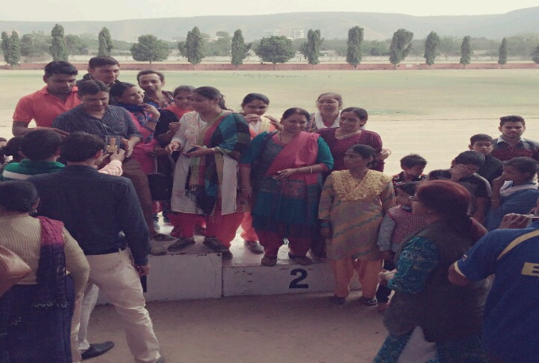
- On 3rd Nov. 2015, Annual sports day was celebrated. Students enjoyed and participated in various games held on the Rajastahn University Sports complex. Sports competitions in all four centers of Prayas followed by refreshment were the attraction for everyone. Students departed for home with sore throats as it was the result of full day hooting for their fellow participants.
- Diwali celebration was also held in school and sweets were distributed.
- On 14th November 2015, children’s day was celebrated. Students loved the liberty of choosing their favorite activity which was given to them on this occasion. They opted out for cultural activities and teachers organized the same.
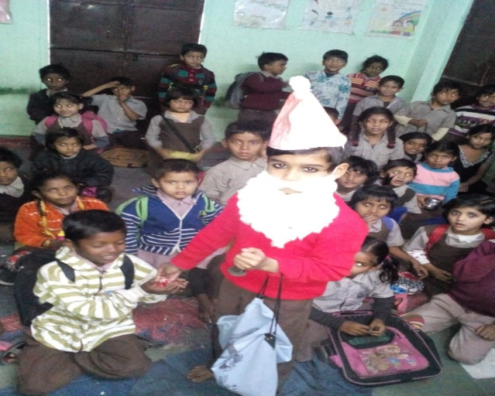
- Christmas celebration was held on 24th December and school was closed (for students only) from 25th to 1st January 2016.
- New Year was celebrated on 2nd January 2016 and good wishes were exchanged with students made new Year Resolutions.
- 24th January was daughters’ day and it was celebrated with parents.
- Makar Sankranti was celebrated with Kite flying on 13th January in school.
- On 26th January a cultural program was held on the occasion of Republic day
- On 12th February all the children gathered at Prayas Jhalana school to pay homage to their dear Jatinder didi on her first death anniversary.
- The colorful festival of Holi was celebrated in school with dry colors and gulaal.
- On 16th March, students of Sanganer school visited Jaipur Zoo and Albert hall museum. They enjoyed the short trip with food and fun.
- On 28th March, on the occasion of Rajasthan day, cultural activities were organised along with stories of historical background of Rajasthan. Students listened and interacted with the eyes wide opened and left mesmerised with the proud feeling
- Ambedkar Jayanti was celebrated on 14th April and students got to know about the significant contribution made by him.
- Ram Navmi was also celebrated in school and students enjoyed halwa poori.
- 22nd April was Earth day and students learnt how to conserve the environment.
- Students enjoyed story reading on the occasion of World Books day held on 23rd April.
- 9th May was Thalassemia day and teachers conducted an awareness program on blood donation and its benefits for society.
- On 16th May Annual results were declared and a farewell party was organised for students of class five.
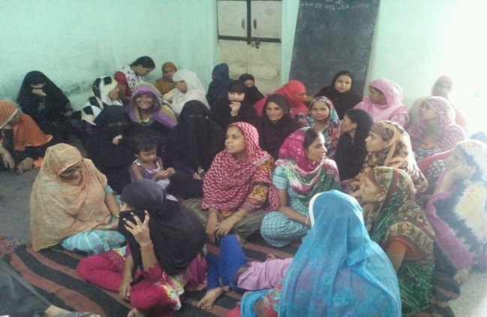
- PTMs are organised on monthly basis and parents discussed progress of their child along with problems (If any).
- Survey was held during summer vacations. 2350 families were surveyed for non-school going children and CWSN (Children with special needs). 11 CWSN were identified, out of these 11 CWSN, one is admitted in Prayas Sanganer school and one is admitted in home based therapy program run by Prayas. 7 CWSN are admitted in private schools nearby their home. 2 CWSN are of severe category and unable to attend any school.
- During survey, 34 pregnant women were identified and counselled to register in Govt. hospitals and also guided for proper nutrition.
- Eid was celebrated on the very first day of school opening.
- On 18thJuly, Foundation day of Prayas was celebrated with great zeal and cultural program was presented by students and teachers of all centres of Prayas at Jhalana premise.
- On 14th August, students enjoyed the energetic program on the occasion of world youth day.
- Independence Day was celebrated on 15th August followed by distribution of sweets.
- Elections for students committee were held on 31st August and all students casted votes for their favourite candidate. Out of total 149 votes, Tannu Praveen got 56 votes and elected as new President of students committee while faizan got elected as vice-precident with 37 votes.
- Teacher’s day was enthusiastically celebrated by teachers and students as well. Students organized a cultural program cum fun activity for teachers and everyone enjoyed themselves.
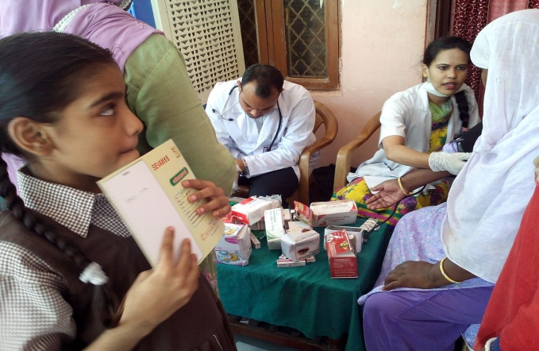
- Teachers elaborated importance of education on the occasion of World Literacy Day.
- On 6th September 2016, a health checkup camp was organised in Sanganer school for all the students.
- On 14th December 1016 Annual sports day was celebrated with great enthusiasm and students participated in various sports organised in Rajasthan University sports stadium.

EXCURSION AND VISIT-
- On 28th March 2016, on the occasion of Rajasthan Divas students went to Inox cinema to watch child films. They enjoyed snacks and chocolates.
- 14th November 2016 on the occasion of Children’s day, all the students were invited to Poornima university for a drawing competition and sports activities.
- Students visited Hotel Rajputana Palace on 23rd December 2016 for Christmas celebration.
STORY OF CHANGE –

Shadik is student of class 1st in Prayas Sanganer School and studying in Prayas since December 2014. Shadik lives in a joint family with his two siblings and his father is working in a shop as fourth class worker and his mother does stitching job from home to earn money.
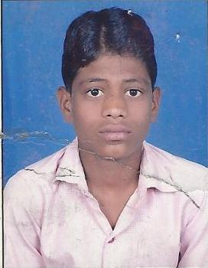
At the time of admission Shadik had lots of behavior problems and he used to talk a lot. he did not know anything in academics and his concepts were not clear.
He used to run out of the class and would scream all the time. Before taking admission in Prayas, he had never been to any school. Shadik joined the school in December 2014 and marked changes are visible in his behavior. He not only sits in the class, but also learn and participates in activities with other classmates and teachers. He is proactively learning all the subjects with other students. His family members and members of the community are happy to see him improving gradually. This year Shadik is promoted in Class first from CWSN class. He is enjoying his mainstream class and learning with regular students. Though he is not at par with other students but we hope to make him learn steadily.

TEACHERS TRAINING –
One
Prayas Organizes workshops for teachers and special educators. This is an ongoing process and help in technical as well as overall development of teaching faculty. During this reporting period A workshop was held from 5th to 7th November 2015 at Prayas for teachers and special educators.
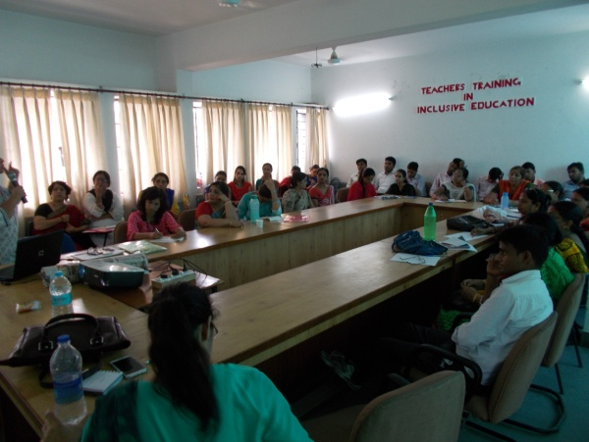
The Workshop topic was : Workshop on Enhancing the role of Special educators in early childhood Special Education, IEP and Skill Development. Our guest faculty were invited from Mumbai, Dr. Preeti Verma, Dr. Sujata Bhan who are well known names in the field of Special Education and Teacher Training.
The session started with a welcome note, followed by a self introduction of all the participants. The Guest faculty was then introduced to everyone. This was followed by an overview of Prayas and its varied activities.
The workshop sessions focused on IEP and its relevance, skill development to prepare IEPs in curricular areas, skill development on IEPs in functional curriculum, relevance of early Intervention, How to prepare case studies and how to document it and Transition Planning. Individual case studies were also discussed. The workshop had a lot of interactive sessions and group activities to make it easy to understand as well as interesting. The participants also shared their real life experiences and problems encountered while working with these children.

Two
Teachers Training of Prayas teachers by Shri Mahesh Gupta District Education Officer Dausa and ex Shikshakarmai Resource Person trainer was conducted on 7th May 2016 at Prayas Special School Jhalana. All the Prayas teachers, special educators and community team participated in the pedagogy training.

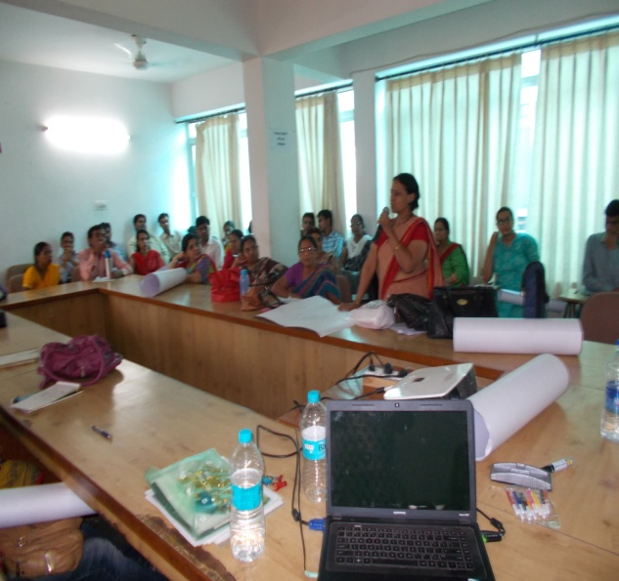
Mr Gupta started by talking about NCF (National Curriculum Framework) 2005. The Framework provides the framework for making syllabii, textbooks and teaching practices within the school education programs in India. He then discussed RTE 2009 and what its objective and implications are. Education is a fundamental right of every child between 6 to 14.
He then discussed and concluded that Learning is a process which brings about an expected change.
It has 5 levels: IPEER (Introduction, Practise, Enrichment, Evaluation and Remedy.)
When you enter the class you have to read the “baal man” and then frame your teaching accordingly so that children accept and absorb what you are putting across.
Learning is imparted in three ways: Teacher to Learner, Learner to Learner and Learner and Material. So if a good teacher tries this, he only needs to do 33% work. Rest the learner does on his own.
The next exercise was on Vocabulary building. The teachers loved the various mind challenging exercises. He then discussed how teaching can be made interesting and “ruchikar’. This is possible if the environment is “sneh yukta” and “bhay mukta”
He related a couple of stories and answered specific queries.
One interesting revelation:
When the govt says do not fail a child till Class VIII. This is normally interpreted by government teachers as why teach, we have to pass them anyways. What is actually expected is that the onus is on the teacher to bring the child to the desired level.
He explained how to set about achieving this. Say for instance you have a 10 year old child coming to school, for the first time and you have to admit him in age appropriate Class V. So where do you start. You cannot compress 5 years course in 1 year. What you need to understand that due to “poorva gyaan” which is previously acquired knowledge from environment and experience, the child has a better acceptance and understanding level than the Class I child. You do not need to teach him all lessons of Class I and so on. Instead you start with basic concepts and a few lessons and then move to next level till you come to the current level. This 10 year old will grasp better than his younger counterpart in Class I.
To conclude overall, the teachers enjoyed this session, specially because the resource person could connect well with them and impart a lot of techniques just by engaging them in talks, interaction and responses. The teachers have requested more such sessions in future.

Three
Another Teachers Training session was organized on 28th May 2016.
CCE Continuous and Comprehensive Education was discussed extensively. Continuous implies every day after teaching you assess how much children have learnt, conduct periodic tests etc. Comprehensive means judge them in varied subjects, by varied means and co curricular activities in all dimensions.

The resource person asked teachers about shortcomings and advised that a teacher should overcome their anger as it is their weakness and hinders the teaching process. A good teacher is one who teaches multiple lessons through one thing.
The discussion then shifted to TLM. What is TLM. TLM need not be anything concrete. Creative work without material is also TLM if it aids the teaching and learning process. TLM should be creative. If the child does not understand, change your strategy of teaching. He narrated the Akbar Birbal story of the mad elephant where Birbal used his hand as a weapon to save the king. So anything can be a TLM .
TLM can be used by teacher to assess and evaluate the child. TLM should be multi purpose, creative, interesting, clear, capable of repeated practice, and with different appeal to di9fferent children. Children themselves are TLM. The entire environment is TLM. Student, teacher and material are all TLM.
The resource person viewed the TLMs made by the teachers, asked the teachers to come up and give presentations and then guided them on multi purpose use of TLM.
The next topic was on good teacher : The teachers came up with good points and finally concluded that a good teacher makes learning interesting, is liked by students, reads the “baal man” or child’s mind, is simple, level based teaching, is a role example, works 33% himself and 33% students and 33% from books and each other. He makes the children active and engaged. He knows his subject, and constantly updates himself. He is strict but does not scold and has a loving temperament. He pays attention to all his students. He encourages students to ask questions and is free from partiality.
The objective of teaching is Knowledge, Understanding, Use of Knowledge
Mr Gupta then explained the value of zero and how India has ruled the world by wrapping all nos in 1-9 by introducing the zero and its placement. By itself zero has no value.
The next topic was on Varna, akshar, swar and vyanjan.
Half ka is vyanjan and becomes full ka when swar a is added to it. A vyanjan cannot be pronounced independently. But a swar can be pronounced independently. Swar + Vyanjan KA is a Varna. Akshar is that which cannot be destroyed. The sound of Varna is akshar. Yaadrichik defines which picture will be called Ka and which will be called kha. The session ended with a psychological experiment.

Four
Teachers Training 6th August 2016
Shri Rampalji Sharma, RetiredJoint Director, Department of Education, Govt. of Rajasthan, Jaipur conducted this training. He divided the session into three parts: Inclusive Education, Classroom Integration and SMC orSchool Management Committee.

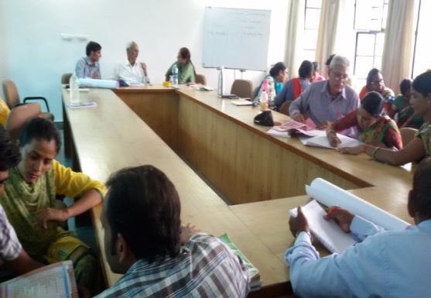
Inclusive Education: Mr Sharma spoke about how the perception of Disability has changed over a period of time. Earlier, the term used for disabled persons was “viklaang” or handicapped. The attitude of neglecting these people was there.
This was changed to “nihshakt” or “weak”. The sympathy factor and helping stand came in
After some time they were called “visheshyogyajana”because it was found that they had some special abilities. In the present day they are called “divyang” or one with divine limbs.

Mr Sharma then spoke about the different Acts and legislations related to PWDs.
1966: Kothari Commission
1968: National Education Policy
1986:National Education Policy
1992: Program of Action
1995: PWD Act
1999: Mental Retardation and Multiple Disabilities Act

Concept of Inclusive Education: Inclusion means giving children and parents and care givers the same opportunity to learn, enjoy and participate in all activities. There are seven basic principles of Inclusive Education.
1. Teaching All Students
Educators should take several different approaches to teaching the same material so that information becomes more interesting and tangible to a greater number of students.

2. Exploring Multiple Identities
Students who are proud of themselves and excited by the world around them will be more compassionate and understanding people; the same is true for educators.

3. Preventing Prejudice
Educators should take a proactive approach to abandon preconceived stereotypes and preventing them from escalating into prejudices and negative biases.

4. Promoting Social Justice
Students are good judges of what is fair, especially when they are affirmatively challenged to consider issues of social justice. Educators should talk to them about issues of social justice and injustice in terms of fair versus unfair, respectful versus disrespectful.

5. Choosing Appropriate Materials
Inclusive classrooms use books and materials that reflect accurate images of diverse peoples and challenge stereotypes.

6. Teaching and Learning About Cultures and Religions
Educators should create curiosity and expand students’ horizons by teaching about others in a positive manner. Students should have the opportunity to learn from their peers as well as other cultures.

7. Adapting and Integrating Lessons Appropriately
Educators should be flexible when using and adapting lessons in curricula, as well as in prescribed curricula in general. Many of the best moments are unplanned and unscripted.

Mr Sharma then spoke about the RTE Act of 2009 and amended in 2012, when Home based program was introduced. He came up with some interesting statistics: In Rajasthan we have 2,66,00,000pwd. Of these, 48.5% are VI, 27.9% have Locomotive Disorder, 10.3% have Mental Retardation, 7.5% have Speech Deficiency and 5.8% are Hearing Impaired.

Classroom Integration
Classrooms should be child centric. The no. of working days and teaching hours for Primary classes is 200 days and 800 hours per year. For Higher classes it is 220 days and 1000 hours. Special efforts and Remedial efforts have to be made for weak children. A Yearly or Annual Teaching Plan has to be drawn. Classroom activities, Seating Strategy, Clubbing of Classes, teaching methods and Teacher Behavior and SMCs were also discussed.
Five
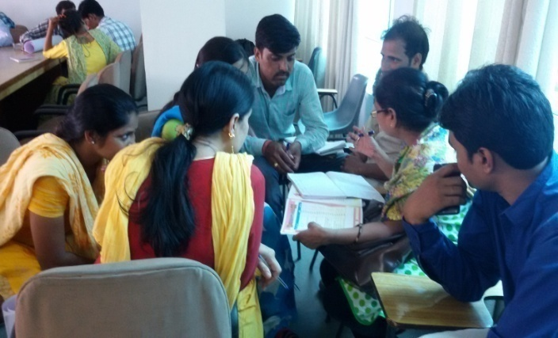
A workshop on Integrating Therapy with School Activities was conducted from 25th to 27th August 2016.The workshop participants comprised of 30 special educators, 9 government school teachers and 1 private school teacher. All these people are working in the area of Disability and Inclusion. Our guest faculty were invited from Delhi: Mrs Sudha Vohra and Mrs Jayashree Ganapati, who are well known names in the field of Special Education and Teacher Training and Mr Soumen Kumar Maity from Ahmedabad who is a specialist in Visual Impairment and Low Vision.
The Resource person spoke on how we do not normally recognize the presence of CWSN in a regular classroom, because we are taught to think in that way only. We are now talking more about CWSN because of PWD and other Acts, Zero Rejection policy in SSA, Home Base program because everyone cannot reach school, UNCRPD and RTE.
The workshop activity then focused on needs of all children in the school going age and activities in school to address their needs, keeping in mind the children with disabilities. The participants were divided in groups and prepared their charts based on their work experience and understanding. These were then discussed individually and supplemented with suggestions.
Post Lunch, Mrs Jayashree gave an Orientation to various therapies, Intervention, Common Therapies like Motor (Physiotherapy and Occupational Therapy), Speech and Hearing and Vision. She then focused on Speech Mechanism, speech problems in children, activities to develop speech, and Augmentative communication.
The second day started with Physiotherapy (Gross Motor) / Occupational therapy and activities in relation to it with practical sessions. The Concept of Circuit Training was also discussed. Eight volunteers from among the participants demonstrated the Circuit Training and a chart were maintained with individual scoring according to their performance. An important lesson learnt was of competing with one’s own self and not with other participants.
The second half of the day was spent on Gross motor activities, Respiration Control with help of Candles and Blowing Thermocol Balls, Blindfold Football, Mirror Image Practice, Feeling and identifying things inside a cloth bag, tasting and identifying unnamed juices.
The Third day session was started by Mr Soumen Maity and was on Vision and low vision training and Mobility Orientation through group activities and presentations. He also showed the equipment that can be used by Low Vision students. This was followed by a Gross motor session demonstration and Brainstorming on activities for gross motor sessions covering all areas, to facilitate planning by teachers.
The participants also shared their real life experiences and problems encountered while working with these children.

COMMUNITY OUTREACH PROGRAMME –
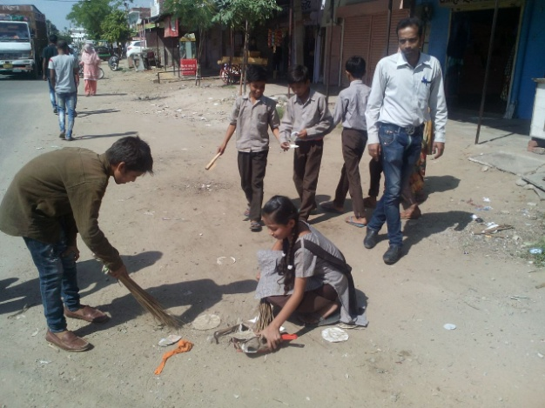
We are working on education for all in the slums and to achieve this we need to be accepted as one of them. Many a times, our team goes to their houses and chats with them about their family and other issues, so that they can trust us and open up about everything. After this level of acceptance, we ask them to admit non school going children to school, and they do it because they find us more reliable.
We do other activities to make them aware like rallies, nukkad natak, meetings and camps. To carry our work further and to reduce dependency on other people we are working to associate community people with us.

Following is list of Community meetings held.
SR. NO. | Date | Agenda | People present
1 | 26/11/15 | Drinking water problem in community and how to talk to Govt authority for this | 153
2 | 29/12/15 | March to the office of PWD department office for drinking water connection | 85
3 | 21/01/16 | Awareness towards Education | 69
4 | 24/03/16 | Cleanliness drive in community | 54
5 | 23/07/16 | Child rights and education | 62

Along with meetings, Prayas team regularly work on right base documentation. In this reporting period Prayas helped 120 people in getting adhar card, 1 widow pension and 24 bank account of students were also opened.

BAL-CLUB ACTIVITIES –

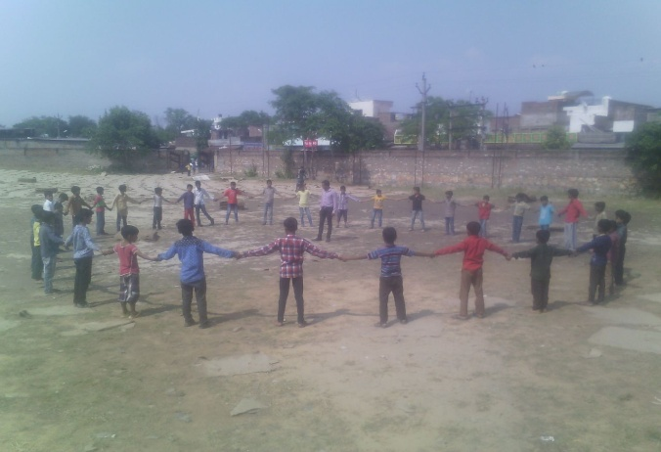
Prayas has Bal clubs in the slums to motivate children for education and change their mindsets from the beginning. Through these bal-clubs, we spread awareness about education, child rights, health & hygiene from grassroots. Meetings are organized for Bal-clubs and in between other celebrations also take place. Various sports and cultural activities were also organised in bal club meetings.

Following is the brief list of bal club activities organised during this reporting period.

SR. NO. | Date | Activity
1 | 21/10/15 | Sports activities
2 | 25/11/15 | Child rights
3 | 23/12/15 | Sports activities
4 | 27/01/16 | Cleanliness drive
5 | 17/02/16 | Discussion for exams and preparation
6 | 23/03/16 | Health and hygiene
7 | 27/07/16 | Games
8 | 24/08/16 | Cricket match
9 | 21/09/16 | Discussion about dengue and malaria
10 | 19/10/16 | General knowledge quiz
11 | 16/11/16 | Yoga
12 | 16/12/16 | Child Rights

CONSTRAINTS –

As reported many times earlier, there is a paucity of space in the present school building, which is a rented accommodation. So we have difficulty in accommodating all school going children of the area.
Continued Education especially for the girl child is a challenge, as our school is only up to class V and parents are reluctant in sending their daughters to distant schools for higher education.
We have applied for a piece of land to build a proper school building for Prayas Sanganer school. However it is still under process and may take some more time.

