Prayas Sanganer School Site Visit

PRAYAS is an organization working for children with special needs and underprivileged children living in the kachhi bastis (slums) of Jaipur and the surrounding areas. The aim is to bring about a positive change in the lives of these children, their families and community.
The site visit was conducted by Praveen Singhvi for ASHA UIUC on 4/24/2018 at Sanganer School Jaipur.

Here is a breakup of children at the Sanganer School
Student strength: 165
Special Student: 11, 2 students out of these 11 were shifted with the normal students as they could study the basics.

Current Issues:
- The school building and surroundings are in much worse shape. The classrooms are dark and poorly lit.
- A few of the rooms were clearly overcrowded and there were two classes combined in one because of space crunch.
- They teachers quit the job as they feel underpaid said Ms. Kalpna Mehta who is in-charge of the school.
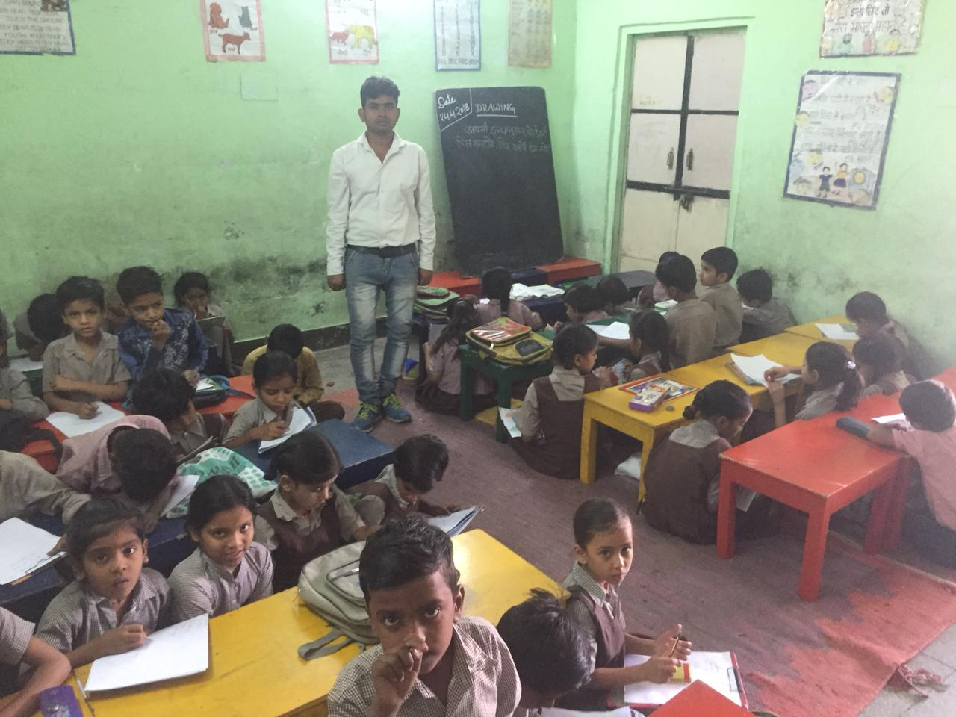
Visit Pictures
