Sep 8, 2016

Funding proposal for Kedi 2016-17

Background;

Project is supported since January 2008
- Area of operation: Dharampur, Valsad District, GUJARAT
- Project Type: - Residential high school for tribal girls. Formal education & Vocational training relevant to tribal villages.
Primary Focus: Tribal Girls- Secondary Focus: Vocational and entrepreneurship training. Kedi has started Std 11 & 12 to enable the tribal girls to continue the education. The admission is also open to non-tribal girls coming from disadvantaged background.

- Area: Hilly area, very rural, over 90% of the population is Tribal, mostly first generation literate, very poor.
- Funds disbursed till date: $184,000
- For year 2015-16 contributed $ 14362. -38 % of total budget from Asha. Special fund allocation was $ 16416.
- Number of beneficiaries: 80

What is the project about? Kedi states as below:
“The project aspires to provide a supportive and conducive environment that would benefit the Adivasis of Dharampur Taluka to progress educationally, economically, socially and thus to bridge the wide gap between Tribal rural-urban society.

The core philosophy of Kedi Residential School is to provide relevant formal education along with vocational training which can prepare tribal girls to work and live in their own villages. Thus, to use literacy as a vehicle of social mobility and as a method for increasing market value for employment. The ability to take independent decision and the desire to take personal responsibility are the major objectives of the education.”

How Asha supports the project?
Asha has been with the Kaivalya Trust’s project from its inception, providing the seed funding to construct the residential and school facilities, as well as for operational expenses for lodging & boarding, uniforms, books, Teachers’ salaries, & vocational training. Because of Asha’s support and Kedi’s efforts, the residential school has secured commitments from other donors, thereby ensuring its sustainability and future and reducing its dependence on Asha’s funds.

What has been the project’s impact?
Huge; Transforming the mindsets, aspirations and lives of Tribal girls. 99% of the students graduating from Kedi have pursued higher studies. Although most girls are first generation school-goers from their illiterate & poor families, they aspire to be Engineers, Doctors and entrepreneurs. They have acquired life skills, self-esteem and self-confidence to compete in today’s India
Kedi is open to all faiths. The tribal girls follow the faith from their tribal tradition, Hinduism and Christianity. This year, 5 non-tribal girls from Muslim faith have joined Kedi. This is a very positive development as in this poor region, Muslim girls face even many challenges for education.
What is the potential for the project?
Kedi has started Std 11 & 12 for commerce streams. This will enable larger number of tribal girls to pursue higher education and professional careers.
Kedi is recognized as a role model for the relevant education for tribal students.
Kedi’s mentor, Aparna, an Architect, has designed several Non-profit schools on Kedi model.
Kedi is working with Central Government’s program for vocational training of youths & is one of the centers.
SUCCESS STORIES
99% of the students passing SSC from Kedi are pursuing higher education. This may be unmatched by even urban schools
Despite coming from remote, illiterate tribal villages, four girl students have become engineers.
Attached presentation “Kedi story” gives more info about activities at Kedi.

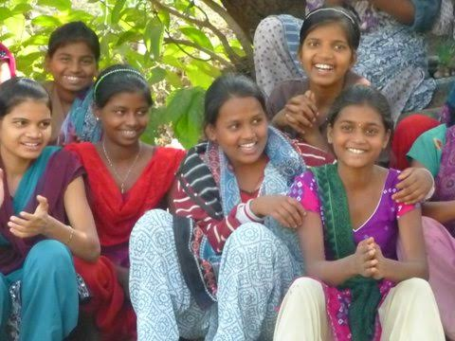
Happy & confident.
Kedi students on the Sports day, Jan 2, 2015. During summer holidays, some of these girls coming from very poor families work on construction projects, carrying heavy loads on their head under scorching sun. Kedi arranges summer programs so that they do not have to work on construction to earn their daily bread.
Summary:
Activity | 2015-2016 Budget
A.1 PERSONNEL: | 1,062,000
A.2 FOOD | 748,000
A.3 EDUCATION | 512,000
A.4 OTHER COSTS: | 262,800
TOTAL EXPENSES | 2,584,800
C.1 Capital Expenditures | Not stated

- Kedi continues to do amazing work for transformation of tribal girls into confident, self-reliant, skilled, well educated women, ready to take on the world on its own terms.
- Kedi gives high quality learning & self-development opportunities to Adivasi girls.
- Kedi has started 11th & 12th standards for Commerce. Kedi plans to start Science stream in 2016-17.
- The salary for teachers has increased over the past year as 3 more teachers at higher salaries are recruited for teaching Std 11 & 12.
- The cost per student per year is Rs 32,300 or $500, including lodging, boarding, health care, education, excursion etc. This is a reasonable level, considering that it is without any grant or subsidy from Government. The Trustees and volunteers work at school without any salaries. Collaborations with other institutes add resource people without need to pay high compensation.
- Dr. Sudarshan Iyengar retired as vice chancellor of the prestigious Gujarat Vidyapith, has joined Kedi as a Trustee and will stay near the campus. He will guide Kedi for achieving excellence. Two other eminent educationists have also joined Kedi as Trustees.
- Kedi has requested a contribution of Rs 1.1 million ($16,900) out of the budget of Rs 2.5 million, or 42% of the budget. The balance budget needs will be met from other donors.
- Kedi was one of the projects promoted at Evening of Hope event. $28K were raised Kedi.
- Submitted for deliberation
Tushar Shah

