REPORT FOR THE MONTH
OF

July 2014 –June 2015

Submitted by:
JOINT OPERATION FOR SOCIAL HELP (JOSH)
www.josh4india.org, josh4india@gmail.com
Report for the Month of July 2014 to June 2015

During the month of July 2014 to June 2015 the following activities were undertaken by Aheli Chowdhury and Saurabh Sharma as part of JOSH:

As mentioned in the previous years reports, JOSH has been working with a mandate to mobilize youth across different sections of the society to work on the issue of education. Effective implementation of the Right to Education Act, 2009 has been the main focus of work of JOSH in the field of education. In this, we have undertaken several activities and programs, amongst them being the ‘RTE Status Study: The Delhi Story’ that JOSH has been doing for the last three years. As part of this study, students from different premier colleges and institutions are mobilized to undertake a systematic survey to track the status of implementation of the RTE Act in Delhi. Last year, revealed several findings, amongst which the most critical being the non implementation of the provision of School Management Committee (hereafter SMC) in Delhi. Section 21 of the Right of Children to Free and Compulsory Education, 2009 mandates the constitution of SMCs in all schools. Three fourth of the SMC is to be comprised of parents and is supposed to be responsible for monitoring of working of schools, prepare and recommend the school development plan, monitor the utilization of the grants, and perform other functions as mandated by the state rules.

SMC is therefore envisaged to be a body that provides a platform for parents to participate in planning and functioning of schools. It clearly has been also given the crucial function of undertaking monitoring of the school functioning along with over seeing utilization of grants to the school. It is for the first time that parents and community members have been entrusted with such important responsibilities. It is a body that has the potential to form an effective connecting bridge between the community and parents and that of the school authorities. It has the potential to become a platform that empowers parents and community members hold the school authorities and the education system accountable and ensure effective delivery of education. But in the context of Delhi, SMCs has been consistently neglected. This fact has been consistently revealed in across all the status surveys undertaken by JOSH in the last few years.

Given this, we decided to focus on pushing for effective formation and strengthening of the SMCs in the schools of Trilokpuri.

- Facilitating Formation of SMCs and Capacity Building On Their Roles And Responsibilities: As part of this, the following activities were undertaken:
  - Formation of School Management Committee:
School Management Committee has a critical role in implementation of RTE Act. SMC is the sole committee ensuring people participation under the RTE Act. For this aim, during this year we focused on formation and capacity building of SMC members. We facilitated formation of SMCs in 13 out of 16 schools run by the Municipal Corporation of Delhi ( hereafter MCD) along the prescribed norms. In order to do this, JOSH had meetings with active parents of the schools and encouraged them to take part in election process for the selection the SMC members. Simultaneously, we distributed pamphlet in the community, undertook door- to- door campaigning and motivated parents to come for such elections to be held in the schools. The parents were invited by the schools also. Along with working with the community, a constant dialogue was held with the schools. The Principals cooperated in terms of having the election in a transparent manner and also were open to support the elected members of the newly formed SMCs. These SMC members are being trained and they have taken charge of school matters.

  - Display boards of SMC in schools: We along with SMC members attended 4 meetings of School Management Committee in different schools on 10th October, 2014 at MCD School Block 7, first shift, 12th December, 2014 at MCD School Block 27, First Shift, 14th November, 2014 at MCD, Block 7, second Shift and 12th December, 2014 MCD Schools, Block 32 Second shift. The main focus was on role of SMC in the school functioning. While the Principals assured that they were ready to extend every possible cooperation to facilitate effective functioning of the SMC, but in most instance they also agreed that they had little understanding about the processes and what needs to be done. They were also unclear about the roles and responsibilities of SMCs. SMC members also raised this issue about lack of trainings and awareness about how they could effectively participate in functioning of the schools. The SMC members asserted that board should be placed on the prominent site of the school having names & addresses of the SMC committee. This would help the parents identify these people and approach them in case of need. The principals agreed on this and MCD School block no. 27 in both shifts and MCD school block no. 7 first shift have already put up boards with details of their SMC members in their respective schools. These boards are helping members in interacting with the community and have also helped in boosting their confidence in dealing with school related matters.

  - SMCs Requesting Government Departments for Capacity Building Trainings: For effective functioning it is critical that the members of SMCs are aware of their roles and responsibilities. But neither Delhi Government department nor MCD has conducted any capacity building trainings for SMC till now. After several discussions during our regular meetings, it was felt that providing capacity building trainings is the duty of the government and there is a need to pressurize them to fulfill that. We therefore started encouraging SMC members of different schools to send memorandums to government requesting them to organize trainings for them. The members of SMC of all 16 MCD schools have sent letters to the Director of Education requesting to hold trainings for them.

Such efforts have also helped in collectivizing the SMC members where they look beyond their individual schools and address more systemic issues. This process of sending memorandum to the Department of Education, can be seen as a step towards helping the SMCs understand themselves as a collective strengthen and make demands from the state that affects all.

  - Inspection of Records of SMC Meeting Minutes: In the month of the December, the Directorate of Education, Delhi Government issued circular No. F.23 (6)/DE/RTEI2011/1456-1463 dated 01/12/2014 according to which any citizen approach any government school and inspect the meeting minutes of the SMC. As per this order, the minutes of the meeting of SMCs would be made available to the parents, members of the public, officers of the Directorate of Education and any legitimate inspection team visiting the school. The inspection team visiting the school must examine this record and write appropriate comments in its report.
It was seen as a welcome move on the part of the government towards transparency and to ensure people’s participation. This was seen as an opportunity to visits schools and check the records relating to the SMC functioning in Trilokpuri area. On 9th December, 2014 we called for a meeting of 25 identified community leaders and parents and encouraged them to visit their schools and inspect the meeting minutes of the SMC. This process of inspection would help in making the parents aware of the functioning of the SMC. Second, this would also help in establishing community monitoring of functioning of the schools. The parents were organized into four teams and trained them on ways to conduct the inspection. Next day on 10th December, 2014, parents along with JOSH members went out to different schools i.e. GBSSS, Kalyan Puri block 1, GBSS Block no. 27 Trilok Puri, SKV Block no. 27 Trilok puri, to undertake inspection. During the inspection process, two schools showed us the records, while one made excuses and denied access to the said records. Complaints were registered reporting this denial of inspection under the GR mechanism.
This process may be seen to have two main outcome- first, it gave the community members the opportunity to enter the schools of Govt. of Delhi which otherwise are shut for everyone and second, it got the Principals of these two schools to offer parents and community members to attend SMC meeting as observers in future meetings. This was an encouraging step in opening up spaces for interaction and participation between the school and the community.
- School Inspection: JOSH has been part of the Right to Information movement and has always strived to ensure transparency and accountability in the government functioning. With this aim a complained was filed with the Central Information Commission (CIC) on 8th June, 2011 under RTI Act requesting disclosure and inspection of records of government schools under Section 4 of the RTI Act, 2005. Following this application, the Central Information Commission (CIC) ordered on 29th July 2011 that any citizen be allowed to inspect records of schools of Delhi government & Delhi Municipal Corporation on last working day of the every month. Since then JOSH has been undertaking the process of school inspection every month and have slowly moved on to involve parents and community members in this process.

This year, regular inspections were held along with parents, community members and SMC members. Preparatory meetings were also held every month before the inspection where issues that emerged during the previous inspection were discussed and follow up actions planned. During the inspection parents are encouraged to follow up on issues found during the previous inspection with the school authorities and also look out for any other concern. Post the inspection, another round of meetings are held to discuss on further action. For instance, during the inspection of month of August, parents found that books have not been given to students whereas the academic session had began in April. They met MCD, Education Director, Mr. Vijayanan on 15th September, 2014 regarding the delaying in distribution of books in the schools. He gave assurance that he will visit some schools and books will be distributed very soon. But nothing happened and more than a month had gone by. The parents were very annoyed as he neither visited the schools nor were the books distributed. Following this the parents group again went to meet the Director on the 11th November, 2014. He promised this time and within two weeks books reached the schools. Mr. Vijayanan also visited schools and checked the hygiene standard in the schools, which has helped in improving the hygiene standards in the schools.

The above mentioned success story reveals the ways the school inspection process has helped in creating a platform for regular interaction, there are numerous other smaller stories of improved functioning of individual schools are reported. This process has allowed the parents, community members and JOSH to slowly work with the schools, through regular follow ups, to become better in terms of implementing the different standards laid down by the RTE Act. Therefore, the data collected over the year from the school inspection process is being put together to form a report of card of the schools.

- Outreach to community through different campaigns, rallies, marches and others demanding for effective GR mechanism: As part of this, the following activities were undertaken:
  - Awareness Campaign on Grievance Redressal:
A circular No.F.23 (l4)/RTE/2012-13/962-965 dated 25.04.2014 was issued by Directorate of Education on grievance redressal notifying a mechanism of registering complains regarding RTE implementation. Before this, there was no such mechanism to deal with complaints under RTE Act. We held total 10 camps & 2 large rallies this year in Trilok Puri for creating awareness amongst the community and through these camps we reached out to more 500 people and made them aware about the procedure for filing grievance. More than 300 grievances were filed during this process under grievance mechanism. These complaints were focused on major problems relating to pupil-teachers ratio, infrastructure, teachers’ insensitive behaviour and school system and denial of admission. Amongst the complaints filed only those complaints pertaining to denial of admission were redressed by the Department of Education, others still remains pending as of date. We are pursuing these grievances.
Around 300 grievances and 90 RTIs have been filled
  - Toilet Campaign for Girls:

After call of the Prime Minister from the Red Fort on the occasion of Independence Day on 15th of August, this year, about the importance of hygiene in toilets of schools, JOSH organized signature campaign for girls in which school student were encouraged to write to the PM an appeal letter mentioning about the poor state of toilets in their schools and urging him to look into the matter. These letters were addresses to the PM and mailed to the PMO. Copies of the letter were marked to the Lieutenant-Governor, the Ministry of Human Resource Development, and the Directorate of Education of the Delhi Government and local Member of Parliament.

A total of 2500 appeal letters were sent, out of which 70% were written by girls only. In these appeal letters girls wrote about the pathetic conditions of schools toilet and about the prevailing sanitation problems. After 3-4 days, shockingly, a list of names of girls was sent back from the Directorate of Education to all the schools and the Principals of these schools were sought an explanation. After which, all these girls were identified and called by principals and threaten with due consequences. They were made to sign another letter which said that they were satisfied with the toilets in their respective schools and that the previous letter was a false note. The students, however, acknowledged that the appeal did have an impact. The toilets in the schools were spruced up and provided with tissue paper, soap, dustbins, and even Dettol, something which they had never seen before.

This incident however, made the girls and parents feel insecure therefore we called for a larger community meeting to discuss the matter. More than 150 parents and 80 students participated in this meeting. In this meeting JOSH raised the issue of girls’ protection as the response of the Directorate of Education of disclosing the names of the girls to the schools was completely against any ethical functioning. The parents also resolved that such matters should not be left and there is need take this fight to a logical end. This incident was widely reported by the media.

  - Admission in Private Schools Under EWS Category
According to the section 12 of the RTE Act 2009, at least 25% seats shall be filled with the children belonging to Economically Weaker Section (EWS) and Disadvantage Group (DG) category in the private schools. Every year government used to hold the procedures especially make the rules, time lines and single window for parents and other systems for admission of this category. However, this year 2015 -16 Directorate of Education allowed schools to set the time lines for commencing the admission and submission which led to a lot of confusion amongst parents.
Nonetheless, we started holding awareness camps from 15th December, 2014 and created awareness on the EWS/DG admission. We held our camps at block 27 Bus stand, 15 block chowk and Subhash Market, 13 block, 5 block near mother dairy. Pamphlets having information regarding procedure of admission and list of nearest schools of the Trilok Puri were distributed to the parents to facilitate the process. More than 1000 people were contacted through camps, individual meetings and door- to- door campaigning. A total of 81 parents completed the documentation as per the required procedure, who were then facilitated in submitting their forms in schools. Some schools, like Ahlcon Public School, Rishab Public School, ASN School, and Somerville School refused to receive forms and gave vague excuses; we submitted such forms to Deputy Director of Education (East District) and also filed 87 grievances against these schools.

JOSH also facilitated consultations on admission of EWS/DG and using of Grievance Redressal mechanism to ensure admission. This consultation was organized by Centre for Social Inclusion and Equity at NCDHR office where different groups of civil society participated. We shared our experience and answered their queries relating to the procedure. We also offered them any assistance for the admission under this category.

Additionally, 90 RTI applications have also been filed on different issues relating to school system and by the parents who applied under the admission of EWS category. Interestingly, in reply of RTIs where we sought the list of EWS students selected this year, the PIO provided department circular no. DE15/Act-I/Misc/EWS/DG/2014/21879-21889 dated 7.03.2014, according to which the disclosure of the details of students admitted under EWS/DG category may tantamount to disclosure of personal information which would cause unwarranted invasion of the privacy of the individual and may also lead to discrimination against the student belonging to EWS/DG category.

4. Janmanch - People’s Forum:
The idea of the Jan Manch is to create a space of interaction and dialogue of the community. JOSH has been holding Jan Manch for the last four years on different issues related to education. Section 21 of the RTE Act, mandates the formation of SMC in all the schools. The objective of School Management Committee is to promote the socio political process of empowering the community to manage the school and take ownership of different processes. It is also responsible to ensure effective participation of parents and strengthen processes of community based monitoring. However, in Delhi the status of formation and functioning of SMCs has been a challenge. As of today there are many problems from lack of proper training of SMC members to inadequate guidelines for functioning of SMCs that plague the system.
Keeping this in mind a need for initiating dialogue at different levels towards strengthening of SMCs and making them functional was felt. It is in this context JOSH organized a “Jan Manch” on 9th March, 2015 at ISI, Lodhi Road, Delhi where experiences of different SMC members were shared and problems raised and steps for way forward discussed. More than 200 parents & SMC members attended the meeting.

The different panels that spearheaded the discussion had experts on education- Maju Varghese from Oxfam, Rajiv from Pardharshita, Annie Namala from Centre for Social Equity and Inclusion, Anuradha from Arth Astha and members from JOSH. Different issues related to the functioning of SMC were raised. For instance, SMC members shared how the Delhi RTE rules have not given signatory powers to the SMC members unlike suggested by the model rules of RTE Act. This has led to Principals completely ignoring the SMC members when it comes to budget and expenditure related functioning of the schools. This issue is related to another violation of the model rules. It was pointed out that as per the model rules of RTE Act, the chairperson of the SMC should be a parent member, whereas in the Delhi rule, the Principal has been made the chairperson. This has led to signatory powers being restricted to the Principal and the teacher of the school and has excluded the parents from overseeing any kinds of financial transaction in the school.

Further, it was added by another SMC member that the maintenance fund provided per school is too less and if we want the schools to be able to take care of repair and maintenance on time then this fund should be increase. Next, issues of discrimination and lack of steps to include children with special needs in schools were also raised.

While lack of power and functioning of SMC was the overarching issue, lack of mechanisms of grievance redressal also compounded the problem. The lack of grievance redressal mechanism emerged as a major hurdle in the implementation of the RTE Act. It is also further weakening the powers of the SMCs as they also have no available mechanism to deal with issues and concerns emerging from the schools.

The meeting concluded with the resolution that a team of representatives of SMC members would meet the Minister of Education, Government of Delhi and submit a charter of demands that were discussed. Following this a charter of demands was drawn up and the general body agreed to gather support on this through signatures of people.

Follow Up of Resolution passed at the Janmanch: As it was resolved at the Janmanch held on 9th of March, 2015, the SMC members collected more than 2000 signatures on the Charter of Demands. After which a small meeting was called to discuss the next steps. It was during this meeting of the SMC members and parents that were decided to seek an appointment with the Education Minister to hand over this charter of demands. Following which on 25th March, 2015 an appointment was sought with the Education Minister and we along with around 50 SMC members visited his residence. However, even after having taken an appointment, the team was turned away by the office of the Education Minister citing that he was busy with other commitments. This incident really disappointed the SMC and parent members, however, a fresh appointment is been sought with the Minister to hand over the Charter of Demands.

- Training and Capacity Building of Urban Poor Youth:

5.1. English Speaking & Computer Literacy Classes:
As part of the Youth Resource Centre (referred as YRC hereafter) JOSH has been running classes for Basic English Speaking and Computer Literacy. These classes, apart from aiming to hone the English Speaking skills and Computer knowledge of the pupils, also aim at mobilizing the youth towards understanding different issues in rights based framework. The curriculum has been designed in a way to improve the English Speaking and Computer Literacy skills of the youth and also includes different thematic workshops and trainings sessions which improve their understanding of community issues. Most of these youth are also engaged in different activities as volunteers, which provides them an opportunity of direct involvement in the area of education.

The session every year begins with mobilization of students. After which, interested students register in the program and an orientation session is organized. The orientation session entails sharing of basic framework of the course curriculum and also understanding the expectation of the students. Next, a pre-test of students are taken of the enrolled students, which helps in designing the curriculum of the course. Apart from this, bi-monthly tests are conducted along with a final examination at the end of the program. | 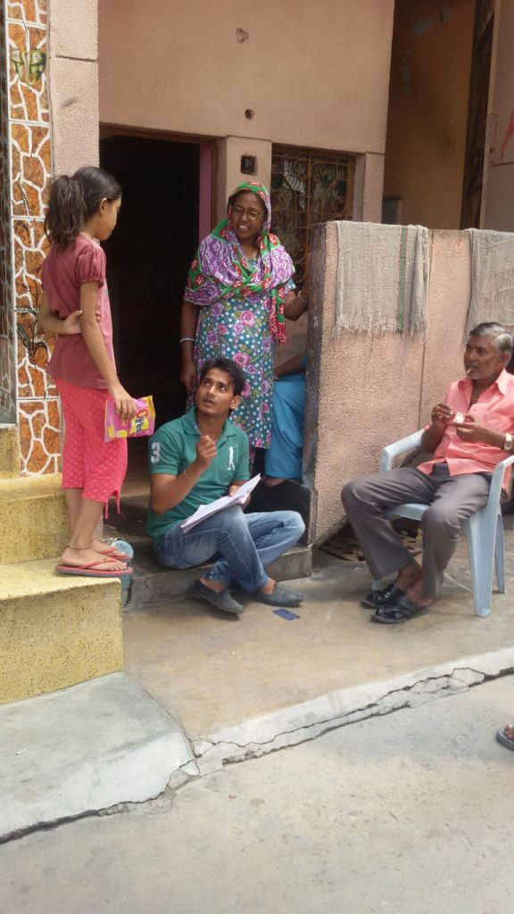

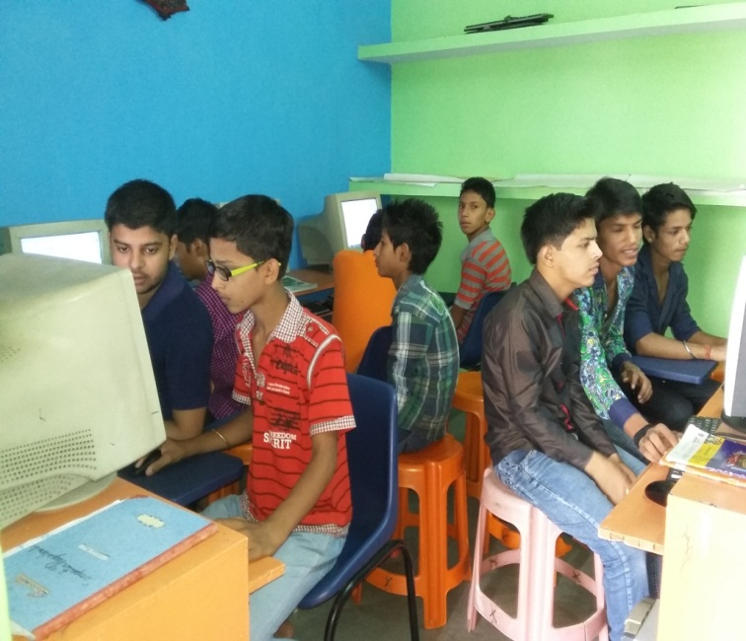 | Computer Literacy Class: The curriculum of the computer course includes MS word, MS Excel, Paints, PowerPoint presentation, internet browsing, paint, e-mail etc. Additionally other basic functions of computer such as use of control panel, C drive, D drive, USB devices etc are also taught. Along with theory classes, practical sessions are also held. At the end of the program, written tests are held in order to evaluate the status of the students at the end of the course.
English Speaking Course: The course on English speaking included imparting understanding on types of sentences, Tenses, Changes of Voice, Narration, Imperative Sentences, Causative sentences, Vocabulary, Proverbs, Idioms and general English. Regular group discussions were held which helps the students to improve public speaking skills and improve confidence level. There was a lot of focus of improving their pronunciation also. | 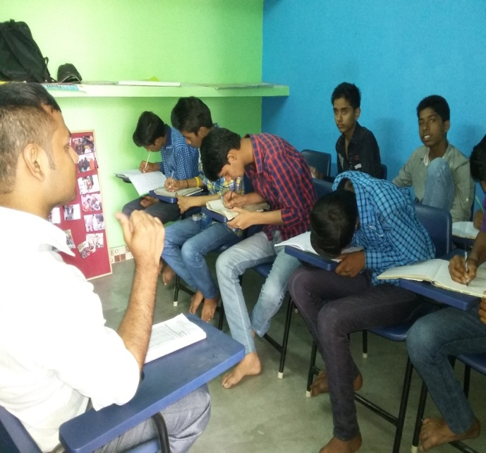

5.2. Capacity Building Sessions:
As mentioned above, youth engagement work along with English speaking and computer operations course and includes different training and capacity building programs. These trainings aim to develop the understanding of youth on social issues and enhance their ability to raise their voice against social evils.
Training on Gender & Equality:
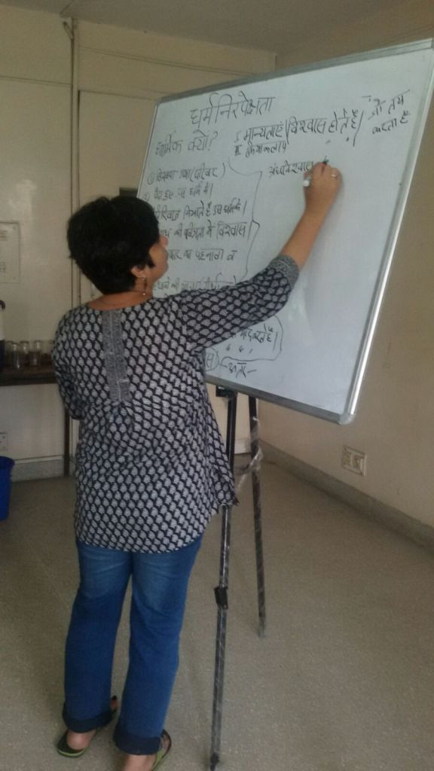  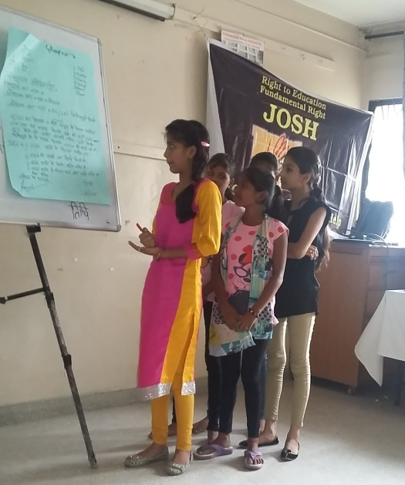 | Every year, YRC caters to fresh batch of boys & girls from the urban poor community. They often come from orthodox and underprivileged families. Their surroundings are insensitive towards gender equality and girls in these communities are the most vulnerable. For inculcating gender sensitization a day long session on Gender Equality was organized for both the boys and the girls. The training session was held on 26 June, 2015 at ISI, Lodhi Road, Delhi. About 40 youth volunteers participated in this workshop. The workshop was facilitated by Mrs. Lokesh from University of Delhi and part of Sri Shakti Sangathan.  The workshop commenced with the introduction of participants. This was followed with different sessions on the meaning, forms and manifestations of gender discrimination and how to combat gender discrimination.

5.3. Participation in School Inspection:
As mentioned above, the school inspection process has evolved to become a regular and ongoing process in JOSH since the passage of the CIC order in 2011. Since JOSH has worked on education by engaging youth, we have consistently strive to train and involve the volunteers of YRC in different activities related to RTE Act implementation. In this regard the volunteers were trained to accompany and work in tandem with the community members in conducting the school inspection in the different schools of the area. This would help them to not only see the school as an educational institution but also understand the governance aspect and the ways in which such institutions functions.
Also these volunteers are involved in several other activities which focus on better implementation of Right to Education Act in their neighborhood schools. The volunteers were therefore trained in the process and also on different issues that can to be noticed during the inspection. The volunteers were given a detailed format meant for conducting school inspection by JOSH. They were also informed about the ways to use the format to consolidate information obtained from the inspection of different schools visited every month.

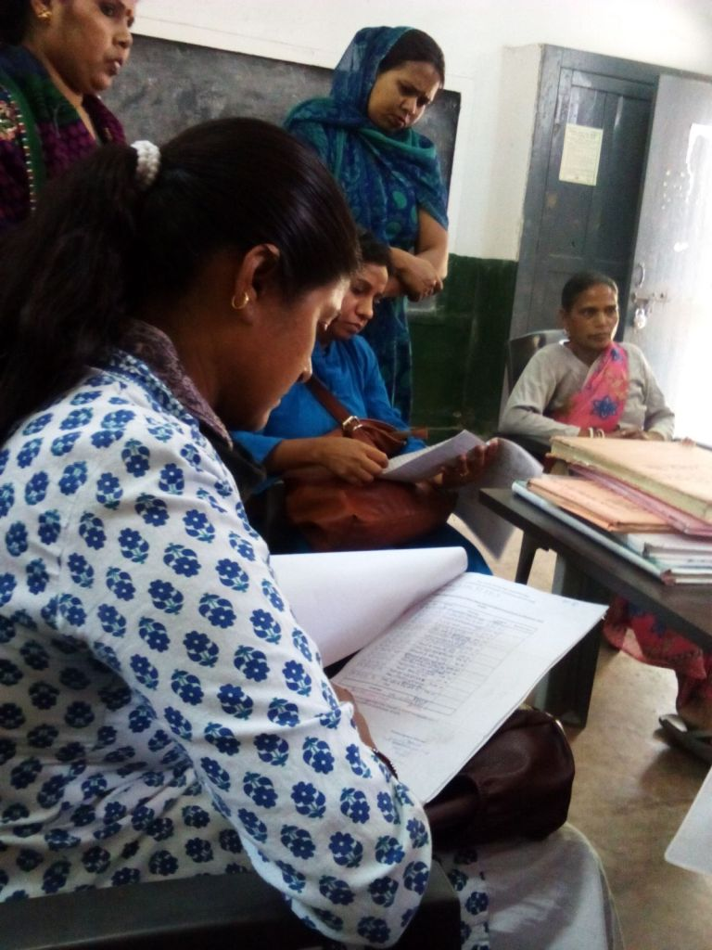 | In the month of 30 April, 2015 JOSH along with about 35 volunteers, SMC members and community members visited all 16 MCD schools for the inspection. This time, volunteers inspected all the records of the school regarding utilization of funds. The parents & SMC members got the first hand opportunity to inspect these documents.
In an MCD School at Block 3, 1st Shift, the team found that the Principal had spent Rs. 8000/- and Rs. 3500/- for cleaning the toilet which according to the parents was an extravagant and unnecessary expenditure. The parents & SMC members raised question on these expenses because she did not discuss with them before utilization the fund. It had been found this practice was done by most of Principals. They did not share budget with SMC members. Therefore SMC members filed written grievances to the Director of Education (MCD). After making complaints some of principals assured that this year they will not repeat this practice and the budget amount will be spent only after consulting the SMC members. 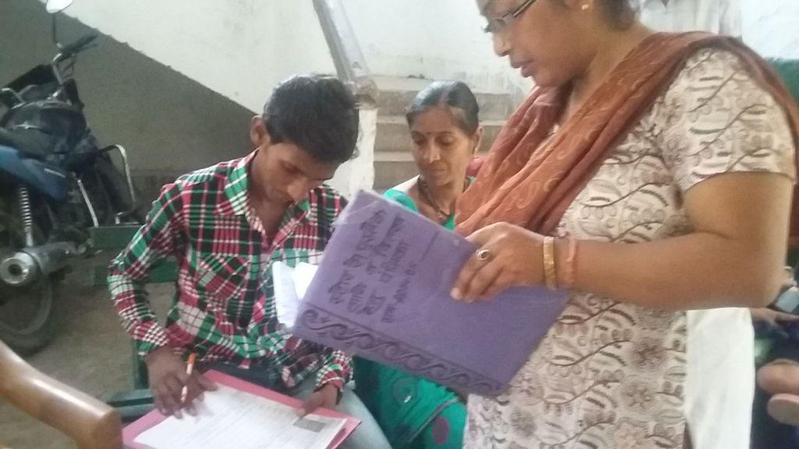
5.4. Focus Group Discussions:
Apart from classes, one day in a week has been set aside for holding FGDs. This activity is very important for the students because it gives them knowledge and understanding of different social and political issues. In these FGDs, we try to clear their doubts and remove the myths through open discussions. They also learn to argue and express their point of view. We had number of FGDs on different issues such as child labor, corruption, abolishment of capital punishment, and Right to Education Act.
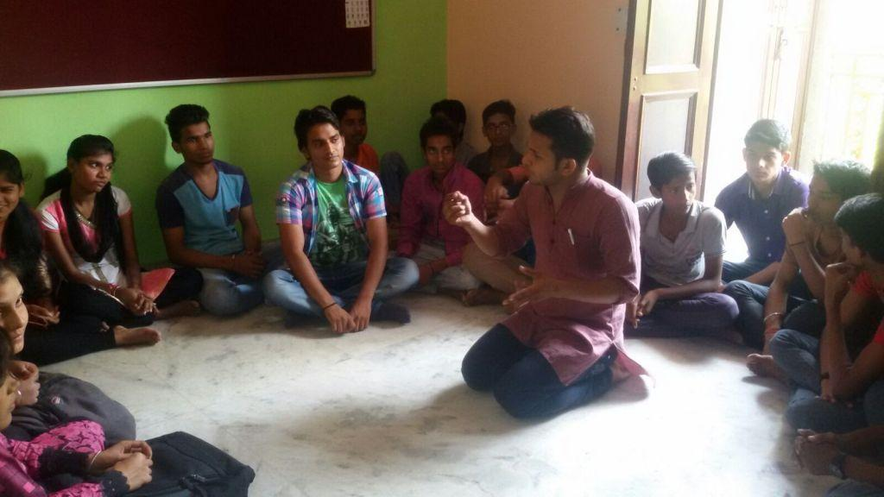
6. Some Success Stories:

Distribution of Text Books:
JOSH has been holding regular school inspection as per the school inspection order of the CIC. It was during these school inspections, that the issue of delay of text books reaching the schools emerged.
As mentioned after the inspection of month of August, the parents and community recognized that the fact that text books had not reached the schools still even when the sessions started in April, is a critical issue and needs to be taken up seriously. During a meeting, it was jointly decided that a group of parents and community members will go and meet the Education Director and bring the matter to his notice.

On the 15th of September, 2014 a group, comprising of parents, community leaders and JOSH staff met MCD, Education Director, Mr. Vijayanan regarding the delay in distribution of books in the schools. During this meeting, Mr. Vijayanan heard the matter and assured the team that he will visit some schools and that the books will be distributed at the earliest. There was however no action and more than a month had passed. Neither was there a visit by Mr. Vijayanan nor did the books reach the schools.

Given this, another meeting was held where it was decided that another visit will be made to the Director of Education’s office. On 11th November, 2014 a group of parents again met him to follow up on the matter. This time again he promised to take immediate action.

The books finally reached the schools within the next two weeks of the visit. Mr. Vijayanan also visited a number of schools in the area and checked for hygiene standard in the schools. After his inspection, there has been a significant improvement in the hygiene standard of the schools.

The main outcome of this experience was that the parents felt that their advocacy efforts had resulted in concrete action in the schools. These processes gave them the confidence to reach out to higher officials with their grievances and also helped in building a sense of a collective.

Display of Boards of SMC in Schools:

The SMC members demanded that a board, with names and details of SMC members be put on the prominent site of the school. The Principals agreed on this and MCD school of block no. 27 in both shifts and MCD school block no. 6 (first shift) have already put up their boards. These boards have helped the members to interact better with community and have also, boosted their confidence. Till now, 4 schools have put up boards listing details of the School Management Committee. The schools are:
- MCD School Block 6 (first shift)
- MCD School Block 27, (first shift)
- MCD, Block 28, (first shift) and
- MCD Schools, Block 32 (second shift)

Scholarships due for Years Released:
Grievance redressel mechanism ensures accountability in the system and at the same time it provides an opportunity to the community to register their complaints/grievances in the government departments. Keeping this in our mind, we held camps to reach out the parents who have problems with the schools or education departments. The camps were held from 17 June - 23 June at different places around Trilok Puri. Through these camps we succeeded in addressing issues such as delaying in distribution of scholarship, denial of admission, delaying in distribution of text books and etc.

During these camps, parents who were construction worker visited our camps. Some of them shared about the delay in distribution of scholarship that are meant for children of construction workers. The Directorate of Education distributes the annual scholarship from Rs. 1200/- to Rs. 6000/- to the students of class I to XII class whose parents are registered as construction workers. But parents complaints that their children had not been received the scholarship for last two years. Many of these parents & students had already approached district offices of Directorate of Education and Labour Deputy Commissioner several times but they did not get any satisfactory information. On getting to know about this, JOSH took the initiative of facilitating filing of complaints for these parents. Complaints of 23 parents were filed and written grievances were sent to Labor Minister of Delhi Government, Sh. Gopal Rai and to the Education Department of Delhi. Within 2 weeks of filing complaints, Labour Deputy Commissioner sent letters to these parents mentioning that the Labour Department had sanctioned the funds to the Directorate of Education and the scholarship will be distributed soon. In the next week of receiving of this letter, the children of construction workers got the scholarship pending for the last two years together.

Case Studies:
- Subah, 13 years old, belongs to West Bengal. He came to Delhi after completing class VII. His parents are labourer in a factory in Noida. During our GR campaign his father approached us. He told that he has been trying to get his child admitted in a government school for last two years but have been denied admission on the grounds that Subah is unable to read and write Hindi.. We along with Subah and his father contacted every government school in the area, but everyone denied admission to this child citing similar reasons. When this case came to our notice, we filed a complaint under GR mechanism. Subsequently an RTI application was filed to know to follow up on the GR application. In the RTI application, an action taken report on the grievance filed was sought. After a month, Subah’s father was called by nearest government school and Subah was given admission in class VII.

Now, his father is very happy who had lost every hope. Although his father is a labourer but he was always keen to send his son to school. He never thought about withdrawing his child from his education. Subah was also very keen to go to school and would be seen wearing his school uniform everywhere he went. With his admission now, the family is excited and now Subah is taking coaching to get himself upto speed in Hindi.

- Sunita lives in juggi basti situated in 32 block, Trilok puri. Two years ago, she applied for a OBC certificates at the SDM (Mayur Vihar) office. Due to some reasons she could not collect the certificates on time. After two months when she reached to receive it, the clerk told that she has to re-apply along with all documents. As re-applying is a long process, she did not re-apply and instead made multiple visits to the SDM office requesting the clerk to look for her certificate. But nothing happened. She was also asked to pay bribe to get the certificate, which she did not give. She came in our monthly meeting and mentioned her case. We filed an RTI application to know the procedure for delivering the OBC certificate and reasons for re-application. Almost after 35 days from filing the RTI application, she got a call from SDM office and was asked to come and collect her OBC certificates. The clerk also requested to take the RTI application back. Sunita now wants to learn about the RTI Act so that she can use it to get other pending work done.

- Pinki lives in block 6, House no. 18, Trilok Puri. She passed class VII from Bihar. She has migrated to Delhi along with her family recently. She wanted to get admission in class VIII therefore she approached to Principal Govt. Girls, Sr, Sec. School, ID 1002039, kalyan Puri for my admission in class VIII. The principal asked for transfer certificate and report card from her previous school, which she did not have. On this basis, she was denied admission. Under the RTE Act, she has right to complete her elementary education and school cannot deny admission on any grounds. During our community meeting, she came with her mother and discussed this problem with JOSH team. We facilitated her in filing online grievance in this regard. After filing complaint principal called Pinki and gave her admission in class VIII. The principal also asked Pinki to take her complaint back, which she has refused.

- Shubham studies in class XI in Rajkiya Sarvodya Bal Vidaylaya , Block no. 1, kalyan Puri. Three years ago, at the time of admission in class VI, his father’s name was misspelled. This had become big trouble for Shubham in getting benefits from school like scholarship. His parents had approached the principal of the school many times requesting her to correct the name, but the principal kept asking his father’s birth certificate or school leaving certificate. Since none of these documents where there, the name remained unchanged. Shubham’s mother, Geeta, contacted JOSH. We met the Principal and request him to consider Voter Identity card, Aadhar card or driving license of Shubham’s father instead of birth certificate or school leaving certificate. The Principal agreed to consider the same and following this Shubham’s father’s name was corrected in the school records.

