V-Excel Educational Trust visit – 2018

  - Date: 7/23/2018
  - By Kamini Parasurama
V-Excel school for Special children
This school is located in Mandaveli, Chennai. This school facilitates the programs
- Kaleidoscopic learning center – school for children with Autism and other mental developmental disabilities
- Remedial center – School for children who goes to regular schools but needs help in certain learning disabilities
- Therapy services – Occupational therapy and physical therapy services
- Bridges learning academy – School supports NOIS curriculum. This is a school for Students who can read and write but dropped out of school due to some unfortunate reasons. This school prepares them slowly by re building self-confidence. Students who passes 12th grade can then join regular college
- Teacher training facility – 6month teacher training programs
In total this facility accommodates 70 to 100 students
Asha supports 35 children in Kaleidoscopic learning center and remedial center.
I met Charu Sriram, Laxmi and team at Mandaveli center. Charu took me around the facility and explained about the programs in that facility.
Laxmi explained all the challenges they face particularly on hiring and retaining skilled occupation therapists.

Birthday celebration in KLC classroom.
They made Ragi cake and Dosa cake. They pay special attention to the diet by not using white sugar, white flour etc.
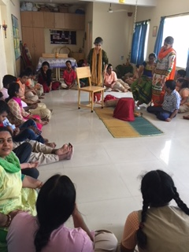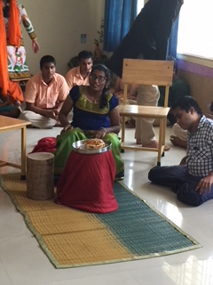

Kaleidoscopic learning classrooms
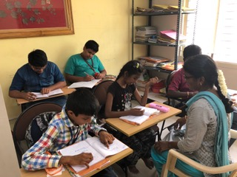

Library built by Dr. Vasudha
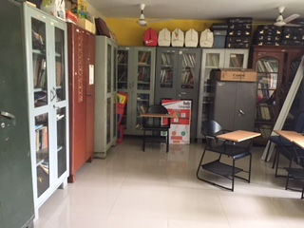

Therapy rooms
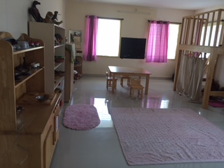
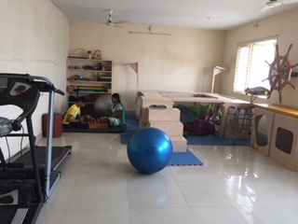

Gardening by students
Therapy playground funded by Asha - one-time fund 2017
This playground plays an important role in Occupation therapy. 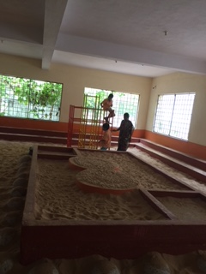
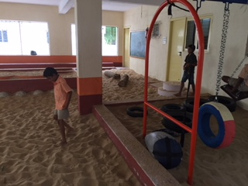

Therapy skating rink funded by Asha – one-time fund 2017
This skating rink plays an important role in Occupational therapy in improving the motor skills
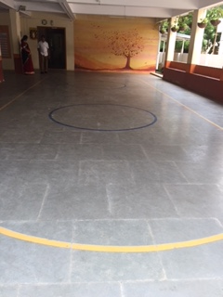

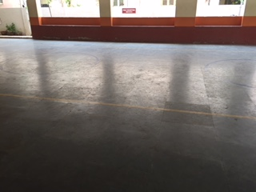
Vocational center in Mylapore:
At this facility students age 15 – 33 with special needs are trained for real jobs appropriate for their skills. The goal is to train and place in real job.
Approximately 30 – 35 students are trained in this facility.
Here I met Mr. Prakash Narayanan. He explained how the program works. They have partnered with few companies that has jobs that requires repeated manual labors like typing, housekeeping, cooking etc. For the past one year they have 11 students at Lemon Tree hotel chain.
They not only train the students, the employers are also trained on how to communicate with the special need students.
V-Excel constantly reaches out to companies to make job placement for the trained individuals.

Computers donated by other organizations for training purpose
Some students are very good at typing or written communication. More computers are required to train them properly
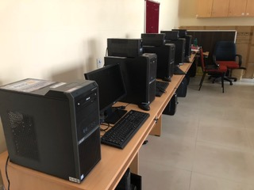

Screen Printing facility
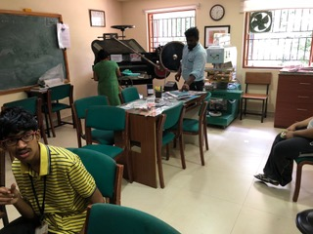

Bead jewels making
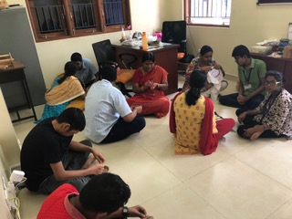

Cooking facility
They are trained to handle knife safely and fire free cooking like baking, Masala powder making etc
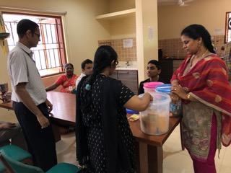

Laundry
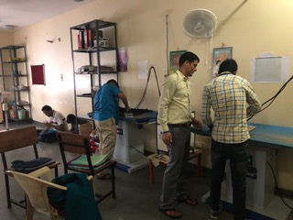

Vikram has very good communication skills. After he finished training, he is working as receptionist in lemon tree and also as a trainer at V-Excel
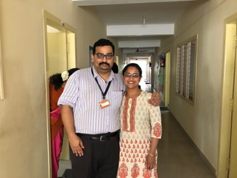

I didn’t have time to visit Early intervention center and satellite centers.
In total V-Excel supports approximately 700 students with special needs.
Management, teachers and trainers are passionate and dedicated individuals working hard to bring awareness about special need children in the society so that parents can identify and accept the reality and open up to train these individuals so that they can also lead a normal life in society.
More people from under privileged group are willing to enroll their children with special needs at V-Excel because V-Excel has partnered with government school and trained the teachers to identify children with special needs.
Asha should consider increasing their annual funding to V-excel as they have started supporting more children from under privileged group.
Asha should also consider funding for vocational training.
Lastly Asha should consider starting a separate funding project to support the salary for skilled Occupational therapists. As per Laxmi, V-excel could afford to pay only 60% of the market salary to the Occupational therapists. At this rate, V-Excel is not able to hire and retain skilled therapists after a hard find. They need 6 Occupational therapists but have only 2 therapists now. Some of the special need children are very difficult to be controlled by female therapists and trainers. Hiring a male therapists and trainers are even more expensive.
So I strongly recommend continuous support for V-Excel. Highly recommend to start a separate funding project to fund for therapist salary.

