V-Excel Educational Trust - Site Visit Report

Date: 09/16/2016
By: Madan Appiah
I am very much impressed by the V-Excel team work. Ms Ajita Panshikar helped me to show the work in Chennai location. They have three centers in Chennai and 3 more outside of Chennai and 2 in Maharashtra. Overall the trust is running school programs for Challenged children from early age to beyond adulthood. Quality of the programs are extremely good and the staffs are well trained and passionate about the work they are doing. The size of the class rooms is reasonably small to provide the required care. My feel is that they are servicing only a tiny fraction of the children. So, more opportunity is there to reach out the unfortunates. They are mainly focusing on early detection of the problem, creating awareness to the parents, running class rooms for various levels of skills, art and craft program and vocational program.
I visited RA Puram center in Chennai on 16th morning. This is the main center where number of class rooms for various skill level students are hosted. I was fortunate to be in the music class where I saw the students and the care the stuffs giving, very impressive. See the below video to experience the same.
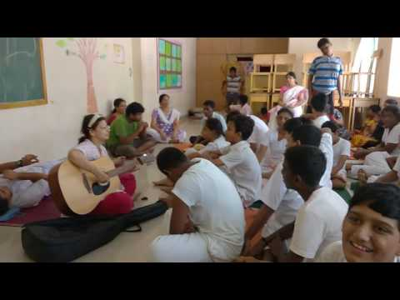

Art and Craft
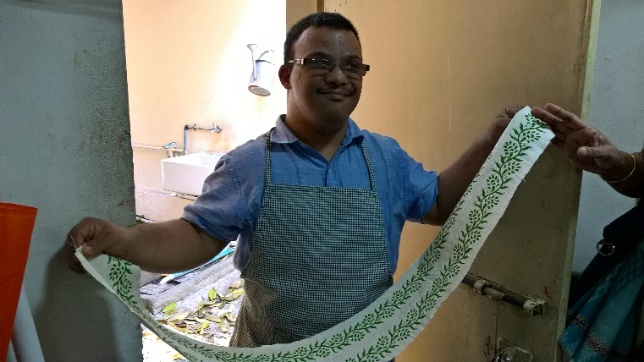
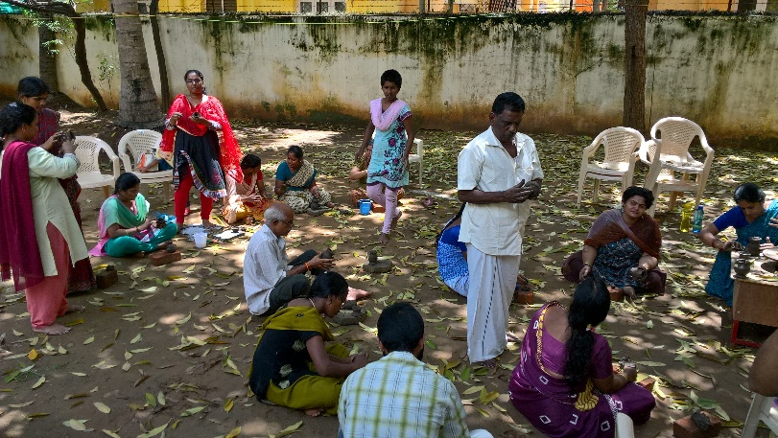
At the Shastri Nagar (Adyar) center, there was a clay art class in progress for instructors and students.
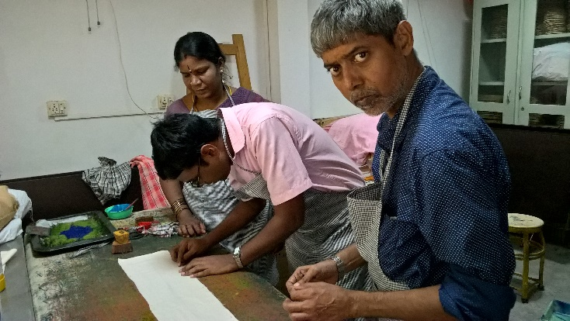
The stuff and the students showed some of the art works created by them.

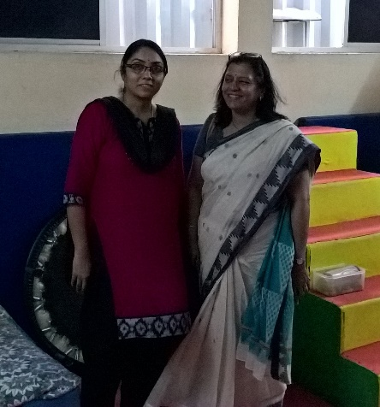
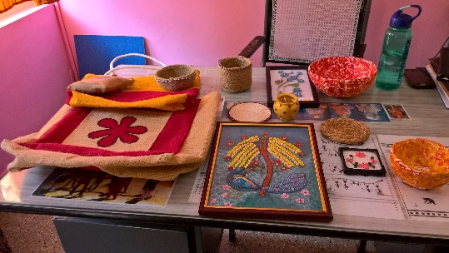
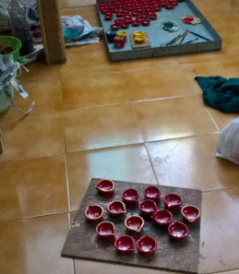
Early Detection Program
I am impressed by the early detection and awareness creation programs conducted by the v-excel team. Ms Lalitha the stuff explained how difficult to create a process to find the early signs and have the parents accept the same. Early intervention and treatment will have a big impact. They are working towards that.

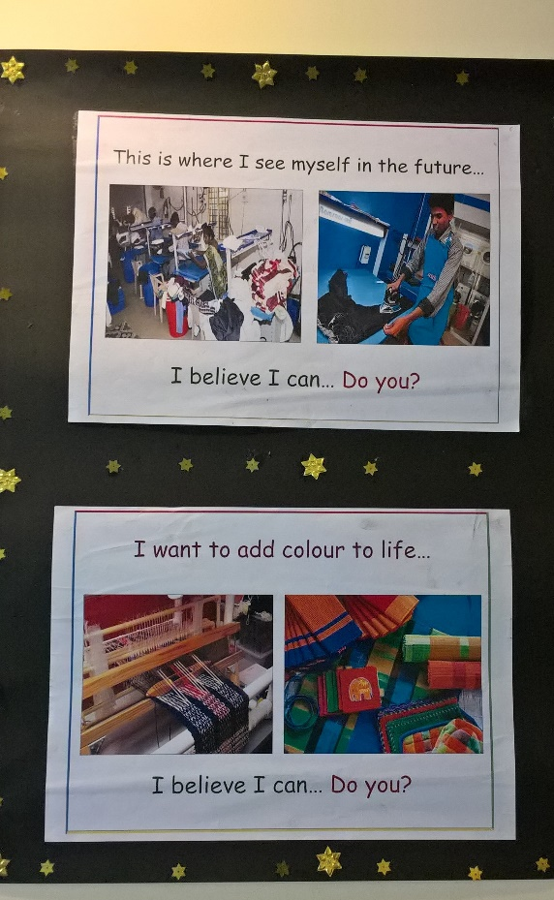
Vocational and Youth Programs
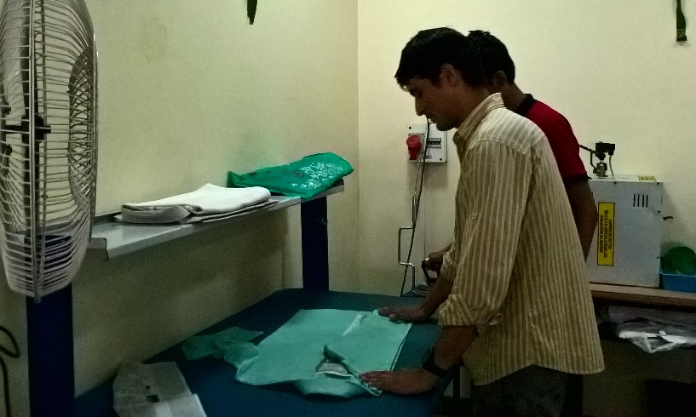
At the Mylapore Center under the administrative office they host the Youth and Vocational Programs. The students are matured at this point and they could perform the tasks assigned to them and motivated to create a career. They kept this under the administrative building to show what a career means.
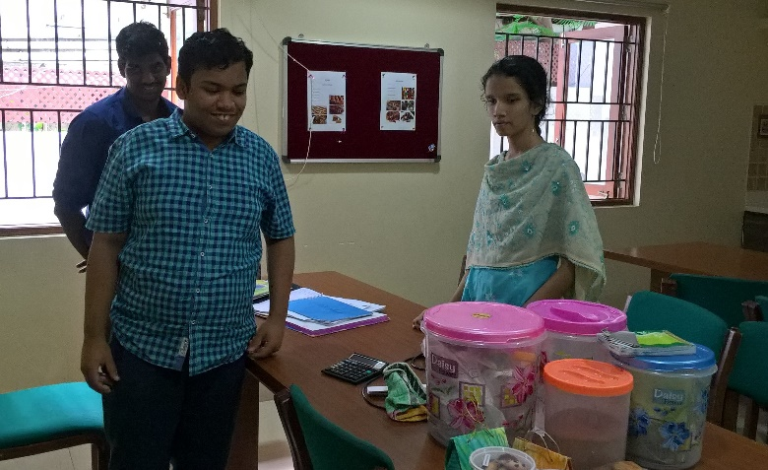
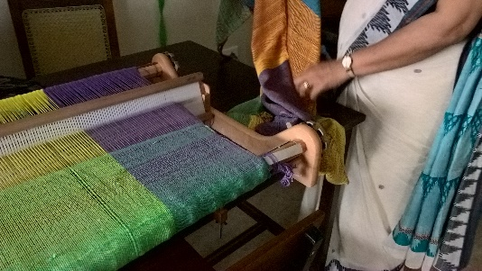
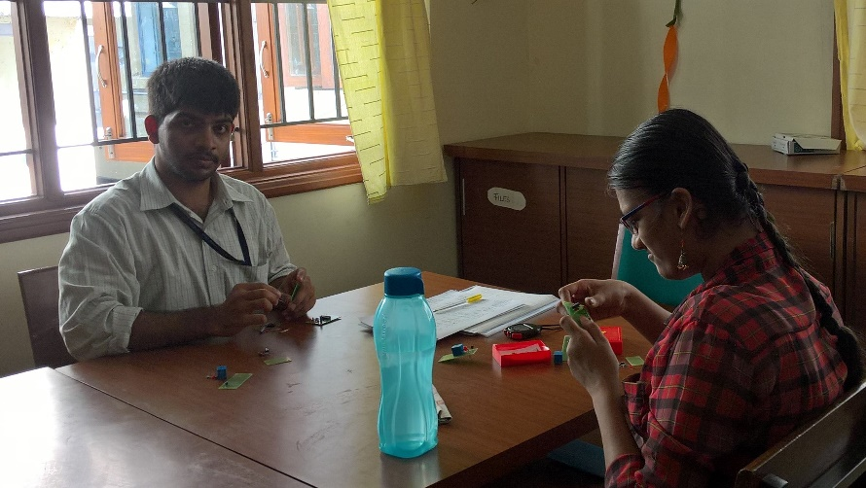
The stuffs are very friendly and working towards their goal.

Satellite Centers
I did not have much time to find the details about their Satellite centers. But from the conversation with Ms Ajita, it looks they are successful in doing so and replicating the work they are performing in the 3 centers in Chennai.

Recommendation
We should continue to support this organization. Scholarship program is the best way to support the org. Finding more needy children is the key to success. Need to evaluate whether the trust is reaching out real needy children, if not, we should encourage them to do so. Satellite centers are the best to reach out such children. The scope is unlimited here.

Appendix
Additional Information about V-Excel can be found in the attached document:

