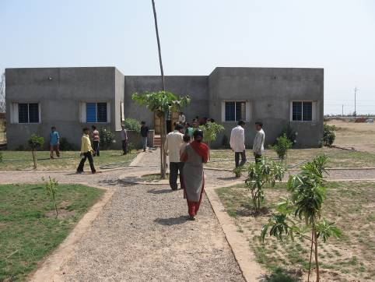

Kataria village school

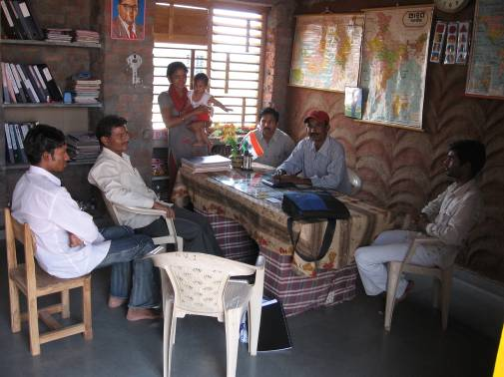

Teachers in the staff room, Kataria village school

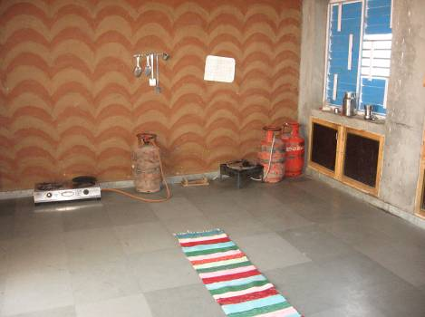

Kitchen facility

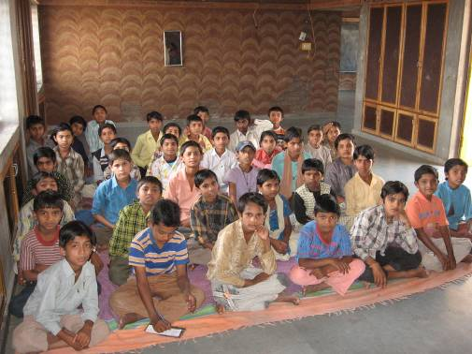
Students in Kataria village school

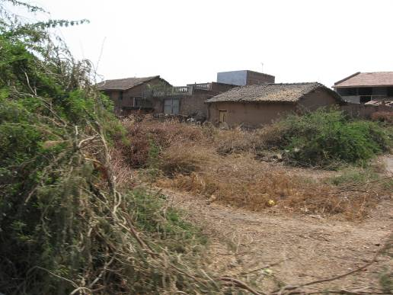

Near-by village

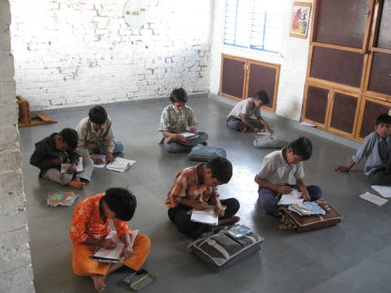

Students studying (Raika village)

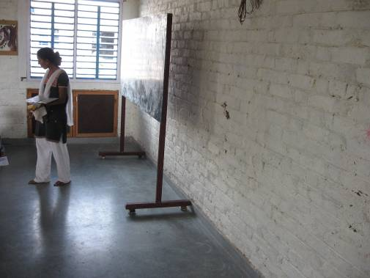

Teacher teaching a class (Raika village)

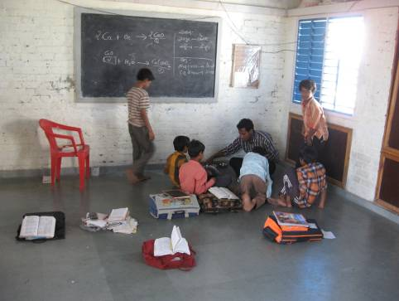

Students conducting a chemistry lab experiment (Raika village)

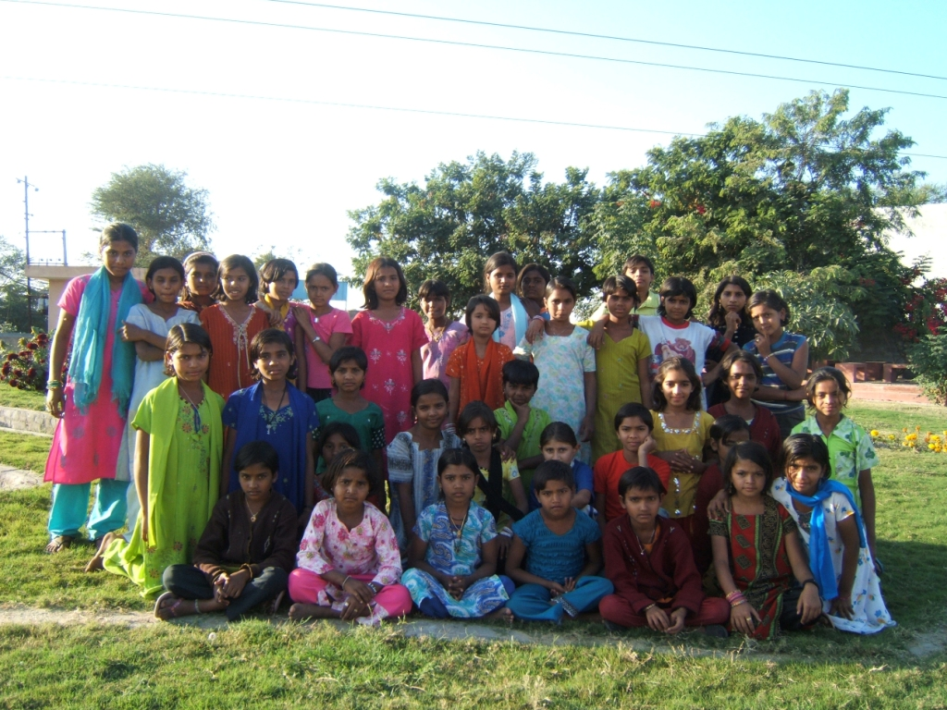

Enrolled female students in a Navsarjan school

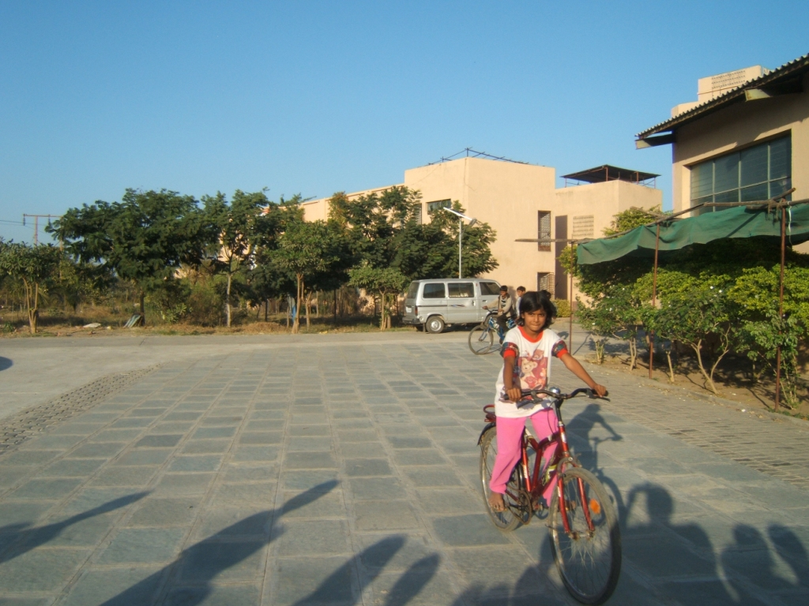

Jagruti, a daughter of woman who earns her livelihood by picking waste rides a bicycle, a rare phenomenon in the community there.

