Dear friends,
We present before you the activities of the last few months
TEACHERS’ EMPOWERMENT at Vishwa Mandal Sevashram, Shirpur, Maharashtra, India
Most of our teachers are 10th or 12th pass.(under graduates)
- In such situation, they need input sessions which strengthen their intellectual capacity. This is the time where the resource persons impart their knowledge and share their experiences with our teachers and supervisors.
- In some of the teachers’ training programmes; the senior teachers themselves conduct some input sessions for the junior members of the Palas project. Here, juniors are given opportunities to share their difficulties and seek guidance from others.
- The senior teachers and supervisors share their experiences of overcoming the similar situations like them in past. It’s a wonderful time where reciprocal relationship happens between them.

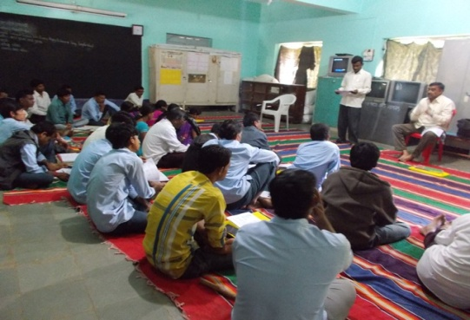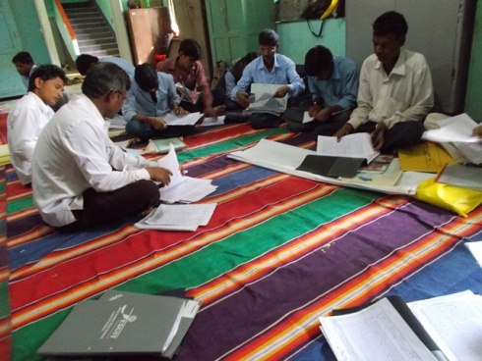

Training Dates :
- Dec 1st and 2nd 2015 (30 teachers)
- Jan 6th and 7th 2016 (30 teachers)
- Feb 1st and 2nd 2016 (28 teachers)
- Mar 2nd and 3rd 2016 (31 teachers)
- April 1st and 2nd 2016 (31 teachers)
- May 3rd and 4th 2016 (31 teachers)

In The Arms Of Nature
Our supervisors Virsing and Kailas organized picnics in their areas.
- In first picnic of Kailas 6 classes participated. He took the children to the Kaupatpada dam.
Fr. Neelam, Rajesh, Ashok, Pramila, Dhoni, Dilvar, Shivadas, Sharad (teachers), Muktilal (our driver) and 4 Guest students members of Tolani College & the Rotaract Club of Bombay also participated in the picnic.
- The second picnic was taken to the Kalapani dam.
Here 4 classes participated. Veersing and his 12 teachers took their children at Saibaba Mandir area. 420 children participated in picnic.
The responsibilities of cooking, collecting wood, conducting games and songs distributed among the teachers and the students. Children felt happy receiving beautiful gifts. They enjoy nature and always like to be in the arms of nature. After games masale-bhat (a special dish) was served to them. Through such fellowship meal a lot of sharing and caring happened among them.

SUMMER STUDY CAMP (13th to 18th April 2016)
Like every year this year also the study camp was organized for the 4th standard students.
This was a pick of our annual activities.
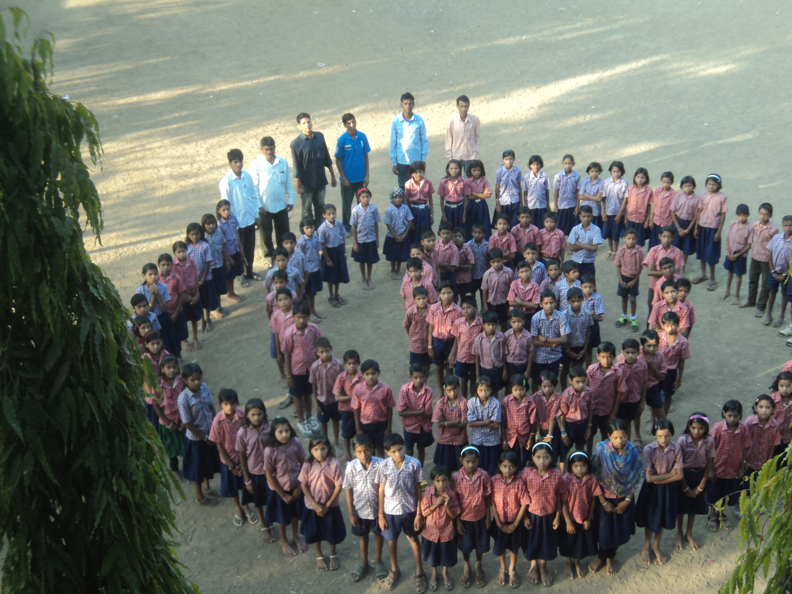
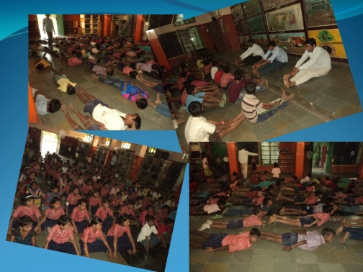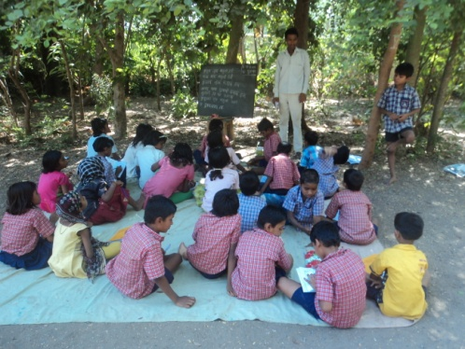

  - 130 students participated in the camp.
  - The first two days as the evening approached, some of the children started crying because they were away from their parents for the first time. It was a hard task for our teachers to engage them in various activities after sunset. As time went on they succeeded to get more participation of such children in all the activities of the day.
  - Here, the more emphasis was given on the main subjects such as Marathi, Maths, Art and Environment. Besides study classes, the children also rendered their services for one hour in cleaning surroundings every day.
  - Evenings were filled with colorful activities where they expressed their talents and learnt many more things from others. They enjoyed chocolates, cold drinks, ice-cream, eggs, bananas, jalebi, biscuits, puffed rice, pen, pencil, eraser and a note book.
  - The last day of the camp they visited the garden and had fun over there. They too saw a lazar show.
They had a wonderful opportunity to interact with the children of different villages of Shirpur. This camp has been a great help for us in order to take a right decision to admit the students in various schools according to their progress.

Distribution of dress (UNIFORMS)
- 970 children received new dress (boys - 506, girls - 464).
- They were very glad while giving their measurement and receiving their new dress.
- It was a beautiful time for the interaction between the teacher and the students; especially while taking the names and measurements for the dress.
- After this activity the attendance of children increased in the class.
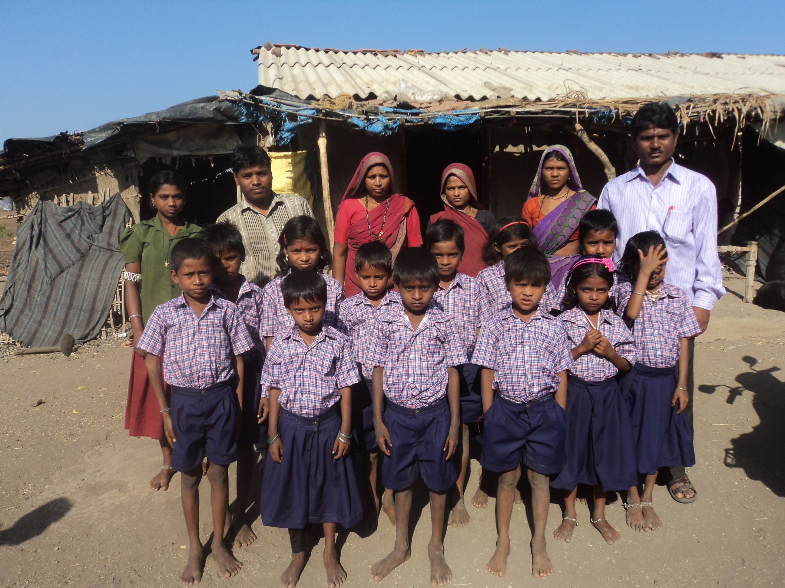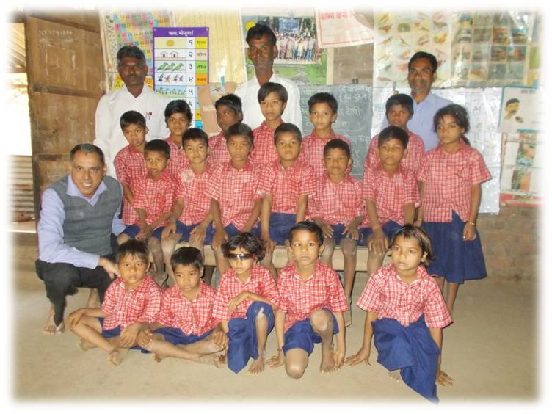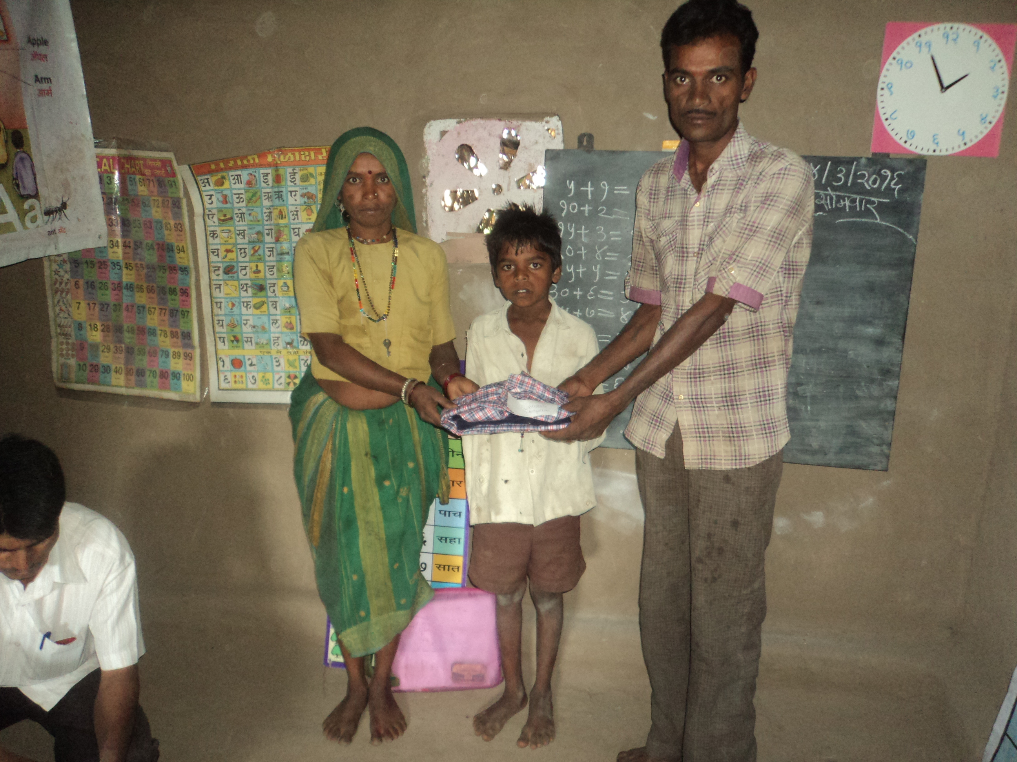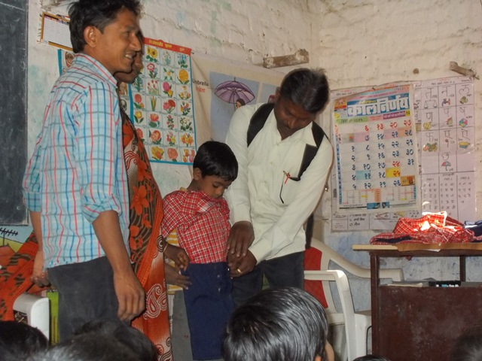

Friendship with the Computer world
Each of the 3 Supervisors was given a laptop in order to conduct educational activities in class
- such as English, Marathi, songs and to show them some video clips.
- It was a big revolution in our teaching methods.
- Our supervisors and teachers found this method very useful.
- They got more participation of the students in class.
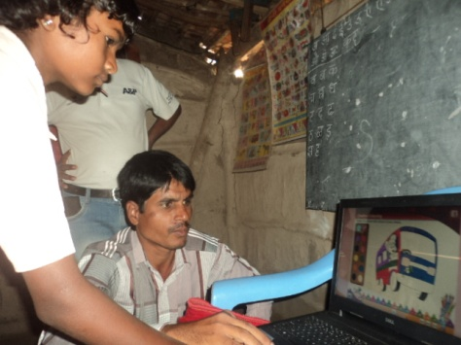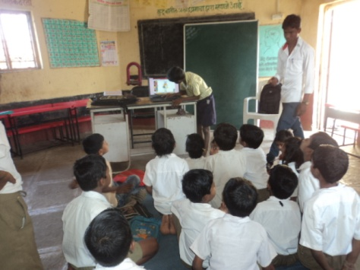
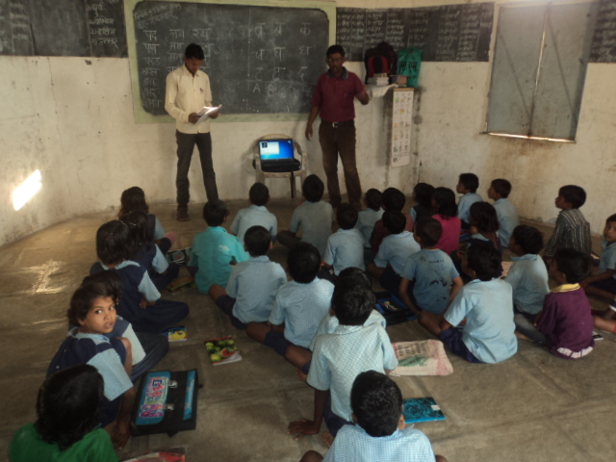

Teacher-parents interaction
- Our supervisors conducted interaction sessions with the parents of the Palas children.
- They discussed on various topics such as children’s attendance in class, their performance, importance of education, gram panchayat, gram sabha, tree plantation, health and care of the trees.
- Parents expressed their opinions about the work of Palas.
- They shared that due to these classes our children are becoming clever, our children like your way of teaching through various charts and study materials.
- They thanked for the new dress which were gifted to their children by ASHA ZURICH Chapter through VMS.
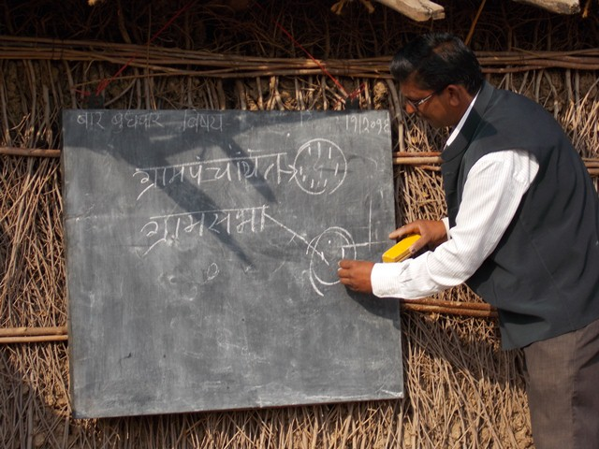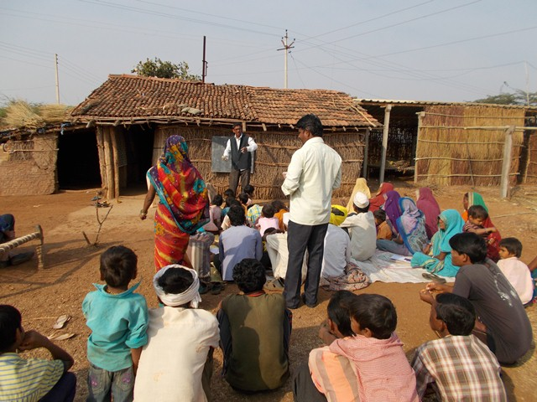

Teachers’ Picnic – 22/5/2016
- This was an exposure for our teachers to come together and share their experiences in relaxation with nature away from their daily schedule.
- Fr. Assis accompanied them. It was also as sort of farewell party for him.
- They were taken to Navadevi (one of the remotest villages of Shirpur).
- It was an overnight picnic where all had good fun in the company of each other.
- One of our teachers who belonged to this village gave the information about the village.
- Teachers learnt new things about the village which they found very useful. They also had interaction with the villagers talking to them about education of their children, their future, plans for village development etc.
- They enjoyed the sumptuous meal which was prepared by them.
Heart filled gratitude - Asha Zurich has been a wonderful support for us in the processes of uplifting our marginalized children. With your kind help we could do our best for the overall development of our students in the ocean of literacy.
This report is painstakingly prepared by our new Coordinator Fr. Joseph Poshapir s.j He was working on the Palas Project 4 years ago and has now taken over from Fr. Assis since June 2016.
We at Shirpur look forward to take Palas to new heights with the experience and commitment of our new Coordinator.
God Bless you all for your generous help in building up the lives of our Adivasi children.

Fr. Neelam Lopes S.J.
Director

