Parner Pre-school Education Project- Annual Budget Proposal
1st April 2022- 31st March 2023

Education Programme Background -
MASUM’s work with children in Purandar (Pune dist.) and Parner (Ahmednagar dist.) is multifold, being curricular as well as extra-curricular. In order to make the right to universal education for children real, MASUM conducts pre-schools (balwadis) and support classes in the interior and highly neglected tribal hamlets of Parner taluka in Ahmednagar district. This work helps in enrollment of Tribal (Thakar and Bhil) children into mainstream government run schools on attaining the age of six years and the support classes facilitate their retention in education.
Implementation Area Details -
This Education project is being implemented in Parner taluka of Ahmednagar district in Maharashtra.
- Three Anganwadi in following villages
- Godasedara
- Mendoh
- Shelwak
- Two support class in following villages
- Mendoh
- Borwak

Recent Achievements:
- Eleven children (6 girls and 5 boys) from Pre-schools have gone to 1st grade having grown to an age of six years, the minimum age for admission into first grade. Seven new children have joined the pre-schools.

- Four tribal girls and four boys from the support class passed the 10th-grade and all of them are continuing their education having taken admission in 11th grade.

- Cooked mid-day meal is being served to all the children. Children’s weight and height is also measured and recorded every month by the teachers. All children were examined (weight, height and anthropometric measurements) by the local ICDS worker and not a single child was found malnourished.
Whenever the news went around about someone in the nearby villages was down with covid-19 infection, the attendance in schools dropped. One of our pre-school teachers also got infected during the recent third wave (less dangerous) and that school had to be closed for 14 days.
We have been successful in managing Covid-19 protocol in schools and run preschools and support classes in these difficult times with no adverse events among children.
These pre-schools and support classes are making significant contributions in making educational opportunities to tribal children living in small hamlets and taking care of their nutrition levels. These children are the first generation going to schools among these tribal hamlets. We will surely be able to continue this process.

Proposed Plan for 2022-23:
In the coming year (2022-23), we propose to continue with all three preschools and two support classes.

Budget:
Budget Head | Per month (Rs.) | Annual Budget
Salaries |  | 314,400
Three preschool Teachers  Nanda Jadhav-3500  Gangu kedar- 3500  Mangal kedar- 3200 | 10,200 | 122,400
Two support class teacher  Dnyandev Jadhav- 4000  Goraksh Chikane- 4000 | 8000 | 96000
One part time field worker (1*8000) | 8000 | 96000
Project related travel cost |  | 48,000
Monthly Meeting at Ralegan | 2000 | 24,000
Monthly monitoring visit per month | 2000 | 24,000
Two-day training for teachers | 12500 | 12,500
Travel
(of Resource persons):2000/-
travel
(of Participants):2000/-
Honorarium:
6000/-
Lodging & boarding:
2500 (250*5persons*2 days)
Educational aids, material and books  (3*1000 for preschool & 2*1000for support class) =5000 |  | 5000
Mid-day meal for children  30 children @Rs.100 per month + Rs.500 x 3 per month cooking charges | 4500 | 54000
IRS. Four Hundred Thirty-Three Thousand Nine Hundred Only |  | Rs. 433,900
Grant requested from ASHA - Two Thousand Five Hundred USD  $2,500 @ IRS 73 = IRS 182,500 |  | Rs. 182,500
Contribution from MASUM’s internal resources |  | Rs.251,400
Funds requested from ASHA 2,500 USD

Notes:
- Salaries of preschool teachers and support class teachers were increased w.e.f January 2022.

Some Activity Photos: -
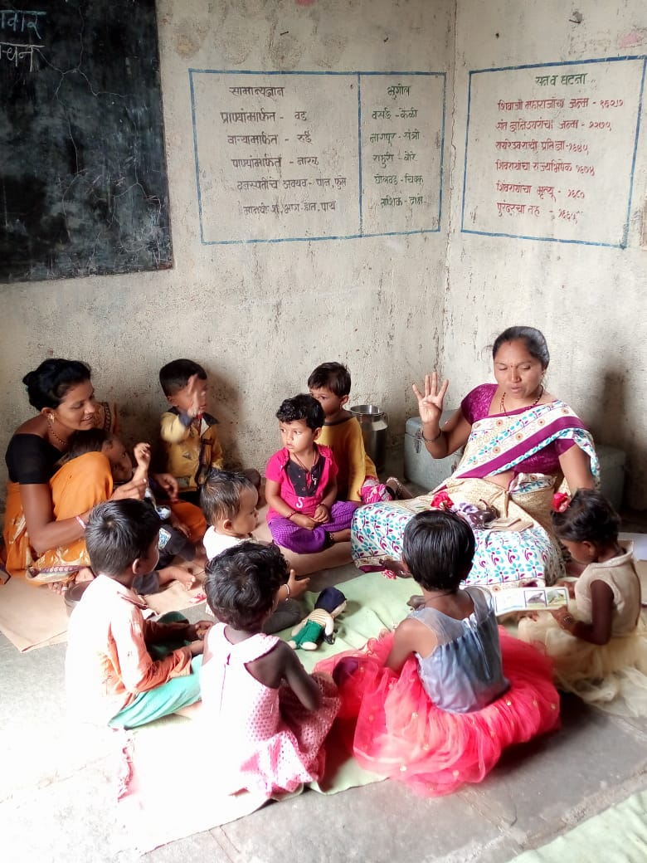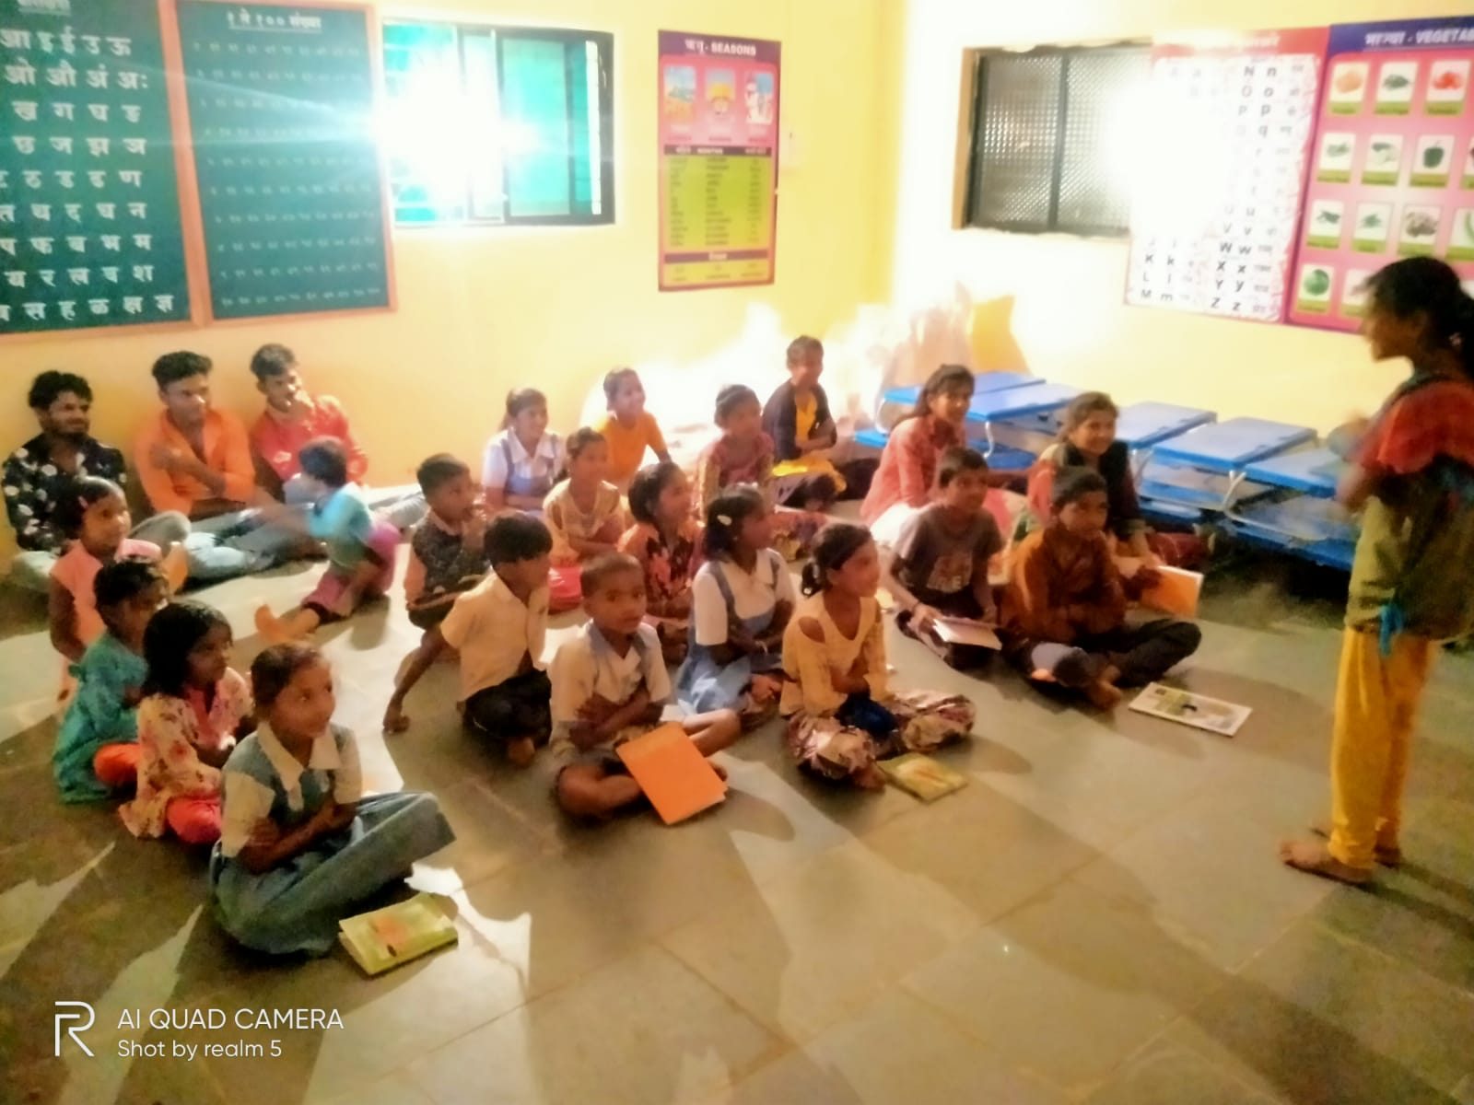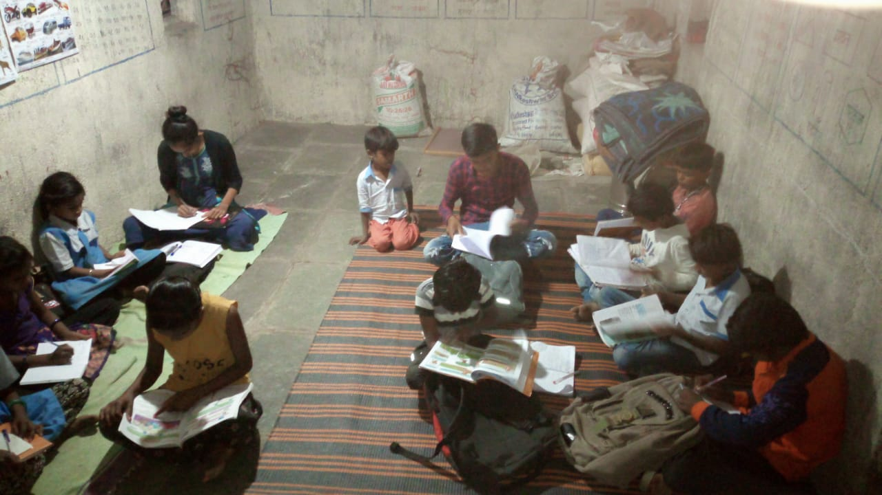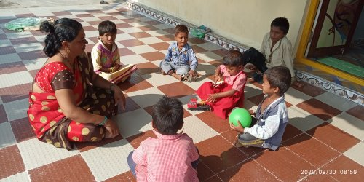

1.Anganwadi (Village Name - Mendoh)

4.Support class(Village Name - Mendoh)

2.Anganwadi (Village Name - Godasedara)
3.Support class(Village Name - Borwak)

