A Report on the Activities of Jagriti Bal Vikas Samiti
for the Year 2003-04
Prepared by
Mahendra K Dwivedi
Secretary
Jagriti Bal Vikas Samiti

A. Migrant Labour Project (MLP)

There were in total 12 centres in the year 2003-04 of which 7 were at Brick-kilns and 5 were at construction sites. Brick-kiln centres started in the month of December 2003. By 15 June 2004 all the brick-kiln centres have been closed down as it has started raining here. List of these centres are given below.

S.No. Name of Centre No. of Children
- Mera Brick-kiln, Chaubeypur 42
- Saran Brick-kiln, Chaubeypur 31
- Kothi centre, Tatiyaganj 64
- Kalra Brick-kiln, Tatiyaganj 46
- Gera Brick-kiln, Mandhana 34
- Murari Brick-kiln, Tikara 30
- Deep Brick-kiln, Bhauti 44
- Dhamikhera, Kalyanpur 68
- Panki Power House, Panki 23
- Hall VIII, IIT 24
- Yog Tower, Parmat 26
- LML centre, Panki 27

Total No. of Students 459

Apart from these 459 children who were enrolled in the MLP centres, there were about 20 such children who earlier studied in such centres and now are going to some schools. We try to help them to pursue their study.

Most of the children in MLP centres had the first experience of schooling. About 380 children who were completely illiterate, learnt reading and writing Hindi and basic operations of Mathematics. About 55 children passed class II and 24 class III. 14 students of earlier centres are studying in class V and VI.

Six students who were studying in class V this year also appeared in the entrance examination of Jawahar Navodaya Vidyalaya for class VI so that they can be assured of proper education in future. We arranged for a tutoring class for this purpose.

MLP centres are non-formal education centres. Centres start at 8.00 am and continue up to 1.00 pm. This year a little change was made in the time table. First two hours for Hindi and Maths, and the rest of the time is allocated for educational games and other activities. Time-table is given below:

8.00 – 8.30 am Prayer, Physical Exercise, Poems and stories by children, Talk between teacher and children on general topics.
8.30 – 9.00 am Hindi Language
9.30 – 10.30 am Maths
10.30 – 11.00 am Lunch (Nutrition such as Chana-moong, Laiya-chana,
Fruits, Sattu, etc. are provided to the children)
11.00 – 11.45 am Our Environment, General Science that we come across in everyday life.
11.45 am -12.15 pm Educational Games
12.15 – 1.00 pm Games, Stories, Songs, Drama, Paintings, etc. (One activity daily)

1. Monthly Teachers' Training Programme
Every month on first Saturday, we hold a teachers meeting. All the teachers from MLP centres and workers gather in the office of Jagriti. It is generally held for 3 hours, currently from 9.30 am to 12.30 pm. This meeting in fact is a training programme for the MLP teachers. The coordinator and the project-incharge of the MLP projects are responsible for preparing the programme for the meeting and for presenting new and interesting methods of teaching. They demonstrate new methods of teaching, explain how to use a particular education kit or cards. MLP centres' teachers share their experiences, and narrate various problems especially in teaching. It also helps others to understand the problem, and paves the way for the solution.

Generally the schedule of this monthly meeting is as follows:

- Song
- Presentation of Maths/Hindi curriculum by a Coordinator / Project-incharge.
- Report by MLP teachers on the last month activities at the centre, Discussion on the problems faced by the teacher or students, etc.; Evaluation of the performaces of children through their Progress Report file; Discussion on health and sanitation situation at centres.
- Presentation of Educational Games by Project-incharge.
- Refreshments
- Reading from an inspiring book on Education, like “Diva Swapna” by Giju Bhai, “Jivan ki Ore” by Makarenko, or “Chota Rajkumar”, etc.
- Song

2. Curriculum Development
Continuing the work of last year on developing materials for class I students for MLP centres, we modified the last year contents substantially. We try to prepare materials on Hindi language based on the knowledge that children already have. So we start with the words that the children are well familiar with like, Nal, Ghar, Bas, etc. and with these words, we try to help them to learn alphabets, etc.

3. Distribution of Woollen Clothes
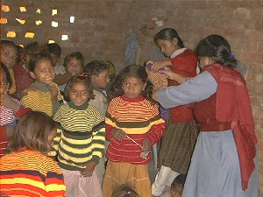Like the previous years, Jagriti Bal Vikas Samiti distributed woollen sweaters in the month of December and January to about 600 migrant workers’ children. These children were not only from the centres run by us, but also from other sites. Also about 150 children were provided with school uniforms.

4. Nutrition
Children of all the 18 centres are provided with nutrition. Two centres are given full Mid-day meal that consists of rice, pulses, vegetables, kheer, fruits, etc. Other 15 centres are also provided daily nutrition in the form of Laiya-chana, Gur-chana, Fruits, Patti, sprouted moong-chana-groundnut, Kheer, etc. Every Saturday children of each centre cook Kheer under the guidance of their teacher. They look forward for this activity to enjoy.

5. Peace March by the Migrant Workers’ Children
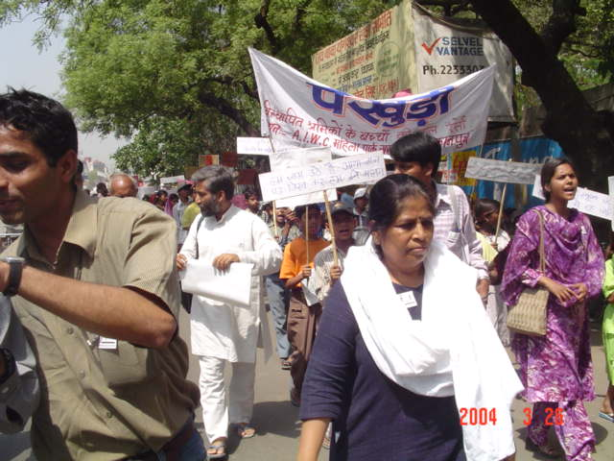
Children of migrant workers in Kanpur took out a Peace March on 26th March 2004 to stress the need for immediate attention towards their education. More than 300 people including the children, their parents, faculties and students from IIT, lawyers, and social activists participated in the procession. Children raised slogans like “Education is our birth right, we will take it; Kaam Nahin Kitaab Chahiye; Karo na aage ab tum bhool, har bhatthe (brickkiln) par ho skool”.

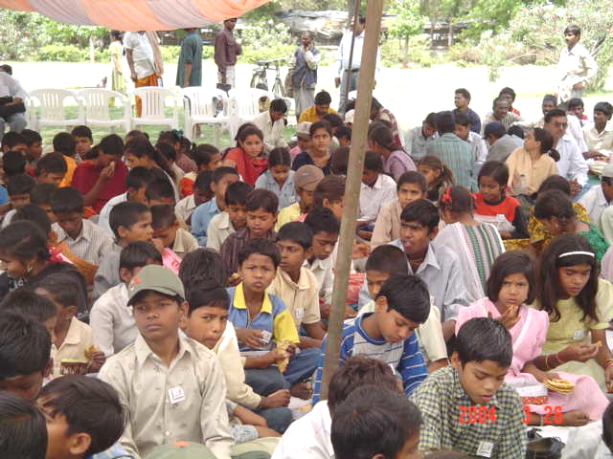
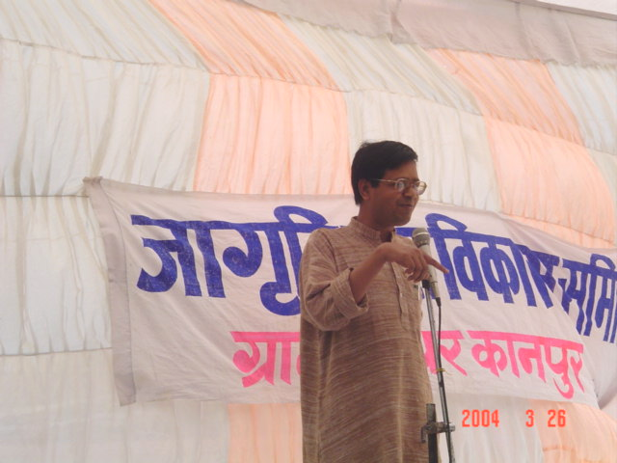
Dr. Sandeep Pandey, Mrs. Vijaya Ramachandran, Shri Vinay Bhai (Sarvodaya Andolan), Prof. Mahendra K Verma, Dr. Amman Madan, Mrs. Dharmowati Garg, Shri Vishnu Shukla, Shri Chandrashekhar and many students from IIT took active part in the children’s show. Peace March started from Shikshak Park (Parade) which changed into a meeting at Phoolbagh. Besides having talks from the distinguished personality, the meeting was characterised by the Songs and Plays by the children. They beautifully depicted the need of education in their life through Natak. All the distinguished personality stressed for the need of school for migrant children. Dr. Sandeep Pandey said that while some of the state government like Tamilnadu is providing cooked mid-day meal to the school children, U.P. government is giving nothing to the children. Crores of Rupees are there under Sarva Shiksha Scheme, but what is actually happening? Mrs. Vijaya Ramachandran asked what the use of Sarva Shiksha Abhiyan is if it is not for the migrant children. She said that even if education for the 5-14 years of children has been made fundamental right, a vast number of migrant workers’ children are totally out of schools. There is Rs. 1276 crores for the U.P. Government for SSA and DPEP for the year 2003-04. She said that there are about 3 lakhs of migrant workers in Kanpur who works at different brick-kilns and construction sites. This includes almost 70 thousands of children who are totally ignored not only by the Government but also by the society. She said that the main aim of the rally is to make a public opinion on it. Rally was covered by almost all the local TV Channels and the Newspapers.

After the meeting, a Memorandum along with the Demands of Children was given to the D.M. office (as D.M. was not present). The demands include:
- Government should ensure that each and every child of 5-14 age-group goes to school.
- There must be a school at each and every brick-kiln.
- There must be a school at such construction site where there are 10 or more children of 5-14 years of age.
- If any child is not going to school, the responsibility should lie with the Brick-kiln Owner or the Construction Builder and the concerned Education Officer.

The result of rally was that the DM issued the letter to the Education Department of Kanpur and the Labour Department to take necessary steps in order to provide educational facilities to the migrant children. We are now talking with the Basic Shiksha Adhikari (BSA) of Kanpur to open centres at each brick-kiln under the scheme of Sarva Shiksha Abhiyan.

6. Health Workshop
Jagriti Bal Vikas Samiti held a Health workshop at Gera centre on 28th April 2004. Dr. Mamta Vyas donated her precious time and investigated about 90 kids and elder persons mostly women. Kids were administered immunization vaccines. Medicines were given to the patients free of cost. On the advice of doctor, we helped 6 persons to a hospital in Kanpur city for check-up. These persons were having eyes problem, pain in chest, etc.

Each centre has a First-Aid box with essential medicines. All children were given Vitamin-C tablets twice in a week in winter. Besides it, some of the workers and children are given medical treatment as per their need. Children of all the centres were given anti-worm tablets as per the advice of Dr. Mamta Vyas.

7. Educational & Fun-trip
After the rally came to the end, all the children went to the Kanpur Museum on 26th March 2004. This was the first time that these children were visiting any museum. Children enjoyed the thing at Museum trip.

8. Meeting with workers
We constantly keep on meeting with the workers just to interact with them. This we do not only when we go to visit a school or site in day time, but also in evening. In evening workers are off from the work. So they get time to spend with us. It greatly helps us to understand their problems and aspirations too. We play with the kids. This helps in developing a sense of confidence in them for us. This is a very important part of our activity.
B. Swami Vivekanand Vidyalaya, Lodhar

Swami Vivekanand Vidyalaya is from K.G. to Class VIII. Total of 157 students were enrolled in the year 2003-04 of which 88 were girls. This has been a characteristic of this school that girls outnumber boys every year. There were 8 teachers in the school last year.

For class V and VIII, U.P. Board holds the examination. This year 22 and 21 students gave exams for class V and VIII respectively. All of them have passed through the class successfully. Most of the students have got first division (more than 60% marks).

Four batches have graduated through our school till this year. From the first two batches, 6 students have passed class X. One girl Teejbai is in class XII this year. Two boys and two girls pulled out from schools.

Following are the activities besides the academic one that took place in the school in the year 2003-04.

1. Drawing Competition
On 31st August, a drawing competition was organized for the students of class 5th to Class 8th. Total of 33 students participated in the event.

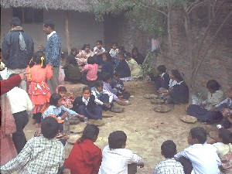
2. Educational and Fun Trip
Students of Class V and below of Swami Vivekanand Vidyalaya took a trip to Kanpur Zoological garden in the month of October 2003. In the month of January, students, teachers and some volunteers visited Bithoor near Kanpur. There they had a picnic also.

Students of Class VI to Class VIII visited Lucknow on 24th February 2004. They were very exited to know that they were going to Planetarium to see how the Universe looks like. It was for the first time that they were visiting a Planatarium. They enjoyed it the most. In the evening we all went to Bara Imambada which is also know as ‘Bhool Bhulaiyya’.

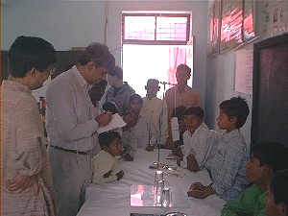
3. Vigyan Mela
One of the basic objectives of Jagriti Bal Vikas Samiti is to make science popular in villages. With this aim, we have been organizing metric mela and Vigyan Mela for the last many years. This year also we organized a Vigyan Mela (science exhibition) in Swami Vivekanand Vidyalaya on 14th and 15th November 2003. More than 40 experiments displaying facts and principles of Physics, Chemistry and Biology were beautifully shown by students. The notable fact of this exercise is that almost all the experiments and models were prepared by children themselves under the guidance of teachers. Three students of class 8 presented a magic show.

The participation of village in the science exhibition was good. More than 400 persons registered their presence during the show. Some faculties and students from IIT also showed great interest in the event.
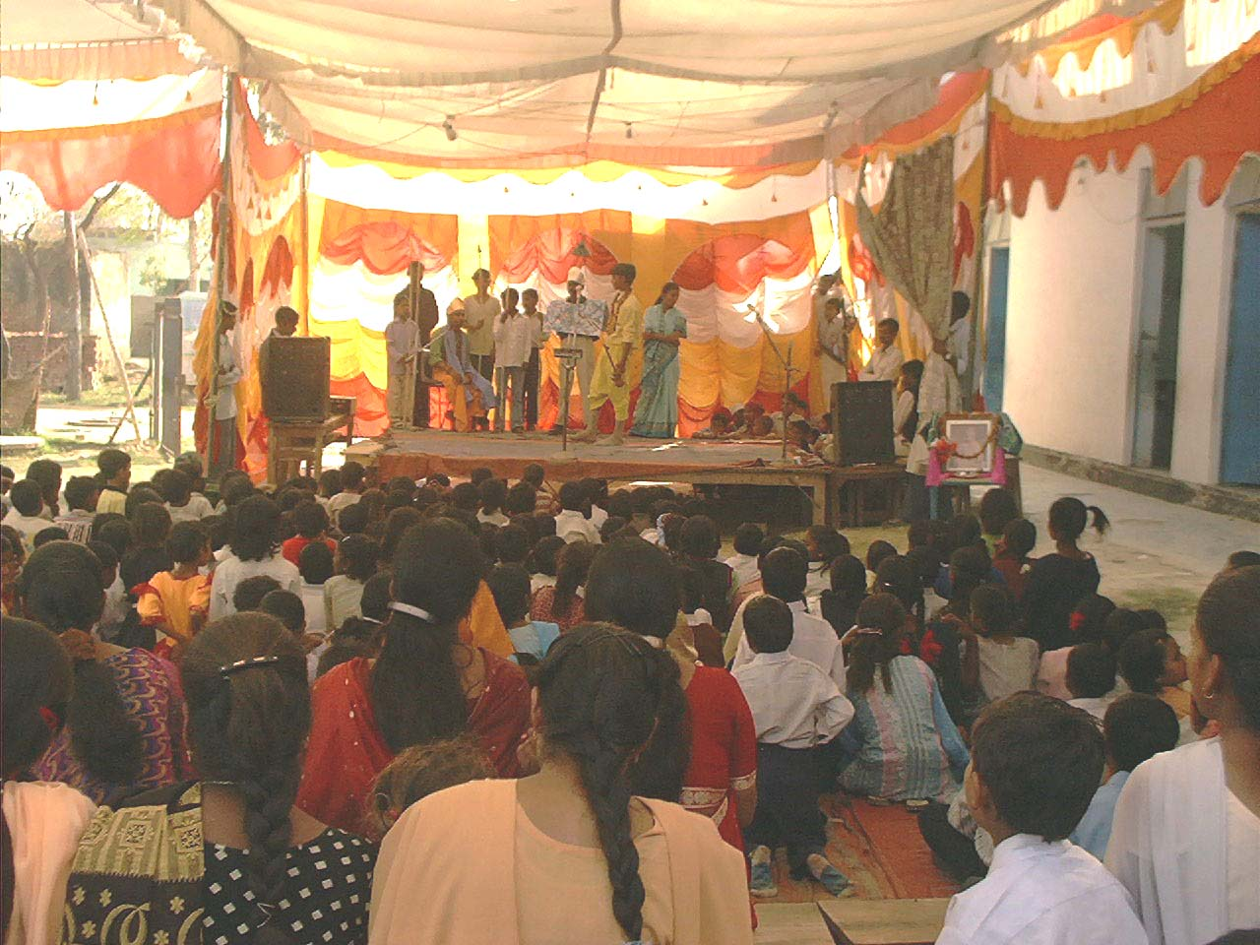
4. Annual Day
Every year Swami Vivekanand Vidyalaya celebrates its Annual Day on the the birth day of Swami Vivekanand. But this year, it was celebrated on 21st February 2004, as January witnesses the cold waves which affect the village participation in the programme. Various cultural functions were performed on the occasion. Children of Evening School (SAC IIT) also participated in the event.

5. Sports Day
On 29th January 2003, Sports Day of the school was celebrated. There were 12 events on this occasion which included Kabaddi and Cricket besides other atheletics events. Kabaddi and Cricket matches were held in the months of August to December.

6. Workshop on Skeleton System & Acting
A workshop on Skeleton System for the children was organized in Swami Vivekanand Vidyalaya on 14th March 2004 under the guidance of Dr. Sushil Joshi of Eklavya. This workshop was of 6 hrs duration which included an animation movie on the topic followed by model making and question-answer session.

The same day was also held the workshop on Acting (Drama). About 15 interested children learnt the art of Acting under the excellent guidance of Dr. Shubhendu Ghosh of Delhi University. This helped not only in removing hesitation and stage-fear from the children but also in improving the acting techniques.

7. Workshop on Painting
An artist from Allahabad Mr. Khalid visited Jagriti Bal Vikas Samiti in April 2004. He taught the students of Swami Vivekanand Vidyalaya skills of Poster Making and Collage Painting from 24th April to 30th April. He also visited the Migrant Workers’ Children schools and interacted with the kids. Some of the students performed very well and are making good paintings.

8. Eklavya Training
Four teachers from Swami Vivekanand Vidyalaya took part in the teachers’ training programme organized by Eklavya in Hoshangabad. The training was aimed for the class VI to VIII. Two teachers from MLP also participated in the training. It was quite helpful to the teachers.

9. Vedio Show
Some vedio show programme was held in Lodhar School with the help of volunteers and teachers. The participation of children in such programme was good.

C. OTHER ACTIVITIES

1. New Executive Committee
New members of Executive Committee of Jagriti Bal Vikas Samiti were elected on May 8, 2004 in its General Body meeting. All the members were elected unanimously. New Executive Committee is as follows:

President: Dr. Prabal Maiti
Secretary: Mr. Mahendra K. Dwivedi
Treasurer: Ms. Madhuchhanda Sharma
Dr. Mahendra Verma
Dr. V. Subrahmanyam
Ms. Vijaya Ramachandran
Shri Suresh Yadav
Miss. Sunita Gaur
Mr. Amar

On 9th May, an informal meeting with all the workers and volunteers was held in IIT. It was an occassion to meet with other workers and to know about their works. It was followed by a lunch.

2. Tailoring and Embroidery Class
Jagriti Bal Vikas Samiti is organizing a tailoring and embroidery class for the village girls. This was started in May and is continuing till date. About 30girls are being benefited with this class.

3. Computer Class
In this summer vacation, a compute class is being held in the school for the village students. Main objective of this class is to generate computer literacy among the village children and to help them learn especially the MS-Word and MS-Excel.

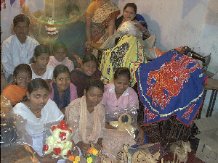4. Orissa Rehabilitation Work
Tailoring class at the village Dighalo is going on successfully. Girls are taking keen interest in it and they have started selling the Saya that they prepare. It continues with 25 women. They have become experts in stitching women garments. They are now practising to prepare men's garments. Besides it, they are also doing the embroidary and coir works. Some of the embroidary and coir works were taken to Kanpur where they were sold.

