‘Mukti’ Site Visit Report

Date – 15-16th February, 2020
Visited by – Padmanava Sen (padmanava.sen@gmail.com) – Asha Bangalore volunteer
Visit Snapshots
- I started at 6 am on Saturday 15th February. We went to Raidighi via a car with three Mukti members (Sankar Halder, Mukti president and his brother Debabrata Halder, currently heading the community business model of Mukti and their accountant). Apart from that, we had Mr Sarada Namhata visiting Mukti and another Mukti volunteer attending the Mukti events on that day. During the 4 hours ride (that is what it takes to go that 70 km in a good day) through Jaynagar, we discussed about the current sustainable efforts of Mukti and also how they responded to the cyclone Bulbul.
- After reaching Raidighi, I went to the new location of the Mukti institute of technology and discussed with the students from MIT. Their profiles and some discussed points are given below:
  - 3rd year Arts student enrolled in Tally/GST/Accounting; Year mode course, hence no class happens in college, only taught in tuition; learned about Mukti through friends; 1 hr 15 min cycle distance from him home; positive usage of smartphone (pdf, Bengali-English translation)
  - A local tuition teacher taking the course to get permanent job (someone he knows mentioned that they would take him if he knows tally)
  - Class 11 student in Arts stream from Raidighi; Learning account management to work during graduation; Joined the course based on parents’ suggestion; use smartphone for whatsapp, fb, tiktok
  - 1st year Arts student from Raidighi; account management; came to know via word of mouth; use smartphone for opening pdf (for courses and tuition); Semester mode college so needs to go regularly, and classes happen too
  - Two Arts 3rd year Raidghi students; learning basic, no computer in school; Wanted to learn computer; use smartphone for fb, whatsapp, youtube
  - 10th student from Jogendrapur
  - 11th student learning account management; learning photoshop now; word of mouth; not in facebook; uses smartphone for dictionary and google search
  - Dropped out after 12; learning account management to get works in bill payment services
  - 4 students from Jogendrapur coaching now in 11th (3) and 10th (1) learning account management. They were going to Mukti coaching centers so they knew about MIT from that connection
- Discussion with students about their school friends and brother/sisters (asked them what jobs their friends or seniors, or elder siblings are getting)
  - Among brother sisters, 2 got primary teacher job, 1 Labour officer
  - Among friends, 1 for primary teacher job and 10+ in companies
  - It is very difficult to get Government job
- Discussion with Yognath and Sukanya regarding MIT and other future steps
  - Generator costs will be shared half and half in summer with the landowner
  - The new location is a bit interior, there were a few eve-teasing incidents after dark by drunk residents. The previous location was better from this point of view.
  - There is a transformer issue that will be fixed soon
  - Electricity problem is less in this line compared to the previous location.
  - Internet connection is worse compared to previous location as it is a bit away and hence the speed went down
  - Don Bosco Tech took 25 residential training students last year. They give two options – Certificate but no job guarantee or probation time after receiving the training with job guarantee (more information on this will be collected from Asha side)
  - There are Government programs like PMKVY, Utkarsha and DDKGY that even pays for training and gives money to trainers in principle. However, their regularity and effectiveness are quite questionable.
- The discussions at MIT covered all the following points after a brief presentation from Yognath
  - New Model
  - New location
  - Student success parameters
  - Employment exchange activities
  - Other govt efforts
  - Pre-selection before interviews in companies
- Around 2 pm, I went back Raidighi kachari ground to attend the MCDF (Mukti community development fund) program with the women self help groups
  - I passed by the stalls where they were selling different edible items and hand-made crafts. I have some discussion to understand how they calculate their profit and loss
  - Program and different groups have been presented during the program
- After this program, I have discussed about organic farming activities with Mukti volunteers
- Sankar Halder explained me their initiatives to bring fundamental societal changes
- On the second day, I visited Purba Sridharpur coaching program
  - I have asked students ‘Why study?’ and ‘Why study specific subjects’. I have also spent some time asking academic questions. We also discussed their problems during studies and the problem with books (specially the helping books as the main books given by Govt are not enough, Sahayika is becoming a necessary part of education)
  - After that we also discussed with teachers how to motivate the students, the problems with textbooks changing every year and any other pending issues.
- After that, I have checked their agricultural campus and the flowers were very beautiful. There are many varieties of trees and that is part of Mukti Greens effort as well
- We quickly visited one nearby community kitchen running since cyclone Bulbul and I noted the problems faced due to Bulbul. The food looked nutritious. They are running these programs from some initial funds given by Kolkata Gives.
- After lunch, we visited the Library area and also noted the vast number of flower pots getting ready for Mukti green efforts. We met with Mukti members on grass root and then left for Kolkata around 6 pm on Sunday.

My viewpoints about the Asha for Education programs being run by Mukti
- Coaching centres – I felt the coaching centers supported by Asha are running well. Apart from that, currently Mukti has started a new model in partnership with government school where the school buildings are used for free after school to give additional classes. This has reduced running costs and beneficial to all parties involved – schoolteachers (as their students doing better), students (less travel), parents (students are spending more time studying), support center teachers (local people are getting jobs). This is greatly benefitting the teacher-student ratio issue of government school. There have been no new recruitment in west Bengal for last 6-7 years specially in this area (after an exam scam) where the number are students are increasing consistently making the quality of education poorer. Sankar has given stress to impart value education via workshops and additional training beyond the traditional book-based education.
- Book bank – there is urgent need of books for cyclone bulbul. More details will follow in a separate proposal from them
- MIT – the new counterparts added to previous program after the survey has started showing positive outcomes. By 2020, the new model should be well established.
- Cyclone Bulbul – I think they responded very timely and evenif I saw many trees that fell during the cyclone but the human life loss has been greatly averted due to their timely actions.

Overall impression about Mukti
I believe Mukti has done phenomenal jobs with their role as HEALER (health, education, agriculture, livelihood, environment and rights) https://muktiweb.org/healer/. They are working with thousands of farmers, thousands of women, thousands of children and at the same time, creating scalable models to improve the livelihood. Not only that, their new community business model seems a good sustainable effort. They started Mukti Fresh with organic farmers and this year it is becoming even. They have started Mukti crafts (for self help groups’ women entrepreneurs), Mukti greens (in their lands, small plants for sale) as well as other activities. In general, the funds that Asha for Education have sent to setup their centers or campus have been greatly utilized to support such efforts. Also, they are innovative in strengthening the system with small pilot cases before establishing scalable models. As mentioned before, in education sector using their coaching center or support schools, they want to add value education to strengthen internal value system of students, societal education (100 hours of community work helping others) as well as physical education among their students. I will look forward to their new ideas of community development and see this projects’ growth.

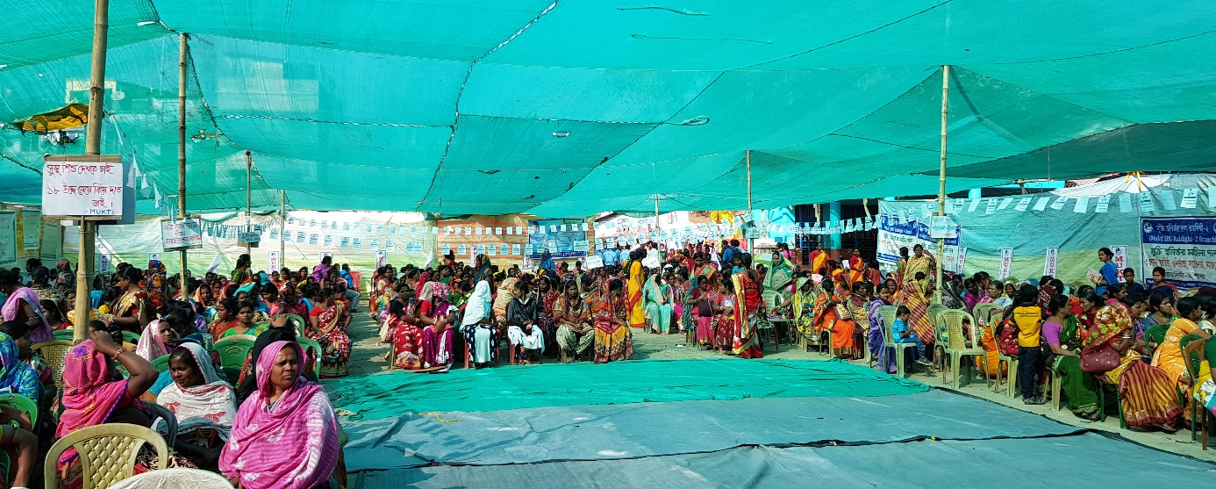
Self help group members during the program
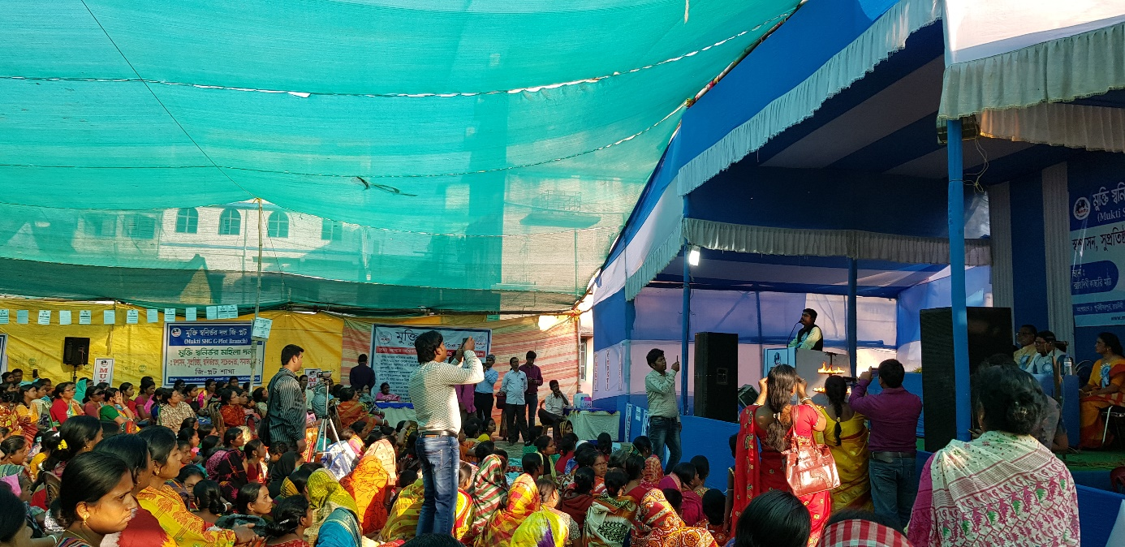
Sankar presenting the goals of MCDF program and how it united thousands women
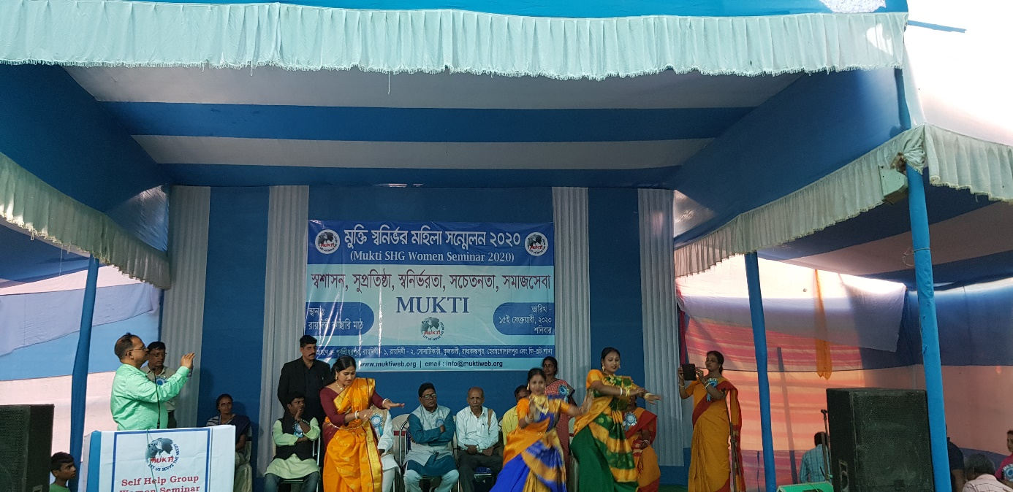
MCDF members presenting dance in the program
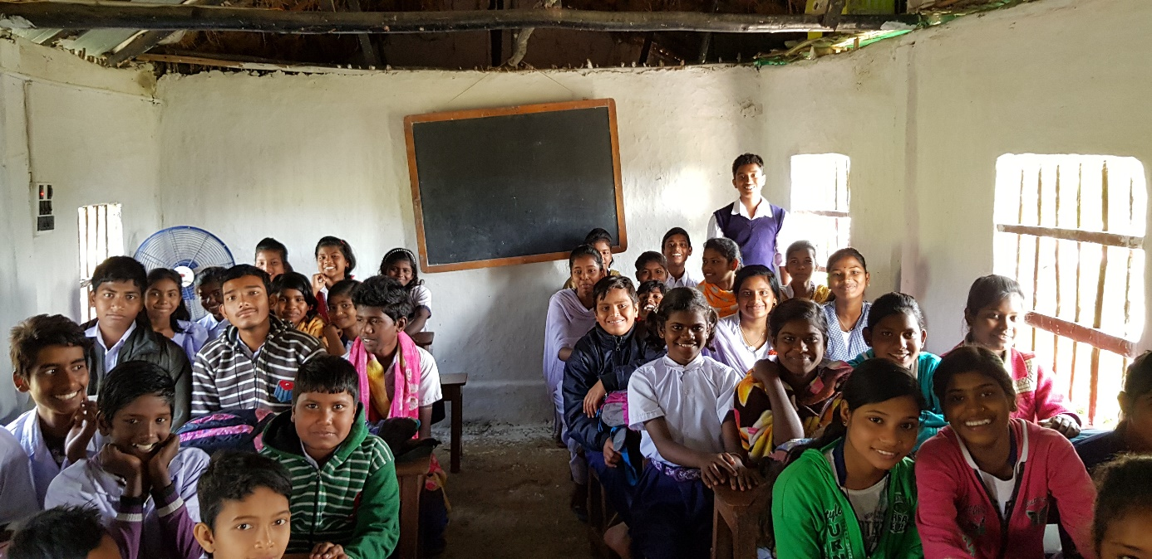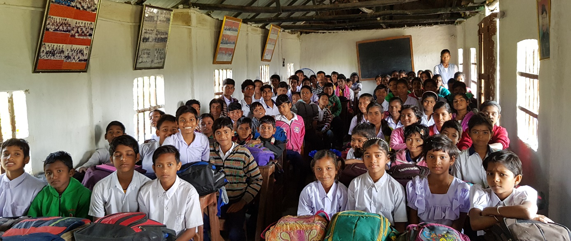
Interaction with children
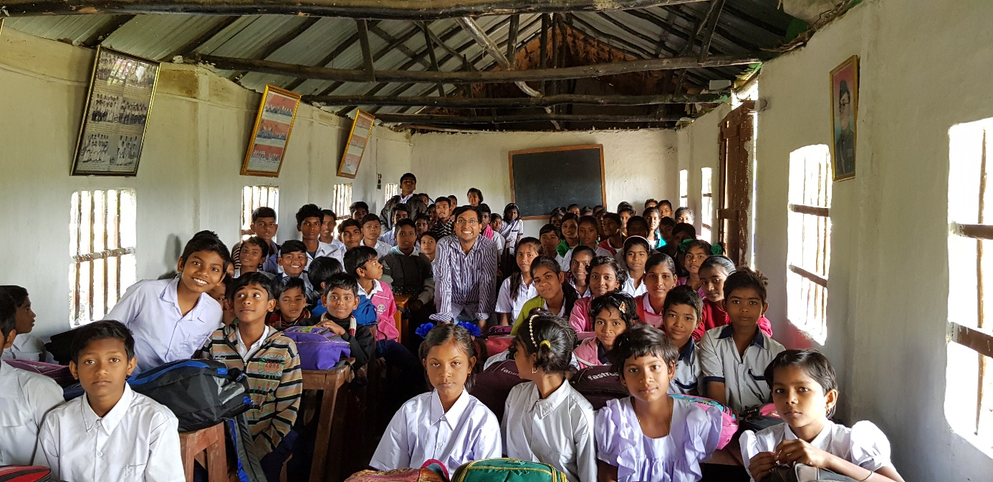
Posing with Students
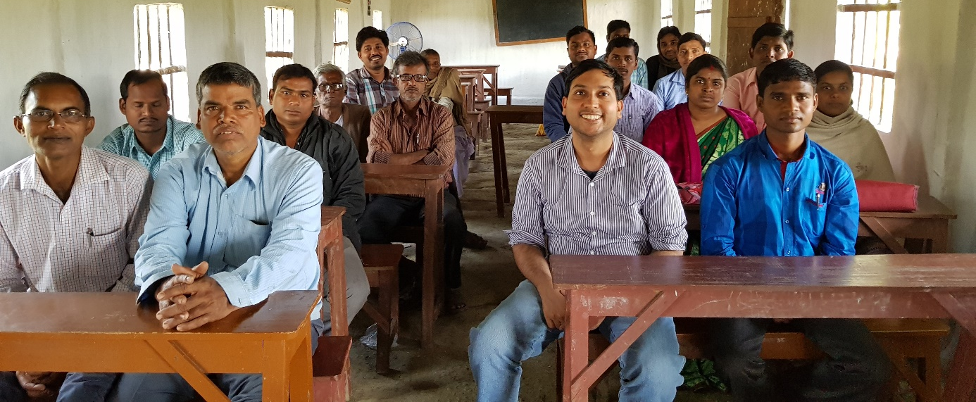
Posing with Teachers
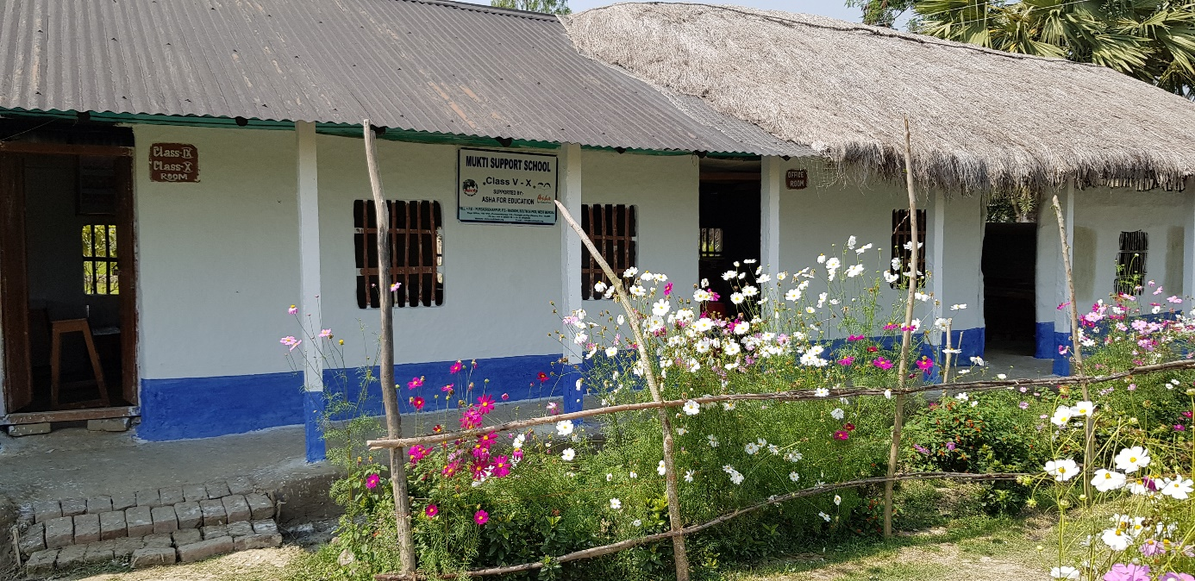
The coaching center surrounded by flowers

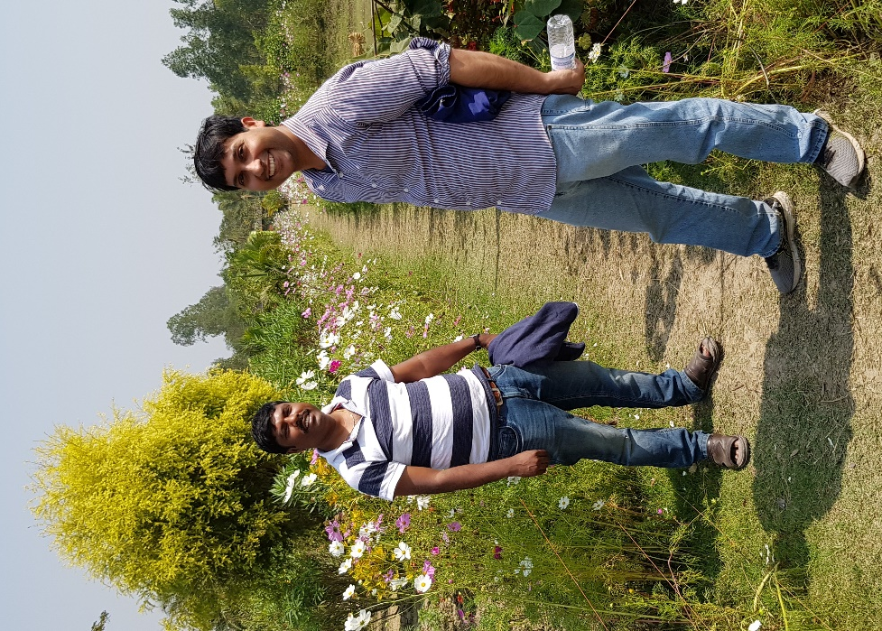
Posed with Mukti president Sankar Halder after many discussions
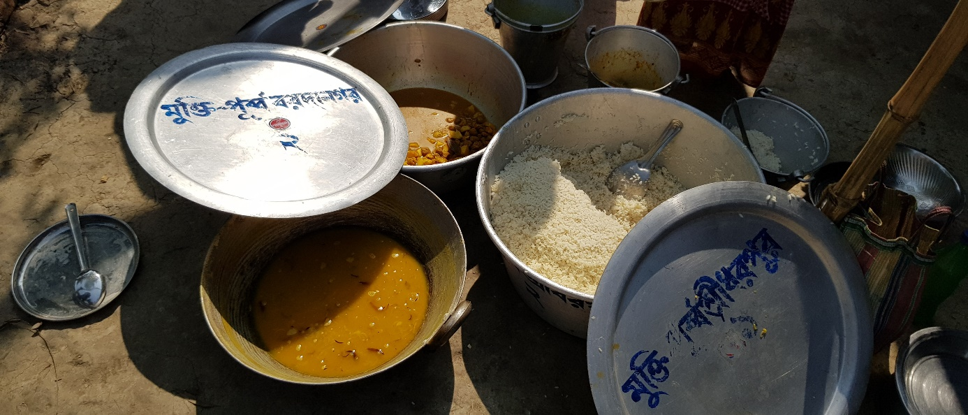
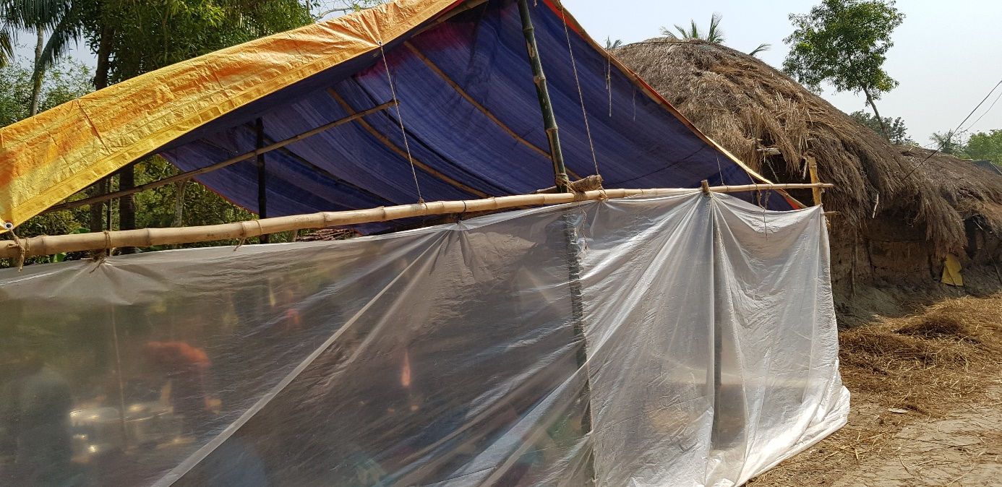
Community kitchen shed and Food served (Started after Cyclone Bulbul)

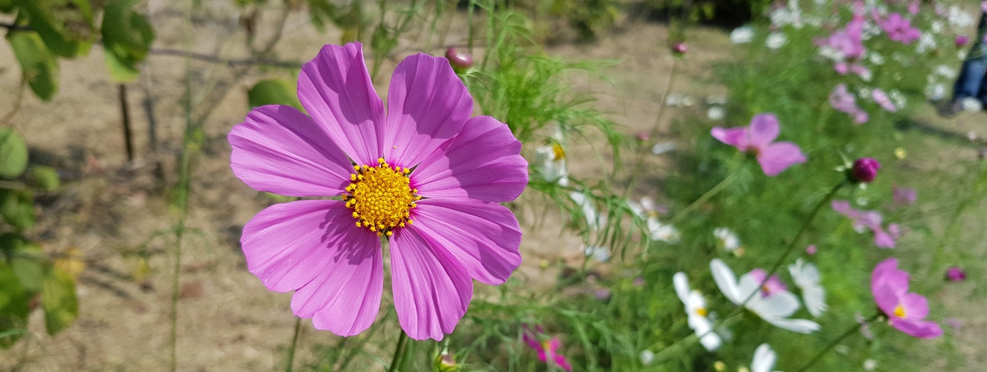
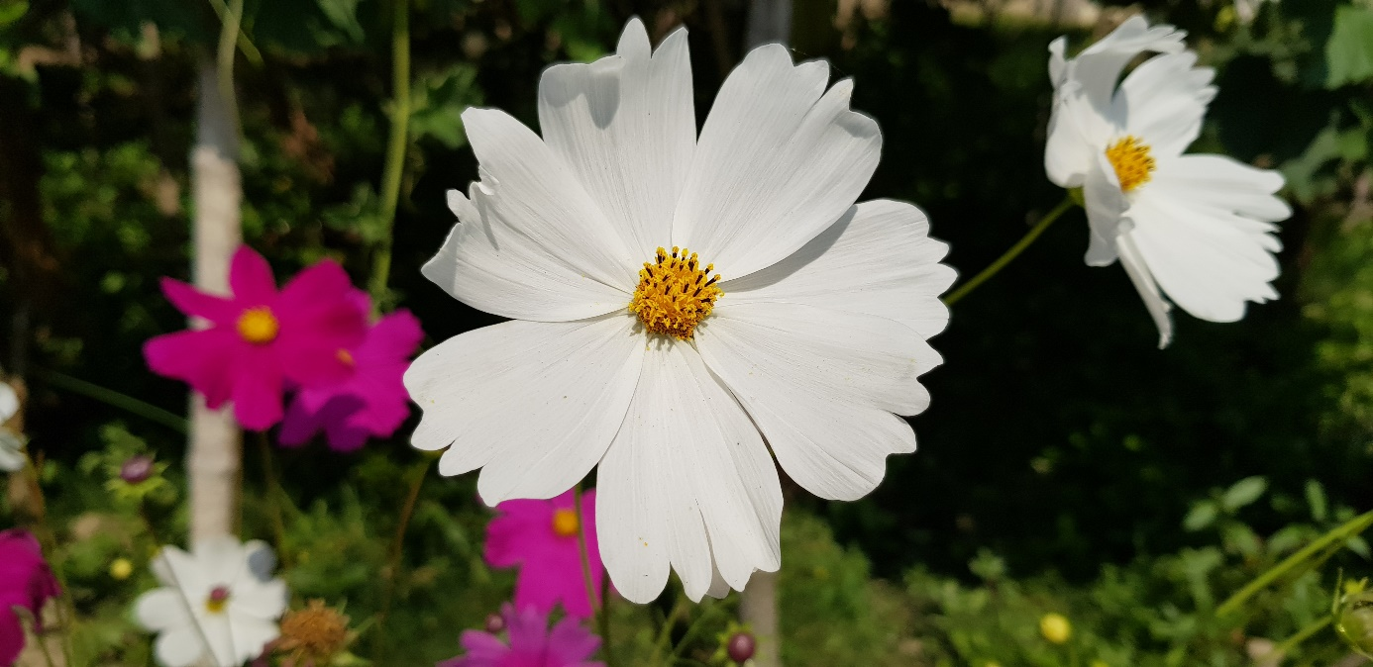
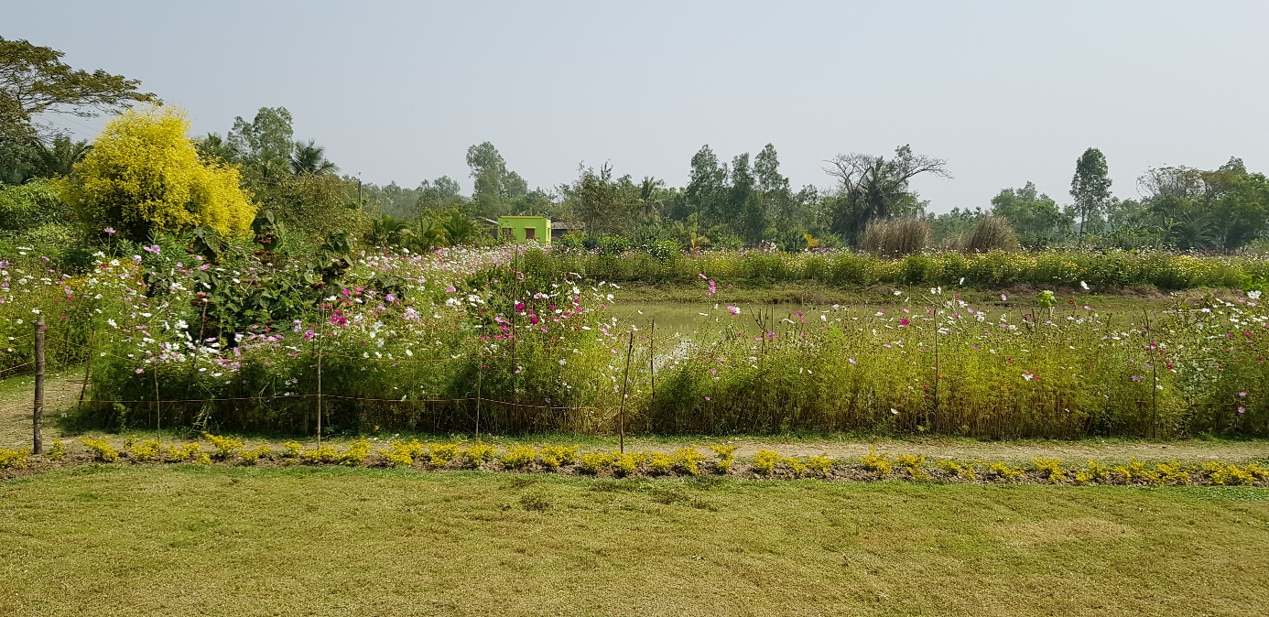
Flowers in Mukti area (which also works as demonstration ground for organic farming, can’t wait to see these flowers all around villages where Mukti works and beyond)

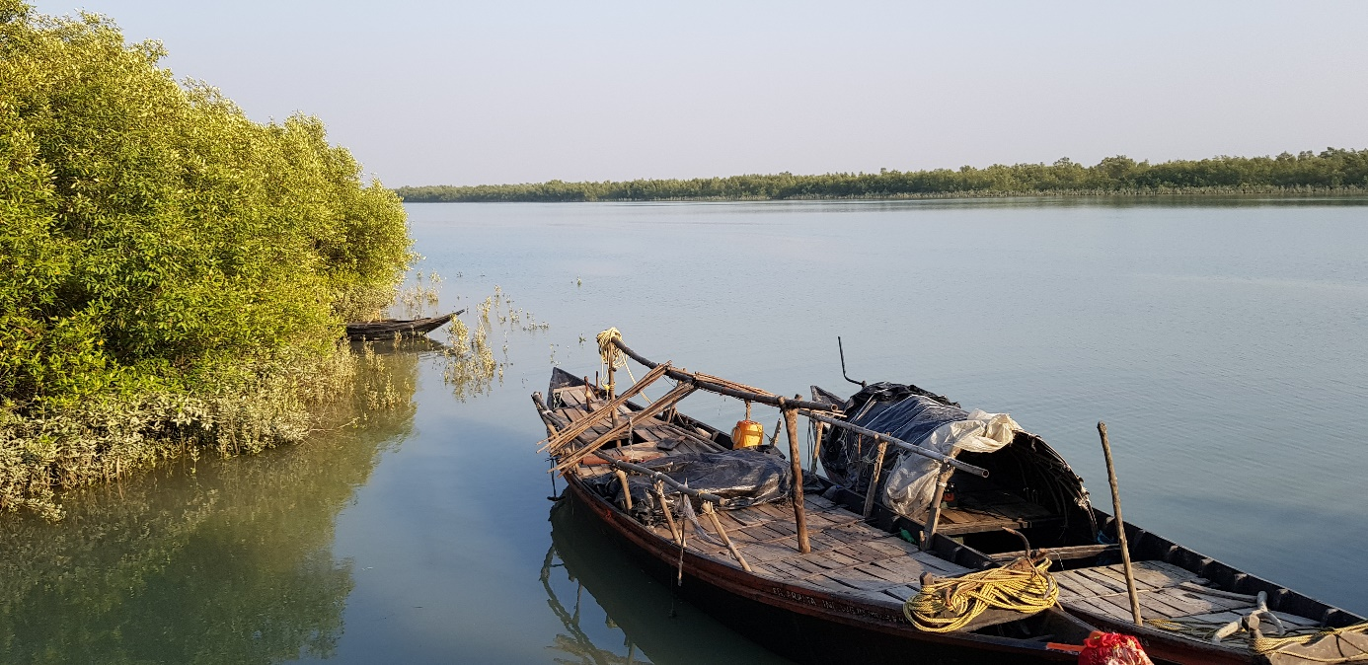
Sundarbans is always beautiful!

