Site Visit Report Project WHY – Delhi
Date: 3.4.18 and 13.4.18 visit done by Tarun Bhalla, former Asha Seattle Volunteer

Post my interaction with Ms. Anouradha Bakshi, I realized that the centre has been open for 17 years now. It was mostly started as an impulse response to the challenges that Ms Bakshi saw around her and ever since it has grown organically. The work they cater to mostly in the domain of Education (primary/supplementary/special needs), however, sometimes they have done work in the domains of health and other related problems as well. As I understand, today, the lead people that are running the project are Shamika, Malini Nambiar with able support from Dharmender and Rani (both - alumni of this project only). Besides several teachers and employees, who are all drawn from the community itself in most cases. The project is spread over six sites, Govindpuri, Giri Nagar, Okhla, Kalka Mandir, Madanpur Khadar and Yamuna. The first four are within a couple of km of each other and the last two are about 4-5 km away from these. All in south-south-east Delhi area. I visited all but the Giri Nagar site, and spent two days with them. I visited the centre along with my daughter.
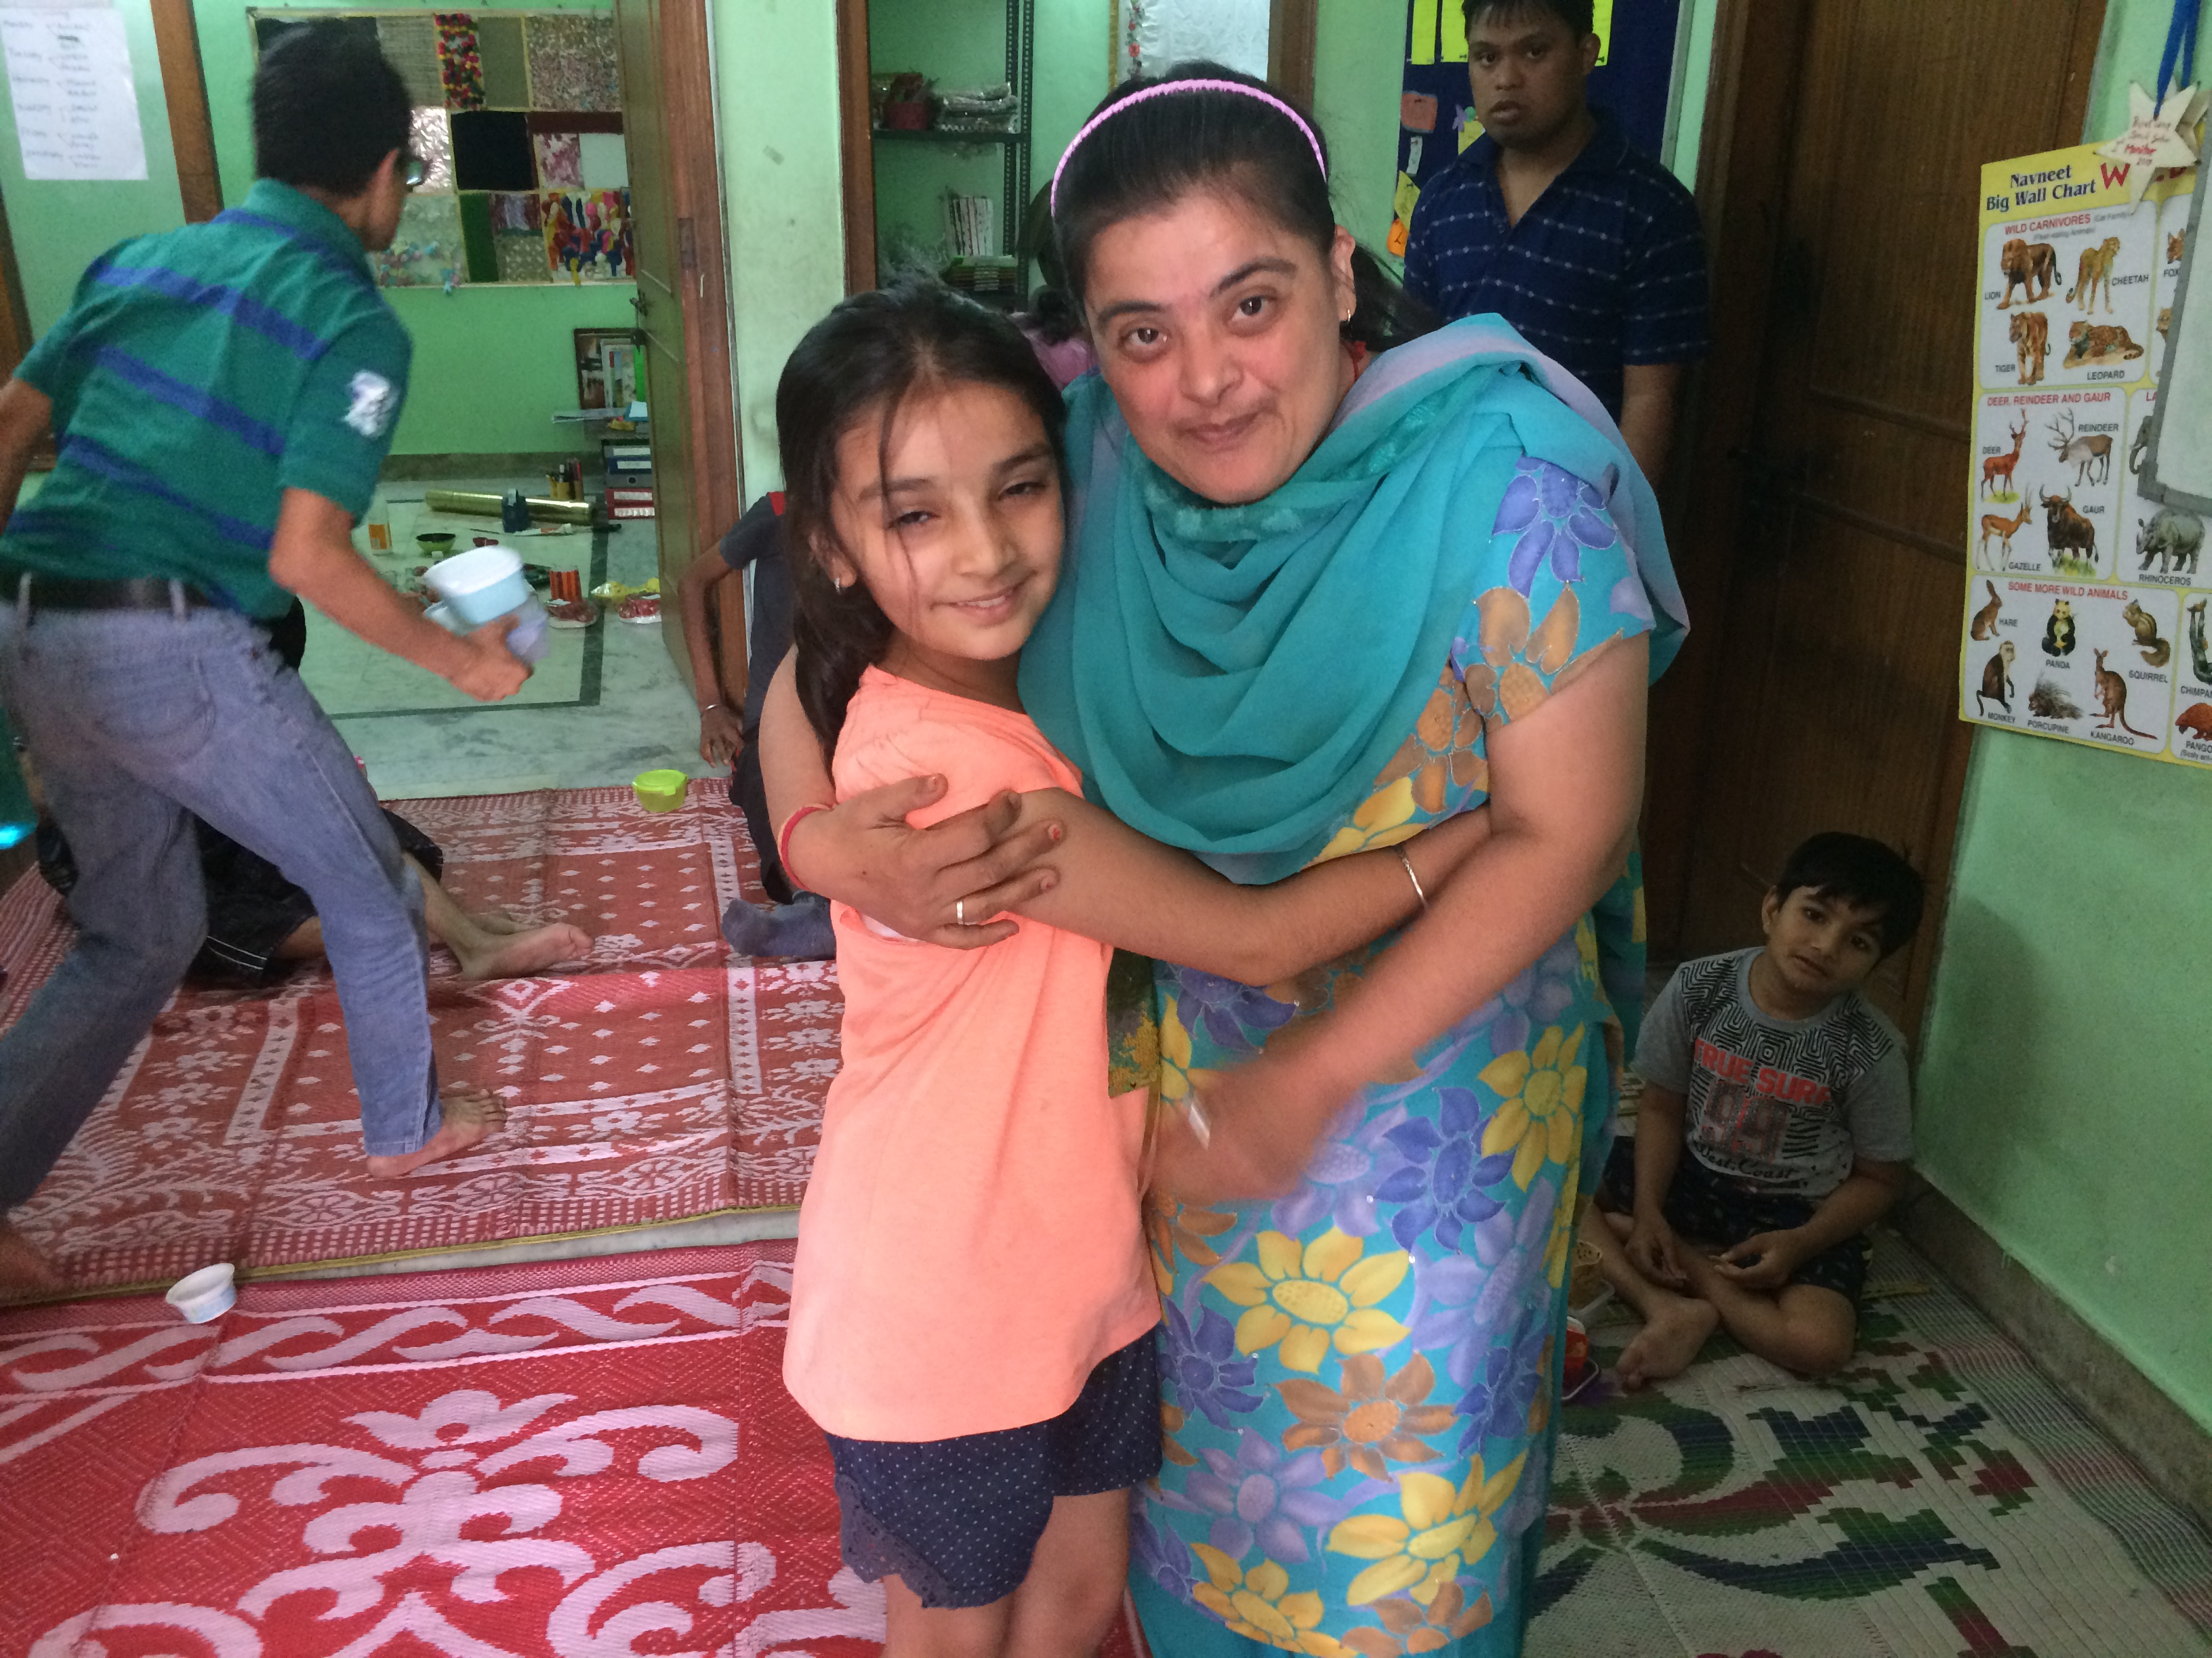
Govind Puri Center
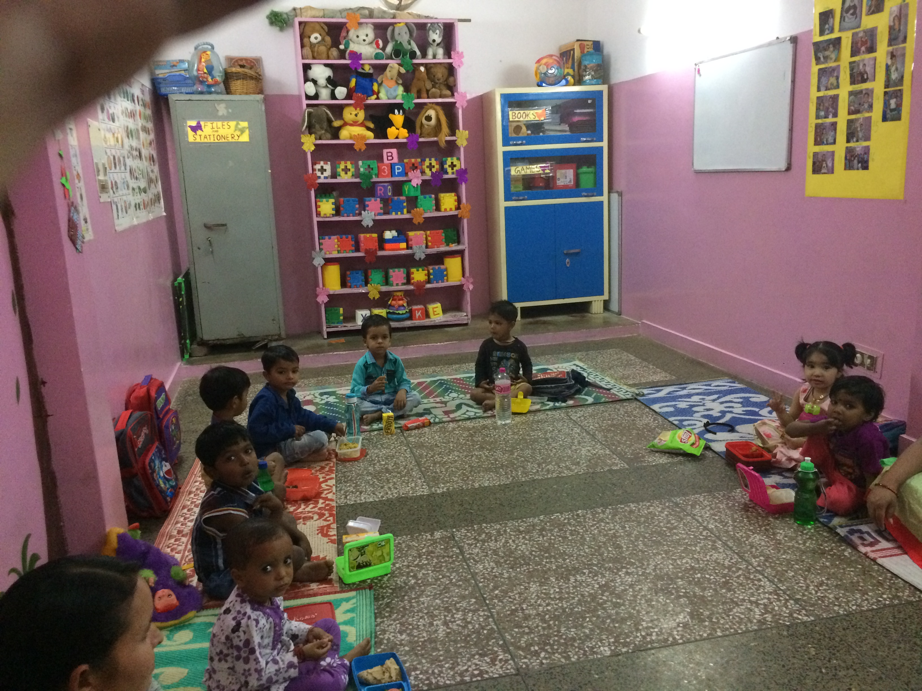
As per the details given by Malini, Govindpuri is running Early Education, Primary and Secondary school level outreach and a Special children centre are in this site. I visited this first. On the attic of a 3 storied building that the trust owns is the field office of Project WHY, where I met Malini, Anouradha, Shamika, Dharmender and Rani. The early education and primary / secondary sections are in this building. I visited the classrooms when classes were in progress. All children of primary and secondary sections go to Government schools, which run in shifts. So, the remedial sessions of Project WHY are also in shifts: Boys come in the morning and girls in the afternoon. On the top floor of the opposite building is the special needs section. I was told that some children were coming there for over 10 years, while one had joined just a couple of weeks before my visit. These children are trained in etiquettes, communicating and some skills. In addition to the salaries of staff, which I could not cross-check with staff during the visit against the claims, the expenses include lunch for the crèche children and transport for special children. I was told that salaries of staff ranged from 10-15 thousand Rupees. I was told the paint and whitewash job was done by the Asha funds that were provided.

Okhla Center
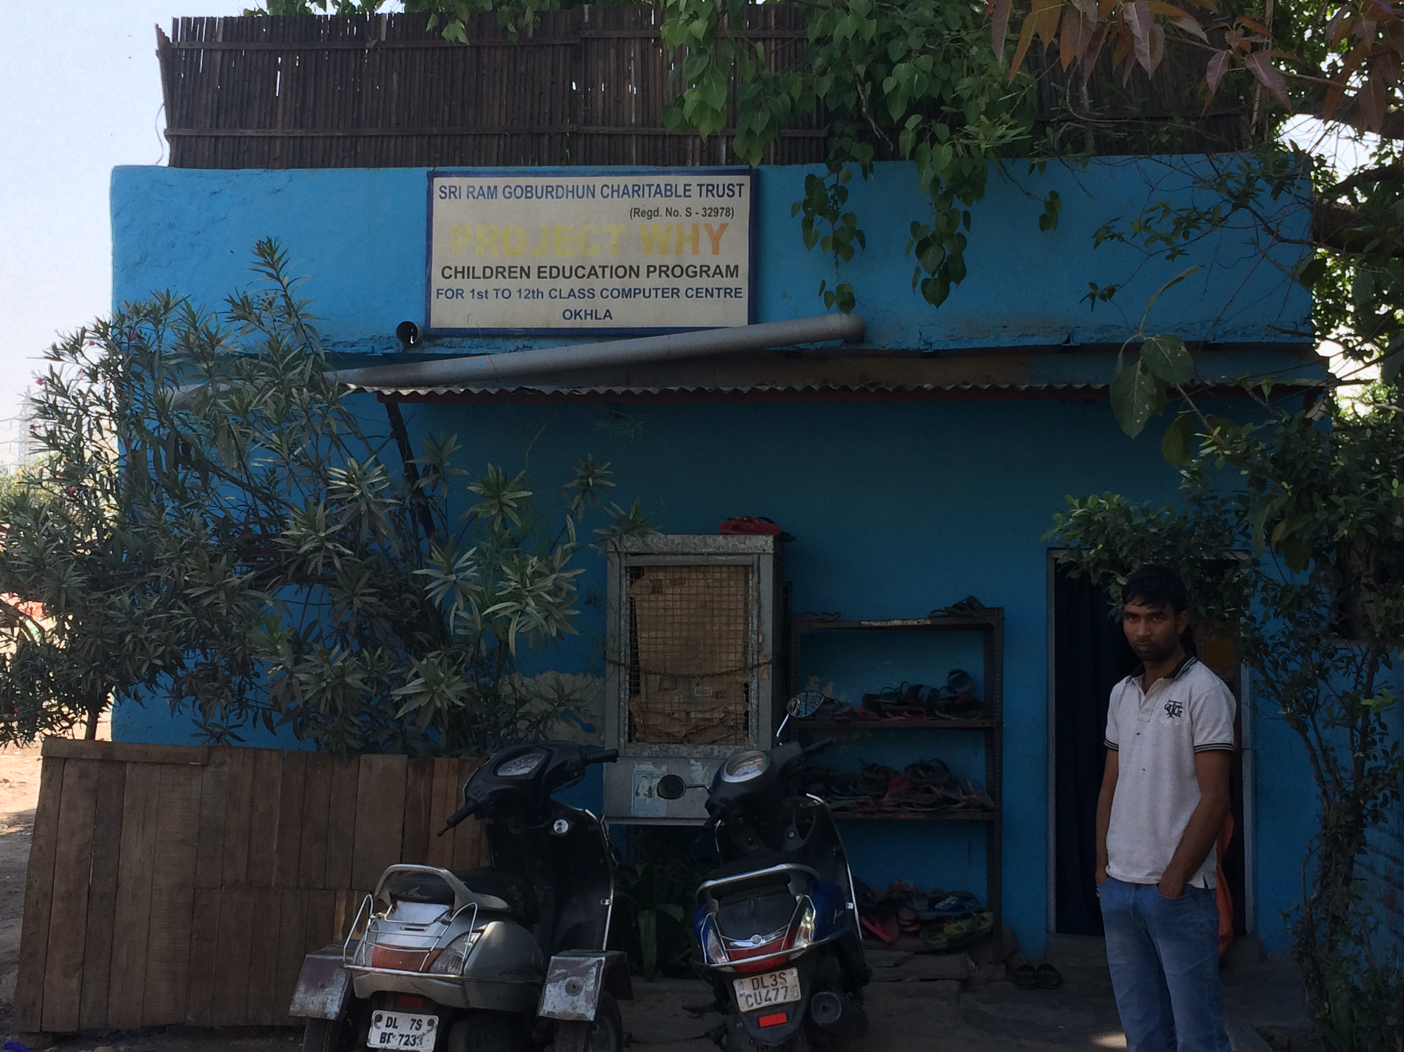
Okhla centre has a small building that has been raised to a single storied structure now, starting from temporary jhuggi structure. It is built bang on top of a garbage sorting area, on the land spared by the community with permission (notional, nothing written: they were told that when they are asked to vacate the area they should be prepared to) of the local police. In this building the ground floor had the primary and computer sections, and the secondary section was on the roof, protected from the scorching sun by some temporary walls, partitions and a mud roof. Despite the temporary structures, the centre has been adorned beautifully by mural art and hand drawn paintings - mostly done by one of the alumni of the Yamuna centre. The community lives in jhuggis around the centre, on this I enquired about the drop out rate and they said it has fallen down over the years as the centre has developed a reputation of sorts. Students have started pouring in not only from Government schools but also private schools given its reputation. I was unable to verify any records of the same.

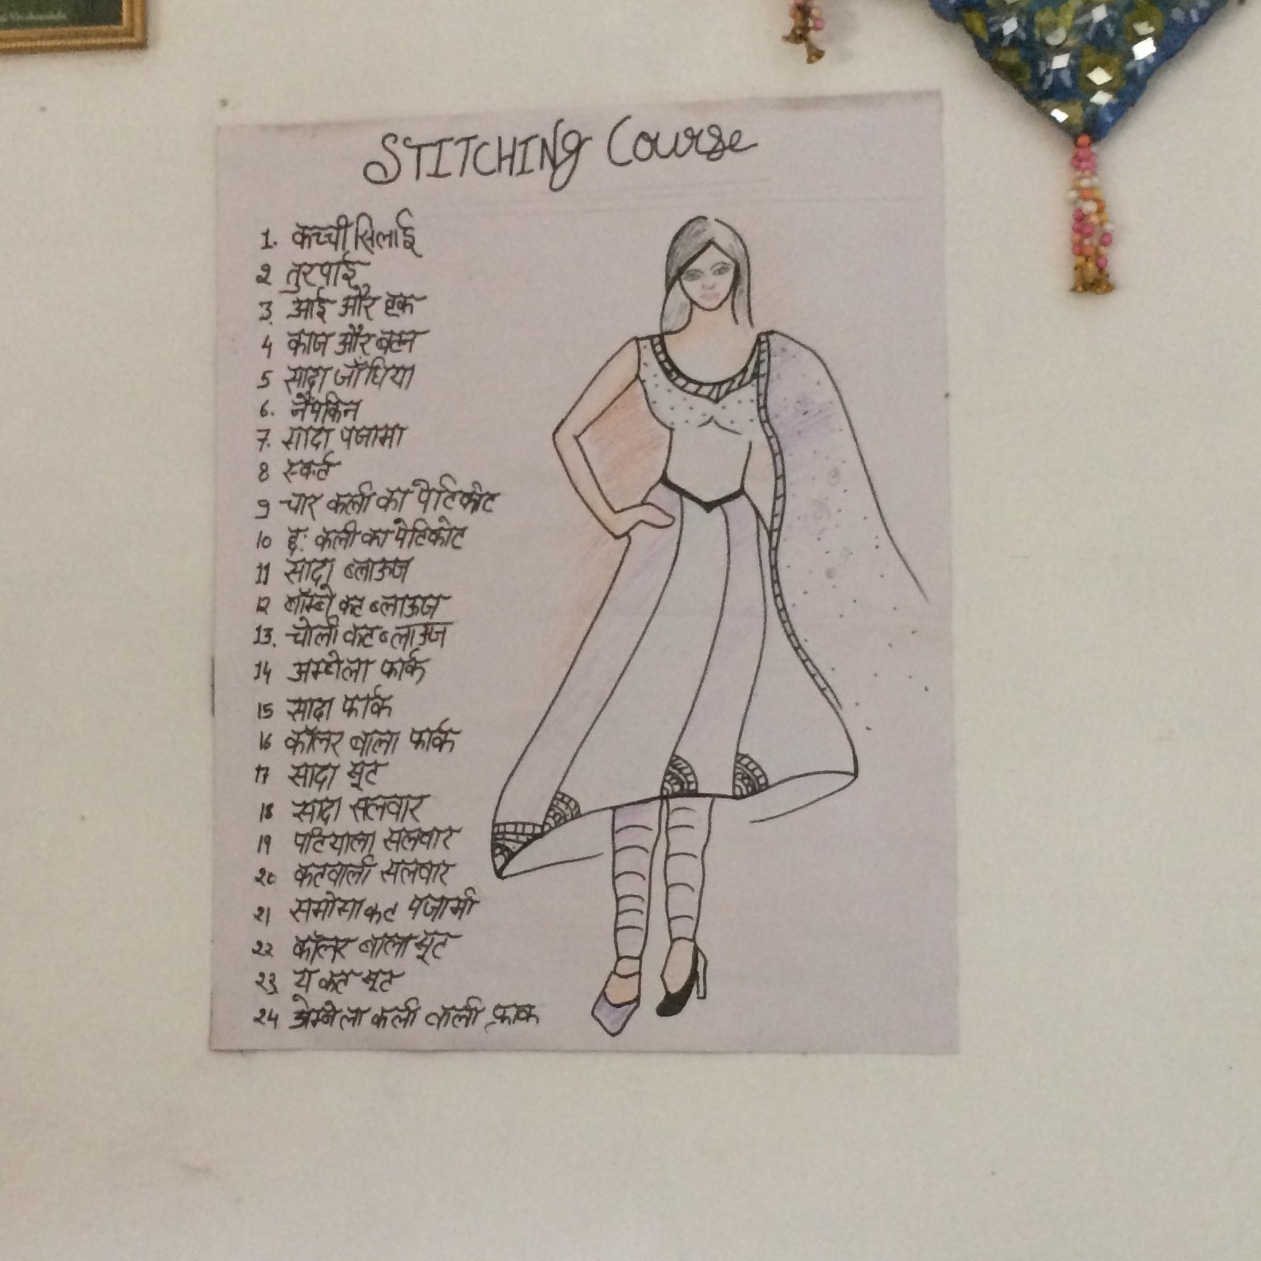
Madanpur Khadar Centre
Madanpur Khadar centre houses the centre for women as well as children in 2 shifts. When I visited this centre, there was a lull at the centre as it was in the middle of the day. I believe three programs are actively running for women (Sewing, Beautician and Computer Center). It also has a site for secondary school children on the first floor. I did get a chance to interact with teachers of both supplemental education and skills program. They seemed to like the way they have been working here and have been with the group for a long time. Mr. Dharmendra is stationed in this centre. The centre mostly caters to the semi-rural neighbourhood where its setup.

Yamuna Centre
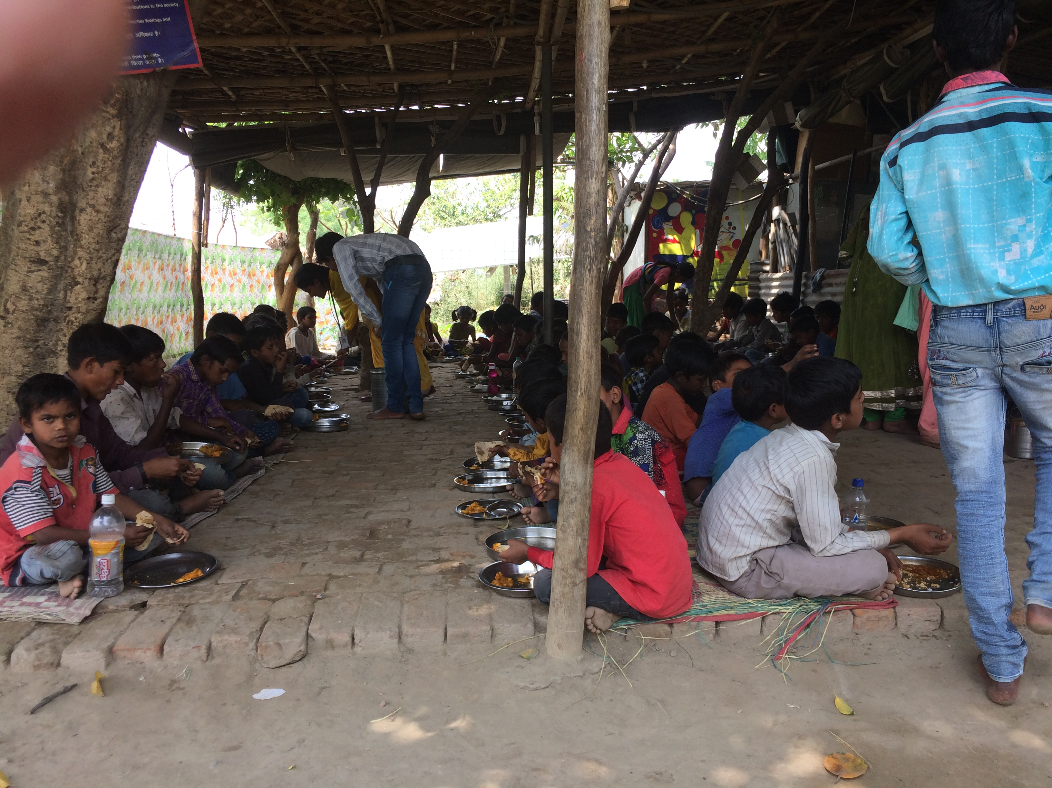
All the above sites cater to children admitted to regular schools, so the role of the Project WHY centre is of remedial education. However, the Yamuna centre is peculiarly different. The population that lives in the flood plains of the river and cultivates vegetables there as labourers for their livelihood, have no papers whatsoever, and the nearest school is some distance away: a couple of kilometers or more. So, none of the children could be admitted to school, and Project WHY centre is their school. There is a local donor, who is a caterer, who has volunteered to donate mid-day meals every day for this centre, with the same quality of food that he serves his clients: good quality food arrives every day in his vehicle on time for mid-day meals here. This, I was told has a substantially positive effect on the attendance and retention of children in the centre. I also ate the same found and the quality of the same was incredible.

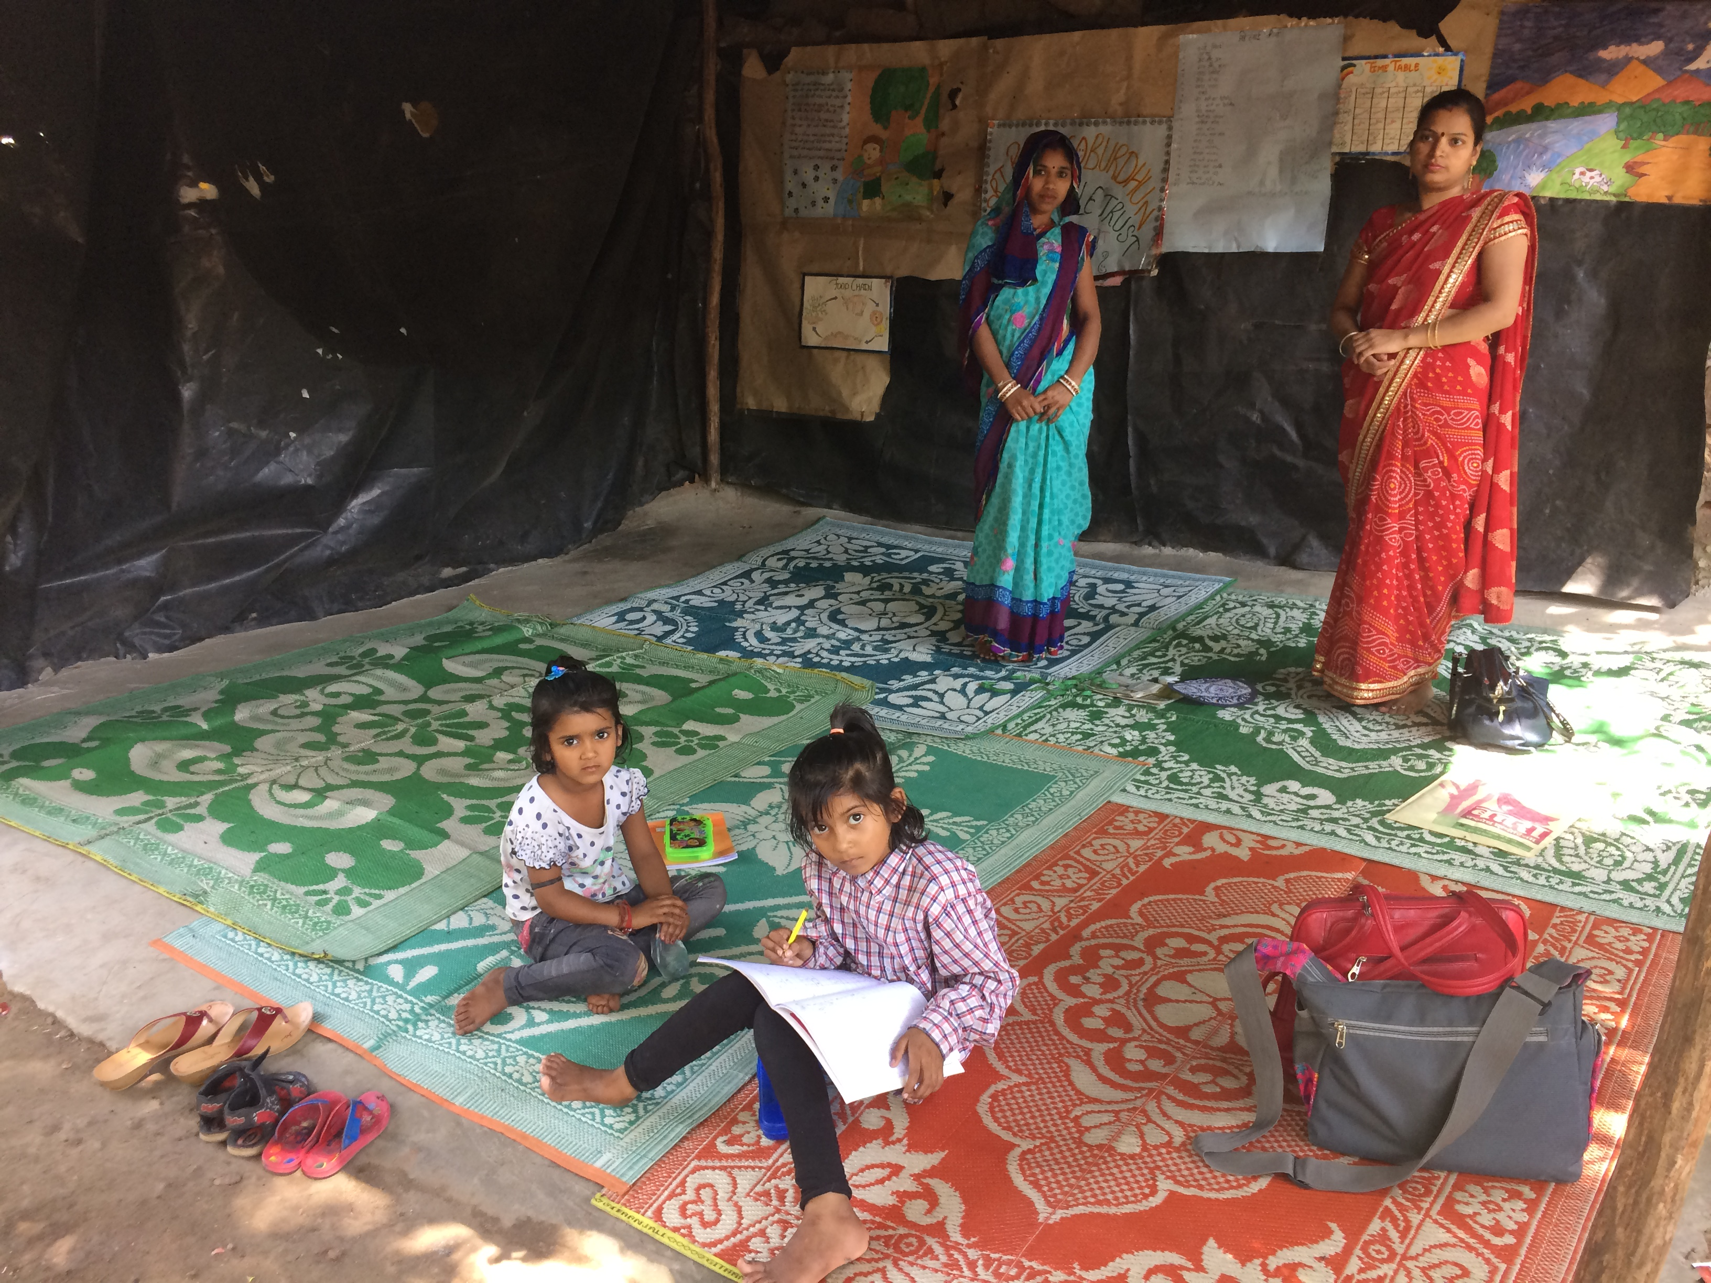
Kalka Mandir Center:

I think this is still in its infancy stage as it was uprooted from its earlier space. The centre has very limited impact and is catering to a few children and some women. I could not gather much on this particular centre as there’s just one teacher and centre incharge involved here. I do have a feeling that the centre may be uprooted again as its in an unauthorised space - but that’s just my opinion.

Giri Nagar Center:
I did not go to this centre as it was under construction

Recommendation:
Overall, the profile of work being done is impressive, and a single project catering to over 900 children in six centres is managed very efficiently. Most teachers in the centres come from the communities themselves, except in the case of Yamuna. This is a plus, since they seem to have no problem of teachers leaving frequently, which is a major problem with many projects of similar nature. The people managing the project are very dedicated.

Overall, it is an excellent project and should be funded. The kind of work that they are doing is mostly remedial and supplemental which by nature is difficult to measure. However, this is the kind of work that makes tremendous difference in children being just ran and won. The lives of close to 1000 children are impacted via this project and the people involved seemed genuine and dedicated. Inclusion of Ms Malini in the leadership team means more professionalism and scalability in their model.

She has shared an ask for more resources to organise some field trips for the children and I whole heartedly support the same. They also need to organise some sort of teacher training programs for their current resources. I think its an excellent idea and we should completely help them with the same.

