Site Visit Report
Mother Project (run by Tomorrow’s foundation, Kolkata)
Date of travel: Feb 6th, 2013
Visitor: Manoj Bhattacharyya (Asha-SV)

Background of the Tomorrow’s Foundation and the Mother Project: Tomorrow’s Foundation (TF) is an independent NGO operating in three states, namely West Bengal, Jharkhand and Chattisgarh of India. The main objective of the TF is to help unprivileged children of these three states. One such project is the Mother Project (MP), named after Mother Teresa and started with her blessing in 1991. Asha-SV supports the MP with partial funding. This project deals with problems faced by poor children attending government school around Kalighat area of Kolkata. In particular, the target group is students attending Dharmadas Trust Model School (DTMS), primary school run by Kolkata Municipal Corporation. The MP also helps DTMS school students when the graduate from this school and attend 18 different local secondary and higher secondary schools. A host of services including remedial education, regular home visits, cultural and sport activities and field trips are organized in this project.

Visit Detail: I had an opportunity to visit DTMS School on the evening of February 6th with Prof Shanti Ghosh Dastider of Jadavpur University. Prof. Ghosh Dastidar is a donor of TF and also arranged for my transportation. The visit was somewhat unannounced and the organizers only heard about my trip in the evening less than an hour prior to my visit. My first impression was that the school was humming with activities.

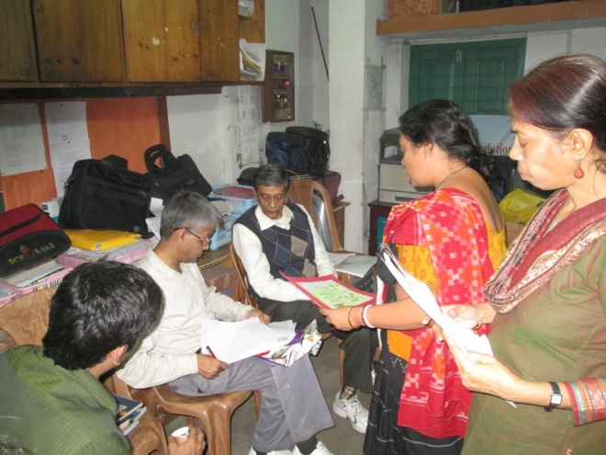
When I first arrived I was greeted by few teachers, they gave me a very detailed presentation of their school, the details of the working and the enrollment information.
At the beginning of 2013, the school had 134 existing students and 15 new enrollees in the primary division. In the secondary studies, the school had 78 students and in HS they had 16 students. In addition to the three school level pupils, they also had 16 students enrolled in different colleges. The HS and college level students were provided coaching support in classes suitable for their levels.
The socio-economical backgrounds of students is worth mentioning. Majority of students come from families where mothers work mainly as maidservants and fathers don’t contribute economically. Average monthly income of families was mentioned as Rs. 4000. Also, the students come from areas where the hygiene and sanitation are very poor.
In my first meeting with the teachers, they went through enormous amount of details about their teaching philosophy and I also took copious amount of notes, as seen in the above photo. Big part of their remedial education philosophy is to track each individual student from elementary education and through secondary and then college level education.
At the beginning of the year, “child-wise planning with baseline assessment” is done. A worksheet is prepared for each student with actionable monthly targets and then actually followed up on a monthly basis.
Even though support is provided for college level students, they have correctly realized that the emphasis is to be placed at the elementary level. As the students progress through elementary education and advance to secondary education “mind mapping” technique is used. In this method, students write sentences based on educational module.
From class six and onwards students are encouraged to enroll into computer classes.
In addition to academic work, each month a host of other activities are organized. Dictionary reading, painting a picture and then writing a story on it, lecture by visitors and special outings on noteworthy days are some such activities.
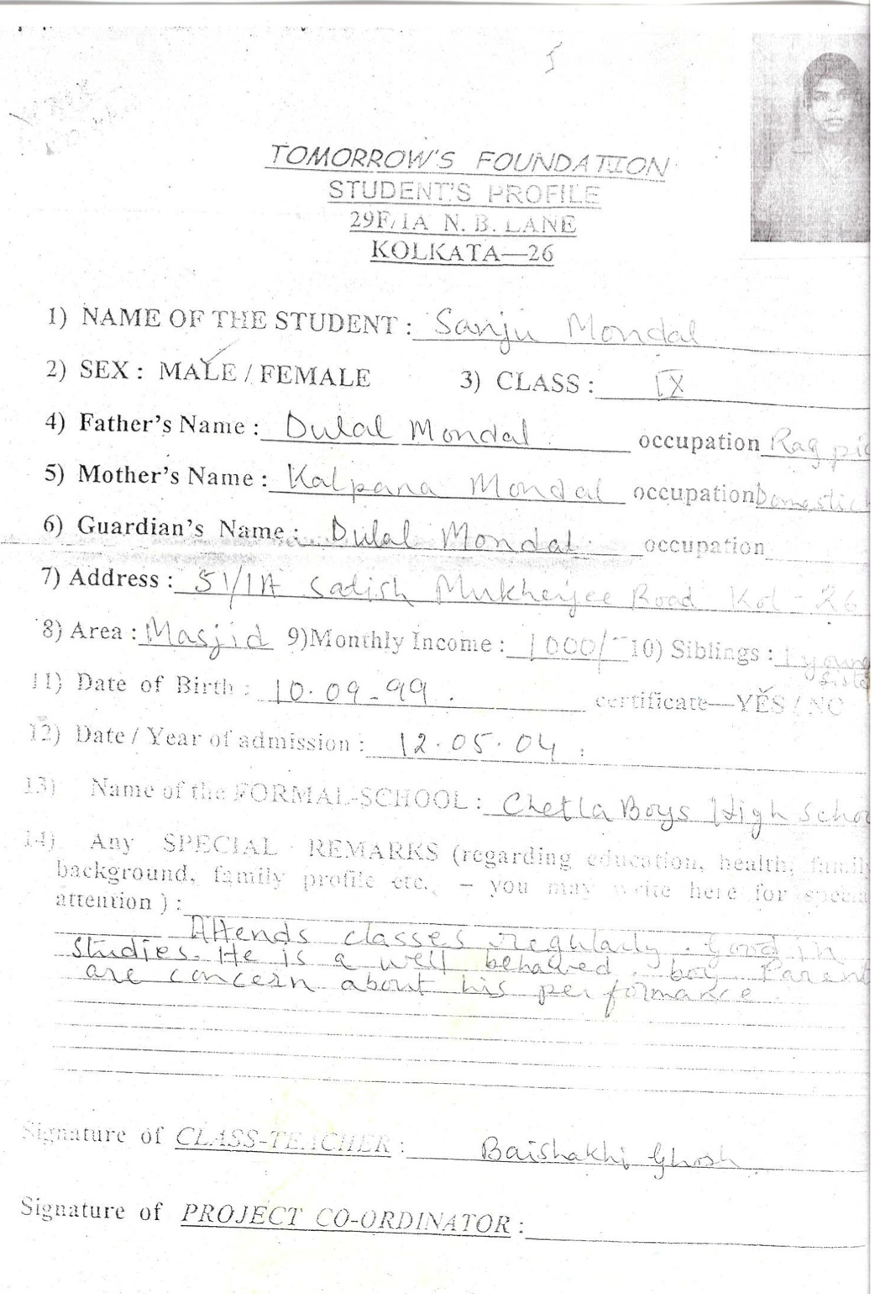
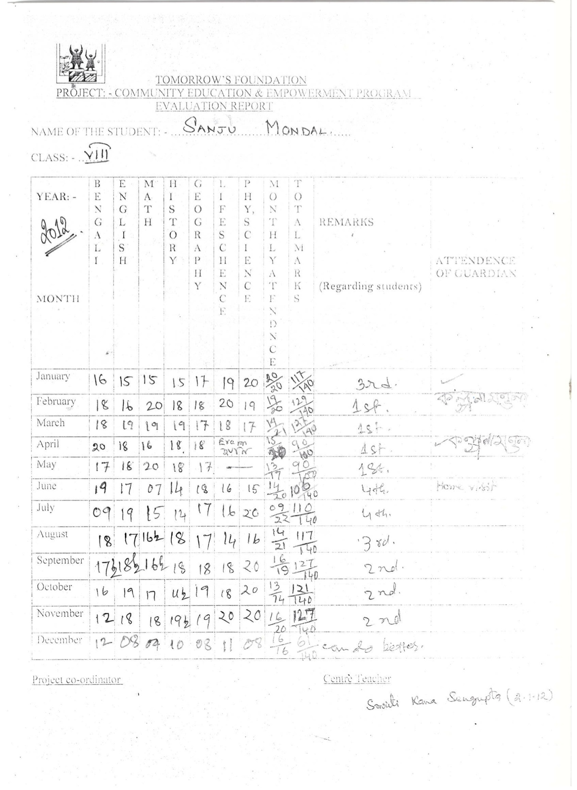
The pictures on the left show how they keep record of each student and monitor their progress on a monthly basis. This process has been very effective in decreasing the dropout rate of students. Students appeared to be enthusiastic about coming to the evening school and meeting other children for a constructive work out.

Following figures show their “area-wise attendance tracking” procedure and also a teachers’ training page. Area-wise attendance tracking has been specially useful in understanding the absences.

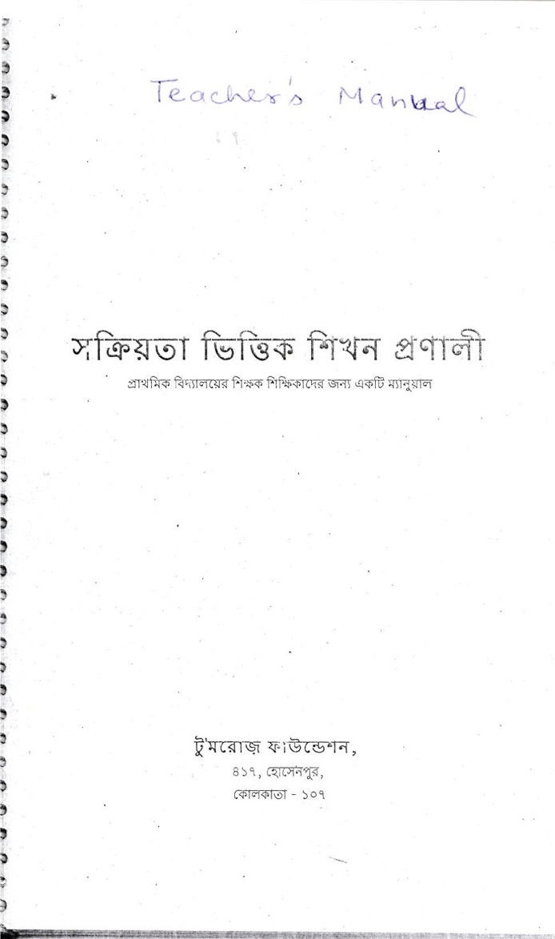
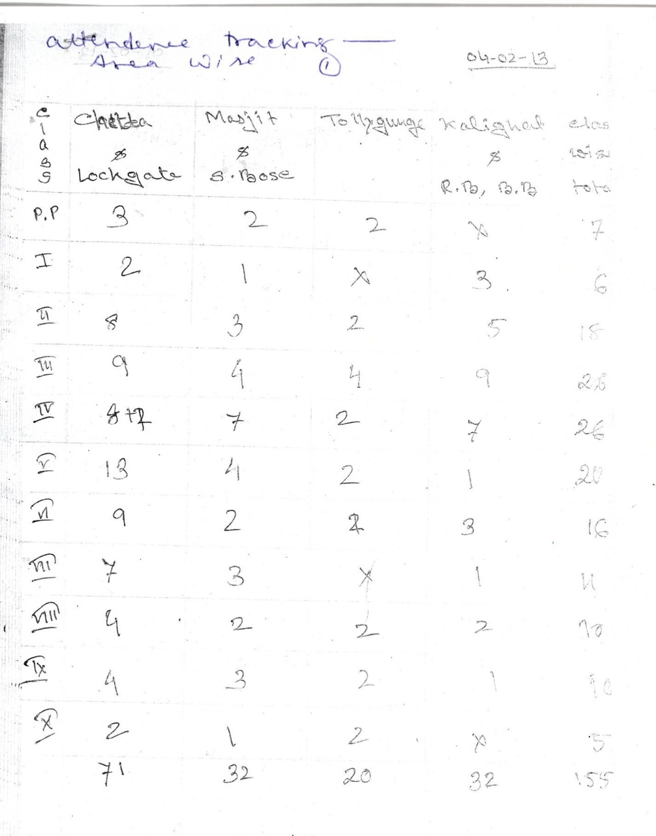
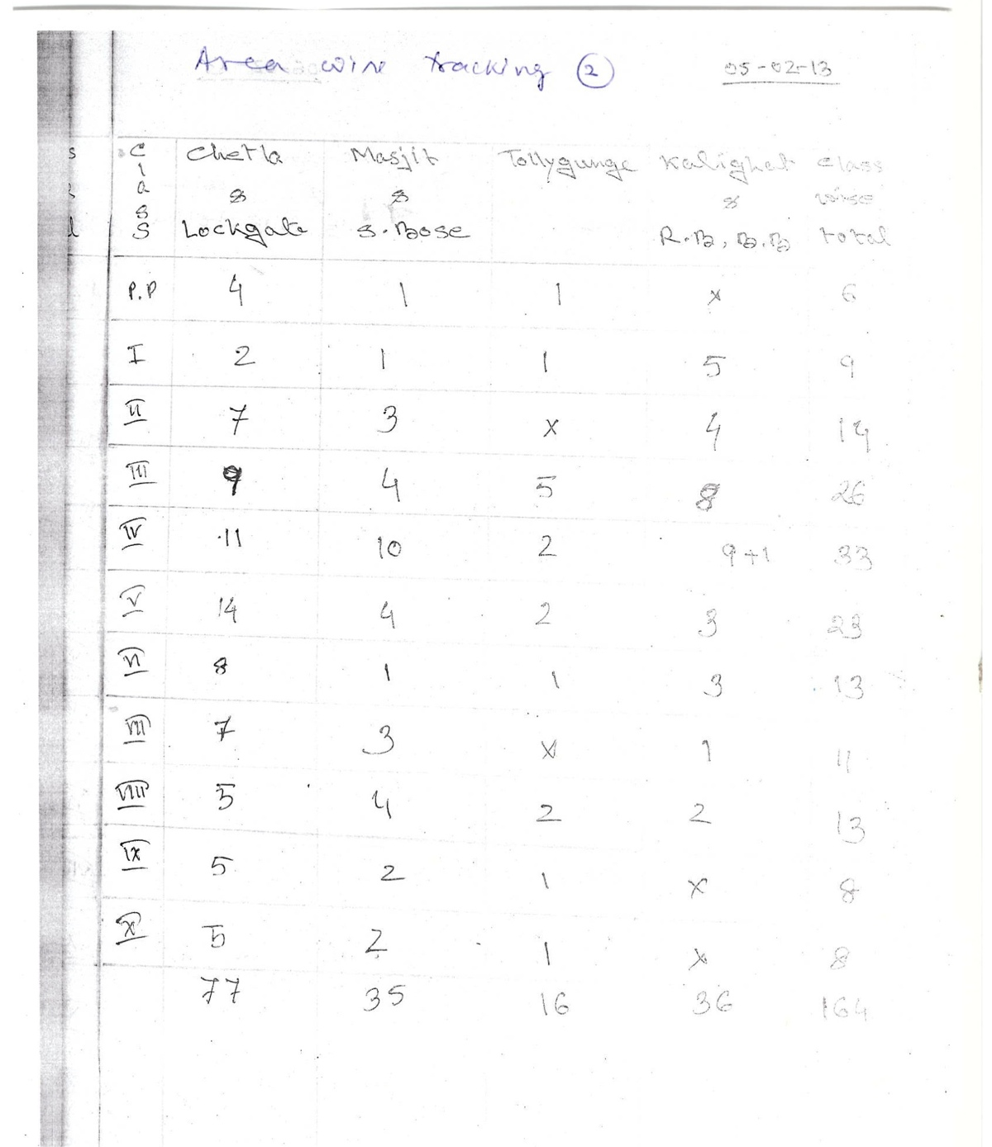
I visited every classroom in progress and tried to follow the lessons. At the end, I engaged in small questions. The energy of the students was heart-warming. The younger children were, especially, eager to show off their works,

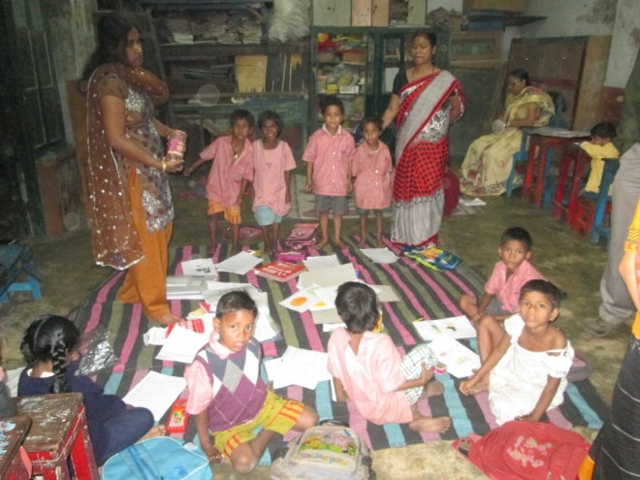
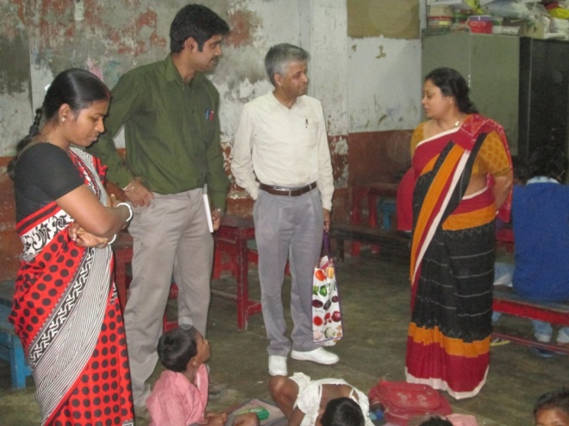

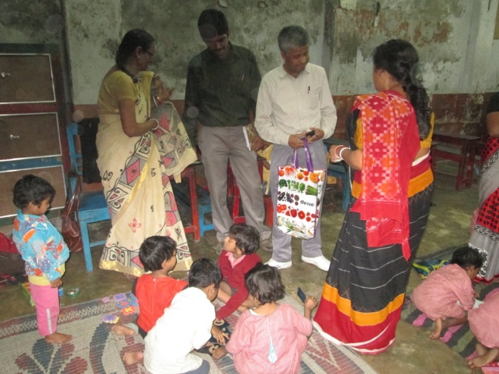
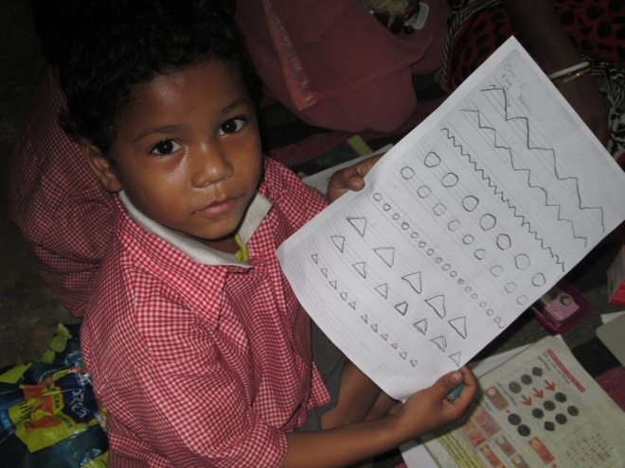

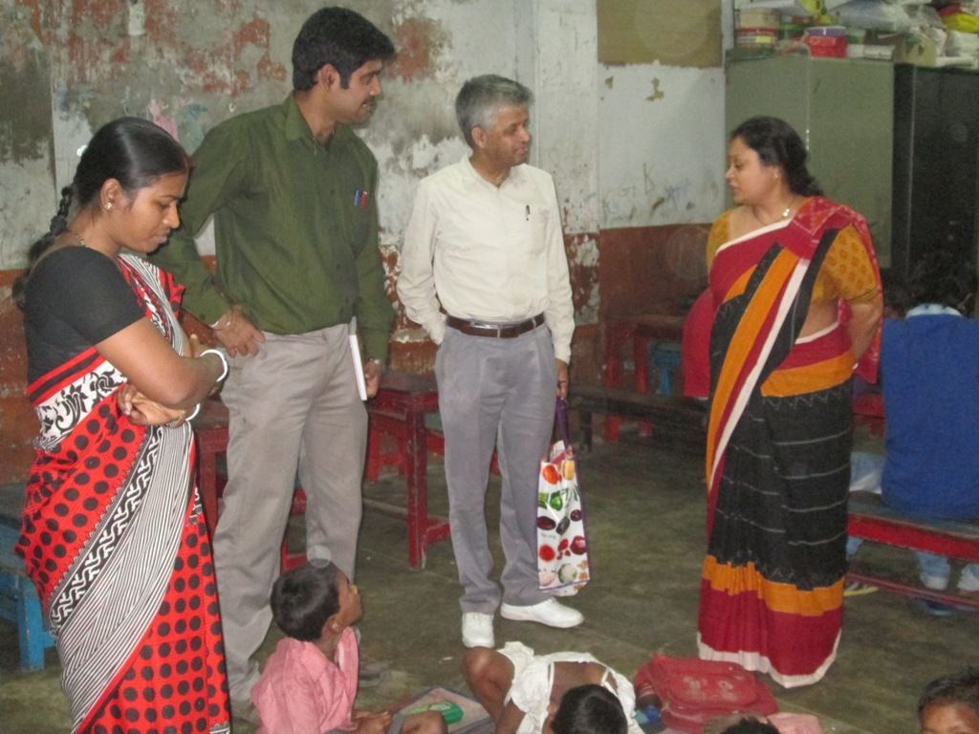
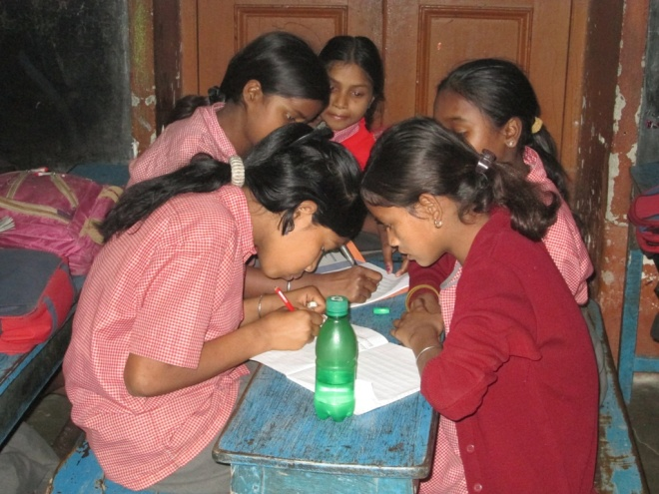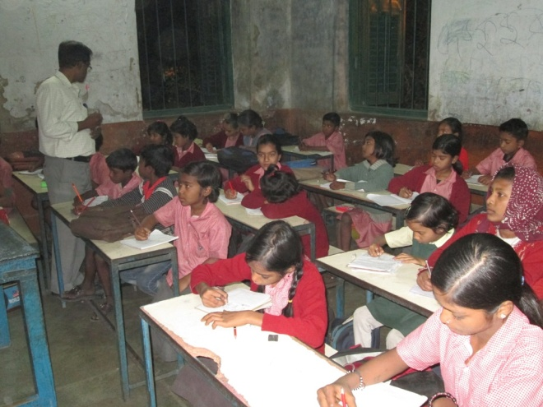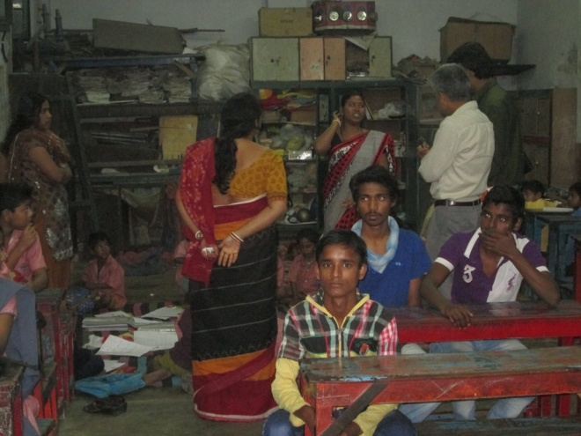

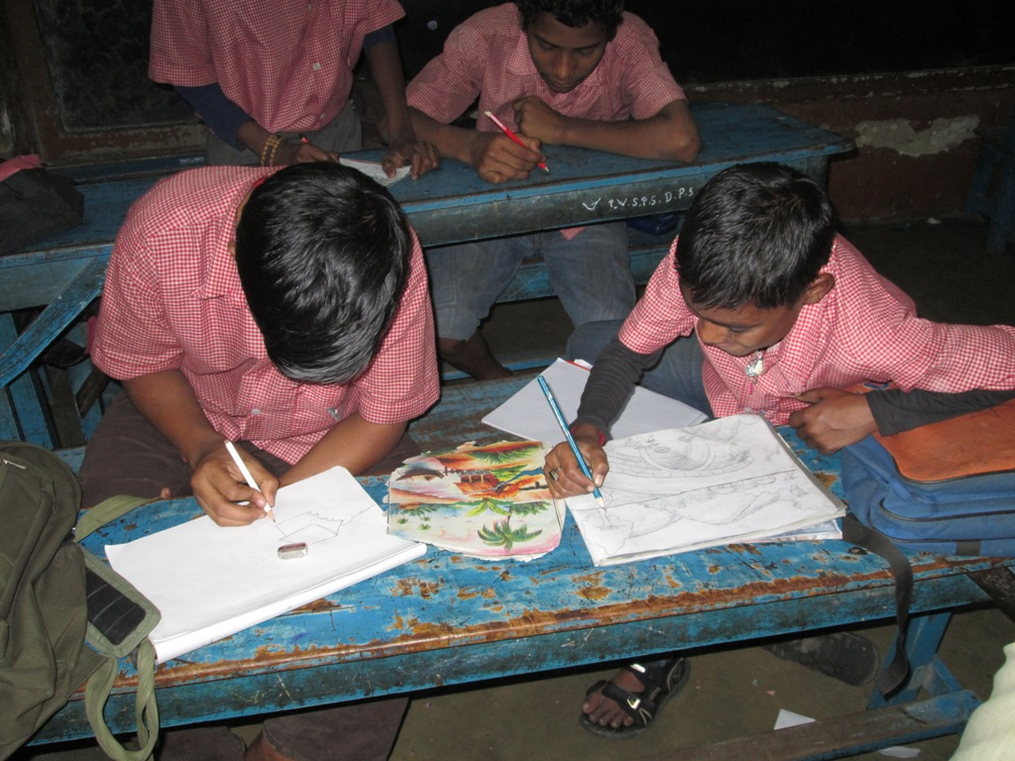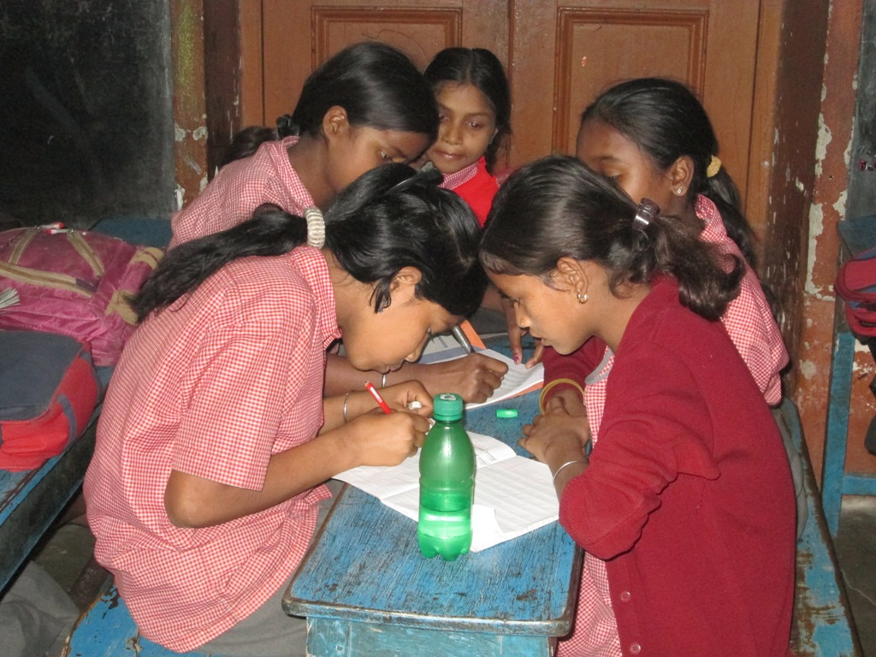

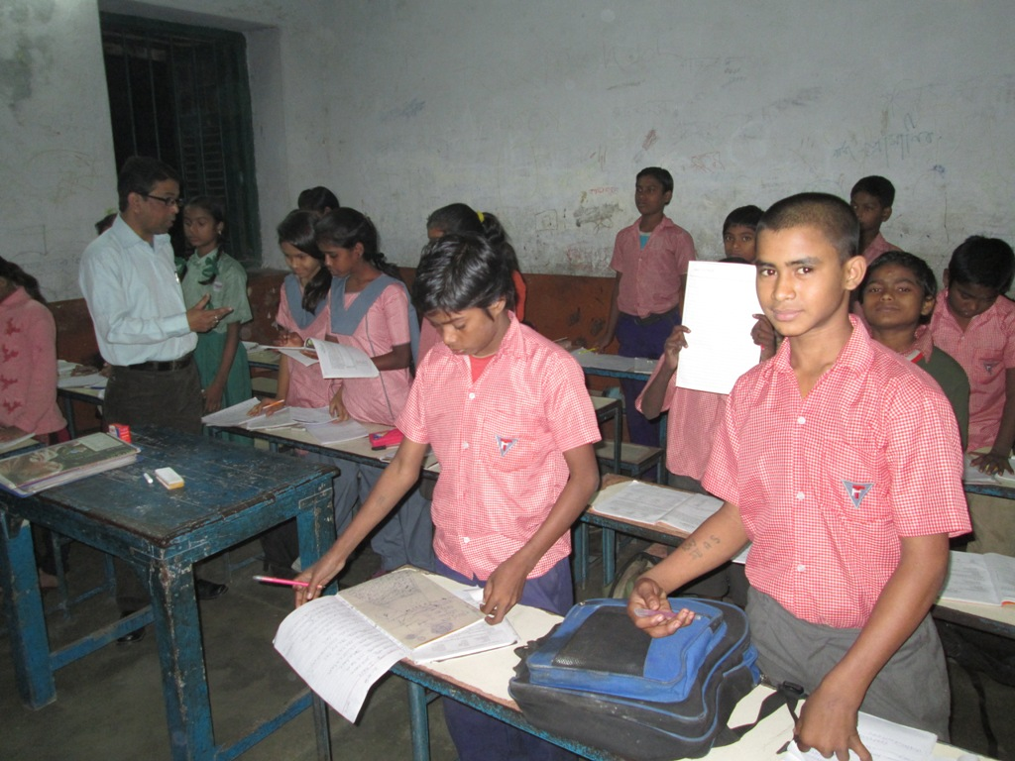

I was especially impressed to find out that many of the teachers at lower grade of primary classes were past students of the Mother Project. They really believed in the cause and wanted to get involved themselves. In many ways, this was a big endorsement to the project.

Meeting senior students, higher secondary and college level, was also an enjoyable experience. Students were confident and expressive. They were proud to talk about their successes. I also met many students who were also soccer players and represented their schools in national level meets.

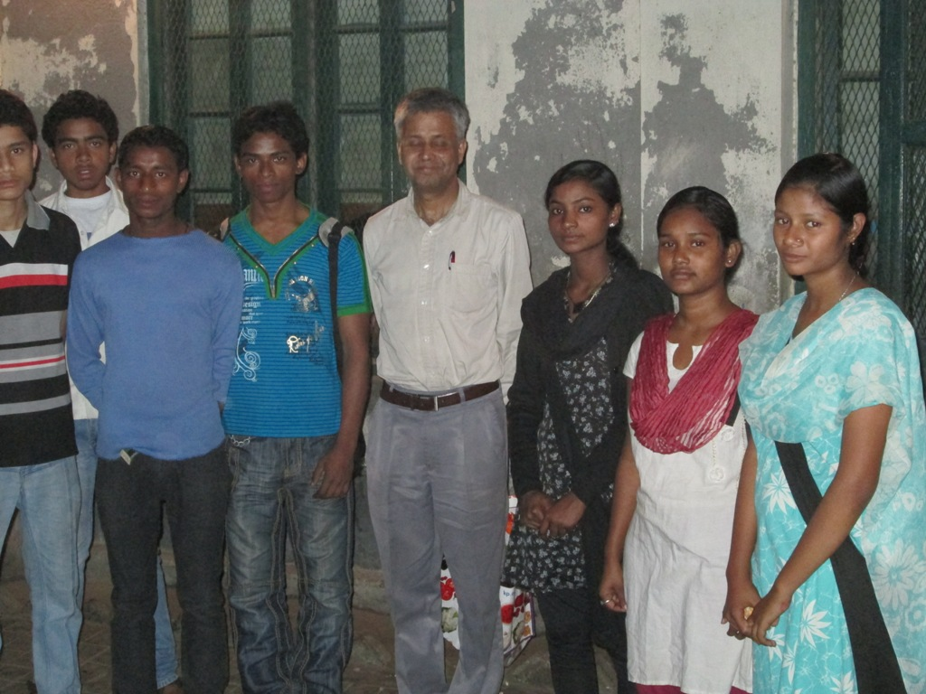
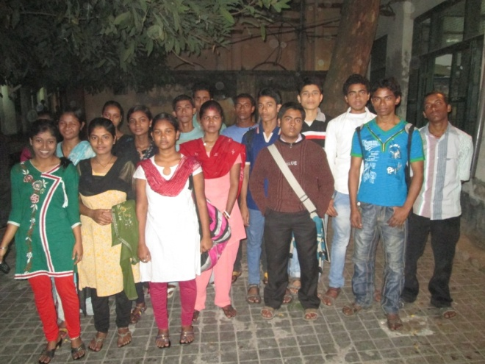

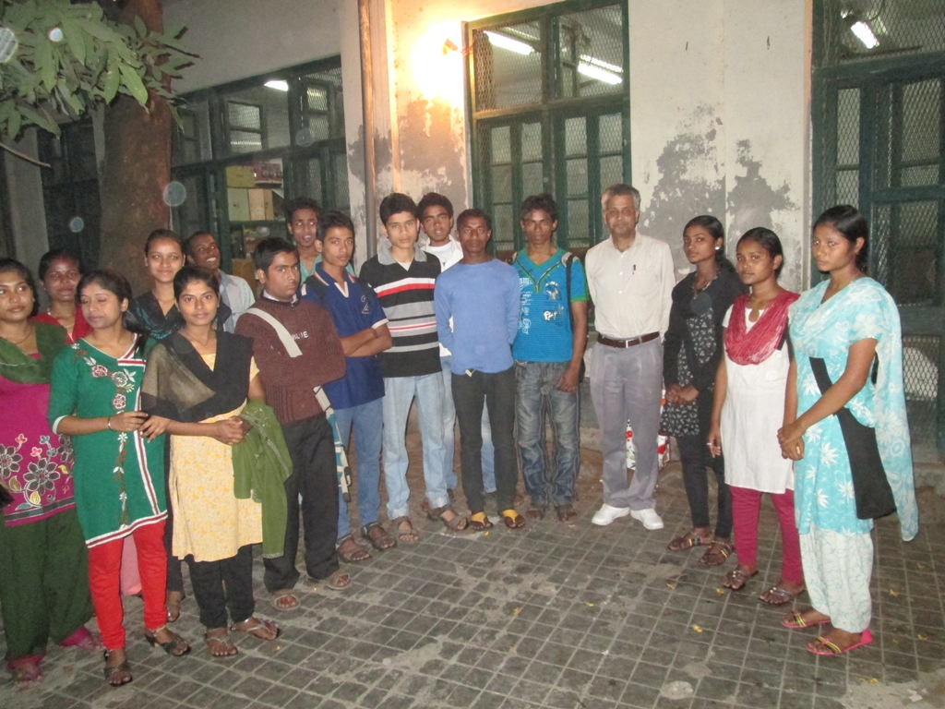
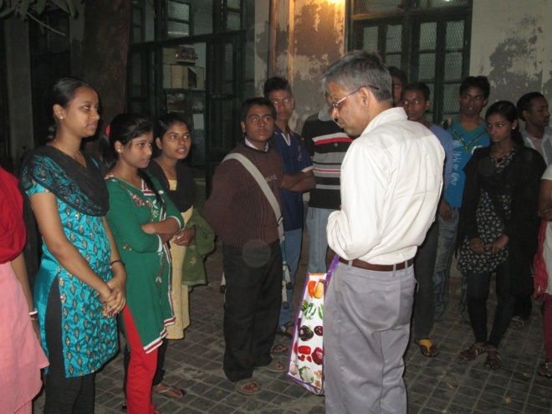

Final Conclusion: Overall, I had a very enjoyable visit and have no hesitation in recommending Asha-SV continuing to support this very worthy project.

