NJSS Visit – Asha for Education – September 15-17, 2016
By Padmanava Sen (Asha Bangalore volunteer, padmanava.sen@gmail.com)
I have spent 3 days in Rajatalab (25 km from Varanasi) to visit Nandlal Master’s work. Panchamukhi, a teacher and employee at Asha Samajik school took me to all the centers outside Nagepur.
On 15th September, I have visited the Benepur knitting center. Ashaji who runs the center is involved with Asha since 2007. There were around 20-30 girls in the center with 13-20 age group. Most of them left education after Class 8th. I asked them why they left studies and most cited financial reasons, distance to school and pressure from family. Few girls are married as well. Half of them are learning this skill-set primarily to know knitting and thus do their household knitting needs by themselves. The rest wants to earn from home by doing this work. They mentioned some needs like few extra knitting machines for the girls who almost completed one year and wants to earn (it can be 50-50 contribution). Few girls requested for a long term beautician course- six months instead of one.
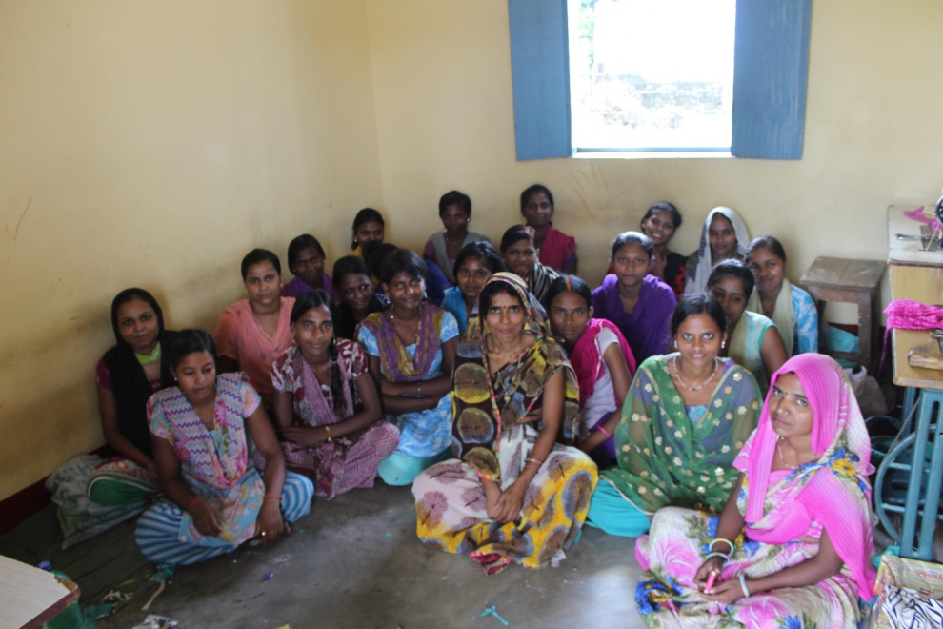
Girls in the center
Then I went to the Self Help group meeting at Kundaria. These groups are mostly formed after the failure of Government schemes where they lost some money. The groups consist of 10-15 members and follow simple methods like monthly contribution of INR 50/80/100, low rate in case of loan (2% a month instead of 10% a month from local moneylenders), transparent accounting as a group, safekeeping of money and accessibility any time from the treasurer in that village. I felt the women were proficient in accounting as detailed accounts are kept in the documents.
Later on 15th, I have met Chance India kids and had a discussion with them regarding their ambitions. I felt they were bright kids and some additional English/computer training will do well. They take care of the library cards and accounting of the books that serve the village students. They need to buy few more useful books for college level students. The computer lab needs improvements as some machines look old and due to electricity problems, it is difficult to train students.
On 16th September, I have visited the students of Asha Samajik School at Nagepur village. I have also talked to the teachers of the school. I have played simple games related to Math with the students and asked them simple questions in Hindi and English. The answers were satisfactory and the student knowledge seems to be par or better than what I have seen in Government schools in the same classes.
The school building looks very good with two stories and 2nd floor have a shaded area where trainings can be done. Some rooms are very big to accommodate special activities for students. The teachers showed me the I-cards that are being issued to students. Also now private books are introduced to overcome the issues of procurement of Government books.
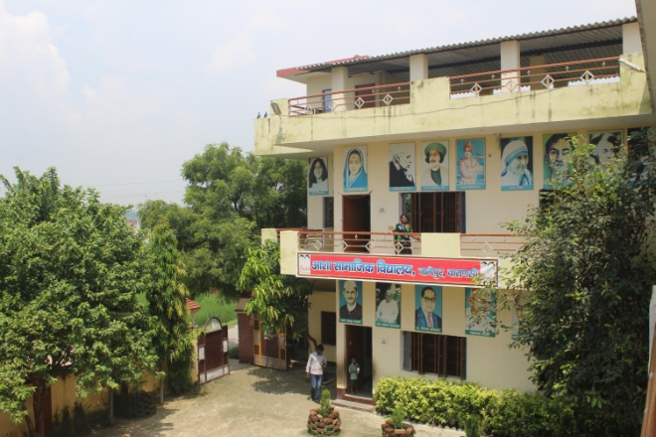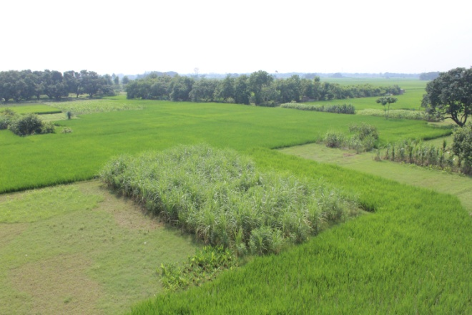
School and surrounding farmlands
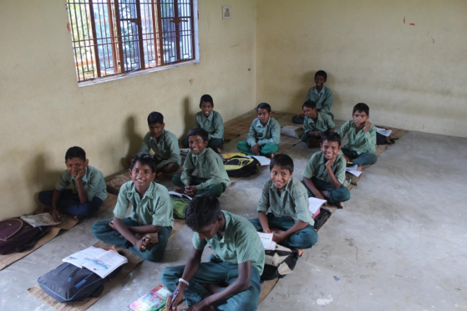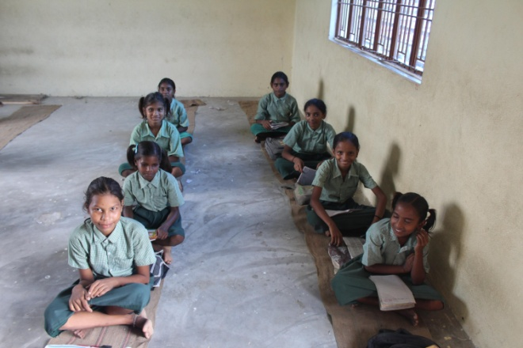

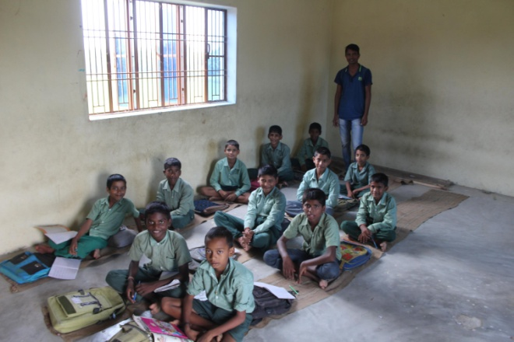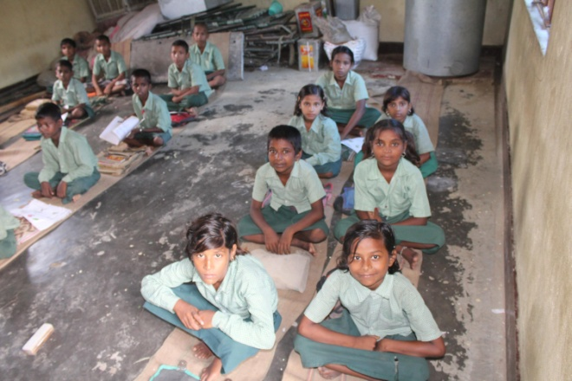
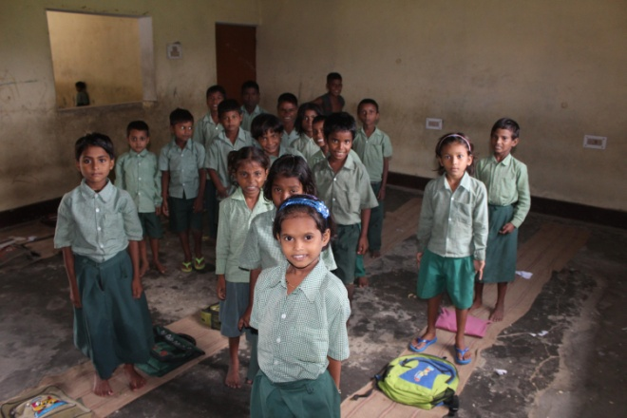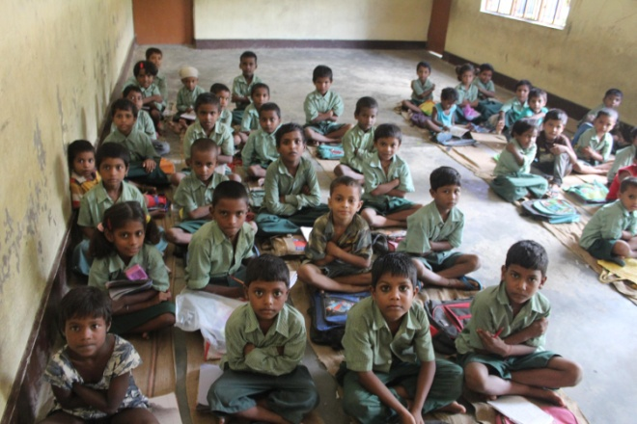
Students in the Asha Samajik School, Nagepur
Later I visited Harsosh village school. Panchmukhi, a teacher in Nagepur school took me to the second school. The teachers were conducting the school under a big tree and usually during monsoons or severely cold days - they move it to a nearby place. The students seem to enjoy their classes in the open and the villagers have built an enclosure as well. Some kids sang songs and recited poems. The teaching methods were very good as much as I can see in the boards. I spent time with kids and then had a separate discussion with the teachers. They mentioned the issues of books, the need of permanent structure, need for travel allowance for two teachers who come from a distance.
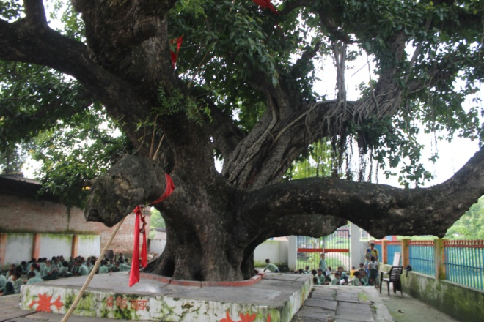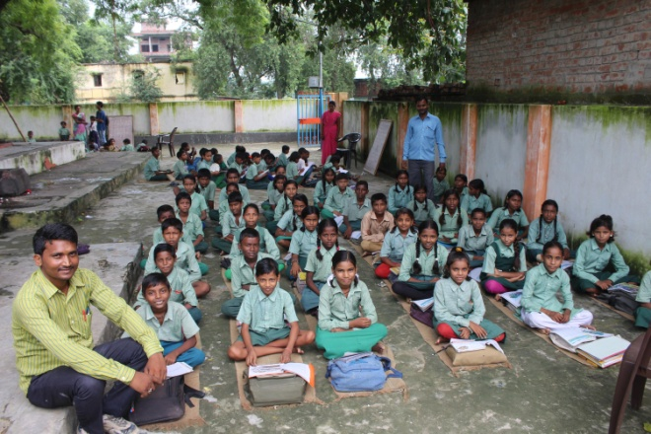
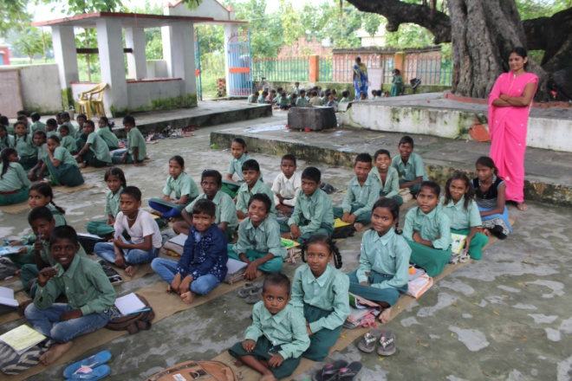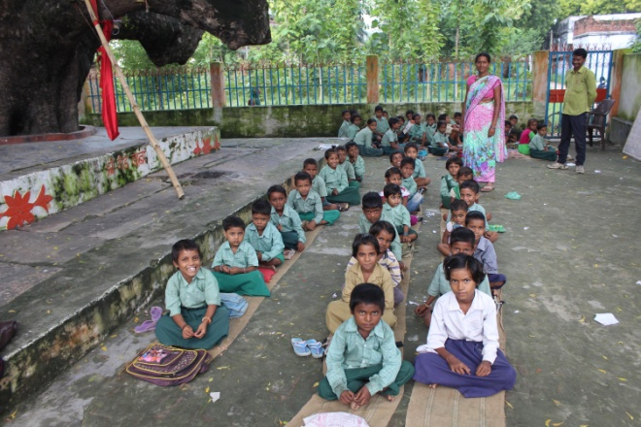
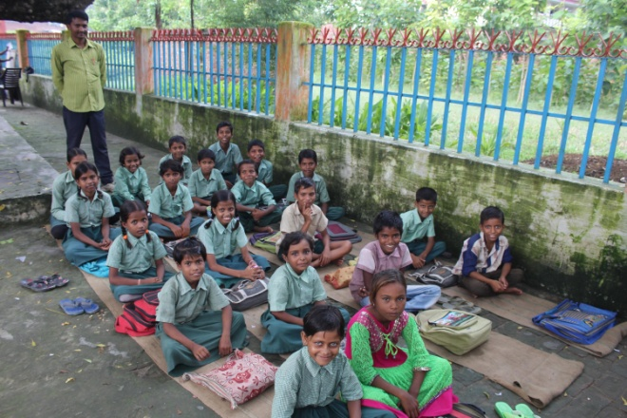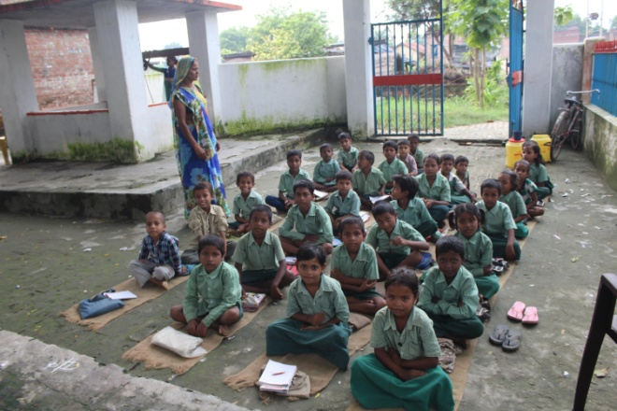
Harsos School and its students
I have also been part of the Kishori residential training that happen in Nagepur center on 16th and 17th. Staying away from home for two straight days seems to be a big step as well for them. Two trainers from Lok Chetana Samiti trained them on gender sensitivity and health. I also took a small 20 minute session with girls on exercises that can strengthen their core, back and Knee. The coordinators from different villager centers were also there and we had a long discussion with them on village issues after dinner on 16th.
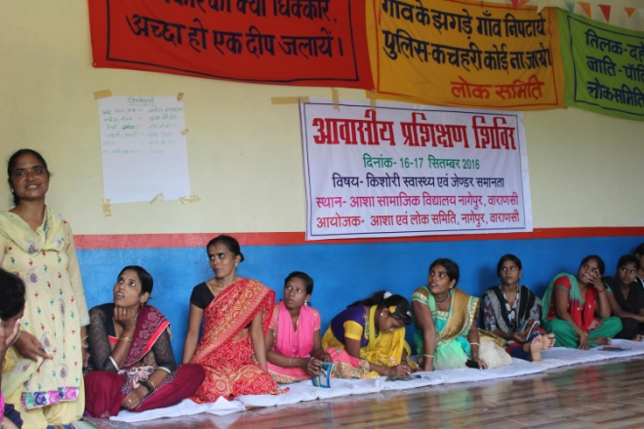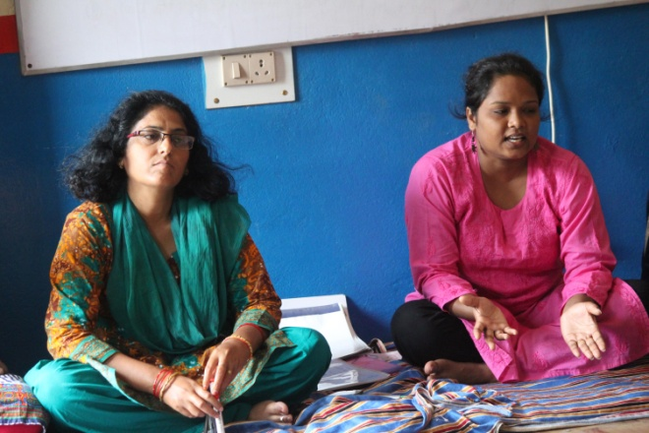
Coordinators for SHG centers and the trainers from Lok Chetana Samiti
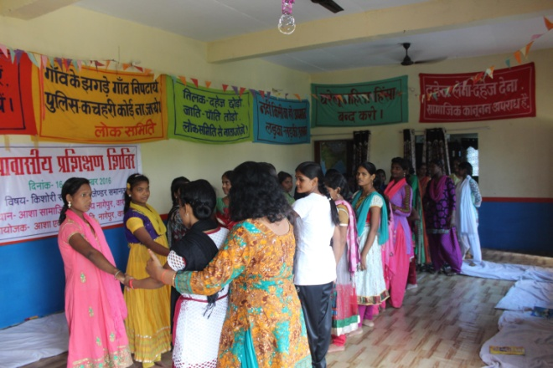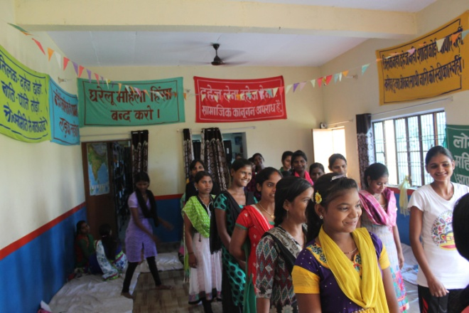
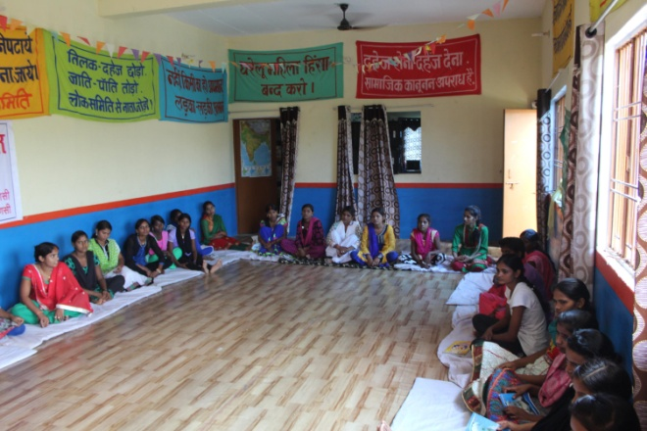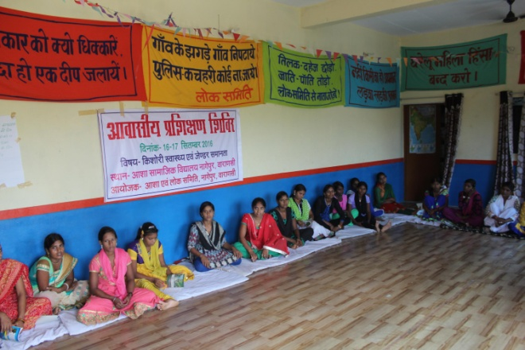
Girls attending sessions and training
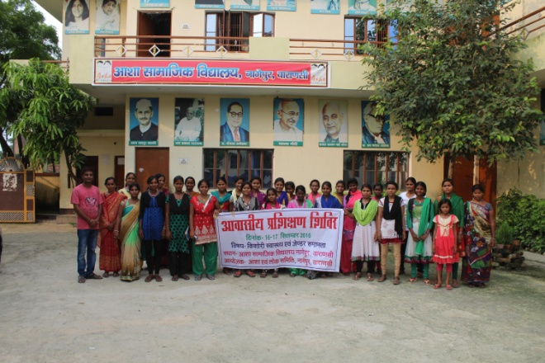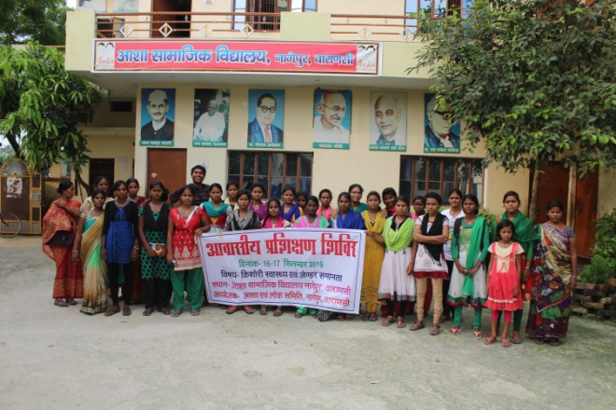
Nandlal Master and me with the group in front of School

