Site Visit Date – July 2, 2016
I reached Kodai at 10:00AM after a 3 hour journey from Madurai. After finishing my breakfast, I reached Grace Kids center Crèche around 11:00. Hilda who is the coordinator across all of the BET crèches came by to take us to GKC. Two of their board members (Mr. Williams (president) and Gnanaprakasam) had visited Kodai on that day to meet me in person. The kids were done with their morning breakfast when I reached the Crèche. The kids gave a very warm welcome and performed dances and songs that they had learnt at the Crèche. I gave them some snacks and chocolates which I had taken with me.
GKC has totally 55 kids enrolled this year (up from 50 in 2015). Around 87 kids are currently in the waiting list. After the graduation (completing the pre-schooling), most of the kids continue schooling at the nearby govt aided school. Over the past year, GKC received water connection from the corporation. They have also setup Sinter tanks to collect rain water. In the present setup they have sufficient water for the Crèche’s daily needs. It has reduced the overall water expenses in 2016 when compared to 2015.
In addition to GKC, I visited the two (Peach tree and Little Lilly) other Crèches run by BET in the Kodai area. Also got a chance to stop by the sewing center run by BET that helps local women earn a livelihood by making baskets, stitching clothes, etc.
We ate lunch at the sewing center. The lunch menu for the day was – rice, Tomato sambar, Potato curry and boiled egg as a side dish. Eggs are served to the kids twice in a week and fish once per week.

I have summarized a few other observations from the day below.
- About 40-45 kids were present in each crèche during my visit. GKC creche has 55 kids enrolled.
- There are 5 staff members (3 teachers, 1 Ayah and 1 cook) in each of the crèches.
- All 3 of the Crèches in the Kodai area are now housed in BET owned buildings. Little Lilly Creche completed the construction of the additional room which was previously funded by ASHA. This is currently used as a multi-purpose room (Kitchen as well as a class room)
- During my visit to all 3 Creches, I was able to meet the entire team of Staffs (3 teachers and 1 Ayah and 1 cook).
- At the sewing center, I saw the women making wire baskets. Most of these are prepared upon receiving orders from the customers. Some of them prepared to send to US as donor gifts and help support their venture.
- The children receive 2 uniforms, one sweater, one wool hat, and one pair of shoes, rubber sandals, per year
- A nurse visits each of the crèche in Kodai 1 day per week and provides necessary medical care, check ups. It helps families overcome their traditional beliefs and take advantage of modern medicines / care. Also they help ensure that vaccinations are given. I noticed that the children medicines are stocked on the school shelf.

- The kid’s weight is regularly measured (month over month basis) and captured it in their chart. Based on the chart, I noticed that most of their kid’s weight increased after they joined the Creche.
- The kids are split into 3 groups and each group is assigned with a teacher. Though two of the classes were held within the building, one of the class was conducted outside the building (open area with the temporary roofing)

One of the Class room is currently in an open space with a temporary roofing.

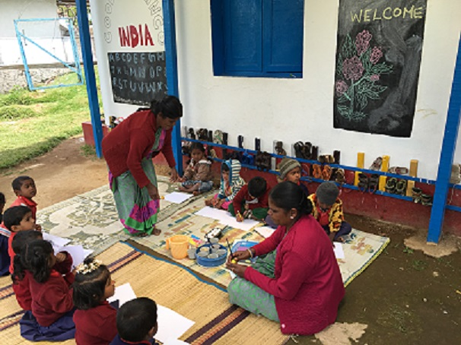

Daily meals menu for the kids
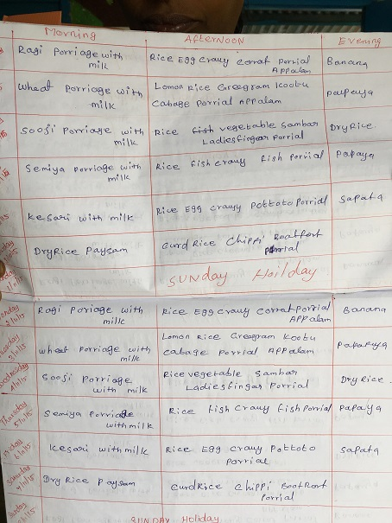

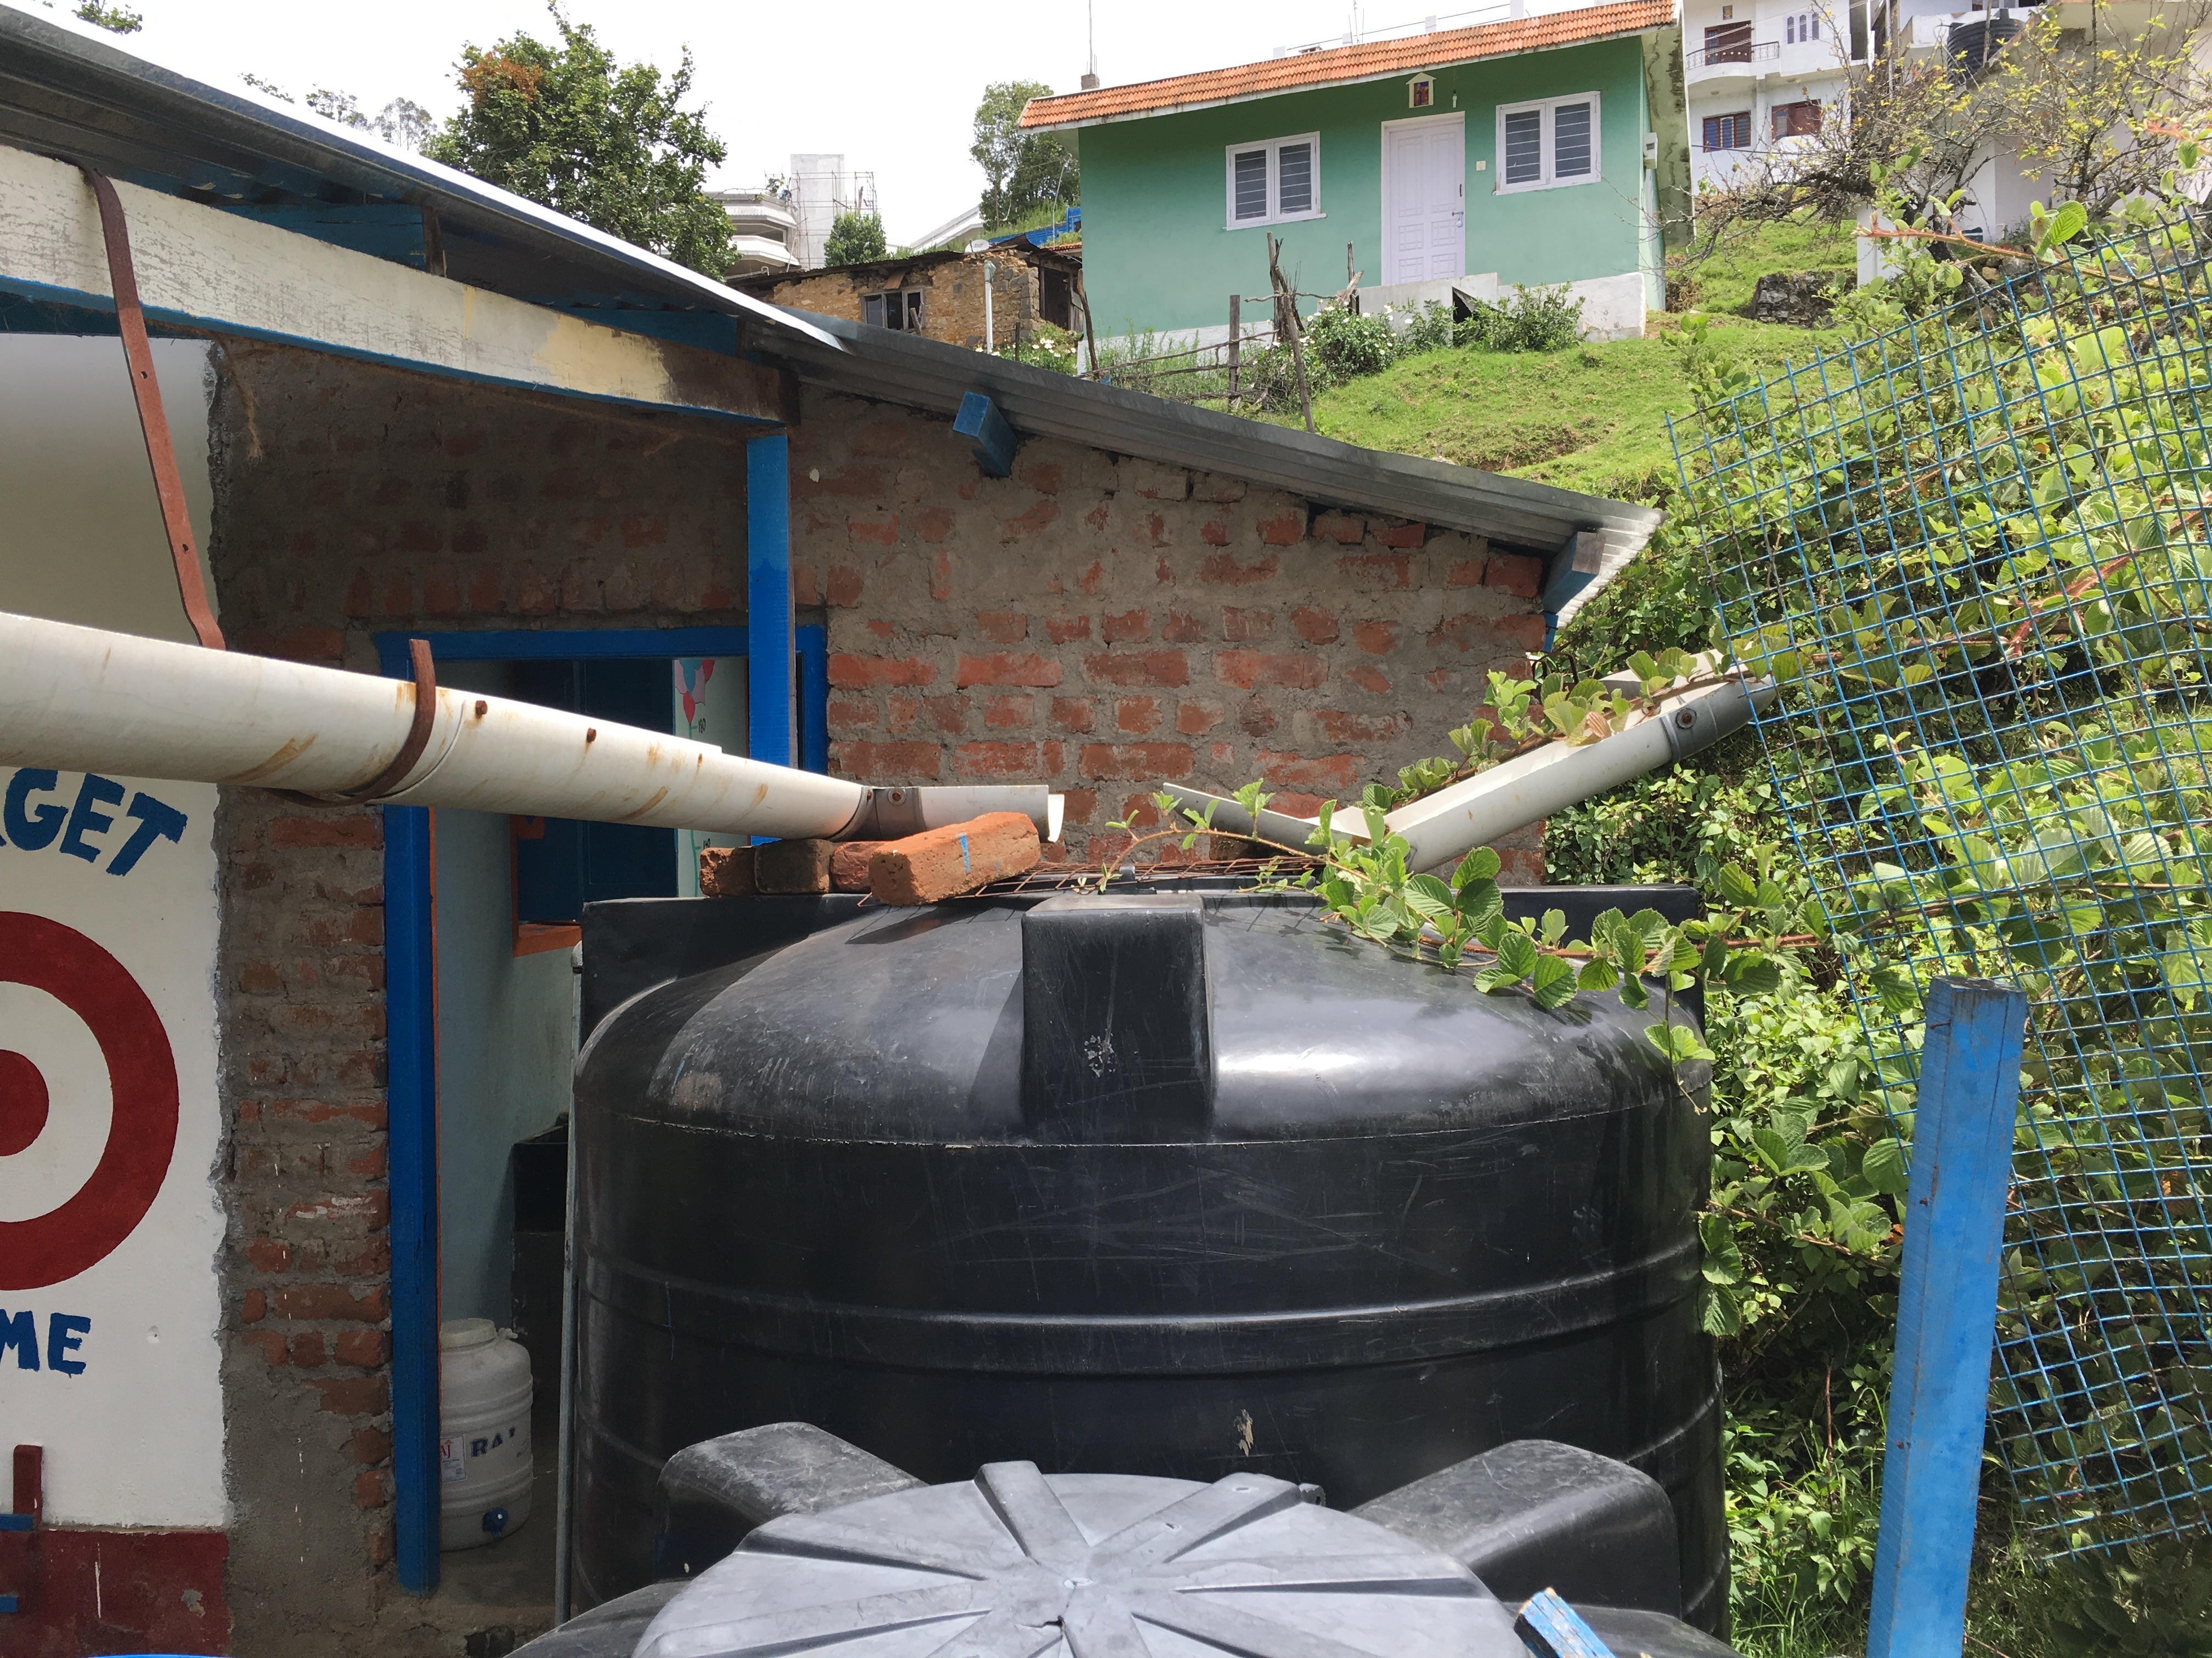
Rain water harvesting at GKC – This fulfills a lot of their water needs. In addition, they have corporation water facility. These two water sources help them meet their water needs
Photo of the Kitchen where the food is prepared for the kids
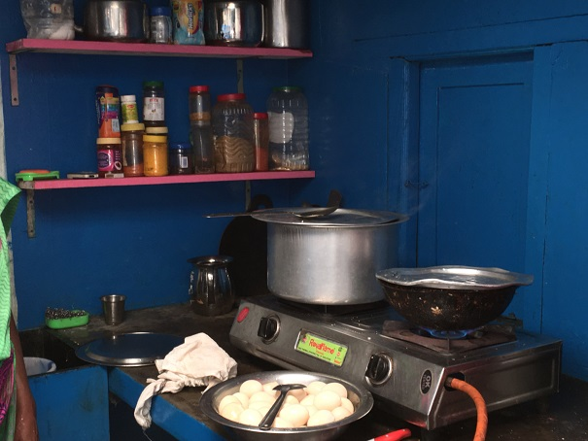

Weight chart of all the kids at the Crèche

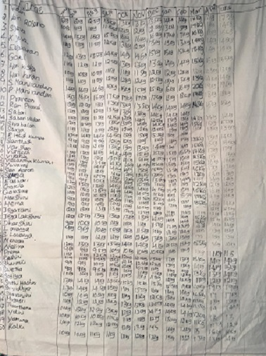

The following photos were taken during kids activities such as singing rhymes, story telling, dancing, group exercises etc.
L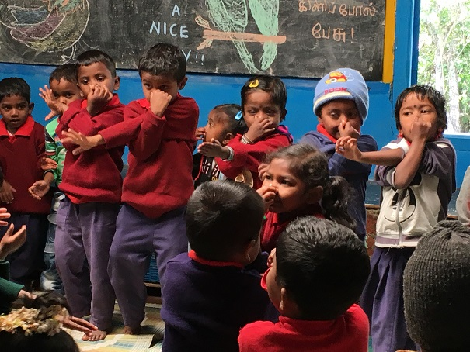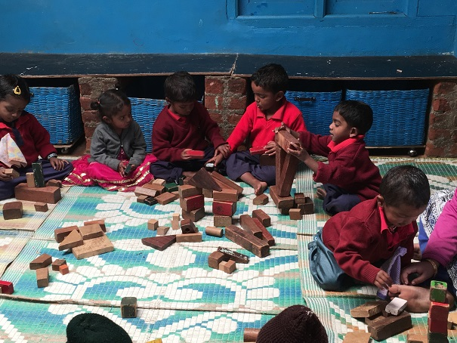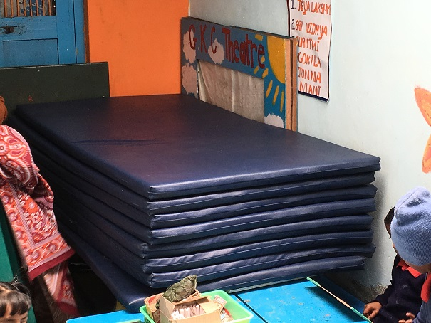
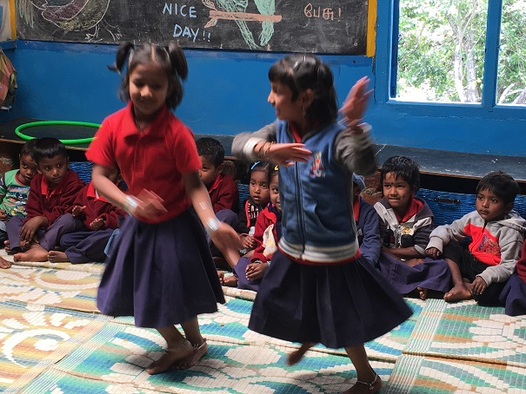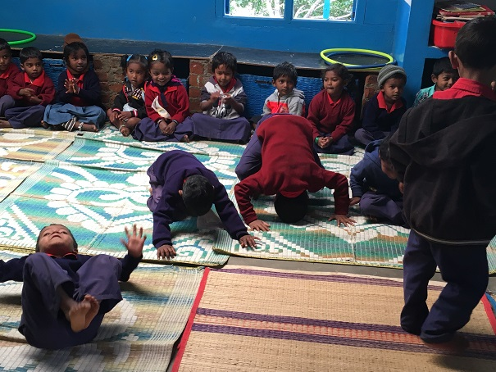

The following are 2 other Creches managed by Betsy Trust, but not funded by ASHA.
Little Lilly Creche
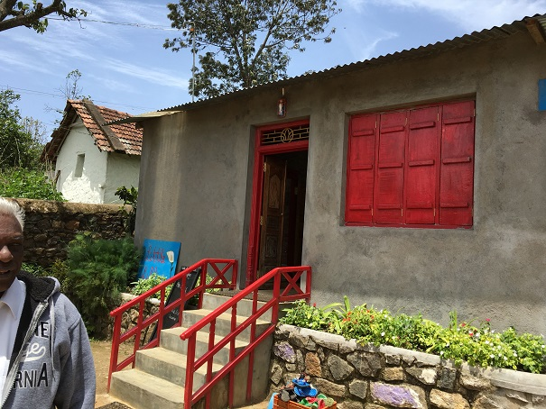
Peach Tree Creche
