Site-visit report

by Sowmya Subramanian(subramanisowmya@yahoo.com)
Chapter: Athens
Project: Sandnya Sanwardan Sanstha (SSS)
(http://www.ashanet.org/projects/project-view.php?p=686)
Type : Institute for mentally challenged. Benefits 82 children
Location: Nagpur, Maharashtra
Date : May 16-17, 2006

SSS is an institute for mentally-challenged and has been an Asha-Athens project since 2005. My visit to the project began with my journey from U.S to Bombay. I arrived in Bombay on 16th May and on the same day I took a flight to Nagpur. (The site-visit expenses were covered by me) I was received at the airport by Mr. Naveen Deshpande, Secretary and one of the founders of SSS, his wife, his daughter, Richa Deshpande who volunteers as a speech therapist at SSS and my friend’s mother, Ms Neeraja Deshmukh. (We got to know of this wonderful project through my friend, Soumitra, a native of Nagpur). Everyone took a special effort to make me feel at home since they knew that I was visiting the project, even before I visited my parents at home in Chennai. We went straight from the airport to the institute in Butibori, 24Kms from Nagpur.
The institute is built on an acre of land and has a two floor building (the second floor is under construction) and six pagoda-like structures. The ground floor houses an office, a living-room for two children, a kitchen and dining hall, a big hall for activities and the physiotherapy unit. The children at school are provided with lunch cooked at school so that all children get to eat the same kind of food while also being trained to eat properly.
Since it was mid-may, the institute which is a day school was closed for holidays, except for a few students in the vocational training unit. Since the mercury was soaring high at about 45˚C, I was told that the vocational units were also ordered to be closed at the end of the week by the local authorities due to water shortage. Soon after providing me with an excellent lunch, Mr. Naveen and his daughter took me on a guided tour around the institute. We began with the physiotherapy unit, which is a small room and held only a few equipments, most of them old with rust.
(***If you are in a hurry, please scroll down to the last page to read the salient points of this site-visit)
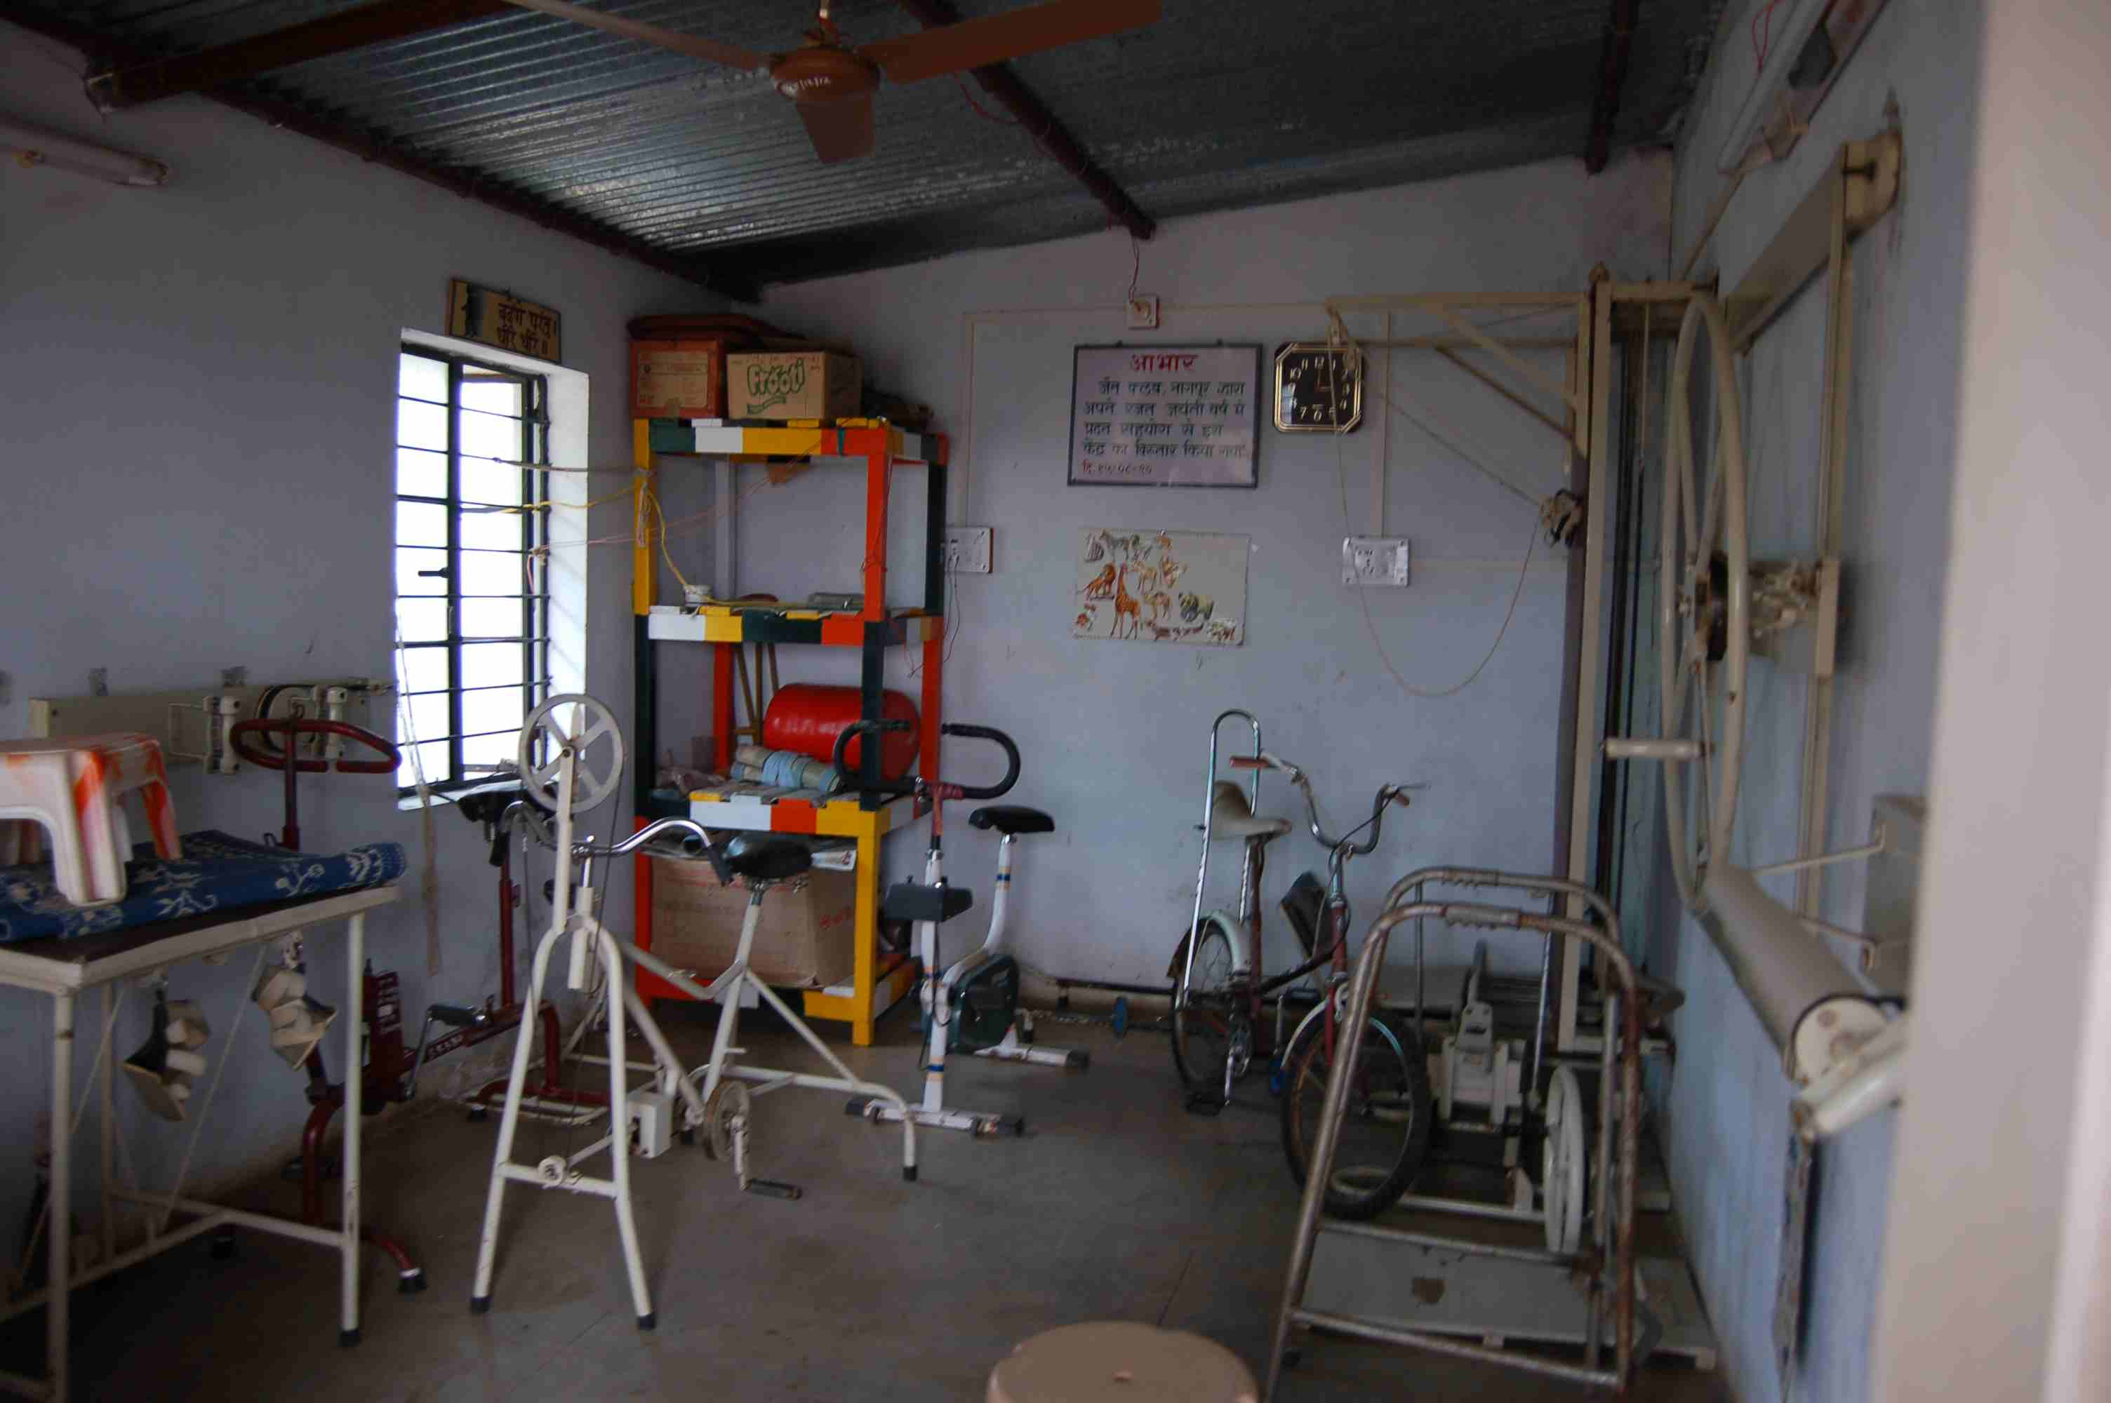

The exercising room had only a few equipments, most of them old with rust!

Personally, I was appalled at the facilities available for these kids, but soon realized that the institute has been doing its best with the donations and funds they receive. (Please, take a look at the 2006-07 budget in the projects page for the donation/funding details). We moved on to take a look at the other class-rooms before getting back to spending time with the four children who were working at the vocational unit. The class-rooms were housed in the individual pagoda-like units.
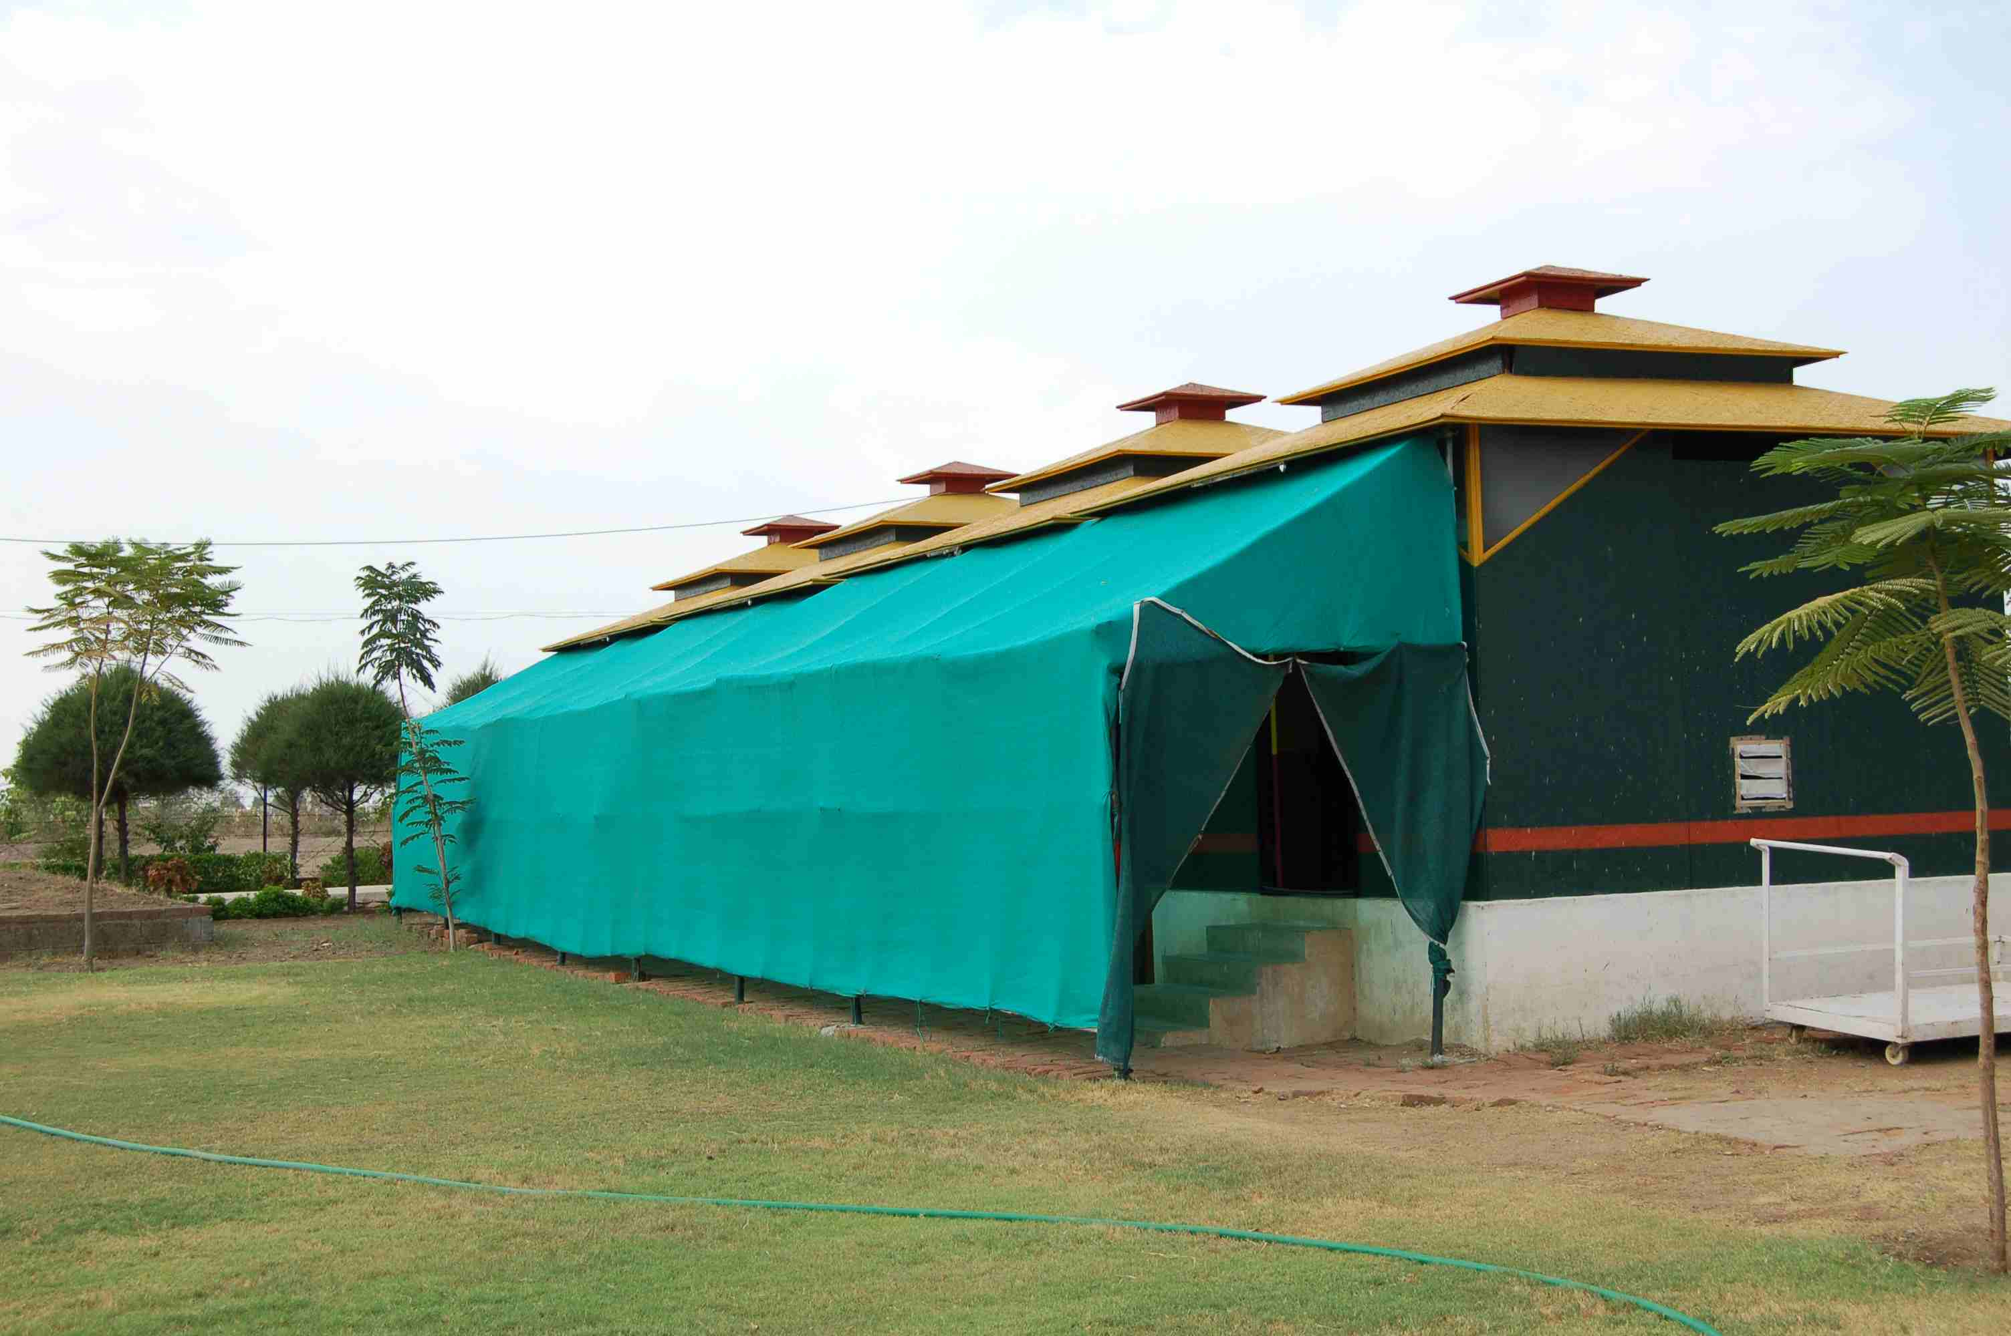
The class-rooms were housed in the individual pagoda-like units
Each class catered to a group of children with a particular level of mental ability: the autistic group, the care group, the pre-primary, the primary group, the secondary group and the vocational group. Beginning from the care group, when a new student enters the institute, teachers work with the children and try to help them move on to the higher classes depending on their mental ability. Where the children are mildly or moderately retarded, efforts were made to get the child to the level of vocational training which serves as the ultimate step towards self-reliance for these children. Every class had a chart with the name and picture of the students in that particular class. The aims/goals (personalized curriculum) for every child were listed in another chart.
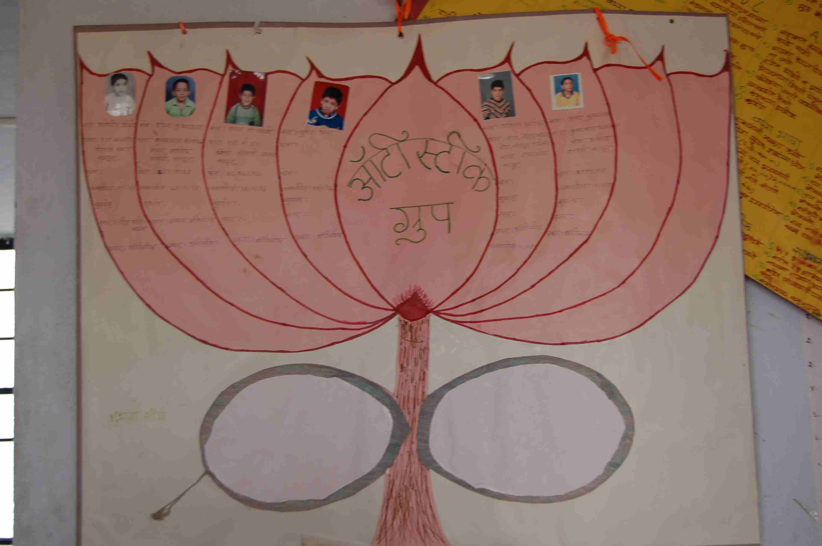

Every class had a chart with the name and picture of the students in that particular class

All around the institute there were posters/notice-boards with writings that were trying to echo a fact to the visitors, that the institute views the children as ‘differently-able’ and NOT mentally challenged. In one of the units, were two ‘charkas’ which were improvised by the institute and being used by the children to strengthen their motor senses. Some children who could reach the vocational level were taught to make works of art. The income generated from the sales of the arts & crafts work made by the children is deposited in to a bank account opened in the name of the children. These accounts are jointly monitored by the institute and a family member. The institute has to its credit, two independently operating vocational units, a Rakhi-making unit and a screen printing unit. Apart from training the children, the institute, I learnt was also conducts counseling sessions for parents, siblings and local dwellers, with whom the children interact everyday. I further came to know that the institute did not provide hostel facilities to discourage lack of interaction/concern between parents and their mentally-challenged children. But recently they have had to take the responsibility of providing food and accommodation to a boy (who was a day scholar at the school) orphaned by his mother’s death. The orphaned boy shares a room with another mentally-challenged kid (son of one of the care-takers at SSS). I tried to meet the boy, but he never came out of his room and learnt that he has become socially (with SSS inmates) withdrawn since his mother’s death.
After peeping into the empty class-rooms, I went to the big hall where the children were making beautiful works of art. I met Parag, Pankaj, Nitu and Manjari who were working slowly and carefully, guided by their teachers (Assistant Teachers).

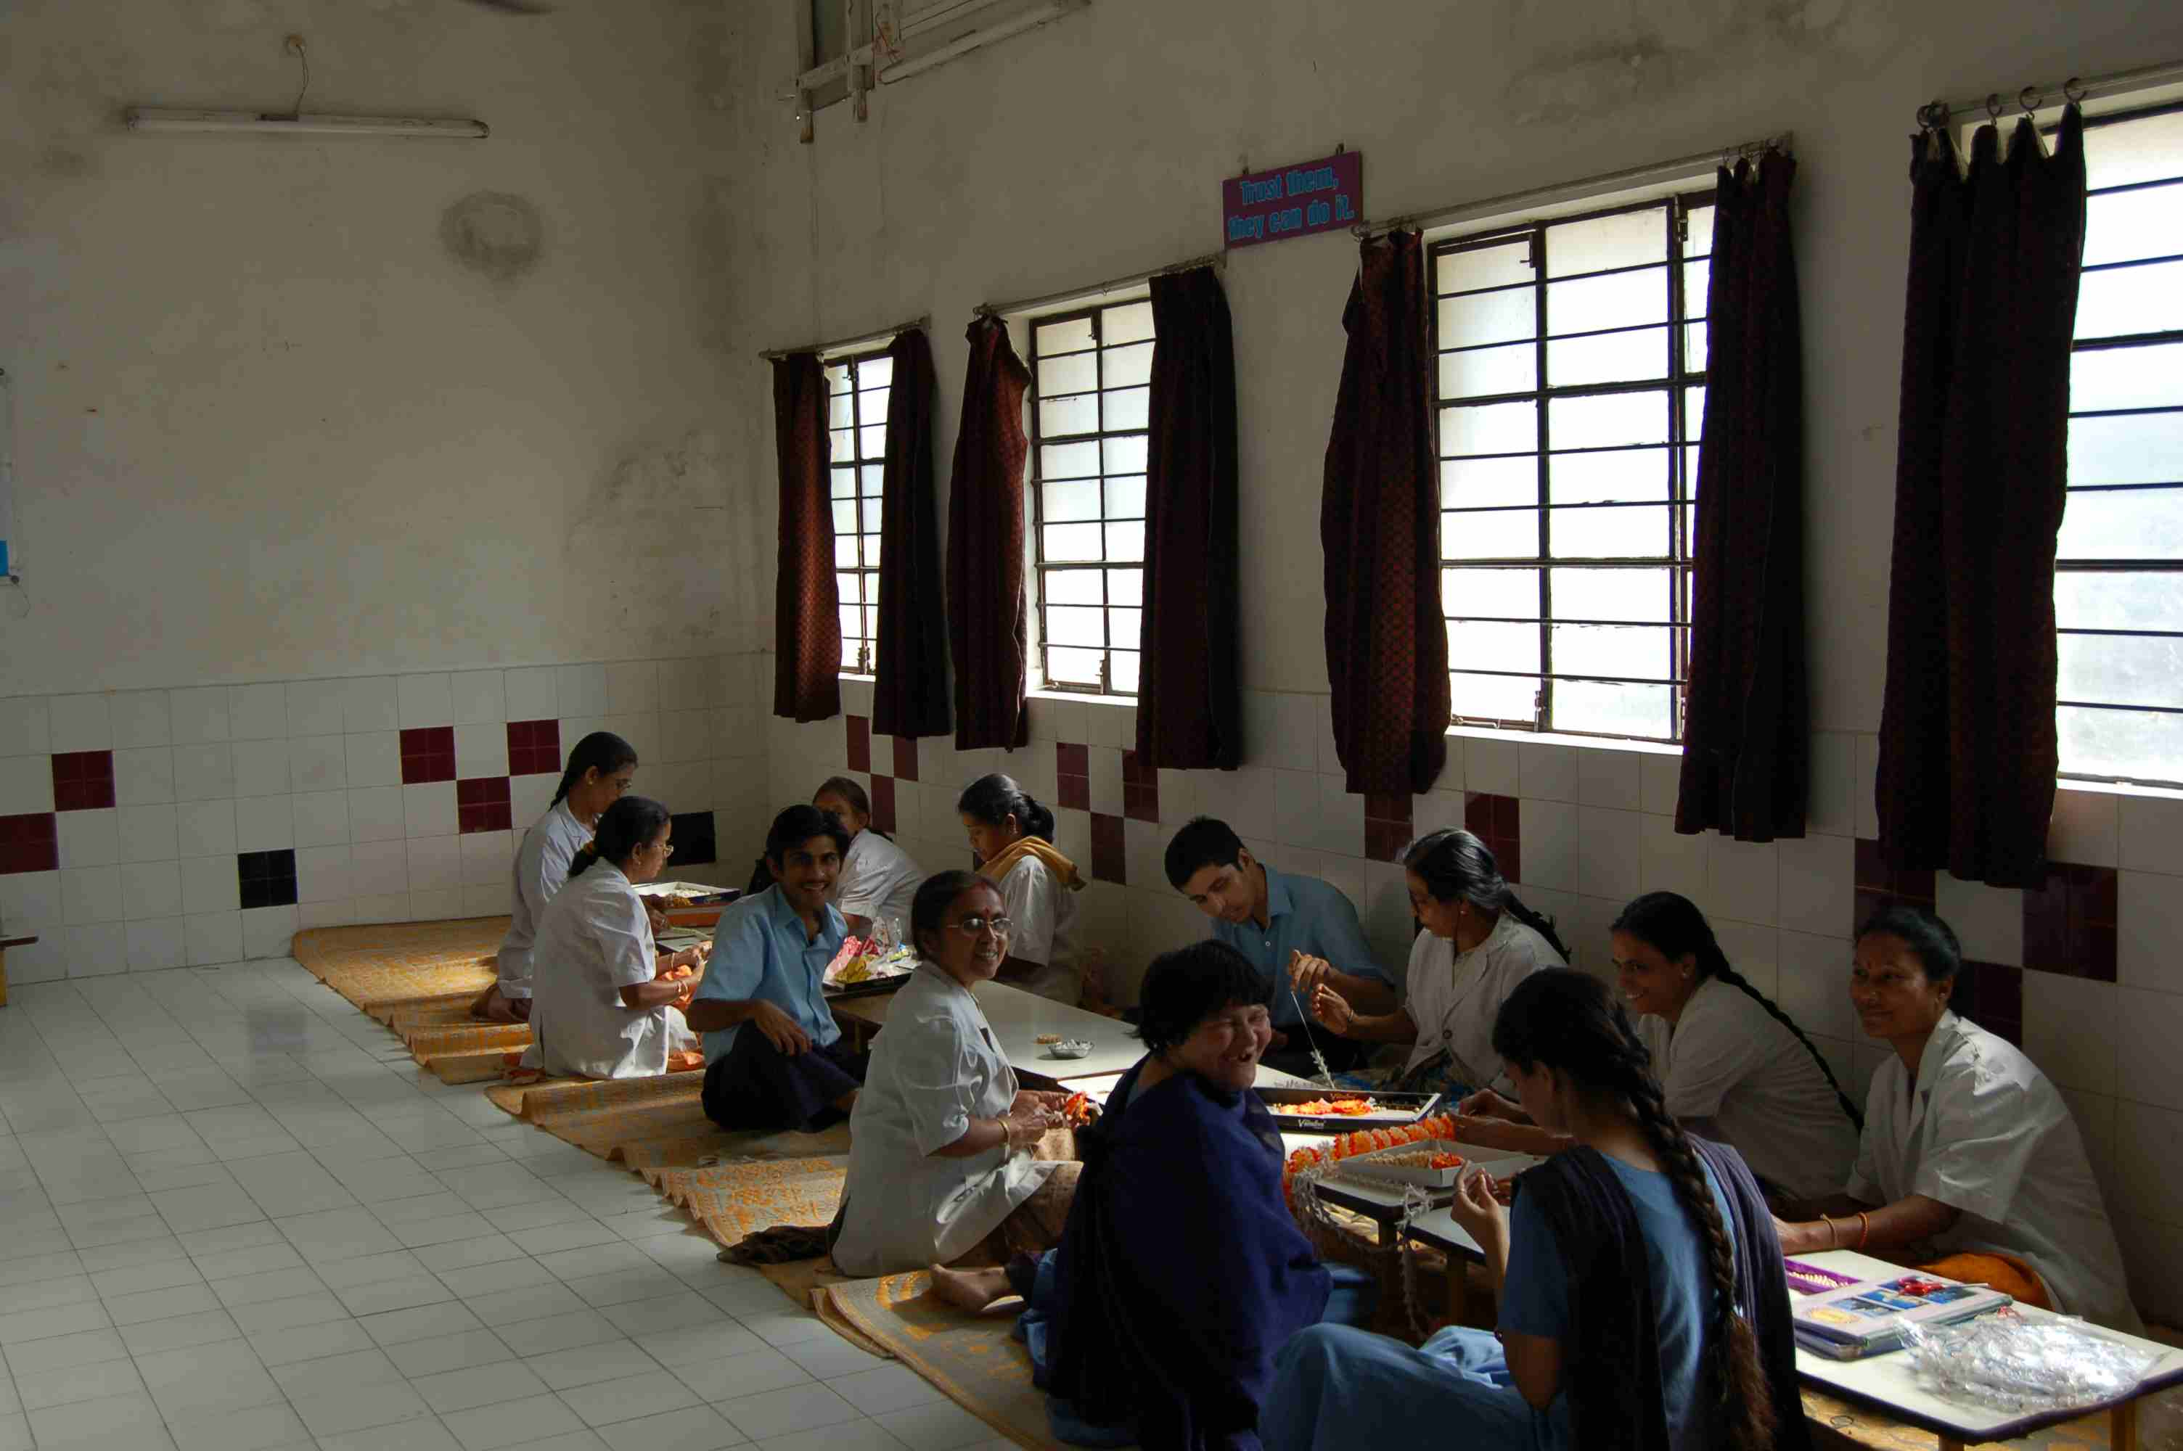
I met Parag, Pankaj, Nitu and Manjari who were working slowly and carefully, guided by their teachers
Though not to pick a favorite, (they all were) but the one who stole my attention was Nitu. She would look in to my face and then cover her face out of shyness. (You can see her smiling at you in the picture above.) When she was asked to teach me, to put the right bead in to the string of an art work she was making, she kept shying away. Finally, Parag (I believe) demonstrated the method of putting the bead on to a string to me. If you were to ask Nitu, who made all these works of art in SSS, she would smile shy and cross her elbows across her chest and say, me ‘of course!’ After great efforts, we got her to pose along with the other three kids for a picture with a backdrop of their art work.
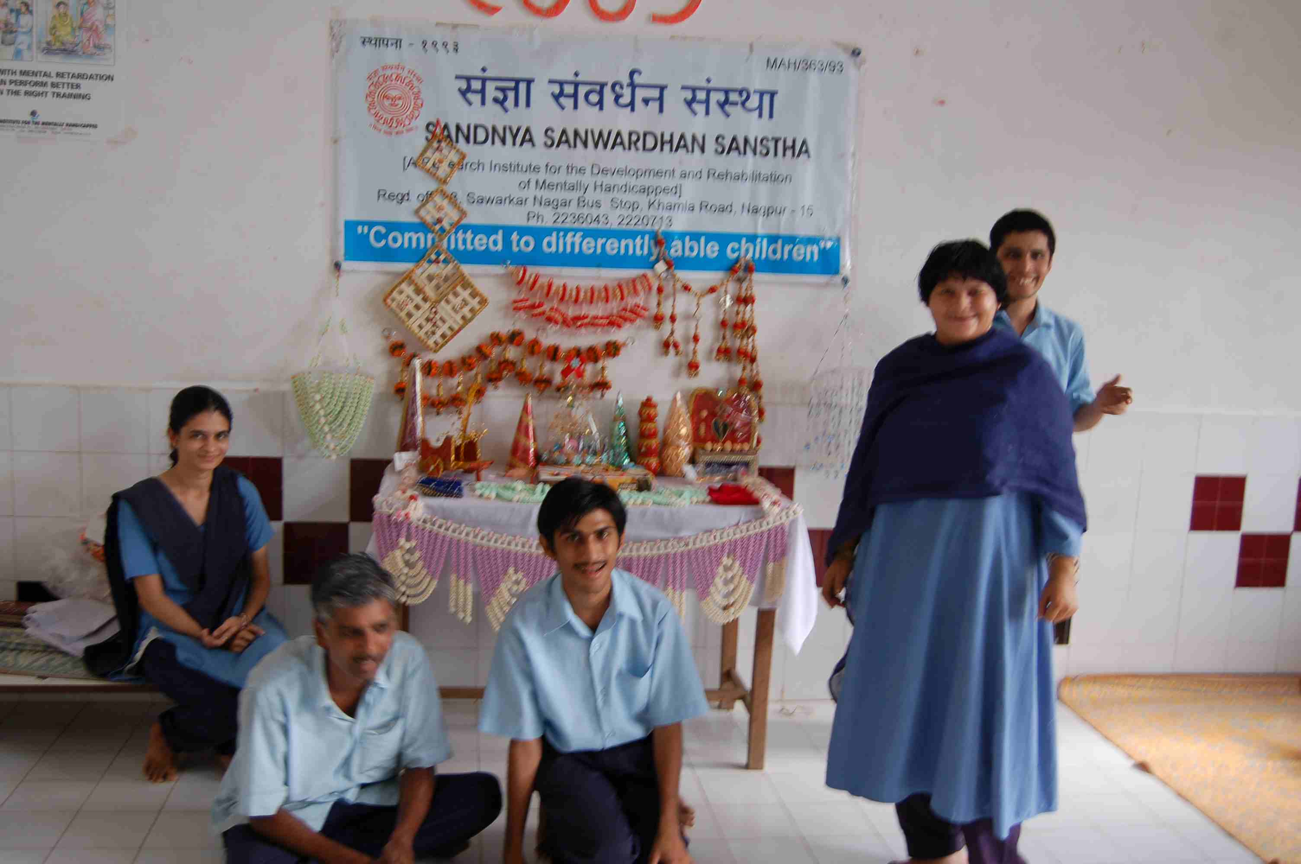

…we got her to pose along with the other three kids for a picture with a backdrop of their art work

One sad thing, I learnt later was that the teachers who work so patiently with these children are under-paid (please refer to the projects page for details) and the same day one of the staff, a Special Educator had submitted his/her resignation. (The elderly looking person you see in the above picture is also a mentally-challenged child!)
I then went on to take a look at the second floor of the building which is under construction. The second floor (4000 sq. ft.) was completed to the RCC slab level at a cost of Rs. 7.5 lakhs by a patron of SSS, who is a building contractor. The completion of the second floor will take care of the shortage of space that the institute faces, in the wake of the necessity to have quarters for care-takers and the orphaned student, shifting some of the classes being conducted in the huts to the comfort of good class rooms and having at least 4 screen printing units set in a big hall for the benefit of vocational training.

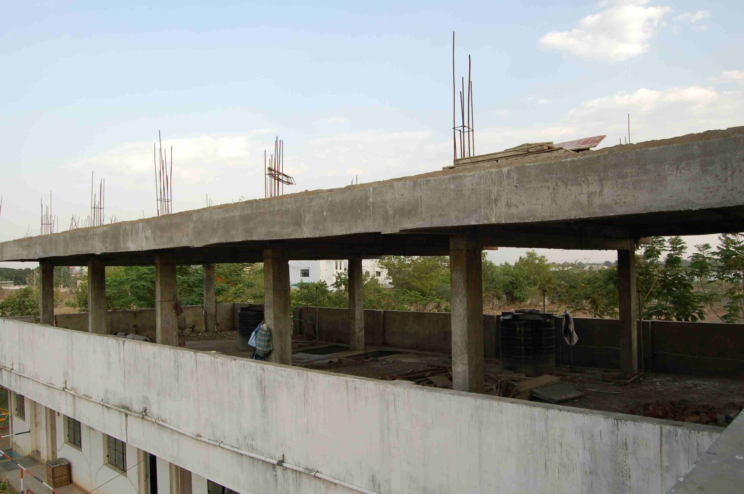

The second floor (4000 sq. ft.) was completed to the RCC slab level…

By this time it was evening and I heard more stories about the problems that the institute faces when dealing with such children and how every time they have solved them in the best possible way.
The next day morning, I was taken along to visit an independent screen printing unit which was being run by four autistic/moderately retarded children in Nagpur. (When I say children, I mean younger as well as old adults.) The four boys are being supervised by a care-taker whom the institute pays for and the profit made from the business is divided among the four children and deposited in to their bank account. The four boys were very happy to see us visit them and served me with water when I asked them for some. One of the guys seemed very responsible. He came back and showed me a file containing their completed orders at least three times. He also took control of the situation when of the boys started to shout by warning him softly that if the boy continued to shout, he was gonna call up his mother and report to her! It was nice to observe how the four boys took care of each other. While I was taking pictures, one of the guys came in and exclaimed to my surprise that I was using a digital camera to take pictures. He later came to me and asked (in Marathi) whether I thought Astrology should be considered as an art or a science. I was stunned!
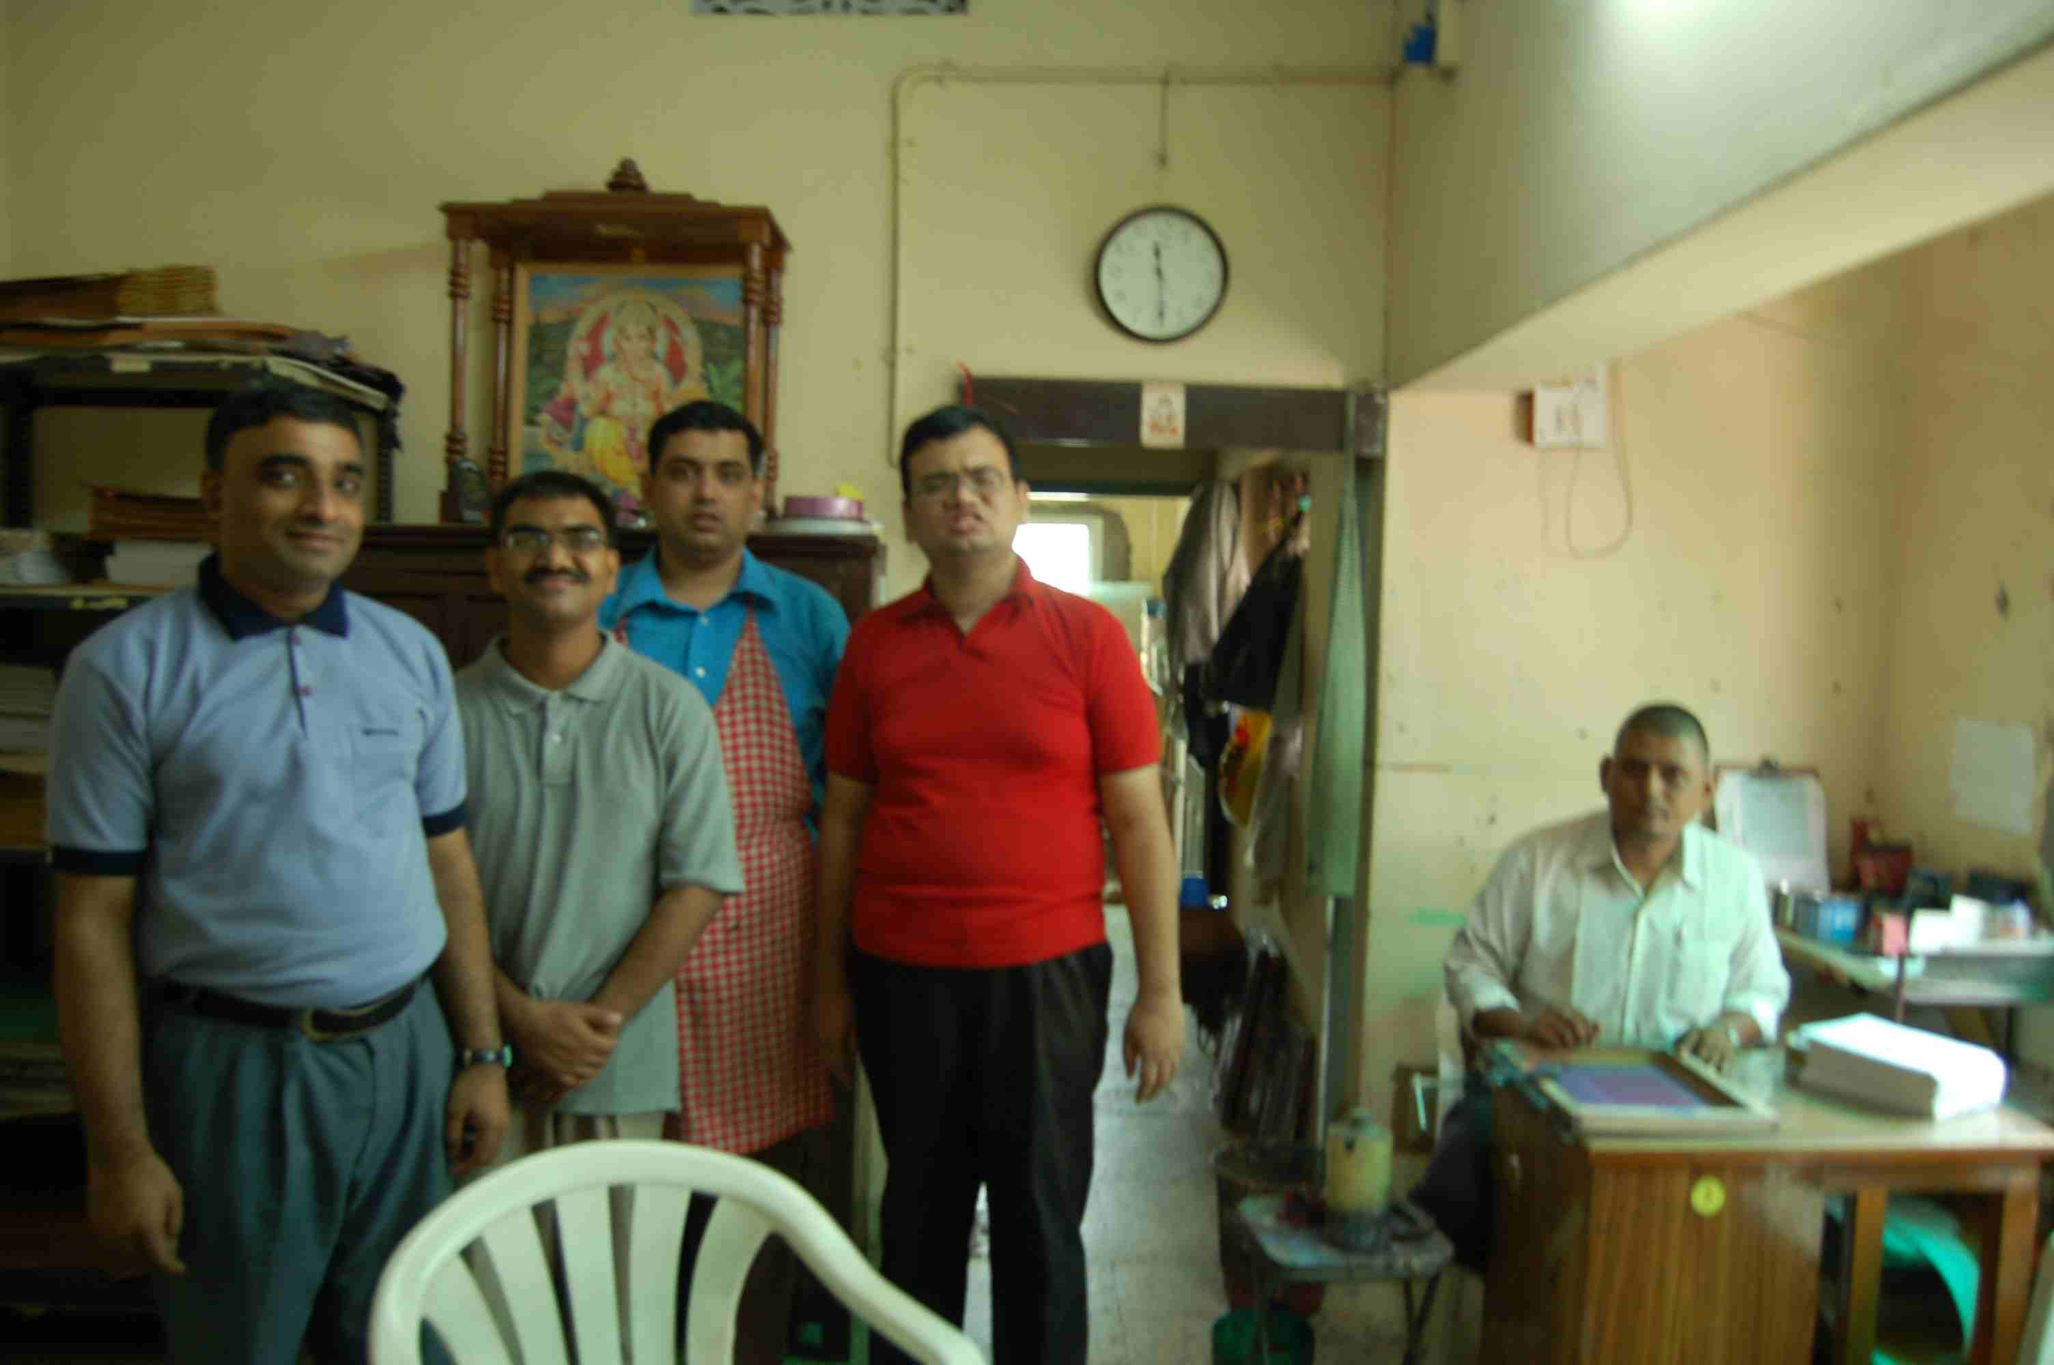
…an independent screen printing unit which was being run by four autistic/moderately retarded children in Nagpur

Stacked with all the surprises of my visit meeting these children and hearing their stories, I finally concluded my trip by visiting the registered office of SSS, from where the staff arranged sales of the various things made by the children.

***If you didn’t have time to read the whole story, here are a few points about the level of dedication of the people behind SSS and their success stories.

- The Secretary, Mr. Naveen, who conducted me through the institute, was very much eager to tell me all about the institute and the children. Except for the time allowance I got to eat and sleep, the rest of the time was spent on conversations about SSS! To me, it reflected his dedication to the cause. Also the fact that his entire family was taking part in the effort and many others whom I did not get to meet made me realize that this is a community effort.
- Initially when I made plans to visit SSS, I planned to take chocolates for them. I was curtly told that if I took any food item to be given to the children, the staff will distribute them and not me. This is to ensure that these children do not associate visitors to the institute with receiving gifts. This highlighted their thoughtfulness behind anything they did.
- A story was narrated to me about the several trips that Mr.Naveen and his colleague undertook to bring back one of the kids who had the habit of just straying away. This highlighted their perseverance towards the cause.
- There was a beautifully maintained garden at the institute. Some of the children have been allotted a plant each, to be taken care of. Everyday, the children go out to their plants, check on them and water them. This highlights their innovative methods of teaching to care!
- A classic story of ragging of a child at the institute by the ‘mentally-able’ students of a nearby college on his way to the school was countered by inviting the students to an educational tour of the institute. The ‘tour’ changed the outlook of the students towards these children and many of them came back to the institute to volunteer! This highlights their diplomacy in dealing with tricky situations and improvising the right method to tackle problems.
- The institute has survived on donations from the Public since 1993, rehabilitated 16 children, raised awareness amongst the community and been successful in soliciting funds in kind, like food grains for noon-meals, construction of 4000 sq. ft., of the second-floor building to RCC slab level, amounting to Rs. 7.5 lakhs, and these speak volumes of their efforts to raise awareness among the community and efficient fund-raising ability.

If you have questions/comments on the site-visit report, do email me at the address above.

