Site visit: April 19, 2017
Manidipa Mukherjee

I went to India for a week and visited Shamayita Math for a day. Since I reached in the afternoon, schools were out, 6 teachers came to see me. They were very happy to have their drinking water for whole year at schools. Last year, two of the Shamayita Marangburu Schools got their drinking water storage facility. Water is pumped from deep well into tank. The tanks have filter, so the water is clean. The third school in Hanspahari already has the drinking water facility. Other than that, the schools also harvest rain water. Lots of different vegetable plants are planted during rainy season. Students recycle any water they can to water the small plants.
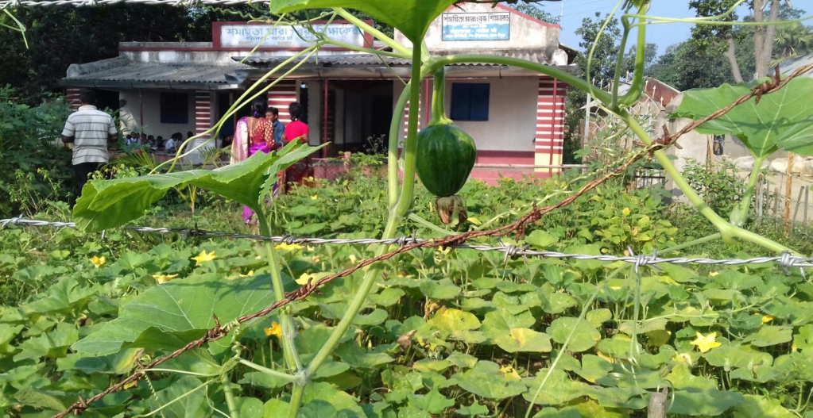
Kitchen Garden in Siulibona
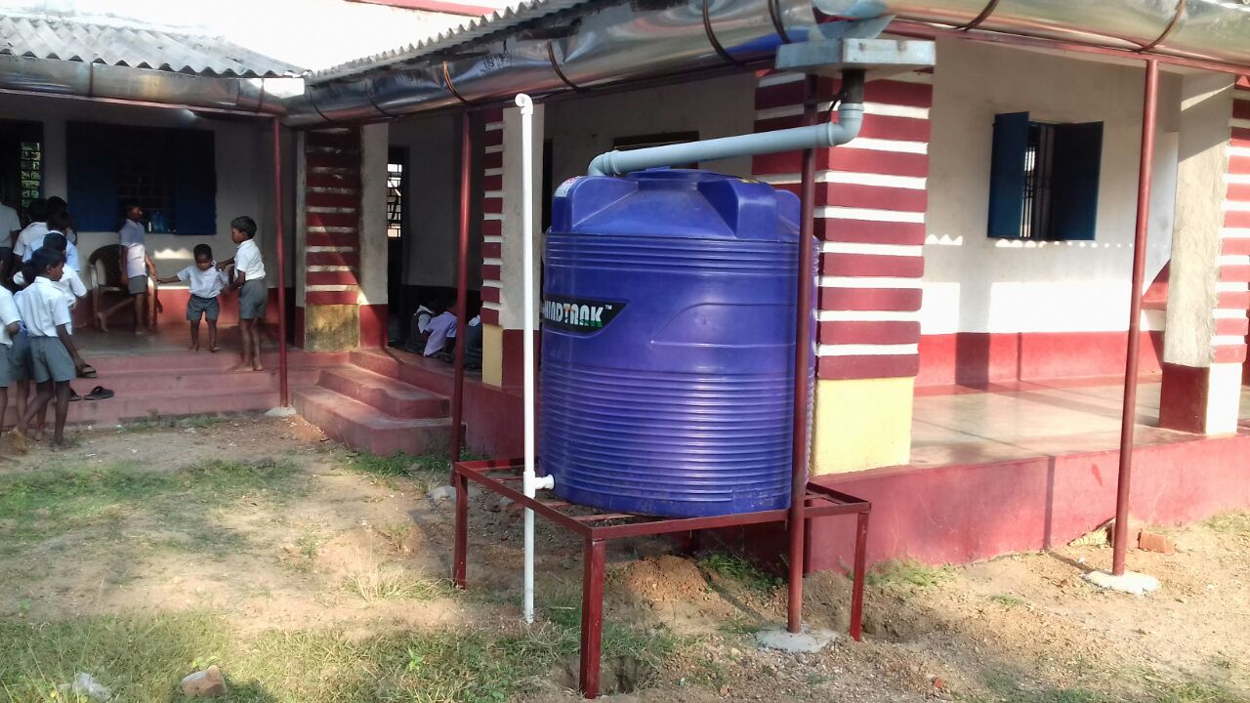
Rain water harvesting in Hanspahari
The teachers were also looking forward to get practical based training in Bengali and Mathematics from Shikshamitra organization (www.shikshamitra-education.org). I told them that I will come next year with more time and go to each schools.

