Site Visit: Shamayita School by Manidipa Mukherjee
July 22nd, 2011

I went to visit Shamayita School (established in 1996) from July 22nd through July 25th of 2011. The school is doing well in academic standards and in its signature performance of no drop out. The students are vibrant even in summer 38-40⁰C average temperature. There are students from kindergarten through 10th grade and also there are higher secondary students of grades 11 and 12. Last year, with the help of Asha for Education, science laboratory has been furnished. There are total 650 students in school today. Asha supports thirteen students to get their education in the school and live in the adjacent school hostel during the school year.
I met the girls supported by Asha and was amazed by their aspirations towards life to become a successful citizen of the world. They are humbled by the opportunity to get their education at Shamayita School than in the school in their village where the teacher is absent half of the year.
From the inception of the school, there are 8 sannyasinis who have been teaching there. Currently, there are about twenty other teachers in the school to handle the classes. The teacher retention is a problem because of various reasons. It takes about two to three years for a new teacher to learn to teach. In the meantime, if the teacher gets married, usually she leaves school. Some cannot handle the art of teaching and are frustrated. Some finds better salary and leaves. I prepared some “Teacher Motivation” training sessions for all the teachers. I encouraged the teachers to use various strategies for teaching mixed ability students in each class. It is very difficult to recruit teachers in this rural school. The school authorities have asked Asha for help to improve teacher salary. About 90% of the students pay tuition, but that does not cover everything.
School also needs some computers. Some old ones are not working and there is an increasing demand of use of computers by 11 and 12 grade students.
Shamayita School is in its youth now (15 years). With all the adverse situations it is thriving as an example in the area. Here is a photograph from the annual program of
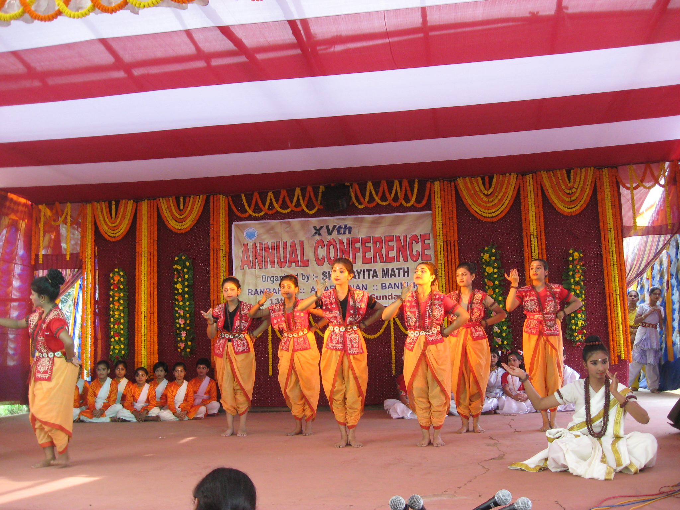

Shamayita School.

