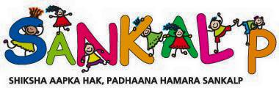
Proposal (2017-18)
Financial Proposal 2017-18
Sankalp is seeking financial assistance of Rs 7,36,960 to meet the following expenditure for the financial year April 2018- March 2019.
- Salaries of teachers - Rs 6,36,960.
To part finance the annual salary pay out for the eight class teachers in Grades 1 to 4.
Monthly Salary scale | Number of teachers on rolls (as on January 1, 2018) | Total annual pay out in INR
Rs 6930 | 6 | 498960
Rs 5750 | 2 | 138000
The actual pay outs may vary depending on the leave availed by teachers / or if there is a change in the number of teachers on rolls. The annual salary increase that is given normally in September every year has not been factored in.
- Student Welfare Activities – Rs 1,00,000.
To part finance the expenditure for 400 students at Rs 250/- per head . The expenditure will be on items like uniforms, sweaters, shoes that will be given to the children based on need and weather conditions during the year.

