Brief Report
Asha Fellow: Vallabhacharya Pandey (July 2018- June 2019)
Since 1994, I am associated with Asha Trust’s activities, dealing with all administrative responsibilities. With this I am working for different awareness programs about people’s rights like RTI, RTE, FSA, MNREGA, Venders Act, Land Acquisition Act, Forest right Act etc. I am also associated with other organizations and groups for working on Environmental issues, Campaign for Common School System and celebration of Gandhi Ji’s 150th Birth ceremony.
Update
- Awareness: Working on awareness about rights and rulings related to RTI Act 2005, RTE Act 2009, MNREGA-2005, Food Security Act 2013, UP Jan Hit Guarantee Act-2011, Venders Act-2014, Forest Right Act 2007 by the way of organizing regular camps, workshop, public meeting, signature campaigns, poster display and pamphlet distribution.
- Gandhi and Baa 150th Birth Ceremony: I am coordinating this program from October 2017, The objective is to bring Gandhi ji’s thought before children sothat they can understand Gandhi JI in a better way. Activities like Gandhi Sandesh Yatra, Gandhi Poster Display, AAO BAPOO KO JAANE Quiz, Painting, puppet show ‘Mohan se Mahatma’ were done more that hundred schools till June 2019. About 30000 children (Class 6th-8th) participated in Gandhi Quiz.
- Right based Movement: I am actively involved with movements of Land acquisition in different places at Varanasi and Ghazipur districts and trying to help farmers to get fare and reasonable compensations according to new Land Acquisition Act 2013.
- Environmental awareness: I regularly participating and organizing several program on conservation of water and energy, air pollution, water pollution and soil pollution. I coordinated environmental rallies; poster display and plantation drive with school children. Campaign of taking “Environmental Oath”during the Morning Prayer at schools is one the very effective activity to make children cautious about environmental issues.(This is 8 points oath often used by former president of India Bharat Ratna Dr. A.P.J. Ablud Kalam Sahab).
- Plantation Drive: Under campaign of Bhu Sewa- Jal Sewa Abhiyan I am encouraging people to establish Panchvati in villages it include tree of Peepal, Paakad, Bargad, Aam and Neem.
- Activity with Government Primary Schools: Activities with students of government primary schools nearby my village are continued; it includes drawing, painting, chart making, poster making, greeting card making, plantation, cleaning drive, Swachchha Bharat.
- Loksabha Election 2019: I coordinated a campaign for fare and maximum poll during General Elections 2019 in about 15 villages of Varanasi and Ghazipur. A cultural team Prerana Kala Manch also supported us in this effort by presenting their Songs and Street play “Girog Band’.
- One Nation Equal Education Campaign: I am coordinating this activity with Mr. Deen Dayal, Suresh and other volunteers. It is to insure equal and quality education for all and for overall improvement of government primary school. In this campaign we are trying to reach many villagers, political representatives, school teachers, leaders. We are approaching them with request to come forward for this goal. We are continuously organizing bike rally, poster exhibition, signature campaign, awareness campaign in small towns and villages; by this activity we are requesting common people to intervene in government schools to improve quality of education and resources there. With result of these activities much amount released from MP and MLA’s fund for the upliftment of recourses in Government primary schools in Varanasi area.
- Panchayti Raj Election 2020: I have started working to make ware people about coming Panchayat Election in Uttar Pradesh. Preparing a detailed leaflet on power of elected representatives within Panchayti Raj Act.
- Participation with other Groups: I actively participated social and cultural activities, events organized by other groups mainly Sajha Sanskriti Manch of Varanasi, it includes programs on Save Ganga, Stop Violence against women, to stop threatening of street venders, to improve harmony in society etc.

Some Photographs / Paper clippings :

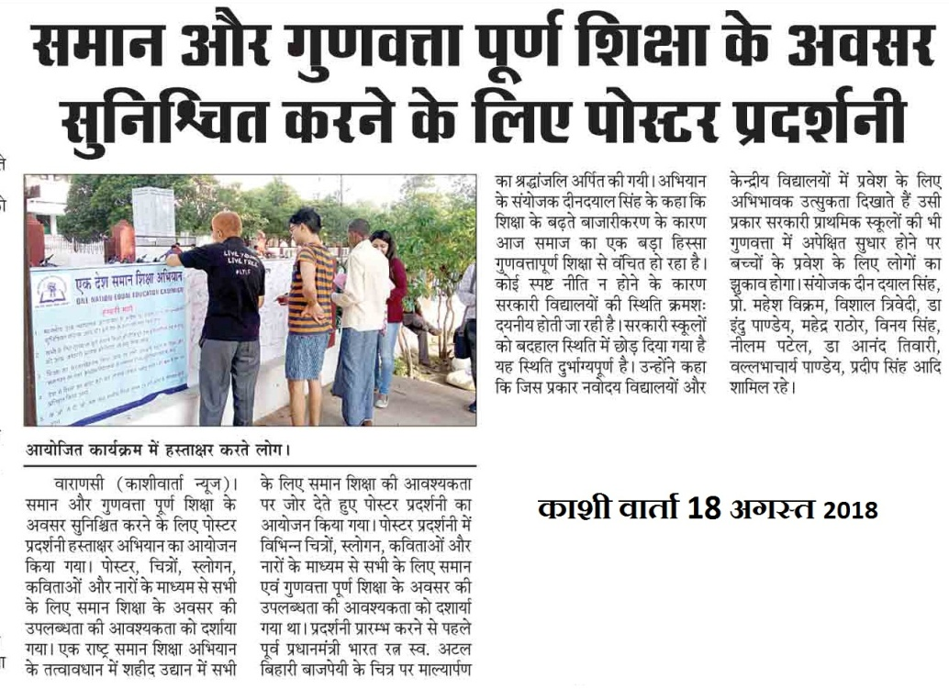
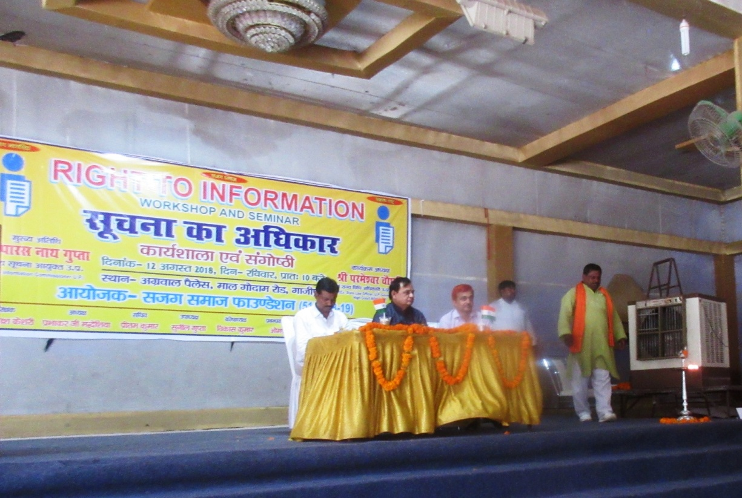

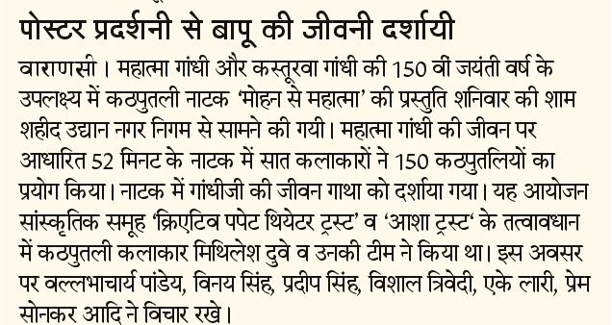
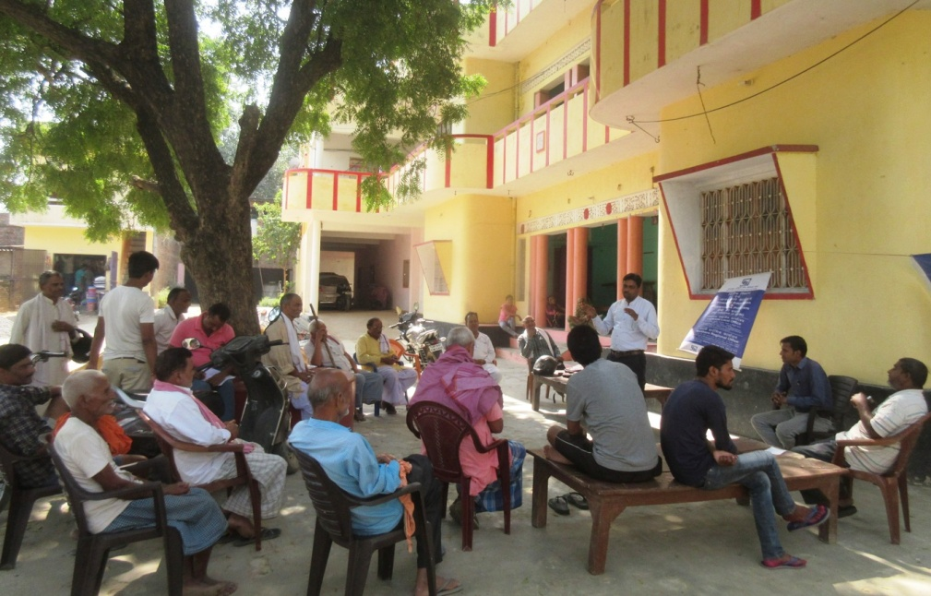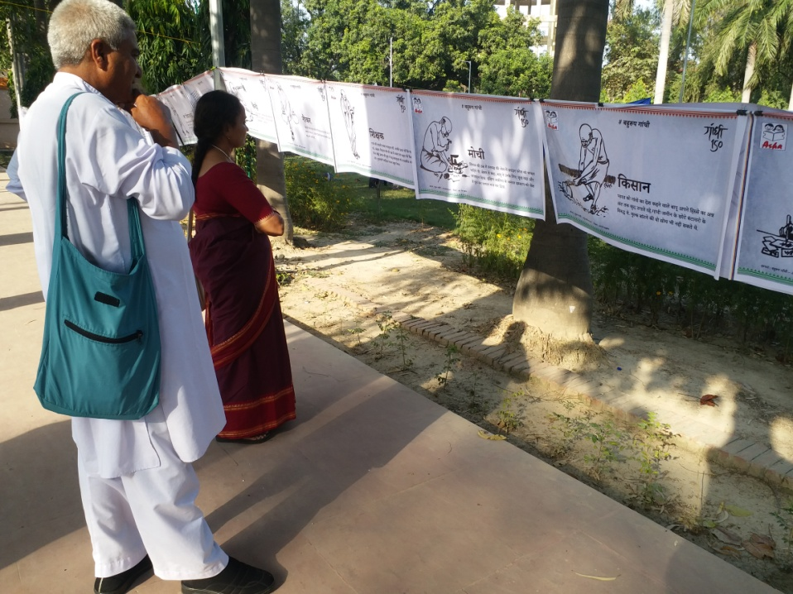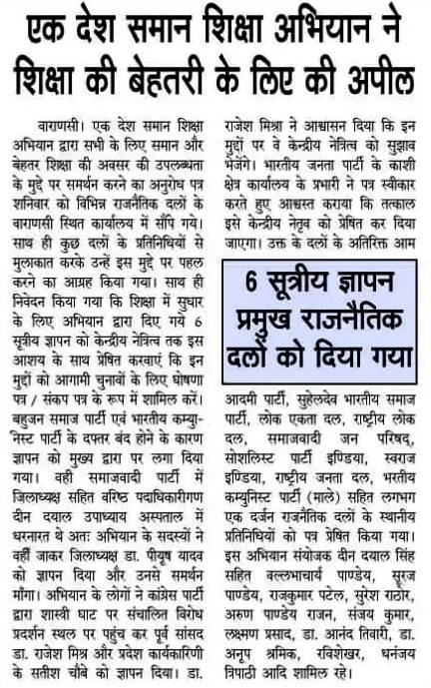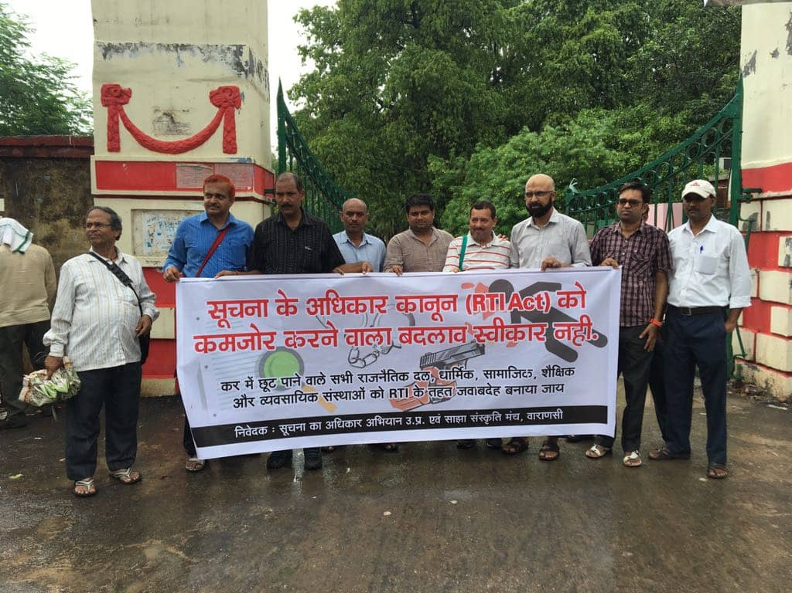

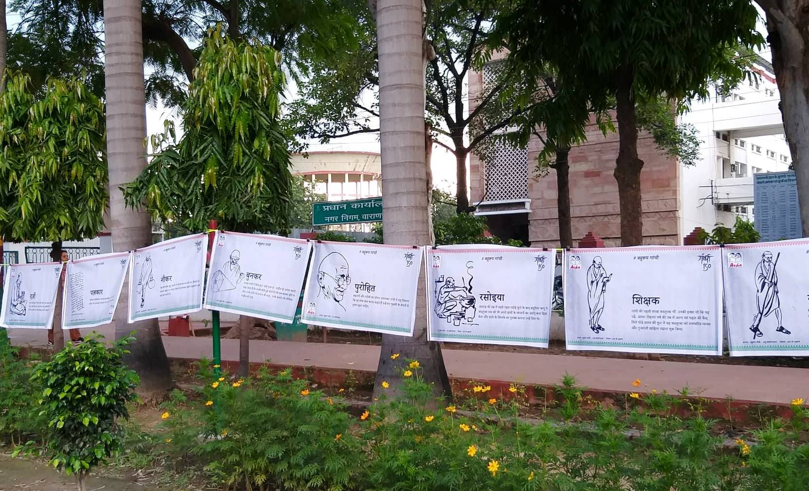
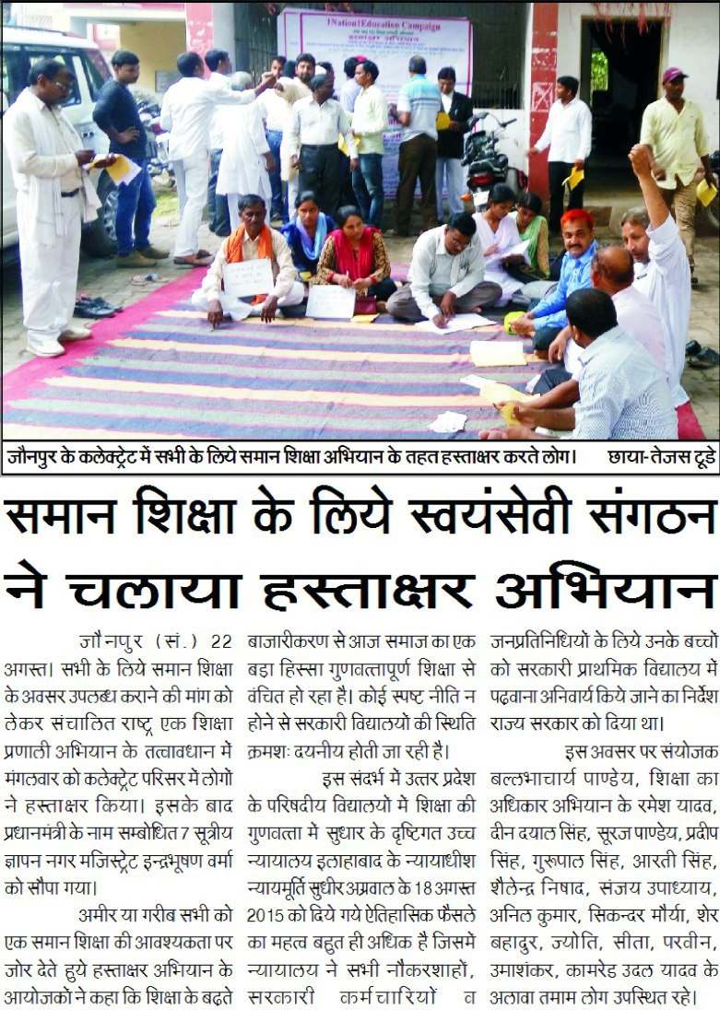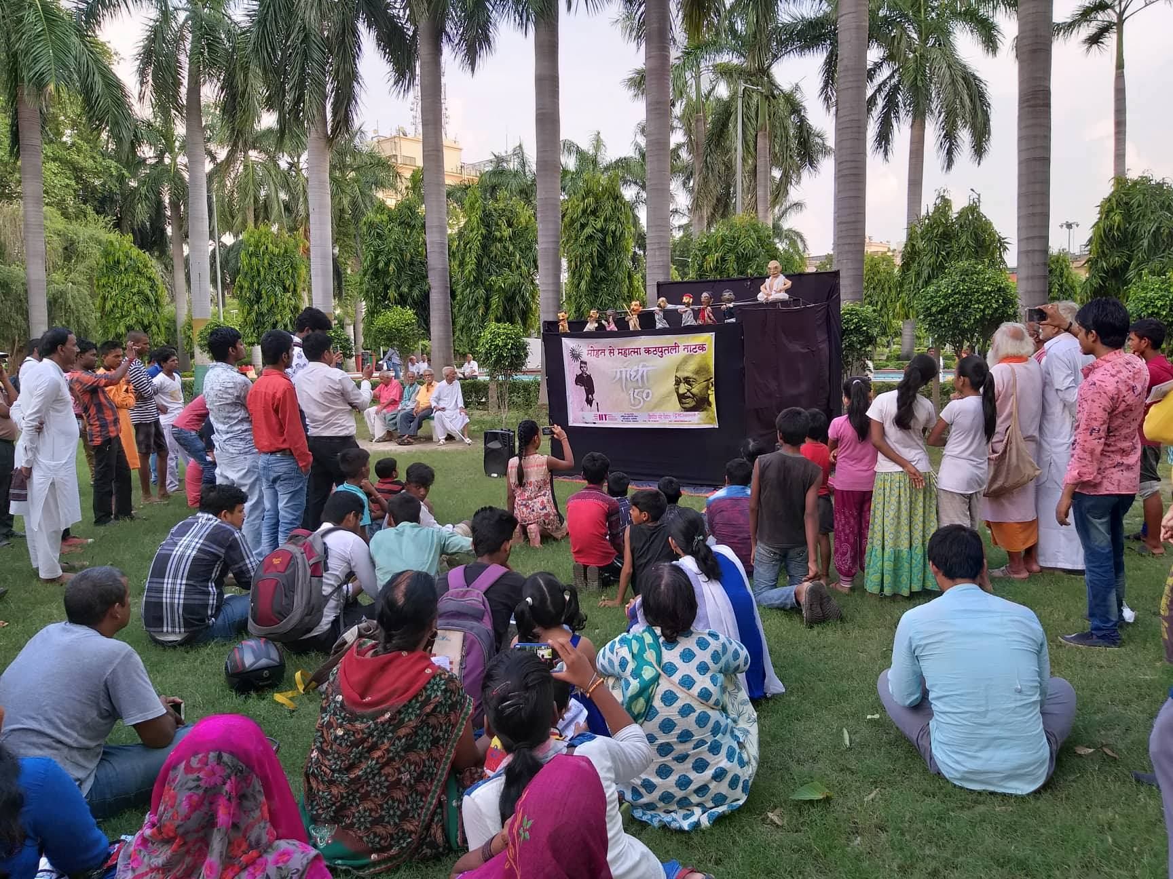

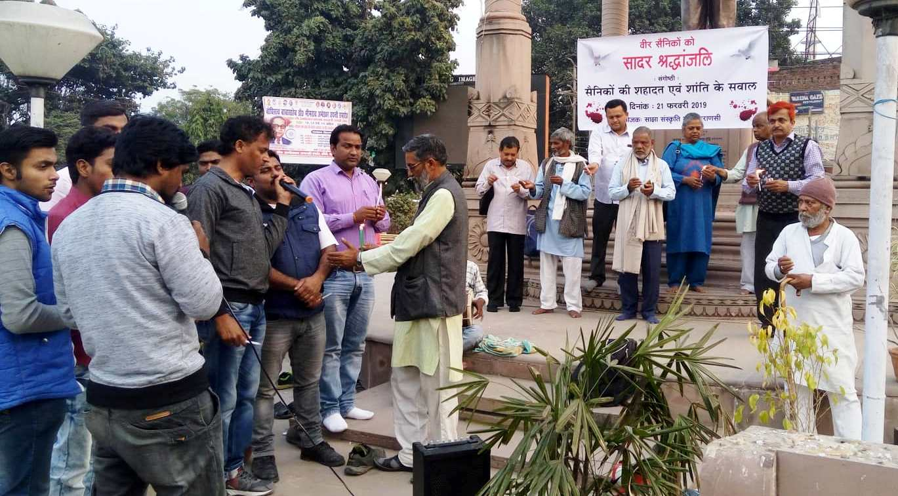

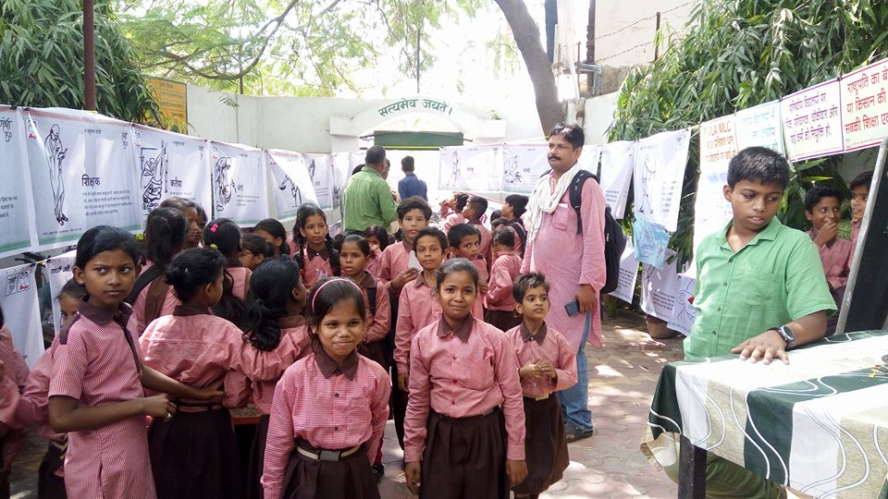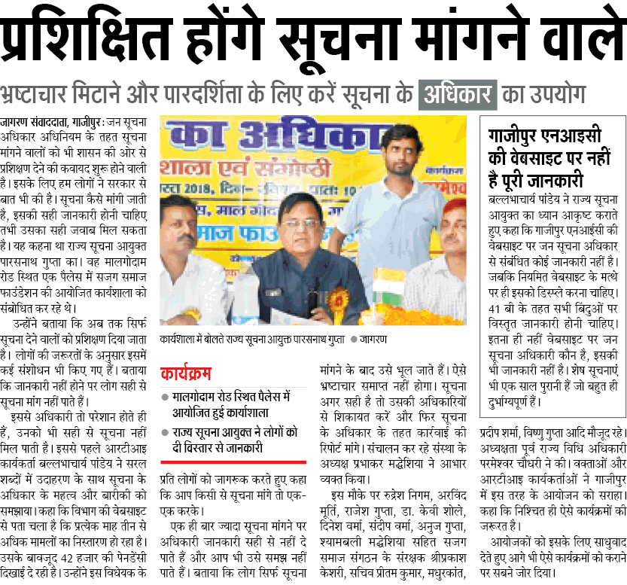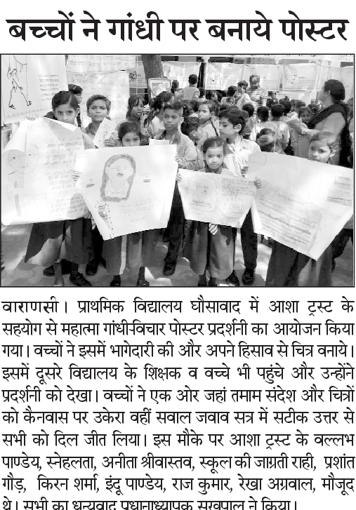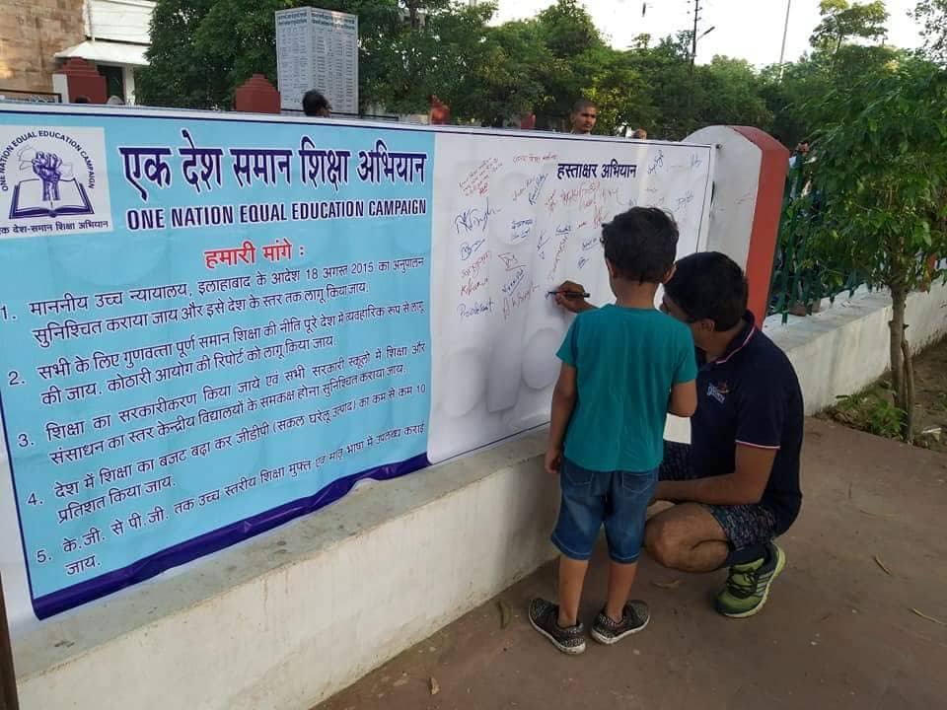

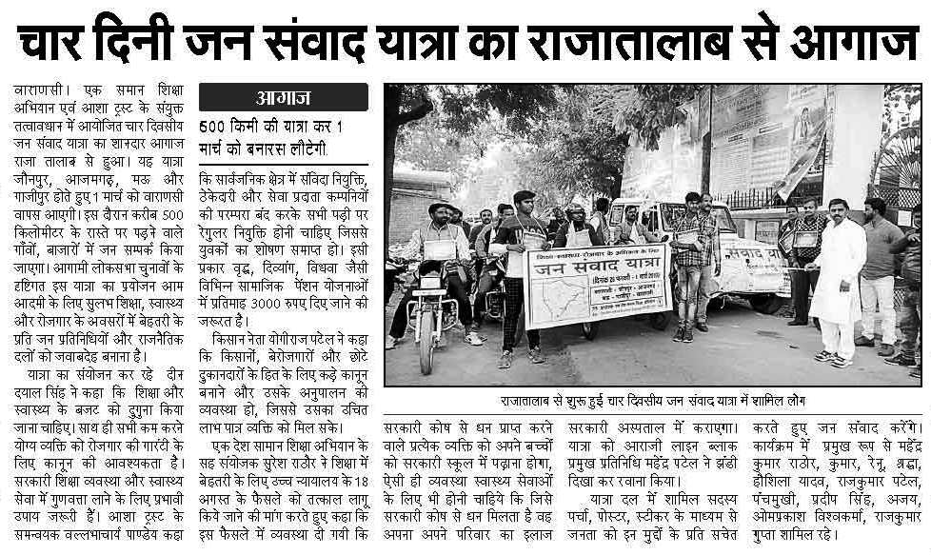
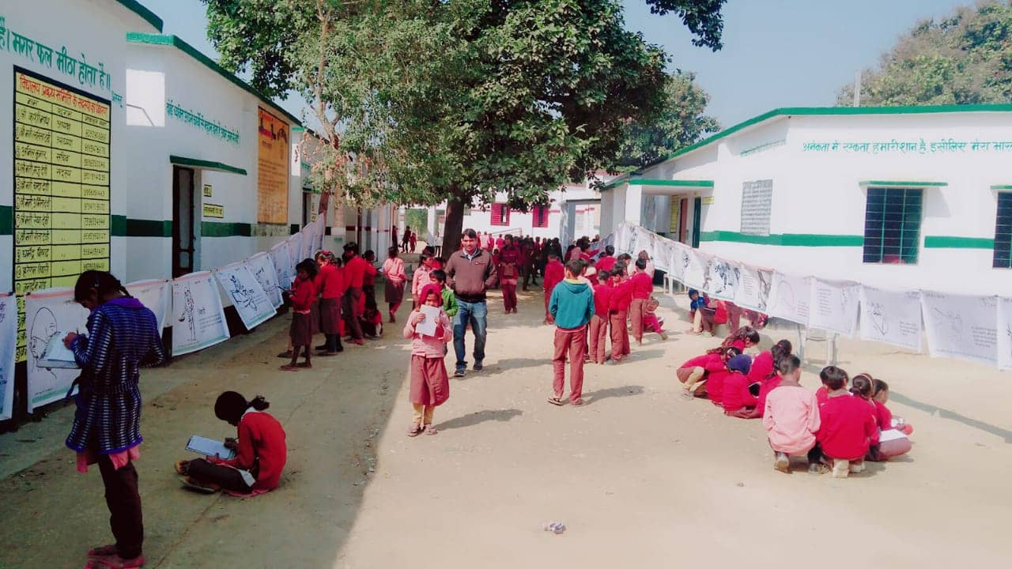

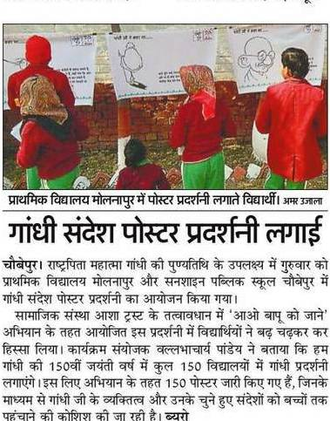

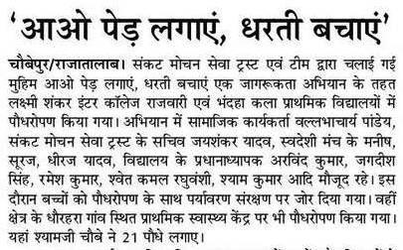
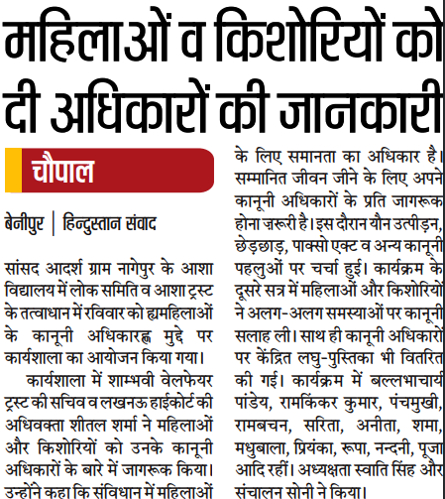
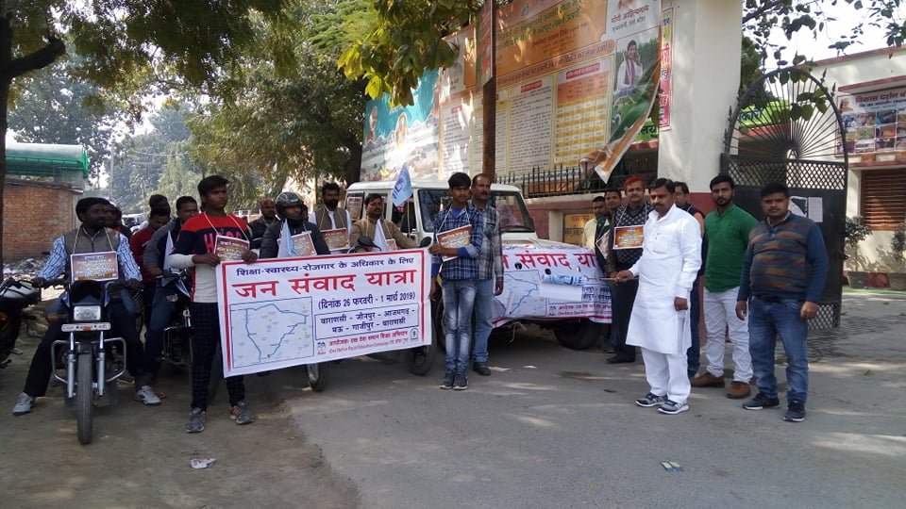

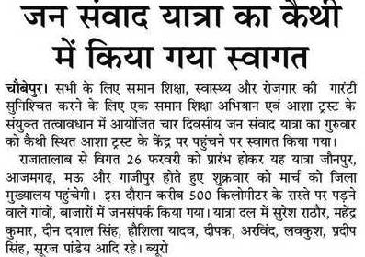
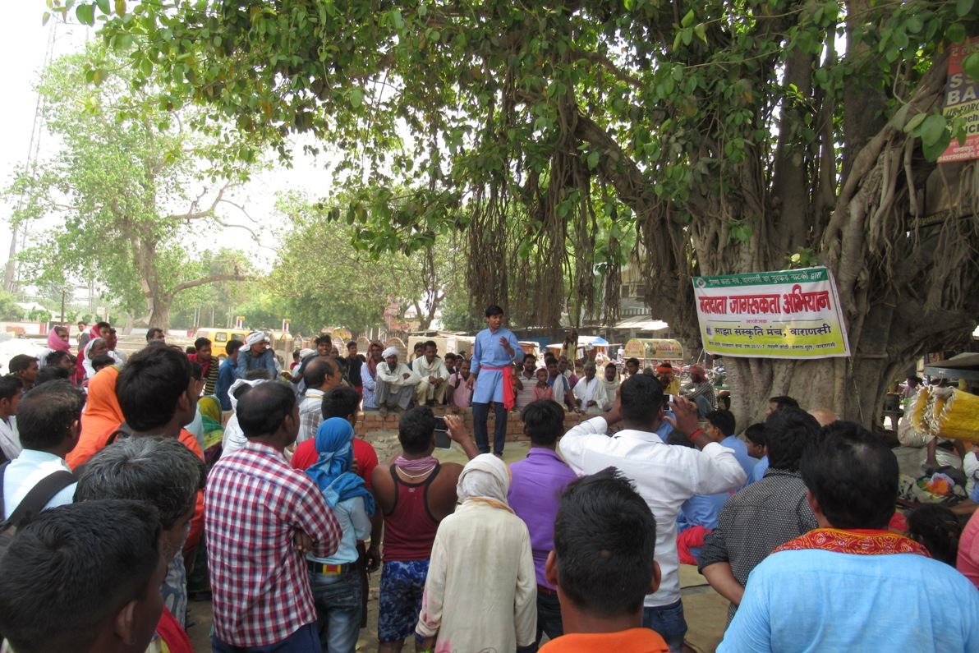

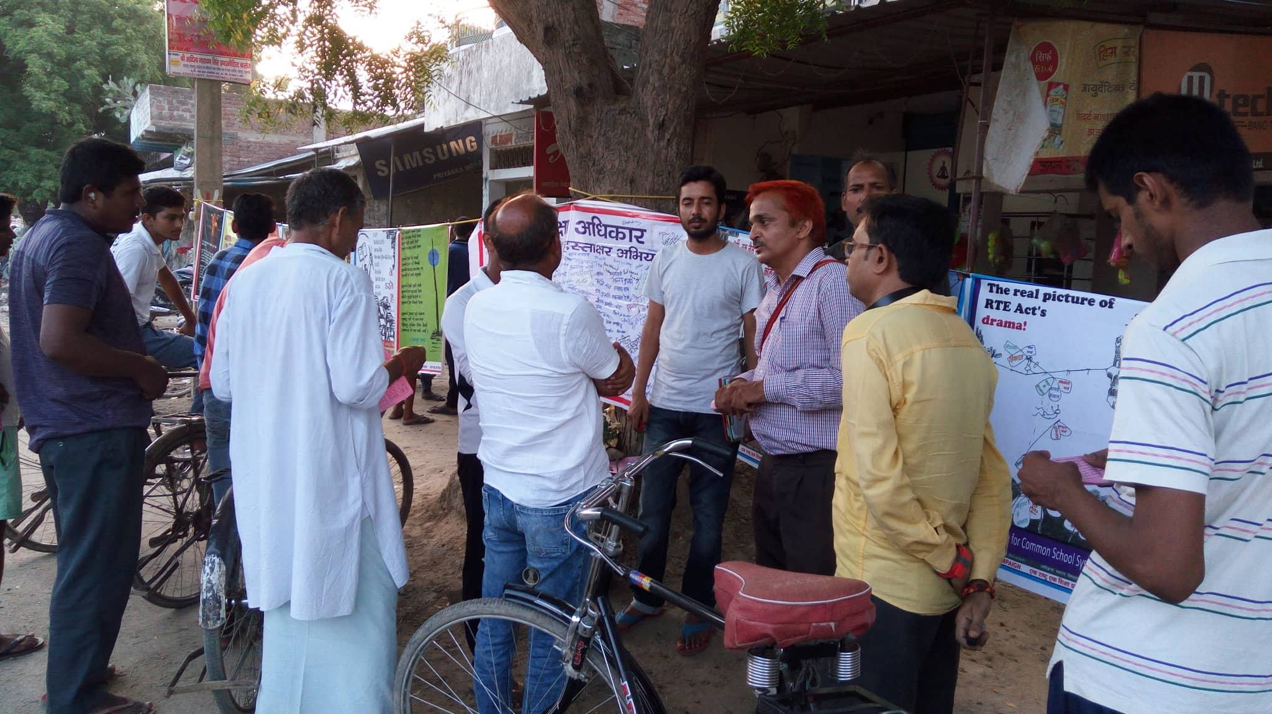
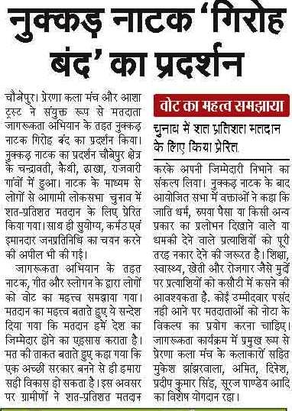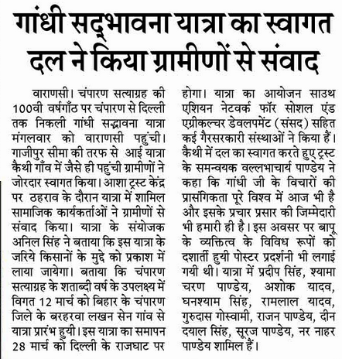

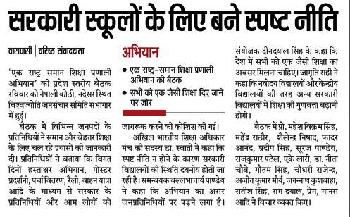
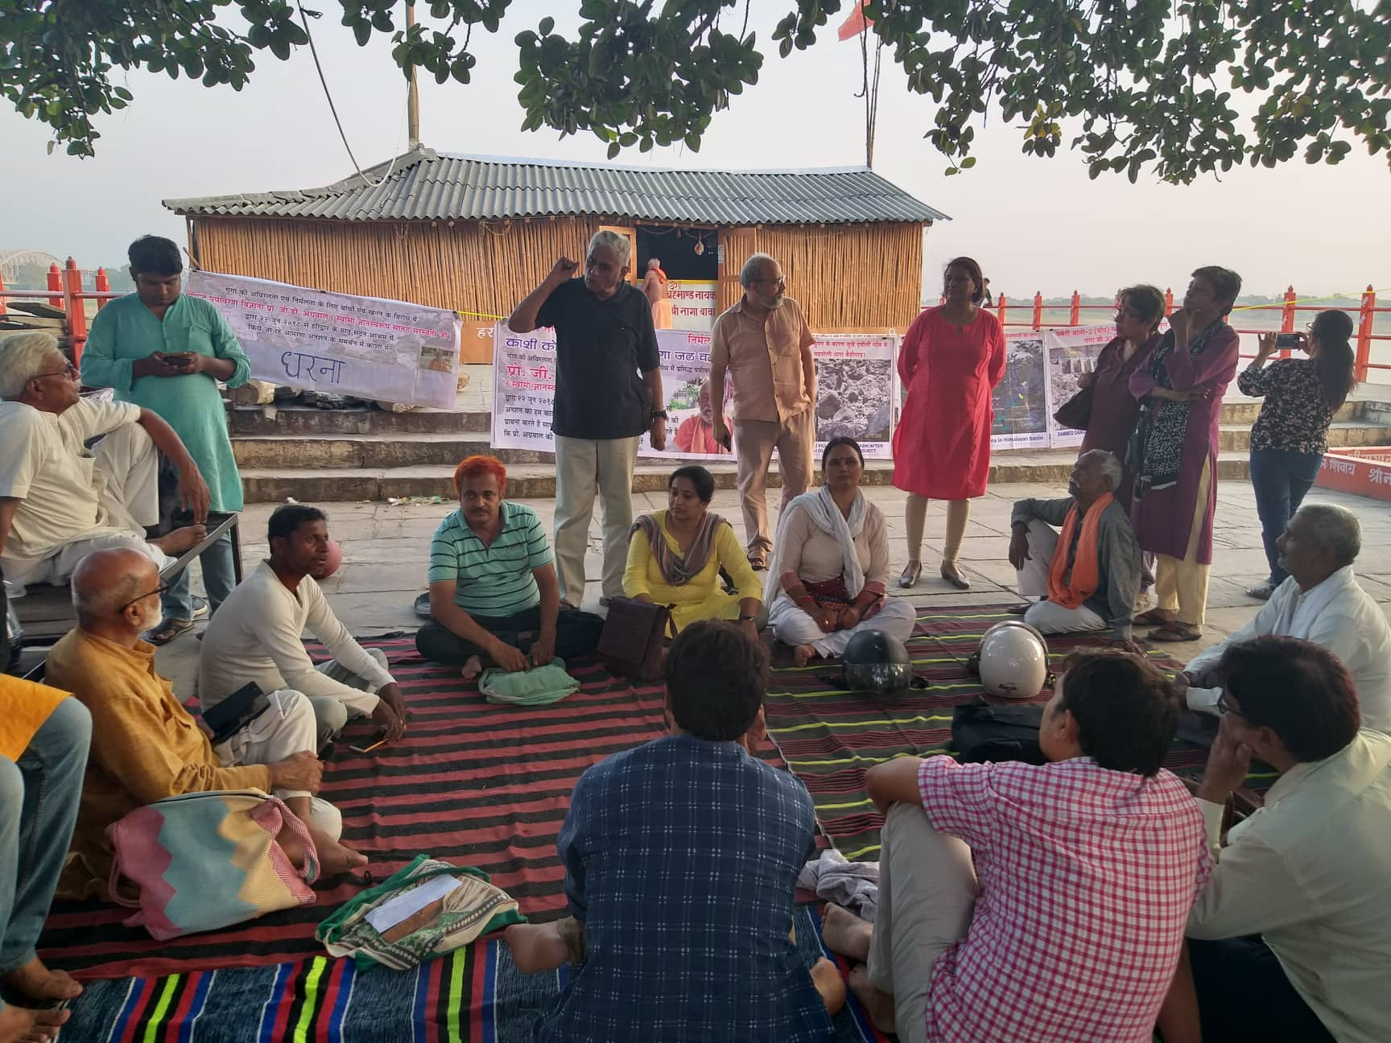

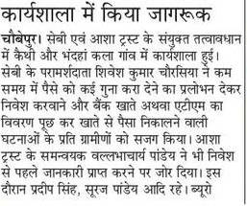
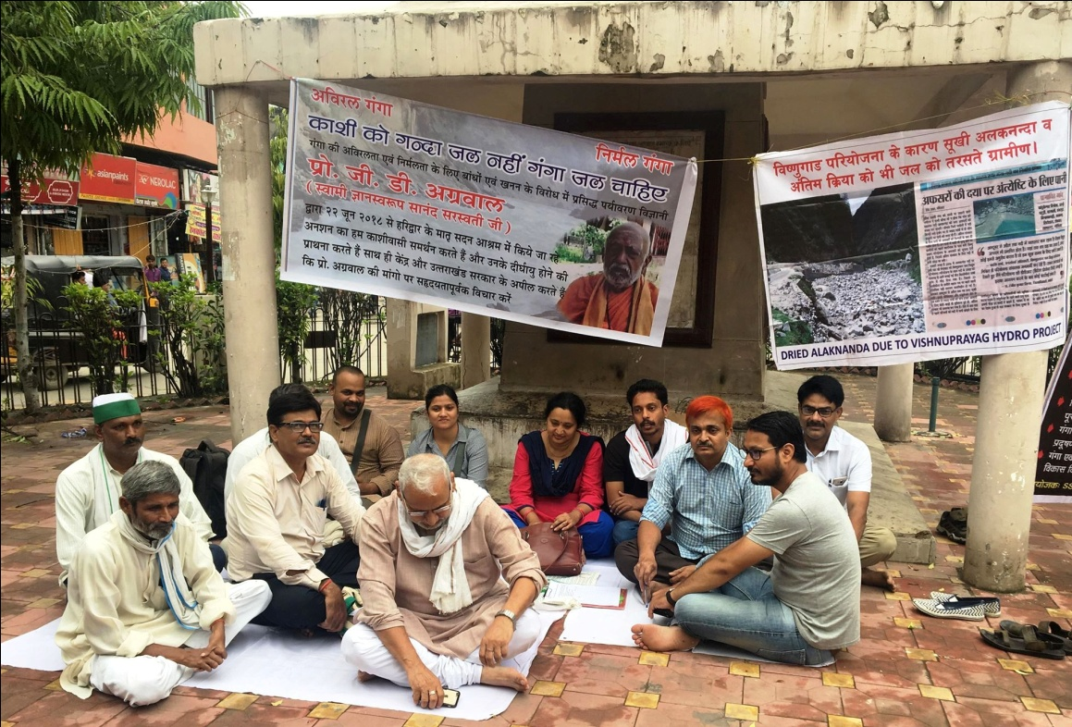
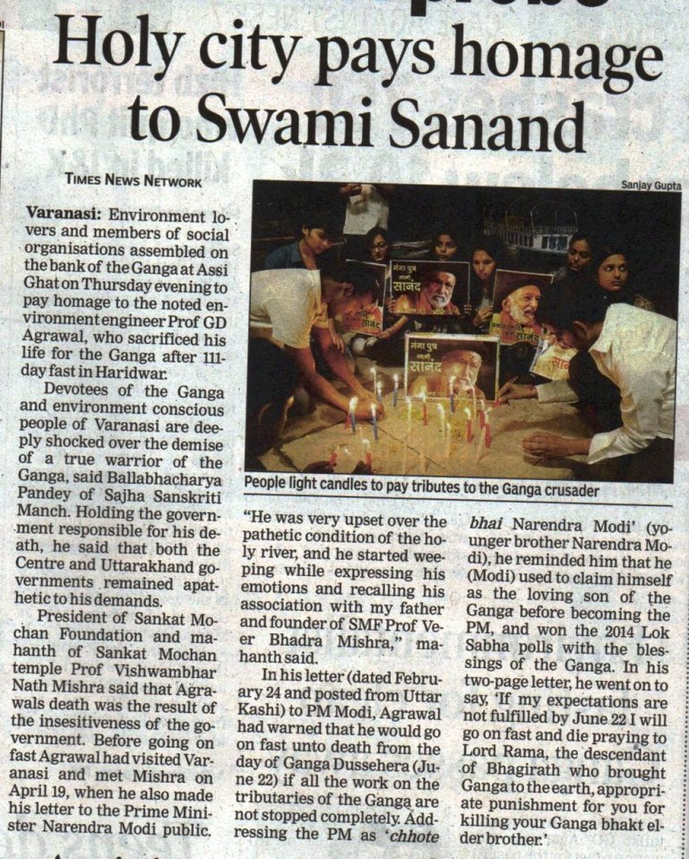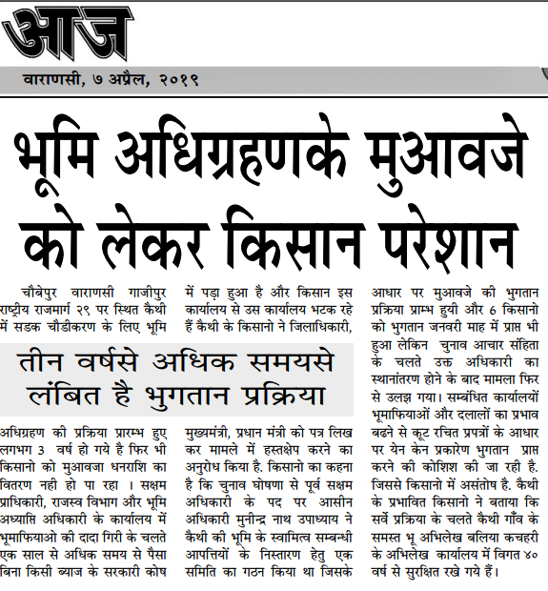
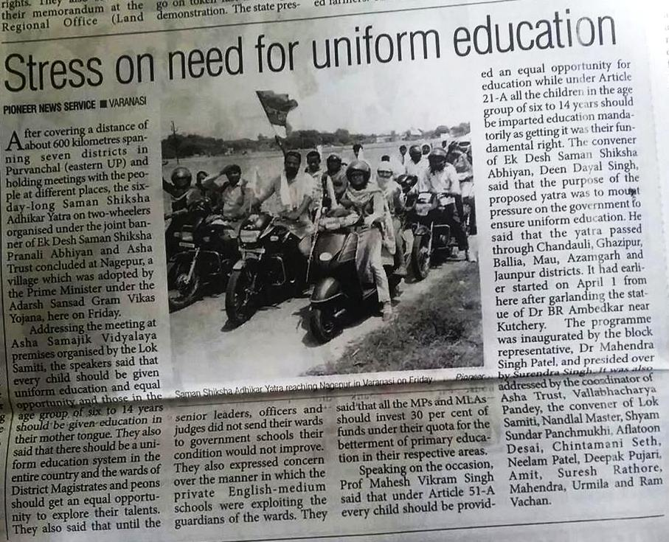

Impact
I think my efforts for making people aware about their rights especially RTI, RTI, FSA, Land Acquisition are very effective and useful. Thousands of people got benefitted in different way. They feel comfort to contact me (24X7) for their genuine problems related to different government offices. A multi dimensional program coordinated by me on Gandhi150 is great achievement I think. By this way more than 50 thousand students of class 6-8th were able to understand Gandhi ji though in a better way. People, representatives of political parties including MP and MLAs now coming forward with us for Improvement of education and infrastructure in government primary school, it is good starting result and achievement of One Nation Equal Education Campaign. Response of my efforts on environmental issues is also satisfactory.

My other activities, photos, paper cuttings can be seen on following links
https://www.facebook.com/vallabh.pandey
https://www.facebook.com/asha.trust.7
https://twitter.com/Vallabh24081970
https://www.facebook.com/One-Nation-Equal-Education-Campaign-%E0%A4%8F%E0%A4%95-%E0%A4%A6%E0%A5%87%E0%A4%B6-%E0%A4%B8%E0%A4%AE%E0%A4%BE%E0%A4%A8-%E0%A4%B6%E0%A4%BF%E0%A4%95%E0%A5%8D%E0%A4%B7%E0%A4%BE-%E0%A4%85%E0%A4%AD%E0%A4%BF%E0%A4%AF%E0%A4%BE%E0%A4%A8-460166307671208/
https://www.facebook.com/profile.php?id=100008104969097

THANKS
Vallabhacharya Pandey
Contact No: 9415256848
ashakashi@gmail.com
vallabh01@gmail.com

