Vallabhacharya Pandey (July 2017- June 2018)
Introduction
I live in village Kaithi which is 30 kilometers from Varanasi HQ. My 1st school was Government Primary School, Kaithi. I completed my B.Sc. (Biology) in 1991 from Ewing Christian College, Allahabad. After graduation I returned in my village and started agriculture on my parental land. 1st time I donated blood in 1989, now counting reaches up to 84.
In 1994, I came in contact with Dr. Sandeep Pandey (founder member of Asha), on his advice I started training programs for self reliance though agricultural activities, like apiculture, bio composting, medicinal plant cultivation etc. From 1997, I am closely associated with Asha Trust’s activities. With administrative responsibilities of trust I am presently working for different awareness programs about people’s rights like RTI, RTE, FSA, MNREGA, Venders Act, Land Acquisition Act etc.
Update
- Continued work on awareness about rights and rulings related to RTI Act, RTE Act, MNREGA, Food Security Act, UP Jan Hit Guarantee Act, Venders Act, Land Acquisition Act 2013 by the way of organizing regular camps, workshop, public meeting, signature campaigns, poster display and pamphlet distribution.
- Continued work on environmental issues. Participated and organized several program on air pollution, water pollution and soil pollution. Organized environmental rallies, poster display and plantation drive with school children.
- I just started a campaign of taking “Environmental Oath” during the morning prayer ( This is 8 points oath often used by Dr. A.P.J. Ablud Kalam Sahab). Now this activity is continued in some schools.
- Gandhi 150: From 2nd Oct 2017, we started regular programs on the occasion of Gandhi Ji and Kasturba Ji’s 150th birth year. Published a pamphlet on Gandhi Ji’s Life history. Organized “Aao Bapu Ko Jane” quiz competition for students of class 6-8. The question paper includes 25 MCQ based on the pamphlet. About 17000 students participated in this quiz and out them 750 get a certificate of application. I coordinated this activity with help of other social groups and students of BHU and IIT BHU.
- We continued activities with students of 5 government primary schools nearby my village; it includes drawing, painting, chart making, poster making, greeting card making, plantation, cleaning drive We are getting good response in these schools.
- To insure equal and quality education we started One Nation Equal Education Campaign in UP. I am coordinating this activity with Mr. Deen Dayal and other volunteers. In this campaign we organized 2 bike rallies for awareness and to get people involved. 1st Saman Shiksha Adhikar Yatra: (1-6 April 2018) covers about 750 kilometers in Varanasi-Chandauli-Ghazipur-Ballia-Mau-Azamgargh-Jaunpur districts. More than 20 thousand pamphlets distributed, about 50 small public meeting done during this yatra. 2nd Saman Shiksha Adhikar Yatra : (19-22 June 2018) covers about 275 kilometers in Varanasi, Chandauli-Mirzapur and Sonbhadra Districts. More than 7 thousand pamphlets distributed and 20 small public meeting done during this phase. We gave a memorandum for ensuring equal and quality education for all to 12 political parties head in Varanasi Office and requested them to included quality of education issue in there manifesto. We are continuously organizing poster exhibition, signature campaign, awareness campaign in small towns and villages, by this activity we are requesting common people to intervene in government schools to improve quality of education and resources there. Till June 30th 18 we send memorandum to PM of India with about 3000 signatures collected during our campaign. This memorandum includes 6 demands.
- I actively participated social and cultural activates, events organized by other groups mainly Sajha Sanskriti Manch of Varanasi, it include programs on Save Ganga, Stop Violence against women, to stop threatening of street venders, to improve harmony in society etc.
- I am actively involved in movements of Land acquisition in 5 place at Varanasi and Ghazipur districts and trying to help farmers to get compensations according to new Land Acquisition Act 2013.

Some Photographs / Paper clippings :
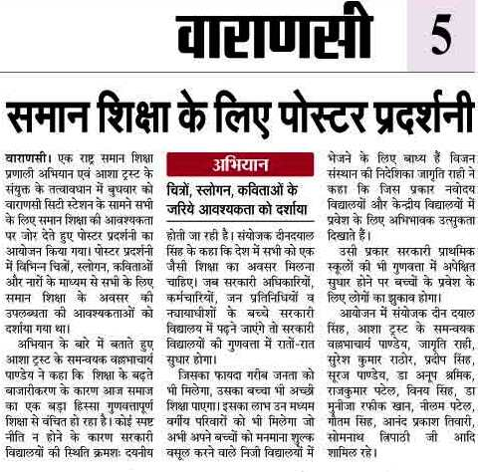
News:Poster Exhibition for Equal and Quality Education
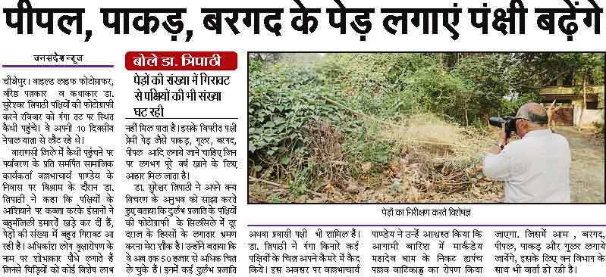
News:Effort to Save Birds
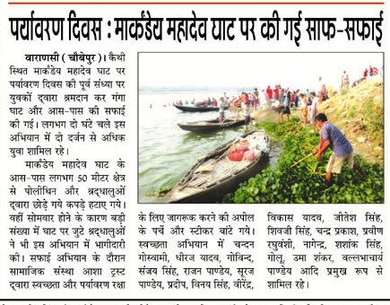
News: Cleaning drive in Ganga Near Kaithi

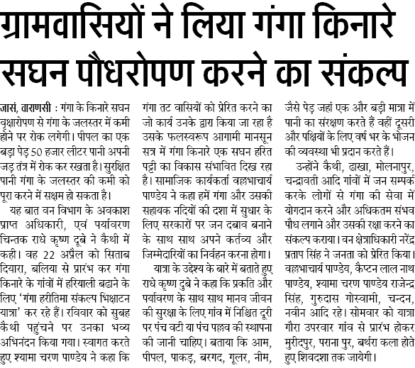
News: Oath for Plantation at the Bank of Ganga
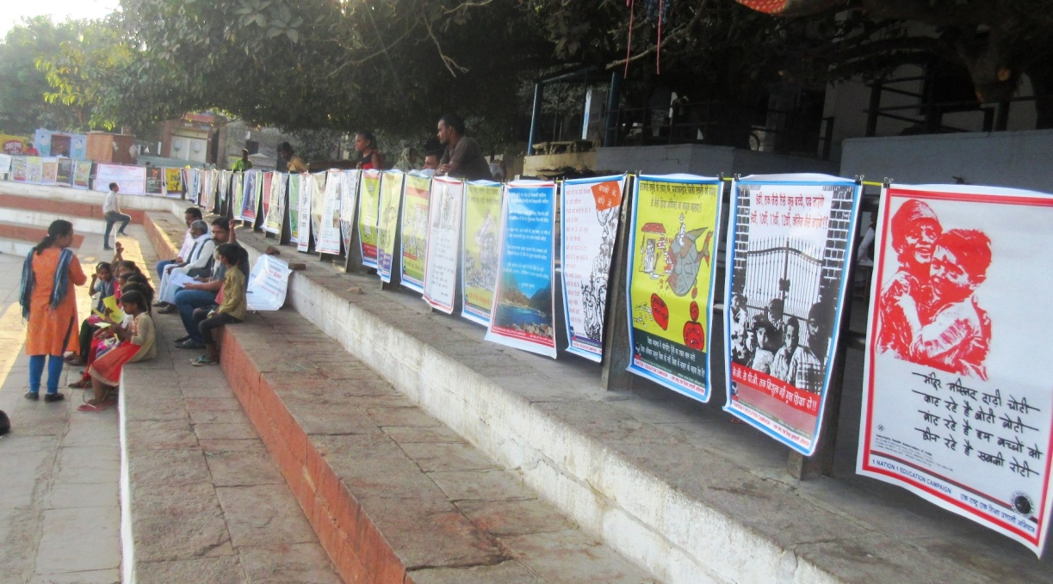
Poster Exhibition
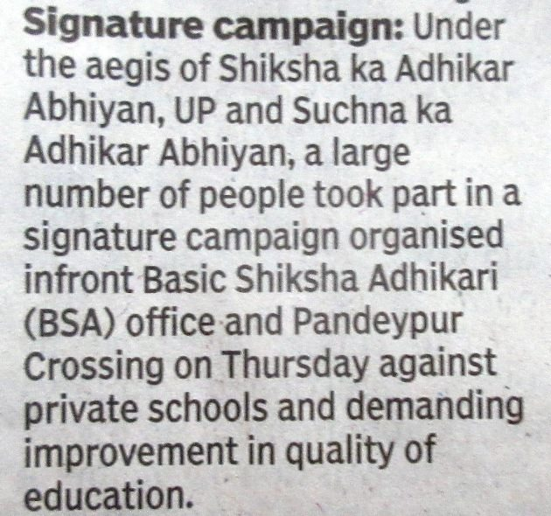
News:Signature Campaign for Education
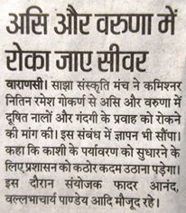
News: Memorandum To stop sever discharge in Asi Varuna River @ Varanasi
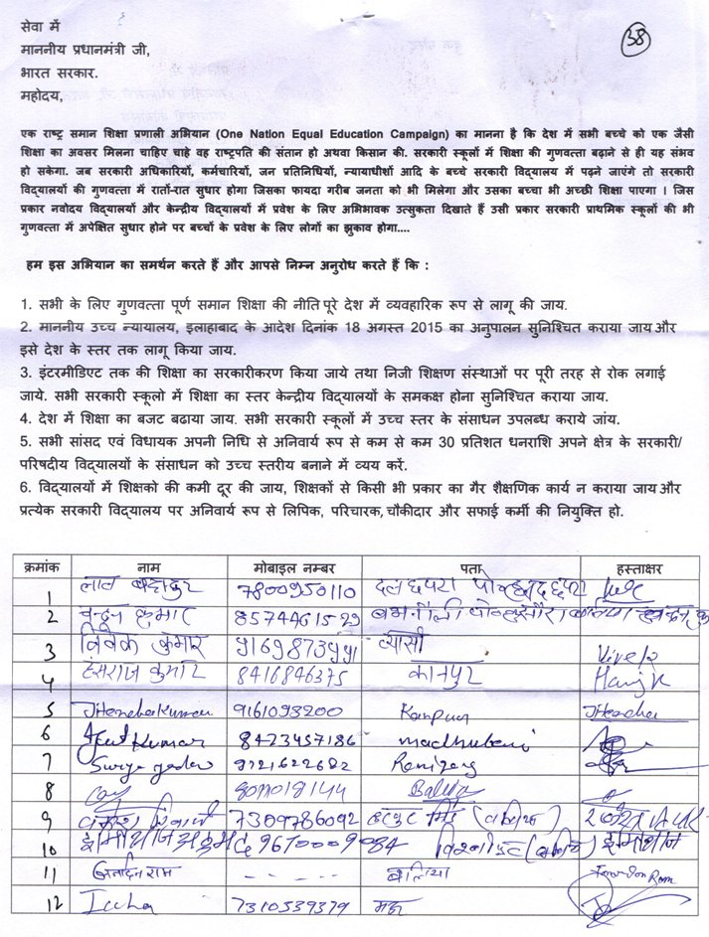
Gyapan to PM send with 3000 signatures for Equal and Quality education
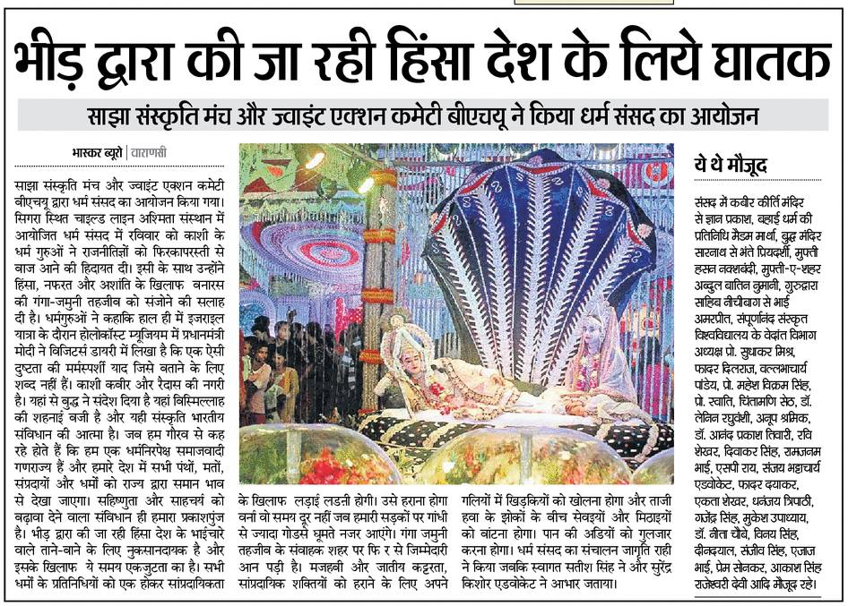
News: An effort for communal harmony
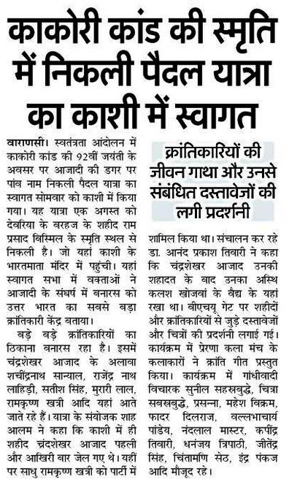
News: Welcome of Kakori Yatra
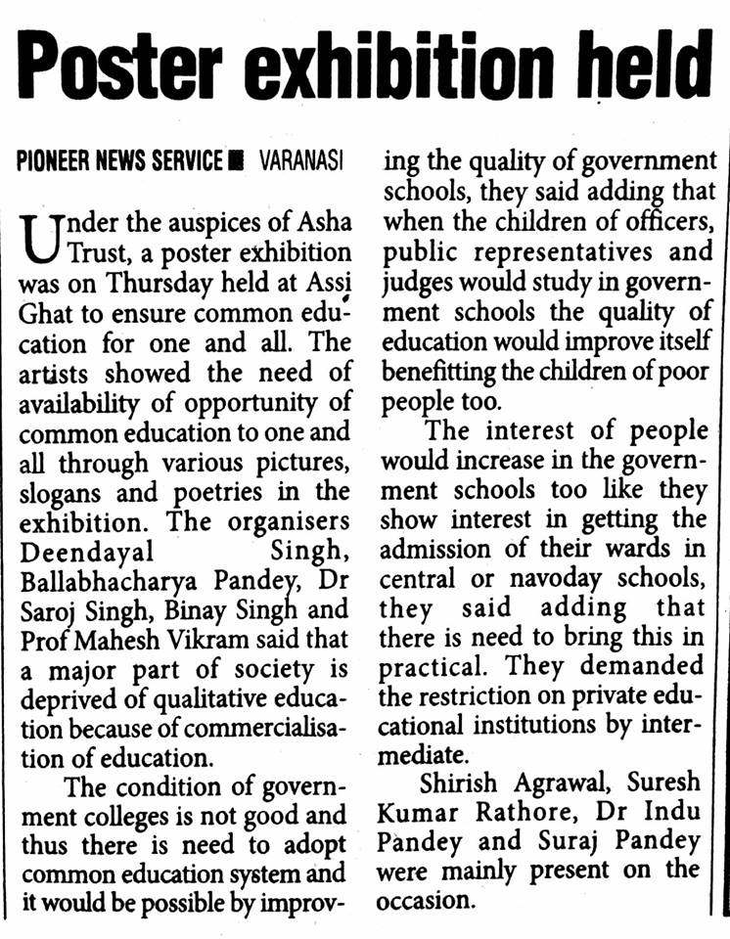
News: Poster Exhibition
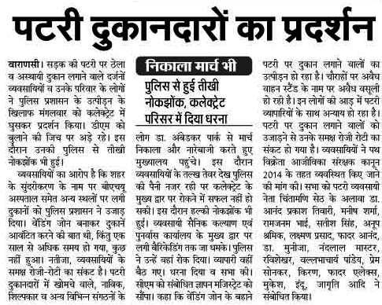
News: A Protest to insure rights of street vendors
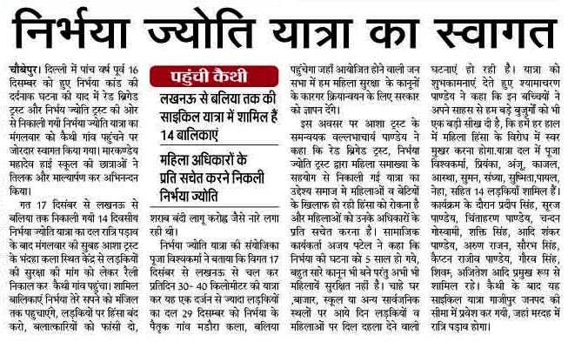
News: Nirbhya Jyoti Yatra welcome at Kaithi
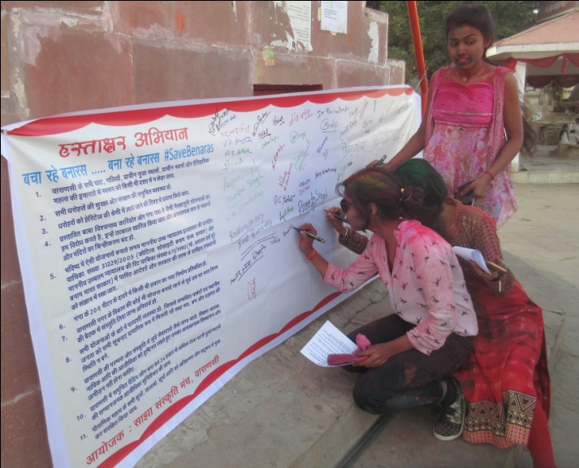
Signature campaign to insure heritage culture of Varanasi
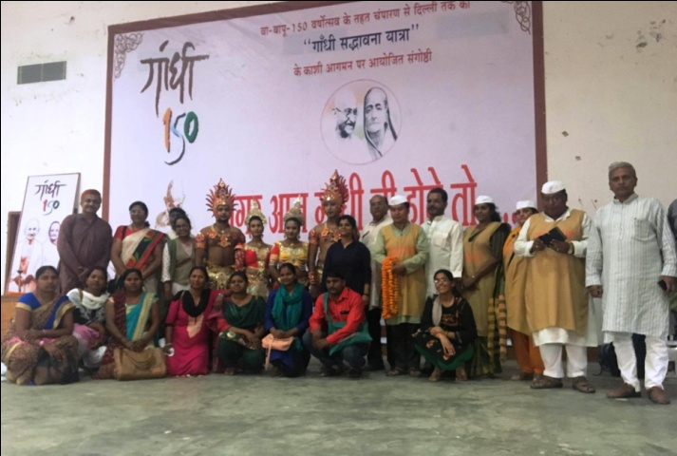
Participation in Seminar: Agar aaj Gandhi Hote to under Gandhi150
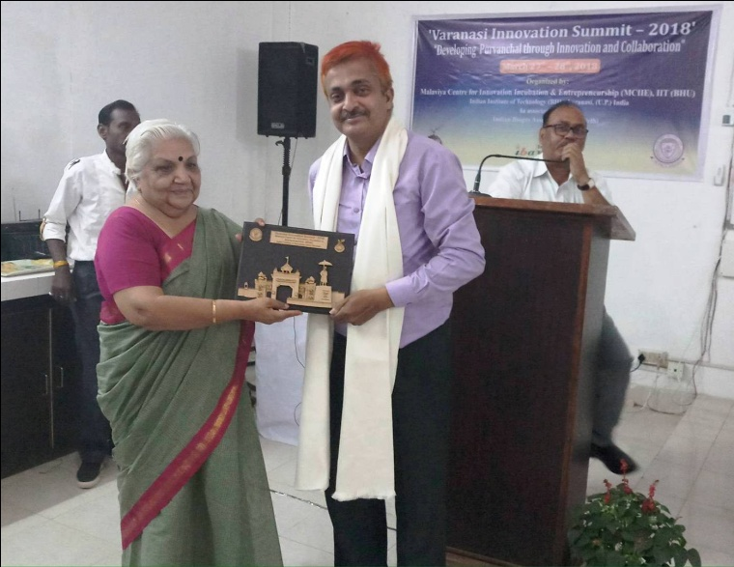
Received Honor at Varanasi Innovation Summit 2018 (IIT BHU)
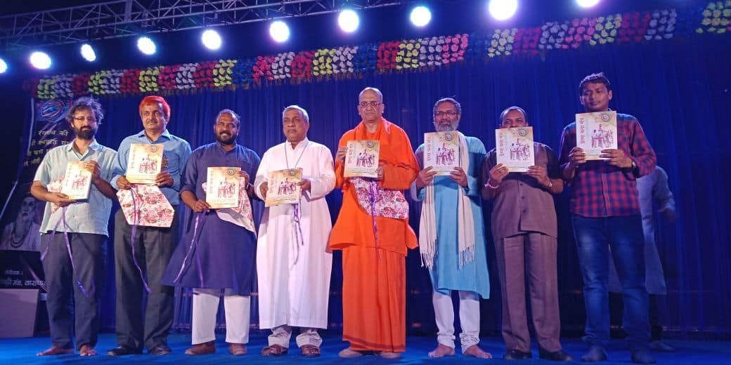
Participation in Silver Jubilee Celebration of Prerna Kala Manch Varanasi
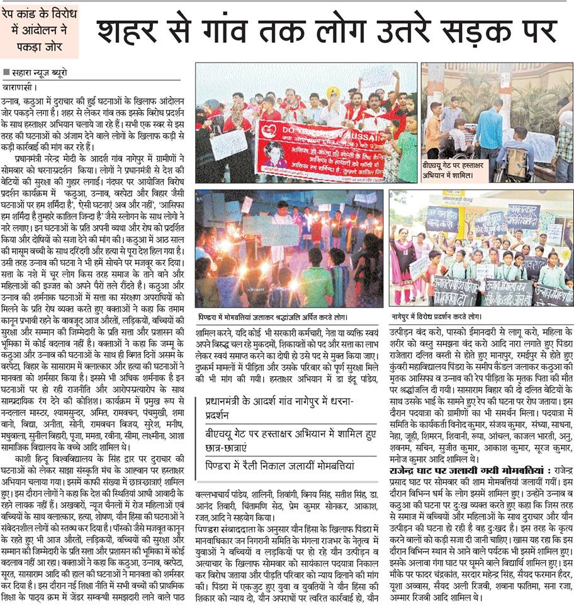
News: Fight against Rape
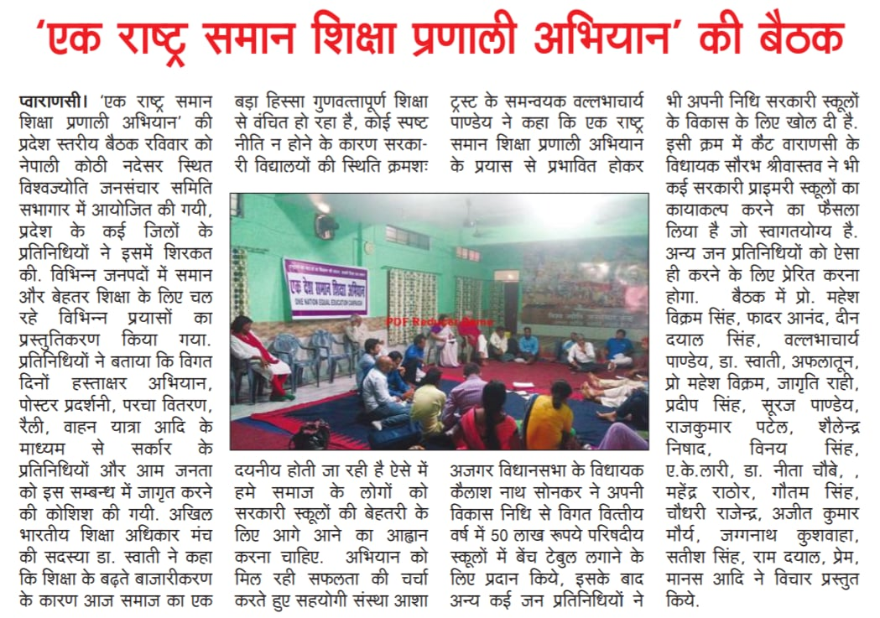
News: One Nation Equal Education Campaign
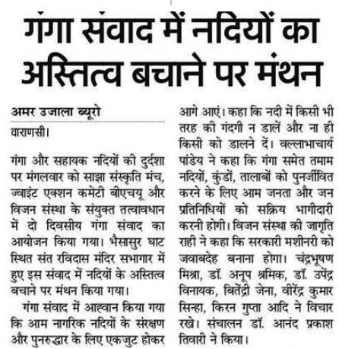
News: Participation in Ganga Samvad
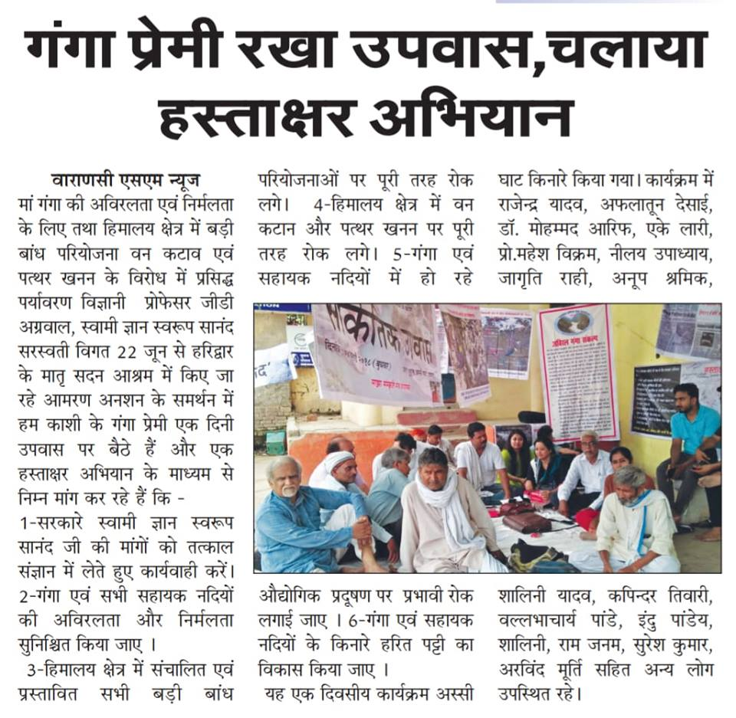
News: One day fast in support of Prof. G D . Agrawal

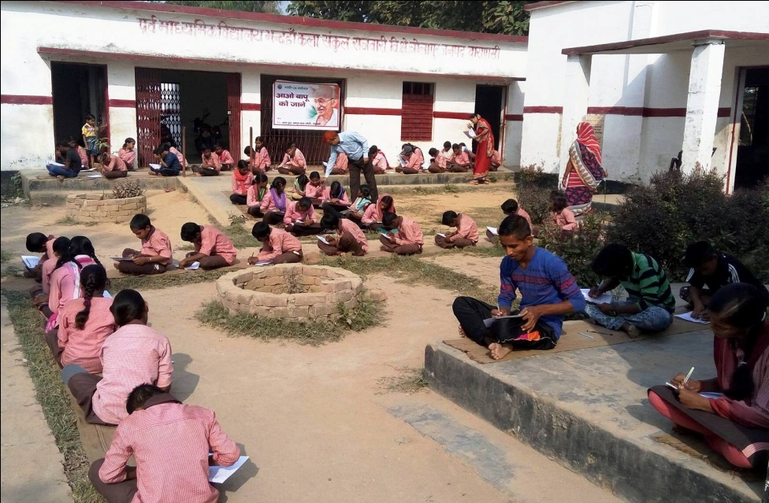
Gandhi150: Aao Bapu Ko Jane Quiz
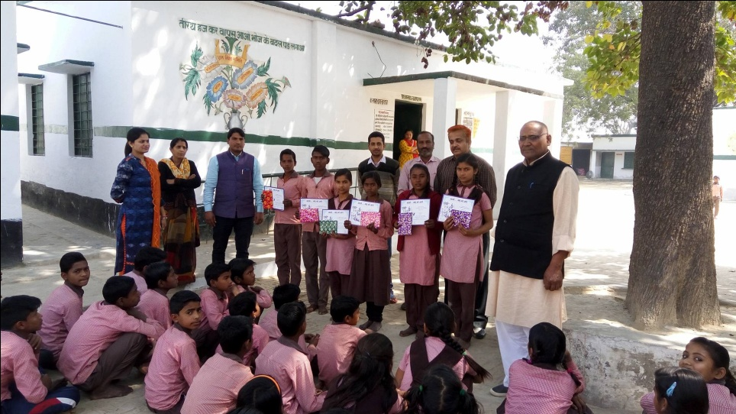
Gandhi150: Aao Bapu Ko Jane: Certificate and Gift Distribution
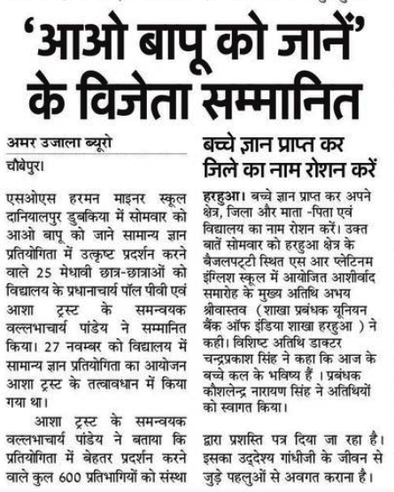
News: Aao Bapu Ko Jane
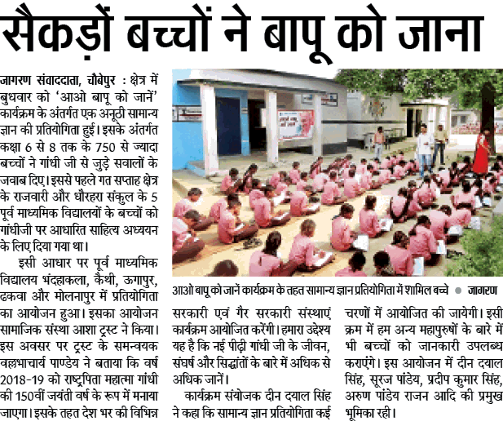
News: Ao Bapu Ko Jane
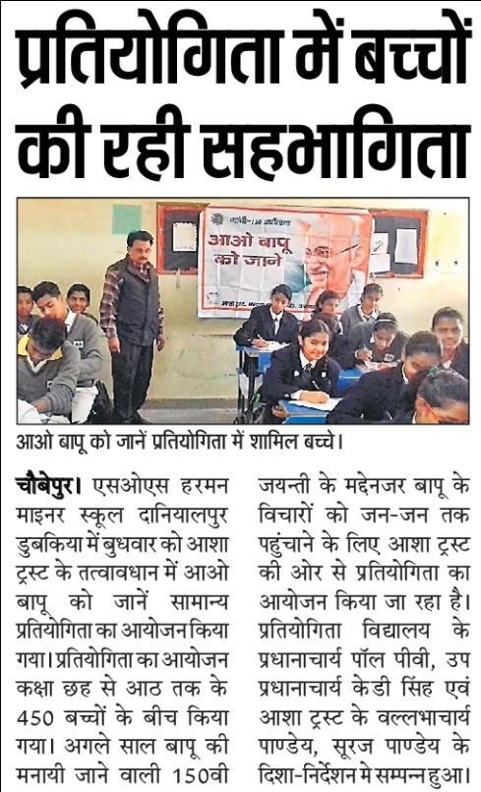
News: Aao Bapu Ko Jane
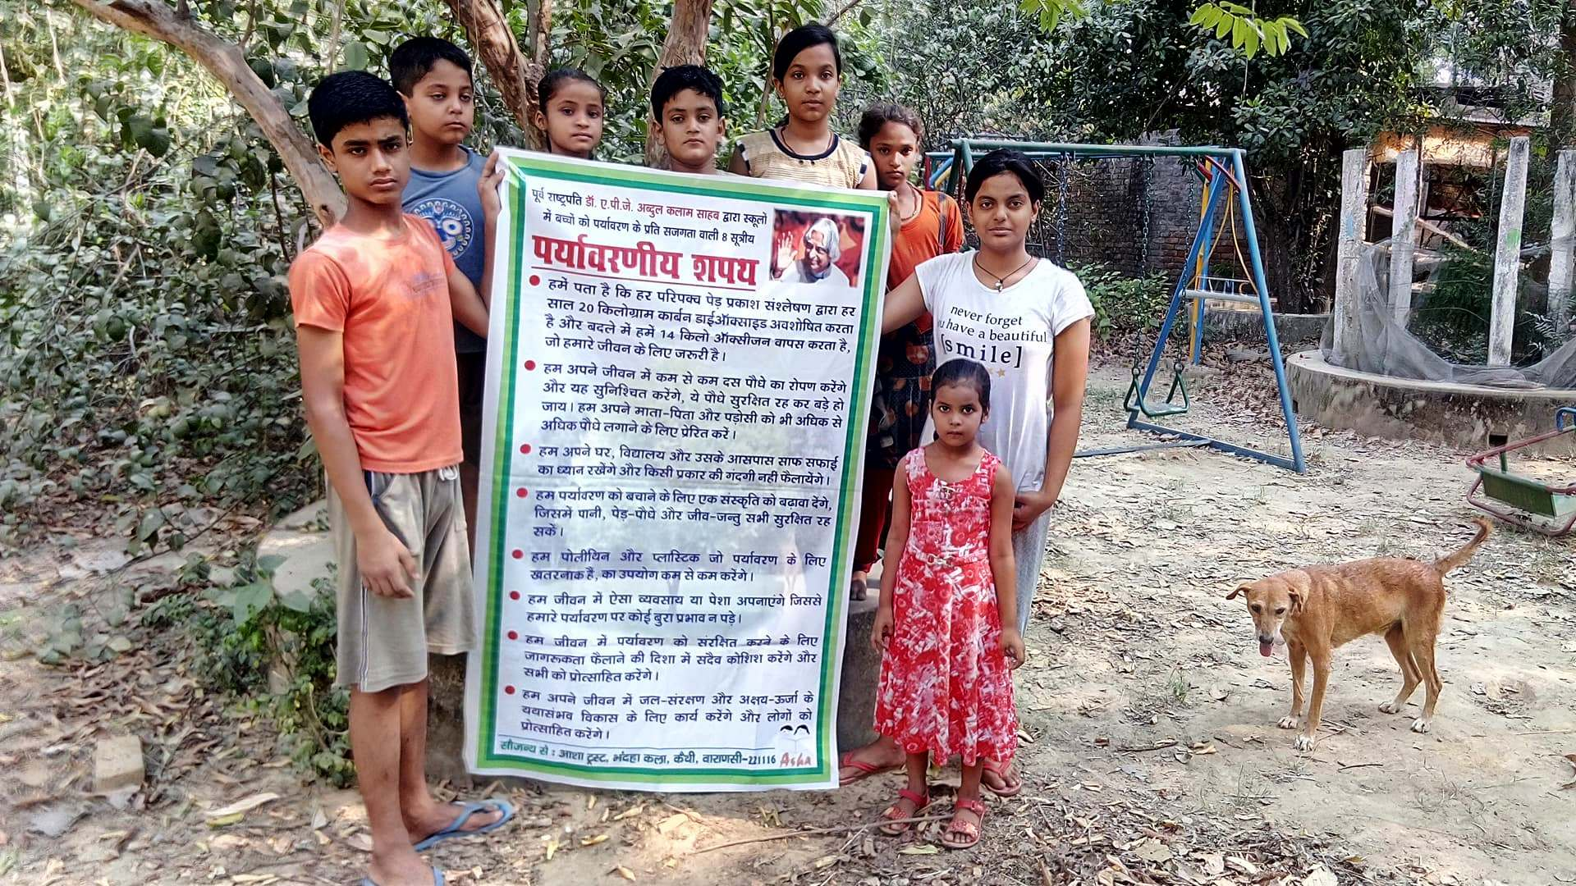
Environmental oath
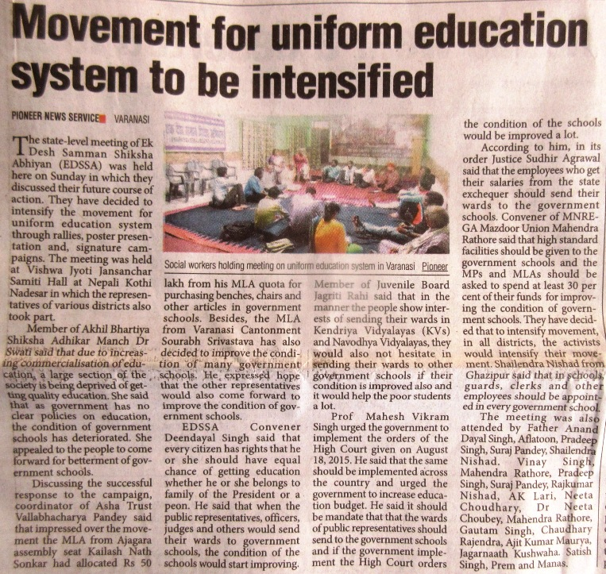
News: Quality and uniform Education
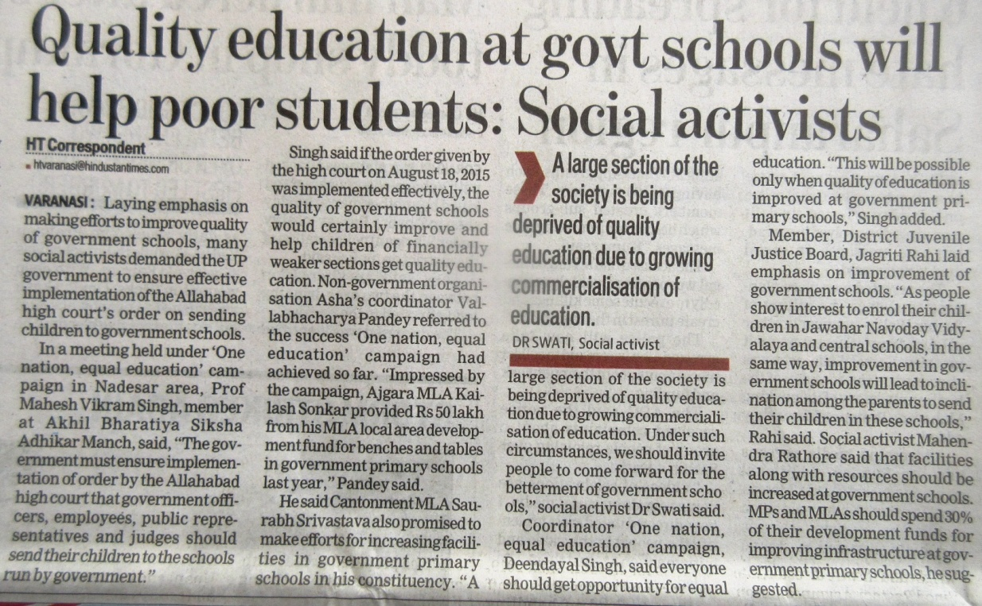
News: Quality and uniform Education
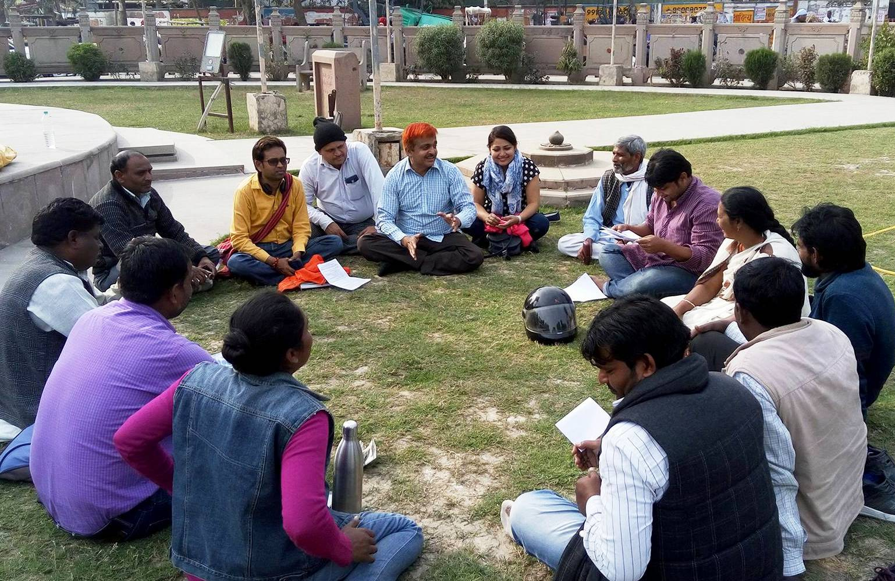
Meeting of Core Group One Nation Equal Education Campagn
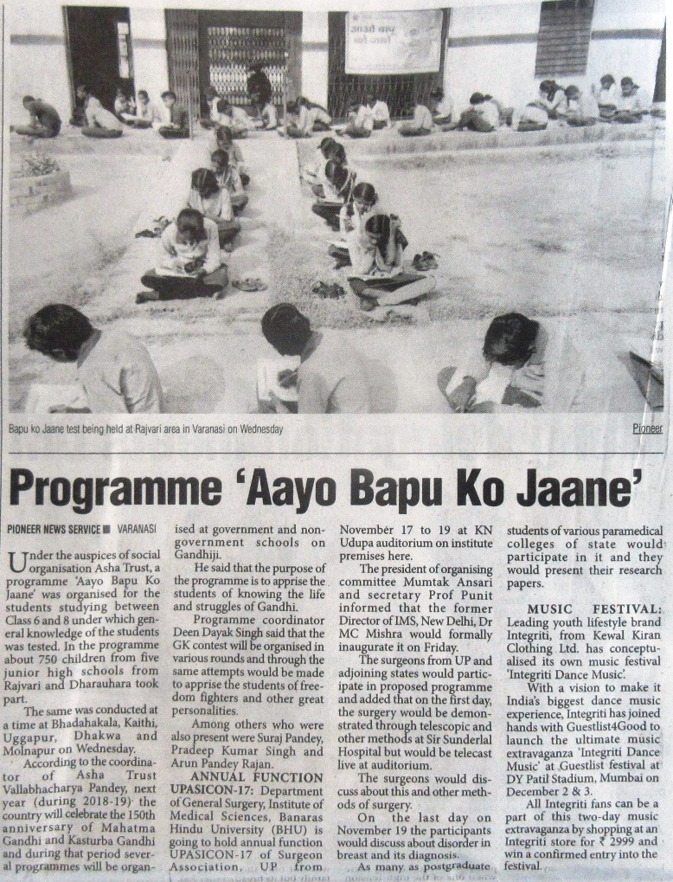
New: Aao Bapu Ko Jane
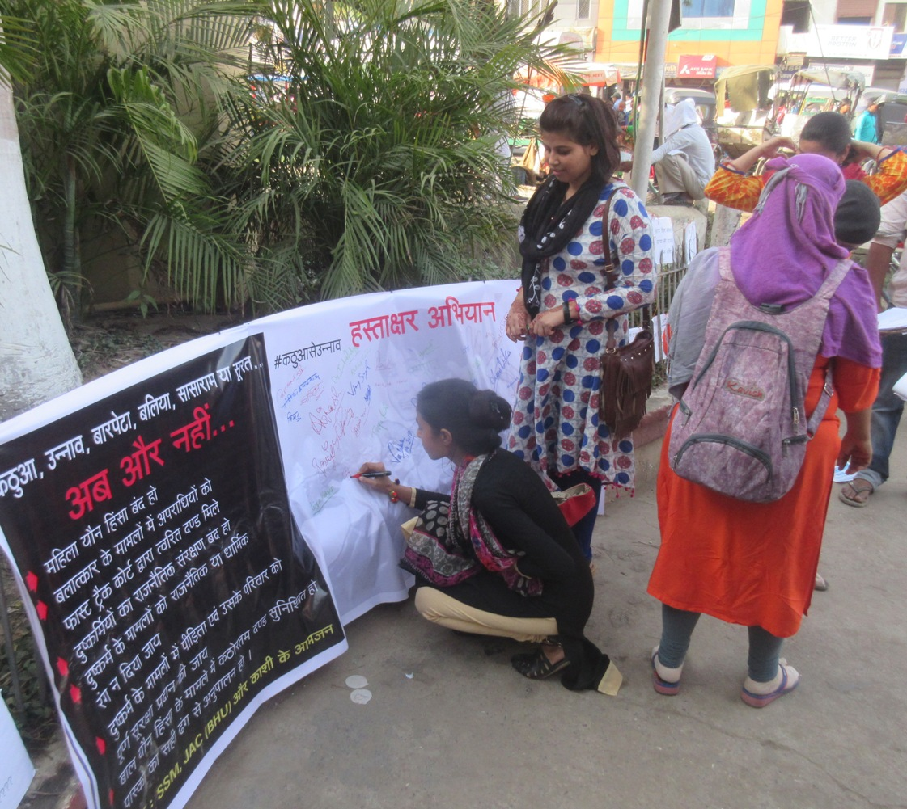
Signature Campaign to stop violence against women
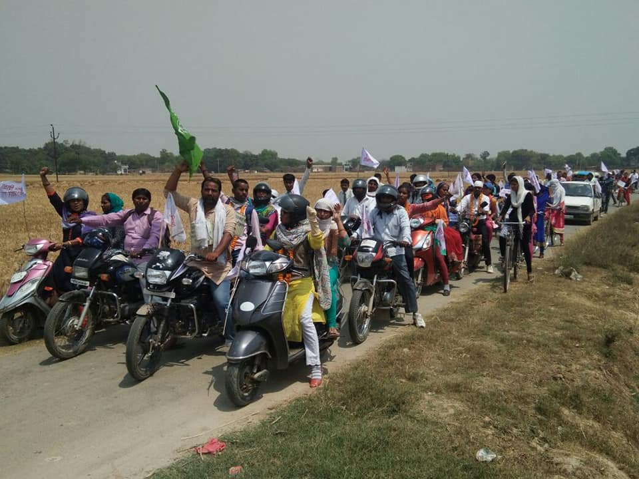
Saman Shiksha Adhikar Yatra 1

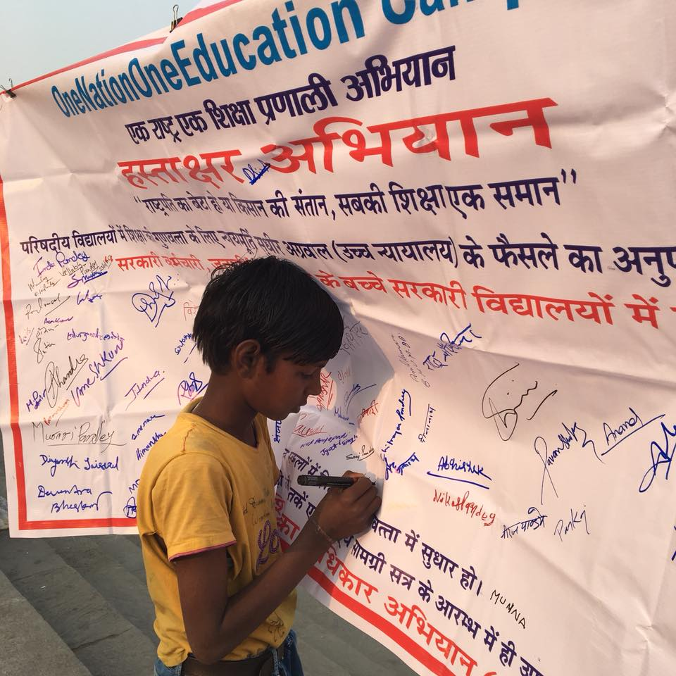
Signature Campaign to Improve education quality in Govt. Primary School
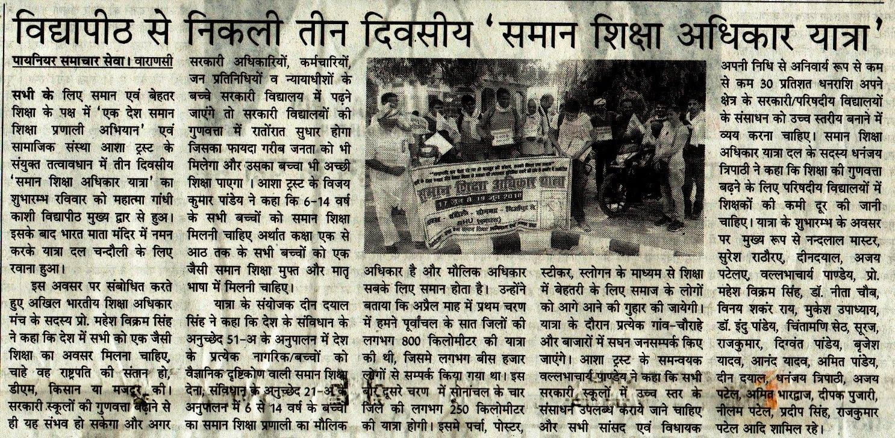
News: Saman Shiksha Adhikar Yatra Phose 2
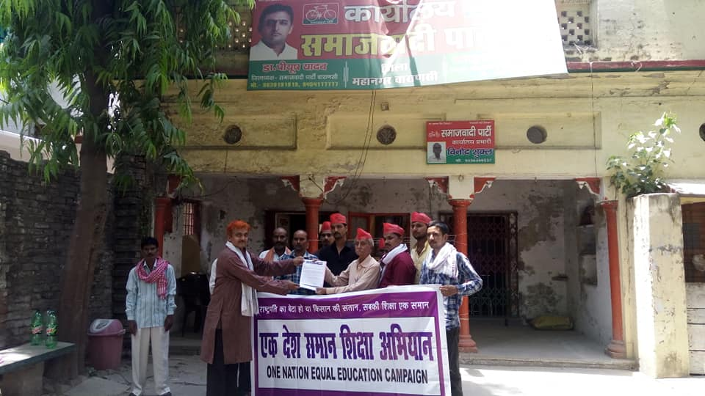
Gyapan to Political Party on Education
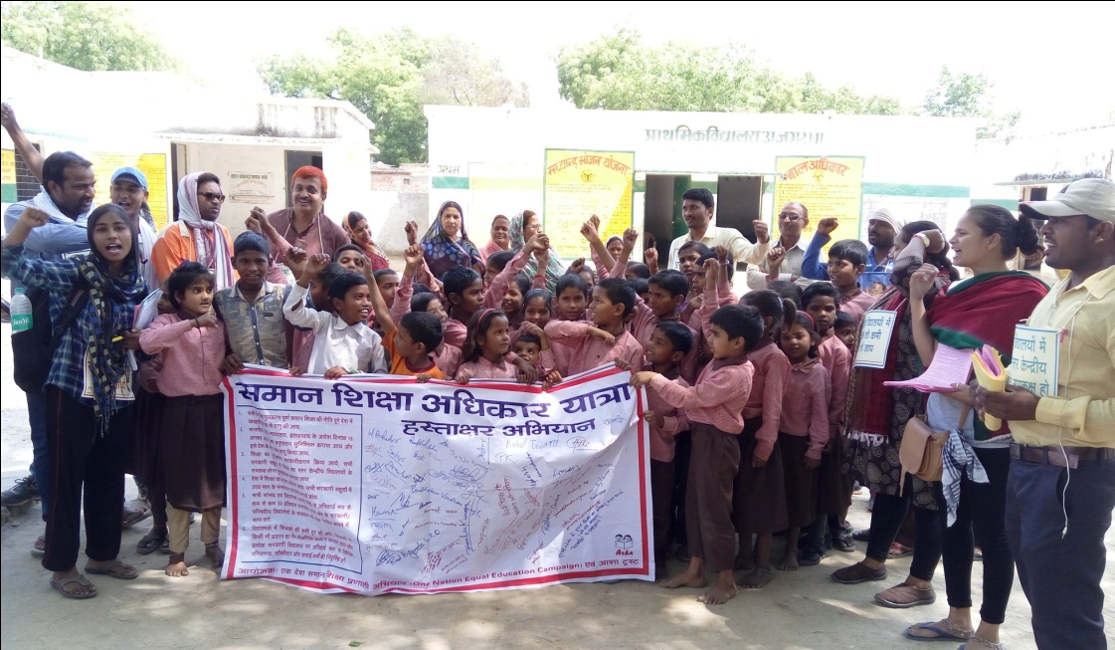
Saman Shiksha Adhikar Yatra Phase 1
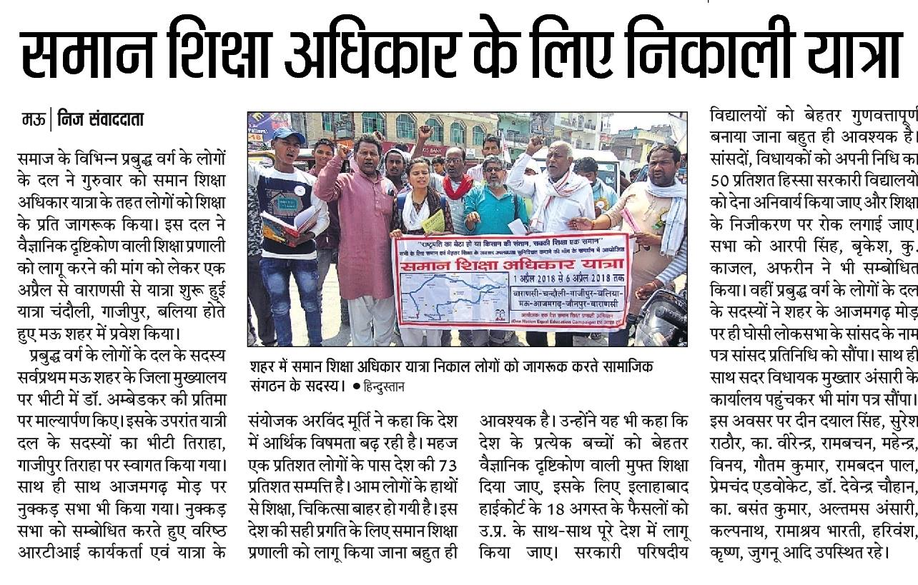
News: Saman Shiksha Adhikar Yatra 1
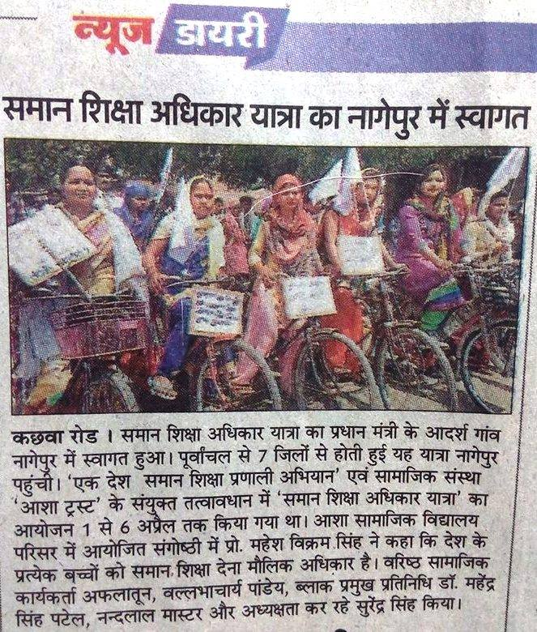
News: Saman Shiksha Adhikar Yatra 1
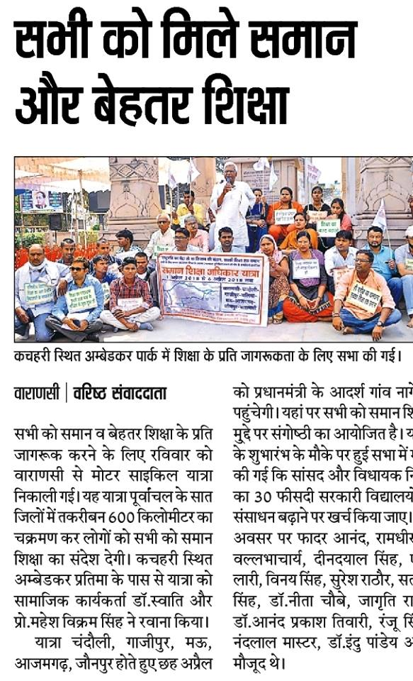
News: Saman Shiksha Adhikar Yatra 1
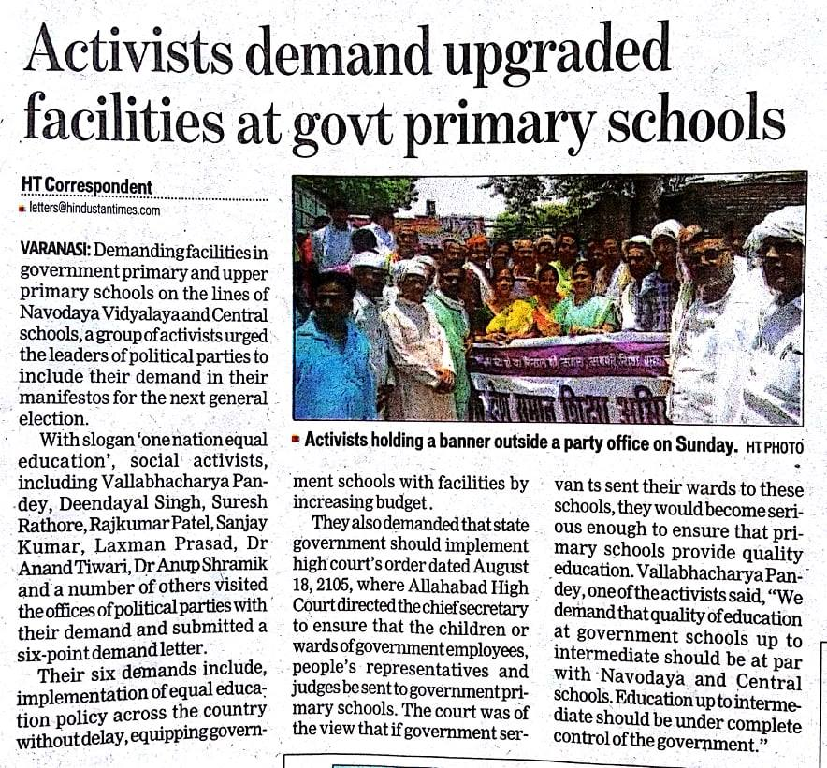
News: Demand Quality Education
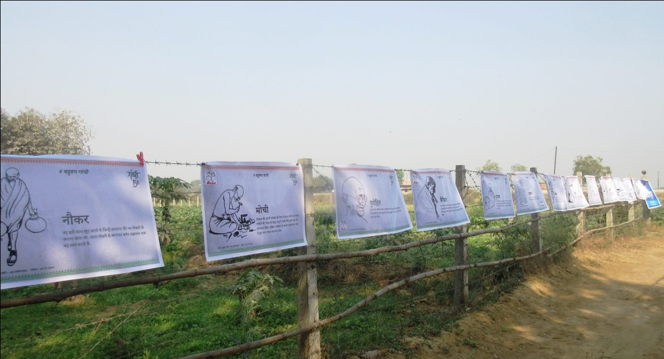
Gandhi 150: Poster Exhibition on Gandhi Ji

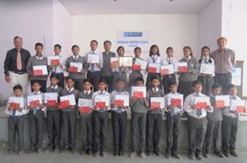
Aao Bapoo Ko Jane Certificate Distribution
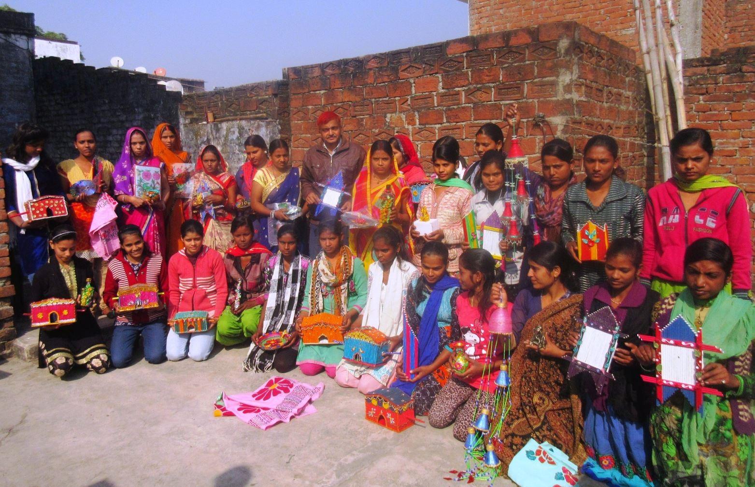
Vocational Training to Rural Women and Girls.

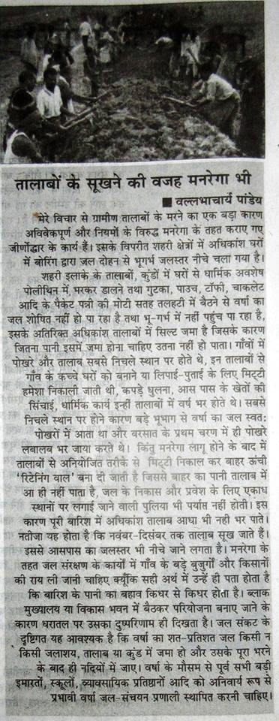
An Article on Environmental Issue published in “Gaon Ke Log” Magazine

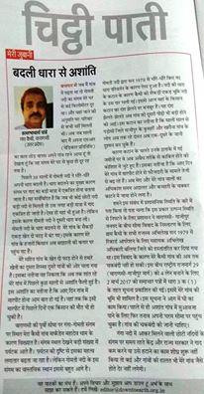
An Article published in Down To Earth on Environmental Issue
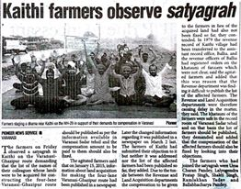
News: Protest for Proper implementation of Land Acquisition Act 2013
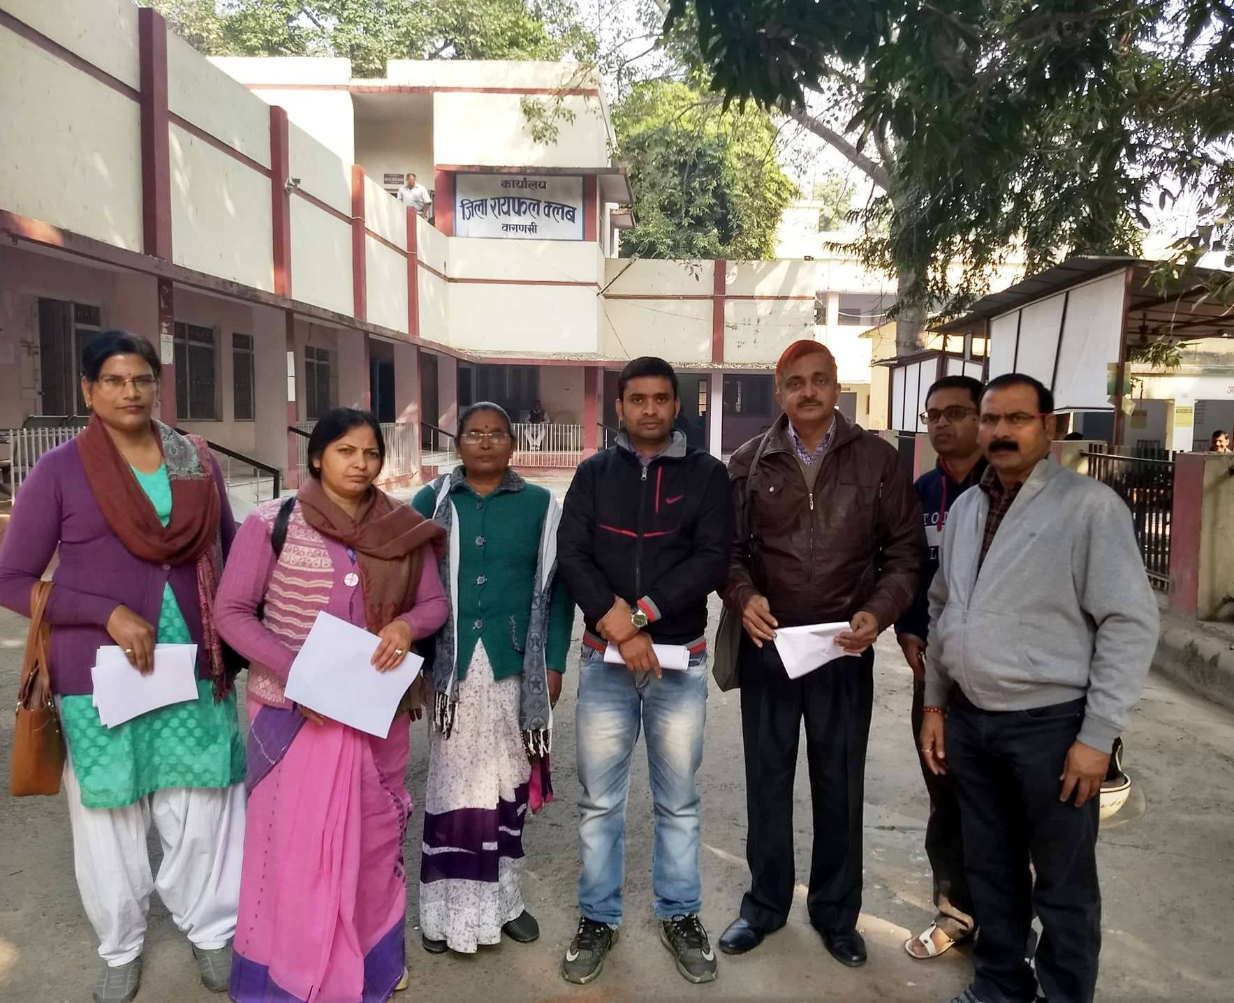
Gyapan to DM of Varanasi to improve basic facilities at Govt. Pr. Schools
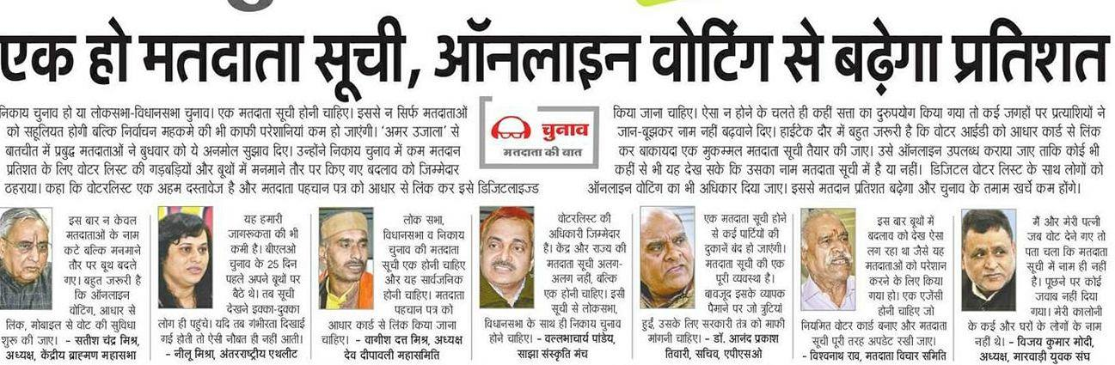
News: Participation in a debate on electoral reform
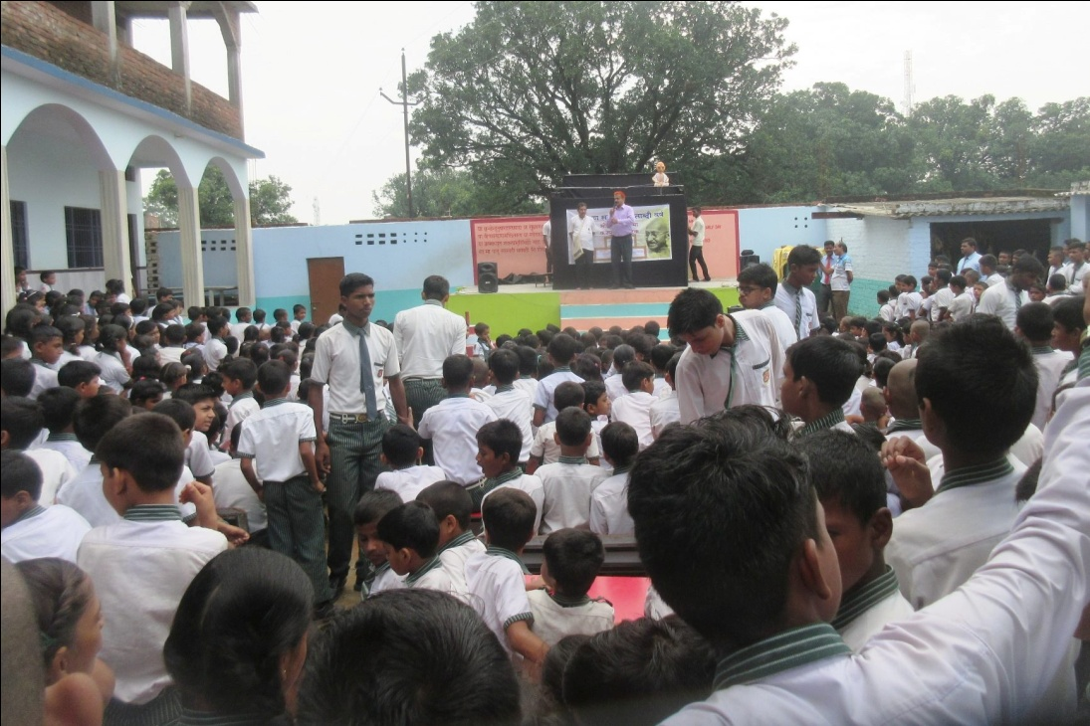
Gandhi150: Mohan Se Mahatam Puppet Show in a School

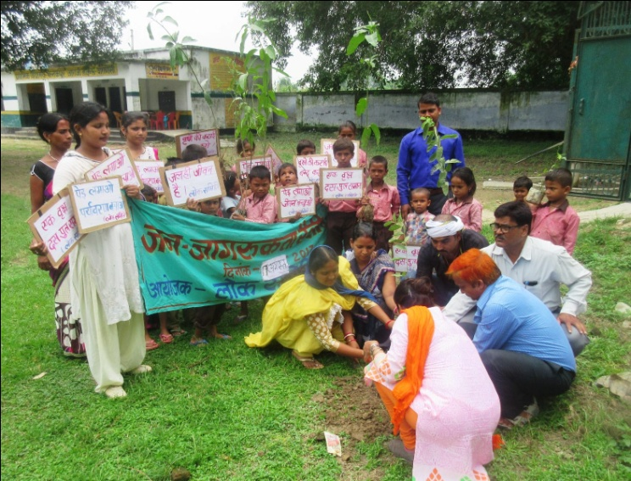
Plantation drives

Impact
I take initiative of 3 major issues with my team members, One Nation Equal Education Campaign, Environmental Oath campaign and Gandhi-150 birth celebration program.
I think that reaching up to 1700 children through 'Aao Bapp Ko jane' is one of my major achievement. By this simple way students of class 6-8 came to know Gandhi ji's life in better way. More than 2000 RTI applications, complains and Appeals filed through RTI camps organized by us during last year. Many people including some MLAs now coming forward with us for Improvement of education and infrastructure in government primary school, it is good starting result and achievement on One Nation Equal Education Campaign. We can claim positive changes in 5 government primary schools where we are involved closely.

My other activities, photos, paper cuttings can be seen on following links
https://www.facebook.com/vallabh.pandey
https://www.facebook.com/asha.trust.7
https://twitter.com/Vallabh24081970
https://www.facebook.com/One-Nation-Equal-Education-Campaign-%E0%A4%8F%E0%A4%95-%E0%A4%A6%E0%A5%87%E0%A4%B6-%E0%A4%B8%E0%A4%AE%E0%A4%BE%E0%A4%A8-%E0%A4%B6%E0%A4%BF%E0%A4%95%E0%A5%8D%E0%A4%B7%E0%A4%BE-%E0%A4%85%E0%A4%AD%E0%A4%BF%E0%A4%AF%E0%A4%BE%E0%A4%A8-460166307671208/
https://www.facebook.com/profile.php?id=100008104969097

THANKS
Vallabh
9415256848
ashakashi@gmail.com
Budget approved from Asha Silicon valley gives fellows 30000 INR/Month so total budget is 30000*12 = 360000 INR for year

