Updates of Belaku Home
1.Period: 1st April to 30th June-2013.
2.Present List of the Belaku children 2013-2014
Sl No | Name | Class | Remarks
1 | Kaveri D/o Dasrah | 9th
2 | Sunil S/o Dasrath | 6th
3 | Abhishek S/o Jayvanth | 7th
4 | Arpitha D/o Abraham | 5th
5 | Pawan S/oTukaram | 9th
6 | Kalpana S/oShanker | 9th
7 | Manjula D/o Dasrath | 5th
8 | Elshon S/oManohar | 8th
9 | Martha D/oBaburao | 8th
7 | Jaganath S/oManohar | 8th
8 | Sony D/oYesheppa | 8
9 | YeshodhaD/o Jalendra | 8
10 | Anushamma D/oShanker | 5th
11 | Akash S/oSuresh | 3rd
12 | Surekha D/o Sailu | 6th
13 | Arun S/oLaxman | 4th
14 | Sachin S/oManohar | 8th
15 | AjaykumarS/o Bhemsha | 5th
16 | Shivkumar S/oSuresh | 5th
17 | Prashanth S/o Swamidas | 9th
18 | Vijaylaxmi D/o Laxman | 6th
19 | Priya D/oPrakash | 10th
20 | Princy D/oPrakash | 8th
11 Girls and 9 Boys

Updates of SSLC Passed Children
All below children were ,10 th passed in March - 2013
Sl.No | Name | Class | Present Status
1 | Yohon ,Tukaram | Studying in Ist PUC, | Got Govt, Hostel facility
2 | Jothi Baburao | Studying in Ist PUC, | She is @ in gardian Home
3 | Ashok Baburao | Studying in Ist PUC, | Got Govt, Hostel facility
4 | Robinson Ravindra | Joined for ITI | From his gardian home.
5 | Anand Bhemsha | Studying in Ist PUC, | Got Govt, Hostel facility

3.Children newly joined to Belaku home.
Sl.No | Name | Class | Remarks
1 | Arpitha D/o Abraham | 5th | Father has runaway, and mother is very poor.
2 | Vijay laxmi D/o Laxman | 6th | Her Father has died, mother is not health, not in working possision.
3 | Surekha D/o Sailu | 6th | Father mother is unhealthy, and very poor.

4. Marks scored in their respective Class
Sl. No | Name | Class | Kannada | Hindi | English | Maths | Science | Social Studies | Total
1 | Kaveri D/o Dasrah | 9th | 61 | 52 | 48 | 51 | 65 | 57
2 | Sunil S/o Dasrath | 6th | 67 | 45 | 38 | 44 | 56 | 62
3 | Abhishek S/o Jayvanth | 7th | 74 | 39 | 45 | 56 | 45 | 58
4 | Princy D/oPrakash | 8th | 68 | 54 | 42 | 47 | 53 | 68
5 | Pawan S/oTukaram | 9th | 75 | 61 | 51 | 68 | 62 | 74
6 | Kalpana S/oShanker | 9th | 70 | 46 | 45 | 54 | 61 | 74
7 | Manjula D/o Dasrath | 5th | 65 | 49 | 52 | 63 | 66 | 78
8 | Elshon S/oManohar | 8th | 74 | 51 | 49 | 52 | 48 | 54
9 | Martha S/oBaburao | 8th | 55 | 42 | 49 | 55 | 42 | 61
10 | Jaganath S/oManohar | 8th | 75 | 51 | 42 | 47 | 58 | 65
11 | Sony D/oYesheppa | 8 | 78 | 54 | 55 | 60 | 62 | 78
12 | YeshodhaD/o Jalendra | 8 | 64 | 45 | 38 | 52 | 60 | 74
13 | Anushamma D/oShanker | 5th | 82 | 68 | 46 | 45 | 55 | 63
14 | Akash S/oSuresh | 3rd | 75 | 44 | 48 | 41 | 49 | 54
15 | Priya D/oPrakash | 10th | 68 | 48 | 44 | 56 | 58 | 64
16 | Arun S/oLaxman | 4th | 74 | 45 | 54 | 51 | 56 | 75
17 | Sachin S/oManohar | 8th | 84 | 65 | 47 | 64 | 68 | 78
18 | AjaykumarS/o Bhemsha | 5th | 64 | 47 | 54 | 56 | 58 | 70
19 | Shivkumar S/oSuresh | 5th | 63 | 56 | 50 | 54 | 58 | 68
20 | Prashanth S/o Swamidas | 9th | 79 | 68 | 55 | 58 | 61 | 75

5.Gender workshop to the Belaku ,PPC staffs and children.
- The gender workshop has been conducted to the belaku statts and Children.the in the workshop we helped them to understand the follwings.
-Personal consturct of gender
-Gender sterotypes
- Socal instituon and the gender process
-Sex vs gender.
This workshop conducted by Sunita ( Belaku part time accountant) and also she had attend the 1 week gender training programme at Visthar Bangalore.

6. Parents/Gardians meetings
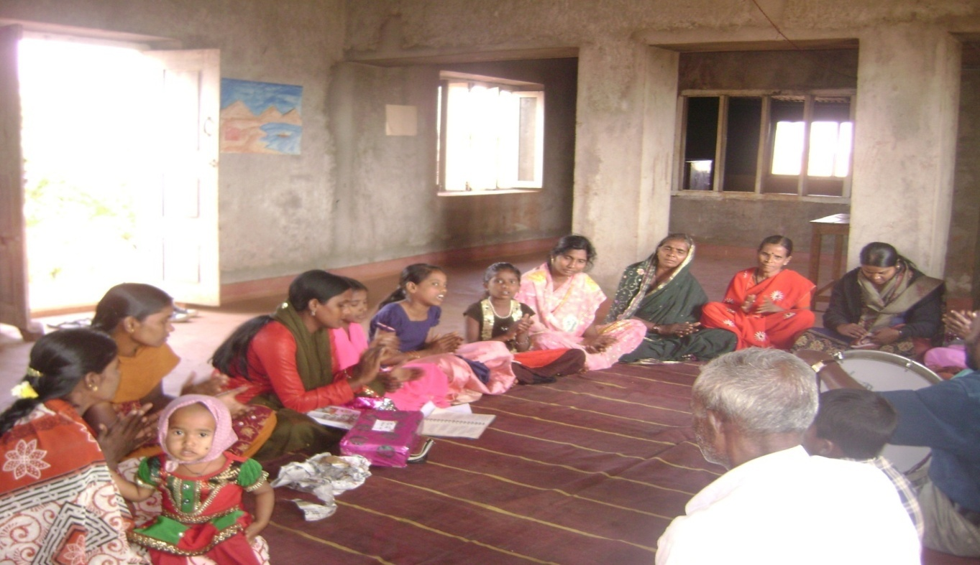
2 Parents/Gardian meetings was conducted in Belaku home. And disscussed the following issues.
- Individual Child performance in educ ation.
- Individual Child health.
- Importance of parents/gardian participation in parents meeting of Belaku project.

7.Celebration of Enviromnent day

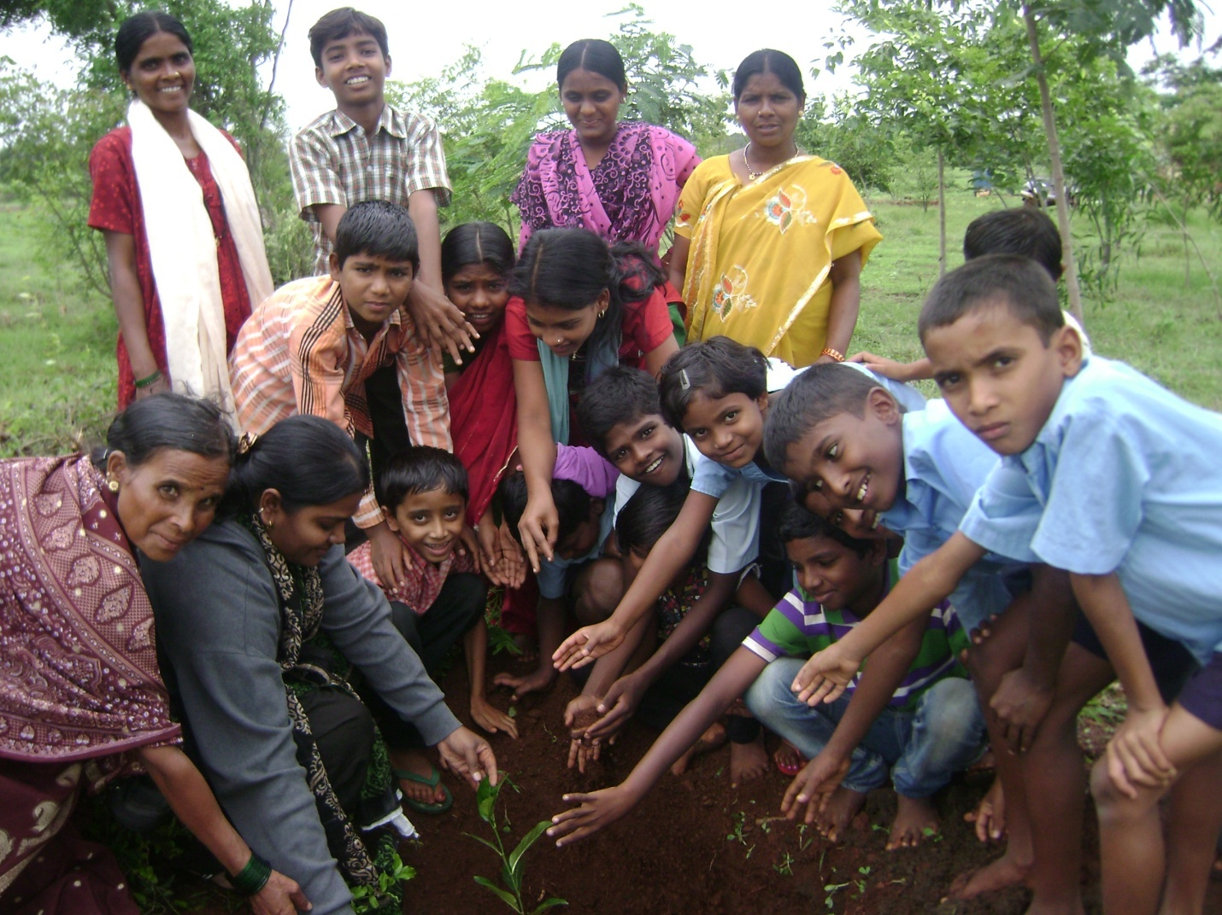
Belaku children and staff planting the plant at Belaku campus
The Belaku childrn and staff were celebrated the enviromnet day, at Belaku Home, and they have planted the plants in the Belaku Campus.After the plantation meeting was organised and disscussed importance of the enviroment day, and Greenary.

9.Expouser trip to the Belaku Children

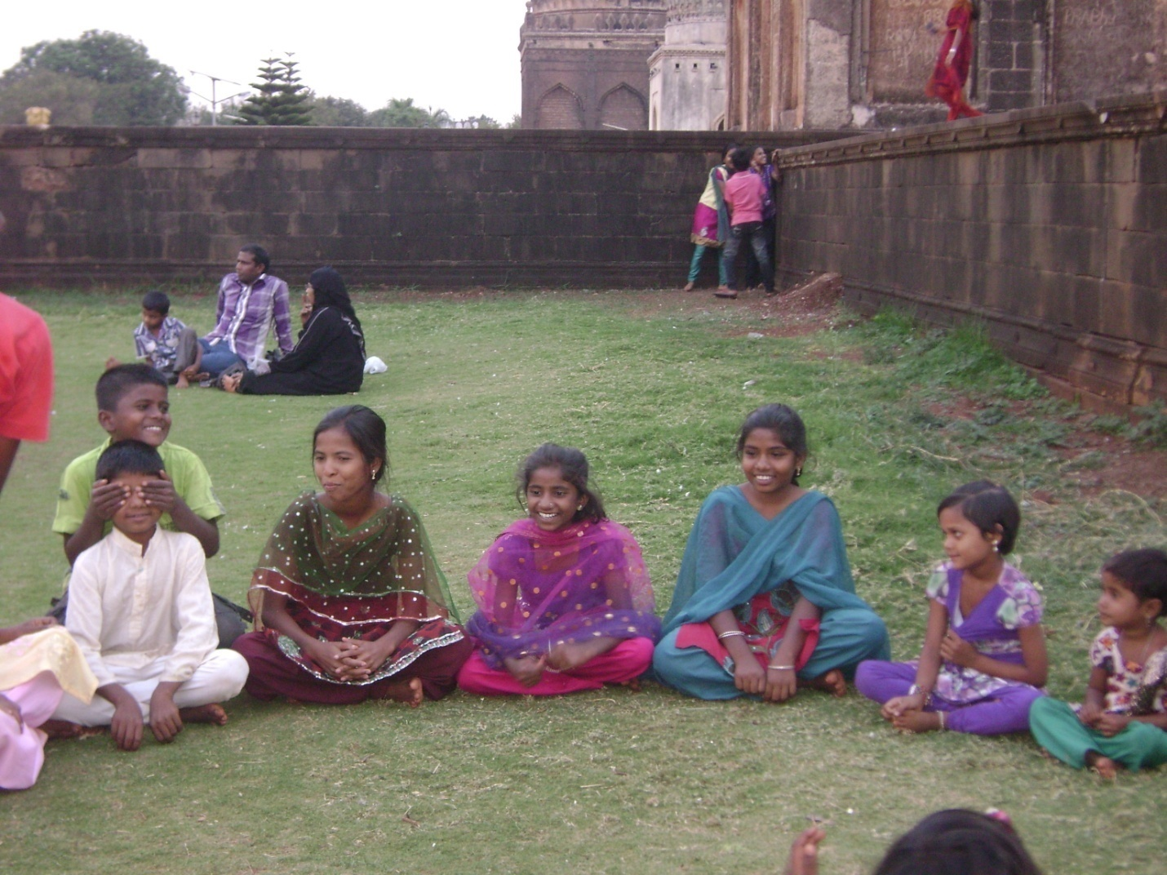
(Belaku children were enjoying the picnic event at Barid shahi Garden)
- The expouser trip of Belaku childrenhas gone to the Barid shahi garden and the children has been enjoyed by the follwing activities .
- Walking in the garden
-Playing, and singing songs.
-Experiencing the diffrent plants, and its importance.
- Eating the special food ( Biriyani)
Mrs. Sunita, Rebekka, Surkha ( Belaku Staff) also participated in the expouser trip.
10. street theater demonstration by the Belaku children
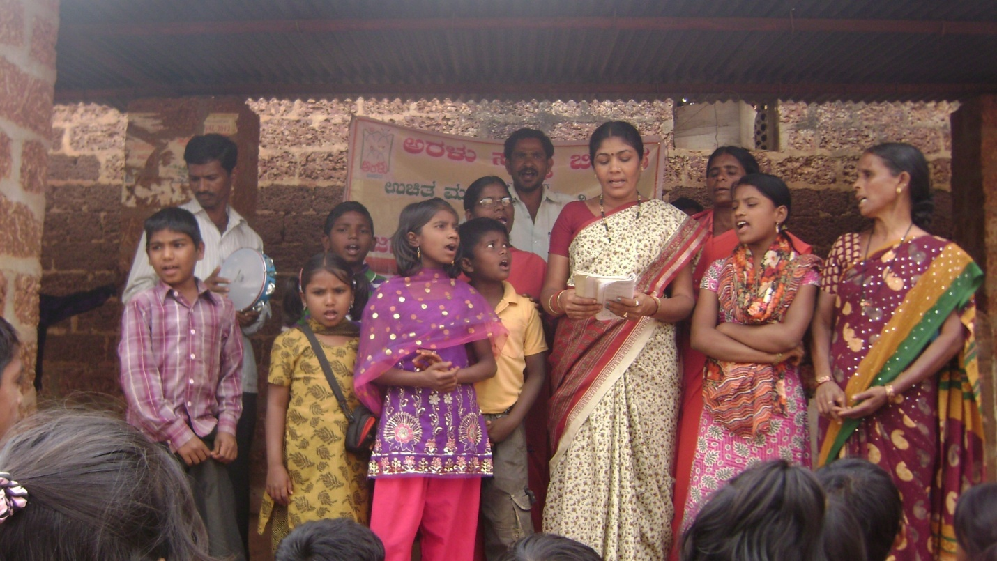
(Street theater demonstration by the Belaku children )
The Belaku children trained in street theator, on the issue of Child marriage, child labour, and Right education.
And they demonstrated in two yedlapur and Bellura village.
This programme is organised by the Mahil chaitannya Gramina Abhivruddi samsthe.

11.. Belaku Staff Meetings
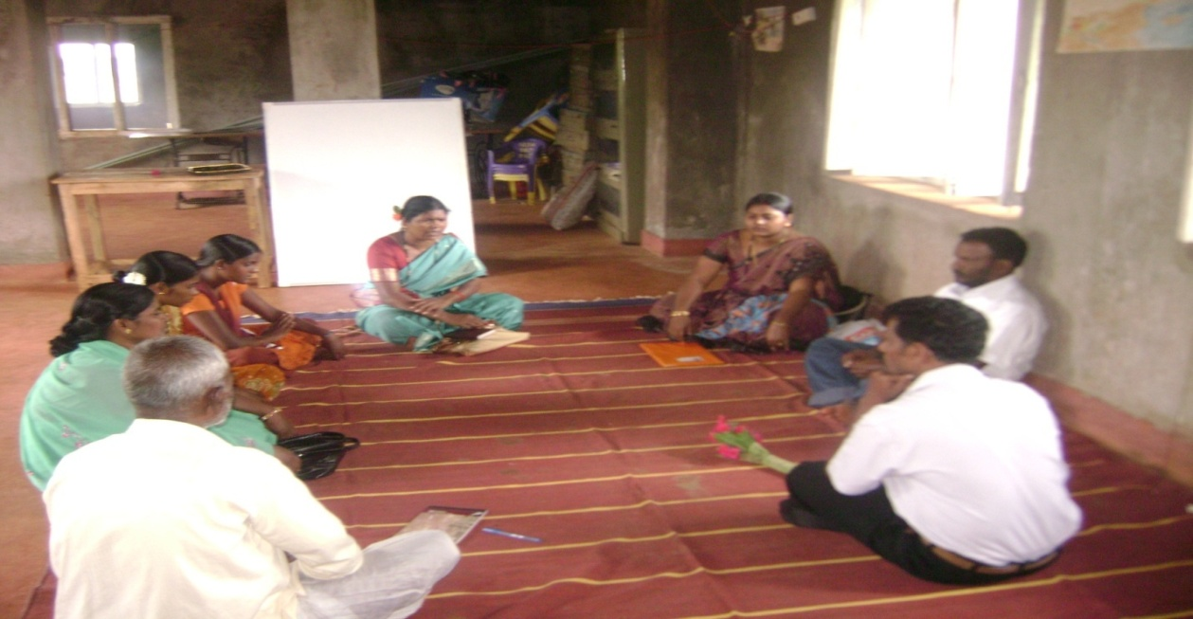
- Three staff meeting has been conducted to the Belaku staffs and the following issues are disscued.
- Child health
- Mantaining the quality of food
- Proper water supply.
- Cleaniness
- Morning yoga and dhyana
- Group work of the children ( like, gardening, cooking and cleaniness
- Status of education (Tution class)
Mr. Prasanna Murthy ( President of Aralu organisation) has been attend the Belaku statt meeting in the month of May-2013.

12.Personalities Visited to Belaku home.
The following persnalities has been visited the Belaku home for various purpose in Ist quarter.
1.Mr. Prasanna Murthy – President of Aralu organisation.visited the organisation to monitor the all projects of Aralu
2.Sr. Leena- from Bhandavi Children home Koppal district.has visited to interact with the children and the Aralu staff.
3.Mr. Nazar – Co-ordinator of VISTHAR,Bangalore.visited to experience the function of Belaku home.
4.Shailaja- Sir, Dorabji Tata Trust, Mubai has visited to conduct a meeting of possible fellows of SDTT.
6.Mrs. USHA, and JOSHEP HID-Fourm Bangalore.Visited to have look of Belaku home.
7. Students of VISTHAR Community Collage has visited the belaku home to intaract with the Aralu staff for learning issues of Child Right.

All the visitors intaracted with children and given the moral support, and also sugested the many development practicess.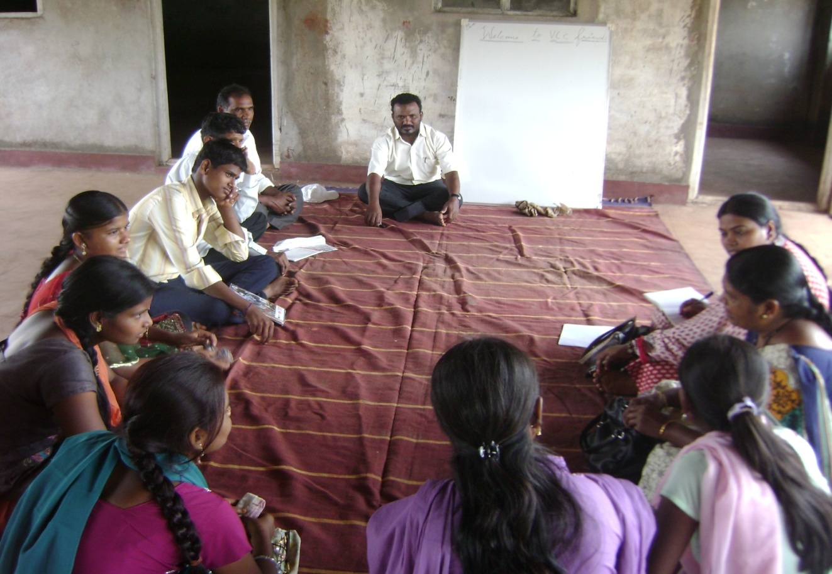
(VCC Student intaractin with the Aralu staffs, at Belaku home)

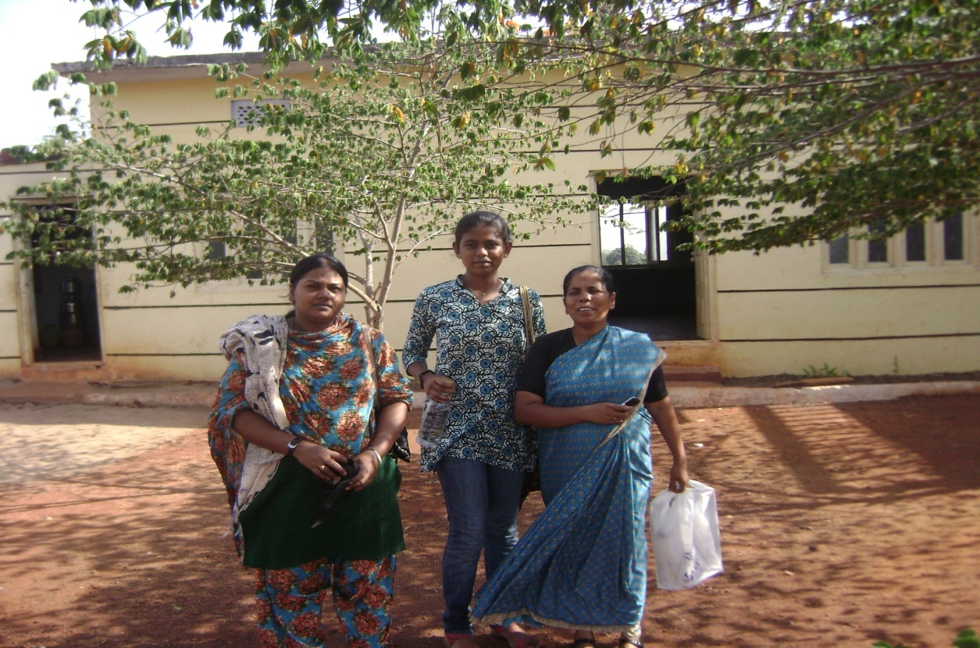
(Sr. Leena’s front of the Belaku home)

Challenges
1.Dhyana/cultural shed was felldown.
Due to havvy rain from 12 to 16 of July the Dhyan /cultural shed , which children use to use for morinig dhyana, cultural programme, staff meetings and training programmes.was felldown, now we are looking forward support to re-construct the same.

Reporter

Meril

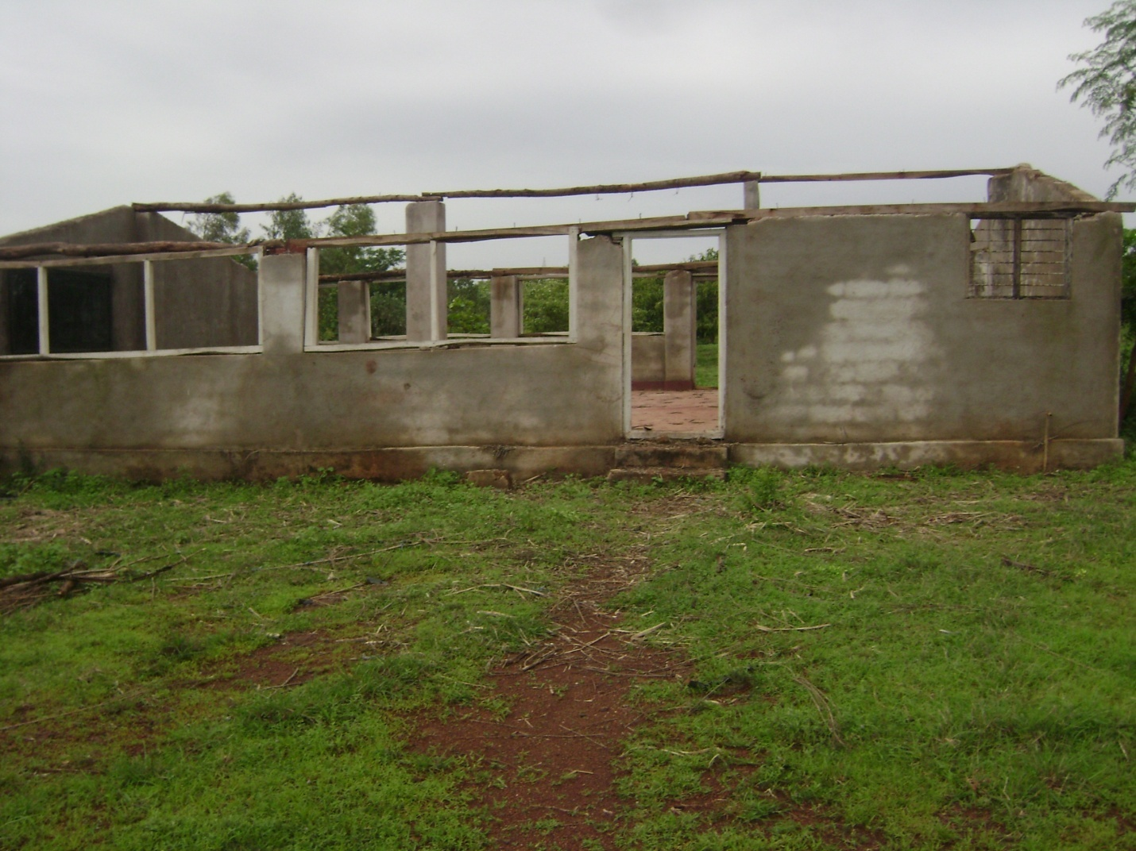
The present picture of dhyana kendra.

