RURAL DEVELOPMENT TRUST
Thirupporur, Kancheepuram District,
Tamil Nadu, India, PIN: 603 110

Activity Report for the Month of
August – 2014

Submitted To

ASHA FOR EDUCATION
USA

RURAL DEVELOPMENT TRUST
Thirupporur, Kancheepuram District
Activity Report for the Month of August – 2014

Introduction
Rural Development Trust is a public charitable organization working for the welfare of the migrant community especially for the Migrant Children by providing education in their native language and health care with the support of trained professionals. To impart quality education to the migrant children RDT is implementing Special School projects since 2005 at the construction sites located in Thiruporur and St.Thomas Mount Blocks of Kancheepuram District, Tamil Nadu with the generous financial and technical support from Asha.
This particular intervention was done for the children of Telugu Migrant Construction Workers to reduce the issues of illiteracy, school dropouts and child laborers and enjoy childhood rights and benefits.
RDT has been providing educational materials, uniforms, and providing nutritious noon meal to all children and conduct free medical camps for all common diseases.
RDT imparts quality education to the children in their native language by recruiting qualified teachers from other districts in all the Special Schools. As a whole, the migrant community receives guidance and support from RDT to alleviate their life difficulties and lead a safe life.
In this report the welfare activities carried out for the month of August 2014 for the migrant workers children through Special School for Migrant Workers Children are narrated with necessary data.
The data on enrollment of migrant workers children in Special School is given below for your kind perusal. RDT is making all the effort in identifying the migrant children who are not enrolled in any school, legal issues of adults related to work, reduce child labour from migrant community, medical guidance for the adolescent girls and pregnant women, health camps on Eye problems, Dental problems, Polio vaccination, referral services to the specialty hospitals and media publicity for the migrant community issues and legal remedy are some of the activities carried out by RDT for the migrant community.

Enrollment Details of the Children in Special Schools in 2014-2015
 | Day care Center |  | First  Std |  | Second Std |  | Third  Std |  | Fourth  Std |  | Fifth  Std |  | Sixth  Std |  | Seventh  Std |  |  |  | Total
Location of the Special School | M | F | M | F | M | F | M | F | M | F | M | F | M | F | M | F | M | F
Egattur | 12 | 17 | 10 | 11 | 4 | 5 | 3 | 7 | 1 | 0 | 6 | 6 | 2 | 12 | 1 | 5 | 39 | 63 | 102
Vaniyanchavadi | 4 | 3 | 4 | 3 | 5 | 4 | 2 | 5 | 2 | 3 | 5 | 3 | - | - | - | - | 22 | 21 | 43
Hiranandani | 4 | 3 | 4 | 4 | 3 | 4 | 5 | 1 | 2 | 3 | 0 | 1 | - | - | - | - | 18 | 16 | 34
Ammapettai | 3 | 8 | 5 | 3 | 2 | 3 | 3 | 3 | 1 | 2 | 2 | 1 | - | - | - | - | 16 | 20 | 36
Pudupakkam | 10 | 7 | 5 | 2 | 2 | 2 | 3 | 2 | 4 | - | 1 | - | 1 | 3 | - | - | 26 | 16 | 42
Melakotaiyur | 8 | 6 | 6 | 5 | 5 | 7 | 2 | 3 | 3 | 2 | 2 | 2 | - | - | - | - | 26 | 25 | 51
Chemanchery | - | - | 5 | 5 | 6 | 6 | 1 | 4 | 0 | 1 | 1 | 0 | - | - | - | - | 13 | 16 | 29
Kovilmaniyam | 2 | 6 | 8 | 2 | 3 | 2 | 1 | 0 | 2 | 0 | 1 | 0 | 0 | 0 | 3 | 0 | 20 | 10 | 30
Perumbakkam | 7 | 8 | 3 | 4 | 6 | 4 | 3 | 4 | 3 | 2 | 1 | 1 | 0 | 0 | 0 | 0 | 23 | 23 | 46
JPR Nagar | 5 | 4 | 4 | 4 | 2 | 2 | 6 | 1 | 4 | 4 | 0 | 0 | 0 | 0 | 0 | 0 | 21 | 15 | 36
Puravankara  (Pudupakkam) | 5 | 5 | 5 | 4 | 3 | 1 | 4 | 2 | 1 | 0 | 0 | 1 | 0 | 0 | 0 | 0 | 18 | 13 | 31
Thalambur | 6 | 4 | 4 | 3 | 3 | 1 | 0 | 1 | 4 | 0 | 3 | 0 | 0 | 0 | 0 | 0 | 20 | 09 | 29
Pudupakkam  (SHOBA) | 5 | 5 | 3 | 4 | 3 | 3 | 2 | 3 | 0 | 2 | 1 | 1 | 0 | 0 | 0 | 0 | 14 | 18 | 32
Total | 66 | 69 | 61 | 48 | 48 | 44 | 42 | 43 | 28 | 23 | 24 | 18 | 03 | 15 | 04 | 05 | 276 | 265 | 541
A. Distribution of Educational Materials
a. Special School for Telugu Migrant Workers Children at Real Vlaue Construction Site
In Real Value Construction Site Centre, the Special School for Orriya Migrant Workers Children is functioning well with 29 children consisting 16 boys and 13 girls. For the educational development of the children, RDT distributed the following educational materials. All the children received the support happily and attending the school regularly.
S. No | Educational Materials | Distributed in Numbers
1 | School Bag | 29
2 | Uniform | 29
3 | Crayons | 29
4 | Color pencils | 29
5 | Two Line Notebook | 29
6 | Single Line Notebook | 29
7 | Drawing Notebook | 29
The Coordinator of the RDT Special School Project Mr. Shankar Rao, visited the school and distributed the above said materials
b. Special School for Telugu Migrant Workers Children at Hiranandini Construction Site
In Hiranandani Construction Site Centre, the special school for migrant workers children is functioning well with a support of a trained teacher and 23 children are studying (12 boys and 11 girls). For the educational development of the children, RDT distributed the following educational materials. All the children received the support happily and attending the Special school regularly.
S. No | Educational Materials | Distributed in Numbers
1 | School Bag | 23
2 | Uniform | 23
3 | Crayons | 23
4 | Colour pencils | 23
5 | Two Line Notebook | 23
6 | Single Line Notebook | 23
7 | Drawing Notebook | 23

The Coordinator of the RDT Special School Project Mr. Shankar Rao, visited the school and distributed the above said materials
c. Special School for Telugu Migrant Workers Children at Mela Kottaiyur village
In Mela Kottaiyur Construction Site Centre, the Special School for Telugu Migrant Workers Children is functioning well with the support of a trained teacher and 30 children are attending the school and studying well. For the educational development of the children, RDT distributed the following educational materials for the school and children. All the children received the support happily and attending the Special school regularly.
S. No | Educational Materials | Distributed in Numbers
1 | Black Board | 02
2 | Pen | 30
3 | Pencil & Eraser | 30

The Coordinator of the RDT Special School Project Mr. Shankar Rao, visited the school and distributed the above said materials

B. Visitors
On 5th August 2014, the RDT Asst. Coordinator Mr. Shankar Rao invited the Block Resource Teacher Educators (BRTE) – SSA Mr. Thangamithran, Mrs. Shini and visited the Special School for Telugu Migrant Workers Children located at Real Value and Hiranandani Construction Sites. The purpose of the visit was to verify the school records and children’s enrollment. Mr. Shankar Rao explained the functional activities of the RDT special school and showed the records that are being maintained in the Special Schools. The BRTE appreciated the activities of the RDT Special Schools and suggested to enroll the children who are migrated.
C. Noon Meal Scheme
In all the Special Schools, RDT is providing nutritious noon meal to the children to improve the nutritional level and to encourage them to attend the school regularly. In many places the migrant children are vulnerable and anemic suffered with mal-nutrition. To avoid this situation, RDT is providing noon meal in all the working days. In the evening, biscuits or bread are distributed to the children for evening refreshment.
D. Staff Meeting
To review the progress of the RDT Special School, weekly meetings are conducted to the RDT Special School Teachers and Administrative Staff. These meetings are conducted on Saturdays. For the month of August 2014, the staff meetings were conducted on 2nd, 9th , 16th , 23rd and 30th .
In this staff meeting, the following matters are discussed.
- Initiatives taken for the development of the Special Schools
- Needs of the Special Schools
- Events proposed for the week or month
- Lessons Completed and Notes of lesson
- Children’s List
- Work Report
- Visitors Detail
The Teachers are submitting the progress report in their concerned school and these reports maintained properly in the RDT office. The teachers are being provided lunch and refreshment for their active participation.

E. Independence Day Celebration
In Egattur Village, RDT Special School for Telugu Migrant Workers Children is functioning in Government Building with the school enrollment of 75 children. For the Independence Day celebration, RDT invited the Egattur Panchayat President Mr. Baskaran to hoist the national flag and preside over the function. All the children gathered at 8.30 am and the teachers prepared the assembly and the Chief Guest arrived at 8.45 am. The flag hoisting ceremony started at 9.00 am and the children sang the national and flag song in Telugu language. After the flag hoisting, chocolates and mixture were distributed to the children.
Prior to the celebration, the children were trained in cultural events like dance, songs and speech about the national leaders.
- Second Standard Students sang the Telugu and English Rhymes
- Girls performed a dance for the national devotional song
- Children dressed like, Bharathiyar, Bala Gangathara Thilakar and Subash Chandra Bosh and delivered independence day message
- The students delivered speech about national leaders
The children who are participated in the events were honored and received prizes from Nehru Yuva Kendra, Egattur.
Like this in all the 13 RDT special Schools located Chemmencherry, Ammapettai, Koil Maniam, Mela Kottaiyur, Pudhupakkam, Vaniyanchavadi, Perumbakkam, Hiranandani, JPR Nagar, Chennai Pattinam, Kazhipattur and Kumaran Nagar) the Independence Day was celebrated with the support of local elected leaders and the parents.
G. Proposal to Procure ABL Cards at Aid India
The Aid India located in Rayapettai, Chennai is an organization produce Activity Based Learning (ABL) Cards and distribute to the educational institutions on order basis. To buy ABL cards to RDT Special Schools, Mr. Elumalai, Director, Mrs. Celine Coordinator and the Asst. Coordinator Mr. Shankar Rao visited Aid India and inquired about its availability of ABL cards in different languages. AID India people also willing visit our office and center on 18th August 2014 and willing to extend their support. After discussing with the teachers it was decided to buy the same for the primary level in all the special schools.
H. Purchase of Telugu Text Books Tamil Nadu Text Book Corporation
The Tamil Nadu Text Book Corporation located in Taramani is selling all kinds of Text Books in different languages. For the distribution of Text Books to the RDT Special School Children, All subject Text Books in Telugu Language was procured from the Tamil Nadu Text Book Corporation and distributed the Children in the following manner
Sl. No | Class | Number of books distributed
1 | First Standard | 25
2 | Second Standard | 18
3 | Third Standard | 20
4 | Fourth Standard | 03
5 | Fifth Standard | 15
6 | Sixth Standard | 19
7 | Seventh Standard | 06
 | Total | 106

Distribution of Telugu Text Books at Egattur
Sl. No | Class | Number of books distributed
1 | First Standard | 16
2 | Second Standard | 06
3 | Third Standard | 02
4 | Fourth Standard | 02
5 | Fifth Standard | 13
6 | Sixth Standard | 15
7 | Seventh Standard | 06
 | Total | 60

Distribution of Telugu Text Books at Semmen Cherry
Sl. No | Class | Number of books distributed
1 | First Standard | 6
2 | Second Standard | 8
3 | Third Standard | 4
4 | Fourth Standard | 1
5 | Fifth Standard | 2
 | Total | 21

Distribution of Telugu Text Books at Amma Pettai
Sl. No | Class | Number of books distributed
1 | First Standard | 2
2 | Second Standard | 2
3 | Third Standard | 2
 | Total | 6

Distribution of Telugu Text Books at Pudupakkam
Sl. No | Class | Number of books distributed
1 | First Standard | 3
2 | Second Standard | 3
3 | Third Standard | 3
6 | Sixth Standard | 4
 | Total | 13

I. Distribution of School Uniforms to the Special School Children at Egattur
For the uniformity of the children, RDT distributed School Uniform to 47 Children according to their size. The children are wearing the uniform regularly and feel themselves as a school going children like other local children.
Distribution of School Uniforms to the Special School Children at Hiranandani
For the Special School Children at Hiranandani, RDT distributed 23 Sets of uniform during the month of August 2014.
J. SSA Training for RDT Special School Teachers at Chengalpattu
To get training on SABL (Simplified Activity based Learning) and SALM (Simplified Activity Learning Methods) and ALM (Activity Learning Methodology) organized by SSA at Chengalpattu, RDT Special School Teachers Mr. Shankar Rao, Mrs. Premla, Mrs. Rajeswari, Mrs. Sandhiya, Mr. Rajesh, Mr. Amiya Kumar Jinna, Mrs. Kaviya, Mrs. Krishna Kumari participated on 25th and 26th August 2014.
During the training the teachers learnt the SABL (Simplified Activity based Learning) and SALM (Simplified Activity Learning Methods) and ALM (Activity Learning Methodology) with practical experience and also enlightened the teachers how to teach the lessons with natural methods with color difference of each subject. The teachers revealed that the training was useful for effective teaching to give quality education to the children.
K. Meeting at Collector Office
The RDT Director Mr. T.K.Elumalai and the Asst. Coordinator Mr. Shankara Rao attended a meeting at the Kancheepuram District Collector office. During the meeting Mr. Elumalai raised the issue of non distribution of noon meals to the RDT Special School Children at Thirupporur Block. He insisted the District Collector to pass order to distribute Noon Meal to all the Special Schools without any discrimination.
L. Reopening of RDT Special School at Koil Maniyam Village
There are large numbers of Telugu Families migrated from Andhra Pradesh living in Thaiyur Panchayat and involving in construction activity. In our area visit, Mr. Shankar Rao, Asst Coordinator identified 28 children between the age group of 6 to 14 at simply at home without attending school due to language issue. RDT sympathetically considered this issue and planned to establish a Special School at Koil Maniyam site.
On 28th August 2014, the RDT Director Mr. Elumalai and the Asst. Coordinator Mr. Shankara Rao with the support of a Telugu teacher Mrs. Santhoshi started the RDT Special School. By that time all the 28 children from the age group of 6 to 14 years presented.
The construction site supervisor Mr. Nataraj and Mr. Surendiran donated a Fan and Tube Light for the Special School. On the first day the Asst. Coordinator Mr. Shankara Rao took the class in Telugu Language and motivated the children to attend the school regularly.
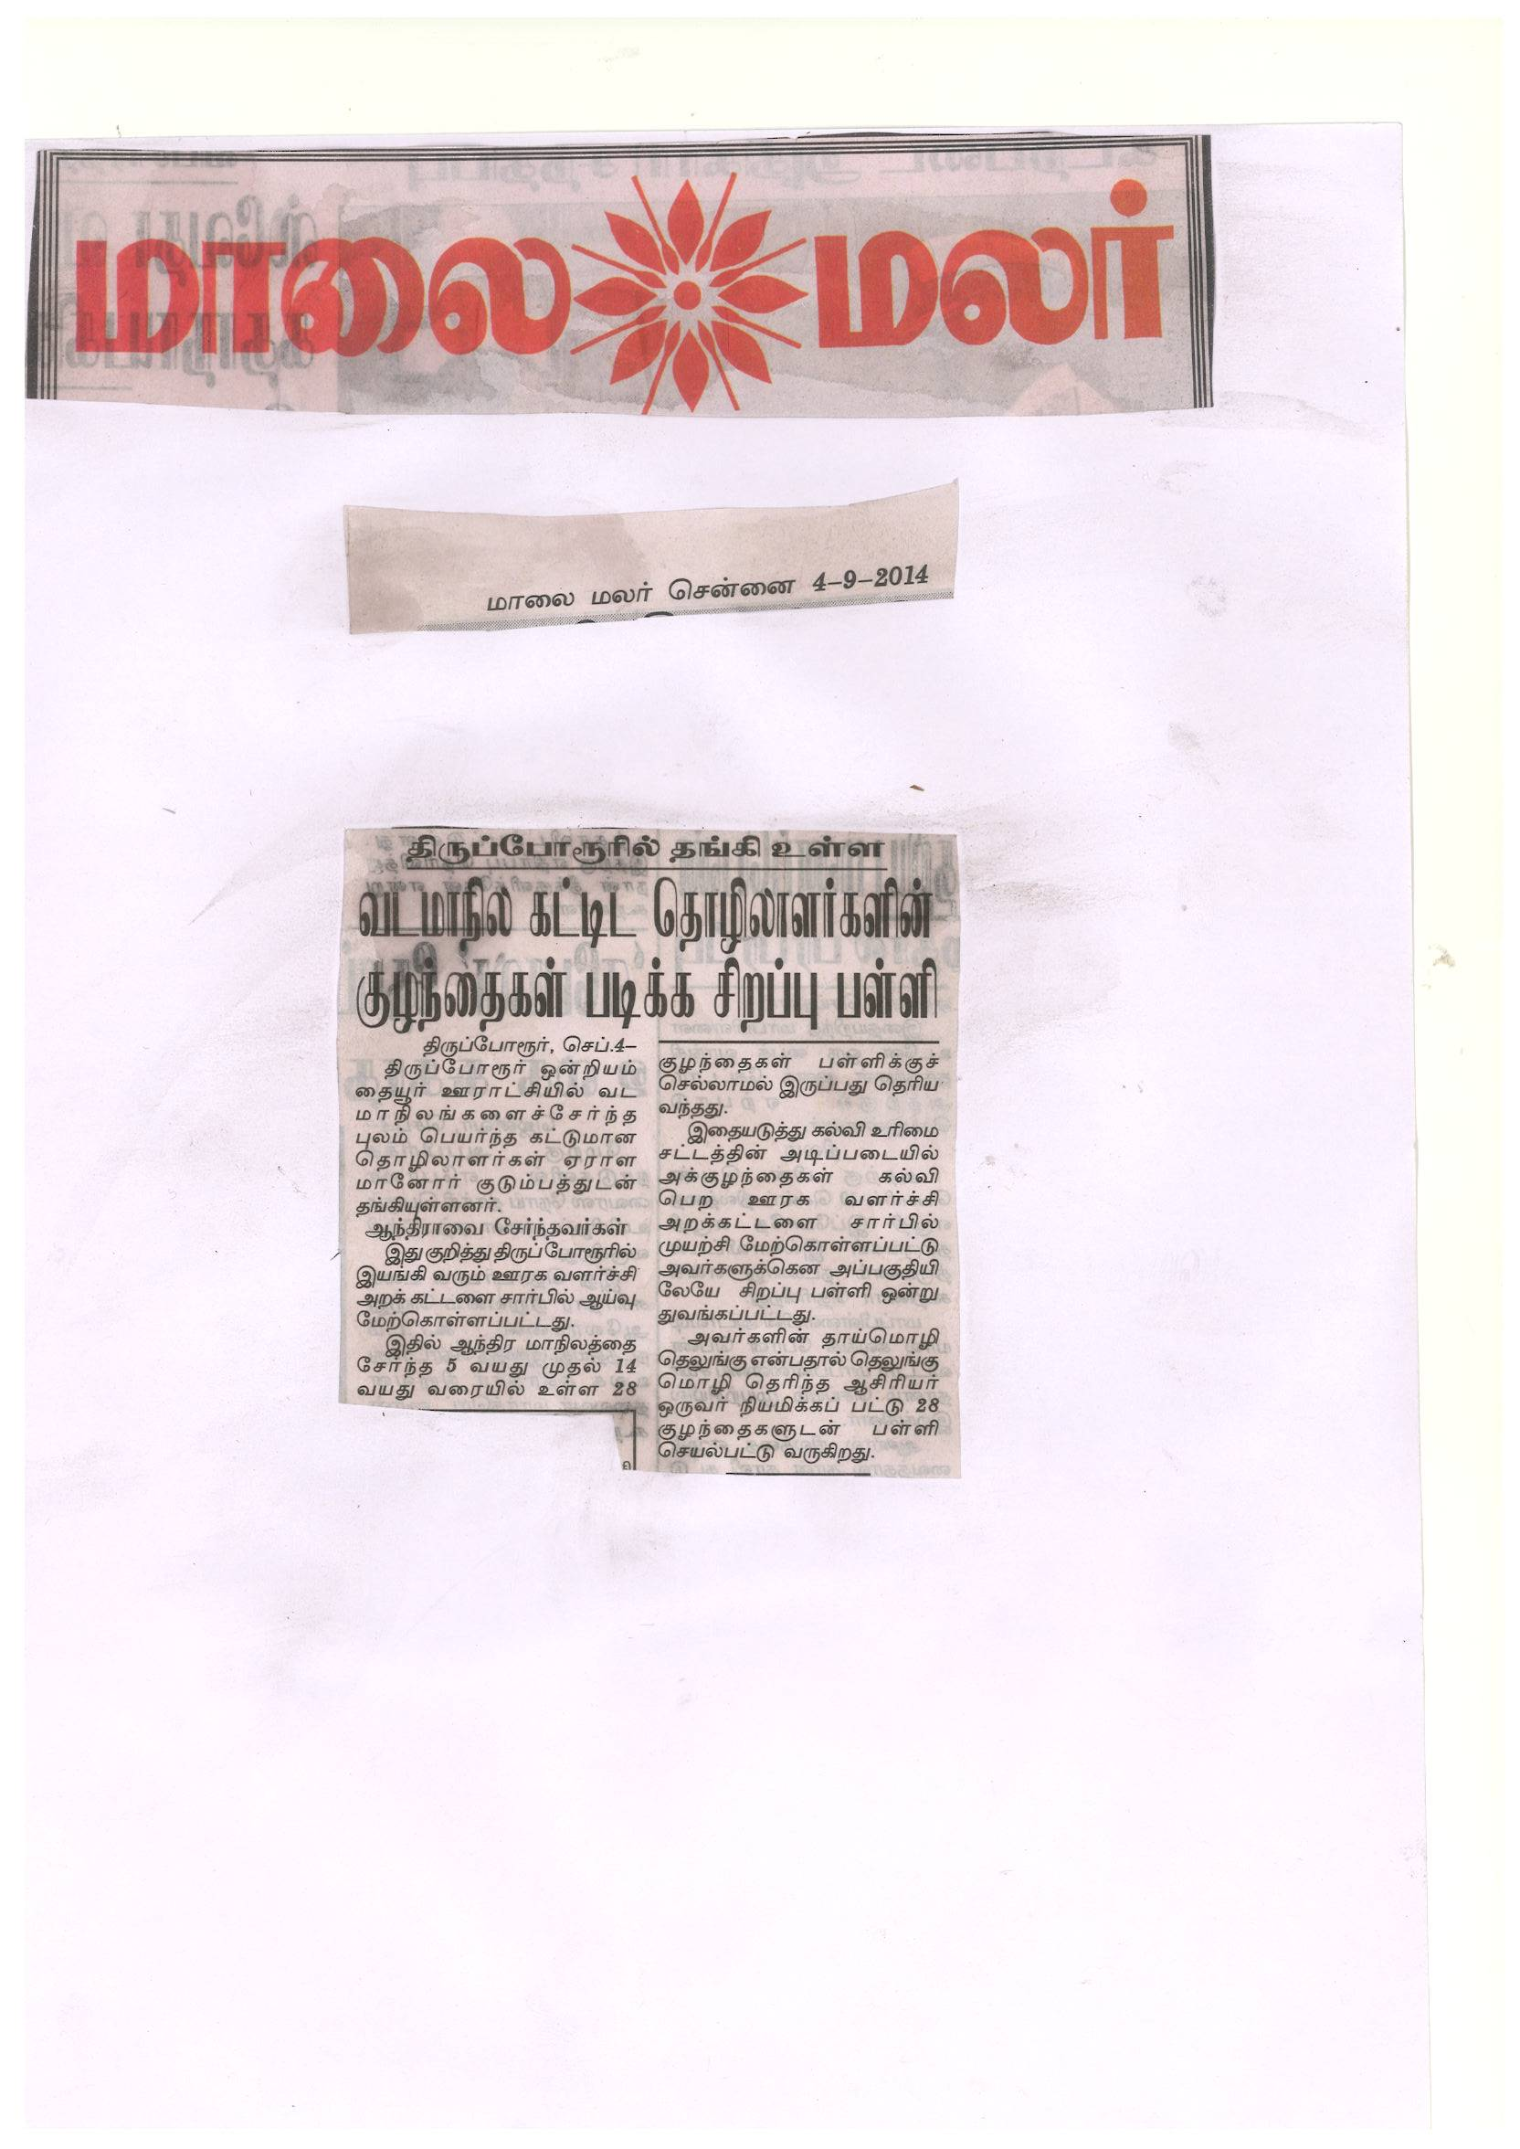
News Paper Clip – Published in Malai Malar News Paper on 4-9-2014

Distribution of Educational Materials to the Children at Koil Maniyam
S.No | Education Materials | Distributed in numbers | S.No | Education Materials | Distributed in numbers
1 | Two Lines Notebook | 28 | 10 | Black Board | 1
2 | Single Line Notebook | 28 | 11 | Chalk | 1 Box
3 | School Bag | 28 | 12 | Duster | 2
4 | Pencil | 28 | 13 | Mat | 4
5 | Pen | 28 | 14 | Broom | 1
6 | Eraser | 28 | 15 | Dustbin | 1
7 | Slate | 28 | 16 | Pot | 1
8 | Text book | 28 | 17 | Pot Cover Plate | 1
9 | Drawing Book | 28 | 18 | Tumbler | 1

L. Survey on Migrant Community
To identify the migrant community in the OMR construction sites, Mr. Shankara Rao, Mrs. Premala, Mrs. Rajeswari and Mr. Rajesh conducted a survey at Egattur village. In Egattur large numbers of migrant workers engaged in construction activity and stay with their families. In this survey they collected the information on why they have been migrated, how much salary they are getting here, what kind of work they are engaged, how much they are paying rent, what is the mode of transport, are they working in the same place or different construction sites. After consolidating the survey RDT will do action plan for the development of the migrant community.
Free Tuition Centre for the Irula Tribal Children at Oragadam
In Oragadam village located at Thiruporur Block there are about 35 tribal families living for more than more 50 years. These families are moving from different places for livelihood support and unable to send their children to school. In this situation, their children never enrolled in their school for many years.
After the intervention of RDT in Oragadam Village, we conducted a survey and identified 25 eligible children for school enrollment. To send them to the nearby Panchayat Union Primary School, RDT provided educational materials like school bag, notebooks, pen, pencil, sharpener, eraser, uniform, footwear.
In the evening RDT established a free tuition centre and identified a volunteer and assistant to give free tuition to all the 25 children. In addition to this RDT provided Black Board, 6 Mats, Chalk and refreshment to encourage the children to attend the free tuition regularly.

Conclusion
This month RDT made efforts to interact with children more specific on their rights aspects. The teachers were also gain good knowledge and experience from SSA trainings organized by Department of Education. We made efforts to work with government particularly district administration to provide more support for migrant children and communities. I am taking this opportunity to thank everyone behind particularly ASHA for Education to our initiatives for the welfare and rights of migrant children.

