Vigyan Ashram Site visit report March 2016 and June 2016

This time when I was in India for extended period, I got an opportunity to visit VA twice. Just after I reached India, I was invited by Yogesh Kulkarni to their Design Innovation Center inauguration by Dr.Neil Greshenfeld (Director, Center for Bits and atom, Massachusetts Institute of Technology (MIT), USA. The ceremony was attended by people from other Fab labs in the country, some government officials and representatives from various industries. The DIC uses the newly built space above the recently built kitchen and classroom with the support from Asha and INDUSA. Yogehs mentioned that to adjust with Dr. Greshenfeld’s schedule they had to wrap up the construction work and get it ready to host around 200 people. The students and staff worked hard to prepare the space. Even though somewhat incomplete, it place was good enough to hold this big group of people on a hot summer afternoon. They showed a small film on how building was made during the function. https://www.youtube.com/watch?v=r3X_9giYojk
Dr.Neil Greshenfeld talked passionately about his association with Vigyan Ashram and his vision for such facilities. After the inauguration ceremony, he had a chat with the press as well as various industry representatives.
Asha and INDUSA got a special mention in the speech by Ranjeet Shanbhag at DIC inauguration. I was presented with a plaque with a thank you note, a stole and solar powered emergency light made in VA at the hands of Dr. Greshenfeld.
I met my schoolmate and Yogesh’s collegemate whose name is also Yogesh Kulkarni. He has left his job to do phD and is planning to teach in colleges and universities. He likes VA’s work and is planning to collaborate with them with his prospective students.
Since everyone was busy with the program and the guests I did not get a chance to look at the new projects in VA. So, I made another site visit in June. My parents and the co-steward Deepali’s parents also wanted to visit VA for some time. We rented a van and all of us along with Yogesh went to VA. We started early in the morning around 7 am. On the way, I got a chance to catch up with Yogesh on the recent changes in VA.
This time I had more time to look around the newly constructed office room, classrooms and kitchen. Most of the office has been moved to a room in the new building. The old office shed is still there for historical reasons. Yogesh prefers to work from there.
In March there was just one big enclosed space upstairs where the ceremony was held. By month of June there were partitions forming different rooms along with furniture and wiring for rooms including the computer room were done. The partitions are such that they can be adjusted to create different sized spaces when needed.
We had breakfast in the VA kitchen. We saw quite a few girl students who had come there for short term courses.
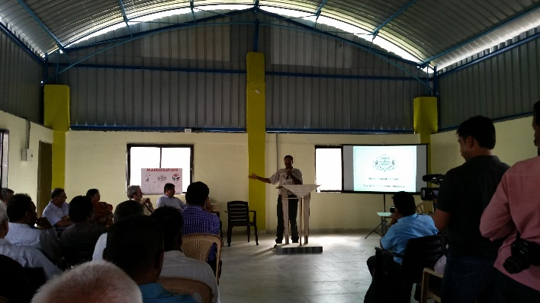  Big open space at the time of the DIC inauguration | 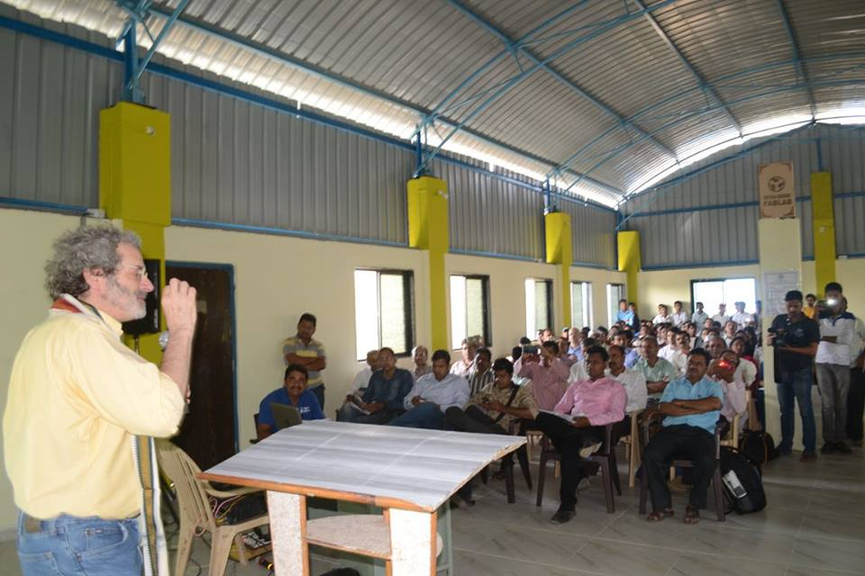  Dr.Neil Greshenfeld at the DIC inauguration
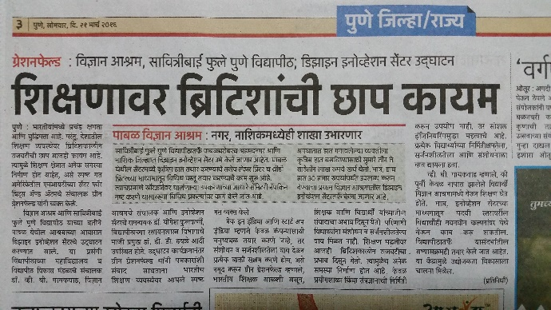  Article about DIC opening in the local newpaper | 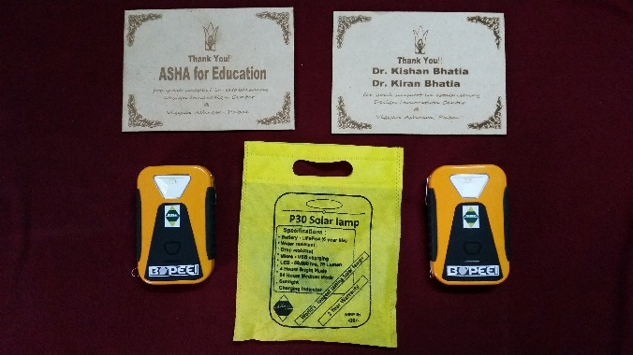  Token of appreciation given to Asha and INDUSA at the time of DIC inauguration
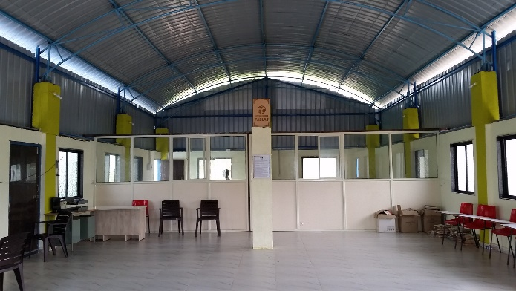  Partitioned space with one big hall for bigger group events | 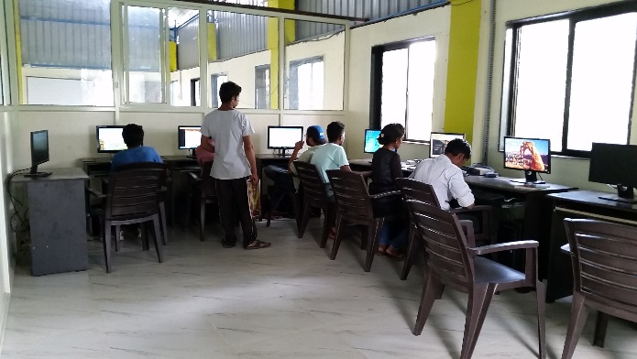  Computer room behind the partitions
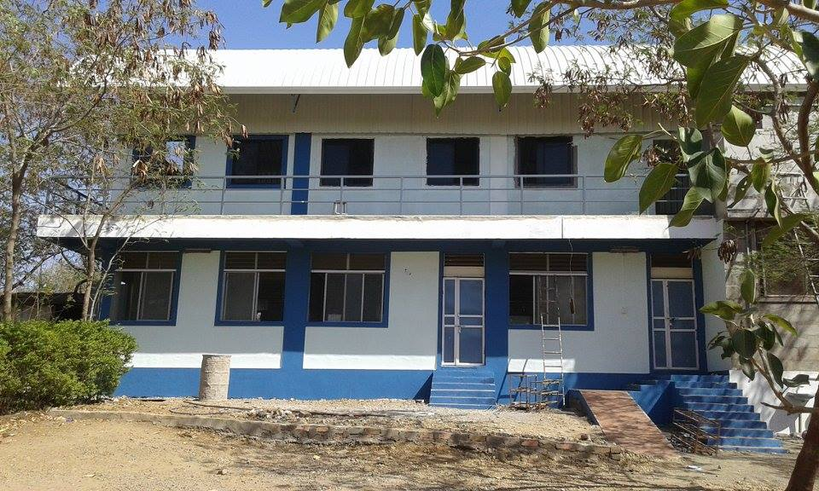  Building from one side | 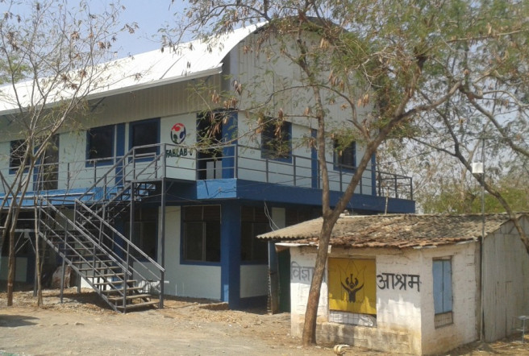  Building from the other side
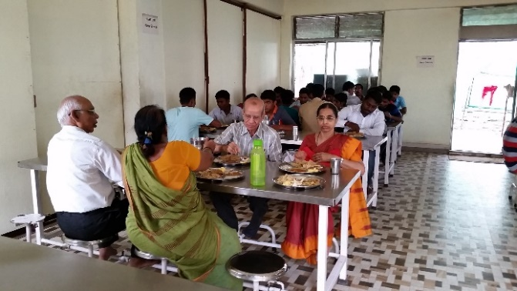  Our parents having lunch in the newly built kitchen | 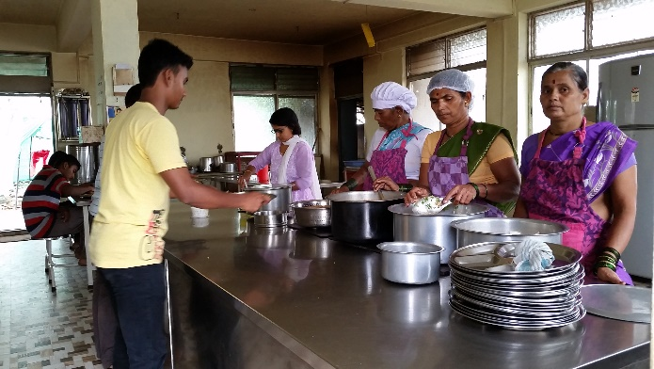  Serving area in the newly built kitchen

The day we went was the last day of the DBRT course. Few students had already finished their last section’s work and had left. Some students were working on finishing touches of their projects. Others were working in the computer lab on the documentation of their projects.
One of them came with us to show us around. He had been selected for internship in one of the big companies and was excited to go there to learn more.
The solutions including machines developed by the students were exhibited neatly with boards explaining the equipment on the campus. This was done as a part of “Technology Demonstration Park” project through DST support. This will help them showcase all their technologies at one place.
In the finishing school building, we saw the new bigger 3-D printing machine and a prosthetic hand printed on it. We met Ms. Supriya Kadam who is a DIC project coordinator there.
Another new development was the microbiology lab. The soil analysis and fertilizer dose calculation will be done in the lab. I talked to couple of staff members there. They have done M.Sc. in Microbiology. The lab was not properly protected from outside contaminants. We could walk in with our street shoes on. I expressed my concern to the staff members. They said it was not functional yet. Once it is, there will be stricter measures in place to control the outside exposure.
After visiting the animal husbandry section, food processing section and the polyhouse we were back in the kitchen for lunch. Since it was a last day of the DBRT batch, there was a feast including spiced rice and a sweet, Shrikhand. After lunch, we went to the office to collect some books and pamphlets that our parents wanted to take with them. We met Pawan Soni, the Science and Technology Entrepreneurship Development Program Manager. He was there since little less than a year. He helps students prepare the business proposals to be presented to the finance organizations like Rand De. He mentioned that looking at the opportunities the VA students get he wished he had got similar environment when he was finishing his education.

It was around 3pm when we started back leaving Yogesh to take care of his routine work.

A week after coming back from the visit parents saw Yogesh’s interview by the local TV channel. They were thrilled to see him on TV since they had met him in person just the previous week.

