Construction of Kitchen-cum-dining hall facility at VIGYAN ASHRAM , Pabal.

Background:

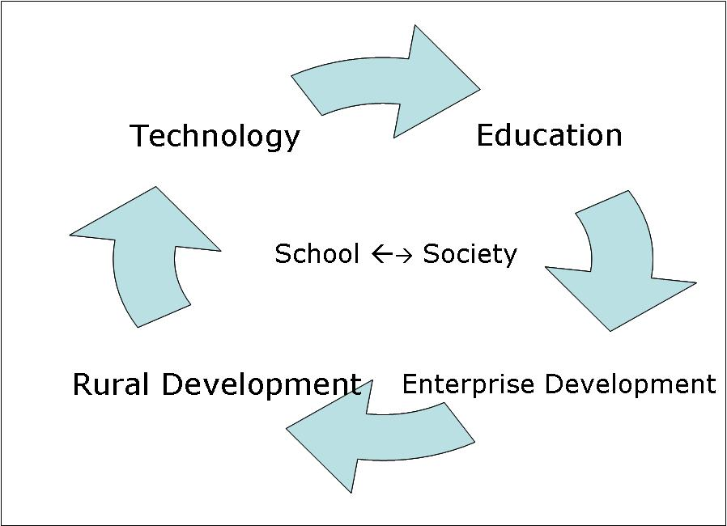
Vigyan Ashram (www.vigyanashram.com ) is a center of Indian Institute of Education (IIE) Pune. ‘Development through Education and Education through development’ is a motto of Vigyan Ashram (fig.1). VA believes that it is necessary to use technology to increase pace of our rural development. Therefore VA trains its students in various appropriate Technologies by ‘Learning while doing’ methodology. As a part of their training, students provide various services to the community. This gives students experience and confidence to start their enterprises.
VA has developed, adapted and disseminated several technologies over last 30 years.

INDUSA Endowments is an unregistered family fund created by Dr.Kishan & Kiran Bhatia in 2000, specifically to help enhance education, rural health-care and rural development.
Its vision is to
- Catalyze rural India’s development by 2020 through the efforts of its youth.
- Empower rural youth with the state of art educational technologies.
- Promote creative and innovative programs created by local NGOs for reforming secondary education.
INDUSA is supporting Vigyan Ashram’s educational program since 2007. Normally INDUSA gives support for infrastructure building having long term use, seed fund for research activities and funds for Library at Vigyan Ashram. So far INDUSA supported ‘INDUSA farm tank’, Indusa solar park, Indusa practical training institute and INDUSA CARE.

ASHA for Education is supporting VA – Diploma in Basic Rural Technology program from long time. Asha for Education- Seattle chapter supports VA and do all monitoring of the project and its fund utilization.
INDUSA donate its funds to Asha for Education for further monitoring and disbursement to VA.

Need of the project:
Vigyan ashram is running its unique one year diploma course DBRT (Diploma in Basic Rural Technology) from last 30 years. With increasing popularity of this course student’s intake capacity is also increased from 20 to 60 students during last 6-7 years. Present facility is of 697.18 Ft ² for kitchen. It is combined facility for cooking area, dining. We are using the same place for meditation and for group discussion (7.30pm to 9pm every day) in the evening. Library and account office and Directors cabin is attached to the same structure. The structure is almost 30 years old. There is immense shortage of space for serving food, dinning and cooking of food. Due shortage of space very often, we can’t accommodate day scholar and/ or short term course students and guests in the kitchen.
Height of the roof in the kitchen is very low and hence it is poorly ventilated with less natural light in day time. It also causes smoke in the kitchen.
During this monsoon season, there was lots of leakage from roof and also percolation and water seepage from the walls. It make it very much urgent to renovate the kitchen and nearby library space. We have decided to retain the office of Dr.Kalbag as it is!

Project objective:
- To build students kitchen-cum-dining hall with 1600 Ft ² build-up area by low cost, energy efficient technologies.

- In the tradition of Vigyan Ashram we decided to construct it using all available cost effective technologies and we have put ourselves target of achieving 50% of cost by using technically suitable solutions.

- The project will also be part of live projects of DBRT students.

Key feature of project -

This kitchen-cum-dining hall construction will have following distinct features like –
- Kitchen building will be constructed as demonstration unit of low cost and energy efficient technology as green building construction as per Third Industrial Revolution (TIR) concept *.
- Building architect will be designed by considering maximum benefit of natural ventilation and light for better cooking ambience, food storage, and meditation facility.
- DBRT students will participate and contribute in construction / manufacturing of building erection.
- Library will have TV facility and also facility to show documentaries to students.
- Construction technologies used will be documented separately, so as to make them available through INDUSATI.

* NOTE -
Third Industrial Revolution (TIR)
Dr.Kishan Bhatia (INDUSA Endowment) is actively engaged with VA in mentoring for various program and working with VA team on new technology possibilities. They are brainstorming a lot about renewal energy possibilities for rural development. Both VA and Dr.Bhatia got fascinated by the book of Jeremy Rifkin on ‘Third Industrial Revolution (TIR) { http://www.thethirdindustrialrevolution.com/ , http://en.wikipedia.org/wiki/The_Third_Industrial_Revolution:_How_Lateral_Power_is_Transforming_Energy,_the_Economy,_and_the_World }

Design consideration & Specifications:

Sr No | Design specifications | Proposed low cost / energy efficient technology | Remark
1 | 1600 Ft ² total Buildup area with dinning, food serving, cooking , material storage space for 60 to 70 students.  (Ground floor) * | Low cost construction technology like use of Mud block, hollow block, pre-fab cement sheet, ferro cement construction, PEB column …… any other economical and energy friendly material. | This will save cost on RCC construction and DBRT students will participate in manufacturing of bricks , ferro cement block etc.
2 | Energy saving  (First Floor )* | Use of INDUSA solar cooking park parabolic cookers, Smokeless Chula, Kitchen waste Biogas, Solar LED lamps. | INDUSA Solar Park - Solar Scheffler – 800 Ft² ( 200 Ft² cooking room + 600 Ft² open space) , PRINCE – 40 ( 200 Ft² open space)
3 | Guest dinning cum TV- Library hall- 400 Ft²  (First floor) * | PEB construction and / or ferro cement construction | Guest dinning with library, TV room for documentary presentation.
4 | Water recycling | Kitchen water recycling, Rain water harvesting with filtration unit. | Recycled kitchen water/ rain water will be used for gardening.
5 | Natural light & ventilation | Necessary arrangements in construction plan.

Note * -
- Said building will be 2 story with 1600 Ft² build-up area at ground floor and 400 Ft² build up area for guest dining hall + 800 Ft² solar cooker installation at first floor.
- Area required for biogas plant, water storage tank, water filtration unit etc are not considered in above plan estimation, so provision for this space will also be made while finalizing drawings.
- All above measurements are worked out tentatively; final design will be made as per selection of low cost alternative technologies and suggestions of architect/ fablab to make maximum use of available space.

Cost consideration:
Sr.No | Details | Amount
1 | Construction cost  (1600 Ft² Ground floor + 600 Ft² First floor = 2200 Ft² * 600 Rs / Ft² ) | Rs.13,20,000.00
2 | Plumbing | Rs.50,000.00
3 | Wiring / electrification with solar panels | Rs.30,000.00
4 | Rain water harvesting / Kitchen biogas | Rs. 50,000.00
5 | Kitchen and dining furniture | Rs.100,000.00
6 | Re-installation of solar cookers | Rs.20,000.00
 | Total | Rs.15,70,000.00

Time line:

The house will be completed in all respect before June 2014.

Architect / Methodology of construction:

Fab Lab @ Barcelona is network member of VA and we know the people there from long time. We approach them to help us in developing a TIR house at Vigyan Ashram. They enthusiastically agreed to it.

Architect Ms.Jui Vijaykumar: She is budding architect and associated with VA from her childhood. She will help us in translating ideas from TIR, green low cost technologies in Indian context.

Design:

A sample design is attached. We are working on finding different materials. Once that is finalized, we will prepare the final drawing.

Output:
Through the project, 1600 Ft ² students kitchen will be constructed with advance low cost and energy saving technologies. This kitchen building will act as demonstration model for VA visitors, rural construction entrepreneurs with proper documentation of feasibility of each technology.

Photo:

Existing kitchen structure, furniture, storage facility and plate washing area attached separately.

