INDUSA-CARE annual progress report
- Project Objective:-

- To train rural youth in t new IT services useful for rural areas. Introducing new software tools in IBT –DBRT curriculum to improve its quality.
- To setup the infrastructure for content creation at Pabal, this will be available through INDUSAPTI site.
- To develop online content in the form of Power point presentations, video based activities, Do-it-yourself (DIY) manuals for Individuals, IBT, Non-IBT school students / teachers on various appropriate technologies.
- To post developed study material on existing blog of INDUSAPTI institute (http://www.learningbydoing.wordpress.com/)

- Work done so far:-
- INDUSA-CARE centre establishment:
INDUSA –CARE computer lab is established at Vigyan ashram, Pabal campus. This computer lab is been used for conducted computer application training, development of educational content, providing computer based services to villagers etc. Lab is having following important features as
- A computer lab with 2 desktop computers, 1 N-computing M300 system for 3 client terminals and 3 UPS based power back up system. (These computers are purchased and assembled by DBRT students as a part of their computer assembling course)
- Android based tablets – 2.
- Furniture like 20 chairs, 8 Computer Tables, 2 cupboards and library books.

INDUSA CARE Computer Lab Images

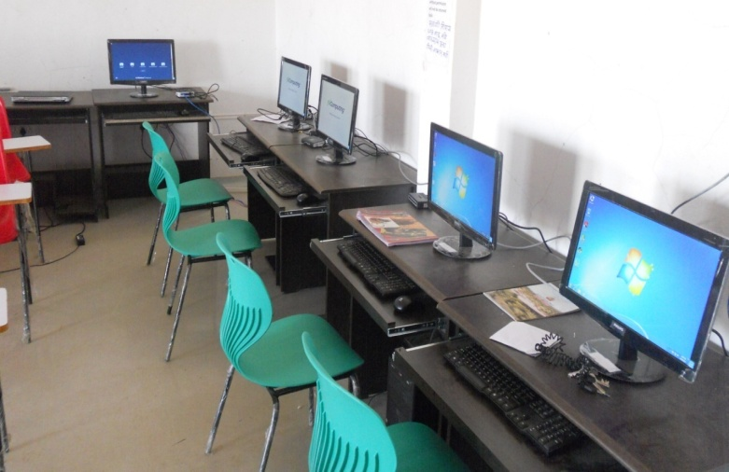
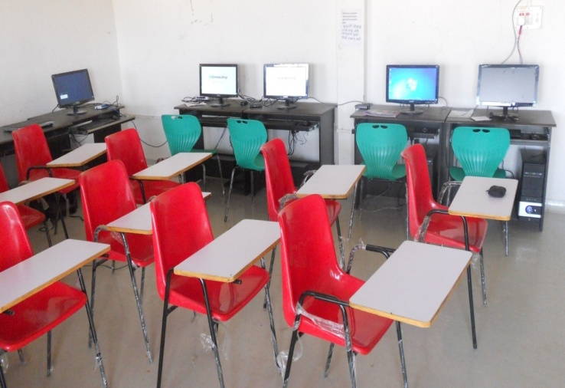

- Content development and on field testing:
As per project objective, new content development work is in progress. Libraries of rural technologies are been development in the form of Power point presentations, Video’s, Technology manuals etc which will ultimately converted in the form of OERs. Following table give overview of total content developed so far under this initiative as -
SR No | Particulars | Total No
1 | Power-point (PPT) presentation | 93
2 | Student Seminars (PPT) | 87
3 | Manuals /Documents | 45
4 | Videos | 26
5 | Complete OERs (Ready for uploading) | 15
6 | OER ready for final editing | 18

Please refer to Annexure at the end of the document for details
These rural technologies after final editing are uploaded on www.learningwhiledoing.in web site. OER will be uploaded on website once website structure is finalized.
National Institute of Open Schooling (NIOS)
VA entered in collaboration with NIOS to develop OER on Rural Technology. This exercise was financed by NIOS. NIOS conducted 5 workshop for VA team on development of OER . We also took help of volunteers of Engineers without border (EWB) for development of OER. 15 active IBT science teachers & 5 teachers from VA participated in OER development. 32 OERs were developed with NIOS support they are also uploaded on NIOS website (www.nios.ac.in) All these developed OERs are also distributed to other IBT schools through IBT instructor’s trainings on CDs. Our field officers visiting IBT schools ensure use of OERs at Schools.
These OERs are field tested at Pabal on DBRT students. For example OER developed on Basics of electrical wiring and developing social space garden (Both developed by EWB volunteers) has been tested in 2 IBT schools in August 2013.
Nai Talim Sameettee
Demonstration of OER and its utility in connecting work with theoretical concept was presented at 75th anniversary of Nai Talim at Wardha in Nov 2012. The framework developed for OER under this project is selected for further development of curriculum for implementing Nai Talim pedagogy. A workshop was held in June 2013 at Sevagram and Sept 2013 at Pune for further development of content. A national workshop is being planned in Nov 2013 at Ahmedabad for developing content in OER format. VA is providing technical support to develop website to them (www.naitalim.in) under INDUSAPTI project.

- Website development (www.learningwhiledoing.in):
It was decided during visit of Asha for Education team in March that website need to be improved by doing user – interface study. A project was given to IDC (IITB) student to develop design for website. She developed template by studying our requirement and content. Quotations were called and work is given to web developer in Pune. He is working on the website. It took more time than expected due to technical difficulties.
- ICT tools for entrepreneur (tablet project):
For identifying and testing new software tools for IBT/ DBRT curriculum and apps in open source available, two tablets were purchased. Some applications like Autodesk Sketchbook Express , Kingsoft Open office , K-9 Email Client , Teamviewer ,webofcam , skype are downloaded and tested. We also found that low cost tablets like Karbon have limited use since they are only Wi-fi based; internal memory is very less and limitation with hindi/Marathi typing etc.
A work on identifying apps useful for rural entrepreneur is under consideration.
- CARE Trainings:
Computer centre facility is used for conducting computer training for DBRT students. Around 40-50 students regularly use this training / lab facility for practicing computer skills, preparing project reports / seminars etc. Apart from DBRT students, short term computer course on computer basics and assembly (7 students completed) and Basics of accounting- Tally (4 Students enrolled) are also conducted for rural youths.
Students during their course work also provide computer repair & maintains service for Pabal and nearby villages. We also got data entry work of accounting of 2 schools as practical work.
We are working on identifying good resource persons to accelerate the program.

- Funds utilized:-
Funds received / INDUSAPTI – INDUSA CARE budget and expenditure and funds balance till Aug end
Sr. NO. | HEADS OF EXPENDITURE | BUDGET ALLOCATED/ SANCTIONED | APRIL 1,2012 TO MACH 31, 2013 | FROM APRIL 1,2013 TO AUGUST 31, 2014 | TOTAL EXPEN- DITURE | FUNDS AVAILBALE FOR EXPENSES
(i) | (ii) | (iii) | (iv) | (v) | (vi) | (vii)
A | INDUSAPTI | 557622 |  |  |  | 294848
1 | Man power INDUSA PTI |  | 156050 |  | 156050
2 | Travel INDUSAPTI |  | 10470 |  | 10470
3 | INDUSAPTI CAPITAL |  | 95188 | 1066 | 96254
 | Total (A) |  | 261708 | 1066 | 262774
B | INDUSA CARE | 1128000
1 | INDUSA CARE Computer |  | 117380 | 4465 | 121845 | 889702.25
2 | INDUSA CARE TRAVEL |  | 1550 | 53725.75 | 55276
3 | INDUSA CARE UTILITY |  |  | 4465 | 4465
4 | INDUSA MANPOWER |  | 6712 | 50000 | 56712
 | Total (B) |  | 125642 | 112655.75 | 238298
C | INDUSA Library |  | 2925 |  | 2925
D | INDUSA SOLAR |  | 9939 | 3925 | 13864
 | TOTAL (A+B+C+D) | 1685622 | 400214 | 117646.75 | 517861 | 1167761.25
Annexure: - Student Seminar PowerPoint PPTs section wise details
Energy and Environment | Agriculture | Workshop | Home and Health
Basic Electricity | Bamboo | Drawing to scale | Blood Group
Battery | Bird Flu | Area and volume | Arogya
Ohms Law | Nursery | Forces | Atmchintan
Biogas | Artificial Insemination | Microstructure of materials | Bakery business
Contour Lines | Dairy | Costing | Cleanliness and health
Cooking stoves | Exotic Veg | Carpentry | Cosmetics
Dc Generators and Motors | Emu Farming | Casting and molding | Gram swachhata
Diesel Engine | Fisheries | Cement Bricks | History of sewing machine
Dumpy Level | Goat Farming | Engineering business | How to give seminar
Electricity bill and auditing | Honeybee | Lathe Machine | Instant Dhokla Mix
Electricity Generation | Poultry | Measurements | Kalin business
Electrical business | Murghas | PEB | Masala
Groundwater and pumps | Monsoon and drought | Plumbing | Fast Food
Wind energy History | Catchment Area | Pulleys and Gears | Preservation
Water pollution | Nursery business | Workshop Safety Awareness | Scorpion bite
Maps,plane table surveying | Soil Testing | Volume of cylinder | Self Help Group
Plastic pollution | Mechanization of farming | Welding and Welding Machine | Shistachar
Pumps and types |  |  | Soap
Refrigerator |  |  | Solar Dryer
Soak pits |  |  | Soymilk
Sanitation and waste management |  |  | Soy processing and tamarind
Screen printing |  |  | Tea making
Solar cooker |  |  | Tamarind
Solar system |  |  | Yogasan
Solar energy
Solar panels
Rainfall measurement
Wires and cables
Wiring accessories
Wireless technology
WLL
Total 29 | Total 17 | Total 17 | Total 24

