Annual Report

2011-12

Vigyan Ashram
At.Post.Pabal Dist.Pune 412403
(A center of Indian Institute Of Education)
128/2, J.P Naik Path, Karve Road, Kothrud
Pune 411038, Ph : 020-25424580
www.vigyanashram.com

Vigyan Ashram Annual Report 2011-12

Financial year 2011-12 is marked with many landmarks for Vigyan Ashram. Most importantly Vigyan Ashram got new workshop facility with the financial support of M/S GKN Plc. and up gradation of food lab with the support of M/S Praj foundation. Important achievements and highlights of different projects of Vigyan Ashram are presented here.
Vigyan Ashram is working on the philosophy of ‘Rural Development through Education System (RDES)’. Fig. 1 shows the model of RDES program. To achieve objective of rural development, VA has program, as shown in the fig. 2.

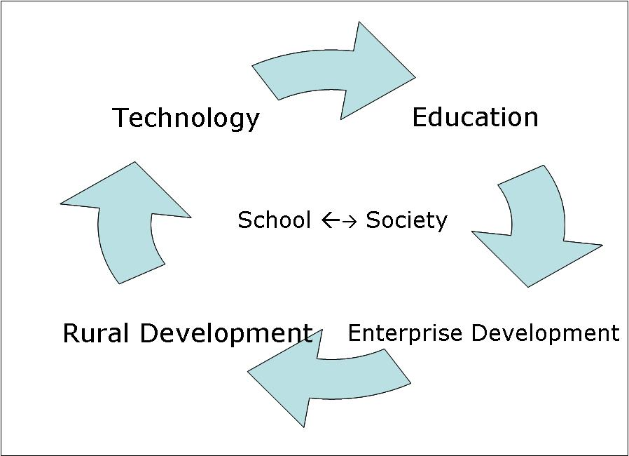
Figure 1: RDES philosophy

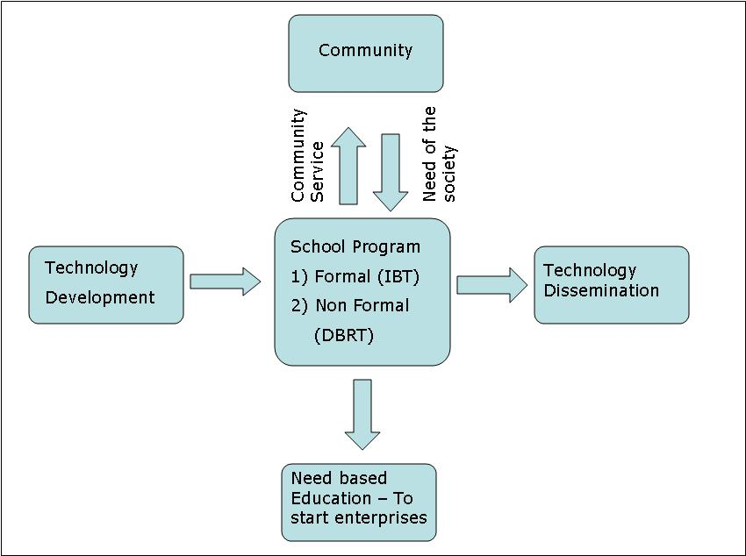
Figure 2: RDES Program

Following are the main program of Vigyan Ashram and major financial partners in the project (Table1).

VIGYAN ASHRAM’S PROGRAM
Technology Development | Non formal Education (DBRT & short term courses Program at Pabal) | Replication Program (Introduction to Basic Technology (IBT)) Program | Infrastructural Development at Pabal center
Supported by
Dept of science and Technology, INDUSA | Asha for Education, E-Boss, Honeywell, individual donor | Asha for education, Lend-a-hand-India, Suzlon foundation, Hemendra Kothari foundation, Govt of Chattisgarh, AID, | GKN Sinter Metal, M/S Praj foundation,  Govt of Maharashtra, E-BOSS (Mr.Meghaji)

We want to take this opportunity to thanks our donors, parents, students, villagers in Pabal and community for their continuous support and faith in Vigyan Ashram’s team.

A) Diploma in Basic Rural Technology (DBRT) Course

(Supported by ASHA for education – Seattle chapter, Mr. Dai Meghaji,)

- DBRT (one year residential program) is a flagship program of VA. This year (2010-11) batch of 37 students completed their training on 25th June. Almost all students got the apprenticeship in the industry or small enterprises as per their interest.

- DBRT 11-12 batch started their training on 10th July with 46 students including 7 girls. We have students from Madhya Pradesh, Assam, Gujarat, and Chhattisgarh besides students from all parts of the Maharashtra.
- Year was busy with students project work, community services, site visits, cultural events, picnic, bicycle trek and lot of other things.
- Students earned Rs.86000/- by giving community services to the community.

Following courses conducted during the year 2011-12 at Pabal.

Course – 1 year Duration
Diploma In Basic Rural Technology (DBRT)  Welding cum fabricator | 50 Students  24 students
Course – 1 – 3 month ‘s Duration
Poultry | 22
Welding and Fabrication | 3
Electrical Technician- 15. | 15
Food Processing –13. | 13
Electric appliances-5. | 5
Electric appliances-5. | 5
Motor Rewinding – 1. | 1
Basic agriculture -1. | 1
Computer (Basic & technician) | 8
Masson / civil construction - | 12
TOTAL | 139

B) IBT Program in Formal School
VA’s educational philosophy of ‘Rural Development through Education System’ is implemented in formal school (8th -10th class) through ‘Introduction to Basic technology’ (IBT) Program. We are trying to disseminate various appropriate technologies to villagers though IBT Program. The Program is implemented in 111 schools and 12130 students. Number of schools and their funding partner are given below.

 | Lend-a-hand-India (Plan100) | Suzlon foundation | Hemendra Kothari foundation | Govt. of Chhattisgarh and Unicef | Bayer crop sciences | Others & self financed
No. of schools | 60 | 17 | 4 | 5 | 5 | 22
No of students | 5570 | 2059 | 371 | 1010 | 680 | 2440

Major Highlights of IBT Program :
- 2502 students appeared for SSC board exam in March 2012. Out of which 2484 students passed the exam. ( 99.32% result)
- Total value of community service provided by IBT schools is approx. Rs.21.49lacs
Year | No. of Schools | Amount in Rupees | Avg. per School (Rs)
2011-2012 | 86 | 2149802 | 24998
2010- 2011 | 55 | 1435395 | 26098
2009- 2010 | 52 | 880351 | 16,929
2008- 2009 | 53 | 404640 | 7634

- IBT – Instructor’s training
Various need based training programs were conducted at Pabal and Khed-Shivapur. New technologies are introduced and new teaching techniques, use of computer in IBT training etc were introduced through training.
Details of training are as:
IBT Co-ordinators trainings- 31 teachers
IBT Instructors training- 245 instructors
- Geographical Spread
IBT program is spread over more than 27 districts. Hemendra Kothari foundation is supporting us in introducing IBT program in forest areas of Pench and Tadoba tiger reserves. With the active support of Unicef in Chhattisgarh, IBT program has started in 5 schools of Bijapur district. We have modified strategy of implementation in Chhattisgarh by introducing one month intensive training program for tribal youth at Pabal. One batch of 33 youth from Bijapur and 24 youth from Datewada district got training at Pabal. Schools in Bijapur district made spectacular progress in agricultural activities, electrical maintenance work. Those services were not at all available in the interior forest areas.
- Instructors as entrepreneur
Twenty one IBT instructors started their own enterprises this year. Following are the details of Instructors & Enterprises started by them.
Sr. No | Name of Entrepreneur | Address / Location | Type of Enterprise
1 | Mr.Vishal Jagtap | Chas Kaman - Pune | Welding Workshop
2 | Mr.Sachin More | Shevgao - Ahmadnager | Motor Winding
3 | Mr.Diwansing Rajput | Shanimandal/ Tillali- Nandurbar | Electrical Shopy.
4 | Mr.Sharad Pagare | Bhrahmanvel - Nandurbar | Compuer training centre
5 | Mr.Pravin Patil | Rajale - Dhule | Sugyan computer Centre
6 | Mr.Amit Patil | Nagas - Sangali | Sugyan computer Centre
7 | Mr.Mudale | Walaval | Welding Workshop
8 | Mrs.Chavan | Mangaon – Raigad | Tailoring shop / training classes.
9 | Mr.Sandeep Rane | Kambhavade - | Welding Workshop
10 | Mr.Shinde | Rahimatpur – Satara | Motor rewinding
11 | Mr.Raut | Rahimatpur – Satara | Welding Workshop
12 | Mr.Ghorpade | Hasur | Electrical
13 | Mr.Bassapa Patil | Belle wadi | Welding Workshop
14 | Mr.Gujar | Shirdhon | Electrical Shopy
15 | Mr.Powar | Shirdhol - | Welding Workshop
16 | Mr.Dipak Bawane | Kallamb - | Welding Workshop
17 | Mr. Gajanan Ghonge | Kallamb | Welding Workshop
18 | Mr.Sunil Kumbre | Jalaka | Electrical Shopy
19 | Mrs.Pratibha Jambe | Jalaka | General Store
20 | Mr.Parsibe | Mukutban | Electrical contractor
21 | Mr. Malluvar | Mukutban | Computer centre.

- Technology Transfer through schools - Following technologies are transferred through schools.

AGRICULTURE - ANIMAL HUSBANDRY | ENERGY - ENVIRONMENT | liquid soap and selling  Water testing  Healthy diet, Soya milk, Blood testing  ENGINEERING  Ferro cement,  Bamboo treatment,  Different Agriculture tools  Ventilation – Low cost housing,  Toilets,  Pedal power, Fabrication Plumbing,  Construction
Drip irrigation, Sprinkler, Vermi composting, Vemi wash, Humidity chamber,  AQUA Portal, Nursery  technique, Azolla culture,  Weather SMS, Seedling Tray,  Vaccination, Poultry, Age estimation, Rice cultivation, Crop using(SRI), Mulching, Silage Feed, concentrate for animals, Pest control, Soil testing | Solar cooker, LED lighting ,Biogas, Soak  pit, Watershed, Smokeless stove(Check  dam construction),  Earthing, Inverter  Computer applications  Plain table survey GPS  FOOD PROCESSING  Solar drying, Food preservation,  Drying of vegetables  Medicinal plant cultivation Soil testing , Mosquito control (Gappi Fish breeding),Making phenyl,

C) TECHNOLOGY

DST Core support: Following is the brief of various R&D carried out by core staff supported by DST.

Sr No | Particular | Status
 | A) Technology
1 | Domestic Solar  Egg Incubator | 500 eggs.. capacity models is designed and fabricated and ready for testing. Earlier trial on lab scaled (20 egg) model was tested with 85 % success rate.
2 | A portable  oleoresin extraction unit | A portable model of supercritical extraction is under development. First unit is fabricated and tested for extraction of oleoresins from custard apple seeds, eucalyptus leaves, ginger etc and results are satisfactory.
3 | Ambient  temperature dryer | Ambient temperature dryer is fabricated (1000 kg fresh leaves capacity), which can be used in drying agro produce for oleoresin/natural color/flavor extraction. Trials are taken on leafy vegetables, fruits. It is found that drying is done effectively & with less energy input.
4 | Business models  around solar equipments | Different solar equipment is used for making food products and its economics is established for WSHG.
5 | Aqua ponics | Demo model of aquaponics is being piloted for studying basic Concepts of this technology.
6 | Low cost  Bio-fertilizer  production unit | Low cost Bio-steel reactors for production of Gibralic acid (GA), Rhizobium, PSB’s, trichoderma etc is fabricated against order from neighbouring farmer.
7 | Portable wet  garbage disposal unit | To address wet garbage disposal issue, portable wet garbage disposal bio-gas unit is made from locally available material like PVC pipes. Trial for Bio-gas output and quantity of waste disposal is going on.
8 | Food processing  Recipes | Food processing recipes for local fruits like Tamarind, wood apple, tomato etc are prepared with their economical viability.
9 | Agricultural tools | Small agricultural tools like Drip winder, coconut peeler, sprinkle stand, ploughs are prepared with their drawing details.
B) Content development work -

1 | IBT Practical hand books as  AaiBayaaMi~kIÊ ]jaa--pyaa-varNaÊ SaotI PaSauPaalanaÊ gaRhAaraogya. | New practical hand books for IBT (Introduction to Basic  Technology) students/staff. These books cover all relevant practical’s details and their correlation with school curriculum.
 | Open Educational Resource(OER) Development | OER development for Rural technology course is in progress in collaboration with National Institute of Open Schooling (NIOS), Pune.
2 | Online portal www.learningwhiledoing.in | A new web site is developed to upload design Manuals / educational contents.
3 | Multimedia CD –  - Fabrication design basic & advance.  - Electrical basic & Advance. | Interactive multimedia content is developed for 2 courses of Vigyan ashram.

D) Workshops / Seminar / Meetings

- STARs forum conference
Vigyan ashram organized Second annual STARs (Skill Training for Advancement of Rural Societies) in Pune on 26th and 27th Dec. STARS forum serve as a collaborative body for mutual support of those engaged in vocational skills training, facilitate advance in this field and promote innovative approaches to reach larger needy populations. Vigyan Ashram is a host organization for the STARs forum & conference.
Total 56 participants from 38 organizations working in skill training in rural areas attended the conference. Following themes were discussed during conference
i) Emerging trades in rural areas ii) Training Needs of the Unorganized Sectors iii) Training Needs & Retraining of the Self-employed Persons iv) Improving Distribution of Relevant Information & enhancing communication with individuals & NGO’s in field.

- Following staff participated in various conferences and workshop.

S.N. | Name of conference /  organiser | Staff member | Topic of training
1 | Fab conference (LIMA) | Yogesh Kulkarni | FABLAB annual conference at LIMA (PERU), sponsored by MIT, USA - Digital Fabrication.
2 | SP Jain Institute of management study ,Mumbai | Rahul Jagtap  Ranjeet Shanbag | NGO management, Brand Building, Human resource management.
3 | Entrepreneurship development – trainers trainings – 5 day workshop by I-create Pvt.Ltd at Panji, Goa | Anand Gosavi  Kailash Jadhav | Entrepreneurship development.
6 | Rural development Action Group – Meeting, IIT, Pawai. | Ranjeet Shanbag | Rural Technology development.
7 | Recognition of Prior Learning (RPL) – 2 days workshop at  New Delhi. | Ranjeet Shanbag | Framework development for RPL in India.
8 | CSR meet , Infosys Pune | Ranjeet Shanbag | Yearly MGO meet.
9 | 1 day workshop on Conceptual Clarity & Brain Storming on  WCE at Vigyan Ashram. | ALL STAFF | Work Centric Education.
10 | NCRI & A.N Sinha Institute,  Patna, Bihar | Yogesh Kulkarni | Contextualising Nai Talim – science and technology Best Practices

E) Infrastructure Development

- Finishing school building
A new workshop ‘Finishing School building’ was inaugurated on 30th Nov at the hand of Mr.Kevin Smith (CEO, GKN Plc) and Mr.Dilip Walse Patil (Speaker, Maharashtra Assembly). The workshop is constructed from the award of GBP 100,000 (Rs.74lacs) received to Vigyan Ashram.
Details about the workshop:
- Dimension of the building is 21.34 * 24.30 mtrs and basement of 6.8*11.85 mtr ( Approx.5600 sq ft). Total cost of construction (civil + PEB) is approx.Rs.48.49lacs i.e Rs.866/- per sq.ft.
- The new building is housing workshop section, Fab lab and electrical section. Food testing laboratory and agricultural section are at lower level.
- New machineries were purchased and installed. Similarly partition for fab lab and electrical section is done. Industrial standard electrical wiring is done.
- In addition to the award amount, GKN Sinter Metal (Pune) volunteered and done epoxy flooring of the complete building and also done landscaping (Green lawn) around the building. Now we have good workshop facility at Pabal.
We are thankful to team of GKN Plc and GKN Sinter Metal for their generous support and involvement in the project.

- Modernisation of food lab :
We have upgraded our food lab with the support of M/S Praj Foundation. We have installed facility like homogenizer-cum-mixer, Fruit pulpier, cutting machine, Glassware’s and chemicals etc. A food testing laboratory is established on the ground floor of finishing school building. The facility was inaugurated at the hands of Mr.Pramod Choudhary (MD, Praj Industries) on 3rd Nov. We are thankful to Praj foundation for their support.

- New Hostel Building work is in progress. The work is carried out by PWD dept from local MLA funds.

- Construction of staff quarter building is started. Our long time supporter Mr.Daimond Meghaji is supporting construction cost of the building.

F) Exhibitions,/ Award/Recognition:
1) Dr.Yogesh Kulkarni received Maha-Intraprenuer award 2011 from Praj industries. Award amount Rs.1 lac is donated to Vigyan Ashram corpus.
2) Dr.Yogesh Kulkarni received Seva Gaurav Purskar from Chimanlal Govindlal trust. Award amount Rs.10000 is donated to Vigyan Ashram corpus.

I) Donations to Ashram

Vigyan Ashram is thankful to donors and well wishers. Their contribution helped us to fulfill many necessities at ashram.

Sr. No. | Name | Donation In Rs.
1 | Mrs. Rosemarie Dai Meghaji | 509865.00
2 | Mr. Yashwant Limaye | 50000.00
3 | ASHOK SHANKAR VAIDYA | 18000.00
4 | DIPTHI DEEPAK LOKANDE | 500.00
5 | E-BOSS | 60000.00
6 | KULKARNI GANGADHAR RAMCHANDRA | 5000.00
7 | MIRA KALBAG | 500.00
8 | M.N.BHAVE PUNE | 100.00
9 | NARENDRA CHOTHE | 1001.00
10 | SHETH CHIMAMLAL MEMO.TRUST | 10000.00
11 | Shri. Rutesh & Parul Shah | 10000.00
12 | VIJAY SHANKAR NANDKARNI | 100.00
13 | ASHOK SHANKAR VAIDYA | 18000.00
14 | BHARAT PACHANGE | 1000.00
15 | DILIP VAIDYA | 501.00
16 | DR. GIRISH BHIRUD | 500.00
17 | RITA KALBAG | 5000.00
18 | SHIVAJI BHATT | 5000.00
19 | VASANT BILGIKAR | 10000.00
 |  | 705067.00
Apart from monetary contribution many people donated equipment to Vigyan Ashram in kinds.

J) Projects Completed this year
- GKN finishing school
- Praj – Modernization of food lab

K) Ongoing Projects:

DBRT program  IBT  Improving facilities in ashram  Technology projects  Improving Agri. Facilities/Solar Park/INDUSAPTI | Asha for education –Seatle, Mr. Diamond Meghaji, Tech Mahindra foundation  Asha for education-Seatle, Suzlon foundation , Bayer crop sciences , Lend-a-hand-India, AID – Chicago, HK foundation, unicef, Govt of Chattisgarh  PRAJ foundation (Animal husbandry project), Mr.Daimond Meghaji(Staff quarter), Govt of Maharashtra (Students hostel)  DST (Govt. of India)  INDUSA

L) Staff Matters

Following staff joined this year: Mr.Pawan bhise (BE. Electronics), Mr. Bhausaheb Waghule (Electrical), Mr. Amitraj Deshmukh (BE. Electronics)

Following staff resigned this Year:
Mr.Bhausaheb Waghole, Mr. Siddharth Kulkarni.

Total staff: 24

{DBRT: 9, IBT: 6, Kitchen: 3, FABLAB- 1 DST: 2, Director: 1, Pune Office: 2}

M) Management committee:
BOT-IIE reconstituted Program organizing committee (POC) of VA as Management committee of VA. This committee comprises of Dr.Arvind Gupta (Chairman), Mr.Ashok Kalbag, Mr.Vijay Kumar, Mr.Sunil Kulkarni, Mr.Pravin Mahajan, Dr.Aruna Giri, Mrs. Mira Kalbag and Dr. Yogesh Kulkarni.
Meeting of PAC & MC were held on 16th May, 19th June, 18th Sept, 3rd Nov, 27th Feb at Pabal.
Vigyan Ashram is thankful to PAC member, Management committee members and Board of trustees of Indian Institute Of Education for their support and guidance.

N) Volunteers:

Vigyan Ashram appreciates efforts taken by many volunteers in promoting VA program. Vigyan Ashram also acknowledges support of villagers in Pabal, IBT schools and their management for their continuous support.

Finance:
Project Income Expense Summary 2011-12

Sr.No | Name of Project | Opening Balance | Receipt | Expenses | Closing Balance
1 | VAM Pabal Campus
 | DBRT | -250635.7 | 972668 | 639102 | 82930.3
 | IBT Asha | 88461.63 |  | 400 | 88061.63
 | Asha Project (Pabal) | 462442.8 | 703973 | 1051887 | 114528.55
 | Honeywell | 180000 |  |  | 180000
 | Total A | 480268.73 | 1676641 | 1691389 | 465520.48
 | VAM | -393893 | 1260595 | 314512.5 | 552189.5
 | Fab Lab | 68939.67 |  |  | 68939.67
 | Total B | -324953.33 | 1260595 | 314512.5 | 621129.17
2 | IAP Project | 1066778.86 |  |  | 1066778.86
3 | ADRA | 545050 |  | 2886 | 542164
4 | Bayer | -33707 |  | 9628 | -43335
5 | Indusa Project | -123634.92 | 591461 | 33839 | 433987.08
6 | Bridge Loan | 325188 | 16000 |  | 341188
7 | PLAN 100 | -822721 | 3250130 | 2662989 | -235579.89
8 | Core Grant | -60187 | 890932 | 1061969 | -231223.75
9 | SUZLON | -457178 | 2715284 | 2497766 | -239660.11
10 | Suzlon AH | 176466 |  |  | 176466
11 | GKN | 3175767 | 3148328 | 6026436 | 297659
12 | HKF | 49359 | 2157800 | 1047260 | 1159898.51
13 | PRAJ | 218546 | 112151 | 300234.5 | 30462.5
14 | IBT Chhatisgarh |  | 1315600 | 1058280 | 257320.25
15 | Oleoresin Project |  | 50000 | 78257 | -28257
16 | STAR Forum |  | 103500 | 88881.69 | 14618.31
17 | Interest Received* |  | 120013 |  | 120013
 | Total C | 4059726.94 | 14471199 | 14868426 | 3662499.76
 | Grand Total A+B+C | 4215042.34 | 17408435 | 16874328 | 4749149.41
* Interest on Saving A/C Received at IIE (Pune)Account.
As per IIE account dept. VA corpus as on 31st March 2011 is Rs. 7362985.57/
-
Interest on Corpus Rs. ___________________(To be received from IIE)
VA Corpus as on 31st March is Rs. _______________.

Photo Gallery:
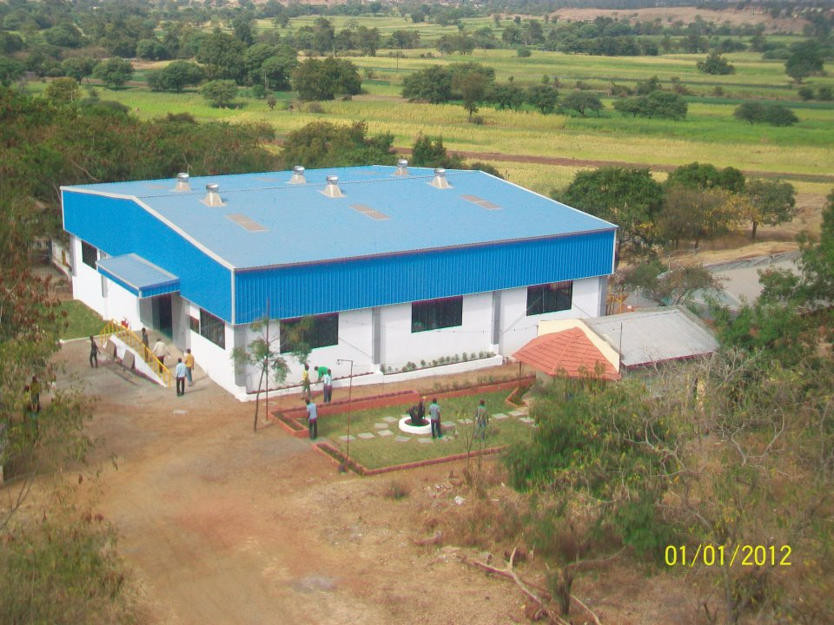
New Workshop building @Vigyan Ashram Pabal

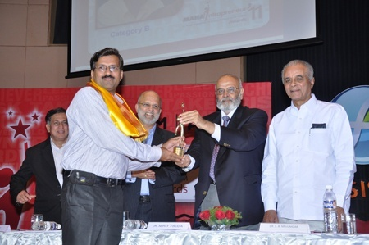

Dr. Yogesh Kulkarni Maha- Intraprenuer Award 2011 constituted by M/S Praj Industries.

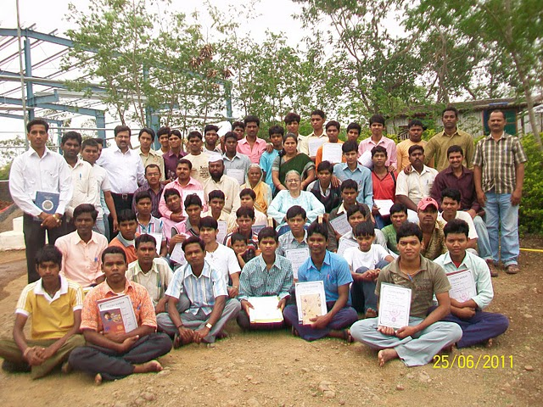DBRT Batch Graduation

