Common toilet block for Dormitory

Introduction / Need of the Project:
Vigyan Ashram (www.vigyanashram.com ) is engaged in training rural youth in various technologies. VA trains students at different levels. It has DBRT (Diploma in Basic Rural Technology) program for school dropouts, Design Innovation Center (DIC) for Graduates and post graduates students and various short term courses. In last decade, VA has upgraded its infrastructure including Ladies hostel (20 girls), Boys hostel ( 40 boys), PG hostel ( 12 students), classroom and admin block and computer center.
We have modified old hostel hall as dormitory. It can house upto 15 short term trainees. The hall is used for short term trainee, IBT instructors training etc. We have demolished old toilet block since they were beyond repair.
Therefore we propose to construct a toilet near the dormitory (Old hostel no.3). It will be useful for the short term trainee as well as guests visiting ashram.
Asha for Education is supporting Vigyan Ashram in development of infrastructure. Therefore this proposal is being submitted Asha for Education for their consideration.

Objective of the proposal:
- Construction of toilet block next to old hostel dormitory.

Nature of facility created and its intended use:
We need additional toilet block. This will help in serving day scholar student and also visitors. Number of day scholar is between 20-40 every month. Further, we also have short term training program.
Number of visitors visiting VA in more than 2000 people in a month. Many times they come in a bus of 40 people. We have only one toilet block for common use ( 3 gents urinal and 1 gents toilet and plus two toilet block for ladies). It become difficult to serve all of them.
Therefore we are proposing to construct additional toilet block comprising of three gents and three ladies urinals and toilet. We wish to have one Indian and one Western toilet in both ladies and gents toilets.

Location of the toilets :
It will be behind the Gotha shed and next to dormitory. It will be accessible from Agri-Animal husbandry dept, solar park and for short term trainee.
Present common toilet block is near the entry. Proposed toilet will be at the last end of ashram campus.
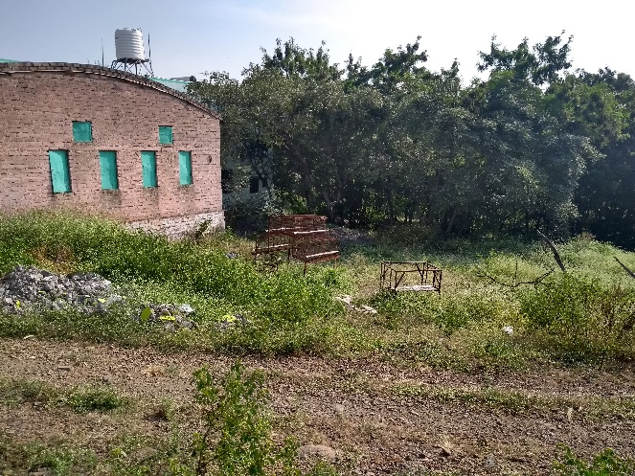  Location of proposed toilet | 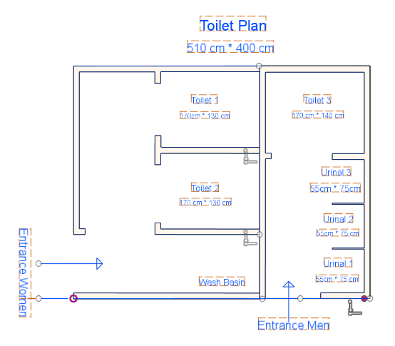  Proposed plan
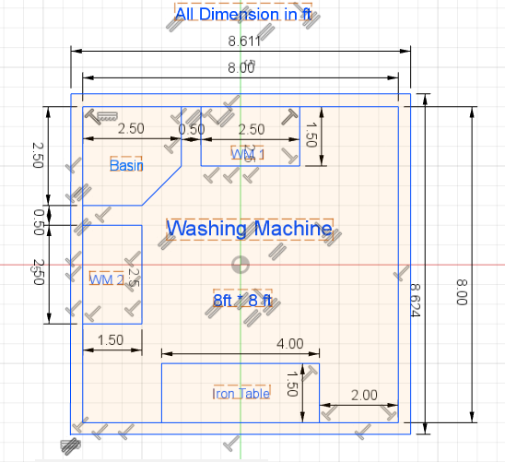  Plan for washing area |  | 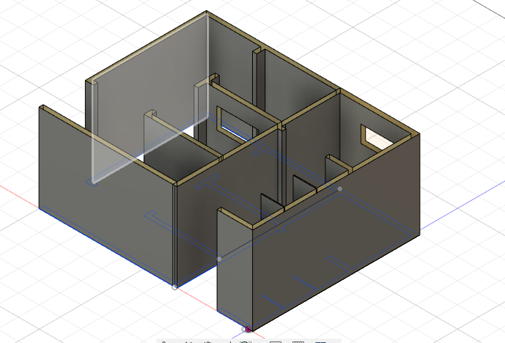  Proposed drawing for toilet block

Area of construction :
Toilet area : 226 sq.ft
A] Toilet
Material | Quantity | Cost
Brick | 5000 | 40000
Cement | 7 bags | 4000
Tiles | 64 sqft | 8000
Toilet Seat | 3 | 10000
Urinal | 3 | 9000
G I Sheet | 3 | 8000
Water Tank | 1000L | 5000
Bio Toilter KK Nag soak pit |  | 25000
Plumbing/Auxilary |  | 30000
Electricity |  | 5000
Excavation for foundation |  | 20000
Construction labor cost |  | 50000
Total |  | 214000

B] Washing area and bathroom : Two units

Material | Quantity | Rate | Cost
Bricks | 1200 | Rs.8/Brick | 9600
Cement  Tiles(flooring) | 3 bags  60sqft |  | 900  4000
G.I Sheet | 9ft*9ft |  | 2100
Water Tank | 750L |  | 5000
Plumbing Auxiliary |  |  | 5000
Electricity |  |  | 5000
Construction labour cost |  |  | 15000
Pump |  |  | 12000
Total |  |  | 53700

Total Costing : A] + B] = Rs.214000 + Rs.53700 = Rs.2,67,700/-

Transport / communication / Account audit / Overheads = Rs.26,770/-

TOTAL Support Expected = Rs.2,94,470/-*
(* This is approx. costing based on our experience and costing done by our instructor and students. )

We have taken the cost in approximation. Our judgement is that we will able to complete the construction of modern toilet within this budget.

Request from Asha for Education :
Asha for Education has invested lots of resources in VA from long time. It has helped VA in developing its infrastructure and host new program. VA is able to upgrade itself due to timely support from Asha for Education. We are thankful for the same.
We are requesting support for the Toilet and washing area = Rs.2,94,470/-

Benefits of the Project :
- We estimate that approx. 15 residential students; 15 Agri – AH students will directly benefit.
- Common toilet will also be useful for visitors to VA.
- Recycling of water from washing area will help in keeping our toilets clean.

Organisation Details :
Vigyan Ashram (a center of Indian Institute of Education)
At.Post.Pabal Dist.Pune 412403 , Phone : +91-9730005016 , vapabal@gmail.com

Contact Person : Dr.Yogesh Kulkarni, Director, Vigyan Ashram, Pabal. Dist.Pune.

