SACSAS Academy, New Dampi
I was glad I could take time out to visit the SACSAS academy.
I was touched by the simplicity, sincerity and the level of commitment of this project, in spite of the remoteness and social disturbances in the area.

The first one is the classroom picture of the Kindergarten. The younger children had an afternoon nap.

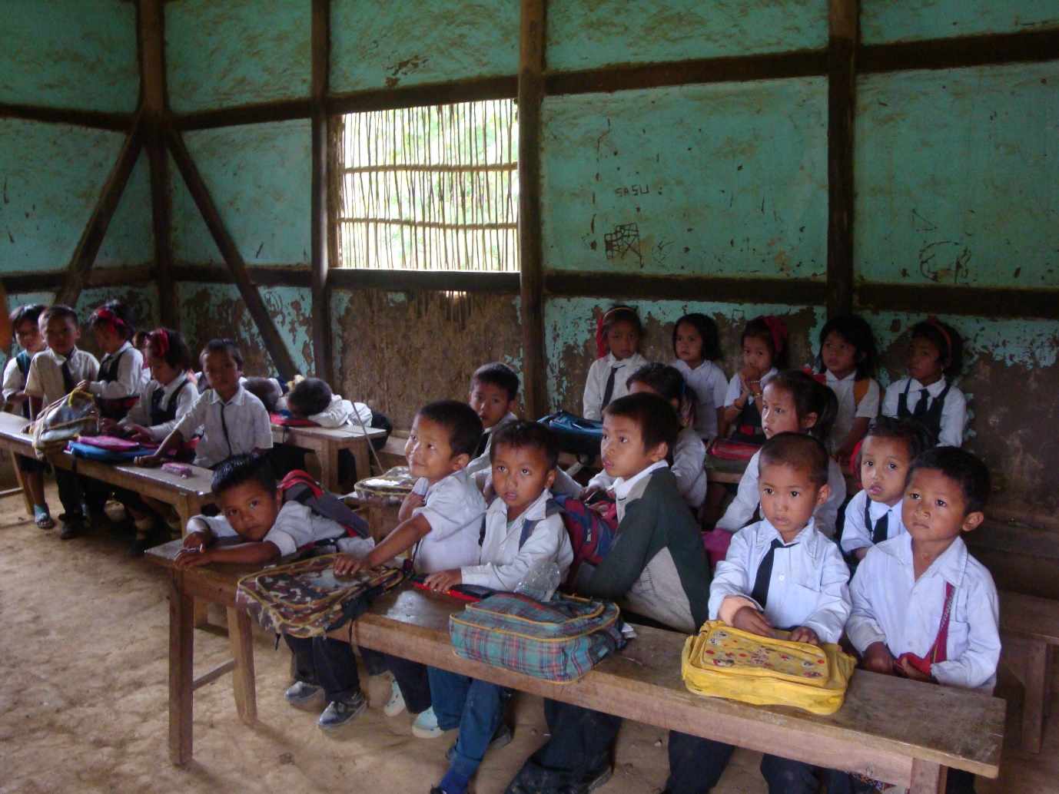

The second picture shows the sanitary facility without the roof and behind is the water tank.
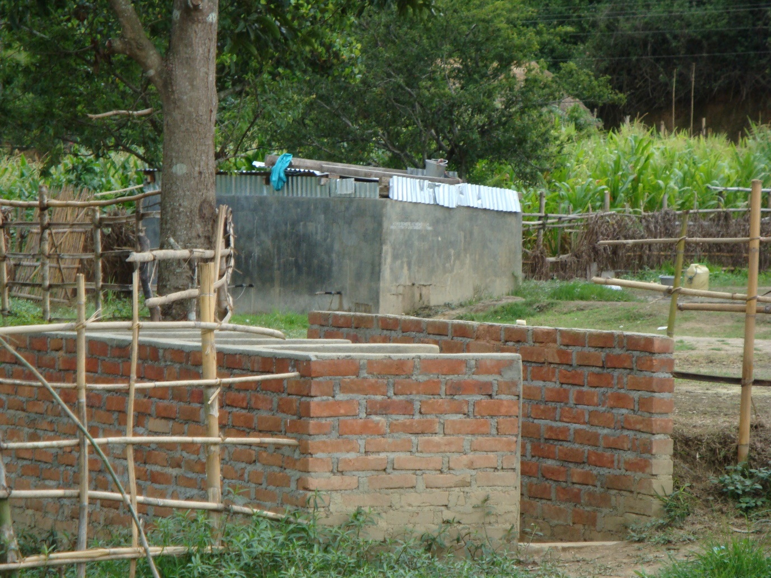

The third picture is a group school picture.
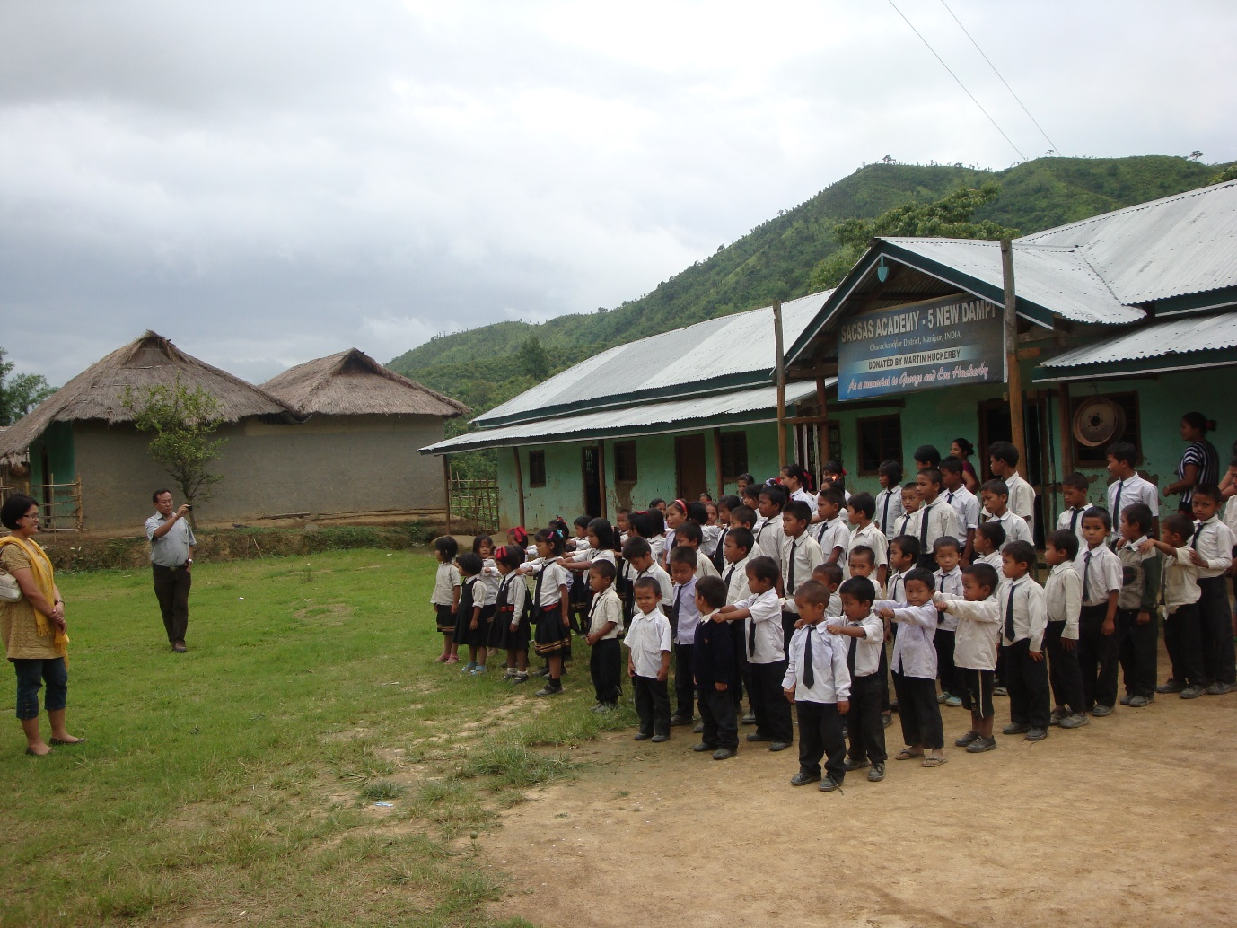
After seeing the poor sanitary facility, I inquired about the cost of a basic septic tank which is Rs. 40,000/.
I will try and raise this amount. I will get in touch with you again for this.

- How are the classes organized in the school? - i.e. are some classes combined together or there are separate rooms for each class?

The classes are combined by 2 years group. The whole school, SACSAS Academy, New Dampi has 4 classrooms. Kindergarten ( various ages 2- 10 years), Class 1 & 11 combined, Class 111 & 1V combined and Class V & V1 combined.

The Kindergarten students are not age dependent, they are rather grouped by their ability. Some students begin late education after they found out that other children of the same age who went to school are more aware and are able to read and write.

- Are the kids sitting on the benches or on the floor? We have the questionairre filled up during the startup of the project that chairs and tables are there in the school.
Some classroom pictures would be really nice for verification.

There are benches and tables in the classrooms. However, the walls are deteriorated and dilapidated. The black boards are being over-used.

- We have from the annual progress report of the New Dampi School that 13 students are presently studying in class VI and will be finishing school.
We are not sure if these students are planning to join the nearby government school or not. We need to know if SACSAS is helping them out to get admission to the regular schools. If its difficult on the part of SACSAS, is there any way to get this through so that the kids dont stop going to school after they pass out from SACSAS.

I spoke to some students from the class V & V1 combined group. They are able to read, converse and understand English. They would like to attend school in the future and enjoy being in school with friends. SACSAS gives a certificate on completion of school and with this, they are able to get admission in nearby government school. The problem is that the nearest school is at least 10 km away in a town called Churachandpur. So, if the students have relatives residing in this town, then they are more likely to continue schooling. I was told 2/3 of the students who passed out from this school is already in the 10th grade. There are however, no further feedback from the rest.

- What do the kids aged 2-6 do in the school? From the progress report, we see that the kids in the age group 2-6 study in class I, II. Is the curriculum like a kindergarten or is it something different? How do the teachers take care of these kids?

There are 25 students in combined Class I & II. The age group is varied and they are under 10 years old. The school follows the Manipur Board of Secondary Education Curriculum.

- How are the teachers teaching the kids in the school? Is there any innovative way in the education method or is it the same way whats followed in other schools ?
whats done for recreation?

The teachers follow the traditional method of education.

During recreation, I was told by the students that they play football, skipping, running and climbing nearby trees.

- How is the sanitary facility and the drinking water facility in school?

The school has one tank to store the drinking water, which is sustainable.

Sanitary facility is very poor. There are no septic tank but, an enclosure without roof.

- How do the kids ( aged 2-6) come to New Dampi village for studying? Is it like the parents drop them in the morning and pick them up in the evening or they go all by themselves? The reason this question came up is because, New Dampi village school is the only one in the area that caters to five surrounding villages.

All the kids walked to school by themselves. Some kids walked 3-4 km or even more unless they are from the same village.

- General problems faced in the school. Can be from teachers side and kids side as well.

The teachers are paid less so, there are frequent changes. They are attracted towards higher paid jobs and if any such opportunity arises the school is not able to keep them.

The students are all happy that they have some place to come, meet up with friends and at the same time get a education.

I was told that the funding from Asha arrived quite late in the previous years and they faced problems in paying for the teachers' monthly wages.

- Whats your feeling about the project in general?

I was touched by the simplicity, sincerity and the level of commitment of this project. The school is functioning very well. It is bringing an educational awareness amongst the villagers. The students have good discipline and they are well motivated. The school is providing an excellent opportunity for these very poor children and it is run professionally.
Some students help their parents during rice farming season. Few students were absent due to sickness. There were equal number of boys to girls ratio.
The school is located at a very remote place and not easily accessible. Social disturbance still prevails in the area.
Asha is supporting a very good cause.
--------------------------------------------------------------------------------------------------------------------------------------

Romita Dutta
romita_ak@yahoo.com

